

Date: June 17, 2026

Request for Quote (RFQ)
Fire Alarm and Fire Suppression System
RFQ 26FS0502 Addendum #1
Notice to Prospective Respondents

The Department of Veterans Affairs (CalVet) invites you to review and respond to this Request for Quote (RFQ) for CalVet Fresno’s Fire Alarm and Fire Suppression System. In submitting your Quote, you must comply with the instructions found herein. Failure to comply with any of the requirements may result in the rejection of your Quote. The services required are delineated in the Statement of Work (SOW). Please read the enclosed document carefully.

To submit a Quote for this solicitation you must comply with the instructions contained in this document as well as the requirements stated in Exhibit A - Statement of Work. By submitting a Quote, your firm agrees to the terms and conditions stated in this RFQ.

Response due date is located in section I. General Information, GH. Key Action Dates. Late responses will not be accepted.

Responses to this RFQ must be submitted by electronic mail to: ITProcurementServices@Calvet.ca.gov
Attention: Long Ho, Procurement Official

Reasonable Accommodation:
To comply with the non-discrimination requirements of the Americans with Disability Act (ADA), it is the policy of the State to make every effort to ensure that its programs, activities and services are available to all persons, including persons with disabilities. For persons with a disability needing a reasonable modification to participate in the procurement process, or for persons having questions regarding reasonable modifications for the procurement process, you may notify CalVet contact above. To ensure that we can meet your need, submit your request for reasonable modification at least five (5) business days before the scheduled event or the due date of procurement documents.

Summary of Changes:

Page(s) | Section | Description of Changes
1 | Notice to Prospective Respondents | Updated G. Key Action Dates to H. Key Action Dates
22 | Appendix B, Business Requirements, B.1 &B.2 | Removed and added language in red font
42 | Form 13, Response to Business Requirements, B.1 | Removed and added language in red font
43-44 | Form 14, Cost Quote | Changes made in red font
50-51 | F. Roles and Responsibilities | Changes made in red font
53-58 | H. Contractors Responsibilities | Changes made in red font
62-63 | Exhibit B-1, Cost Worksheet | Changes made in red font

Contents
I. General Information 5
A. Purpose of RFQ 5
B. Availability 5
C. Period of Performance 5
D. Information Technology Provisions 5
E. Eligible Bidders 6
F. Loss Leader 6
G. Mandatory Pre-Bid Walkthrough 6
H. Key Action Dates 6
I. Submission of Questions 7
J. Submission of Quote 7
K. Award of Contract 9
L. Protests 9
M. State’s Right to Reject 10
N. Economic Incentive Program 10
O. TACPA Contract Preference 10
P. RFQ Response Guidelines 12
Q. Confidentiality 12
II. Evaluation Information 13
A. Administrative, Business, and Technical Requirements 13
B. RFQ Submission Checklist 13
C. Scoring Evaluation 13
D. Preference and Incentive Programs 17
Appendix A, Administrative Requirements 19
Appendix B, Business Requirements 22
Appendix C, Technical Requirements 23
Contractor’s Bid Submittal Information 24
Form 1, Bidder Preferences and Certification 26
Form 2, Declarations 27
Form 3, Commercially Useful Function Certification 28
Form 4, Workers’ Compensation Certification 30
Form 5, Commercial General Liability Certification 31
Form 6, Payee Data Record 32
Form 7, Secretary of State Status 33
Form 8, Seller’s Permit 34
Form 9, Contractor’s Bid Certification 35
Form 10, Contractor Certification Clauses 36
Form 11, List of Proposed Subcontractors 40
Form 12, California Civil Rights Laws Certification 41
Form 13, Response to Business Requirements 42
Form 14, Cost Quote 43
Form 15, Summary of Applicable Engagement 45
Form 16, Response to the Statement of Work 46
Form 17, Contractor’s License Information 47
III. Sample Contract Package 48
Exhibit A – Statement of Work 49
A. Contract Description 49
B. Purpose 49
C. Term 49
D. Amendments 49
E. Contacts 49
F. Roles and Responsibilities 50
G. State Responsibilities 51
H. Contractor Responsibilities 52
I. Accidents/Damage 58
J. Work Area 59
K. Problem Escalation 59
L. Data Handling 59
Exhibit B – Budget Detail and Payment Provisions 61
A. Payment Provisions 61
B. Travel 61
C. Budget Contingency Clause 61
D. Prompt Payment Clause 61
Exhibit B-1, Cost Worksheet 62
Exhibit C – General Services Procurement Division – Information Technology General Provisions – (Cloud Computing Services) – GSPD-ITGP (Cloud) 64
Exhibit D – Information Security Incident Management 65
Exhibit E – Information Security and Confidentiality 67
Exhibit F – Agreements with External Entities 68
Exhibit G – Vendor Remote Access Policy 70
Exhibit H – Patch Management Policy 72
Exhibit I – California Civil Rights Law Certification 74

Request for Quote (RFQ)

General Information

Purpose of RFQ
The objective of this RFQ is to provide all preventive maintenance including, but not limited to system inspection, testing, application of software patches and upgrades, and repairs for the fire suppression and alarm systems to ensure they are functioning at an optimum level. These systems are critical in regard to providing health and safety for all the residents and staff at the Fresno home.
Service Locations
The Contractor shall provide all products and services required to achieve these tasks at the following location:
Department of Veterans Affairs
Veterans Home of California (VHC) – Fresno
2811 W. Cesar Chavez Blvd.,
Fresno, CA 93706

The State will not reimburse the Contractor for any travel related costs.

Availability
All candidates submitted by the Contractor must be available during the term of the Contract. The selected Contractor and proposed staff must be able to meet the requirements of the RFQ and be ready to begin work on the anticipated Contract start date indicated in the Key Action Dates, unless notified otherwise by CalVet.

Period of Performance
The anticipated term of this Contract begins on the date indicated in the Key Action Dates, for a term of three (3) years at the rates stated in Exhibit B-1, Cost Sheet. If the Contractor starts performance before final approval of the Contract, it shall be considered voluntary on the part of the Contractor and free of charge.

Information Technology Provisions
The following information is incorporated into this RFQ. Please read the documents carefully. Bidder must agree to the terms and conditions listed below by signing the Contractor’s Bid Certification Sheet which can be found in Section II – Contractor’s Bid Submittal Checklist section of this RFQ. Please read the documents carefully.
Bidder Instructions (Effective 11/09/11)
https://www.documents.dgs.ca.gov/dgs/FMC/GS/PD/DGSPD%20451.pdf
General Services Procurement Division – Information Technology General Provisions – (Cloud Computing Services) – GSPD-ITGP (Cloud) (Revised 02/20/2025)
https://www.dgs.ca.gov/-/media/Divisions/PD/Acquisitions/Solicitation-Document-Attachments/IT-General-Provisions-Cloud-DGS-PD-402ITGP-Revised-02202025.pdf
Refer to Exhibit C - General Services Procurement Division – Information Technology General Provisions –– (Cloud Computing Services) – GSPD-ITGP (Cloud) for more information.

Eligible Bidders
Public or private corporations, agencies, organizations, associations, or individuals may submit a Quote in response to this RFQ. The Bidder must be legally constituted and qualified to do business within the State of California (registered with the Secretary of State). With the exception of Bidders whose legal status precludes incorporation (i.e., public agencies, sole proprietorships, and partnerships). Bidders that are not fully incorporated by the deadline for submitting Quotes will be disqualified. The Bidder must also not be listed on either list of the 500 largest tax delinquencies pursuant to §7063 or §19195 of the State of California Revenue and Taxation Code.

Loss Leader
It is unlawful for any person engaged in business within this State to sell or use any article or product as a “loss leader” as defined in Section 17030 of the State of California Business and Professions Code.

Mandatory Pre-Bid Walkthrough
A mandatory pre-bid walkthrough is scheduled at 10:30 a.m. on June 19, 2026 for the purpose of viewing the site and discussing concerns regarding this RFQ.

Key Action Dates
Listed below are the Key Action Dates and times by which the actions shall be completed. If the State finds it necessary to change any of these dates, it will be accomplished via an addendum to this RFQ. Dates are estimated and may be extended as necessary.
Key Action Dates | Date/Time Due
Release of Solicitation | June 17, 2026
Mandatory Pre-Bid Walkthrough | June 19, 2026
Submission of Written Questions | June 22, 2026 by 2:00 p.m.
Response to Questions | June 23, 2026
Submission of Quote | June 30, 2026 by 2:00 p.m.
Intent to Award | July 1, 2026
Last Day to Protest | July 8, 2026
Anticipated Contract Start Date | July 1, 2026
Responses to this RFQ must be submitted by electronic mail to: ITProcurementServices@Calvet.ca.gov
Attention: Long Ho, Procurement Official
(with a cc to Long.Ho@Calvet.ca.gov)

Submission of Questions
All questions and required attachments/documentation must be submitted electronically with the subject, “Fire Alarm and Fire Suppression System - Fresno RFQ” to: ITProcurementServices@calvet.ca.gov with a cc to Long.Ho@Calvet.ca.gov.
All questions submitted by the deadline will be responded to at the same time with all questions and answers posted to Cal eProcure in the form of a question and answer set.
Oral communications by Agency/state entity officers and employees concerning this solicitation shall not be binding on the State and shall in no way excuse the Bidder of any obligations set forth in this solicitation.
All questions regarding the content of this RFQ shall be submitted via e-mail according to the following format:
Item | Section Reference | Bidder Question
Example: 1 | Example: Section I.L., Submission of Questions | Example: What is the…?
Questions not submitted by the due date stated in the Key Action Dates shall be answered at the State’s option.
It shall be the Bidder’s responsibility to immediately notify the Procurement Official identified in Section I. H., in writing, whenever its intent to bid changes or whenever there is a change in the bidder’s designated contact information. The State shall not be responsible for Quote correspondence not received by the Bidder if the bidder fails to notify the State, in writing, about any change pertaining to the designated contact person.

Submission of Quote
Award of Contract, if made, shall be in accordance with the RFQ information and evaluation to a responsible Bidder with a Quote that complies with all the requirements of the RFQ and any addenda. Award, if made, shall be made within forty-five (45) days after the scheduled date for Contract Award as specified in the RFQ; however, a Bidder may extend the Quote beyond forty-five (45) days in the event of a delay of Contract award.
Quotes should provide straightforward and concise descriptions of the firm's ability to satisfy the requirements of this RFQ. The Quote must be complete and accurate. Omissions, inaccuracies or misstatements may be sufficient cause for rejection of a Quote.
    - All Quotes shall include the Attachments and supporting documentation identified in “RFQ Submission Checklist.” Quotes that do not include the proper "required attachments" shall be deemed non-responsive. A non-responsive is one that does not meet the basic requirements.
    - All documents requiring a signature must bear an original signature or electronic signature of a person authorized to bind the Bidder firm.
    - Quotes must be submitted for the performance of all the services described herein. Any deviation from the work specifications will not be considered and will cause a Quote to be rejected.
    - A Quote may be rejected if it is conditional or incomplete, or if it contains any alterations of form or other irregularities of any kind. The State may reject any or all Quotes and may waive an immaterial deviation in a Quote. The State's waiver of immaterial deviation shall in no way modify the RFQ document or excuse the Bidder from full compliance with all requirements if awarded the Contract.
    - Costs for developing Quotes and in anticipation of award of the Contract is entirely the responsibility of the Bidder and shall not be charged to the State of California.
    - An individual who is authorized to bind the Bidder contractually shall sign the Bidder Preferences and Certification form. The signature should indicate the title or position that the individual holds in the firm. An unsigned Quote may be rejected. If the Quote is made under a fictitious name or business title, the actual legal name of Bidder must be provided.
    - A Bidder may modify a Quote after its submission by withdrawing its original Quote and resubmitting a new Quote prior to the Quote submission deadline. Bidder modifications offered in any other manner, oral or written, will not be considered.
    - A Bidder may withdraw its Quote by submitting a written withdrawal request to the State, signed by the Bidder or an authorized agent. A Bidder may thereafter submit a new Quote prior to the Quote submission deadline. Quotes may not be withdrawn without cause subsequent to Quote submission deadline.
    - The State may modify the RFQ prior to the date fixed for submission of Quotes by the issuance of an addendum to all parties who received a Quote package.
    - The awarding agency reserves the right to reject all Quotes. The agency is not required to award a Contract.
    - Before submitting a response to this solicitation, Bidders should review, correct all errors and confirm compliance with the RFQ requirements.
    - Where applicable, Bidder should carefully examine work sites and specifications. Bidders shall investigate conditions, character, and quality of surface or subsurface materials or obstacles that might be encountered. No additions or increases to the Contract amount will be made due to a lack of careful examination of work sites and specifications.
    - General Services Procurement Division – Information Technology General Provisions –– (Cloud Computing Services) – GSPD-ITGP (Cloud) (Revised 02/20/2025). The State does not accept alternate Contract language from a prospective Bidder. A Quote with such language will be considered a counter Quote/Bid and will be rejected. The State’s General Services Procurement Division – Information Technology General Provisions –– (Cloud Computing Services) – GSPD-ITGP (Cloud) are not negotiable and may be viewed at Exhibit C.
    - Payee Data Record. Bidder must complete and submit to the awarding agency the Payee Data Record (STD204) to determine if the Bidder is subject to state income tax withholding pursuant to California Revenue and Taxation Code Sections 18662 and 26131. No payment shall be made unless a completed STD204 has been returned to the awarding agency. This form can be found at https://www.documents.dgs.ca.gov/dgs/fmc/pdf/std204.pdf.
    - Contractor Certification Clauses. Bidder must sign and submit to the awarding agency, page one (1) of the Contractor Certification Clauses (CCC), which can be found on the Internet at https://www.dgs.ca.gov/-/media/Divisions/OLS/Resources/CCC-042017.pdf?la=en&hash=4DE3E4DC414511AE378794200BA43EBF91C758EE.
    - California Civil Rights Laws Certification. Pursuant to Public Contract Code section 2010, the Bidder shall complete Form 12, California Civil Rights Laws Certification, certifying compliance with the following:
      - California Civil Rights Laws: For Contracts over $100,000 executed or renewed after January 1, 2017, the Bidder certifies compliance with the Unruh Civil Rights Act (section 51 of the Civil Code) and the Fair Employment and Housing Act (section 12960 of the Government Code); and Contractor certifies that such policies are not used in violation of the Unruh Civil Rights Act (Section 51 of the Civil Code) or the Fair Employment and Housing Act (Section 12960 of the Government Code).
      - Employer Discrimination Policies: For Contracts over $100,000 executed or renewed after January 1, 2017, if a Bidder has an internal policy against a sovereign nation or peoples recognized by the United States government, the Contractor certifies that such policies are not used in violation of the Unruh Civil Rights Act (Section 51 of the Civil Code) or the Fair Employment and Housing Act (Section 12960 of the Government Code).

Award of Contract
Award of Contract, if made, will be in accordance with the RFQ information on Evaluation to a responsible Bidder whose Quote complies with all the requirements of the RFQ documents and an addenda thereto, except for such immaterial defects as may be waived by the State. Award, if made, will be made within forty-five (45) days after the scheduled date for Contract Award as specified in the RFQ; however, a Bidder may extend the offer beyond forty-five (45) days in the event of a delay of Contract award.
The State reserves the right to determine the successful Bidder(s) either on the basis of individual items or on the basis of all items included in its RFQ, unless otherwise expressly provided in the State’s RFQ. Unless the Bidder specifies otherwise in its bid, the State may accept any item or group of items of any bid. The State reserves the right to modify or cancel in whole or in part it’s RFQ.
Written notification of the State’s intent to award will be made to all Bidders. If a Bidder, having submitted a bid, can show that its bid, instead of the bid selected by the State, should be selected for Contract award, the Bidder will be allowed five (5) working days to submit a Notice of Intent to Protest, according to the instructions contained in the paragraph titled “Protests” of this RFQ.

Protests
Any Bidder’s issues regarding solicitation requirements must be resolved (or attempts to resolve them must have been made) before a protest may be submitted according to the procedure below. These issues will first be resolved by the contact for the solicitation or if they result in a protest, the protest will be submitted to DGS Procurement Division Deputy Director to hear and resolve issues and whose decision will be final.
If a Bidder has submitted a bid which it believes to be responsive to the requirements of the RFQ and to be the bid that should have been selected according to the evaluation procedures in the solicitation and the Bidder believes the State has incorrectly selected another Bidder for award, the Bidder may submit a protest of the selection as described below. Protests regarding selection of the “successful vendor” will be heard and resolved by the Victim Compensation and Government Claims Board whose decision will be final.
All protests of award must be made in writing, signed by an individual authorized to bind the Bidder contractually and financially, and contain a statement of the reason(s) for protest; citing the law, rule, regulation or procedure on which the protest is based. The protester must provide facts and evidence to support the claim. Protests must be mailed or delivered to:
Dispute Resolution Unit
Department of General Services
Procurement Division
707 Third Street, Second Floor South
West Sacramento, CA 95605
PDProtest@dgs.ca.gov
All protests to the RFQ or protests concerning the evaluation, recommendation, or other aspects of the selection process must be received by the DGS Procurement Division Deputy Director as promptly as possible, but not later than the date indicated in the Notification of Intent to Award. Certified or registered mail must be used unless delivered in person, in which case the protester should obtain a receipt of delivery.

State’s Right to Reject
A Quote may be rejected if it is conditional or incomplete, or if it contains any alterations of form or other irregularities of any kind. The State may reject all Quotes and may waive any immaterial deviation in a Quote. The State’s waiver immaterial defect shall in no way modify the RFQ document or excuse the proposing firm from full compliance with all requirements if awarded the Contract. CalVet reserves the right to reject all Quotes at its sole discretion. If all Quotes are too high, CalVet is not required to award a Contract (State of California PCC § 10344(d), § 10377(d)).

Economic Incentive Program
Bidders may be eligible for additional preferences when their place of business is located within certain economic regions and when they hire persons living and working within those economic regions. For more information, refer to Section N below.

TACPA Contract Preference
The Department of General Services, Procurement Division, (DGS-PD) Support Services Unit (SSU) administers the Target Area Contract Preference Act (TACPA) program.
This solicitation provides for the optional TACPA preference. Bidders are not required to apply for this preference. Denial of the TACPA preference request is not a basis for rejection of the bid/offer.
The TACPA workplace and workforce preferences will be evaluated for this solicitation. California-based companies seeking TACPA preferences will need to complete and submit preference request forms with the bid/offer. The following webpage contains required preference request forms and an interactive map to determine if a business is located within a TACPA qualified zone: Request-a Target-Area-Contract-Preference
By submitting TACPA forms, a bidder given a TACPA preference agrees to the TACPA contract provisions required by Government Code section 4535 and provided in section 1896.40 of Title 2 of the California Code of Regulations (CCR) in addition to requirements specified on the TACPA form STD 830.
Pursuant to the TACPA, the state shall award workplace and workforce preferences to eligible California-based companies for state solicitations exceeding $100,000.00 for the purchase of goods and services, including Information Technology goods and services, except a contract in which the worksite is fixed by the provisions of the contract. (See Government Code (GC) §§ 4530 – 4535.3)
    - Preference Amounts Specific to Solicitations for SERVICES
      - A workplace preference of 5 percent to California-based companies who demonstrate and certify under penalty of perjury that not less than 90 percent of the total labor hours required to perform the contract shall be accomplished at an identified worksite or worksites located in a distressed area
      - A workforce preference, as specified in GC Section 4533.1, to California-based companies that demonstrate and certify, under penalty of perjury, that the workforce completing those labor hours are persons with a high risk of unemployment, as defined in GC Section 4532. Section 4533.1 specifies workforce preferences from 1 percent to 4 percent depending on the percentage of a bidder’s workforce required to perform the contract who are persons with high risk of unemployment as committed to and certified by the bidder.
    - Preference Maximum Amounts
      - The maximum preference cost for the workplace preference cannot exceed $50,000.00.
      - The maximum preference cost for the workforce preference cannot exceed $50,000.00.
      - The maximum combined preferences and incentives resulting from a workplace preference, workforce preference, and other preferences or incentives provided under any other provision of law shall be 15% but may not in any case exceed $100,000.00 in total.
    - Preference Precedence
California certified small business bidders qualified in accordance with GC 14838 shall have precedence over non-small business bidders in that the application of any bidder preference for which non-small business bidders may be eligible, including the workplace and workforce preferences under TACPA, shall not result in the denial of the award to a small business bidder. This shall apply to those cases where the small business bidder is the lowest responsible bidder, as well as to those cases where the small business bidder is eligible for award as the result of application of the 5-percent small business bidder preference and incentive.
    - Assistance to Bidders & Distressed Area Map
The Department of General Services, with the cooperation of the Governor's Office of Planning and Research, shall assist prospective bidders in identifying those areas of the state which qualify as distressed areas for purposes of the TACPA preferences (Title 2 California Code of Regulations (CCR) 1896.38).

The following webpage contains an interactive map to determine if a business is located within a TACPA qualified zone: Request-a-Target-Area-Contract-Preference.

For assistance, bidders may contact DGS-PD SSU at: TACPA@dgs.ca.gov

The Employment Development Department (EDD) shall assist bidders seeking to certify that they will employ persons with high risk of unemployment in recruiting eligible job applicants and shall certify such applicants, except youths participating in qualified cooperative education programs who shall otherwise be certified (2 CCR 1896.39).

RFQ Response Guidelines
Responses to this RFQ shall contain all data/information requested. It is the Bidder’s responsibility to provide all required data and any other information deemed necessary for the State’s evaluation team to determine and verify the Bidder’s ability to meet the requirements of this RFQ.
At the State’s option prior to award, Bidders may be required to submit additional written clarifying information, including rationale for their proposed solution. Failure to submit the required written information as specified may be grounds for Quote rejection.

Confidentiality
Bidder material becomes public only after the notice of Intent to Award is released. If material marked “confidential,” “proprietary,” or “trade secret” is requested pursuant to the Public Records Act, the State will make an independent assessment whether it is exempt from disclosure. If the State disagrees with the Bidder, the State will notify the Bidder and give them a reasonable opportunity to justify their position or obtain a court order protecting the material from disclosure.
The Bidder should be aware that marking a document “confidential” or “proprietary” in a Final Quote may exclude it from consideration for award and will not keep that document from being released after notice of award as part of the public record, unless a court has ordered the State not to release the document. The content of all working papers and discussions relating to the Bidder’s Quote shall be held in confidence indefinitely, unless the public interest is best served by an item’s disclosure because of its direct pertinence to a decision, agreement or the evaluation of the Quote.
Any disclosure of confidential information by the Bidder is a basis for rejecting the Bidder’s Quote and ruling the Bidder ineligible to further participate. Any disclosure of confidential information by a State employee is a basis for disciplinary action, including dismissal from State employment, as provided by Government Code §19570 et seq. Total confidentiality is paramount; it cannot be over emphasized.

Evaluation Information
The winning bid will be based on the highest score received which is calculated by adding the points earned for technical and cost requirements.

Administrative, Business, and Technical Requirements
The Administrative, Business, and Technical requirements will be evaluated on a Pass/Fail basis. Quotes will first be screened to determine if the Bidder has complied with appropriate submittal instructions and required components. Quotes that meet the “pass/fail” criteria will be eligible to have their cost quote evaluated. QUOTES THAT DO NOT PASS ALL THE MANDATORY REQUIREMENTS WILL BE DEEMED NON-RESPONSIVE AND WILL BE REJECTED.
The State has established certain requirements with respect to Quotes to be submitted by prospective Bidders. The use of “shall,” “must,” or “will” (except to indicate simple futurity) in this RFQ indicates a requirement or condition that is mandatory. Should a Bidder respond to a mandatory requirement using language that fails to explicitly commit the Bidder after Contract award by using terms such as “may” or “could,” the State may interpret the response as a material deviation. A deviation, if not material, may be waived by the State. A deviation from a requirement is material if the deficient response is not in substantial accord with the RFQ requirements, provides an advantage to one Bidder over other Bidders, or has a potentially significant effect on the delivery, quantity, or quality of items Quote, the amount paid to the Bidder or on the cost to the State. Material deviations cannot be waived.
The State has determined that it is best to define its own needs, desired operating objectives, and desired operating environment. The State will not tailor these needs to fit some solution a Bidder may have available; rather, the Bidder shall propose to meet the State’s needs as defined in this solicitation.
The Bidder qualifications and solution requirements listed in this section are denoted as follows:
- (M) Sections labeled as “Mandatory” or “M” are not negotiable. To be considered responsive and responsible to these requirements, all requirements identified as (M) must be responded to. A “fail” will result in a Quote being deemed non-responsive and, therefore, will be disqualified. Failure to respond to any (M) requirements where indicated shall result in a “fail” and disqualification of the Quote.

RFQ Submission Checklist
The RFQ Submission Checklist will be used to evaluate the Bidder’s RFQ. Bidders may also use the checklist to verify that appropriate documentation and requirements are met. Bidders are not required to submit the checklist.

Scoring Evaluation
The Contractor is responsible for performing all tasks, responsibilities, and services identified in the resulting Contract at the rates provided on EXHIBIT B-1: COST WORKSHEET for the term of the Contract as identified in the SOW, including all costs for the optional year(s). All Contractors must provide individual costs as indicated on the cost worksheet and submit with their response.
A “Value Effective” approach will be used in reviewing Contractor responses to this RFQ. An assessment committee will review and assess Quotes based on the degree to which they Quote the best value to CalVet. A multiple phase process will be used to review and/or rate responses. A multiple stage process will be used to review and/or rate responses. Quotes that do not comply with the mandatory components stipulated in this RFQ may be deemed non-compliant and the Contractor disqualified. The State may reject any response found to be non-compliant at any stage of the review. The State reserves the right to modify or cancel this procurement in its entirety or in part at any time. The Contractor is required to thoroughly review the RFQ to ensure that its response is fully compliant with the RFQ requirements and thereby avoid the possibility of being ruled non-compliant. If the State finds that a Contractor’s Final Quote has a material deviation from a specified requirement, the Contractor will be deemed non-compliant and will be the basis for rejecting the Contractor’s Quote. CalVet may reject any response found to be non-responsive at any stage of review. If deemed necessary, CalVet may collect additional documentation (i.e., missing forms, missing appendix items, missing data from RFQ forms) to enable initial responsiveness to the RFQ requirements. Responses that appear to meet the initial RFQ requirements and contain the required documentation will be submitted to a review team. By submitting a Quote, Contractors agree to the terms and conditions stated in the SOW and the proposed Contract. Responses received after this deadline will be rejected.
  - Phase I – Acceptance
Shortly after the submission deadline, CalVet will review each response for initial responsiveness to the RFQ requirements (i.e., timeliness and completeness).
  - Phase II – Response Review/Rating
Quotes that appear to meet the initial RFQ requirements and contain the required documentation will be submitted to the assessment team.
The assessment team will review and compare all responses to one another and assign a numeric score to each response based on its adequacy, thoroughness, and the degree to which the solution best meets the Program’s needs and represents the best value to the State.
The assessment team will use the following scoring system to assign points. The following chart is a list of the considerations that will be considered when assigning points to a response.
RFQ Requirement | Scoring
Administrative Requirements
Required Forms, Documents, Certifications | Pass/Fail
Technical Requirements
Summary of Applicable Engagements | 25 Points
Response to the SOW | 75 Points
Cost Requirements
Contractor’s Cost | 100 Points
Scoring Criteria
Scoring Scale Written Responses |  |  | Definition of Criteria Terms
Scores are a percentage of their maximum scores with 0 being the lowest and 100 being the highest. |  |  | Term | Definition
Scores | Criteria |  | Best Practice | Considered to be a foremost, capable and competent method(s)
80-100 | Significantly exceeds requirements, achievable, applies best practices, clearly and concisely presented, logically organized and well-integrated. |  | Achievable | Doable with proposed resources, schedule and constraints
60-79 | Somewhat exceeds requirements, achievable, applies best practices, clearly and concisely presented, logically organized and well-integrated. |  | Integrated | Linked to one or more components/elements of the business case
40-59 | Meets requirements, achievable, suitable, acceptably presented, organized and integrated. |  | Presented | Both written and oral form
20-29 | Somewhat less than meeting requirement, achievable, somewhat suitable, less than acceptably presented, somewhat unorganized, somewhat integrated. |  | Concisely | To the point, without any hyperbole
1-19 | Significantly less than requirements, not fully achievable, suitable or addressed. |  | Logically | Sensible, easy to follow and plausible
0 | Not addressed or failed to answer question appropriately. |  | Suitable | Not necessarily a best practice, but achieves objectives
Note: Scores can be entered as whole numbers or as decimals (for example, 3.5). |  |  | Addressed | Referenced or comment provided
    - Administrative Assessment
The Administrative Requirements of this RFQ will be scored as Pass or Fail. Responsiveness to the requirements listed in this RFQ will be either given a “Pass” (i.e., complied with requirement, completed, and returned document) or “Fail” (i.e., did not comply with requirement, did not complete or return document). If a supplier receives a Fail for any of these requirements, the response may be rejected.
    - Technical Assessment
This RFQ will be Pass or Fail and scored. The Contractor may achieve a maximum of one hundred (100) points. Scoring will be based on its adequacy, thoroughness, and the degree to which the Contractor meets or exceeds the RFQ requirements and overall best value to the State.
    - Cost Assessment
Cost Requirements of this RFQ will be scored and can achieve a score of up to one hundred (100) points. The Assessment Team will review, calculate, and score Form 14 – Cost Worksheet to verify that it is complete with total cost of Contractors’ Quotes. The Contractor with the lowest total cost based on the assessment performed below will receive a maximum of one hundred (100) points. The Assessment Team will perform the following formula for the cost assessment:
(Lowest Proposed total cost / Contractor’s Proposed total cost) * 100 points = Score
Points in the examples below explain the calculations and have no other significance.
EXAMPLE: Cost Assessment Score
Contractor Cost | Percentage  (Lowest Proposed Total Cost divided by the Contractor’s Total Cost) | Cost Score
Quote A $300,000 | $270,000/$300,000 = .90 (90%) | .90 x 100 = 90
Quote B $277,000 | $270,000/$277,000 = .97 (97%) | .97 x 100 = 97
Quote C $270,000 | $270,000/$270,000 = 1.0 (100%) | 1.0 x 100 = 100
EXAMPLE: Maximum Non-Cost and Cost Points Available
Contractor Quote | Response to SOW | Summary of Applicable Engagements | Cost Score | Total Points
Quote A | 60 | 24 | 90 | 174
Quote B | 59 | 24 | 97 | 180
Quote C | 70 | 25 | 100 | 195
All proposed costs for all line items must be all inclusive, thereby including the cost of any and all services required in this solicitation.
The intent is to structure the pricing format in order to facilitate a straightforward comparison among all Bidders and foster competition to obtain the best market pricing. Consequently, the CalVet requires that each Bidder’s cost be in the format outlined in the Form 14, Cost Quote. Therefore, the Bidder is advised that failure to comply with the instructions listed in this section, such as submission of an incomplete Quote, use of alternative pricing structures or different formats than the one requested, may be the basis for rejection of the Bidder’s Quote.
Important Note: It is imperative that no cost information is included in the body of the Quote. Cost information must be submitted in the Form 14, Cost Quote, as a separate attachment and clearly labeled.
If a Bidder’s Quote has been determined to be non-responsive during the evaluation of requirements, cost will not be evaluated. Quote must be based on CalVet’s Statement of Work; Exhibit A. Each Bidder's cost shall be evaluated for responsive Quotes from responsible Bidders that passed the mandatory administrative and business requirements.

Preference and Incentive Programs
Preference and Incentive Programs are each identified below. When the Bidder satisfies the requirements and requests bid preferences and incentives, the Bidder must clearly identify in their bid submission for which of the programs it qualifies. Denial of those preference or incentive requests is not a basis for rejection of the bid.
NOTE: Pursuant to GC § 14837, only a SB who performs a Commercially Useful Function (CUF) relevant to the SOW included in this RFQ may be used to qualify the Bidder for the SB Preference or Non-Small Business Subcontractor Preference. Pursuant to Military and Veterans Code Section 995.5, only a DVBE who performs a CUF relevant to the SOW in this RFQ may qualify the Bidder for the DVBE Incentive.
- Commercially Useful Function
A business that is performing a commercially useful function is one that does ALL of the following:
    - Is responsible for execution of a distinct element of the work of the Contract
    - Carries out its obligation by actually performing, managing, or supervising the work involved
    - Performs work that is normal for its business, services and function
    - Is not further subcontracting a portion of the work that is greater than that expected to be subcontracted by normal industry practices
    - Is responsible, with respect to products, inventories, materials, and supplies required for the Contract, for negotiating price, determining quality and quantity, ordering, installing, if applicable, and making payment
- Small Business Preference
California Government Code (GC) Section 14835, et seq., requires a preference be given to Bidders who are California Certified Small Business (SB). The rules and regulations of this law, including the definition of a SB for the delivery of goods and services, are contained in California Code of Regulations, Title 2, Section 1896 et seq.

A preference is available to a certified SB. A Bidder claiming this preference must be certified by the Office of Small Business and Disabled Veteran Enterprise Services (OSDS) as a SB. Questions regarding certification should be directed to the OSDS at (916) 375-4940.

To be considered as a certified SB, the Bidder must have a complete application package on file with the OSDS by 5:00 p.m. on the Deadline for Final Bid Submission date. Questions regarding the certification approval process should be directed to the OSDS. A copy of the regulations, instructions and format for claiming the Small Business Preference is available at: http://www.dgs.ca.gov/pd/Programs/OSDS/GetCertified.aspx.
To claim the Small Business Preference please see Form 1, Bidders Preferences and Certification.
- Non-Small Business Subcontractor Preference:
A preference is available to a non-small business (NS) claiming 25% California-certified small business subcontractor participation. A Bidder claiming this preference must list one or more SB subcontractor(s), whom the Bidder commits to subcontract in an amount of at least twenty-five percent (25%) of the work performed under this Contract.
To claim the Non-Small Business Subcontractor Preference please see Form 1, Bidders Preferences and Certification.
- Disabled Veteran Business Enterprise:
The Mandatory DVBE Participation Requirement is being waived for this RFQ.
- Applying Preference and Incentives
Preferences and incentives are used for bid tabulation purposes to determine the lowest responsive responsible bid. Strict adherence to the laws and regulations to apply the preferences and incentives will be followed. If awarded the Contract, the preference and/or incentive does not alter the amount of the resulting Contract. Please be aware that Contracts awarded with applied preferences or incentives will be monitored throughout the life of the Contract for compliance to statutory, regulatory and contractual requirements.

The SB preference of 5% will be applied when a responsible Bidder that is not a CA certified SB or a NS claiming 25% CA certified SB subcontractor participation submits the lowest responsive bid. (Note: NS claiming SB subcontractor preference cannot displace an award from a certified SB.) Pursuant to California Code of Regulations (CCR) 2 CCR§ 1896.8, there is a $50,000.00 cap of the amount of SB preference.

Sample bid tabulation:
Bidder | A | B | C
Responsive & Responsible? | Yes | Yes | Yes
5% DVBE requirement met? | Yes | Yes | No
Small Business | SB | NS | No
NET BID AMOUNT | $110,100.00 | $109,500.00 | $107,300.00
Initial Ranking | 3 | 2 | 1
SB Preference Amount | $5,390.00 | $5,390.00 | none
Subtotal | $104,710.00 | $104,110.00 | $107,300.00
Ranking after SB Preferences | 2 | 1 | 3

Appendix A, Administrative Requirements

 | Administrative Requirements | Score Type
A.1 | Statement of Work (SOW)  Exhibit A, Statement of Work, identifies how the State Contract will be structured. No negotiations or alterations (unless specified otherwise) in the Contract are permitted. Bidder must be able to perform the work identified in the SOW. Complete From 9, Contractor’s Bid Certification to certify that the Bidder is able to meet the requirements of this RFQ. | M
A.2 | Bidder Preferences and Certification  If Bidder is a California Certified Small Business and/or DVBE, complete Form 1, Bidder Preferences and Certification. | M
A.3 | Declaration Forms  All Bidders must complete the Bidder Declaration GSPD-05-105, Form 2, Declarations, and include it with the Quote response. When completing the declaration, Bidders must identify all subcontractors proposed for participation in the Contract. Bidders awarded a Contract are contractually obligated to use the subcontractors for the corresponding work identified unless the State agrees to a substitution and it is incorporated by amendment to the Contract. If not using subcontractors, submit the form and indicate “NONE” in the appropriate section. | M
A.4 | Commercially Useful Function  Military and Veterans Code Section 999 et seq. requires all small business, micro businesses and disabled veteran enterprises to perform a “commercially useful function” in any Contract they perform for the state.  The Bidder must provide a written statement detailing the role, services and/or goods the subcontractor(s) will provide to meet the Commercially Useful Function requirement, using the Commercially Useful Function Certification. The criteria and definition for performing a commercially useful function are contained in the DVBE Program Requirements page entitled Resources & Information. Form 3, Commercially Useful Function (CUF). This is not mandatory and is only applicable to California Certified Small Business and/or DVBE. | M
A.5 | Workers’ Compensation Insurance  The Bidder must maintain in force (as required by State law) a valid Workers’ Compensation Insurance Policy for all employees engaged in the performance of the Contract and agree to furnish the State satisfactory evidence thereof at the time of the bid submittal and at any time the State may so request.  Satisfactory evidence of a certificate of insurance showing a minimum amount of not less than $1,000,000 employer’s liability, for all employees proposed in the performance of this Contract must be included in the Quote and must be provided to the State at any time the State may request. Bidders must complete Form 4, Workers’ Compensation Insurance Certification. | M
A.6 | Commercial General Liability Insurance  The Bidder and proposed subcontractors must maintain in force (as required by State law) a valid Commercial General Liability Insurance Policy. Satisfactory evidence of a certificate of insurance showing a minimum amount of not less than $1,000,000.00 must be included in the Quote and must be provided to the State at any time the State may request. Form 5, Commercial General Liability Certification. | M
A.7 | Payee Data Record and Seller’s Permit  The Bidder is required to sign the Payee Data Record, STD. 204 and provide a copy of CA Seller’s Permit. Form 6, Payee Data Record and Form 8, Seller’s Permit. | M
A.8 | Secretary of State Certification  All Corporations, Limited Liability Corporations, and Limited Partnerships must be registered and in ‘Active’ status with the California Secretary of State (SOS) to be awarded a Contract. Form 7, Secretary of State Certification.  Bidder’s Quote must contain a copy of the Bidder’s certification with the SOS to do business in California. If certification has not been received, a copy of Bidder’s application and statement of status must be included.  The Bidder must be certified with the SOS, if required by law to do business in California. If the Bidder does not currently have this certification, the successful Bidder must be certified before Contract award can be made. | M
The SOS may be contacted as follows:
California Secretary of State
Division of Corporate Filing and Services
1500 Eleventh Street, Third Floor
Sacramento, CA 95814-5701
The required document(s) may also be obtained through the Certification Unit at 916-657-5448 or at the SOS website http://www.sos.ca.gov/.
A.9 | Subcontractor(s) Exceeding ten (10%) percent of the Contract  All proposed subcontractors must be identified on the completed GSPD-05-105, Form 2, Declarations.  Any subcontractor that the Bidder chooses to use in fulfilling the requirements of this RFQ, and which is expected to receive more than ten percent (10%) of the value of the Contract, must also meet all requirements of the RFQ, as applicable. The Bidder’s Quote must include the following RFQ Forms for each subcontractor expected to receive more than ten (10%) percent of the value of the Contract:  Form 3, Commercially Useful Function  Form 5, Commercial Liability Insurance | M
A.10 | Bidder’s Additional Documents  All additional documents, such as addendums or end user Contracts, required by the Bidder shall be included in the bid response for review by CalVet. If these documents are not included in the bid they will not be considered by CalVet.  CalVet will not sign or incorporate proposed addendums and end user Contracts that contradict or supersede California State Contract Laws and the State of California Information Technology General Terms and Conditions. The State of California General Terms and Conditions can be found at: https://www.dgs.ca.gov/-/media/Divisions/PD/Acquisitions/Solicitation-Document-Attachments/IT-General-Provisions-Cloud-DGS-PD-402ITGP-Revised-02202025.pdf | M
A.11 | List of Proposed Subcontractors  The Bidder must submit with Final Quote a list of proposed subcontractors or indicate that none are to be used on Form 11, List of Proposed Subcontractors. The State reserves the right to approve or object to the use of proposed subcontractors on the list. | M
A.12 | Contractor Certification Clauses  General Terms and Conditions incorporate by reference certain mandated contractor certification clauses (“CCC’s”), such as the Drug-Free Workplace Act of 1990 (GC § 8350, et seq.) and the Expatriate Corporation, Domestic Partnerships and Sweatfree Code of Conduct Certifications. These certifications are included in the Contractor Certification Clauses (CCC), and found on the DGS/OLS website. Complete and submit Form 10, Contractor Certification Clauses, with Final Quote submittal. | M
A.13 | Contractor’s License Information  Contractors and subcontractors performing cable and/or wiring installation work or structural modifications for the State are required to have the appropriate State Contractor’s license. The company submitting the Quote, as well as any subcontractors performing the work, must have the appropriate license(s). The license must be in the name of the company or the name of the “qualifying individual” of the company. Complete and submit Form 17, Contractor’s License Information, with Final Quote submittal. | M

Appendix B, Business Requirements
 | Business Requirements | Score Type
B.1 | Bidder must have a minimum of at least five (5) years of service experience comparable in size and complexity to this Contract. What is Describe the company’s and technician’s experience in this specific industrycompleting similar work as described in the SOW. | M
B.2 | Bidder must provide references for similar service contracts. How will the Bidder meet CalVet’s specific requirements and provide your detailed approach to the Statement of Work to be used on Form 16, Response to the Statement of Work. | M
B.3 | Bidder must provide their safety record. | M

Appendix C, Technical Requirements
 | Technical Requirements | Score Type
C.1 | Bidders must provide a brief summary of at least two (2) applicable engagements undertaken by the Contractor’s organization, with similar tasks and with the same or similar resources being Quoted to be used on Form 15, Summary of Applicable Engagements. | M
C.2 | Bidders are requested to adhere to a standard structure in developing their detailed narratives in response to the RFQ to be used on Form 16, Response to the Statement of Work. | M

Contractor’s Bid Submittal Information
RFQ Submission Checklist
The following checklist shall be used by the Evaluation Committee (EC) to verify applicable documentation received for the Bidder’s RFQ. Bidders may also use the checklist to verify that appropriate documentation and requirements are submitted. The State makes no warranty that the checklist is a full comprehensive listing of every requirement specified in the RFQ. The checklist is only a tool to assist participating Bidders in compiling their Quote response. Bidders are encouraged to carefully read the entire RFQ. Bidders are required to submit a checklist that identifies revisions, additions, or subtractions related to Administrative Requirements, Business Technical Requirements, and Costs that may differ from the provided example.
Bidder’s Name:
Evaluation Criteria | Yes | No | Pass/Fail/ Scoring
Response To RFQ Requirements
Tab 1 – Table of Contents
All major parts of the response to this RFQ, including all RFQ forms are identified by page number
Tab 2 – Requirements Response shall include completed copies of:  ADMINISTRATIVE REQUIREMENTS  Form 1, Bidder Preference and Certification  Form 2, Declarations (GSPD-05-105; STD 843)  Form 3, Commercially Useful Function  Form 4, Workers Compensation Certification  Form 5, Commercial General Liability  Form 6, Payee Data Record (STD. 204)  Form 7, Secretary of State Status  Form 8, Seller’s Permit Number  Form 9, Contractor’s Bid Certification Sheet  Form 10, Contractor’s Certification Clauses  Form 11, List of Proposed Subcontractors  Form 12, California Civil Rights Laws Certification  Form 17, Contractor’s License Information  Business Requirements  Form 13, Response to Business Requirements  Technical Requirements  Form 15, Summary of Applicable Engagement  Form 16, Response to the Statement of Work |  |  | Pass/Fail  Pass/Fail  Pass/Fail  Pass/Fail  Pass/Fail  Pass/Fail  Pass/Fail  Pass/Fail  Pass/Fail  Pass/Fail  Pass/Fail  Pass/Fail  Pass/Fail  Pass/Fail  Scoring  Scoring

COST
Form 14, Cost Quote will not be evaluated until Mandatory requirements have been evaluated as described in RFQ. |  |  | Scoring

Form 1, Bidder Preferences and Certification

I am requesting the following quoting preferences in response to RFQ #25CS0547 and have attached the appropriate supporting documentation, as required by the RFQ.

Small Business Preference
I am not claiming any Small Business Preference.
I am a California Certified Small Business applying for a preference on this Quote. A copy of my Small Business approval letter from DGS is attached.
I have/will have a Small Business Certification request application submitted to DGS no later than 2:00 PM on the Final Quote due date.
I am a Non-Small Business, claiming to provide a twenty-five percent commercially useful function business opportunity to California Certified Small Business Subcontractors. We have provided the list of small business contractors that will be used for this Contract on the Bidder Declaration Form. I am attaching a copy of the Small Business approval letter from DGS for each subcontractor to this form.
I am a Small Business Nonprofit Veteran Service Agency, claiming a 5% small business preference as specified in the Military and Veterans Code section 999.50.
I am not a California Certified DVBE.
I am a California Certified DVBE. A copy of my DVBE approval letter from DGS is attached.
I have/will have a DVBE Certification request application submitted to DGS no later than 2:00 PM on the Final Quote due date.

Sincerely,

Bidder Signature Date

Print Name and Title:

Company Name:

Form 2, Declarations

Bidder Declaration
All Bidders shall complete the Bidder Declaration form and include it with the Quote response. When completing the declaration, Bidders shall identify all subcontractors proposed for participation in the Contract.
Refer to the following website link to obtain the appropriate form:
https://www.documents.dgs.ca.gov/dgs/fmc/gs/pd/gspd05-105.pdf
DVBE Declaration
Bidders who have been certified by California as a DVBE (or who are proposing rental equipment and have obtained the participation of subcontractors certified by California as a DVBE) shall also submit a completed form(s) STD 843 (Disabled Veteran Business Enterprise Declarations). All disabled veteran owners and disabled veteran managers of the DVBE(s) shall sign the form(s). Refer to the following website link to obtain the appropriate form:
STD 843:
https://www.documents.dgs.ca.gov/dgs/fmc/gs/pd/pd_843.pdf

Form 3, Commercially Useful Function Certification
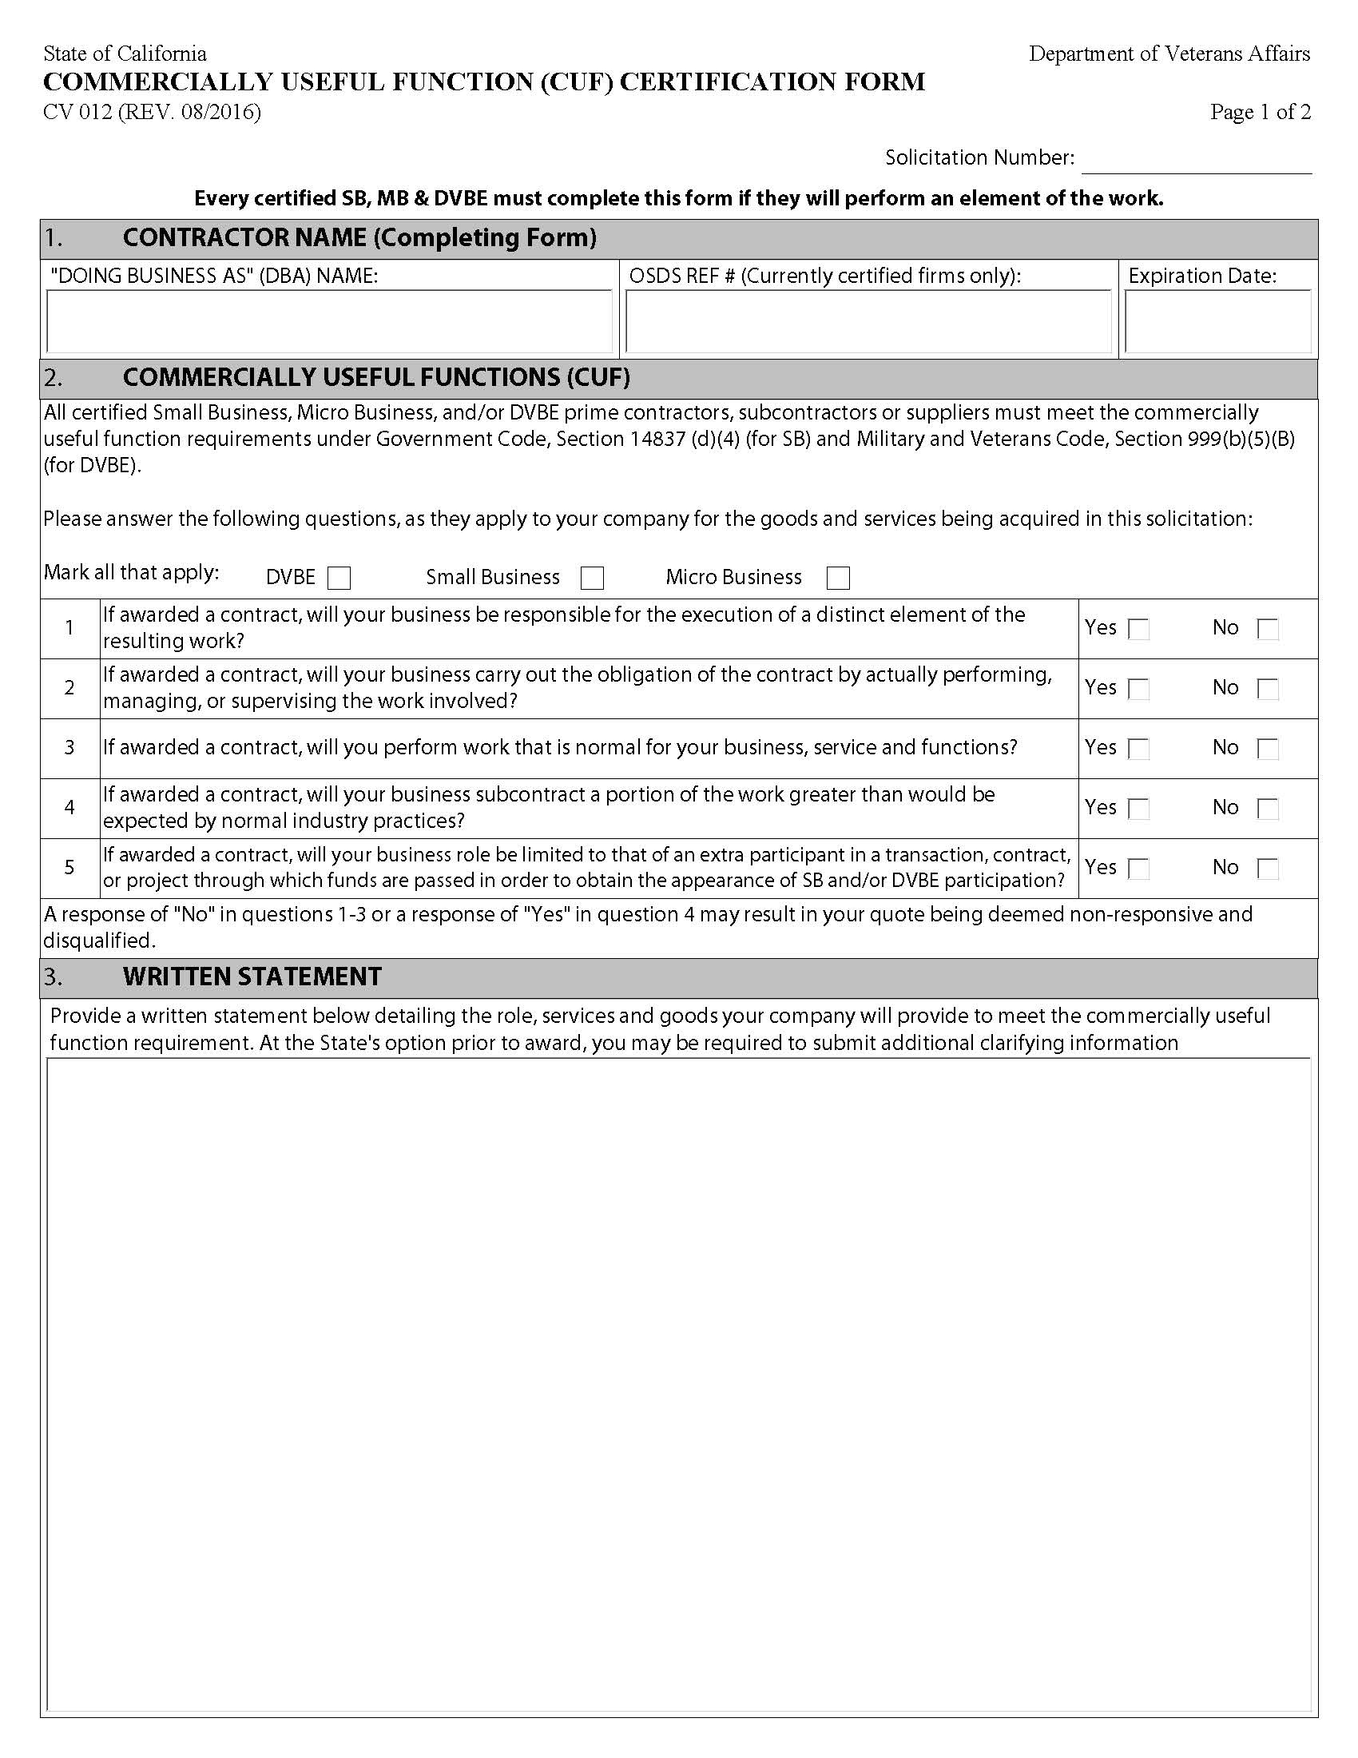

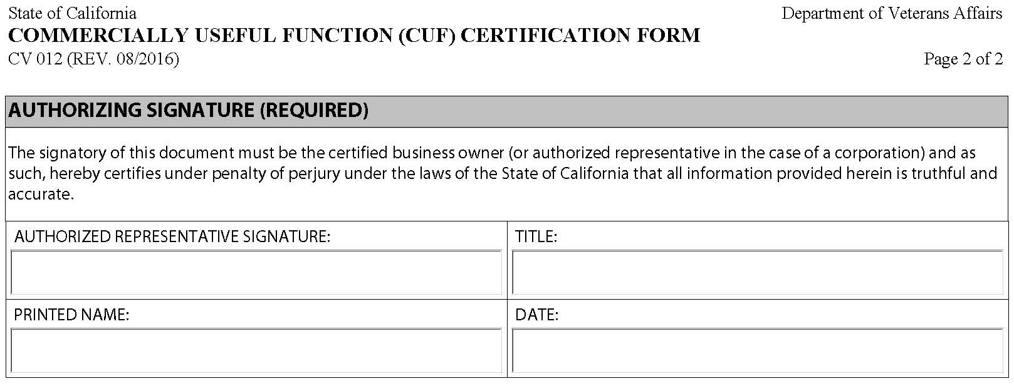

Form 4, Workers’ Compensation Certification

The undersigned in submitting this document hereby certifies the following:
I am aware of the provisions of Section 3700 of the California Labor Code which requires every employer to be insured against liability for workers’ compensation or to undertake self-insurance in accordance with such provisions before commencing the performance of the work of this Contract.

______________________________ ____________________________
Signature Date

__________________________ ____________________________
Name and Title (Print or Type) Street Address

___________________________ ____________________________
Firm Name City, State ZIP

Form 5, Commercial General Liability Certification

(Attach a valid Commercial General Liability Certificate of Insurance to this Form)

Form 6, Payee Data Record

Bidders are required to sign the Payee Data Record, STD 204, before Contract award. Refer to the following website link for more details:
http://www.documents.dgs.ca.gov/dgs/fmc/pdf/std204.pdf

Form 7, Secretary of State Status

Business Name (as registered with SOS):
Business Type:
Secretary of State Number:
Status with the Secretary of State:
Refer to the following website links to verify status and obtain the required documentation:
Search | California Secretary of State

Form 8, Seller’s Permit

If applicable, you must provide a copy of your company’s California retailer’s seller’s permit or certification of registration and, if applicable, the permit or certification of all participating affiliates, issued by California Department of Tax and Fee Administration (CDTFA), pursuant to all requirements as set forth in Sections 6487, 7101, and Sections 6452.1, 6487.3, 18510 of the Revenue and Taxation Code, and Section 10295.1 of the Public Contract Code. In order to expedite the process of verifying the validity of the permit, provide the BOE permit number in the space provided below.
RETAILER’S SELLER’S PERMIT NUMBER: _________________________

Form 9, Contractor’s Bid Certification

The submission of this Quote does not obligate the California Department of Veterans Affairs to fund the proposed Contract. If the Quote is approved for funding, a Contract will be executed between the State of California and the Bidder. When funding is authorized, the Bidder will be expected to adhere to the terms of the executed Contract.
Sign and date below in the signature block for your firm’s agreement to meet the requirements of this RFQ. The certification must include signature of person who is authorized to bind the firm contractually.

Name of Bidding Firm (Legal name as it will appear on the Contract)
Mailing address |  | City |  |  | State | Zip Code
Telephone number | Fax number |  |  | Email address (If applicable)
( ) | ( )
Name of Contact Person |  |  | Telephone number (If different from above)
 |  |  | ( )

Bidding Preferences Claimed (Check only the preferences claimed)
Certified small business or micro business preference Certification #___________
Non-small business subcontractor preference (committing use of 25% or more of small business subcontract(s))

Certification # ___________
DVBE Incentive (committing to use DVBE subcontract(s) Certification #______________
BID.

Bidder's signature: |  | Date signed:
Printed/typed name: | Title:

Form 10, Contractor Certification Clauses
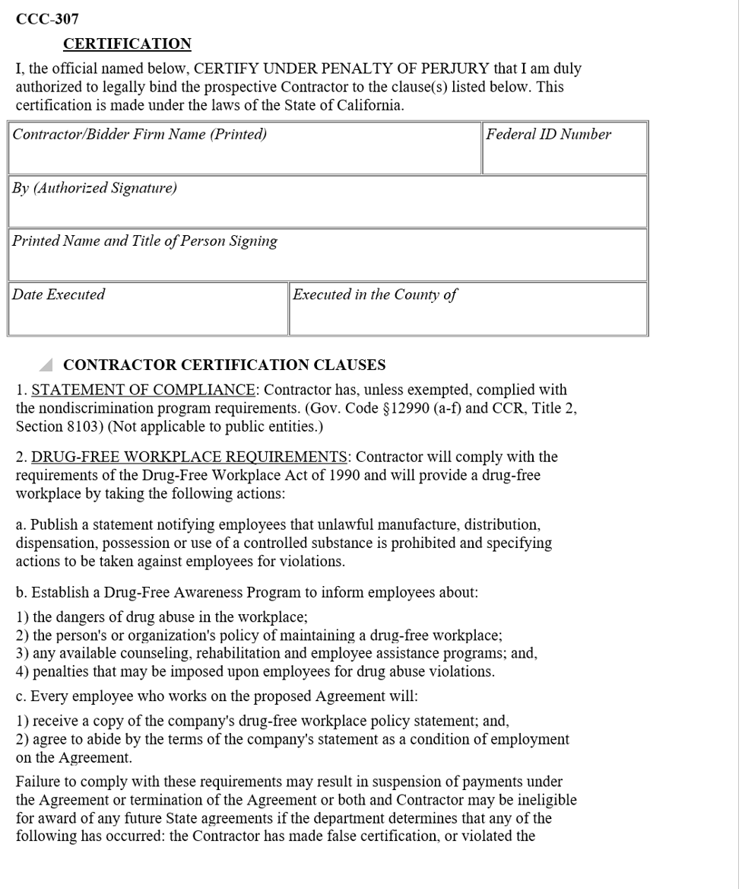
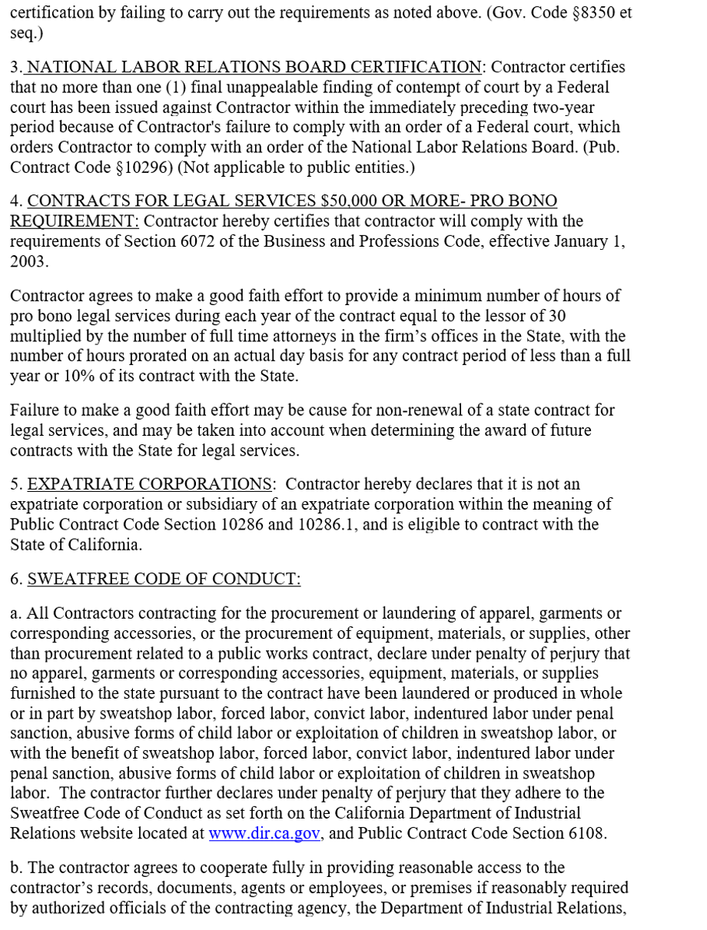
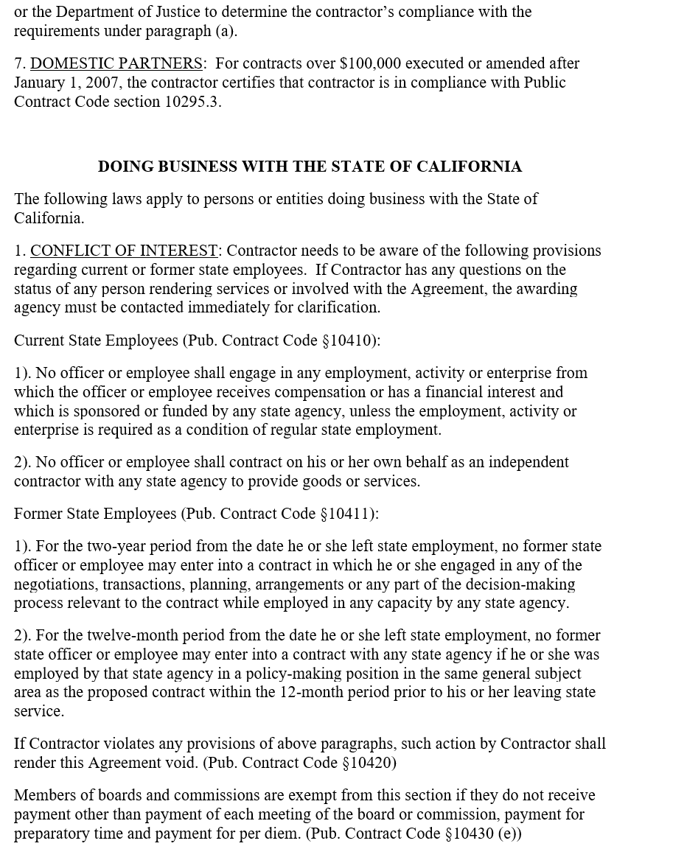
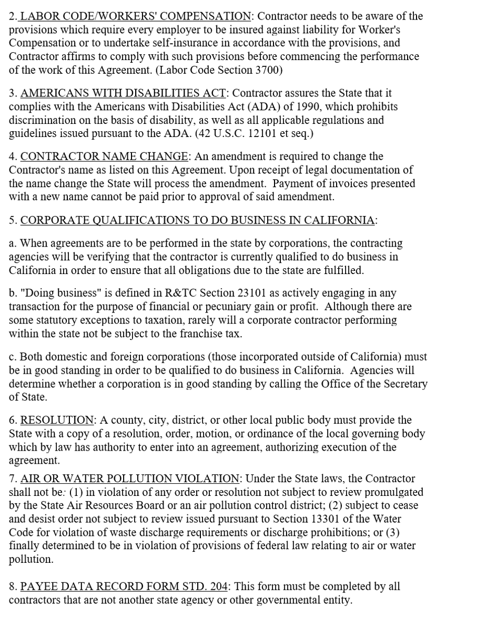

Form 11, List of Proposed Subcontractors

Listed hereinafter is the name and address of each subcontractor who will be employed and the kind of work which each will perform if the Contract is awarded. I understand that under Government Code Section 4100 through 4113 (see note below), I must here clearly set forth the name and address of each subcontractor who will perform work or labor or render service to me in or about the construction of the work in an amount in excess of one-half of one percent (1/2 of 1%) of my total Quote and that as to any work in which I fail to do so, I agree to perform that portion myself or be subject to penalty under the act.
IF MORE THAN ONE SUBCONTRACTOR IS LISTED FOR THE SAME TYPE OF WORK, SPECIFY THE PORTION OF THAT TYPE OF WORK THAT THE INDIVIDUAL SUBCONTRACTOR WILL BE PERFORMING. LIST THE SUBCONTRACTORS’ APPLICABLE CONTRACTOR’S LICENSE NUMBER(S), IF AVAILABLE. VENDORS OR SUPPLIERS OF MATERIALS ONLY NEED NOT BE LISTED.
If additional space is required for the listing of proposed subcontractors, reproduced additional sheets showing the required information, as indicated below, shall be attached hereto and made a part of the Final Quote.
SUBCONTRACTOR  NAME AND ADDRESS | TYPE OF WORK | LICENSE NO. | EXPIRATION DATE

NOTE: The above listing requirement will for purposes of this Quote be construed in accordance with the provisions of the Subletting and Subcontracting Fair Practices Act (“The Act”) as set forth in Government Code Sections 4100 through 4113.

Form 12, California Civil Rights Laws Certification

Pursuant to Public Contract Code Section 2010, if a Bidder executes or renews a Contract over $100,000 on or after January 1, 2017, the Bidder hereby certifies compliance with the following:

1. CALIFORNIA CIVIL RIGHTS LAWS: For Contracts over $100,000 executed or renewed after January 1, 2017, the Contractor certifies compliance with the Unruh Civil Rights Act (Section 51 of the Civil Code) and the Fair Employment and Housing Act (Section 12960 of the Government Code); and

2. EMPLOYER DISCRIMINATORY POLICIES: For Contracts over $100,000 executed or renewed after January 1, 2017, if a Contractor has an internal policy against a sovereign nation or peoples recognized by the United States government, the Contractor certifies that such policies are not used in violation of the Unruh Civil Rights Act (Section 51 of the Civil Code) or the Fair Employment and Housing Act (Section 12960 of the Government Code).

CERTIFICATION

I, the official named below, certify under penalty of perjury under the laws of the State of California that the foregoing is true and correct.  Bidder Firm Name (Printed) |  | Federal ID Number
By (Authorized Signature)
Printed Name and Title of Person Signing
Date Executed | Executed in the County and State of

Form 13, Response to Business Requirements

Contractors must provide a response to the following three (3) business requirements.
B.1 - Bidder must have a minimum of at least five (5) years of service experience comparable in size and complexity to this Contract. What isDescribe the company’s and technician’s experience in this specific industrycompleting similar work as described in the SOW.

B.2 - Bidder must provide references for similar service contracts. How will the Bidder meet CalVet’s specific requirements and provide your detailed approach to the Statement of Work.

B.3 - Bidder must provide their safety record.

Form 14, Cost Quote

Submission of this cost sheet is MANDATORY and must be provided as its own, separate attachment. Upon award, bid below will become part of the Contract in as Exhibit B-1, Cost Sheet. The Bidder shall set forth the rates in the space provided. Failure to indicate a dollar amount for any item will be understood by the State that the Bidder will provide the item at no cost.

The basis of Award shall be used to determine the lowest responsible bid. The State makes no guarantee, expressed or implied, on the actual amount of services that shall be required for the Contract and is subject to change based on needs of the State. However, the rates offered by Bidder shall be binding for the term of the Contract.

Item No. | Description | # of Visits | Unit Cost | Extended Cost
1 | (Year 1) FIRE ALARM & FIRE SPRINKLERFire Alarm & Fire Sprinkler/  Quarterly Preventative Maintenance and Testing Service | 4 | $ | $
2 | FIRE SUPPRESSIONFire Suppression  Semi-Annual Maintenance and Testing Services | 2 | $ | $
3 | FIRE ALARM & FIRE SPRINKLERFire Alarm & Fire Sprinkler  Annual Maintenance and Testing Service | 1 | $ | $
Item No. | On-Call Services | Hours | Unit Cost | Total Item Cost
4 | Standard On-Site Service Monday ~ Friday 8:00 ama.m. to 5:00 pmp.m. | 180 | $ | $
5 | Priority On-Site Service Monday ~ Friday 5:00 pmp.m. to 11:00 pmp.m. | 120 | $ | $
6 | Premium On-Site Service Monday ~ Friday 11:00 pmp.m. to 8:00 ama.m. Saturday, Sunday and Federal Holidays | 120 | $ | $
Reserve for Parts Allotment |  |  |  | $20,000.00
Total Costs |  |  |  | $

Item No. | Description | # of Visits | Unit Cost | Extended Cost
1 | (Year 2) FIRE ALARM & FIRE SPRINKLERFire Alarm & Fire Sprinkler/  Quarterly Preventative Maintenance and Testing Service | 4 | $ | $
2 | FIRE SUPPRESSIONFire Suppression  Semi-Annual Maintenance and Testing Services | 2 | $ | $
3 | FIRE ALARM & FIRE SPRINKLERFire Alarm & Fire Sprinkler  Annual Maintenance and Testing Service | 1 | $ | $
4 | 5-year facility-wide Fire Alarm and Suppression System Inspection and Test per NFPA 25, 72, and additional applicable Code/Standards. | 1 | $ | $
Item No. | On-Call Services | Hours | Unit Cost | Total Item Cost
5 | Standard On-Site Service Monday ~ Friday 8:00 ama.m. to 5:00 pmp.m. | 180 | $ | $
6 | Priority On-Site Service Monday ~ Friday 5:00 pmp.m. to 11:00 pmp.m. | 120 | $ | $
7 | Premium On-Site Service Monday ~ Friday 11:00 pmp.m. to 8:00 ama.m. Saturday, Sunday and Federal Holidays | 120 | $ | $
Reserve for Parts Allotment |  |  |  | $20,000.00
Total Costs |  |  |  | $

Item No. | Description | # of Visits | Unit Cost | Extended Cost
1 | (Year 3) FIRE ALARM & FIRE SPRINKLERFire Alarm & Fire Sprinkler/  Quarterly Preventative Maintenance and Testing Service | 4 | $ | $
2 | FIRE SUPPRESSIONFire Suppression  Semi-Annual Maintenance and Testing Services | 2 | $ | $
3 | FIRE ALARM & FIRE SPRINKLERFire Alarm & Fire Sprinkler  Annual Maintenance and Testing Service | 1 | $ | $
Item No. | On-Call Services | Hours | Unit Cost | Total Item Cost
4 | Standard On-Site Service Monday ~ Friday 8:00 ama.m. to 5:00 pmp.m. | 180 | $ | $
5 | Priority On-Site Service Monday ~ Friday 5:00 pmp.m. to 11:00 pmp.m. | 120 | $ | $
6 | Premium On-Site Service Monday ~ Friday 11:00 pmp.m. to 8:00 ama.m. Saturday, Sunday and Federal Holidays | 120 | $ | $
Reserve for Parts Allotment |  |  |  | $20,000.00
Total Costs |  |  |  | $

Summary of Cost
Year 1 | $
Year 2 | $
Year 3 | $
Total Costs | $

Form 15, Summary of Applicable Engagement

Contractors must provide a brief summary of at least two applicable engagements undertaken by the Contractor’s organization, with similar tasks and with the same or similar resources being Quoted. Sample tasks are strongly preferred, but not required. References for these engagements must be provided for these engagements.
Company Name:
Project/Engagement Name:
Resource’s Reference
Contact Name:
Email Address:
Phone Number:
Summary of engagement:

Form 16, Response to the Statement of Work

Contractor Name: ____________________________________
To enable the effective review and comparison of Quotes received under this RFQ, Contractors are requested to adhere to a standard structure in developing their detailed narratives in response to the RFQ.
The narratives must adhere to the same structure and outline of this RFQ and use the same numbering scheme and headings for Quote sections. Narratives should explain how tasks will be executed. Where additional information is felt to be appropriate or necessary, Contractors are requested to include this information in appendices to their Quotes, and to refer to this information within the appropriate sections of their Quote.
The response to the SOW must provide:
- A point-by-point response to all items and sub items included in the SOW Exhibit A, H. Contractor Responsibilities – response shall not exceed 100 pages. This cover page is not included in the one hundred (100) page total. Identify each task when responding.
- Font should be Arial, Size 12 and single spaced.
- Overview of required tasks and outcomes.
- Description of approach, methodology and strategies of how each task will be performed.
- Schedule with a timeline for each task, for any required installation activities, including any sub tasks to complete the tasks and due dates for each task.

Form 17, Contractor’s License Information

Bidder shall complete the applicable contractor’s license information below in accordance with the Contractor’s State License Board, Department of Consumer Affairs. A Contractor’s license of appropriate Class [enter class number] is required before any Bidder can contract business (e.g. submit a Quote) which includes the installation of cable and wiring, electrical modification. In addition, if structural modifications are required, a Class B license is required.

CONTRACTOR:
Class |  | License No:
Licensee: |  | Expiration Date:
Note: Bidder (Firm’s Name or a Responsible Managing Employee) must be licensed in addition to all subcontractor(s) performing under this Contract.
SUBCONTRACTOR 1:
Class |  | License No:
Licensee: |  | Expiration Date:
Relationship of Licensee to Contractor:
SUBCONTRACTOR 2:
Class |  | License No:
Licensee: |  | Expiration Date:
Relationship of Licensee to Contractor:
(Use additional sheets if necessary.)

Sample Contract Package
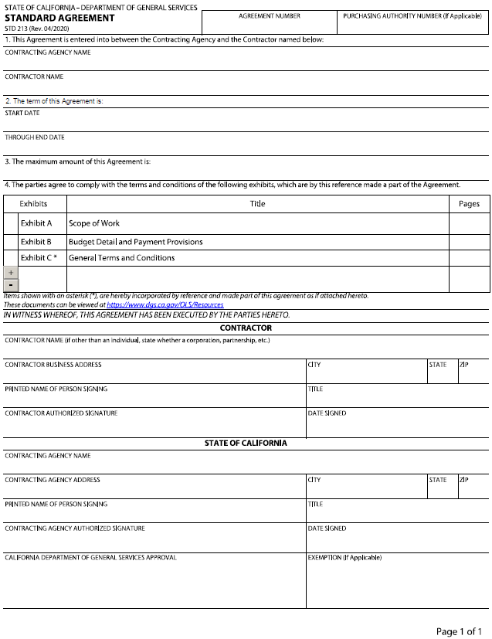

Exhibit A – Statement of Work

Contract Description
TBD, hereinafter referred to as “Contractor,” agrees to provide the California State Department of Veterans Affairs, hereinafter referred to as “CalVet” or “State,” with all preventive maintenance including, but not limited to, system inspection, testing, application of software patches and upgrades, and repairs for the Fire Suppression and Alarm Systems to ensure all systems are functioning at an optimum level. These systems are critical to providing Health and Safety for all the residents and staff at the Fresno (Home). The Contractor and the State each will be considered a “Party” to this Contract and together will be “Parties.”

Service Location:
Department of Veterans Affairs
Veterans Home of California (VHC) – Fresno
2811 W. Cesar Blvd.,
Fresno, CA 93706

Purpose
The purpose of this Contract to obtain fire alarm and fire suppression services for the CalVet Fresno Home.

Term
The Contract will have a term of three (3) years from Date of Execution, or Effective Date. The Contractor shall not be authorized to deliver goods or commence performance of services described in this Contract prior to the Effective Date. Any delivery of goods or performance of services by Contractor prior to the Effective Date shall be at no cost to the State.

Amendments
Consistent with the terms and conditions of the original solicitation, and upon mutual consent, CalVet and Contractor may execute amendments to add time, money, and/or modify languages to this Contract. No amendment or variation of the terms of this Contract shall be valid unless made in writing, and agreed upon by both parties and approved, as required. No verbal understanding or agreement not incorporated into the Contract is binding on any of the parties.

CalVet may exercise its option to terminate the resulting Contract at any time with thirty (30)
calendar days prior written notice.

Contacts
The contacts during the term of this Contract will be:

Contract Contacts
CalVet Contract Manager | Contractor Contract Manager
Name: | Name:
Address: | Address:
Phone: | Phone:
Email: | Email:
CalVet Contract Administrator | Contractor Technical Manager
Name: | Name:
Address: | Address:
Phone: | Phone:
Email: | Email:
CalVet Technical Manager
Name:
Address:
Phone:
Email:

The Parties agree that in the event of changes to the named staff below, the Party making the change will provide notification to the other Party in writing within ten (10) business days of the change in staff. Notice is to include a contact name, phone, mailing address, and email address for replacement staff. All such staff notices shall be incorporated into this Contract and do not require a Contract Amendment.

Roles and Responsibilities
The Contract Roles and Responsibilities during the term of this Contract will be:
Role | Responsibilities
CalVet Contract Manager | - Receives invoices for payment and forwards to Accounting for processing  - Contacts the Contractor for any maintenance services required  - Ensure compliance with all applicable state and federal laws and regulations  - Verify that the Contractor has fulfilled all requirements of the Contract before approving the final invoice  - Maintain Contract documents
CalVet Contract Administrator | - Acts as contact for Contract language questions  - Responsible for amendments and changes to Contract documents
CalVet Technical Manager | - Manages the technical aspects of the Contract  - Acts as principal interface to the Contractor Technical Lead(s)  - Ensures that CalVet technical standards, including Information Security policies as stated in the exhibits, are met
Contractor Contract Manager | - Acts as the principal interface to the CalVet Contract Manager on Contract matters  - Manages responsibilities and work performed as identified in Section H  - Ensures Contractor staff, including subcontractors, comply with the roles and responsibilities of the Contract  - Resolves all material issues raised by the CalVet Contract Manager  - Acts as contact for Contract language questions  - Responsible for working with the CalVet Contract Administrator on amendments and changes to Contract documents
Contractor Technical Manager | - Manages the technical aspects of the Contract  - Ensures technical functionality is achieved  - Acts as principal interface to the CalVet Technical Lead(s)  - Ensures that CalVet technical standards, including Information Security policies as stated in the exhibits, are met

Role | Responsibilities
Contractor Contract Manager | - Acts as the principal interface to the CalVet Contract Manager on Contract matters  - Manages responsibilities and work performed as identified in Section H  - Ensures Contractor staff, including subcontractors, comply with the roles and responsibilities of the Contract  - Resolves all material issues raised by the CalVet Contract Manager  - Acts as contact for Contract language questions  - Responsible for working with the CalVet Contract Administrator on amendments and changes to Contract documents
Contractor Technical Manager | - Manages the technical aspects of the Contract  - Ensures technical functionality is achieved  - Acts as principal interface to the CalVet Technical Lead(s)  - Ensures that CalVet technical standards, including Information Security policies as stated in the exhibits, are met

State Responsibilities
  - CalVet shall provide access to the premises during normal business hours of 7:00 am to 5:00 pm Pacific Time (PT), Monday through Friday, excluding State Holidays, unless alternative hours are mutually agreed upon.
  - CalVet shall notify Contractor, in writing, of any changes made in the equipment, operating procedures, movement of equipment to a different location, or new equipment is added.
  - Calvet shall reserve the right to request verifications of qualifications of a technician.
  - CalVet, upon request of emergency and non-emergency service, will provide all necessary information for the Contractor to respond to Emergency requests, including a telephone number, the location of the needed service, the contact person, and any other pertinent instructions to enable the Contractor to perform the duties as described within this Contract.
  - CalVet shall provide staff to escort Contractor staff while on home premises if background check is not cleared.
  - Calvet shall inspect work performed by the Contractor after completion and shall be responsible for determining acceptability of the work performed and the operability of the equipment.

Contractor Responsibilities
- Contractor shall provide all labor, supplies, materials, programming, and testing necessary to maintain the fire alarm and suppression systems at the Home.
- Contractor shall provide preventative, support, and repair services during normal business hours of 7:00 am to 5:00 pm PT, Monday through Friday, excluding State Holidays, unless alternative hours are mutually agreed upon between CalVet Contract Manager and Contractor. All preventive maintenance includes, but is not limited to, system inspection, testing, and application of software patches/firmware updates and upgrades.
- Contractor shall perform software patches/firmware updates as required by the system’s manufacturer.
- Contractor shall schedule preventative maintenance visits with the CalVet Contract Manager prior to visiting the Home. Quarterly preventative maintenance and testing services shall include all labor, travel, tools, equipment, materials, oil, fluids, incidentals, etc.
- Contractor shall provide service call response seven (7) days per week, twenty-four (24) hours per day.
- Contractor shall respond to requests for emergency repair service calls within thirty (30) minutes.
- Contractor shall comply with the Home’s sign-in and sign-out policy by reporting to the security/front desk upon arrival and departure from the facility, and by wearing identification badges and/or uniforms bearing the name of the Contractor as well as visitor badges issued by the Home.
- Contractor shall perform all work in accordance with manufacturer’s specifications.
- Contractor shall provide manufacturer certified technicians for all services.
- Contractor shall render the system fully operational before the technician leaves the Home. In the event the system cannot be made operational, the technician shall notify the CalVet Contract Manager or authorized representative of the status. The vendor will inform the Home before leaving the premises.
- Listed Equipment:
QTY | Equipment Name
7 | Ansul Fire Suppression Kitchen Hoods
1 | Faraday FM200 Clean Agent Flood System
1 | Notifier® Fire Alarm and Sprinkler System, which includes 1 Main Notifier ® Central Fire Alarm Panel, 2 Remote Annunciator Sub Panels
10 | Notifier NFS-320 Pre-Action Fire Alarm Panel and Sprinkler System Riser Associated Pipe and Sprinkler Heads
239 | Fire Smoke Dampers
7 | Fire Dept Connection / Post Indicator Valve
7 | Wet Pipe Fire Sprinkler System Riser, Associated pipe and Sprinkler Heads
5 | Fire Hydrants
5 | Warf Hydrants (Private Fire Hydrants)

- The State reserves the right to add or delete equipment that has become obsolete. Additional equipment will be serviced at the unit rates specified herein. Contractor shall be notified in writing by the Contract Manager of equipment that has been added and/or removed from the list.
- The Contractor shall maintain qualified technicians and adequate equipment/parts to make repairs within twenty-four (24) hours. This includes emergency calls, call-back service and regularly scheduled maintenance.
- All services performed under this Contract shall be performed by qualified and trained service technicians.
- Services include but are not limited to the following equipment: control valves, alarm valves, check valves, pre-action/deluge valves, dry pipe, wet pipe, risers, quick opening devices, pressure reducing and relief valves, water supplies/tanks/filters, dampers, supervisory and local alarms, sprinklers, and piping.
- Replacement of peripheral equipment devices, i.e., smoke detectors, manual pull stations, batteries, are included in this Contract.
- The State reserves the right to salvage any equipment and may elect to include a fire drill at the time of testing the system.
- Licenses, Permits, and Certification Requirements
Contractor shall ensure all Contractor’s licenses, permits, and certification requirements are verified and current throughout the term of this Contract and provided to the Contract Manager.
- Contractor shall ensure all employees complete the proprietary Notifier ® Factory training. All technicians must maintain up-to-date training and certification.
- Contractor must maintain C-16 Fire Protection Contractor license during the term of this Contract.
- Contractor shall possess a current and valid California State Contractors License Board (CSLB) Class A or Class B license along with a C-10 and C-16 license.
- Contractor must haveshall possess a National Institute for Certification in Engineering Technologies (NICET) level IV certification and ensure compliance with the National Fire Protection Association (NFPA), and local, and State of California Fire Marshall standards.
- Service technicians must be Notifier® and Faraday certified, trained, knowledgeable, and qualified to service, maintain and program all Notifier® and Faraday System Components. Contractor shall provide the State with proof of the required training for each service technician providing services under this Contract. Acceptable proof may be a resume showing experience, training, and factory school completion.
- Contractor shall be a certified Notifier® Engineered Systems Distributor (ESD) Certified for Notifier.
- Contractor shall possess an OSHA-certified equipment operator during the term of this Contract.
- Contractor shall possess an Alarm Company License by Bureau of Security and Investigative Services (BSIS) during the term of this Contract.
- Contractor shall possess a certification of Fire/Life Safety from the California Department of Industrial Relations during the term of this Contract.
- Contractor shall provide the minimum qualifications to the Contract Manager.
- All services performed under this Contract shall be performed by qualified and trained service technicians.
- Contractor shall provide service technicians who are Notifier® factory-trained on the equipment specified in this Contract. Contractor shall provide the State with proof of the required training for each service technician providing services under this Contract. Acceptable proof may be a resume showing experience, training, and factory school completion.
- Contractor shall maintain an OSHA-certified equipment operator.
- Contractor shall hold an Alarm Company License by Bureau of Security and Investigative Services (BSIS).
- Contractor shall hold a certification of Fire/Life Safety from the California Department of Industrial Relations.
- All work equipment, materials, and installation shall conform to the California Code of Regulations Title 24, 8, 19, and 22; NFPA codes/standards and all Federal, State, and local regulations applicable to this Contract.
- Contractor shall conduct quarterly Fire Alarm and Water Based Fire Protection System inspection, testing, repair, and preventative maintenance per the California Code of Regulations Title 19 and all NFPA codes/standards. The Quarterly and Semi-Annual Inspections testing and maintenance shall include, but are not limited to:
- Inspect all system components for damage and/or leaks. All devices and equipment shall be inspected, tested, cleaned, repaired, replaced, and maintained in accordance with manufacturer instructions and NFPA 25 to ensure proper operation.
- Verify proper operation of all system components, including but not limited to: flow switches, water flow bells, electric bells, risers, tamper switches, retard chambers, pressure-reducing and relief valves, fire department connections, main drains, water flow alarms, priming water, low-air-pressure alarms, and quick-opening devices.
- Perform diagnostic testing on all control panel equipment.
- Conduct functional testing of all audible and visual notification appliances and initiating devices, including smoke, heat, and duct detectors, as well as manual pull stations.
- Perform functional testing of water flow and tamper switches in accordance with NFPA 72 requirements.
- Operate and verify the functionality of all control valves, perform inspectors’ test flow at each riser, and confirm proper signage and tagging for certification.
- Contractor shall perform Semi-Annual inspection, testing, and maintenance in accordance with the California Code of Regulations, Title 19, the California Fire Code (CFC), and all applicable NFPA codes and standards. Semi-Annual Inspection activities shall include, but are not limited to, the following:Per the guidelines of California Code of Regulations Title 19, and all NFPA codes/standards. The Semi-Annual inspection testing and maintenance shall include but are not limited to:
- Inspect, test, clean, repair, replace, and maintain all system components in accordance with manufacturer instructions and the requirements of NFPA 72, NFPA 25, and applicable CFC Renewal 6-10-26 regulations to ensure all equipment remains in proper working condition. All components being inspected, tested, cleaned, repaired, replaced and maintained in good working order in accordance with the manufacturer’s instructions and as required by NFPA 72, 25 and California Fire Code (CFC) Renewal 6-10-26 regulatory requirements.
- Verify the operation of all manual and automatic initiating, indicating, and releasing circuits, controls, and devices, including associated auxiliary functions. All devices shall be inspected for damage, defects, and/or leaks and confirmed to be in good working order. Operation of manual and automatic initiating, indicating and releasing circuits, controls and devices as well as related auxiliary functions and controls. All devices being checked will be checked to be free of, but not limited to, damage, defects and/ or leaks and to be in good working condition.
- Provide a written report of all system deficiencies to the Contract Manager, along with a digital copy emailed in PDF format on company letterhead. All identified deficiencies shall be corrected and brought into compliance within ten (10) business days of the report date. Written report of system deficiencies must be forwarded to the Contract Manager as well as a digital copy via. email with company letter head exported as PDF file. Any deficiencies reported are to be repaired and brought to compliance standards within ten (10) business days of report findings.
- Contractor shall, upon request and in advance notice, Pprovide a brief training session for the operation and features of the system at no additional charge during a scheduled preventative maintenance visit, upon request, and with advance notice from the CalVet Contract Manager.
- Perform inspection, testing, cleaning, repair, and preventative maintenance on system equipment, including but not limited to manual and automatic releasing devices, audible and visual alarm indicating devices, pressure‑reducing and relief valves, agent supplies/tanks, dampers, supervisory and local alarms, discharge nozzles, and associated piping. All work shall comply with the CFC, Title 19 requirements, and applicable NFPA standards. Contractor shall complete performance of inspection, testing, cleaning, repair, and preventative maintenance services to the following equipment, but not limited to: manual and automatic releasing devices, audible/visual alarm indicating devices, pressure reducing and relief valves, agent supplies/tanks, dampers, supervisory and local alarms, discharge nozzles and piping conditions in accordance with California Fire Code (CFC), Title 19 specifications.
- Contractor shall perform Annual inspection, testing, and maintenance in accordance with the California Code of Regulations, Title 19, and all applicable NFPA codes and standards. Annual Inspection activities shall include, but are not limited to, the following: Per the guidelines of California Code of Regulations, Title 19 and all NFPA codes/standards, the annual inspection, testing, and maintenance shall include but are not limited to:
- Inspect, test, clean, repair, replace, and maintain all system components to ensure proper operation, in accordance with manufacturer instructions and the requirements of NFPA 25 and 72. All components shall be inspected, tested, cleaned, repaired, replaced and maintained in good working order in accordance with the manufacturer’s instructions and as required by NFPA 25.and 72.
- Perform annual testing and inspection of system components including, but not limited to: Main Drain Test, pre‑action and deluge valve interiors, dry pipe valve and deluge‑opening device interiors, pressure‑reducing and relief valves, hose connections and racks, control valve positions and operation, and full‑flow testing. All components shall be checked for damage, defects, and leaks, and confirmed to be in good working condition. Annual Main Drain, pre-action/deluge valve interiors, Dry Pipe Valve/deluge-opening device interiors, pressure reducing and relief valve hose connections and racks, control valve positions and operation, full flow testing, checks to be free of but not limited to damage and or leaks and to be in good working condition.
- Conduct annual Fire Alarm System preventative maintenance, including smoke detector cleaning, documentation of detector sensitivity, control panel analysis to identify potential device failures, battery testing, power supply testing, panel testing and cleaning, and cleaning of card‑edge and cable connectors using isopropyl. Inspect, test, and perform preventative maintenance on twenty five percent (25%) of all smoke/fire dampers installed at the facility, in accordance with manufacturer instructions and NFPA 72 requirements. Annual Fire Alarm System preventative maintenance, on the following: smoke detector cleaning, report documentation of detector sensitivity. Control panel analysis, to detect potential devices failures, battery testing, power supply testing, panel testing and cleaning, card edge connector and cable connector cleaning with isopropyl. Smoke/Fire Damper inspection, test and preventive maintenance of 25% of facilities total installed units in accordance with manufacturer’s instructions and as required by NFPA72
- Contractor shall rRepair or replace any defective device(s) identified found during annual regular maintenance and/or testing. Repairs not includedcovered under routine in maintenance shalllwill be billed under towards the Non-Eemergency Service and Repairs cost category.
- Clean and vacuum the interior of all the panels.
- Generate obscuration rate/sensitivity report for one hundred percent (100%) of smoke/duct detectors and clean up to twenty-five percent (25%) smoke/duct detectors, on a rotating basis. Smoke/duct detectors will be cleaned using a vacuum device and ozone safe compressed air blow out, in accordance with manufacturer’s instructions and as required by NFPA 72
- Perform Aa Main Drain Test in accordance withper NFPA 25 and current State of California Code of Regulations Title 19 (most recent edition) requirements,. This includesing recording of the sprinkler supply gauge readings with main drain valve fully open and closed.
- Test the Elevator recall system as part of the fire alarm testing procedure. Testing shall and be witnessed by the elevator servicing company.
- Repair all Ddeficiencies identified during testing and restore equipment to compliance with manufacturer requirements. shall be repaired and brought to compliance standards as specified by the manufacturer. Repairs may include, but are not limited to the following: repair of main panel and the annunciators, fire alarm system wirings, pull station, strobe, fire dampers, smoke damper, smoke sensor, fire bells, speakers, riser and its associated parts (pressure gauge and valves, etc.) and any other device and equipment which is considered a part of fire alarm system.
- Contractor shall conduct a five (5) year facility-wide Fire Alarm and Suppression System Inspection and Test per NFPA 25, 72, and additional applicable Code/Standards. The Contractor shall provide the next service due in December 2027.
- Incidental Repair Services
- Contractor shall provide unlimited visits for any incidental repair services requested or necessary to keep the equipment fully operational.
- Any deficiencies reported are to be repaired and brought into compliance with standards within ten (10) business days of report findings.
- Repair services shall be provided upon request from the CalVet Contract Manager or designee.
- Contractor shall make every effort to complete the repair during standard business hours. The State, at its discretion, may allow access to the equipment during non-standard business hours when necessary.
- Contractor shall make every effort to complete repairs the same working day. Unless the repair requires part(s) that must be ordered, no repair may take longer than five (5) working days to complete. When a delay in repair will occur due to part(s) that must be ordered, written notification shall be presented to the CalVet Contract Manager immediately.
- Parts Replacement
      - Contractor shall include replacement of any part that becomes inoperable, or that otherwise affects the operation of the equipment in any way. Contractor shall notify the CalVet Contract Manager prior to ordering and/or installing the part. A written estimate of the required part(s) shall be submitted in writing to the CalVet Contract Manager and approved before replacement.
      - Parts replaced by the Contractor shall be new or warrantied as new.
      - Contractor shall maintain an adequate supply and/or be able to obtain within a reasonable amount of time any necessary replacements parts in order to perform repairs and maintenance in a timely manner.
      - Consumables and other supply items are hereby excluded.
      - Any parts that have been replaced become the property of the Home.
- Equipment Removal
      - Contractor shall perform all services required under this Contract on State premises. In the event that equipment must be removed from State premises for repair, prior approval from the CalVet Contract Manager shall be obtained.
      - CalVet Contract Manager or designee shall record the serial number(s) of the equipment being removed and inspect the equipment. No equipment shall be removed from State premises until inspection and recording of the serial number(s) has been completed.
      - Upon return of the equipment by the Contractor, the CalVet Contract Manager or designee shall check the serial number(s) against those previously recorded and inspect the equipment for acceptability.
      - Contractor shall be responsible to pick up and deliver equipment from State premises.
      - Upon completion of repair, the Contractor shall notify the State to schedule a delivery date and time. Under no circumstances shall equipment removed from State premises be kept by the Contractor longer than five (5) working days, unless prior written permission has been obtained from the CalVet Contract Manager.
- Vendor Vetting Compliance
      - A background check will be required for each technician visiting the Home to ensure veterans’ safety and security at the Contractor’s expense. The background check will need toshall be completed within thirty (30) days off from Contract execution and sent to the Contract Manager via. email.
- Workmanship
      - Contractor shall conform to all applicable city, county, state and federal laws, including Title 17 and Title 22 of the California Code of Regulations, ordinances, regulations, guidelines, pamphlets, circulation letters, or any other applicable directive in the performance of work under this Contract.
      - The State shall inspect work performed by the Contractor after completion. The State is solely responsible for determining acceptability of the work performed and the operability of the equipment.
- Document Requirements – After completion of maintenance and/or repair services, the Contractor shall submit a complete report to the CalVet Contract Manager of the services provided. The report shall include:
      - Date of Service.
      - Description of service provided, including replacement of any worn or nonfunctioning parts.
      - Printed name and signature of service technician.
      - Location of equipment.
      - Equipment make, model, and serial number.
      - Description of any noted deficiencies and suggested corrective action.
      - Total labor hours expended.
      - Signature of State employee certifying indicated services were performed.

Accidents/Damage
Damage caused to the equipment covered herein due to fire, abuse, act God, accident, unauthorized alterations, disasters, the elements, failure of electrical power, misuse, use of unauthorized agents, vandalism or negligence by the State or its officers, agents, employees, or residents, are not covered by this Contract.

Work Area
- The Contractor shall ensure that the work is kept clean and free of debris, as necessary, to maintain a safe working environment for staff and residents.
- Contractor shall perform services with as little disruption to the State’s operations as possible.
- Contractor shall remove all tools, equipment, and other work materials belonging to Contractor from the Home premises at the end of each working day.
- CalVet shall not be responsible for storage of any Contractor property.

Problem Escalation
The parties acknowledge and agree that any point of contact may wish to escalate concerns pertaining to the administration of this Contract. Such issues may include, but are not necessarily limited to, invoice processing and Contractor timeliness in meeting contractual obligations.

Concerns (risks/issues) shall be reported as part of regular status reports. Additionally, there may be instances where the severity of the problem justifies escalated reporting. To this extent, the point of contact will notify CalVet in the following order:
- CalVet Technical Manager
- CalVet Contract Manager

Data Handling
- Information Security Incident Management
Contractor must report information security incidents in accordance with the California Department of Technology’s (CDT), Statewide Administrative Manual (SAM) 5340. - Exhibit D - Information Security Incident Management. All information security incidents must be reported immediately to the CalVet Information Technology Helpdesk at (916) 653-2521.
- Information Security and Confidentiality
To preserve the integrity of the security and confidentiality measures integrated into the State’s automated information systems, any employee of the contractor or subcontractors working on-site or remotely with CalVet information or on CalVet information system are required to sign the Confidentiality Statement, Exhibit E - Information Security and Confidentiality.
- Agreements with External Entities
CalVet requires all external entities to enter into written agreements when they engage in the development, use and/or maintenance of information systems, products, solutions, and/or services, Exhibit F - Agreements with External Entities.
- Vendor Remote Access Policy
If CalVet initiates a remote access session with Contractor, an Exhibit G - Vendor Remote Access Policy must be on file to confirm Contractor has read CalVet’s Vendor Remote Access Policy and shall comply with the provisions contained therein.
- Patch Management Policy
CalVet shall remain up-to-date on all available patches created to correct known hardware and software security vulnerabilities (where such do not cause instability or risk to CalVet infrastructure) and shall, when appropriate, immediately apply patches to all hardware and software as described in Exhibit H - Patch Management Policy.
- California Civil Rights Laws Certification
Pursuant to Public Contract Code section 2010, the Bidder shall complete Form 11, California Civil Rights Laws Certification, certifying compliance with the following:
- California Civil Rights Laws: For Contracts over $100,000 executed or renewed after January 1, 2017, the Bidder certifies compliance with the Unruh Civil Rights Act (Section 51 of the Civil Code) and the Fair Employment and Housing Act (Section 12960 of the Government Code); and Contractor certifies that such policies are not used in violation of the Unruh Civil Rights Act (Section 51 of the Civil Code) or the Fair Employment and Housing Act (Section 12960 of the Government Code).
- Employer Discrimination Policies: For Contracts over $100,000 executed or renewed after January 1, 2017, if a Bidder has an internal policy against a sovereign nation or peoples recognized by the United States government, the Contractor certifies that such policies are not used in violation of the Unruh Civil Rights Act (Section 51 of the Civil Code) or the Fair Employment and Housing Act (Section 12960 of the Government Code), Exhibit I, California Civil Rights Laws Certification.

Exhibit B – Budget Detail and Payment Provisions

Payment Provisions
- In consideration of performance and completion of the work in a satisfactory manner and upon receipt of the Contractor’s itemized invoice and details within the billing period, the State agrees to compensate the Contractor for actual expenditures incurred as specified in Exhibit B-1, Cost Worksheet.
- Payments shall be made in arrears upon completion of the work and invoice approved by the CalVet Contract Manager.
- Invoice shall contain the following information:
- Contract number
- Contractor’s itemized list of work completed
- Period covered by the invoice
- Total amount of invoice due and payable
- All invoices shall be submitted to:
Original Copy via mail (Hardcopy) | Approval Copy via Email
Department of Veterans Affairs | Department of Veterans Affairs
CalVet Accounting | CalVet Contract Manager
1227 O Street, RM #403  Sacramento, CA 95814  APinvoices@calvet.ca.gov | (TBD)

Travel
Travel costs are included with the associated work of this Contract and will not be paid as a separate item.

Budget Contingency Clause
It is mutually agreed that if the Budget Act of the current year and/or any subsequent years covered under this Contract does not appropriate sufficient funds for the program, this Contract shall be of no further force and effect. In this event, the State shall have no liability to pay any funds whatsoever to Contractor or to furnish any other considerations under this Contract and Contractor shall not be obligated to perform any provisions of this Contract.
If funding for any fiscal year is reduced or deleted by the Budget Act for purposes of this program, the State shall have the option to either cancel this Contract with no liability occurring to the State other than as contained herein or Quote a Contract amendment to Contractor to reflect the reduced amount. Notwithstanding anything to the contrary, any outstanding invoices due to Contractor for (a) work already conducted for accepted work or (b) for work in progress and unpaid, shall still be due to Contractor.

Prompt Payment Clause
Payment will be made in accordance with and within the time specified in Government Code, Chapter 4.5 (commencing with Section 927).

Exhibit B-1, Cost Worksheet
The rate listed below is in effect for the term of the Contract, including any extension of the term through a formal amendment.

Item No. | Description | # of Visits | Unit Cost | Extended Cost
1 | (Year 1) FIRE ALARM & FIRE SPRINKLERFire Alarm & Fire Sprinkler/  Quarterly Preventative Maintenance and Testing Service | 4 | $ | $
2 | FIRE SUPPRESSIONFire Suppression  Semi-Annual Maintenance and Testing Services | 2 | $ | $
3 | FIRE ALARM & FIRE SPRINKLERFire Alarm & Fire Sprinkler  Annual Maintenance and Testing Service | 1 | $ | $
Item No. | On-Call Services | Hours | Unit Cost | Total Item Cost
4 | Standard On-Site Service Monday ~ Friday 8:00 ama.m. to 5:00 pmp.m. | 180 | $ | $
5 | Priority On-Site Service Monday ~ Friday 5:00 pmp.m. to 11:00 pmp.m. | 120 | $ | $
6 | Premium On-Site Service Monday ~ Friday 11:00 pmp.m. to 8:00 ama.m. Saturday, Sunday and Federal Holidays | 120 | $ | $
Reserve for Parts Allotment |  |  |  | $20,000.00
Total Costs |  |  |  | $

Item No. | Description | # of Visits | Unit Cost | Extended Cost
1 | (Year 2) FIRE ALARM & FIRE SPRINKLERFire Alarm & Fire Sprinkler/  Quarterly Preventative Maintenance and Testing Service | 4 | $ | $
2 | FIRE SUPPRESSIONFire Suppression  Semi-Annual Maintenance and Testing Services | 2 | $ | $
3 | FIRE ALARM & FIRE SPRINKLERFire Alarm & Fire Sprinkler  Annual Maintenance and Testing Service | 1 | $ | $
4 | 5-year facility-wide Fire Alarm and Suppression System Inspection and Test per NFPA 25, 72, and additional applicable Code/Standards. | 1 | $ | $
Item No. | On-Call Services | Hours | Unit Cost | Total Item Cost
5 | Standard On-Site Service Monday ~ Friday 8:00 ama.m. to 5:00 pmp.m. | 180 | $ | $
6 | Priority On-Site Service Monday ~ Friday 5:00 pmp.m. to 11:00 pmp.m. | 120 | $ | $
7 | Premium On-Site Service Monday ~ Friday 11:00 pmp.m. to 8:00 ama.m. Saturday, Sunday and Federal Holidays | 120 | $ | $
Reserve for Parts Allotment |  |  |  | $20,000.00
Total Costs |  |  |  | $

Item No. | Description | # of Visits | Unit Cost | Extended Cost
1 | (Year 3) FIRE ALARM & FIRE SPRINKLERFire Alarm & Fire Sprinkler/  Quarterly Preventative Maintenance and Testing Service | 4 | $ | $
2 | FIRE SUPPRESSIONFire Suppression  Semi-Annual Maintenance and Testing Services | 2 | $ | $
3 | FIRE ALARM & FIRE SPRINKLERFire Alarm & Fire Sprinkler  Annual Maintenance and Testing Service | 1 | $ | $
Item No. | On-Call Services | Hours | Unit Cost | Total Item Cost
4 | Standard On-Site Service Monday ~ Friday 8:00 ama.m. to 5:00 pmp.m. | 180 | $ | $
5 | Priority On-Site Service Monday ~ Friday 5:00 pmp.m. to 11:00 pmp.m. | 120 | $ | $
6 | Premium On-Site Service Monday ~ Friday 11:00 pmp.m. to 8:00 ama.m. Saturday, Sunday and Federal Holidays | 120 | $ | $
Reserve for Parts Allotment |  |  |  | $20,000.00
Total Costs |  |  |  | $

Summary of Cost
Year 1 | $
Year 2 | $
Year 3 | $
Total Costs | $

Exhibit C – General Services Procurement Division – Information Technology General Provisions – (Cloud Computing Services) – GSPD-ITGP (Cloud)

https://www.dgs.ca.gov/-/media/Divisions/PD/Acquisitions/Solicitation-Document-Attachments/IT-General-Provisions-Cloud-DGS-PD-402ITGP-Revised-02202025.pdf
(Revised and Effective 2/20/2025)

Exhibit D – Information Security Incident Management

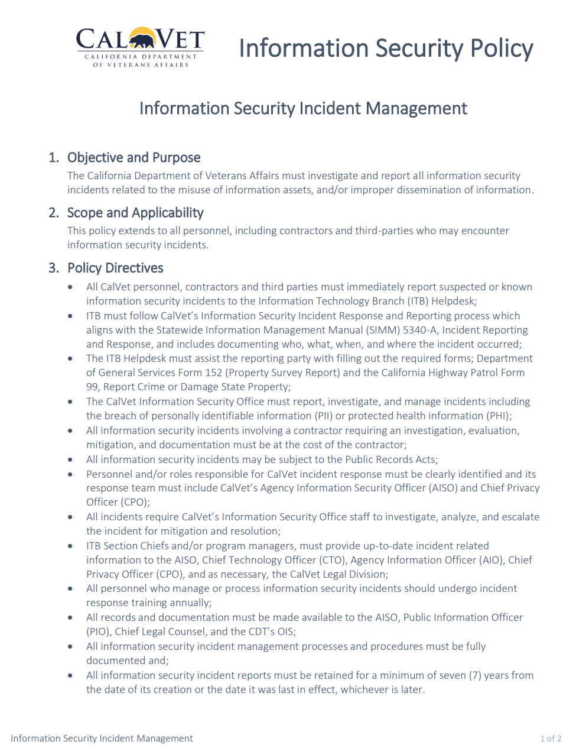

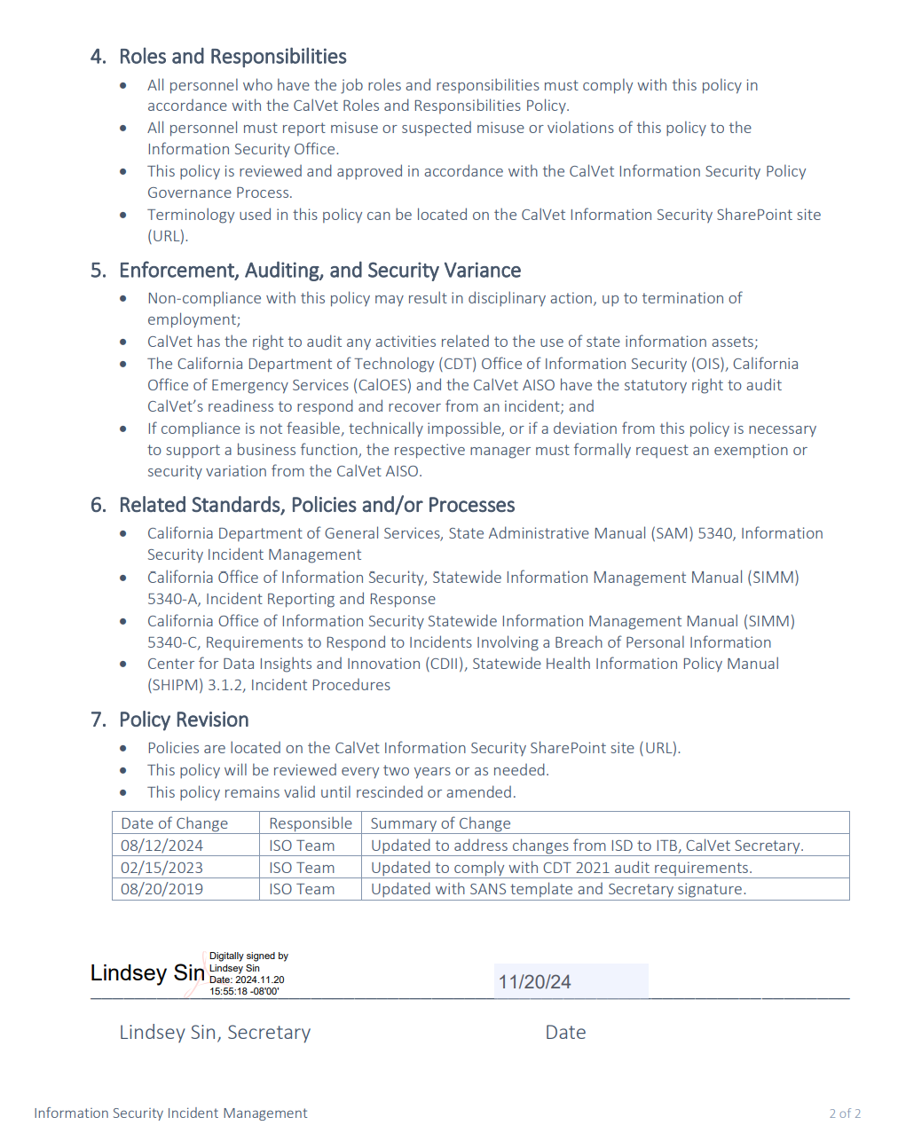

Exhibit E – Information Security and Confidentiality

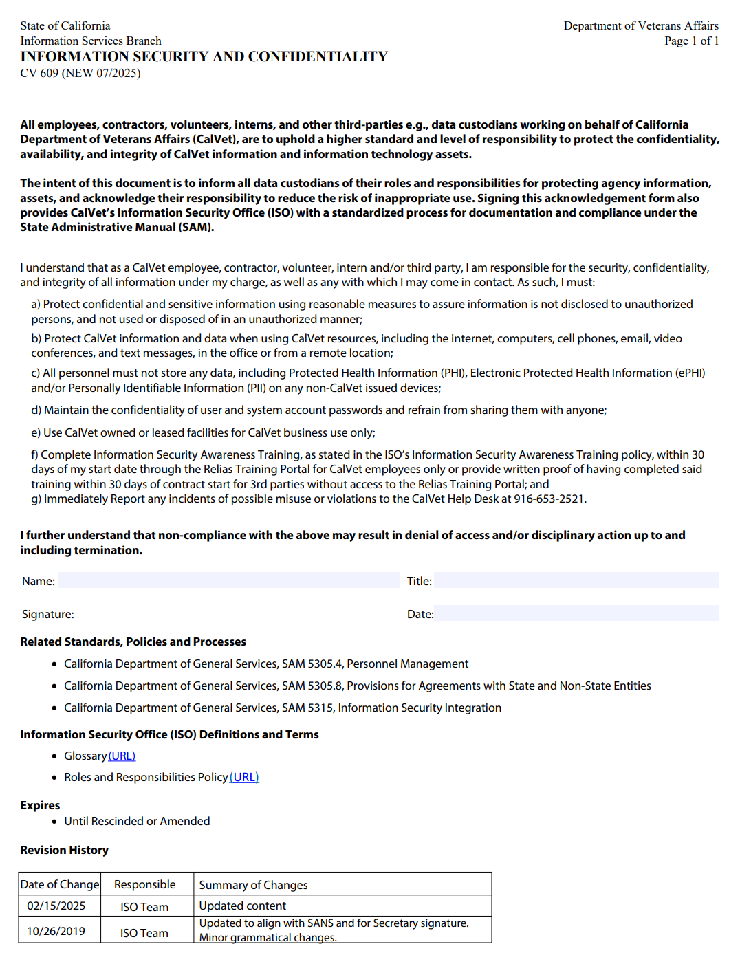

Exhibit F – Agreements with External Entities

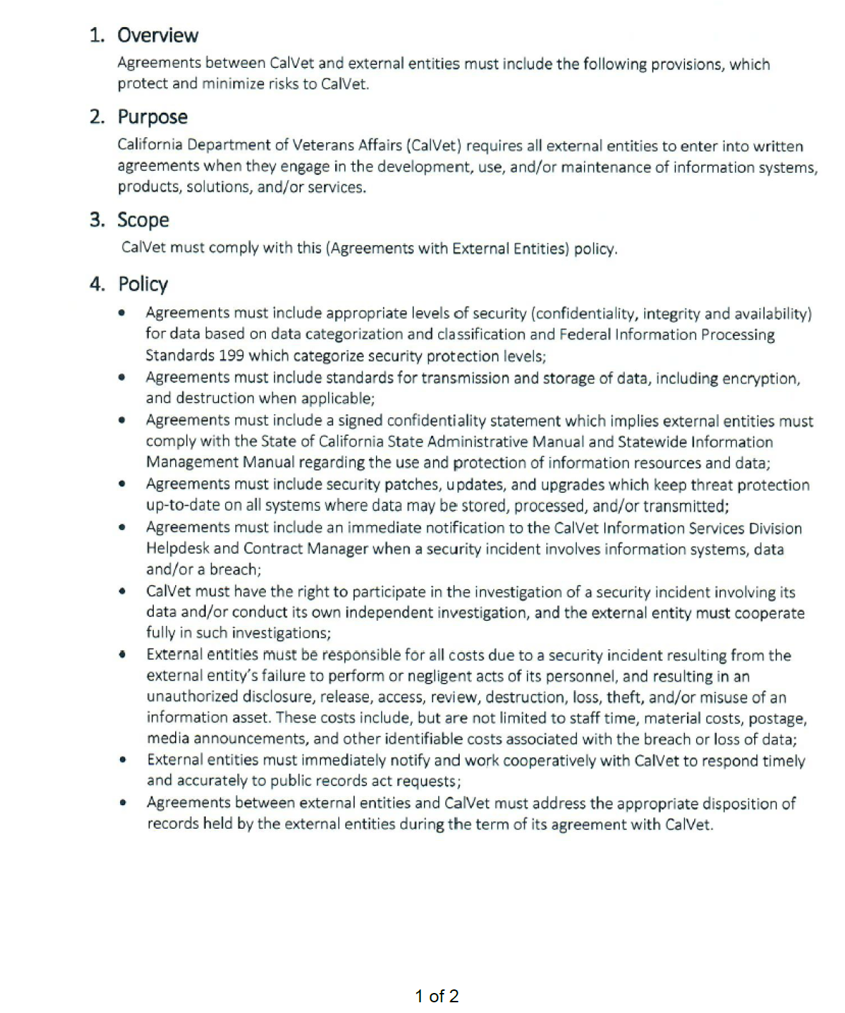

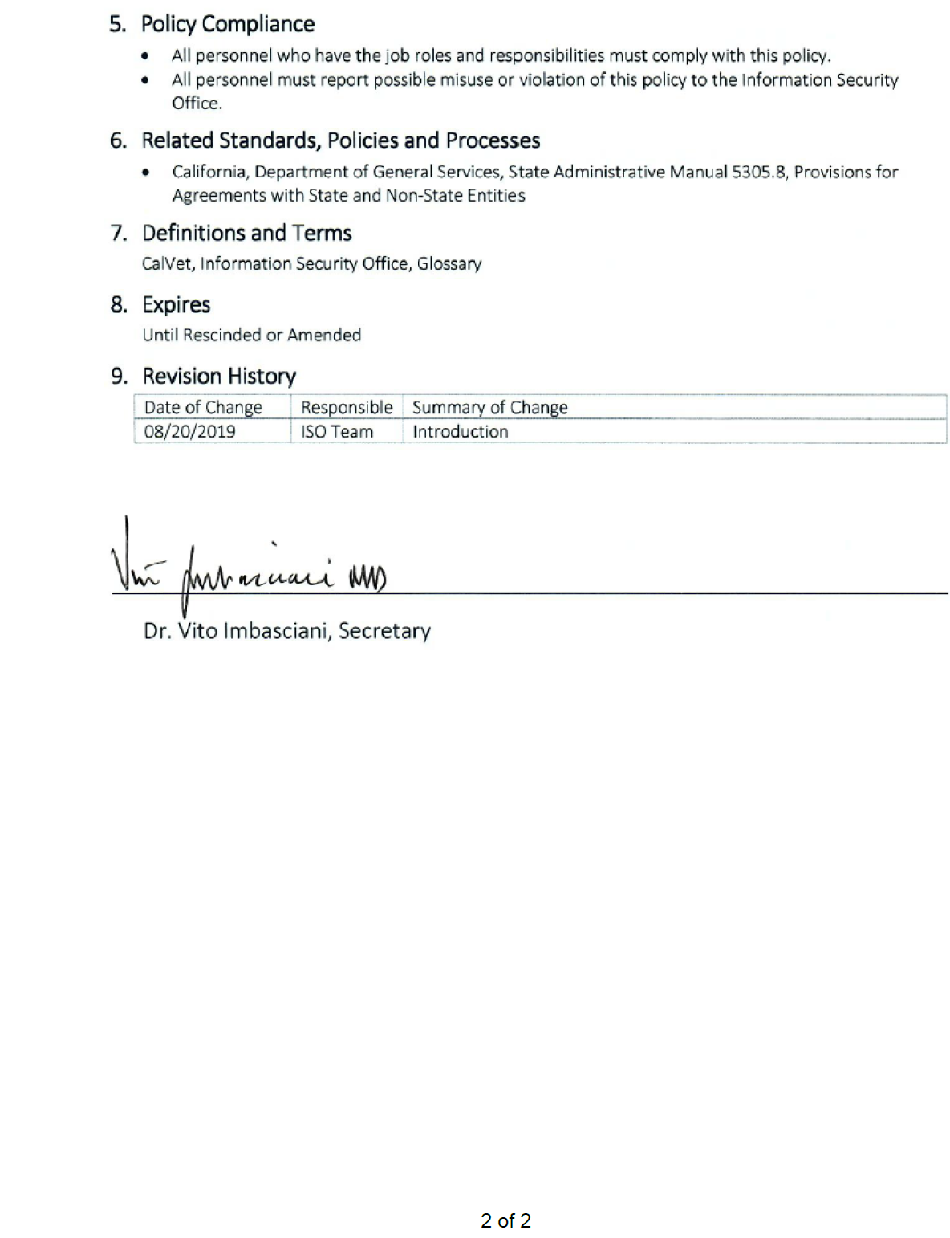

Exhibit G – Vendor Remote Access Policy

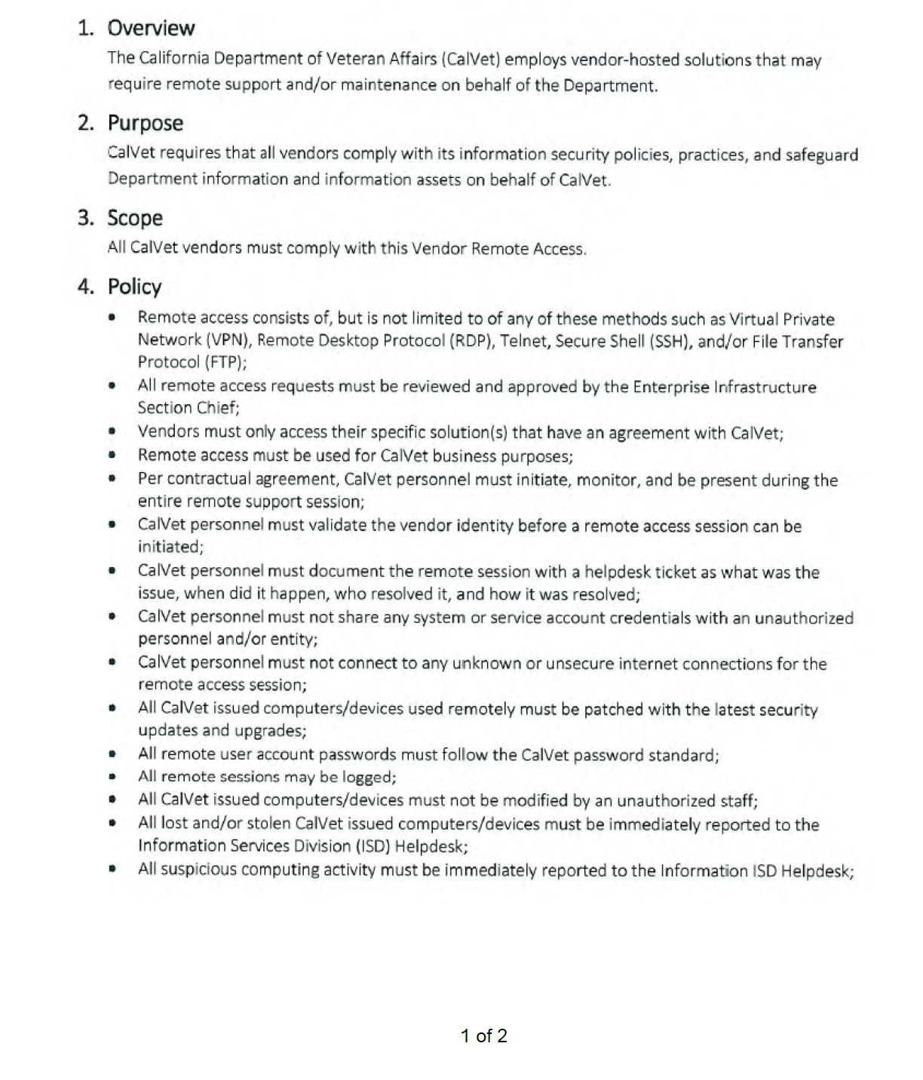

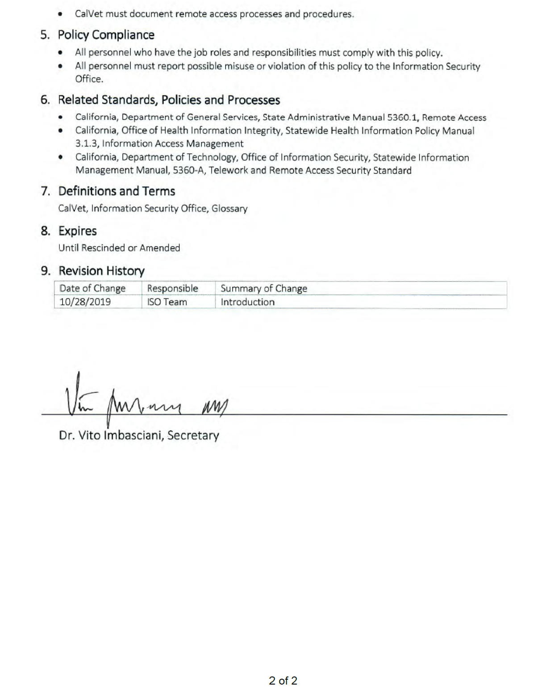

Exhibit H – Patch Management Policy

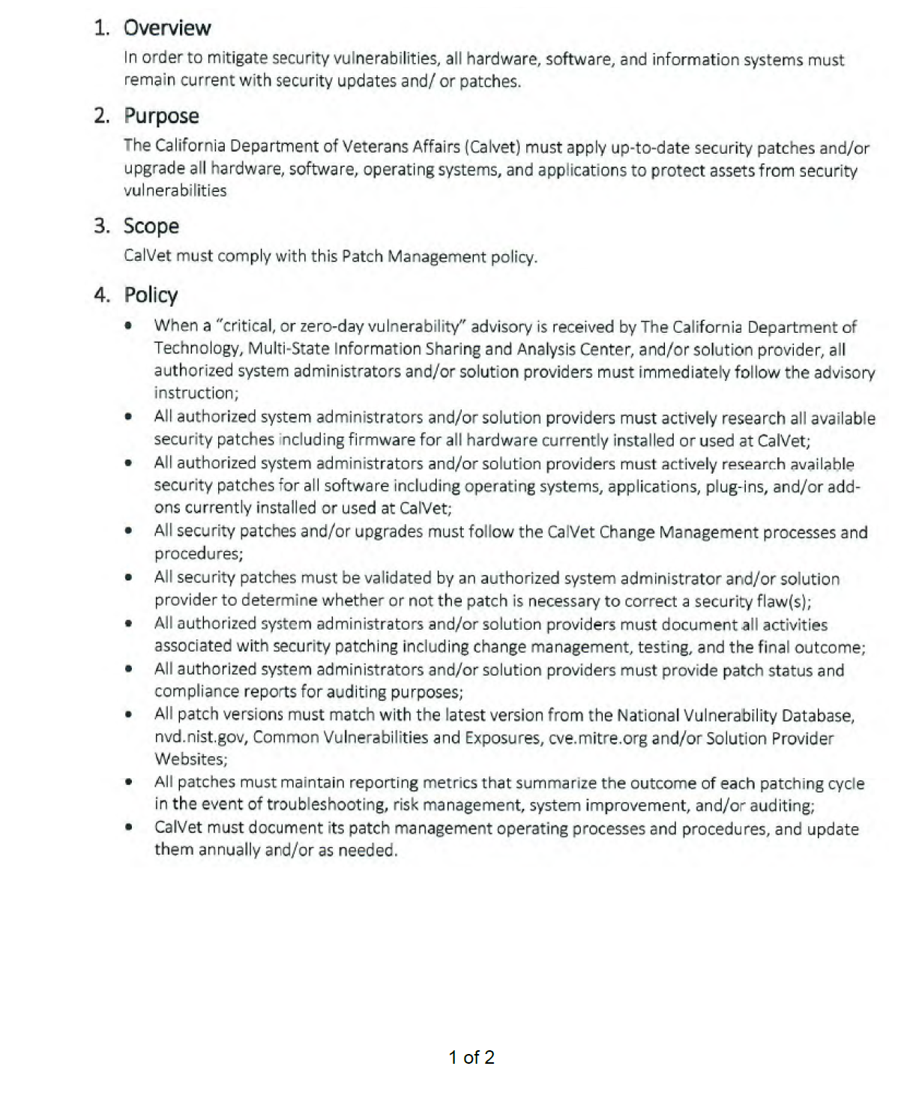

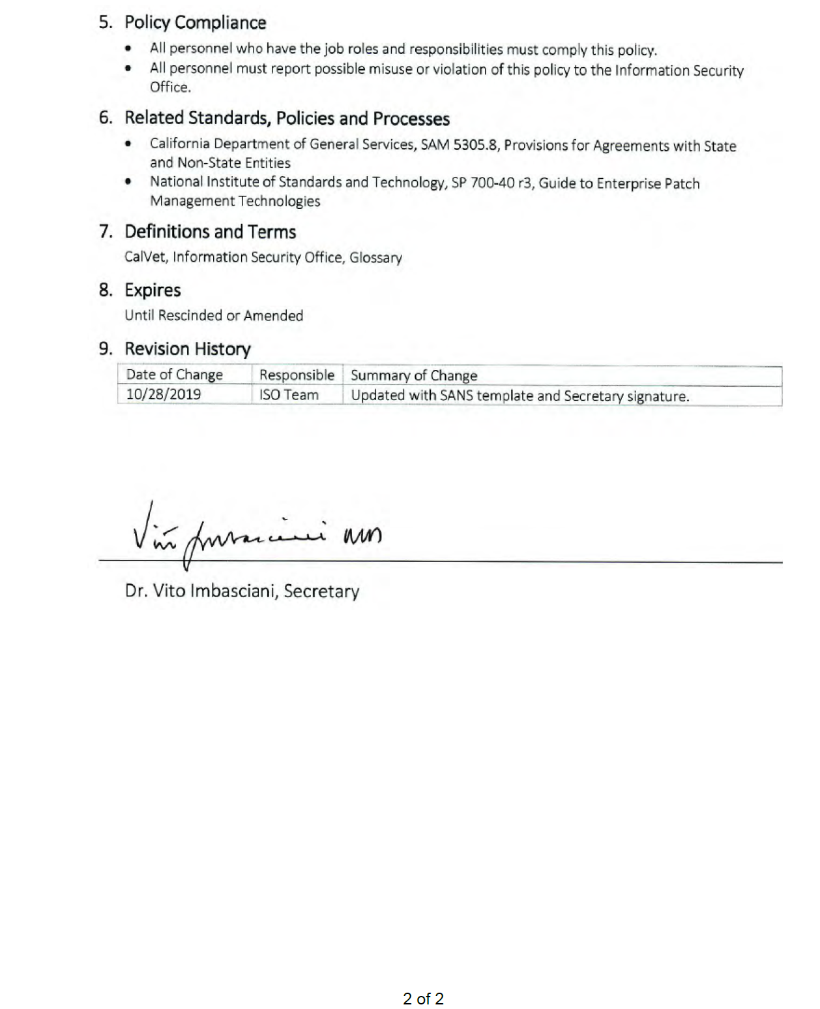

Exhibit I – California Civil Rights Law Certification

Pursuant to Public Contract Code section 2010, if a Bidder executes or renews a Contract over $100,000 on or after January 1, 2017, the Bidder hereby certifies compliance with the following:

1. CALIFORNIA CIVIL RIGHTS LAWS: For Contracts over $100,000 executed or renewed after January 1, 2017, the Contractor certifies compliance with the Unruh Civil Rights Act (Section 51 of the Civil Code) and the Fair Employment and Housing Act (Section 12960 of the Government Code); and
2. EMPLOYER DISCRIMINATORY POLICIES: For Contracts over $100,000 executed or renewed after January 1, 2017, if a Contractor has an internal policy against a sovereign nation or peoples recognized by the United States government, the Contractor certifies that such policies are not used in violation of the Unruh Civil Rights Act (Section 51 of the Civil Code) or the Fair Employment and Housing Act (Section 12960 of the Government Code).

CERTIFICATION

I, the official named below, certify under penalty of perjury under the laws of the State of California that the foregoing is true and correct.  Bidder Firm Name (Printed) |  | Federal ID Number
By (Authorized Signature)
Printed Name and Title of Person Signing
Date Executed | Executed in the County and State of

