REQUEST FOR QUALIFICATIONS
NOTICE TO PROSPECTIVE FIRMS
Architectural & Engineering (A&E) Retainer - Structural Plan Review Services
Division of the State Architect – CR 25-288212
Addendum 1 changes
May 12, 2026

You are invited to review and respond to this Request for Qualifications (RFQ) being offered by
the Department of General Services (DGS), Division of the State Architect (DSA).

DSA is requesting submissions from professional Structural firms (Firms) for a retainer contract that will be used on an as-needed basis for structural plan reviews of various projects identified during the term of the contract for the DSA Regional Offices located in Oakland, Sacramento, Los Angeles, and San Diego (See RFQ Attachment 11 Sample Agreement, Exhibit A, Attachment 1 for DSA Regional Map). Education Code §§ 17305, 81135.]

Firms are encouraged to carefully read this entire solicitation. The need to verify all documentation and responses prior to submission is the responsibility of the Firm and cannot be overemphasized. Please ensure insurance requirements are considered.

In the opinion of the Office of Business and Acquisition Services (OBAS) this RFQ is complete and without need of explanation. However, if you have questions regarding this RFQ, please contact the below listed Acquisition Analyst. Please note that verbal information given will not be binding on the State unless such information is issued in writing as an official addendum to this RFQ.

Marion Brooks, Acquisition Analyst
Office of Business and Acquisition Services
Contracts Services Section
707 Third Street, MS508
West Sacramento, CA 95605
279-799-4505
Marion.Brooks@dgs.ca.gov

RFQ Table of Contents

Section |  |  | Page
A. | INFORMATION |  | 3
B. | MINIMUM QUALIFICATIONS |  | 4
C | SUBMISSION REQUIREMENTS AND INFORMATION |  | 4
D. | SUBMITTING A STATEMENT OF QUALIFICATION |  | 5
E. | EVALUATION AND SELECTON |  | 8
F. | PREFERENCE AND INCENTIVE PROGRAMS |  | 11
ATTACHMENTS
 | 1) | Statement of Qualifications Submission Attachment Checklist | 12
 | 1A) | Region Response Identifier | 13
 | 2) | Certification Sheet | 14
 | 3) | Payee Data Record (STD 204) | 16
 | 4) | Copy of License(s) (for the Principal in Charge and for each Plan Reviewer) | 17
 | 5) | Bidder Declarations (GSPD-05-105) | 18
 | 6A) | Certification – Darfur Contracting Act | 19
 | 6B) | Certification – Unruh Civil Rights Act (California Civil Rights Laws Attachment) | 21
 | 6C) | Certification – Iran Contracting Act Certification | 22
 | 7) | Federal Form SF330 Parts I & II (Firm) (for the Firm’s Principal in Charge and for each Plan Reviewer) | 23
 | 8) | Firm’s Submission Response | 24
 | 9) | Evaluation Criteria | 25
 | 10) | Resumes of Key Personnel Proposed | 27
 | 11) | Sample Standard Agreement (STD 213) and Exhibits | 28

Information

- The State is interested in obtaining professional architectural and engineering services as described in RFQ Attachment 11, Sample Standard Agreement (STD 213) and Exhibits. Please note that any orange font language in the attached sample contract is for informational purpose only and will not appear in the final contract.

- Firms awarded a retainer contract will provide structural plan review services on an “as-needed” basis to review plans and specifications for compliance with all applicable laws. Services may include structural plan review and back check review of drawings and specifications, review of change orders, Construction Change Documents (CCD), addendums, deferred approvals, alternate designs, revisions and over-the-counter review for California K-12 public schools and community colleges.

- All work performed from an awarded retainer contract shall comply with all applicable statutes and regulations, DSA policy, DSA procedures, and DSA guidelines as they relate to structural plan review. All work must be performed under the supervision of, and approved by, the Firm’s principal structural engineer, licensed in the State of California in accordance with the California Business and Professions Code, Division 3 (hereafter Principal in Charge).

- Required DSA Academy Training - Upon receiving notification from DSA that the Firm has passed the evaluation process and will be receiving a Contract, the Principal in Charge and Plan Reviewer(s) will be required to complete the DSA Academy Training courses prior to being awarded a Task Order (see RFQ Attachment 11, Exhibit A, Sample Standard Agreement, Section 8).

- Division of State Architect (DSA) anticipates there will be multiple contracts awarded for each DSA Regional Office in Oakland, Sacramento, Los Angeles and San Diego. For each DSA Regional Office, DSA will create a rotational list of Firms qualified for projects in the respective geographic area (see RFQ Attachment 11, Sample Standard Agreement, Exhibit A, Attachment 1 for DSA Regional Map). The rotational list will be used on an “as-needed” basis for the plan review services. The amount of work will not be guaranteed.

- The estimated total contract amount will not exceed $1,000,000.00 and the contract will remain in effect for four (4) years or until fully expended, whichever occurs first. Firms may be issued work during the first three (3) years of the contract term. During the fourth year new work will not be assigned; this period will allow Firms to complete structural plan reviews and back check work previously issued. All work must be completed prior to the expiration date of the contract term.

- Firms interested in providing professional services for this contracting opportunity must submit a response as described herein.

Minimum Qualifications

NOTE: Submissions that do not meet minimum requirements may be rejected.

- Licenses/Certifications:

  - A Firm must be registered with the State of California, Secretary of State, if required by law.
  - A Firm must have a California licensed Structural Engineer as the Principal in Charge.
  - A Firm must have a California licensed Structural Engineer for each Plan Reviewer.

Submission Requirements and Information

- Key Action Dates

Listed below are the important action dates and times by which actions must be taken or completed. If OBAS finds it necessary to change any of these dates, it will be accomplished by addendum to this RFQ. ALL DATES AFTER THE DEADLINE FOR FINAL SOQ SUBMISSION ARE APPROXIMATE AND MAY BE ADJUSTED AS CONDITIONS INDICATE, WITHOUT ADDENDUM TO THIS RFQ.

Event | Date | Time (PT)
RFQ available to prospective firms | May 12, 2026
Written Question Submission Deadline | June 1, 2026
Questions and Answers to be Posted | June 9, 2026
Deadline for Final SOQ Submission | July 1, 2026 | 2:00 p.m.

- Written Questions
  - Firms requiring clarification of the intent or content of this RFQ, or on procedural matters regarding the procurement process, may request clarification by submitting questions in writing. Firms may submit questions to the Acquisition Analyst listed on page 1 of the Notice to Prospective Firms via email or via U.S. mail. If sending via U.S. mail, the envelope must be clearly marked “Questions Relating to RFQ 25-288212 DSA Architectural & Engineering Retainer – Structural” and sent to the Acquisition Analyst listed on the Notice to Prospective Firms for this RFQ. To ensure a response, questions must be received in writing by the date given for written questions in Key Action Dates (See Section C.1.). Question and Answer Sets will be provided to all Firms and will be posted to the California State Contracts Register (CSCR) event as an Addendum.

  - Requests for Changes to the RFQ – If the Firm believes that one or more of the RFQ requirements is onerous, unfair, or imposes unnecessary constraints to the Firm, the Firm may request a change to the RFQ by submitting, in writing, the recommended change(s) and the facts substantiating this belief and reasons for making the recommended change. Such requests must be submitted to the Acquisition Analyst by the date specified herein for written questions concerning the RFQ. Such changes will be made at the sole option of OBAS. If OBAS determines that any requested change is in the best interest of the State, all Firms will be notified of the change in the form of an Addendum to this RFQ.

  - If a Firm discovers any ambiguity, conflict, discrepancy, omission or other error in this RFQ, the Firm will immediately notify OBAS of such error(s) in writing and request clarification or modification of the document. If a Firm fails to notify OBAS, prior to the Deadline for Final SOQ Submission, of an error known to the Firm, or an error that reasonably should have been known, the Firm will submit at their own risk, and if awarded the contract, will not be entitled to additional compensation or time by reason of the error or its later correction.

Submitting a Statement of Qualification

- Submitting a SOQ is a mandatory step for all Firms interested in this contracting opportunity.

  - Introduction letters, expensive bindings, colored displays, promotional materials, etc., should not be included in the response and may cause the submission to be rejected. Emphasis should be concentrated on conformance to the RFQ instructions, responsiveness to the RFQ requirements and completeness and clarity of content. Do not add additional documents that are not identified in RFQ Attachment 1 Statement of Qualifications Submission Attachment Checklist. .

  - The SOQ shall be complete in all respects as described in this RFQ. A SOQ may be rejected if it is conditional or incomplete, or if it contains any alterations of form or other irregularities of any kind..

  - A complete SOQ submission shall consist of all items identified in the RFQ Attachment 1, Statement of Qualifications Submission Attachment Checklist, including the Attachment 1, in the attachment order.

  - The Firm will submit their response as follows:

    - Electronic submittal via File Upload (preferred method of RFQ submission – please notify Acquisition Analyst via email if Firm is unable to accommodate electronic submittal via File Upload) OR

    - Physical Copy Submittal (please notify Acquisition Analyst via email if Firm chooses physical copy submittal of their RFQ). The Firm must submit six (6) copies of all required documents. The Master Copy will be marked as “Master Copy” and contain original (wet) or electronic signatures (scans of wet signatures are permissible). Master Copy will be submitted in a manner to where easy duplication is achievable (i.e. do not use comb bindings, binders etc. – binder clips are acceptable).In the event of a discrepancy between the copy with original signatures and the electronic copy, the copy with original signatures shall prevail.

    - The required documents must be numbered and clearly labeled as depicted in the RFQ Attachment 1, Statement of Qualification Submission Attachment Checklist.

  - The Firm will deliver their SOQ submission in such a way that the outside of the SOQ submission is clearly labeled as indicated below:

RFQ – DSA Architectural & Engineering Retainer – Structural
CR25-288212
DO NOT OPEN
Department of General Services, The Ziggurat
Attn: Marion Brooks, Office of Business and Acquisition Services, Mailstop 508
707 Third Street
West Sacramento, CA 95605

  - MAILED SOQ Submissions: Shall be sent to the address above.

  - HAND DELIVERED SOQ Submissions: Shall be placed in the DGS/OBAS Bid/Proposal Drop Box located in the lobby at 707 3rd Street, West Sacramento, CA 95605. The Drop Box will be opened Tuesday through Thursday at 2:00 PM each day and package(s) in the box will be certified as being received before 2:00 pm that day. The Drop Box will not accept package(s) larger than a medium-sized shipping box (~12” (L) x 3 1/2” (W) x14 1/8” (H)). Firms that intend to hand deliver package(s) larger than this should notify and coordinate at least 24 hours in advance with the Acquisition Analyst identified in the Notice of Prospective Firms to have their package(s) received.

  - FILE UPLOADS: The OBAS Active Solicitations website allows Firms to submit their SOQ prior to the date and time specified in the Key Action Dates in Section C.1 above.

Link to the OBAS Active Solicitation website to upload SOQ documents:

https://cadgs.sharepoint.com/:f:/s/OBAS-Active-Solicitations/IgAb0aF9tdGjRp-ttT4Kk9zLAXQSgwbnau6OjbQcqMXBpNA

https://cadgs.sharepoint.com/sites/OBAS-Active-Solicitations/Shared%20Documents/Forms/AllItems.aspx?viewid=75df540a%2Dc4b4%2D4e51%2Da2fe%2Da8c4f69b7f3c
UPLOAD TO FILE CR25-288212DSAStructualPlanReviewConsultant

Files uploaded to the website must be compatible with Microsoft Office Suite and Adobe as specified in the table below. Files shall not be password protected:

Item | Acceptable File Formats
All Attachments | .doc, .docx, .xls, .xlsx, .pdf, .zip

  - Firms shall identify any files uploaded with their Business Name and description of attachment. For example, Acme Inc Attachment 1A, Region Response Identifier.pdf

  - Firm shall complete the Contact information section of the File Upload form with the following information:

    - First Name: Enter Company or Firm Name
    - Last Name: Enter Contact Name

  - Prior to the bid due date, Firms may request assistance regarding the File Upload form from the Acquisition Analyst identified on page 1 of this RFQ.

  - It is the responsibility of the Firm to ensure timely delivery of their SOQ submission. A postmark or facsimile transmission will not be accepted as meeting the delivery time requirements if the SOQ submission is received after the specified deadline. A Firm that is hand-delivering their SOQ submission should allow extra time for traffic, sparse parking, slow elevators and clearing security procedures.

  - The SOQ submission implies no obligation on the part of DSA to contract for services.

  - Developing the SOQ submission is entirely the responsibility of the Firm and will not be chargeable to the State.

- Rejection of Submissions
  - SOQ Submissions not received by the date and time specified, or not sealed, will be rejected.

  - Facsimile (FAX) submissions will not be considered.

  - The SOQ submission must not contain false or misleading statements, or provide contradictory attributes or conditions claimed by the Firm. If, in the opinion of OBAS, such information was intended to mislead OBAS in its evaluation of the SOQ, and the attribute, condition, or capability is a requirement of this RFQ, it will be the basis for rejection of the SOQ submission.

  - Deviations in the SOQ submission, whether or not intentional, may cause the SOQ submission to be non-responsive and not considered for award.

  - The State does not accept alternate contract language from a prospective contractor. A submission with such language will be considered a counter proposal and will be rejected. The State’s General Terms and Conditions (GTC) are not negotiable.

  - OBAS is not required to award a contract. OBAS reserves the right to reject any or all submissions and to waive informalities and minor irregularities in responses received and to accept all or any portion of a submission, if deemed in the best interest of the State and not contrary to law.

- Errors in the Submission

  - The Firm is cautioned to not rely on OBAS during the evaluation to discover and report to the Firm any defects and errors in the submitted documents. The Firm, before providing a submission, should carefully proof their documents for errors and adherence to the RFQ requirements.

  - The Firm may modify its submission by withdrawing its original submission and resubmitting a new submission prior to the final submission deadline. Modifications offered in any other manner, oral or written, will not be considered.

  - The Firm may withdraw a submission by submitting a written withdrawal request to OBAS, signed by an authorized agent. A Firm may thereafter submit a new submission prior to the submission deadline.

  - OBAS may modify the RFQ prior to the submission due date noted on the Notice to Prospective Firms by posting an Addendum on the California State Contracts Register (CSCR) website, located at the following address: https://caleprocure.ca.gov/pages/Events-BS3/event-search.aspx

  - OBAS reserves the right to reject any/all submissions. OBAS is not required to award an agreement.

  - OBAS may, at its sole option, correct discrepancy/errors on the copy set on the basis that if intent is not clearly established by the complete submission the set marked as Master Copy will have priority over additional copies.

Evaluation

- A Firm shall respond to each evaluation criteria identified in RFQ Attachment 9, indicating how they believe their experience fulfills the requirements.

- OBAS will appoint State employee(s) to further verify and evaluate the firm submissions as described in the RFQ. The further review may also include, but is not limited to:

- Darfur certification has been evaluated
- Iran certification has been evaluated
- California Civil Rights Laws Attachment
- Tax delinquent eligibility evaluated
- Corporate standing has been verified with State of California, Secretary of State
- Review of Russia Sanctions, pursuant to EO N-6-22
- Commercially Useful Function (CUF) analysis for any SB or DVBE;
- License validation at California Department of Consumer Affairs

- During submission review, if any of the required documents are missing, OBAS may reject the submission as incomplete and the submission will not be further evaluated. If any of the required documents have been modified or contain alterations, OBAS may reject the SOQ submission as non-responsive. OBAS reserves the right to ask clarifying questions during this evaluation.

- The documents provided by the Firm in their SOQ submission enable the State to evaluate for responsiveness. OBAS reserves the right to ask clarifying questions during evaluation, such as for CUF; however, the answers cannot change or alter the SOQ submission. Should a discrepancy exist between the answer provided and the SOQ submission, the SOQ submission will be considered correct.

- Submissions meeting minimum qualifications will be further evaluated. The State will select an evaluation team that will be responsible for the review and evaluation of the RFQ selection criteria. The evaluation team will arrive at consensus for each submission.

- The State and each Firm will enter into negotiations to create fixed rates specifying the hourly rates for specific classifications of employees and/or services to be provided. Should DGS be unable to negotiate a satisfactory rate for a given project with the Firm considered to be the most qualified at fair and reasonable compensation, negotiations with that Firm for that project shall be terminated. DGS shall then undertake negotiations with the second most qualified Firm and so on.

- Upon successful review and acceptance, the State will commence contract development for the retainer agreement(s) to develop a pool of most qualified Firms for each region. More than one contract may be issued for each region and the State reserves the right to limit the pool to only one qualified Firm. Upon contract development the State will route the contract(s) to obtain signatures and approvals for an executed contract.

NOTE: The length of time between SOQ submission and contract award notification may vary. During evaluation and selection, Firms may not be provided information as to status until such time as evaluation and selection has been completed.

- News releases pertaining to any award resulting from this RFQ may not be made without prior written approval of:

The Public Information Officer
707 Third Street, MS 101
West Sacramento, CA 95605
Phone: (916) 376-5037
Email: DGSPublicAffairs@dgs.ca.gov

- Disposition of SOQ Submission
- Upon completion of evaluation and selection process, all documents submitted in response to this RFQ will become the property of the State of California, and will be regarded as public records under the California Public Records Act (Gov. Code § 6250 et seq.) and subject to review by the public.

- Upon cancellation of the solicitation, the OBAS Acquisition Analyst will offer to return the bid at Bidder’s expense. A Bidder may request that OBAS destroy the bid, rather than pay for its return.

- Performance of Service

- Upon award of contract, the winning Firm must provide a Certificate of Insurance (COI) within ten (10) working days from award of contract. This COI will identify the required insurance as indicated in RFQ Attachment 11, Standard Sample Agreement, Exhibit D, Item 7, Insurance Requirement and will provide the required insurance endorsements as indicated in RFQ Attachment 11, Standard Sample Agreement, in Exhibit D, Item 7, Insurance Requirement.

- Upon award of the contract, the winning Firm agrees to sign the contract on the State’s Standard Agreement (STD 213), with Exhibits. The STD 213 (See sample contract agreement provided, RFQ Attachment 11.) must be signed by an individual authorized to bind the firm contractually.

- Upon award of the contract, the winning Firm will need to submit a signed certification page of the Contractor’s Certification Clauses (CCC 04/2017). If you do not have Internet access, a hard copy can be provided by contacting the Acquisitions Analyst listed on the Notice to Prospective Firms. Otherwise, the Contractor’s Certification Clauses are available on the OLS Standard Contract Language for Non-It Services web page.

- Upon award of the contract, the winning Firm may need to provide a DGS PD 843 Disabled Veteran Business Enterprise Declarations form if the Firm is a DVBE identified on RFQ Attachment 5, Bidder Declaration (GSPD-05-105) within ten (10) working days. If you do not have Internet access, a hard copy can be provided by contacting the Acquisitions Analyst listed on the Notice to Prospective Firms. Otherwise, the DGS PD 843 is available at the following link: https://www.documents.dgs.ca.gov/dgs/fmc/gs/pd/pd_843.pdf

Preference and Incentive Programs

There are no mandatory participation requirements for Small Business (SB) or Disabled Veteran Business Enterprise (DVBE) services for this contract opportunity, although the State encourages SB and DVBE wherever possible. If you believe your Firm qualifies as a SB or DVBE, you may visit https://caleprocure.ca.gov/pages/index.aspx for more information or call the Office of Small Business and Disabled Veteran Business Enterprise Services (OSDS) at (916) 375-4940 for further information. Please note no preference or incentives in the qualifications category can be given under the contracting law set up for professional services (Architectural, Engineering, Environmental Services, etc.) contracts.

ATTACHMENT 1

STATEMENT OF QUALIFICATIONS SUBMISSION ATTACHMENT CHECKLIST

Complete this checklist to confirm the attachments are in your SOQ Submission. Place a check mark or “X” next to each item that you are submitting to the State. This checklist must be returned with your submission. Do not add additional documents, introduction letters, expensive bindings, colored displays, promotional materials that are not identified in RFQ Attachment 1 Statement of Qualifications Submission Attachment Checklist.

Attachment |  | Required | Attachment Name/Description
☐ | Attachment 1 | YES | Statement of Qualifications Submission Attachment Checklist
☐ | Attachment 1A | YES | Region Response Identifier
☐ | Attachment 2 | YES | Certification Sheet
☐ | Attachment 3 | YES | Payee Data Record (STD 204)
☐ | Attachment 4 | YES | Copy of License(s) (for the Principal in Charge and for each Plan Reviewer)
☐ | Attachment 5 | YES | Bidder Declarations (GSPD-05-105)
☐ | Attachment 6A | YES | Certification – Darfur Contracting Act
☐ | Attachment 6B | YES | Certification – Unruh Civil Rights Act (California Civil Rights Laws Attachment)
☐ | Attachment 6C | YES | Certification – Iran Contracting Act Certification
☐ | Attachment 7 | YES | Federal Form SF330 Parts I & II (Firm) (for the Firm’s Principal in Charge and for each Plan Reviewer)
☐ | Attachment 8 | YES | Firm’s Submission Response
☐ | Attachment 9 | YES | Evaluation Criteria
☐ | Attachment 10 | YES | Resumes of Key Personnel Proposed
The following attachments are included in the RFQ as reference only and should not be included in the SOQ submission.

N/A | Attachment 11 | NO | Sample Standard Agreement (STD 213) and Exhibits

ATTACHMENT 1A

REGION RESPONSE IDENTIFER

Respondent to select the Region(s) they would like to be considered for a retainer contract(s). The Regions are defined in the RFQ Attachment 10, Exhibit A, Attachment 1. If a Respondent intends to use a different team for any specific Region(s), a separate RFQ submission is required.

DSA performs review through electronic-plan (e-plan) review of electronic drawings and specifications. DSA requires the Firm to provide electronic plan review. Electronic plan review is a process by which electronic drawings and specifications can be reviewed and marked using computer tools such as a PDF editor (Bluebeam). Compensation will not be provided for travel time or travel-related expenses. The final back check review process is an electronic process to take place at the designated DSA Regional Office unless otherwise approved by the regional office, and will be completed by the same individuals who performed the initial plan review.

OAKLAND:

Willing to accept work out of the Oakland Regional Office.

SACRAMENTO:

Willing to accept work out of the Sacramento Regional Office.

LOS ANGELES:

Willing to accept work out of the Los Angeles Regional Office.

SAN DIEGO:

Willing to accept work out of the San Diego Regional Office.

ATTACHMENT 2

CERTIFICATION SHEET

This Certification Sheet must be signed and returned along with all the "required attachments" as an entire package with original (wet) or electronic signatures.

- Our all-inclusive SOQ is submitted as identified on RFQ Attachment 1, Submission Attachment Checklist.

- All required attachments, as applicable, are included with this certification sheet.

- I have read and understand that DVBE participation is not a requirement of receiving this contract, although DVBE participation is encouraged.

- The signature affixed hereon and dated certifies compliance with all the requirements of this document. The signature below authorizes the verification of this certification.

NOTE: An Unsigned Certification Sheet May Be Cause for Rejection

1. Company Legal Name |  |  |  | 2. Telephone Number |  |  | 2a. Email
 |  |  |  | ( )
3. Address
Indicate your organization type:
4. ☐ Sole Proprietorship |  |  | 5. ☐ Partnership |  |  |  | 6. ☐ Corporation
Indicate the applicable employee and/or corporation number:
7. Federal Employee ID No. (FEIN) |  |  |  |  | 8. California Corporation No.
9. Indicate applicable license and/or certification information:

10. Name (Print) |  |  |  |  | 11. Title
12. Signature |  |  |  |  | 13. Date
14. Are you certified with the Department of General Services, Office of Small Business and Disabled Veteran Business Enterprise (OSDS) as:
a. California Small Business  Yes No  If yes, enter certification number: |  |  |  | b. Disabled Veteran Business Enterprise Yes No  If yes, enter your certification number below:
NOTE: A copy of your Certification is required to be included if either of the above items is checked “Yes”.
Date application was submitted to OSDS, if an application is pending:

Completion Instructions for Certification Sheet

Complete the numbered items on the
Certification Sheet by following the instructions below.

Item Numbers | Instructions
1, 2, 2a, 3 | Must be completed. These items are self-explanatory.
4 | Check if your firm is a sole proprietorship. A sole proprietorship is a form of business in which one person owns all the assets of the business in contrast to a partnership and corporation. The sole proprietor is solely liable for all the debts of the business.
5 | Check if your firm is a partnership. A partnership is a voluntary agreement between two or more competent persons to place their money, effects, labor, and skill, or some or all of them in lawful commerce or business, with the understanding that there will be a proportional sharing of the profits and losses between them. An association of two or more persons to carry on, as co-owners, a business for profit.
6 | Check if your firm is a corporation. A corporation is an artificial person or legal entity created by or under the authority of the laws of a State or nation, composed, in some rare instances, of a single person and his successors, being the incumbents of a particular office, but ordinarily consisting of an association of numerous individuals.
7 | Enter your federal employee tax identification number.
8 | Enter your corporation number assigned by the California Secretary of State’s Office. This information is used for checking if a corporation is in good standing and qualified to conduct business in California.
9 | Complete, if applicable, by indicating the type of license and/or certification that your firm possesses and that is required for the type of services being procured.
10, 11,  12, 13 | Must be completed. These items are self-explanatory.
14 | If certified as a California Small Business, place a check in the "Yes" box, and enter your certification number on the line. If certified as a Disabled Veterans Business Enterprise, place a check in the "Yes" box and enter your service code on the line. If you are not certified to one or both, place a check in the "No" box. If your certification is pending, enter the date your application was submitted to OSDS.

ATTACHMENT 3

PAYEE DATA RECORD (STD 204)

A Firm must complete the Payee Data Record STD 204, located at the following internet site:
http://www.documents.dgs.ca.gov/dgs/fmc/pdf/std204.pdf

If you do not have Internet access, a hard copy can be provided by contacting the Acquisition Analyst listed on the Notice to Prospective Firms.

The completed Payee Data Record STD 204 must be included in the SOQ submission, as Attachment 3.

ATTACHMENT 4

COPY OF LICENSE(S)

A Firm must have a California Structural Engineer license for the Principal in Charge and for each Plan Reviewer – copy of licenses to be attached.

ATTACHMENT 5

BIDDER DECLARATIONS

A Firm must complete the Bidder Declaration form GSPD-05-105, located at the following internet site: http://www.documents.dgs.ca.gov/dgs/fmc/gs/pd/gspd05-105.pdf

If you do not have Internet access, a hard copy can be provided by contacting the Acquisition Analyst listed on the Notice to Prospective Firms.

Documentation of the Bidder Declaration must be included in the submission, as Attachment 5.

ATTACHMENT 6A

DARFUR CONTRACTING ACT

Firm must complete and submit the Darfur Contracting Act Certification with their bid submission as Attachment 6A.

Effective January 1, 2009, a company will not bid on or submit a proposal for a contract for goods or services without addressing the requirements of the Darfur Contracting Act of 2008 (Act). The Act was passed to preclude State agencies generally from contracting with “scrutinized” companies that do business in the African nation of Sudan (of which the Darfur region is a part). Understand that a scrutinized company is a company doing business in Sudan as defined in Public Contract Code Section 10476. Scrutinized companies are ineligible to, and cannot, bid on or submit a proposal for a contract with a State agency for goods or services unless it has been granted permission by the Department of General Services. (Pub. Contract Code § 10477, subd. (a)). The Department of General Services may permit a scrutinized company, on a case-by-case basis, to bid on or submit a proposal for a contract with a State agency for goods or services, if it is in the best interest of the State.

Public Contract Code Sections 10475-10481, applies to any company that currently or within the previous three (3) years has had business activities or other operations outside of the United States. For such a company to bid on or submit a proposal for a State of California contract, the company must certify that it is either:

1. A contractor that has NOT had business activities or other operations outside of the United States within the previous three (3) years;
or

2. A contractor that has had business activities or other operations outside of the United States within the previous three (3) years, but is NOT a scrutinized company per Public Contract Code section 10476;
or

3. A contractor that is a scrutinized company as defined in Public Contract Code section 10476, but has received written permission from the Department of General Services to submit a bid or proposal pursuant to Public Contract Code section 10477, subdivision (b).

Darfur Contracting Act Certification

- I, the official named below who is authorized to legally bind the bid submission, Certify under Penalty of Perjury that the contractor listed below has NOT had, within the previous three (3) years, business activities or other operations outside of the United States.

Contractor/ Company Name (Printed) | Federal ID Number
By (Authorized Signature)

Printed Name and Title of Person Signing

OR

2. I, the official named below who is authorized to legally bind the bid submission, Certify Under Penalty of Perjury that the contractor listed below has had, within the previous three (3) years, business activities or other operations outside of the United States, but is NOT a scrutinized company per Public Contract Code section 10476. This certification is made under the laws of the State of California.

Contractor/ Company Name (Printed) |  | Federal ID Number
By (Authorized Signature)

Printed Name and Title of Person Signing

Date Executed | Executed in the County and State of

OR

3. We are a scrutinized company as defined in Public Contract Code section 10476, but we have received written permission from the Department of General Services (DGS) to submit a bid or proposal pursuant to public Contract Code section 10477, subdivision (b). A copy of the written permission from DGS is included with our bid submission.

Contractor/ Company Name (Printed) | Federal ID Number
By (Authorized Signature)

Printed Name and Title of Person Signing

ATTACHMENT 6B
STATE OF CALIFORNIA DEPARTMENT OF GENERAL SERVICES CALIFORNIA CIVIL RIGHTS LAWS ATTACHMENT OFFICE OF LEGAL SERVICES
DGS OLS 04 (Rev. 01/17)

Pursuant to Public Contract Code section 2010, a person that submits a bid or proposal to, or otherwise proposes to enter into or renew a contract with, a state agency with respect to any contract in the amount of $100,000 or above shall certify, under penalty of perjury, at the time the bid or proposal is submitted or the contract is renewed, all of the following:

- CALIFORNIA CIVIL RIGHTS LAWS: For contracts executed or renewed after
January 1, 2017, the contractor certifies compliance with the Unruh Civil Rights Act (Section 51 of the Civil Code) and the Fair Employment and Housing Act (Section 12960 of the Government Code); and

- EMPLOYER DISCRIMINATORY POLICIES: For contracts executed or renewed after January 1, 2017, if a Contractor has an internal policy against a sovereign nation or peoples recognized by the United States government, the Contractor certifies that such policies are not used in violation of the Unruh Civil Rights Act (Section 51 of the Civil Code) or the Fair Employment and Housing Act (Section 12960 of the Government Code).

CERTIFICATION

I, the official named below, certify under penalty of perjury under the laws of the State of California that the foregoing is true and correct.
Proposer/Bidder Firm Name (Printed) |  | Federal ID Number

By (Authorized Signature)
Printed Name and Title of Person Signing
Executed in the County of |  | Executed in the State of
Date Executed

ATTACHMENT 6C

IRAN CONTRACTING ACT CERTIFICATION

1. CERTIFICATION:

I, the official named below, certify I am duly authorized to execute this certification on behalf of the vendor/financial institution identified below, and the vendor/financial institution identified below is not on the current list of persons engaged in investment activities in Iran created by DGS and is not a financial institution extending twenty million dollars ($20,000,000) or more in credit to another person/vendor, for 45 days or more, if that other person/vendor will use the credit to provide goods or services in the energy sector in Iran and is identified on the current list of persons engaged in investment activities in Iran created by DGS.

Vendor Name/Financial Institution Name (Printed) |  | Federal ID Number
By (Authorized Signature)

Printed Name and Title of Person Signing

Date Executed | Executed in the County and State of

OR

2. EXEMPTION:

Pursuant to Public Contract Code sections 2203(c) and (d), a public entity may permit a vendor/financial institution engaged in investment activities in Iran, on a case-by-case basis, to be eligible for, or to bid on, submit a proposal for, or enters into or renews, a contract for goods and services.

If you have obtained an exemption from the certification requirement under the Iran Contracting Act, please fill out the information below, and attach documentation demonstrating the exemption approval.

Vendor Name/ Financial Institution Name (Printed) | Federal ID Number
By (Authorized Signature)

Printed Name and Title of Person Signing | Date

ATTACHMENT 7

FEDERAL FORM 330 Parts I & II (Firm)
Contract-Specific Qualifications and General Qualifications

Forms may be found through the following website:
https://www.gsa.gov/reference/forms/architectengineer-qualifications

(Required for the Firm’s Principal in Charge and for each Plan Reviewer)

If you do not have Internet access, a hard copy can be provided by contacting the Acquisition Analyst listed on the Notice to Prospective Firms.

ATTACHMENT 8

Firm’s Submission Response

The Firm will submit the following:

1) A Letter of Interest that includes the Firm’s legal name and a written statement on the Firm’s capacity to provide professional plan review services to DSA. The Firm must certify that the information included in the RFQ is accurate. The Letter of Interest, which includes the certification, must be signed by an individual who is authorized to bind the Firm.
2) A written statement of the Firm’s ability to have sufficient staff to meet DSA and client project schedules and deadlines.
3) A written statement of qualifications for the Principal in Charge and Plan Reviewers that is responsive to the selection criteria. This written statement may include illustrated plans, sketches, awards, or photographs of recent relevant projects in 8 ½” X 11” format.
4) A written statement demonstrating that the Principal in Charge and Plan Reviewers have sufficient knowledge of statutes and regulations applicable to building and site design for structural requirements for K-12 public schools and community colleges in the State of California.
5) If the Principal in Charge and Plan Reviewers have previously completed the DSA Academy training, a copy of the certificates shall be included.

ATTACHMENT 9

EVALUATION CRITERIA

CRITERIA |  | EVALUATION
1. | The degree to which the SOQ demonstrates ability to accommodate DSA Deadlines. | ☐ Firm has demonstrated this criteria  ☐ Firm has not demonstrated this criteria
2. | The degree to which the SOQ demonstrates that the Firm has sufficient professional plan review services to meet DSA and client project schedules and deadlines. | ☐ Firm has demonstrated this criteria  ☐ Firm has not demonstrated this criteria
3. | The degree to which the SOQ demonstrates Principal in Charge Experience principals to be assigned to the discipline projects.
3a. | The Principal in Charge has a minimum of five (5) years of recent work experience within the last eight (8) years, which includes work in progress or completed, performing or managing structural design or structural plan review of K-12 public schools or community colleges in the State of California. This work experience must be demonstrated by listing work in Attachment 10 “Statement of Qualifications Resumes of Key Personnel Proposed.” | ☐ Firm has demonstrated this criteria  ☐ Firm has not demonstrated this criteria
3b. | The Principal in Charge has sufficient knowledge of statutes and regulations applicable to building and site design for structural requirements for K-12 public schools or community colleges in the State of California. | ☐ Firm has demonstrated this criteria  ☐ Firm has not demonstrated this criteria
4 | The degree to which the SOQ demonstrates Plan Reviewer’s Experience.
4a | Each Plan Reviewer has a minimum of five (5) years of recent work experience within the last eight (8) years, which includes work in progress or completed, performing or managing structural design or structural plan review of K-12 public schools or community colleges in the State of California. This work experience must be demonstrated by listing work in Attachment 10 “Statement of Qualifications Resumes of Key Personnel Proposed.” | ☐ Firm has demonstrated this criteria  ☐ Firm has not demonstrated this criteria
4b | Each Plan Reviewer has sufficient knowledge of statutes and regulations applicable to building and site design for structural requirements for K-12 public schools or community colleges in the State of California. | ☐ Firm has demonstrated this criteria  ☐ Firm has not demonstrated this criteria
5. | The degree to which the SOQ demonstrates Principal in Charge have sufficient knowledge of statutes and regulations applicable to building and site design for structural requirements for K-12 public schools and community colleges in the State of California. | ☐ Firm has demonstrated this criteria  ☐ Firm has not demonstrated this criteria
6 | The degree to which the SOQ demonstrates Plan Reviewers have sufficient knowledge of statutes and regulations applicable to building and site design for structural requirements for K-12 public schools and community colleges in the State of California. | ☐ Firm has demonstrated this criteria  ☐ Firm has not demonstrated this criteria
7 | If the Firm is electing to use a plan reviewer, the degree to which the SOQ demonstrates the below criteria of the Plan Reviewer.
7a | Firms may include Plan Reviewers in the SOQ response. Plan Reviewers are not required in order for a Firm to be awarded a contract. However, any Plan Reviewer who does not possess a valid Structural Engineer license in the State of California and is not approved in a SOQ evaluation shall not perform plan review services under any contract. | ☐ Plan Reviewer has a structural engineer license  ☐ Plan Reviewer does not have a structural engineer license

QUALIFCATION CRITERIA SUMMARY
Does the RFQ submission meet all the criteria? | ☐ Yes, the Firm has met the RFQ submission criteria.  ☐ No, the Firm has not met the RFQ submission criteria for this solicitation opportunity.

ATTACHMENT 10

STATEMENT OF QUALIFICATIONS
RESUMES OF KEY PERSONNEL PROPOSED
1. NAME:

2. ROLE IN THE CONTRACT:

3a. YEARS EXPERIENCE – TOTAL:

3b. YEARS EXPERIENCE – WITH CURRENT FIRM:

4. FIRM NAME and LOCATION (City and State):

5. EDUCATION (Degree and Specialization):

6. CURRENT PROFESSIONAL REGISTRATION (State and Discipline):

7. OTHER PROFESSIONAL QUALIFICATIONS (Publications, Organizations, Training, Awards, etc.)

8a. RELEVANT PROJECT – TITLE and LOCATION (City and State):
8a. RELEVANT PROJECT – YEAR COMPLETED – PROFESSIONAL SERVICES:
8a. RELEVANT PROJECT – YEAR COMPLETED – CONSTRUCTION (if applicable):
8a. RELEVANT PROJECT – BRIEF DESCRIPTION (Brief scope, size, cost, etc.) and SPECIFIC ROLE:
8a. RELEVANT PROJECT – BRIEF DESCRIPTION – Check here if project performed with current Firm:

8b. RELEVANT PROJECT – TITLE and LOCATION (City and State):
8b. RELEVANT PROJECT – YEAR COMPLETED – PROFESSIONAL SERVICES:
8b. RELEVANT PROJECT – YEAR COMPLETED – CONSTRUCTION (if applicable):
8b. RELEVANT PROJECT – BRIEF DESCRIPTION (Brief scope, size, cost, etc.) and SPECIFIC ROLE:
8b. RELEVANT PROJECT – BRIEF DESCRIPTION – Check here if project performed with current Firm:

8c. RELEVANT PROJECT – TITLE and LOCATION (City and State):
8c. RELEVANT PROJECT – YEAR COMPLETED – PROFESSIONAL SERVICES:
8c. RELEVANT PROJECT – YEAR COMPLETED – CONSTRUCTION (if applicable):
8c. RELEVANT PROJECT – BRIEF DESCRIPTION (Brief scope, size, cost, etc.) and SPECIFIC ROLE:
8c. RELEVANT PROJECT – BRIEF DESCRIPTION – Check here if project performed with current Firm:

8d. RELEVANT PROJECT – TITLE and LOCATION (City and State):
8d. RELEVANT PROJECT – YEAR COMPLETED – PROFESSIONAL SERVICES:
8d. RELEVANT PROJECT – YEAR COMPLETED – CONSTRUCTION (if applicable):
8d. RELEVANT PROJECT – BRIEF DESCRIPTION (Brief scope, size, cost, etc.) and SPECIFIC ROLE:
8d. RELEVANT PROJECT – BRIEF DESCRIPTION – Check here if project performed with current Firm:

8e. RELEVANT PROJECT – TITLE and LOCATION (City and State):
8e. RELEVANT PROJECT – YEAR COMPLETED – PROFESSIONAL SERVICES:
8e. RELEVANT PROJECT – YEAR COMPLETED – CONSTRUCTION (if applicable):
8e. RELEVANT PROJECT – BRIEF DESCRIPTION (Brief scope, size, cost, etc.) and SPECIFIC ROLE:
8e. RELEVANT PROJECT – BRIEF DESCRIPTION – Check here if project performed with current Firm:

ATTACHMENT 11

SAMPLE STANDARD AGREEMENT

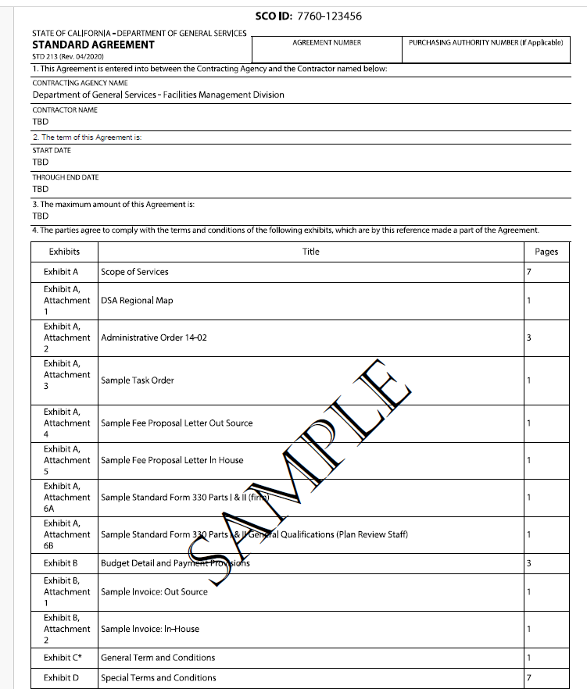

EXHIBIT A

SCOPE OF SERVICES

The State of California (State), Department of General Services (DGS), Division of the State Architect (DSA), shall contract with sufficient numbers of qualified plan review Firms for assistance in performing the plan review required under the Field Act. (Education Code §§ 17305, 81135.)

- SUMMARY

    - The Contractor shall provide structural plan review services as requested by DSA in the (insert Region) to be used on an as-needed basis. See Exhibit A, Attachment 1, DSA Regional Map.

    - The region is defined as:
[Applicable region will be included while the others will be deleted].

Oakland: Alameda, Contra Costa, Del Norte, Humboldt, Lake, Marin, Mendocino, Monterey, Napa, San Benito, San Francisco, San Mateo, Santa Clara, Santa Cruz, and Sonoma

Sacramento: Alpine, Amador, Butte, Calaveras, Colusa, El Dorado, Fresno, Glenn, Kings, Lassen, Madera, Mariposa, Merced, Modoc, Placer, Plumas, Nevada, Sacramento, San Joaquin, Shasta, Sierra, Siskiyou, Solano, Stanislaus, Sutter, Tehama, Trinity, Tulare, Tuolumne, Yolo, and Yuba

Los Angeles: Inyo, Kern, Los Angeles, Mono, Santa Barbara, San Luis Obispo, and Ventura

San Diego: Imperial, Orange, Riverside, San Bernardino, and San Diego

- The services will include the review of plans and specifications including back check, review of construction change documents, addendums, deferred approvals, alternate designs, revisions, and over-the-counter review for California K-12 public schools and community colleges pursuant to Education Code sections 17280 et seq. and 81130 et seq.; and California Code of Regulations Title 24.

- DSA does not guarantee that the Contractor will be authorized to perform any amount of work or that any dollar amount of the contract will be expended. DSA is not obligated to issue work to the Contractor, and the Contractor is not entitled to any payment for work not authorized by DSA.

- All work must be performed under the supervision of, and approved by, the Firm’s Principal in Charge, licensed in the State of California in accordance with the California Business and Professions Codes, Division 3 (hereafter Principal in Charge). The Principal in Charge for this contract is listed in Exhibit A, Section 2.

2. CONTRACT ADMINISTRATORS

- The Contract Administrators during the term of this Agreement will be:

Representatives | DSA Contract Administrator | Contractor’s Contract Administrator
Name and Title: | To Be Entered | To Be Determined  Principal in Charge
Work Address:
City, State, Zip:
Work Phone Number:
E-mail Address:
Email Address for Invoices:

- The State reserves the right to identify a DGS Designated Representative in the absence of the DGS Contract Administrator.
- Any changes in Contractor’s Contract Administrator must be immediately reported in writing to the DSA Contract Administrator.
- Any notice by either party shall be given in writing either by personal service, electronic mail, overnight delivery service, or by depositing it in a United States mail deposit box with the postage thereon fully prepaid and addressed to State at the address identified in Exhibit A, Section 2.A in this Agreement, or addressed to any other place or places State or Contractor may by written notice give to the other.

3. STANDARD CONDITIONS OF SERVICE

      - Contractor is expected to act in a professional and courteous manner at all times.
      - Contractor must meet DSA work schedules and deadlines.
      - Contractor agrees to comply with DGS Policy in using State IT Resources. See current policy Exhibit A, Attachment 2, Administrative Order 10-04.
      - Any addition or replacement of staff must meet or exceed the skill level, knowledge, and experience that the Contractor proposed in their Statement of Qualifications (SOQ). In order to add or change a Principal in Charge or Plan Reviewer, the Contractor must submit a letter of request to the DSA Contract Administrator identifying the names of the new and replaced Principal in Charge or Plan Reviewer, description of the new Principal in Charge or Plan Reviewer’s skills, knowledge, experience, education, and license status; and include the Contract number. A completed Standard Form 330 (SF-330) must be included with the letter of request. If Contractor is requesting to replace the Principal in Charge or Plan Reviewer, the proposed Principal in Charge or Plan Reviewer will be required to complete the DSA Academy courses prior to being approved. (See Exhibit A, Section 8) The letter of request and SF-330 will be forwarded to the DSA Contract Administrator. DSA will review and issue a written approval or denial to the Contractor within two (2) weeks after receipt of a correctly completed letter of request and SF-330. See Exhibit A, Attachment 6A and 6B.
      - DSA performs review through electronic-plan (e-plan) review of electronic drawings and specifications. DSA will require the Contractor to provide electronic plan review. Electronic-plan review is a process by which electronic drawings and specifications can be reviewed and marked using computer tools such as a PDF editor (Bluebeam).
      - Contractor may be required to perform in-person where the Contractor will be required to meet with the project design professionals at the applicable DSA Regional Office where the plans will be reviewed electronically by both parties. Travel expenses are not reimbursable and will be considered as part of the Contractor’s fee for the work assignment (Task Order).
      - DSA uses digital signatures for Task Order documents. DSA utilizes an Electronic Contract Process that will require Contractors to use digital signatures to receive and return Task Order documents.

- TASK ORDERS

- Task Orders must be utilized to authorize work under this Agreement so long as (i) the Task Order does not exceed the general scope of work set forth in this Agreement, and (ii) the Task Order is not intended to amend any terms of this Agreement.
- Task Orders shall only be issued during the first thirty-six (36) months of the term of this Agreement as defined in Section 2 of the STD 213. The first thirty-six (36) months of this Agreement shall be referred to as “Phase 1-Active Phase”. During the last twelve (12) months of the term of this Agreement as defined in Section 2 of the STD 213, only work authorized under Task Orders issued during Phase 1-Active Phase shall be completed. The last twelve (12) months of this Agreement shall be referred to as “Phase 2-Completion Phase”. At the sole discretion of the State, a Task Order may be issued during Phase 2-Completion Phase to the extent necessary to complete work authorized during Phase 1-Active Phase.

- TASK ORDER PROCESS

- DSA will initiate the Task Order process using a rotational list for each DSA Regional Office in the four geographic areas.
- All firms awarded a contract will be placed on a rotational list that is created by a random drawing of Firm names. During the term of the rotational list, as specific work is identified by the DSA as being eligible for contracting, DSA shall contact a Firm on the list, on a rotational basis.
- The Firm must have sufficient staff and be available to perform the work. If the contacted Firm does not have sufficient staff or is not available, DSA shall continue to contact Firms on the list, on a rotational basis, until an available Firm is identified.
- DSA will contact the Principal in Charge of the identified Firm to request a fee proposal for a specific work assignment (see samples of fee proposals, Exhibit A - Attachments 4 and 5.) Small projects may be “bundled” together for one Task Order assignment.
- DSA will negotiate with the identified Firm, including a price and timeframe that the DSA determines is fair and reasonable. If the identified Firm is unable to negotiate a satisfactory contract with the DSA, DSA will terminate negotiations, and shall undertake new negotiations, on a rotational basis, with the next Firm available for performance from the list until a successful negotiation is achieved.
- If DSA is unable to negotiate a satisfactory contract with a Firm on two separate occasions, the Firm may be removed from the rotational list.
- Task Orders are issued as follows:
- Work pursuant to this Agreement shall be authorized utilizing Task Orders. See sample Task Order in Exhibit A, Attachment 3.
- After work to be performed under this Agreement is identified, a Task Order will be prepared. The Task Order will identify the scope of services, project deliverables, budget and project schedule. The Task Order shall designate a DSA Project Manager or Regional Manager.
- Task Orders shall be negotiated for a fixed amount identified in this Agreement.
- Contractor shall not commence work pursuant to a Task Order prior to the start date identified by the State.
- Contractor shall not be entitled to payment for any work performed pursuant to a Task Order prior to the start date identified or after the expiration of this Agreement.
- Work authorized pursuant to a Task Order shall be completed in accordance with the schedule identified in the Task Order. In no event shall work be authorized to extend beyond the contract term expiration date identified in Section 2 of the STD 213.
- The total amount payable by DSA for work authorized pursuant to a Task Order shall not exceed the amount agreed to in the contract.
- Each Task Order shall specify the name of the State’s representative for that Task Order.
- Each Task Order shall specify the name of the Contractor’s Principal in Charge.
- Once a Task Order is executed, Contractor’s Task Order Representative is not authorized by the State to make any commitments or changes which will affect the price, terms or conditions of this Agreement absent an amendment.
- Each Task Order shall clearly identify the scope of work, project name, DSA application number, DSA regional office and regional manager, negotiated dollar amount, plan review return date, and back check date.
- Contractors shall promptly process and return the Task Order to DSA within three (3) business days.

- STANDARD CONDITIONS OF WORK

- All work must be performed under the supervision of, and approved by, the Principal in Charge. The Principal in Charge is responsible for negotiating and submitting proposals to DSA in a timely manner. The Principal in Charge must return the signed Task Orders to DSA.
B. All work performed must comply with all applicable statutes and regulations. All plan reviews and associated work shall meet DSA policy, procedures, guidelines, and quality control standards.
C. All work must be completed during the contract term. Under no circumstance shall the Contractor perform work after the contract term has ended.
D. All work product including all information, materials and documents developed in the performance of this Agreement are the sole property of the State. If the Contractor performs the work required under this Agreement with the assistance of a (CAD) Technology, the Contractor shall deliver to the State, on request, the disk(s) that contains the files and shall specify disk format and the supplier of the software and hardware necessary to use the files.
- DESCRIPTION OF WORK

- At the request of DSA, the Principal in Charge will negotiate the cost of a plan review project. The Principal in Charge will review the plans and specifications and provide DSA with a fee proposal (see the sample fee proposal in Exhibit A, Attachment 4, out-sourced plan review). If the fee proposal is acceptable to DSA, the Contractor will be issued a Task Order for the specific project.
  - At DSA’s discretion, the final back check review process shall be performed at the designated DSA Regional Office and will be completed by the same individuals who performed the initial plan review. Virtual (not in-person) back check review will be allowed during initial phase of the back check at DSA’s concurrence. Compensation will not be provided for travel time or travel related expenses. All work shall be completed by the due dates specified in the Task Order.
- At DSA’s request, the Principal in Charge will negotiate the cost of performing In-House plan review services. In-House plan review services may include a variety of small projects, construction change documents, addendums, deferred approvals, alternate designs, revisions, and over-the-counter review. The Principal in Charge will review the proposed work and provide DSA with a fee proposal (see the sample fee proposal in Exhibit A, Attachment 5, in-house plan review).
- At DSA’s request, the Contractor will provide plan review services under the Collaborative Process which engages DSA early in the design phase of the project. Contractor will attend preliminary meetings with the design team and DSA at the DSA Regional Office, complete post-meeting desk reviews, and provide communications with DSA and the design team.
- At DSA’s request, the Principal in Charge will provide two separate fee proposals for Phase 1-Collaborative Meetings and Desk Reviews and Phase 2-Plan Review and Back Check. If the fee proposals are acceptable to DSA, the Contractor will be issued two contract Task Orders. The first Task Order will be executed prior to the preliminary meetings and the second Task Order will be executed prior to DSA intake.
- If the fee proposal is acceptable to DSA, the Contractor will be issued a Task Order for the work. If the Contractor provides In-House plan review services, they shall be provided at the designated DSA regional office. In-House plan review services may be scheduled on an “as-needed” basis by the DSA Regional Office.
- In accordance with Education Code sections 17305 and 81135, if DSA is unable to negotiate a satisfactory Task Order with the Contractor at a fee or schedule that the DSA determines to be fair and reasonable and in the State’s best interest, DSA shall terminate negotiations with the Contractor. The DSA shall then undertake negotiations with the next qualified contractor on the rotational list until a successful negotiation is achieved.
- The Principal in Charge and all Plan Reviewers assigned to a project will be required to complete a Conflict of Interest (COI) statement for each DSA application number for which they will be completing plan review services. The COI statements must be returned to DSA with the Contractor’s fee proposal. Pursuant to Education Code sections 17306 and 81136, the Contractor must be impartial in the plan review process and may not have a financial interest in the entity that is requesting the plan review (e.g., school district).

8. TRAINING

- The Principal in Charge and Plan Reviewer(s) working for the Contractor must have completed training required by the DSA prior to being awarded a Task Order. The term of the Agreement may cover plan review services for projects submitted under either the 2022 California Building Code (CBC), or the 2025 CBC. The Principal in Charge and the approved Plan Reviewer(s) will be required to have completed the following training courses before being awarded a Task Order:

- Mandatory Prerequisite:
    - Electronic Plan Review

- 2022 CBC projects:
- DSA Structural Plan Review (2013 CBC or newer), and
- 2022 DSA Code Amendments – Structural Safety

- 2025 CBC projects:
- DSA Structural Plan Review (2016 CBC or newer), and
- 2025 DSA Code Amendments – Structural Safety

- Principal in Charge and Plan Reviewers that have successfully completed the required 2025 CBC training courses will be allowed to conduct plan review services on both 2019 2022 and 2022 2025 CBC projects. Principal in Charge and approved Plan Reviewers that have successfully completed the required 2022 CBC training courses, but not the 2025 CBC training courses, will only be allowed to conduct plan review services on 2022 CBC projects. Completion of DSA Structural Plan Review - 2019 CBC or newer counts as satisfying the requirement to complete the Electronic Plan Review course.)
- The Contractor shall register for courses and pay the course fees as outlined on the DSA Academy webpage via the DSA Learning Management System (LMS). The fees, Contractor’s hours, and other costs incurred for the DSA Academy training are non-billable and will not be paid by DSA.
- If, during the contract term, Title 24 of the California Code of Regulations or DSA plan review procedures are revised, DSA will determine if new courses to reflect the revised codes and/or procedures will be required; and if so, DSA will notify Contractor of the required course and schedule.

      - CONTRACTOR'S TEAM

- Contractor has been selected to perform the work herein, in part, based upon the professional experience and demonstrated competence of the Principal in Charge and Plan Reviewers. Contractor agrees work will be performed by the individuals approved by DSA. Substitution of individuals is not allowed except with written approval of the State and submission of SF-330. See Exhibit A, Attachment 6A and 6B.
- Contractor covenants that Contractor has no existing interest and will not acquire any interest, direct or indirect, which could conflict in any manner or degree with the performance of services required under this Agreement and that no person having any such interest shall be employed by Contractor.
- Contractor, and the agents and employees of Contractor, in the performance of the agreement, shall act in an independent capacity and not as officers or employees or agents of the State of California.

      - GENERAL PROVISIONS

- Contractor agrees to provide all necessary expertise and services to professionally and diligently prosecute the work authorized by a Task Order.
B. Contractor shall:
1) Consult, as necessary, with normal and customary employees, agencies, and/or representatives of the State regarding the work of each Task Order.
2) Attend meetings with the State, other professionals employed by the State and local and regional agencies as needed and directed to perform the work.
3) Cooperate with other professionals employed by the State for other work related to a Task Order.
4) Review site surveys, available site-related literature, and previously prepared Project reports furnished to Contractor or obtained by Contractor pursuant to this Agreement and advise the State by written report or memo whether such data are sufficient for purposes of design, or whether additional data are necessary for completion of design.
5) Abide by all regulations imposed by funding sources, such as auditing requirements and payroll affidavits.
6) Provide a professional level of review of all deliverables to assure quality, technical accuracy, and the coordination of all design documents furnished by Contractor under this Agreement. Contractor shall, without additional compensation, correct or revise any errors in its designs, drawings, specifications and other services.

EXHIBIT A, ATTACHMENT 1

DSA REGIONAL MAP
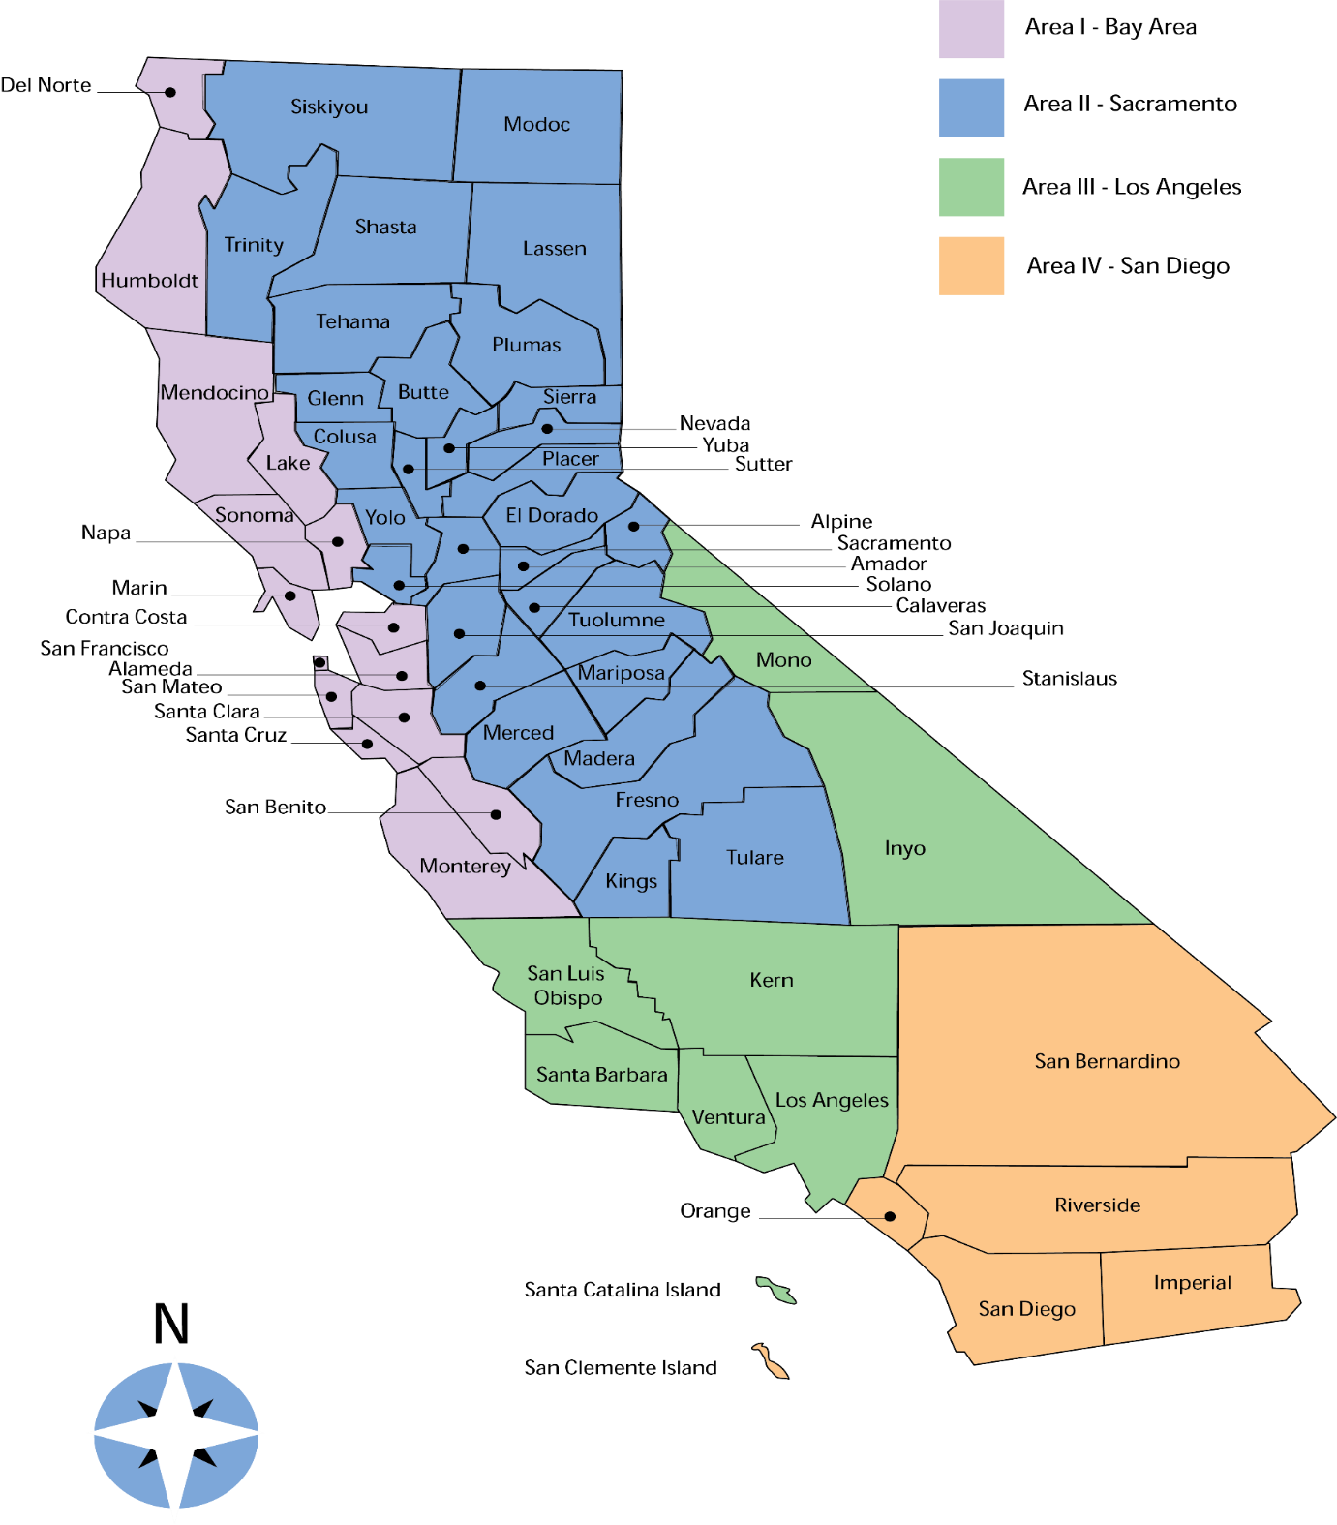

EXHIBIT A, ATTACHMENT 2

ADMINISTRATIVE ORDER 10-04

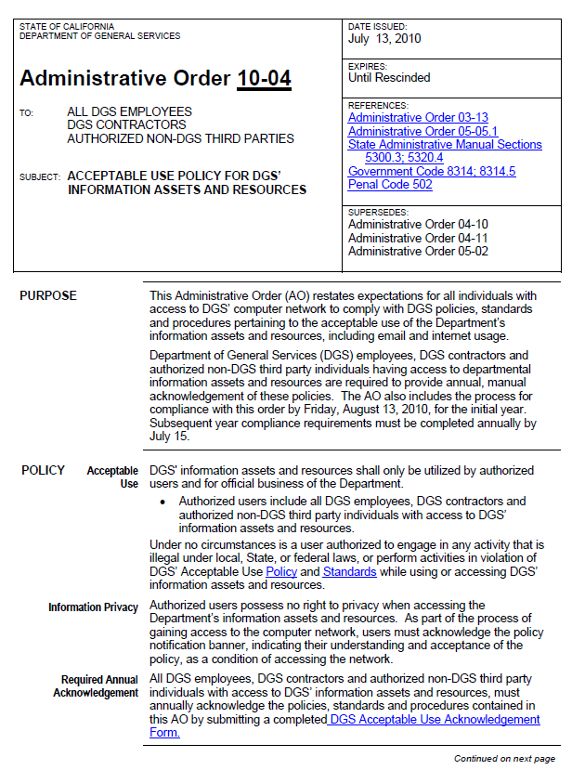
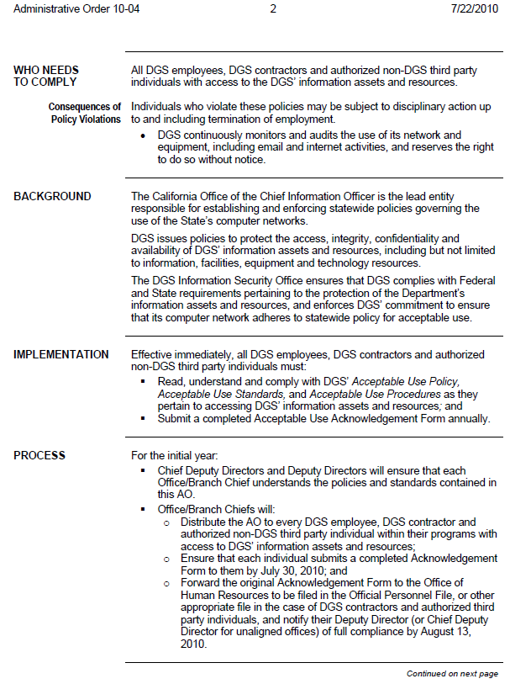

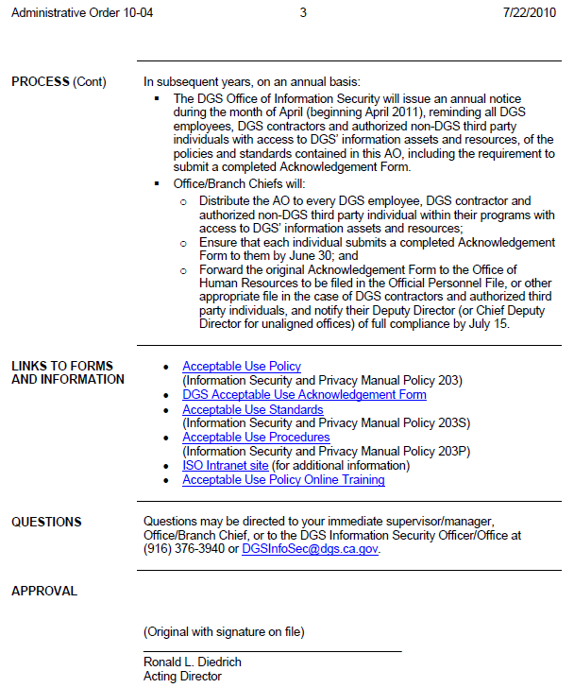

EXHIBIT A, ATTACHMENT 3

SAMPLE TASK ORDER

Pursuant to the above-referenced Agreement between the Department of General Services and CONTRACTOR, (TITLE OF RETAINER AGREEMENT) this Task Order is executed for delivery of the services described herein. All terms and conditions of the original Agreement shall remain in full force and effect.

PROJECT TITLE:
CLIENT:
REGIONAL OFFICE/REGIONAL MANAGER:
TASK ORDER AMOUNT: $
CUMULATIVE AUTHORIZATION: $
DSA PROJECT #: | DSA TASK #:
Other funding information or special instructions if applicable:

State’s Task Order Representative: Contractor’s Task Order Representative:
Department of General Services  Division of State Architect  1102 Q Street, Suite 5100  Sacramento, CA 95811  Attn: DSA Contract Administrator  Phone:  Email: | Name and Title:  Address:  City, State, Zip:  Phone:  Email:

SCOPE OF WORK: See following page(s).
CONTRACTOR’S NAME

BY (Authorized Signature) | DATE SIGNED (Do not type)
PRINTED NAME AND TITLE OF PERSON SIGNING

ADDRESS

STATE AGENCY NAME
DEPARTMENT OF GENERAL SERVICES, DIVISION OF THE STATE ARCHITECT
BY (Authorized Signature) | DATE SIGNED (Do not type)
PRINTED NAME AND TITLE OF PERSON SIGNING

ADDRESS
1102 Q Street, Suite 5100, Sacramento, CA 95811

EXHIBIT A, ATTACHMENT 4

SAMPLE FEE PROPOSAL LETTER, OUT-SOURCED PLAN REVIEW

Date

Company Name
Address
Phone
e-mail

Department of General Services
Division of the State Architect, _________ Regional Office
Attn: ________________
Regional Office Address

Project Name(s):
Application No(s):
Contract No:

Project Description:

Include the discipline of plan review (Structural, Access, or Fire & Life Safety), in accordance with the ______ (edition) California Building Code, description of project(s) (name of project, proposed structures for review, & estimated cost of construction).

Scope of Services:

List what the plan review services include, list the name of each Plan Reviewer that will be conducting the review, and the proposed initial plan review return date.

Fee Arrangement:

If there are multiple projects, please list the plan review fee for each project, and the total amount.

Sincerely,

_______________________________
Principal in Charge Signature

_______________________________
Printed Name & Title
EXHIBIT A, ATTACHMENT 5

SAMPLE FEE PROPOSAL LETTER, IN-HOUSE PLAN REVIEW

Date

Company Name
Address
Phone
e-mail

Department of General Services
Division of the State Architect, _________ Regional Office
Attn: ________________
Regional Office Address

Contract No.:

Scope of Services:

(Company Name) will provide In-House Structural plan review services including review of construction change documents, addendums, deferred approvals, alternate designs, over-the-counter reviews, and revisions for services at the _________________ Regional Office.

List the name of each Plan Reviewer that will be providing In-House services.

Fee Arrangement:

List the hourly rate per Plan Reviewer, the total number of hours, and the total amount.

Sincerely,

_______________________________
Principal in Charge Signature

_______________________________
Printed Name & Title

EXHIBIT A, ATTACHMENT 6A

SAMPLE STANDARD FORM SF330, Parts I & II (FIRM)

To be entered upon award

EXHIBIT A, ATTACHMENT 6B

SAMPLE STANDARD FORM SF330, Part II General Qualifications (Plan Review Staff)

To be entered upon award

EXHIBIT A, ATTACHMENT 7

CONFLICT OF INTEREST AFFIDAVIT

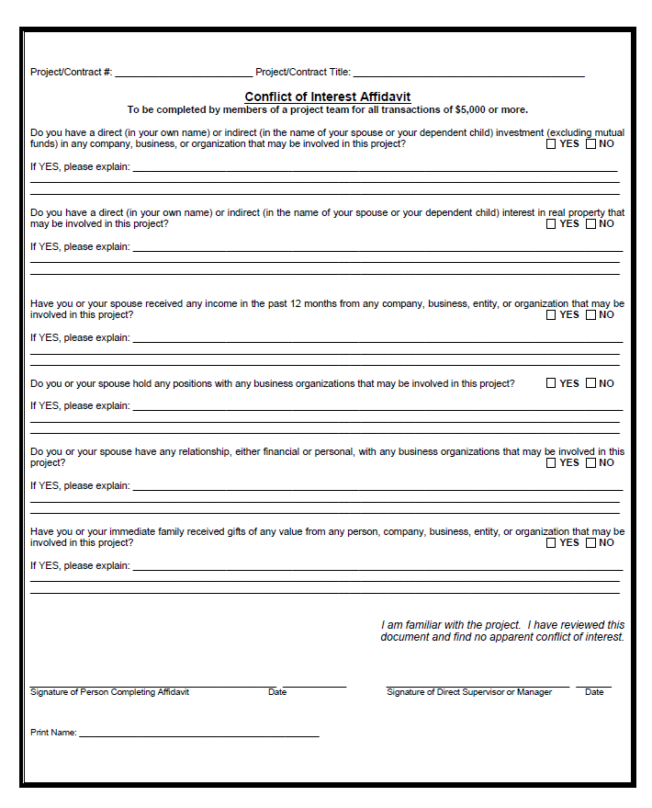

EXHIBIT B

BUDGET DETAIL AND PAYMENT PROVISIONS

- INVOICING AND PAYMENT

- For services satisfactorily rendered, and upon receipt and approval of the invoices, the State agrees to compensate the Contractor in accordance with the rates specified in the Task Order under which the services were performed.

- Reimbursement for Phase 1 services shall not exceed 85% of the Task Order Amount.

2) Reimbursement for Phase 2 services shall be paid only upon completion of the Task Order.

- Itemized invoices shall be submitted in arrears of the service performed. Invoices must be submitted with the Contractor’s letterhead information exactly matching the Contractor name on the Standard Agreement 213 and be signed by an authorized representative.

- Invoices will include:
  - Contract Number
  - Date of Invoice
  - Date of Service
  - Location of Service
  - Description of Service(s), applicable rate(s) and total dollar amount

    - Task Order Number
    - Task Order amount
    - Prior billing amount
    - Prior percentage complete
    - Current billing amount
    - Current billing percentage complete

  - Additional invoicing requirements include:

    - File numbers
    - Application numbers
    - Project names
    - Date and hours of services performed, by staff name, and discipline

  - In-House invoices shall also include the contracted hourly rate and number of hours completed, and timesheets.
  - Contractor’s California Certified Small Business Certification Reference Number or Disabled Veteran Business Enterprise Reference Number
  - Contact phone number for billing questions

- The DGS Supplier Payment Page includes detailed information on how to submit invoices to DGS and how to check the status of payments:
https://www.dgs.ca.gov/OFS/Services/Page-Content/Office-of-Fiscal-Services-Services-List-Folder/DGS-Supplier-Payment

- There are 3 options for submitting invoices to DGS as follows:
  - Through the Invoice Payment Portal (this is the preferred method of delivery)
https://dgs.service-now.com/dgs_ssp

  - By Mail
Department of General Services
Division of the State Architect, Headquarters
Attn: Fiscal Services
1102 Q Street, Suite 5100
Sacramento CA 95811

or

dsacontractprinvoices@dgs.ca.gov

  - By Email
    - For the appropriate email address, please visit the DGS Supplier Payment page above and select “How to Submit Invoices to DGS”

- Incorrect, incomplete, or improperly submitted invoices will be rejected by DSA Fiscal Services or DSA Regional Office staff. The Contractor will receive an Invoice Dispute Notice, STD 209 by e-mail or mail with the reason as to why the invoice was rejected. It is the Contractor’s responsibility to rectify the error and resubmit a revised invoice to DSA Fiscal Services. A revised invoice must include the original invoice number with an “R” at the end of the original invoice number. Failure to provide and resubmit corrected invoice will result in a delay of payment. Under no circumstances will a credit memo be accepted in lieu of a revised invoice.

- BUDGET CONTINGENCY CLAUSE

- It is mutually agreed that if the Budget Act of the current year and/or any subsequent years covered under this Agreement does not appropriate sufficient funds for the program, this Agreement shall be of no further force and effect. In this event, the State shall have no liability to pay any funds whatsoever to the Contractor or to furnish any other considerations under this Agreement and the Contractor shall not be obligated to perform any provisions of this Agreement.

- If funding for any fiscal year is reduced or deleted by the Budget Act for purposes of this program, the State shall have the option to either cancel this Agreement with no liability occurring to the State, or offer an Agreement Amendment to the Contractor to reflect the reduced amount.

- This contract is subject to any additional restrictions, limitations or conditions enacted by the Legislature that may affect the provisions, terms or funding of this contract in any manner.

- PROMPT PAYMENT CLAUSE

- Payment will be made in accordance with, and within the time specified in, Government Code Chapter 4.5, commencing with section 927.

- CONTRACTOR OVERPAYMENTS

- If the State determines that an overpayment has been made to the Contractor, the State will seek recovery immediately upon discovery of the overpayment by: (a) calling the Contractor’s accounting office to request a refund of the overpayment amount, or (b) offsetting subsequent Contractor payments by the amount of the overpayment if Contractor repayment or credit is not received within thirty (30) days from the date of notice.

- If Contractor discovers it has received an overpayment, Contractor must notify the State and refund the overpayment immediately.

EXHIBIT B, ATTACHMENT 1
SAMPLE INVOICE (Out-Sourced projects)

Date

Company Name
Phone
e-mail
Invoice No.: 2
Invoice Date: January 10, 2023
Fed ID: 12-3456789

Department of General Services
Division of the State Architect, Headquarters
Attn: Fiscal Services
1102 Q Street, Suite 5100
Sacramento, CA 95811

Project Name:
DSA Application No:
Contract No:
Task Order No:

Billing Period: [INSERT A START DATE] through [INSERT DATE]

Professional Services:

(Structural, Access, or Fire & Life Safety) plan check services performed by [Insert Name and Title]

Application No. | Fee | Prior % Complete | Prior Billing | Current % Complete | Current Billing | % Completed to Date
01-109777 | $1,000.00 | 85.00% | $ 850.00 | 15.00% | $ 150.00 | 100.00%
Total: | $1,000.00 | 0.85 | $ 850.00 | 15.00% | $ 150.00 | 100.00%

Total due this invoice: $150.00
Remit to address:

EXHIBIT B, ATTACHMENT 2
SAMPLE INVOICE (In-House projects)

Company Name
Phone
e-mail
Invoice No.: 1
Invoice Date: January 10, 2023
Fed ID: 12-3456789

Department of General Services
Division of the State Architect, Headquarters
Attn: Fiscal Services
1102 Q Street, Suite 5100
Sacramento, CA 95811

Contract No.:
Task Order No.:
Task Order Amount: $[INSERT AMOUNT]
Billing Period: [INSERT A START DATE] through [INSERT DATE]

Professional Services:

In-House (Structural, Access, or Fire & Life Safety) plan review services performed by [Insert Name(s) and Title(s)]
Hourly Rate: [Insert Dollar Amounts, i.e., $130.00, $110.00]
Total maximum hours under the Task Order: [Insert hours and rate, i.e., 30 hours at $130.00, 170 hours at $110.00]

Month | Prior % Complete | Prior Hours billed | Prior Billing | Current % Complete | Current Hours billed | Current Billing | % Completed to date | Remaining hours
2/2/2008 | 5.00% | 10 | $1,130.00
3/2/2008 | 7.00% | 14 | $1,582.00
4/2/2008 |  |  |  | 9.00% | 18.5 | $2,034.00 | 21.00%
Total: | 12.00% | 24 | $2,712.00 | 9.00% | 18.5 | $2,034.00 | 21.00% | 176

Total due this invoice: $ 2,034.00

Detailed Breakdown:
In-House review services performed on 4/2/08 and 4/8/08: 18.5 hours (Krista Jones)
Total 18.5 Hours at $110.00/hr.
Remit to address:

EXHIBIT C
GENERAL TERMS AND CONDITIONS

PLEASE NOTE: This page will not be included with the final contract. The General Terms and Conditions will be included in the contract by reference to Internet site:

https://www.dgs.ca.gov/OLS/Resources/Page-Content/Office-of-Legal-Services-Resources-List-Folder/Standard-Contract-Language

If Contractor/bidder does not have Internet access, a hard copy will be provided by contacting the Acquisitions Analyst listed on the Notice to Prospective Firms.

EXHIBIT D

SPECIAL TERMS AND CONDITIONS

- Standard Conditions of Service

  - Contractor will abide by all State and Federal laws in performance of this contract.

  - The Contractor shall maintain all license(s) required by law for accomplishing any work required with this agreement. In the event any license(s) expire at any time during the term of this agreement, Contractor agrees to provide to the State a copy of the renewed license(s) within thirty (30) days following the expiration date. In the event the Contractor fails to keep in effect at all times all required license(s), the State may, in addition to any other remedies it may have, terminate this agreement upon occurrence of such event.

  - The Contractor certifies that it has appropriate systems and controls in place to ensure that State funds will not be used in the performance of this Contract for the acquisition, operation or maintenance of computer software in violation of copyright laws.

  - If signing this contract as a sole proprietor, Contractor certifies that it is not an alien that is ineligible for state and local benefits, as defined in Subtitle B of the Personal Responsibility and Work Opportunity Act (8 U.S.C. § 1601 et seq.).

  - Pursuant to Public Contract Code section 10295.4, persons or companies identified as the largest tax delinquents by the Franchise Tax Board (FTB) or the California Department of Tax and Fee Administration (CDTFA) are ineligible to enter into any contract with the state for non-IT goods or services. Any contract entered into in violation of section 10295.4 is void and unenforceable.

  - If contract activities include collection of organic waste, the Contractor must be aware and adhere to Public Resources Code § 42649.1 et. seq. concerning organic waste recycling requirements. Organic waste includes: food waste, green waste, landscape and pruning waste, nonhazardous wood waste, and food-soiled paper waste that is mixed in with food waste.

  - If applicable, The Contractor's, and any subcontractor's, own data center or cloud computing, where data may be stored, must be physically located in the continental United States or Hawaii. Remote access to data from outside the continental United States or Hawaii is prohibited.

- EXCISE TAX: The State of California is exempt from Federal Excise Taxes, and no payment will be made for any taxes levied on employees' wages. The State will pay for any applicable State of California or local sales or use taxes on the services rendered or equipment or parts supplied pursuant to this agreement. California may pay any applicable sales or use tax imposed by another state.

- RIGHT TO TERMINATE

  - The State reserves the right to cancel all or a portion of the service for any reason, subject to thirty (30) days written notice to the Contractor.

  - This agreement can be immediately terminated for cause. The term “for cause” means that the Contractor fails to meet the terms, conditions, and/or responsibilities of the contract. In this instance, the contract termination shall be effective as of the date indicated on the State’s notification to the Contractor.

- RESOLUTION OF CONTRACT DISPUTES

  - In the event of a dispute, Contractor will attempt resolution with the DSA Contract Administrator with a written explanation of the situation. If no resolution is found, Contractor shall file a “Notice of Dispute” with the Department of General Services within ten (10) days of the failed resolution at the following address:

Attn: Division of the State Architect
Department of General Services,
1102 Q Street, Suite 5100
Sacramento, CA 95811

  - DSA State Architect or designee shall meet with the Contractor for purposes of resolving the dispute. The decision of the DSA State Architect or the designee shall be final. In the event of a dispute, the language contained within this agreement and its attendant Exhibits shall prevail over any other language.

  - Neither the pendency of a dispute nor its consideration by the DSA State Architect will excuse the Contractor from full and timely performance in accordance with the terms of the Agreement.

- HEALTH AND SAFETY PROVISIONS

  - Contractor shall abide by all health and safety mandates issued by federal, state, and local governments and/or public health officers as well as those issued by DGS, and worksite specific mandates. If multiple mandates exist, the Contractor and subcontractors shall abide by the most restrictive mandate. The term “employee”, “worker”, “state worker” or “state employee” in health and safety mandates includes contractor personnel.

  - Costs associated with adhering to health and safety mandates are the responsibility of the Contractor. Contractor is responsible for the tracking and compliance of health and safety mandates and may be audited upon request.

- SUBCONTRACTORS

  - Subcontracting is not allowed on this contract.
- INSURANCE REQUIREMENT

  - General Provisions Applying to All Policies
    - Coverage Term – Coverage needs to be in force for the complete term of the contract. If insurance expires during the term of the contract, a new certificate must be received by the State at least thirty (30) days prior to the expiration of this insurance. Any new insurance must still comply to the original terms of the contract.
    - Policy Cancellation or Termination & Notice of Non-Renewal – Contractor is responsible to notify the State within 5 business days of any cancellation, non-renewal or material change that affects required insurance coverage. In the event Contractor fails to keep in effect at all times the specified insurance coverage, the State may, in addition to any other remedies it may have, terminate this Contract upon the occurrence of such event, subject to the provisions of this Contract.
    - Deductible – Contractor is responsible for any deductible or self-insured retention contained within their insurance program.
    - Primary Clause – Any required insurance contained in this contract shall be primary, and not excess or contributory, to any other insurance carried by the State.
    - Insurance Carrier Required Rating – All insurance companies must carry a rating acceptable to the Office of Risk and Insurance Management. If the Contractor is self-insured for a portion or all of its insurance, review of financial information including a letter of credit may be required.
    - Endorsements – Any required endorsements requested by the State must be physically attached to all requested certificates of insurance and not substituted by referring to such coverage on the certificate of insurance.
    - Inadequate Insurance – Inadequate or lack of insurance does not negate the Contractor’s obligations under the contract.

  - Commercial General Liability – Contractor and any subcontractors shall maintain general liability on an occurrence form with limits not less than $1,000,000 per occurrence for bodily injury and property damage liability combined. If Commercial General Liability insurance or other form with a general aggregate limit is used, either the general aggregate limits shall apply separately to this project/location, or the general aggregate limit shall be twice the required occurrence limit. If the aggregate applies “per project/location” it shall so state on the certificate. The policy shall include coverage for liabilities arising out of premises, operations, independent contractors, products, completed operations, personal & advertising injury, and liability assumed under an insured contract. This insurance shall apply separately to each insured against whom claim is made or suit is brought subject to the Contractor’s limit of liability. The policy must be endorsed to include the State of California, its officers, agents and employees as additional insured, but only with respect to work performed under the contract. The additional insured endorsement shall be provided with the certificate of insurance.

  - Automobile Liability – Contractor shall maintain motor vehicle liability with limits not less than $1,000,000 combined single limit per accident. Such insurance shall cover liability arising out of a motor vehicle including owned, hired and non-owned motor vehicles. The policy must be endorsed to include the State of California, its officers, agents and employees as additional insured, but only with respect to work performed under the contract. The additional insured endorsement shall be provided with the certificate of insurance.

  - Workers Compensation and Employers Liability – Contractor shall maintain statutory worker’s compensation and employer’s liability coverage for all its employees who will be engaged in the performance of the Contract. Employer’s liability limits of $1,000,000 are required. The Workers’ Compensation policy shall be endorsed with a waiver of subrogation in favor of the State.

  - Errors and Omissions/Professional Liability- Contractor shall maintain Errors and Omissions/Profession liability with limits of not less than $1,000,000 each incident and $2,000,000 aggregate covering damages caused by negligent, acts or omissions. The policy retro date must be shown on a certificate of insurance and must be before the Contract date, or before the date contract work begins. Insurance must be maintained, and evidence of insurance must be provided for at least five (5) years after completion of the contract of work. If coverage is canceled or non-renewed, and not replaced with another claims-made policy form with a retroactive date prior to the contract effective date, the Contractor must purchase “extended reporting” coverage for a minimum of five (5) years after the completion of work.

- EVALUATION:

  - Pursuant to PCC § 10367, the Contractor is hereby advised that they will be evaluated based on their performance, which includes, but is not limited to, work product, adherence to timelines and deadlines, staffing, timely processing of contract documents (i.e., task orders, amendments), accepting of work, and the level of success in meeting all other contractual agreements.
  - Pursuant to PCC § 10369, within 60 days of the completion of the contract, a Contract/Contractor Evaluation, form STD 4, must be prepared and DSA shall document the performance of the Contractor in doing the work or in delivering the services for which the contract was awarded. The evaluations shall remain on file with DSA for a period of 36 months.
  - If the Contractor did not satisfactorily perform the work or service specified in the contract, DSA shall place one copy of the unsatisfactory evaluation form in a separate DSA contract file and send one copy of the form to DGS/OLS within five (5) working days of completion of the evaluation.
  - Upon filing an unsatisfactory evaluation with DGS/OLS, DSA shall notify and send a copy of the evaluation to the Contractor within 15 days. The Contractor shall have 30 days to submit a written response to the evaluation to the DSA Contract Administrator. The Contractor’s response shall be filed with the evaluation in DSA’s separate contract file and in DGS/OLS’s files. Pursuant to PCC § 10370, the evaluations and Contractor responses on file with DSA and DGS/OLS are not public records and should be maintained in a separate file.

- RUSSIAN SANCTION ORDERS: On March 4, 2022, Governor Gavin Newsom issued Executive Order (EO) N-6-22 regarding Economic Sanctions against Russia and Russian entities and individuals. “Economic Sanctions” refers to sanctions imposed by the U.S. government in response to Russia’s actions in Ukraine, as well as any sanctions imposed under state law. The EO directs state agencies to terminate contracts with, and to refrain from entering any new contracts with, individuals or entities that are determined to be a target of Economic Sanctions. Accordingly, should the State determine Contractor is a target of Economic Sanctions or is conducting prohibited transactions with sanctioned individuals or entities, that shall be grounds for termination of this agreement. The State shall provide Contractor advance written notice of such termination, allowing Contractor at least 30 calendar days to provide a written response. Termination shall be at the sole discretion of the State.

- NEWS RELEASES: News releases pertaining to award of, or work performed as a result of, contract may not be made without prior written approval of:

The Public Information Officer
707 Third Street, MS 101
West Sacramento, CA 95605
Phone: (916) 376-5037
Email: DGSPublicAffairs@dgs.ca.gov

- WAIVER OF RIGHTS: Any action or inaction by the State or the failure of the State on any occasion, to enforce any right or provision of the Contract, shall not be construed to be a waiver by the State of its rights hereunder and shall not prevent the State from enforcing such provision or right on any future occasion. The rights and remedies of the State herein are cumulative and are in addition to any other rights or remedies that the State may have at law or in equity.

- CONFIDENTIALITY STATEMENT: All financial, statistical, personal, technical and other data and information relating to the State’s operations which are designated confidential by the State and made available to the Contractor in order to carry out this Agreement, or which become available to the Contractor in carrying out this Agreement, shall be protected by the Contractor from unauthorized use and disclosure.

