State of California • Natural Resources Agency Gavin Newsom, Governor

DEPARTMENT OF PARKS AND RECREATION Armando Quintero, Director

SIERRA DISTRICT ADMINISTRATION
PO BOX 266, TAHOMA CA 96142

ADDENDUM #2
Issued: June 24, 2026

Sierra District – Alpine-Mono Sector

Mono Lake ADA Boardwalk Materials
Purchase # S25683109

Bid Date: June 30, 2026, at 2:00 PM PT
Revised Bid Due Date: July 1, 2026 at 2:00 PM PT

The changes in this addendum shall be included in this procurement, and this addendum shall be part of the procurement documents. All conditions not affected by this addendum remain unchanged.

The solicitation package has been updated to include answers to questions received from the initial posting date through 2:00PM PST, Wednesday, June 24th, 2026.

All conditions not affected by this addendum remain unchanged.

ADDENDUM #2
Issued: June 24, 2026

Sierra District – Alpine-Mono Sector

Mono Lake ADA Boardwalk Materials
Purchase # S25683109

Bid Date: June 30, 2026, at 2:00 PM PT
Revised Bid Due Date: July 1, 2026 at 2:00 PM PT

Question and Answers:

- Are you requesting a quote specifically for the materials to be delivered to Mono Lake for the boardwalk project?
  - CA State Parks is requesting bids on the boardwalk materials, inclusive of delivery, to Mono Lake SNR. Installation of the materials is not part of this solicitation.

- Please provide the final delivery address for the materials.
  - Mono Lake Tufa State Natural Reserve
US-395
Lee Vining, CA
93541

- To ensure we can accurately meet all required specifications, please provide a sample photo, drawing, or blueprint for this project.
  - At this time, we do not have exact specifications for the boardwalk. We have included an example photograph from an unrelated boardwalk on Parks property to provide a reference to the materials we are seeking from the awarded bidder.
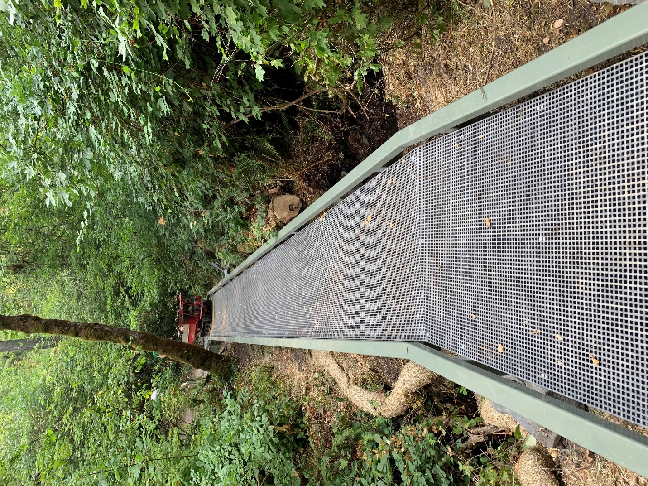

- Regarding Attachment 2 – Technical Requirements/Statement of Work (page 2), Could you clarify what information should be entered in the blank columns and whether the numbers next to the “LENGTH” column represent the quantity for each item?
  - The blank column is for multiplying the Quantity column, if needed.
  - Yes, the Quantity column states the amount of each individual item needed.
  - An Excel version of Attachment 2 – Technical Requirements/Statement of Work, Page 2 is included with Addendum #2

- Please confirm whether items listed with a quantity of zero should be excluded from the scope or still considered for pricing or reference.
  - Items listed with a quantity of zero are excluded from this scope.

- Could you confirm the dimensions/specifications of the decking clips to ensure compatibility with the FRP mesh decking and supporting frame?
  - CA State Parks does not have exact dimensions/specifications for the decking clips. The clips must attach the mini-mesh decking securely and safely to the joist.

- Is dark grey or another color acceptable for the FRP Mini Mesh Decking (48" x 72" x 1.5", 185 panels), or is the specified color RAL 080-30-26 strictly required?
  - The color Smoked Oak, RAL 080-30-26, is required.

END OF QUESTION AND ANSWER

The rest of this page left blank intentionally.

