DEPARTMENT OF CALIFORNIA HIGHWAY PATROL

June 23, 2026 Page 1 of 1

ADDENDUM NUMBER 1

TO

IFB - NUMBER 26C650001
CALIFORNIA HIGHWAY PATROL
Addendum #1 revises the IFB, Time Schedule, Item B, Page 1 as follows:

- IFB, Time Schedule, Item B, Page 1:

From:
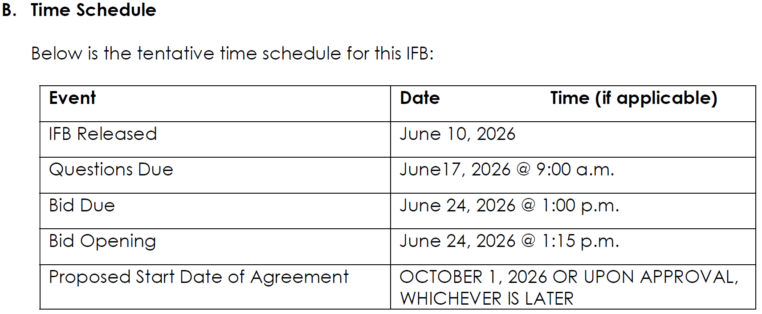
To:
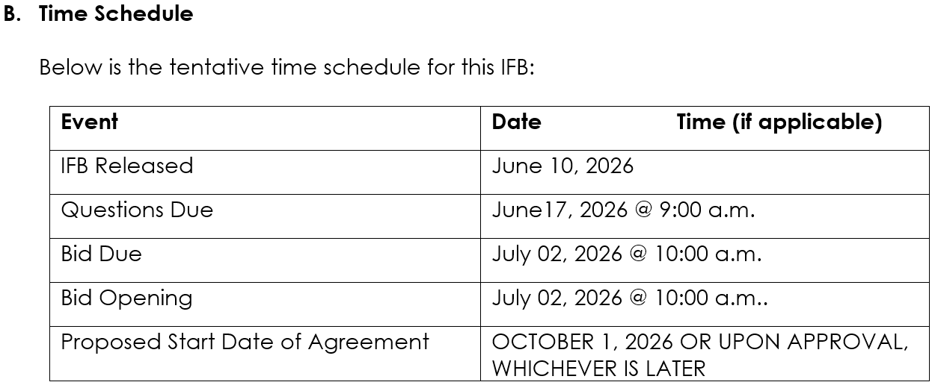
A COPY OF THIS ADDENDUM IS NOT REQUIRED TO BE SUBMITTED WITH YOUR SUBMISSION. If you have any questions, contact Zeanna Merilice, Contract Services Unit, at (916) 843-3610.

