INVITATION FOR BID
Notice to Prospective Bidders
IFB – Underground Storage Tank Services
CR-25-279264

June 18, 2026

You are invited to review and respond to this Invitation for Bid (IFB) for Underground Storage Tank Services being offered by the Department of General Services, Facilities Management Division (FMD).

Note that all agreements entered into with the State of California will include by reference General Terms and Conditions (GTC 02/2025) and Contractor Certification Clauses (CCC 4/2017) that may be viewed and downloaded at the following internet site: https://www.dgs.ca.gov/OLS/Resources/Page-Content/Office-of-Legal-Services-Resources-List-Folder/Standard-Contract-Language. If you do not have Internet access, a hard copy can be provided by contacting the Acquisition Analyst listed below.

Bidders are encouraged to carefully read the entire solicitation. The need to verify all documentation and responses prior to the submission of bids is the responsibility of the bidder and cannot be overemphasized. Please ensure insurance requirements and, if applicable, prevailing wages are considered in your bid amount. Should prevailing wage be required, February 2026 rates will apply. Note: Bidder (and any listed subcontractor) must be registered with the Department of Industrial Relations (DIR), if required by law to do so.

In the opinion of the Office of Business and Acquisition Services (OBAS), this IFB is complete and without need of explanation. However, if you have questions regarding this IFB please contact the below listed Acquisition Analyst. Please note that verbal information given will not be binding on the State unless such information is issued in writing as an official addendum to this IFB.

Erica Alvarez, Acquisition Analyst
Office of Business and Acquisition Services
Contract Services Section
(279) 239-6176
Erica.Alvarez@dgs.ca.gov

Table of Contents
A. Purpose and Description of Services 3
B. Bidder Minimum Requirements 5
1) Licenses: 5
2) Insurance: 5
3) References: 5
4) Disabled Veterans Business Enterprise (DVBE) Participation: 5
C. Bid Requirements and Information 6
1) Key Action Dates: 6
2) Non-Mandatory Walk-Through: 6
3) Written Questions: 7
4) Submission of Bid: 7
5) Rejection of Bid Submissions: 9
6) Errors in the Bid Submission: 9
7) Evaluation and Selection: 10
8) Award and Protest: 13
9) Disposition of Bids: 14
10) Performance of Service: 14
D. Preference and Incentive Programs 15
1) Small Business Preference: 15
2) Disabled Veteran Business Enterprise Requirement and Incentive: 17
3) Applying Preference and Incentives: 19
IFB ATTACHMENTS 21
ATTACHMENT 1 - BID SUBMISSION ATTACHMENT CHECKLIST 21
ATTACHMENT 2 - BID/BIDDER CERTIFICATION SHEET 22
ATTACHMENT 3 - BIDDER DECLARATION 24
ATTACHMENT 4 - PAYEE DATA RECORD 25
ATTACHMENT 5 - BIDDER REFERENCES 26
ATTACHMENT 6 - DARFUR CONTRACTING ACT 27
ATTACHMENT 6A - CALIFORNIA CIVIL RIGHTS LAWS ATTACHMENT 29
ATTACHMENT 7 - PROOF OF INSURANCE 30
ATTACHMENT 8 - COST SHEET 31
ATTACHMENT 9 - SAMPLE AGREEMENT 64

A. Purpose and Description of Services

- The State of California (State), Department of General Services (DGS), Facilities Management Division (FMD) manages, maintains and operates state buildings and grounds statewide, pursuant to Government Code Section 14685 (a), which authorizes DGS to establish rules and regulations for the government and maintenance of state buildings and grounds. FMD is procuring services for aboveground and underground storage tank maintenance and repairs on state property.

- The Bidder shall provide all labor, equipment, and materials required to provide services for underground storage tanks (UST) and aboveground storage tanks (AST) for the equipment identified in Attachment 9, Sample Agreement, Exhibit A, Attachment 1, Equipment List.

- The services will be performed at the following locations:

State Building Locations
Energy Commission Building (008) 1516 9th Street  Sacramento, CA 95814 | Twin Towers (039 & 045)  744 P Street  Sacramento, CA 95814
Employment Development Department, Solar Building (013) 722 Capitol Mall  Sacramento, CA 95814 | Department of Justice (075) 4949 Broadway Street  Sacramento, CA 95814
Paul Bonderson Building (016) 901 P Street  Sacramento CA 95814 | CalEPA (Building #024)  1001 I Street  Sacramento, CA 95814
Elihu Harris State Building (602)  1515 Clay Street  Oakland, CA 94612 | Ronald M George SOC  Building (#402)  455 Golden Gate Ave.  San Francisco, CA 94102

- The anticipated term of the contract will be for five (5) years.

- The Bidder’s rates will stay in effect for the entire contract term. The Bidder will be afforded the opportunity at the non-mandatory walk-through to examine work sites and specifications and investigate conditions, character, and quality of surface, subsurface materials or obstacles and conditions that might be encountered. No additions or increases to the agreement amount will be made due to conditions that existed at the walk-through.

- The Bidder’s required services are provided in Attachment 9, Sample Agreement. The winning Bidder will be required to adhere to all Agreement terms as indicated in Attachment 9, Sample Agreement. Please note that any orange font language in the attached sample contract is for informational purpose only and will not appear in the final contract.

- This contract is subject to Prevailing Wage. Contractor and Sub-contractor(s) must be registered with DIR, if required by law to do so, in order to submit a bid.

- The Bidder must be advised of Executive Order N-6-22 Russia Sanctions. On March 4, 2022, Governor Gavin Newsom issued Executive Order (EO) N-6-22 regarding Economic Sanctions against Russia and Russian entities and individuals. “Economic Sanctions” refers to sanctions imposed by the U.S. government in response to Russia’s actions in Ukraine, as well as any sanctions imposed under state law. By submitting a bid, Bidder represents that it is not a target of Economic Sanctions. Should the State determine Bidder is a target of Economic Sanctions or is conducting prohibited transactions with sanctioned individuals or entities, that shall be grounds for rejection of the Bidder’s bid any time prior to contract execution, or, if determined after contract execution, shall be grounds for termination by the State.

- The State of California seeks to realize the potential benefits of GenAI, through the development and deployment of GenAI tools, while balancing the risks of these new technologies.

Bidder / Offeror must notify the State in writing if it: (1) intends to provide GenAI as a deliverable to the State; or (2), intends to utilize GenAI, including GenAI from third parties, to complete all or a portion of any deliverable that materially impacts: (i) functionality of a State system, (ii) risk to the State, or (iii) Contract performance. For avoidance of doubt, the term “materially impacts” shall have the meaning set forth in State Administrative Manual (SAM) § 4986.2 Definitions for GenAI.

Failure to report GenAI to the State may result in disqualification. The State reserves the right to seek any and all relief to which it may be entitled to as a result of such non-disclosure.

Upon notification by a Bidder / Offeror of GenAI as required, the State reserves the right to incorporate GenAI Special Provisions into the final contract or reject bids/offers that present an unacceptable level of risk to the State.

Government Code 11549.64 defines “Generative Artificial Intelligence (GenAI)” as an artificial intelligence system that can generate derived synthetic content, including text, images, video, and audio that emulates the structure and characteristics of the system’s training data.

B. Bidder Minimum Requirements
NOTE: Bidders that do not meet all minimum requirements will be rejected.

Licenses:
  - A Bidder must be registered with the State of California, Secretary of State, if required by law.
  - A valid Class A-General Engineering Contractors License with a HAZ Certification attached, or a valid classification B-General Building Contractor License and a classification C-61 Limited Specialty with a subcategory D-40 Service Station Equipment and Maintenance License.

- Insurance:

A Bidder must submit current proof of insurance for the following:
  - General Liability
  - Commercial Automobile Insurance
  - Worker’s Compensation

A certificate of insurance (COI) may be provided as proof of insurance. The COI or proof of insurance documents will be named Attachment 8, Proof of Insurance, and be submitted with the bid. Endorsements to insurance policies are not required for bid submission. Endorsements to insurance policies are only required by the winning Bidder as indicated in Attachment 9, Sample Agreement.

NOTE: Contact your insurance representative to ensure your insurance program satisfies the requirements of the sample contract found in IFB Attachment 9, Exhibit D, Section 8, prior to bidding.

- References: Bidders must provide three (3) or more references. Required Attachment 5, Bidder References, must be completed and submitted with the bid submission. NOTE: References to include satisfactory job performance on operations within the last five (5) years that are similar to parking lot management services as required in this solicitation.

- Disabled Veterans Business Enterprise (DVBE) Participation: Pursuant to Public Contract Code section 10115 subdivision (c) and Military and Veterans Code (MVC) section 999.2 subdivision (a), Bidders must meet a DVBE participation goal. The required participation for this agreement is 3%. Bidder must document the required DVBE program participation on Attachment 3, Bidder Declaration (GSPD-05-105).
NOTES:
- Multiple DVBEs can be used to fulfill the requirements of this contract. Each DVBE must be listed on Attachment 3 (GSPD-05-105)
- Pursuant to MVC section 999.5, only a DVBE who performs a Commercially Useful Function (CUF) relevant to the Scope of Work included in this IFB may qualify the Bidder, or be used to qualify the Bidder, for DVBE participation.

C. Bid Requirements and Information

Key Action Dates:

Listed below are the important action dates and times by which actions must be taken or completed. If OBAS finds it necessary to change any of these dates, it will be accomplished by addendum to this IFB.

Event | Date | Time (PT)
IFB available to prospective bidders | June 18, 2026
Non-Mandatory walk-through – Department of Justice (075) | June 22, 2026 | 8:00 a.m.
Non-Mandatory walk-through - Energy Commission Building (008) | June 22, 2026 | 9:00 a.m.
Non-Mandatory walk-through - Twin Towers (039 & 045) | June 22, 2026 | 10:00 a.m.
Non-Mandatory walk-through Paul Bonderson Building (016) | June 22, 2026 | 11:00 a.m.
Non-Mandatory walk-through - Employment Development Department, Solar Building (013) | June 22, 2026 | 1:00 p.m.
Non-Mandatory walk-through - CalEPA (Building #024) | June 22, 2026 | 2:00 p.m.
Non-Mandatory walk-through - Elihu M. Harris State Building (602) - Oakland | June 23, 2026 | 10:00 a.m.
Non-Mandatory walk-through - Ronald M George SOC Building (#402) – San Francisco | June 23, 2026 | 1:00 p.m.
Written Question Submission Deadline | June 25, 2026
Questions and Answers to be Posted | July 1, 2026
Deadline for Final Bid Submission | July 7, 2026 | 2:00 p.m.
Bid Opening: May be attended In-person at address identified in Section C.7 below, or virtually via the following link)  Teams meeting link: Join Meeting  Teams meeting ID: 220 481 704 944 799  Teams Passcode: Pf6dH6y3 | July 8, 2026 | 10:30 a.m.

Non-Mandatory Walk-Through:
  - The non-mandatory walk-through for each facility is scheduled according to the Key Action Date listed above. Bidders will need to present identification and sign in at each facility.

  - Any questions arising from the non-mandatory walk-through shall be submitted in writing to the Acquisition Analyst listed on the Notice to Prospective Bidders by the Key Action Date listed above.

  - In the event a Bidder is unable to attend the non-mandatory walk-through, an authorized representative may attend on their behalf. The representative may only attend for one (1) Bidder. Subcontractors may not represent a prime contractor at the non-mandatory walk-through.

  - Persons needing assistance due to a physical impairment will be given reasonable accommodation upon request for the non-mandatory walk-through. The Bidder must call Erica Alvarez at (279) 239-6176 or email Erica.Alvarez@dgs.ca.gov no later than the fifth working day prior to the scheduled date and time of the non-mandatory walk-through to arrange for a reasonable accommodation.

Written Questions:
  - Bidders requiring clarification of the intent or content of this IFB, or on procedural matters regarding the competitive procurement process, may request clarification by submitting questions in writing. Bidders may submit questions to the Acquisition Analyst listed on the Notice to Prospective Bidders via email or via U.S. mail. If sending via U.S. mail, the envelope must be clearly marked “Questions Relating to IFB Underground Storage Tank Services” and sent to the Acquisition Analyst listed on the Notice to Prospective Bidders for this IFB. To ensure a response, questions must be received in writing by the date given for written questions in Key Action Dates (See Section C.1.). Question and Answer Sets will be provided to all Bidders and will be posted as an official Addendum.

  - Requests for Changes to the IFB – If the Bidder believes that one or more of the IFB requirements is onerous, unfair, or imposes unnecessary constraints to the Bidder in proposing less costly or alternate solutions, the Bidder may request a change to the IFB by submitting, in writing, the recommended change(s) and the facts substantiating this belief and reasons for making the recommended change. Such requests must be submitted to the Acquisition Analyst by the date specified herein for written questions concerning the IFB. Such changes will be made at the sole option of OBAS. If OBAS determines that any requested change is in the best interest of the State, all Bidders will be notified of the change in the form of an Addendum to this IFB.

  - If a Bidder discovers any ambiguity, conflict, discrepancy, omission or other error in this IFB, the Bidder will immediately notify OBAS of such error(s) in writing and request clarification or modification of the document. If a Bidder fails to notify OBAS, prior to the Deadline for Final Bid Submission, of an error known to the Bidder, or an error that reasonably should have been known, the Bidder will bid at their own risk, and if awarded the contract, will not be entitled to additional compensation or time by reason of the error or its later correction.

Submission of Bid:
- The bid submission is a mandatory step for all Bidders. Bidders are strongly encouraged to carefully read the entire solicitation prior to a submission of bid. The need to verify all documentation and responses prior to the submission of the bid cannot be overemphasized.

- Introduction letters, expensive bindings, colored displays, promotional materials, etc., should not be included in the bid submission and may cause the bid to be rejected. Emphasis should be concentrated on conformance to the IFB instructions, responsiveness to the IFB requirements and completeness and clarity of content. Developing the bid submission and attending the non-mandatory walk-throughs for each facility is entirely the responsibility of the Bidder and will not be chargeable to the State.

- The bid submission must be complete in all respects as described in this IFB. A bid submission may be rejected if it is conditional or incomplete, or if it contains any alterations of form or other irregularities of any kind. A bid submission will be rejected if any such defect or irregularity constitutes a material deviation from the IFB requirements.

- A completed bid package must consist of all items identified in the Attachment 1, Bid Submission Attachment Checklist, including Attachment 1. Documents must be submitted in the order listed in Attachment 1, Bid Submission Attachment Checklist. A bid submission not including all required attachments will be deemed non-responsive. A non-responsive bid is one that does not meet the basic bid requirements, and is considered a material deviation which is cause for rejection.

- An individual who is authorized to bind the bidding firm contractually will sign Attachment 2, Bid/Bidder Certification Sheet. The signature must indicate the title or position that the individual holds in the firm. An unsigned bid may be rejected. The “Bid/Bidder Certification Sheet” must be submitted with bid submission/package.

- Bids and related documents must be completed in ink, typewritten or electronically prepared. No erasures or “white out” are permitted. Errors may be crossed out and corrections printed in ink or typewritten adjacent to the error. The person signing Attachment 2, Bid/Bidder Certification Sheet, must initial corrections, in ink.

- All documents requiring a signature must bear an original (wet) signature of a person authorized to bind the bidding firm. The Bidder will submit one copy of all required documents with original (wet) signatures. Electronic signatures including scans of wet signatures are permissible for all proposal documents.

- The Bidder will deliver their sealed bid in such a way that the outside is clearly labeled as indicated below:

IFB Underground Storage Tank Services – CR 25-279264
DO NOT OPEN
Department of General Services, The Ziggurat
Attn: Erica Alvarez, Office of Business and Acquisition Services, Mailstop 508
707 Third Street
West Sacramento, CA 95605

- MAILED BIDS: Shall be sent to the address above.

- HAND DELIVERED BIDS: Shall be placed in the DGS/OBAS Bid/Proposal Drop Box located in the lobby at 707 3rd Street, West Sacramento, CA 95605. The Drop Box will be opened at 2:00PM Tuesday through Thursday and bids in the box will be certified as being received before 2:00PM that day.

- It is the responsibility of the Bidder to ensure timely delivery of the bid. A postmark or facsimile transmission will not be accepted as meeting the delivery time requirements. Bidders hand-delivering their bids should allow extra time for traffic, sparse parking, slow elevators and clearing security procedures.

- The bid submission implies no obligation on the part of FMD to purchase or contract for services.

Rejection of Bid Submissions:
  - A bid submission not received by the date and time specified in Section C.1. Key Action Dates, or not sealed, will be rejected.

  - Facsimile (FAX) and electronic submissions will not be considered.

  - The bid submission must not contain false or misleading statements, or provide contradictory attributes or conditions claimed by the Bidder. If, in the opinion of OBAS, such information was intended to mislead OBAS in its evaluation of the bid, and the attribute, condition, or capability is a requirement of this IFB, it will be the basis for rejection of the bid submission.

  - Deviations in the bid submission, whether or not intentional, may cause the bid submission to be non-responsive and not considered for award.

  - Any material submitted by any Bidder in the final bid submission that is marked “CONFIDENTIAL” or “PROPRIETARY” will cause the entire bid submission to be deemed non-responsive and rejected.

  - The State does not accept alternate contract language from a prospective contractor. A bid submission with such language will be considered a counter proposal and will be rejected. The State’s General Terms and Conditions (GTC) are not negotiable.

  - OBAS is not required to award a contract. OBAS reserves the right to reject any or all bids and to waive informalities and minor irregularities in bids received and to accept all or any portion of a bid, if deemed in the best interest of the State and not contrary to law. OBAS’s waiver of any immaterial deviation or defect will in no way modify the IFB documents or excuse the contractor from full compliance with the IFB specification, if awarded the contract.

Errors in the Bid Submission:
- The Bidder is cautioned to not rely on OBAS during the evaluation to discover and report to the Bidder any defects and errors in the submitted documents. The Bidder, before providing a bid submission, should carefully proof their documents for errors and adherence to the IFB requirements.

- The Bidder may modify a bid after its submission by withdrawing its original bid and resubmitting a new bid prior to the final bid submission deadline. Modifications offered in any other manner, oral or written, will not be considered.

- The Bidder may withdraw a bid by submitting a written withdrawal request to OBAS, signed by the Bidder or an authorized agent. A Bidder may thereafter submit a new bid prior to the final bid submission deadline. Bids may not be withdrawn without cause subsequent to final bid submission deadline.

- OBAS may modify the IFB prior to the key action date for submission of bids by posting an Addendum on the CSCR website, located at the following address:
https://caleprocure.ca.gov/pages/Events-BS3/event-search.aspx.

- OBAS reserves the right to reject any/all bid submissions. OBAS is not required to award an agreement.

Evaluation and Selection:
- The bid opening is open to the public and can be attended virtually as identified in Section C.1 Key Action Dates. Bidders attending the bid opening in-person will need to meet and sign in at the security guard station in the lobby at the address below. A DGS representative will meet attendees in the lobby and escort all parties to the bid opening location.

Ziggurat Building
707 Third Street
West Sacramento, CA 95605

The bid opening will consist of the opening of each bid received in a timely manner, checking the bid for the presence or absence of required signatures and checking the bid for the required attachments as identified on Attachment 1, Bid Submission Attachment Checklist. Bid submissions received after the Deadline for Final Bid Submission will not be opened. During the bid opening, OBAS will read aloud and record the Bidder’s Name and their Total Bid Amount onto a Preliminary Bid Tabulation. Bidders do not need to attend the bid opening as the Preliminary Bid Tabulation will be made available immediately after the bid opening is completed and it will be emailed to the bidders that submitted a bid.

- OBAS will appoint State employee(s) to further verify and evaluate the bid submissions as described in the IFB to identify the lowest responsive responsible bidder. The further review may also include, but is not limited to:

    - Cost Sheet calculations have been verified;
    - SB Preferences have been evaluated, confirmed and calculated;
    - DVBE Participation Requirement and Incentives have been evaluated, confirmed and calculated;
    - Darfur certification has been evaluated;
    - California Civil Rights Attachment has been evaluated;
    - Largest tax delinquents eligibility confirmed;
    - Corporate standing has been verified with State of California, Secretary of State;
    - Review of Russia Sanctions, pursuant to EO N-6-22;
    - Validation of References
    - Department of Industrial Relations (DIR) registration;
    - Commercially Useful Function (CUF) analysis; and
    - California State License Board License

- During further review, if any of the required documents are missing, the evaluation committee may reject the bid submission as non-responsive. If any of the required documents are incomplete, the evaluation committee may reject the bid submission as non-responsive. If any of the required documents have been modified or contain alterations, the evaluation committee may reject the bid submission as non-responsive.

- The documents provided by the Bidder in their bid submission enable OBAS to evaluate for responsiveness. OBAS reserves the right to ask clarifying questions during evaluation, such as for CUF; however, the answers cannot change or alter the bid submission. Should a discrepancy exist between the answer provided and the bid submission, the bid submission will be considered correct.

- The Bidder will need to complete the Cost Sheet including the calculations in the tables provided in IFB Attachment 8, Cost Sheet.

Sample of calculations for IFB Attachment 8, Cost Sheet, as follows:
Description | A | B | C
Description | Service Rate | Frequency per Year | Annual Total  Calculated Amount  (A x B)
Monthly UST Designated Operator Inspection | $100.00 | 13 | $1,300.00
Annual UST Spill Bucket Test | $500.00 | 1 | $500.00
Annual UST Monitoring System Certification | $500.00 | 1 | $500.00
ANNUAL TOTAL  (Sum of Column C) |  |  | $2,300.00
CALCULATED PREVENTIVE MAINTENANCE TOTAL  (Annual Total x 5) |  |  | $11,500.00

- If, in the further review of IFB Attachment 8, Cost Sheet, a mathematical discrepancy is found, the line amounts listed in column A, for Tables 1–3 and 5–6, and in Columns A, B, and D for Table 4, will be considered correct and the discrepancy will be adjusted accordingly.

If a field within the Cost sheet is left blank, it will be construed as a bid of $0.00.

If a field within the Cost Sheet is marked with anything other than a number (i.e. N/A) the bid may be deemed nonresponsive.

- The Total Bid Amount identified in the cost sheet summary will become the Net Bid Amount. The Net Bid Amount will be used to determine the lowest responsive responsible bidder to apply preference and incentives, as applicable, in a Final Bid Tabulation.

Sample Final Bid Tabulation on next page:

Bidder | A | B | C | D
Responsive & Responsible?
Small Business
NET BID AMOUNT
Initial Ranking
SB Preference Amount
Subtotal - 1
Ranking after SB Preferences
NSB Preference Amount
(Applied only if Rank 1 bidder is not an SB after application of SB Preference)
Subtotal - 2
Ranking after NSB Preference
DVBE Incentive %
(Applied only to SBs if Rank 1 bidder is an SB after application of SB Preference)
DVBE Incentive Amount
Subtotal - 3
Ranking after DVBE Incentive
Evaluated Bid Total

- OBAS will determine the validity of references, DIR registration, and signatory authority of winning bidder prior to awarding contract or posting Notice of Intent to Award. OBAS’s determination of a bid being responsive and responsible will be final.

- Nothing in this section will require the awarding of the contract if no bids are received offering a contract price that, in the opinion of FMD, is a reasonable price.

Award and Protest:
  - Contract award, if made, will be awarded to the Bidder whose bid has the lowest responsive responsible submission.
    - In the event of a tie, representatives of the State will flip a coin to determine the winning bidder. The coin flip will be witnessed and documented by two (2) or more State employees.

  - A Notice of Intent (NOI) to Award will be posted on the Department of General Services Office of Business and Acquisition Services webpage five (5) working days before the award of the contract, if required by law. NOIs will be posted on the Award Notifications Resource page at the following link: https://www.dgs.ca.gov/OBAS/Resources/Page-Content/OBAS-Resources-List-Folder/Award-Notifications.

  - If a Bidder, prior to the award of agreement, files a notice of protest with DGS/OLS, specifying the grounds that the Protestant was the lowest priced responsible Bidder, then the agreement will not be awarded until either the protest has been withdrawn or DGS/OLS has decided the matter.

Within five (5) days after filing the notice of protest, the Protestant will file with DGS a full and complete detailed written statement specifying the grounds for the protest. The notice of protest and the full and complete detailed written statement must be sent to:

Department of General Services, Office of Legal Services (OLS),
Attention: Bid Protest Coordinator;
707 Third Street, 7th Floor, Suite 7-330;
West Sacramento, CA 95605;
Email Address: OLSProtests@dgs.ca.gov.

OLS will accept protests via mail, email or hand delivery; although, the preference is via email.

  - News releases pertaining to any award resulting from this IFB may not be made without prior written approval of:

The Public Information Officer
707 Third Street, MS 101
West Sacramento, CA 95605
Phone: (916) 376-5037
Email: DGSPublicAffairs@dgs.ca.gov

Disposition of Bids:
  - Upon bid opening, all documents submitted in response to this IFB will become the property of the State of California, and will be regarded as public records under the California Public Records Act (Gov Code § 6250 et seq.) and subject to review by the public.

  - Upon cancellation of the solicitation, the OBAS Acquisition Analyst will offer to return the bid at Bidder’s expense. A Bidder may request that OBAS destroy the bid, rather than pay for its return.

Performance of Service:
  - Upon award of contract, the winning Bidder must provide a COI within ten (10) working days from award of contract. This COI will identify the required insurance as indicated in Attachment 9, Sample Agreement, Exhibit D, Item 8, Insurance Requirement and will provide the required insurance endorsements as indicated in Attachment 9, Sample Agreement, in Exhibit D, Item 8, Insurance.

  - Upon award of the contract, the winning Bidder agrees to sign the contract on the State’s Standard Agreement (STD 213), with Exhibits. The STD 213 (See sample contract agreement provided in Attachment 9) must be signed by an individual authorized to bind the firm contractually.

  - Upon award of the contract, the winning Bidder will need to submit a signed certification page of the Contractor’s Certification Clauses (CCC 04/2017). If you do not have Internet access, a hard copy can be provided by contacting the Acquisitions Analyst listed on the Notice to Prospective Bidders of the IFB. Otherwise, the Contractor’s Certification Clauses are available on the OLS Standard Contract Language for Non-It Services web page.

  - Upon award of the contract, the winning bidder must provide a Payee Data Record STD 204 for each subcontractor listed on Attachment 3, Bidder Declaration (GSPD-05-105), within ten (10) working days.

  - Upon award of the contract, the winning bidder may need to provide a DGS PD 843 Disabled Veteran Business Enterprise Declarations form if the contractor is a DVBE within ten (10) working days. OBAS will also request a DGS PD 843 form from all DVBE subcontractors identified on Attachment 3, Bidder Declaration (GSPD-05-105) within ten (10) working days of award. If you do not have Internet access, a hard copy can be provided by contacting the Acquisitions Analyst listed on the Notice to Prospective Bidders of the IFB. Otherwise, the DGS PD 843 is available at the following link: https://www.documents.dgs.ca.gov/dgs/fmc/gs/pd/pd_843.pdf

D. Preference and Incentive Programs

Preference and Incentive Programs are each identified below. When the Bidder satisfies the requirements and requests bid preferences and incentives, the Bidder must clearly identify in their bid submission for which of the programs it qualifies. Denial of those preference or incentive requests is not a basis for rejection of the bid.

Small Business Preference:

California Government Code (GC) section 14835, et seq., requires a preference be given to Bidders who are California Certified Small Business (SB). The rules and regulations of this law, including the definition of a SB for the delivery of goods and services, are contained in California Code of Regulations, title 2, section 1896 et seq.

- A preference is available to a certified SB. A Bidder claiming this preference must be certified by the Office of Small Business and Disabled Veteran Enterprise Services (OSDS) as a SB. Questions regarding certification should be directed to the OSDS at (916) 375-4940.

To be considered as a certified SB, the Bidder must have a complete application package on file with the OSDS by 5:00 p.m. on the Deadline for Final Bid Submission date. Questions regarding the certification approval process should be directed to the OSDS. A copy of the regulations, instructions and format for claiming the Small Business Preference is available at: https://www.dgs.ca.gov/PD/Services/Page-Content/Procurement-Division-Services-List-Folder/Certify-or-Re-apply-as-Small-Business-Disabled-Veteran-Business-Enterprise

To claim the Small Business Preference please see Attachment 3, Bidder Declaration (GSPD-05-105).

NOTE: Pursuant to GC 14837, only a SB who performs a Commercially Useful Function (CUF) relevant to the Scope of Work included in this IFB may qualify the Bidder for a SB preference. A business that is performing a commercially useful function is one that does ALL of the following:

- Is responsible for execution of a distinct element of the work of the contract;
- Carries out its obligation by actually performing, managing, or supervising the work involved;
- Performs work that is normal for its business, services and function;
- Is not further subcontracting a portion of the work that is greater than that expected to be subcontracted by normal industry practices; and
- Is responsible, with respect to products, inventories, materials, and supplies required for the contract, for negotiating price, determining quality and quantity, ordering, installing, if applicable, and making payment.

- Non-Small Business Subcontractor Preference:

A preference is available to a non-small business (NS) claiming 25% California-certified small business subcontractor participation. A Bidder claiming this preference must list one or more SB subcontractor(s), whom the Bidder commits to subcontract in an amount of at least twenty-five percent (25%) of the work performed under this contract.

To claim the Non-Small Business Subcontractor Preference please see Attachment 3, Bidder Declaration (GSPD-05-105).

NOTE: Pursuant to GC 14837, only a SB who performs a Commercially Useful Function (CUF) relevant to the Scope of Work included in this IFB may be used to qualify the Bidder for the Non-Small Business Subcontractor Preference. A business that is performing a commercially useful function is one that does ALL of the following:

- Is responsible for execution of a distinct element of the work of the contract;
- Carries out its obligation by actually performing, managing, or supervising the work involved;
- Performs work that is normal for its business, services and function;
- Is not further subcontracting a portion of the work that is greater than that expected to be subcontracted by normal industry practices; and
- Is responsible, with respect to products, inventories, materials, and supplies required for the contract, for negotiating price, determining quality and quantity, ordering, installing, if applicable, and making payment.

Disabled Veteran Business Enterprise Requirement and Incentive:

There is a 3% DVBE participation minimum requirement for this contract. Pursuant to Military and Veterans Code Section 999.5, subdivision (a), an incentive will be given to Bidders who provide additional (more than the minimum requirement of 3%) DVBE participation on the contract.

The DVBE Incentive is as follows:

Confirmed DVBE Participation | Incentive
7% and above | 5%
6% to 6.99% | 4%
5% to 5.99% | 3%
4% to 4.99% | 2%
3.01% to 3.99% | 1%
3% | No incentive – minimum 3% participation required
0% - 2.99% | Participation less than 3% is considered non-responsive

A Bidder is eligible to receive this additional DVBE incentive if they are a certified DVBE or if a non DVBE Bidder commits to use a certified DVBE(s) as subcontractor(s).

- Certified DVBE Bidder additional incentive considerations:

  - Document DVBE participation on Attachment 3, Bidder Declaration (GSPD-05-105).
  - At the State’s option a DVBE Bidder working in combination with other DVBE(s) will submit proof of its commitment by submitting a written confirmation from the DVBE(s) identified as a subcontractor on Attachment 3, Bidder Declaration (GSPD-05-105). When requested, the written confirmation must be submitted via email within the timeframe identified in the notification. Failure to submit the written confirmation as specified may be grounds for bid rejection.

- Non-DVBE Bidder additional incentive considerations:

  - Commit to using certified DVBE(s) for more than 3% of the bid value.
  - Document DVBE participation on Attachment 3, Bidder Declaration (GSPD-05-105).
  - At the State’s option prior to contract award, a Bidder is to submit proof of its commitment by submitting a written confirmation from each DVBE identified as a subcontractor on Attachment 3, Bidder Declaration (GSPD-05-105). The IFB Acquisitions Analyst named in the solicitation may contact each listed DVBE, by mail, email, fax or telephone, for verification of the Bidder’s submitted DVBE information. When requested, the document(s) must be submitted to the address specified and within the timeframe identified in the notification. Failure to submit the written confirmation as specified may be grounds for bid rejection.

- Locating DVBE Subcontractors
  - State Resources: Access the list of all certified DVBEs by using the Department of General Services, Procurement Division (DGS-PD), online certified firm database at: www.caleprocure.ca.gov

To begin your search, click on “Small Business and Disabled Veteran Business Enterprise Services,” then click “SB/DVBE Search.” Search by “Keywords” or “United Nations Standard Products and Services Codes (UNSPSC) that apply to the elements of work you want to subcontract to a DVBE. Check for subcontractor ads that may be placed on the California State Contracts Register (CSCR) for this solicitation prior to the closing date. You may access the CSCR at: www.caleprocure.ca.gov. For questions regarding the online certified firm database and the CSCR, please call the OSDS at (916) 375-4940 or send an email to: OSDSHelp@dgs.ca.gov

  - Local Resources: For a list of local DVBE organizations: https://www.dgs.ca.gov/-/media/Divisions/PD/OSDS/Certification/CUF/Referral-Organizations.pdf?la=en&hash=83C2593E5D854FB850909D64CEE110C00BE264BE

NOTE: Pursuant to Military and Veterans Code section 999 only a DVBE who performs a Commercially Useful Function (CUF) relevant to the Scope of Work included in this IFB may qualify the Bidder or be used to qualify the Bidder for a DVBE participation and/or DVBE incentive. A business that is performing a commercially useful function is one that does ALL of the following:

- Is responsible for execution of a distinct element of the work of the contract;
- Carries out its obligation by actually performing, managing, or supervising the work involved;
- Performs work that is normal for its business, services and function;
- Is not further subcontracting a portion of the work that is greater than that expected to be subcontracted by normal industry practices; and
- Is responsible, with respect to products, inventories, materials, and supplies required for the contract, for negotiating price, determining quality and quantity, ordering, installing, if applicable, and making payment.

Applying Preference and Incentives:

  - Preferences and incentives are used for bid tabulation purposes to determine the lowest responsive responsible bid. Strict adherence to the laws and regulations to apply the preferences and incentives will be followed. If awarded the contract, the preference and/or incentive does not alter the amount of the resulting contract. Please be aware that contracts awarded with applied preferences or incentives will be monitored throughout the life of the contract for compliance to statutory, regulatory and contractual requirements.

  - The SB preference of 5% will be applied when a responsive and responsible bidder that is not a CA certified SB submits the lowest responsive bid. NSB will receive a 5% preference if the lowest responsive bid is not a SB after application of the SB Preference. (Note: Pursuant to Government Code (GC) 14838 (g) NSB claiming SB subcontractor preference cannot result in denial of the award to a certified SB.)

  - The DVBE incentive will be applied to each qualified bidder’s verified DVBE participation percentage from the number 1 ranked responsive and responsible net bid, regardless if the number 1 bidder is an SB/DVBE. If a SB is ranked number 1 after SB preference has been applied, the DVBE incentive is only calculated for bidders certified as SBs.

Sample bid tabulation on next page:

Bidder | A | B | C | D
Responsive & Responsible? | Yes | Yes | Yes | Yes
Small Business | SB | NSB | No | SB
NET BID AMOUNT | $110,100.00 | $109,500.00 | $107,300.00 | 110,200.00
Initial Ranking | 3 | 2 | 1 | 4
SB Preference Amount | $5,365.00 | none | none | $5,365.00
Subtotal -1 | $104,735.00 | $109,500.00 | $107,300.00 | $104,835.00
Ranking after SB Preferences | 1 | 4 | 3 | 2
NSB Preference Amount  (Applied only if Rank 1 bidder is not an SB after application of SB Preference) | - | $5,365.00  (Not applied as SB is rank 1 after SB Preference is Applied) | - | -
Subtotal -2 | $104,735.00 | $109,500.00 | $107,300.00 | $104,835.00
Ranking after NSB Preference | 1 | 4 | 3 | 2
DVBE Incentive %  (Applied only to SBs if Rank 1 bidder is an SB after application of SB Preference) | 2% | None | 3% | 3%
DVBE Incentive Amount | $2,146.00 | - | $3,219.00  (Not applied as SB is rank 1 after SB Preference is Applied) | $3,219.00
Subtotal - 3 | $102,589.00 | $109,500.00 | $107,300.00 | $101,616.00
Ranking after DVBE Incentive | 2 | 4 | 3 | 1
Evaluated Bid Total | $97,224.00 | $109,500.00 | $107,300.00 | $94,105.00

IFB ATTACHMENTS

ATTACHMENT 1 - BID SUBMISSION ATTACHMENT CHECKLIST

A complete bid submission will consist of the items identified below. Complete this checklist to confirm the items in your bid. Place a check mark or “X” next to each item that you are submitting to the State. For your bid to be responsive, all required attachments must be returned. This checklist should be returned with your bid submission.

Attachment Required Attachment Name/Description

_____ Attachment 1 YES Bid Submission Attachment Checklist

_____ Attachment 2 YES Bid/Bidder Certification Sheet

_____ Attachment 3 YES Bidder Declaration

_____ Attachment 4 YES Payee Data Record

_____ Attachment 5 YES Bidder References

_____ Attachment 6 YES Certifications - Darfur Contracting Act

_____ Attachment 6A YES Certifications – Unruh Civil Rights Act
(California Civil Rights Laws Attachment)

_____ Attachment 7 YES Proof of Insurance

_____ Attachment 8 YES Cost Sheet

The following attachment is included in the IFB as reference only and should not be included in the bid submission.

_N/A_ Attachment 9 NO Sample Agreement

ATTACHMENT 2 - BID/BIDDER CERTIFICATION SHEET

This Bid/Bidder Certification Sheet must be signed and returned along with all the "required attachments" as an entire package with electronic or original signatures. The bid must be transmitted in a sealed envelope in accordance with IFB instructions.

- Our all-inclusive bid is submitted as identified on IFB Attachment 1, Bid Submission Attachment Checklist.

- All required attachments are included with this certification sheet.

- I have read and understand the DVBE participation requirements.

- The signature affixed hereon and dated certifies compliance with all the requirements of this bid document. The signature below authorizes the verification of this certification.

An Unsigned Bid/Bidder Certification Sheet May Be Cause for Rejection

1. Company Name |  |  |  | 2. Telephone Number |  |  | 2a. Email Address
 |  |  |  | ( )
3. Address
Indicate your organization type:
4. Sole Proprietorship |  |  | 5. Partnership |  |  |  | 6. Corporation
Indicate the applicable employee and/or corporation number:
7. Federal Employee ID No. (FEIN) |  |  |  |  | 8. California Corporation No.
9. Indicate applicable license and/or certification information:

10. Bidder’s Name (Print) |  |  |  |  | 11. Title
12. Signature |  |  |  |  | 13. Date
14. Are you certified with the Department of General Services, Office of Small Business and Disabled Veteran Business Enterprise (OSDS) as:
a. California Small Business  Yes No  If yes, enter certification number: |  |  |  | b. Disabled Veteran Business Enterprise Yes No  If yes, enter your certification number below:
NOTE: A copy of your Certification is required to be included if either of the above items is checked “Yes”.
Date application was submitted to OSDS, if an application is pending:

Completion Instructions for Bid/Bidder Certification Sheet

Complete the numbered items on the
Bid/Bidder Certification Sheet by following the instructions below.

Item Numbers | Instructions
1, 2, 2a, 3 | Must be completed. These items are self-explanatory.
4 | Check if your firm is a sole proprietorship. A sole proprietorship is a form of business in which one person owns all the assets of the business in contrast to a partnership and corporation. The sole proprietor is solely liable for all the debts of the business.
5 | Check if your firm is a partnership. A partnership is a voluntary agreement between two or more competent persons to place their money, effects, labor, and skill, or some or all of them in lawful commerce or business, with the understanding that there will be a proportional sharing of the profits and losses between them. An association of two or more persons to carry on, as co-owners, a business for profit.
6 | Check if your firm is a corporation. A corporation is an artificial person or legal entity created by or under the authority of the laws of a State or nation, composed, in some rare instances, of a single person and his successors, being the incumbents of a particular office, but ordinarily consisting of an association of numerous individuals.
7 | Enter your federal employee tax identification number.
8 | Enter your corporation number assigned by the California Secretary of State’s Office. This information is used for checking if a corporation is in good standing and qualified to conduct business in California.
9 | Complete, if applicable, by indicating the type of license and/or certification that your firm possesses and that is required for the type of services being procured.
10, 11,  12, 13 | Must be completed. These items are self-explanatory.
14 | If certified as a California Small Business, place a check in the "Yes" box, and enter your certification number on the line. If certified as a Disabled Veterans Business Enterprise, place a check in the "Yes" box and enter your certification number on the line. If you are not certified to one or both, place a check in the "No" box. If your certification is pending, enter the date your application was submitted to OSDS.

ATTACHMENT 3 - BIDDER DECLARATION

A Bidder must complete the Bidder Declaration form GSPD-05-105, located at the following internet site: http://www.documents.dgs.ca.gov/dgs/fmc/gs/pd/gspd05-105.pdf

If you do not have Internet access, a hard copy can be provided by contacting the Acquisition Analyst listed on the Notice to Prospective Bidders.

When completing the declaration, Bidders must identify all subcontractors proposed for participation in the contract. Bidders awarded a contract are contractually obligated to use the subcontractors for the corresponding work identified unless the State agrees to a substitution.

The completed Bidder Declaration GSPD-05-105 must be included in the bid submission, as Attachment 3.

ATTACHMENT 4 - PAYEE DATA RECORD

A Bidder must complete the Payee Data Record form STD 204, located at the following internet site:
http://www.documents.dgs.ca.gov/dgs/fmc/pdf/std204.pdf

If you do not have Internet access, a hard copy can be provided by contacting the Acquisition Analyst listed on the Notice to Prospective Bidders.

The completed Payee Data Record STD 204 must be included in the bid submission, as Attachment 4.

ATTACHMENT 5 - BIDDER REFERENCES

Submission of this attachment is mandatory. Failure to complete and return this attachment with your bid will cause your bid to be rejected and deemed nonresponsive.

References to include satisfactory job performance on operations by the Bidder within the last five (5) years that are similar in scope and type of work required in this solicitation.

Reference 1
Name of Firm: | Value of Service:
Address (Street, City, State, Zip Code)
Contact Person: | Telephone Number:
Dates of Service: | Email Address:
Brief Description of Service Provided:

Reference 2
Name of Firm: | Value of Service:
Address (Street, City, State, Zip Code)
Contact Person: | Telephone Number:
Dates of Service: | Email Address:
Brief Description of Service Provided:

Reference 3
Name of Firm: | Value of Service:
Address (Street, City, State, Zip Code)
Contact Person: | Telephone Number:
Dates of Service: | Email Address:
Brief Description of Service Provided:

ATTACHMENT 6 - DARFUR CONTRACTING ACT

Bidder must complete and submit the Darfur Contracting Act Certification with their bid submission as Attachment 6.

Effective January 1, 2009, a company will not bid on or submit a proposal for a contract for goods or services without addressing the requirements of the Darfur Contracting Act of 2008 (Act). The Act was passed to preclude State agencies generally from contracting with “scrutinized” companies that do business in the African nation of Sudan (of which the Darfur region is a part). Understand that a scrutinized company is a company doing business in Sudan as defined in Public Contract Code Section 10476. Scrutinized companies are ineligible to, and cannot, bid on or submit a proposal for a contract with a State agency for goods or services unless it has been granted permission by the Department of General Services. (Pub. Contract Code § 10477, subd. (a)). The Department of General Services may permit a scrutinized company, on a case-by-case basis, to bid on or submit a proposal for a contract with a State agency for goods or services, if it is in the best interest of the State.

Public Contract Code Sections 10475-10481, applies to any company that currently or within the previous three (3) years has had business activities or other operations outside of the United States. For such a company to bid on or submit a proposal for a State of California contract, the company must certify that it is either:

1. A contractor that has NOT had business activities or other operations outside of the United States within the previous three (3) years;
or

2. A contractor that has had business activities or other operations outside of the United States within the previous three (3) years, but is NOT a scrutinized company per Public Contract Code section 10476;
or

3. A contractor that is a scrutinized company as defined in Public Contract Code section 10476, but has received written permission from the Department of General Services to submit a bid or proposal pursuant to Public Contract Code section 10477, subdivision (b).

Darfur Contracting Act Certification

            - I, the official named below who is authorized to legally bind the bid submission, Certify under Penalty of Perjury that the contractor listed below has NOT had, within the previous three (3) years, business activities or other operations outside of the United States.

Contractor/ Company Name (Printed) | Federal ID Number
By (Authorized Signature)

Printed Name and Title of Person Signing

.OR
2. I, the official named below who is authorized to legally bind the bid submission, Certify Under Penalty of Perjury that the contractor listed below has had, within the previous three (3) years, business activities or other operations outside of the United States, but is NOT a scrutinized company per Public Contract Code section 10476. This certification is made under the laws of the State of California.
Contractor/ Company Name (Printed) |  | Federal ID Number
By (Authorized Signature)

Printed Name and Title of Person Signing

Date Executed | Executed in the County and State of
OR

3. We are a scrutinized company as defined in Public Contract Code section 10476, but we have received written permission from the Department of General Services (DGS) to submit a bid or proposal pursuant to public Contract Code section 10477, subdivision (b). A copy of the written permission from DGS is included with our bid submission.

Contractor/ Company Name (Printed) | Federal ID Number
By (Authorized Signature)

Printed Name and Title of Person Signing

ATTACHMENT 6A - CALIFORNIA CIVIL RIGHTS LAWS ATTACHMENT

STATE OF CALIFORNIA DEPARTMENT OF GENERAL SERVICES
CALIFORNIA CIVIL RIGHTS LAWS ATTACHMENT OFFICE OF LEGAL SERVICES

DGS OLS 04 (Rev. 01/17)

Pursuant to Public Contract Code section 2010, a person that submits a bid or proposal to, or otherwise proposes to enter into or renew a contract with, a state agency with respect to any contract in the amount of $100,000 or above shall certify, under penalty of perjury, at the time the bid or proposal is submitted or the contract is renewed, all of the following:

- CALIFORNIA CIVIL RIGHTS LAWS: For contracts executed or renewed after
January 1, 2017, the contractor certifies compliance with the Unruh Civil Rights Act (Section 51 of the Civil Code) and the Fair Employment and Housing Act (Section 12960 of the Government Code); and

- EMPLOYER DISCRIMINATORY POLICIES: For contracts executed or renewed after January 1, 2017, if a Contractor has an internal policy against a sovereign nation or peoples recognized by the United States government, the Contractor certifies that such policies are not used in violation of the Unruh Civil Rights Act (Section 51 of the Civil Code) or the Fair Employment and Housing Act (Section 12960 of the Government Code).

CERTIFICATION

I, the official named below, certify under penalty of perjury under the laws of the State of California that the foregoing is true and correct.

Proposer/Bidder Firm Name (Printed) |  | Federal ID Number

By (Authorized Signature)
Printed Name and Title of Person Signing
Executed in the County of |  | Executed in the State of
Date Executed

ATTACHMENT 7 - PROOF OF INSURANCE

A Bidder must submit current proof of insurance as Attachment 8 for the following:

- General Liability
- Commercial Automobile Insurance
- Worker’s Compensation

A certificate of insurance (COI) may be provided as proof of insurance. The COI and/or proof of insurance documents will be named Attachment 7 and be submitted with the bid submission. Endorsements to insurance policies are not required for bid submission.

Contact your insurance representative to ensure your insurance program satisfies the requirements of the IFB Sample Standard Agreement, Exhibit D, Section 8, prior to bidding.

ATTACHMENT 8 - COST SHEET

ENERGY COMMISION BLDG. #008

- PREVENTIVE MAINTENANCE

Description | A | B | C
Description | Service Rate | Frequency per Year | Annual Total  Calculated Amount  (A x B)
Monthly UST Designated Operator Inspection | $ | 13 | $
Annual UST Spill Bucket Test | $ | 1 | $
Annual UST Monitoring System Certification | $ | 1 | $
ANNUAL TOTAL  (Sum of Column C) |  |  | $
CALCULATED PREVENTIVE MAINTENANCE TOTAL  (Annual Total x 5) |  |  | $

- 36-MONTH SECONDARY CONTAINMENT TEST

Description | A | B | C
Description | Service Rate | Frequency | Annual Total  Calculated Amount  (A x B)
36-month Secondary Containment Test | $ | 3 | $
36-MONTH SECONDARY CONTAINMENT TEST TOTAL

- 36-MONTH OVERFILL PREVENTION EQUIPMENT

Description | A | B | C
Description | Service Rate | Frequency | Annual Total  Calculated Amount  (A x B)
36-month Overfill Prevention Equipment | $ | 3 | $
36-MONTH OVERFILL PREVENTION EQUIPMENT TOTAL

- FORESEEABLE REPAIR SERVICES¹

Description | A | B | C | D | E | F | G
Description | Number of Labor Hours | Normal Business Hourly Rate² | Calculated Labor Amount  (A x B) | Part Replacement Amount³ | Total Combined Replacement Amount  (C+D) | Est  Qty | Calculated Total  Amount  (E x F)
Remove and  Replace Pipe Penetration Boot |  | $ | $ | $ | $ | 5 | $
Calibrate Veeder Root System |  | $ | $ | $ | $ | 1 | $
Remove and Replace Veeder  Root Sensors |  | $ | $ | $ | $ | 3 | $
Remove and Replace Spill  Bucket Assy. |  | $ | $ | $ | $ | 1 | $
FORESEEABLE REPAIR SERVICES TOTAL  (Sum of Column G) |  |  |  |  |  |  | $

¹ Table 4: Foreseeable Repair Services amounts are used for evaluation purposes. Cost Sheet amounts are not a guarantee of service but shall be used should these services become necessary during the term of the Agreement.

² Table 4: The State will pay the Foreseeable Repair Services at the fixed price specified as the Total Combined Replacement Amount (Column E) based on the calculations with the Normal Business Hourly rate. Should FMD require the repairs be performed outside of normal business hours, the Foreseeable Repairs Normal Business Hourly Rate (Column B) shall be replaced by the applicable Per Hourly Rate from Table 5 Unforeseeable Repair Services to calculate the Total Calculated Labor Cost (Column C) and Total Combined Replacement Amount (Column E). The State will not pay a separate hourly rate and/or parts replacement amount.

³ Table 4: Foreseeable Repair Services: The Parts Replacement Amount (Column D) are all inclusive, including tax, markup, etc. The Part Replacement Amount is included in the Total Combined Replacement Amount and will not be paid separately.

- UNFORESEEABLE REPAIR SERVICES¹
Type of Service | A | B | C
Type of Service | Rate² | Estimated Number of Hours | Annual Calculated Amount  (A x B)
Normal Business Hours as identified in Exhibit A, Scope of Work Section 5.A.1. | $  Per Hour | 24 | $
Outside of Normal Business Hours as identified in Exhibit A, Scope of Work, Section 5.A.1. | $  Per Hour | 8 | $
Emergency –Within Normal Business Hours  (Requires response as identified in Exhibit A, Scope of Work Section 8.B) | $  Per Hour | 8 | $
Emergency –Outside Normal Business Hours  (Requires response as identified in Exhibit A, Scope of Work Section 8.B) | $  Per Hour | 8 | $
Parts Allowance |  |  | $ 5,000.00
Parts Mark-Up³ | __________% | $ 5,000.00 | $
ANNUAL TOTAL  (Sum of Column C) |  |  | $
CALCULATED UNFORESEEABLE REPAIR SERVICES TOTAL  (Annual Total x 5) |  |  | $

¹ Table 5: Unforeseeable Repair Services amounts are used for evaluation purposes. Cost Sheet amounts are not a guarantee of service but shall be used should these services become necessary during the term of the Agreement.
² Table 5: Unforeseeable Repair Services rate is for one (1) Service Technician. Should the Contractor require more than one (1) Service Technician to perform services, approval must be obtained by the Facilities Management Division (FMD) Contract Administrator or FMD Designated Representative prior to commencement of service.
³ Table 5: Unforeseeable Repair Services. Any Unforeseeable Repair Service requiring an unforeseeable repair part shall require actual receipt for the part when invoicing FMD. A Purchase Order or Purchase Estimate is not to be used in place of a receipt.

- TECHNICAL SUPPORT SERVICES¹
Type of Service | A | B | C
Type of Service | Per Hourly Rate² | Estimated Number of Hours | Annual Calculated Amount  (A x B)
Technical Support Services | $ | 12 | $
ANNUAL TOTAL  (Sum of Column C) |  |  | $
CALCULATED TECHNICAL SUPPORT SERVICES TOTAL  (Annual Total x 5) |  |  | $
¹ Table 6: Technical Support Services amounts are used for evaluation purposes. Cost Sheet amounts are not a guarantee of service but shall be used should these services become necessary during the term of the Agreement.
² Table 6: Technical Support Services rate is for one (1) Service Technician. Should the Contractor require more than one (1) Service Technician to perform services, approval must be obtained by the Facilities Management Division (FMD) Contract Administrator or FMD Designated Representative prior to commencement of service.

- TRAINING SESSION¹
Type of Service | A | B | C
Type of Service | Cost per Course ² | Estimated Number of Hours | Annual Calculated Amount  (A x B)
Daily Operation of the UST/AST | $ | 24 | $
ANNUAL TOTAL  (Sum of Column C) |  |  | $
CALCULATED TECHNICAL SUPPORT SERVICES TOTAL  (Annual Total x 5) |  |  | $

¹ Table 7: Training Session amounts are used for evaluation purposes. Cost Sheet amounts are not a guarantee of service but shall be used should these services become necessary during the term of the Agreement.
² Table 7: Training Session rate is for one (1) Training Course. Should the Contractor require more than one (1) training course, approval must be obtained by the Facilities Management Division (FMD) Contract Administrator or FMD Designated Representative prior to commencement of service.

ENERGY COMMISION BLDG. #008 SUMMARY

A |  | B
Table |  | Bid Amount
1 | Preventive Maintenance  CALCULATED PREVENTIVE MAINTENANCE TOTAL  (Annual Total x 5)
2 | 36-MONTH SECONDARY CONTAINMENT TEST TOTAL
3 | 36-MONTH OVERFILL PREVENTION EQUIPMENT TOTAL
4 | Foreseeable Repair Services  FORESEEABLE REPAIR SERVICES TOTAL  (Sum of Column G)
5 | Unforeseeable Repair Services  CALCULATED UNFORESEEABLE REPAIR SERVICES TOTAL  (Annual Total x 5)
6 | Technical Support Services  CALCULATED TECHNICAL SUPPORT SERVICES TOTAL  (Annual Total x 5)
7 | Training Session  TRAINING SESSION TOTAL  (Annual Total x 5)

Total Bid Amount

(Sum of Column B)

OB- 8 BLDG. #039 & 9 BLDG. #045

- PREVENTIVE MAINTENANCE

Description | A | B | C
Description | Service Rate | Frequency per Year | Annual Total  Calculated Amount  (A x B)
Monthly UST Designated Operator Inspection | $ | 13 | $
Annual UST Spill Bucket Test | $ | 1 | $
Annual UST Monitoring System Certification | $ | 1 | $
36-month Secondary Containment Test | $ | 1 | $
36-month Overfill Prevention Equipment | $ | 1 | $
ANNUAL TOTAL  (Sum of Column C) |  |  | $
CALCULATED PREVENTIVE MAINTENANCE TOTAL  (Annual Total x 5) |  |  | $

- 36-MONTH SECONDARY CONTAINMENT TEST

Description | A | B | C
Description | Service Rate | Frequency | Annual Total  Calculated Amount  (A x B)
36-month Secondary Containment Test | $ | 3 | $
36-MONTH SECONDARY CONTAINMENT TEST TOTAL

- 36-MONTH OVERFILL PREVENTION EQUIPMENT

Description | A | B | C
Description | Service Rate | Frequency | Annual Total  Calculated Amount  (A x B)
36-month Overfill Prevention Equipment | $ | 3 | $
36-MONTH OVERFILL PREVENTION EQUIPMENT TOTAL

- FORESEEABLE REPAIR SERVICES¹

Description | A | B | C | D | E | F | G
Description | Number of Labor Hours | Normal Business Hourly Rate² | Calculated Labor Amount  (A x B) | Part Replacement Amount³ | Total Combined Replacement Amount  (C+D) | Est  Qty | Calculated Total  Amount  (E x F)
Remove and  Replace Pipe Penetration Boot |  | $ | $ | $ | $ | 5 | $
Calibrate Veeder Root System |  | $ | $ | $ | $ | 1 | $
Remove and Replace Veeder  Root Sensors |  | $ | $ | $ | $ | 3 | $
Remove and Replace Spill  Bucket Assy. |  | $ | $ | $ | $ | 1 | $
Remove and Replace Drop  Fill Tube |  | $ | $ | $ | $ | 1 | $
Remove and Replace Veeder  Root |  | $ | $ | $ | $ | 1 | $
FORESEEABLE REPAIR SERVICES TOTAL  (Sum of Column G) |  |  |  |  |  |  | $

¹ Table 4: Foreseeable Repair Services amounts are used for evaluation purposes. Cost Sheet amounts are not a guarantee of service but shall be used should these services become necessary during the term of the Agreement.
² Table 4: The State will pay the Foreseeable Repair Services at the fixed price specified as the Total Combined Replacement Amount (Column E) based on the calculations with the Normal Business Hourly rate. Should FMD require the repairs be performed outside of normal business hours, the Foreseeable Repairs Normal Business Hourly Rate (Column B) shall be replaced by the applicable Per Hourly Rate from Table 5 Unforeseeable Repair Services to calculate the Total Calculated Labor Cost (Column C) and Total Combined Replacement Amount (Column E). The State will not pay a separate hourly rate and/or parts replacement amount.
³ Table 4: Foreseeable Repair Services: The Parts Replacement Amount (Column D) are all inclusive, including tax, markup, etc. The Part Replacement Amount is included in the Total Combined Replacement Amount and will not be paid separately.

- UNFORESEEABLE REPAIR SERVICES¹
Type of Service | A | B | C
Type of Service | Rate² | Estimated Number of Hours | Annual Calculated Amount  (A x B)
Normal Business Hours as identified in Exhibit A, Scope of Work Section 5.A.1. | $  Per Hour | 24 | $
Outside of Normal Business Hours as identified in Exhibit A, Scope of Work, Section 5.A.1. | $  Per Hour | 8 | $
Emergency –Within Normal Business Hours  (Requires response as identified in Exhibit A, Scope of Work Section 8.B) | $  Per Hour | 8 | $
Emergency –Outside Normal Business Hours  (Requires response as identified in Exhibit A, Scope of Work Section 8.B) | $  Per Hour | 8 | $
Parts Allowance |  |  | $ 5,000.00
Parts Mark-Up³ | __________% | $ 5,000.00 | $
ANNUAL TOTAL  (Sum of Column C) |  |  | $
CALCULATED UNFORESEEABLE REPAIR SERVICES TOTAL  (Annual Total x 5) |  |  | $

¹ Table 5: Unforeseeable Repair Services amounts are used for evaluation purposes. Cost Sheet amounts are not a guarantee of service but shall be used should these services become necessary during the term of the Agreement.
² Table 5: Unforeseeable Repair Services rate is for one (1) Service Technician. Should the Contractor require more than one (1) Service Technician to perform services, approval must be obtained by the Facilities Management Division (FMD) Contract Administrator or FMD Designated Representative prior to commencement of service.
³ Table 5: Unforeseeable Repair Services. Any Unforeseeable Repair Service requiring an unforeseeable repair part shall require actual receipt for the part when invoicing FMD. A Purchase Order or Purchase Estimate is not to be used in place of a receipt.

- TECHNICAL SUPPORT SERVICES¹
Type of Service | A | B | C
Type of Service | Per Hourly Rate² | Estimated Number of Hours | Annual Calculated Amount  (A x B)
Technical Support Services | $ | 12 | $
ANNUAL TOTAL  (Sum of Column C) |  |  | $
CALCULATED TECHNICAL SUPPORT SERVICES TOTAL  (Annual Total x 5) |  |  | $

¹ Table 6: Technical Support Services amounts are used for evaluation purposes. Cost Sheet amounts are not a guarantee of service but shall be used should these services become necessary during the term of the Agreement.
² Table 6: Technical Support Services rate is for one (1) Service Technician. Should the Contractor require more than one (1) Service Technician to perform services, approval must be obtained by the Facilities Management Division (FMD) Contract Administrator or FMD Designated Representative prior to commencement of service.

- TRAINING SESSION¹
Type of Service | A | B | C
Type of Service | Cost per Course ² | Estimated Number of Hours | Annual Calculated Amount  (A x B)
Daily Operation of the UST/AST | $ | 24 | $
ANNUAL TOTAL  (Sum of Column C) |  |  | $
CALCULATED TECHNICAL SUPPORT SERVICES TOTAL  (Annual Total x 5) |  |  | $

¹ Table 7: Training Session amounts are used for evaluation purposes. Cost Sheet amounts are not a guarantee of service but shall be used should these services become necessary during the term of the Agreement.
² Table 7: Training Session rate is for one (1) Training Course. Should the Contractor require more than one (1) training course, approval must be obtained by the Facilities Management Division (FMD) Contract Administrator or FMD Designated Representative prior to commencement of service.

OB- 8 BLDG. #039 & 9 BLDG. #045 SUMMARY

A |  | B
Table |  | Bid Amount
1 | Preventive Maintenance  CALCULATED PREVENTIVE MAINTENANCE TOTAL  (Annual Total x 5)
2 | 36-MONTH SECONDARY CONTAINMENT TEST TOTAL
3 | 36-MONTH OVERFILL PREVENTION EQUIPMENT TOTAL
4 | Foreseeable Repair Services  FORESEEABLE REPAIR SERVICES TOTAL  (Sum of Column G)
5 | Unforeseeable Repair Services  CALCULATED UNFORESEEABLE REPAIR SERVICES TOTAL  (Annual Total x 5)
6 | Technical Support Services  CALCULATED TECHNICAL SUPPORT SERVICES TOTAL  (Annual Total x 5)
7 | Training Session  TRAINING SESSION TOTAL  (Annual Total x 5)

Total Bid Amount

(Sum of Column B)

DEPARTMENT OF JUSTICE BLDG. #075

- PREVENTIVE MAINTENANCE

Description | A | B | C
Description | Service Rate | Frequency per Year | Annual Total  Calculated Amount  (A x B)
Monthly UST Designated Operator Inspection | $ | 13 | $
Annual UST Spill Bucket Test | $ | 1 | $
Annual UST Monitoring System Certification | $ | 1 | $
36-month Secondary Containment Test | $ | 1 | $
36-month Overfill Prevention Equipment | $ | 1 | $
Annual Precision Line Testing | $ | 1 | $
ANNUAL TOTAL  (Sum of Column C) |  |  | $
CALCULATED PREVENTIVE MAINTENANCE TOTAL  (Annual Total x 5) |  |  | $

- 36-MONTH SECONDARY CONTAINMENT TEST

Description | A | B | C
Description | Service Rate | Frequency | Annual Total  Calculated Amount  (A x B)
36-month Secondary Containment Test | $ | 3 | $
36-MONTH SECONDARY CONTAINMENT TEST TOTAL

- 36-MONTH OVERFILL PREVENTION EQUIPMENT

Description | A | B | C
Description | Service Rate | Frequency | Annual Total  Calculated Amount  (A x B)
36-month Overfill Prevention Equipment | $ | 3 | $
36-MONTH OVERFILL PREVENTION EQUIPMENT TOTAL

- FORESEEABLE REPAIR SERVICES¹

Description | A | B | C | D | E | F | G
Description | Number of Labor Hours | Normal Business Hourly Rate² | Calculated Labor Amount  (A x B) | Part Replacement Amount³ | Total Combined Replacement Amount  (C+D) | Est  Qty | Calculated Total  Amount  (E x F)
Remove and  Replace Pipe Penetration Boot |  | $ | $ | $ | $ | 5 | $
Calibrate Veeder Root System |  | $ | $ | $ | $ | 1 | $
Remove and Replace Veeder  Root Sensors |  | $ | $ | $ | $ | 3 | $
Remove and Replace Spill  Bucket Assy. |  | $ | $ | $ | $ | 1 | $
FORESEEABLE REPAIR SERVICES TOTAL  (Sum of Column G) |  |  |  |  |  |  | $

¹ Table 4: Foreseeable Repair Services amounts are used for evaluation purposes. Cost Sheet amounts are not a guarantee of service but shall be used should these services become necessary during the term of the Agreement.
² Table 4: The State will pay the Foreseeable Repair Services at the fixed price specified as the Total Combined Replacement Amount (Column E) based on the calculations with the Normal Business Hourly rate. Should FMD require the repairs be performed outside of normal business hours, the Foreseeable Repairs Normal Business Hourly Rate (Column B) shall be replaced by the applicable Per Hourly Rate from Table 5 Unforeseeable Repair Services to calculate the Total Calculated Labor Cost (Column C) and Total Combined Replacement Amount (Column E). The State will not pay a separate hourly rate and/or parts replacement amount.
³ Table 4: Foreseeable Repair Services: The Parts Replacement Amount (Column D) are all inclusive, including tax, markup, etc. The Part Replacement Amount is included in the Total Combined Replacement Amount and will not be paid separately.

- UNFORESEEABLE REPAIR SERVICES¹
Type of Service | A | B | C
Type of Service | Rate² | Estimated Number of Hours | Annual Calculated Amount  (A x B)
Normal Business Hours as identified in Exhibit A, Scope of Work Section 5.A.1. | $  Per Hour | 24 | $
Outside of Normal Business Hours as identified in Exhibit A, Scope of Work, Section 5.A.1. | $  Per Hour | 8 | $
Emergency –Within Normal Business Hours  (Requires response as identified in Exhibit A, Scope of Work Section 8.B) | $  Per Hour | 8 | $
Emergency –Outside Normal Business Hours  (Requires response as identified in Exhibit A, Scope of Work Section 8.B) | $  Per Hour | 8 | $
Parts Allowance |  |  | $ 5,000.00
Parts Mark-Up³ | __________% | $ 5,000.00 | $
ANNUAL TOTAL  (Sum of Column C) |  |  | $
CALCULATED UNFORESEEABLE REPAIR SERVICES TOTAL  (Annual Total x 5) |  |  | $

¹ Table 5: Unforeseeable Repair Services amounts are used for evaluation purposes. Cost Sheet amounts are not a guarantee of service but shall be used should these services become necessary during the term of the Agreement.
² Table 5: Unforeseeable Repair Services rate is for one (1) Service Technician. Should the Contractor require more than one (1) Service Technician to perform services, approval must be obtained by the Facilities Management Division (FMD) Contract Administrator or FMD Designated Representative prior to commencement of service.
³ Table 5: Unforeseeable Repair Services. Any Unforeseeable Repair Service requiring an unforeseeable repair part shall require actual receipt for the part when invoicing FMD. A Purchase Order or Purchase Estimate is not to be used in place of a receipt.

- TECHNICAL SUPPORT SERVICES¹
Type of Service | A | B | C
Type of Service | Per Hourly Rate² | Estimated Number of Hours | Annual Calculated Amount  (A x B)
Technical Support Services | $ | 12 | $
ANNUAL TOTAL  (Sum of Column C) |  |  | $
CALCULATED TECHNICAL SUPPORT SERVICES TOTAL  (Annual Total x 5) |  |  | $
¹ Table 6: Technical Support Services amounts are used for evaluation purposes. Cost Sheet amounts are not a guarantee of service but shall be used should these services become necessary during the term of the Agreement.
² Table 6: Technical Support Services rate is for one (1) Service Technician. Should the Contractor require more than one (1) Service Technician to perform services, approval must be obtained by the Facilities Management Division (FMD) Contract Administrator or FMD Designated Representative prior to commencement of service.

- TRAINING SESSION¹
Type of Service | A | B | C
Type of Service | Cost per Course ² | Estimated Number of Hours | Annual Calculated Amount  (A x B)
Daily Operation of the UST/AST | $ | 24 | $
ANNUAL TOTAL  (Sum of Column C) |  |  | $
CALCULATED TECHNICAL SUPPORT SERVICES TOTAL  (Annual Total x 5) |  |  | $

¹ Table 7: Training Session amounts are used for evaluation purposes. Cost Sheet amounts are not a guarantee of service but shall be used should these services become necessary during the term of the Agreement.
² Table 7: Training Session rate is for one (1) Training Course. Should the Contractor require more than one (1) training course, approval must be obtained by the Facilities Management Division (FMD) Contract Administrator or FMD Designated Representative prior to commencement of service.

DEPARTMENT OF JUSTICE BLDG. #075 SUMMARY

A |  | B
Table |  | Bid Amount
1 | Preventive Maintenance  CALCULATED PREVENTIVE MAINTENANCE TOTAL  (Annual Total x 5)
2 | 36-MONTH SECONDARY CONTAINMENT TEST TOTAL
3 | 36-MONTH OVERFILL PREVENTION EQUIPMENT TOTAL
4 | Foreseeable Repair Services  FORESEEABLE REPAIR SERVICES TOTAL  (Sum of Column G)
5 | Unforeseeable Repair Services  CALCULATED UNFORESEEABLE REPAIR SERVICES TOTAL  (Annual Total x 5)
6 | Technical Support Services  CALCULATED TECHNICAL SUPPORT SERVICES TOTAL  (Annual Total x 5)
7 | Training Session  TRAINING SESSION TOTAL  (Annual Total x 5)

Total Bid Amount

(Sum of Column B)

BONDERSON BLDG. #016

- PREVENTIVE MAINTENANCE

Description | A | B | C
Description | Service Rate | Frequency per Year | Annual Total  Calculated Amount  (A x B)
Monthly UST Designated Operator Inspection | $ | 13 | $
Annual UST Spill Bucket Test | $ | 1 | $
Annual UST Monitoring System Certification | $ | 1 | $
36-month Secondary Containment Test | $ | 1 | $
36-month Overfill Prevention Equipment | $ | 1 | $
ANNUAL TOTAL  (Sum of Column C) |  |  | $
CALCULATED PREVENTIVE MAINTENANCE TOTAL  (Annual Total x 5) |  |  | $

- 36-MONTH SECONDARY CONTAINMENT TEST

Description | A | B | C
Description | Service Rate | Frequency | Annual Total  Calculated Amount  (A x B)
36-month Secondary Containment Test | $ | 3 | $
36-MONTH SECONDARY CONTAINMENT TEST TOTAL

- 36-MONTH OVERFILL PREVENTION EQUIPMENT

Description | A | B | C
Description | Service Rate | Frequency | Annual Total  Calculated Amount  (A x B)
36-month Overfill Prevention Equipment | $ | 3 | $
36-MONTH OVERFILL PREVENTION EQUIPMENT TOTAL

- FORESEEABLE REPAIR SERVICES¹

Description | A | B | C | D | E | F | G
Description | Number of Labor Hours | Normal Business Hourly Rate² | Calculated Labor Amount  (A x B) | Part Replacement Amount³ | Total Combined Replacement Amount  (C+D) | Est  Qty | Calculated Total  Amount  (E x F)
Remove and  Replace Pipe Penetration Boot |  | $ | $ | $ | $ | 5 | $
Calibrate Veeder Root System |  | $ | $ | $ | $ | 1 | $
Remove and Replace Veeder  Root Sensors |  | $ | $ | $ | $ | 3 | $
Remove and Replace Spill  Bucket Assy. |  | $ | $ | $ | $ | 1 | $
FORESEEABLE REPAIR SERVICES TOTAL  (Sum of Column G) |  |  |  |  |  |  | $

¹ Table 4: Foreseeable Repair Services amounts are used for evaluation purposes. Cost Sheet amounts are not a guarantee of service but shall be used should these services become necessary during the term of the Agreement.
² Table 4: The State will pay the Foreseeable Repair Services at the fixed price specified as the Total Combined Replacement Amount (Column E) based on the calculations with the Normal Business Hourly rate. Should FMD require the repairs be performed outside of normal business hours, the Foreseeable Repairs Normal Business Hourly Rate (Column B) shall be replaced by the applicable Per Hourly Rate from Table 5 Unforeseeable Repair Services to calculate the Total Calculated Labor Cost (Column C) and Total Combined Replacement Amount (Column E). The State will not pay a separate hourly rate and/or parts replacement amount.
³ Table 4: Foreseeable Repair Services: The Parts Replacement Amount (Column D) are all inclusive, including tax, markup, etc. The Part Replacement Amount is included in the Total Combined Replacement Amount and will not be paid separately.

- UNFORESEEABLE REPAIR SERVICES¹
Type of Service | A | B | C
Type of Service | Rate² | Estimated Number of Hours | Annual Calculated Amount  (A x B)
Normal Business Hours as identified in Exhibit A, Scope of Work Section 5.A.1. | $  Per Hour | 24 | $
Outside of Normal Business Hours as identified in Exhibit A, Scope of Work, Section 5.A.1. | $  Per Hour | 8 | $
Emergency –Within Normal Business Hours  (Requires response as identified in Exhibit A, Scope of Work Section 8.B) | $  Per Hour | 8 | $
Emergency –Outside Normal Business Hours  (Requires response as identified in Exhibit A, Scope of Work Section 8.B) | $  Per Hour | 8 | $
Parts Allowance |  |  | $ 5,000.00
Parts Mark-Up³ | __________% | $ 5,000.00 | $
ANNUAL TOTAL  (Sum of Column C) |  |  | $
CALCULATED UNFORESEEABLE REPAIR SERVICES TOTAL  (Annual Total x 5) |  |  | $

¹ Table 5: Unforeseeable Repair Services amounts are used for evaluation purposes. Cost Sheet amounts are not a guarantee of service but shall be used should these services become necessary during the term of the Agreement.
² Table 5: Unforeseeable Repair Services rate is for one (1) Service Technician. Should the Contractor require more than one (1) Service Technician to perform services, approval must be obtained by the Facilities Management Division (FMD) Contract Administrator or FMD Designated Representative prior to commencement of service.
³ Table 5: Unforeseeable Repair Services. Any Unforeseeable Repair Service requiring an unforeseeable repair part shall require actual receipt for the part when invoicing FMD. A Purchase Order or Purchase Estimate is not to be used in place of a receipt.

- TECHNICAL SUPPORT SERVICES¹
Type of Service | A | B | C
Type of Service | Per Hourly Rate² | Estimated Number of Hours | Annual Calculated Amount  (A x B)
Technical Support Services | $ | 12 | $
ANNUAL TOTAL  (Sum of Column C) |  |  | $
CALCULATED TECHNICAL SUPPORT SERVICES TOTAL  (Annual Total x 5) |  |  | $

¹ Table 6: Technical Support Services amounts are used for evaluation purposes. Cost Sheet amounts are not a guarantee of service but shall be used should these services become necessary during the term of the Agreement.
² Table 6: Technical Support Services rate is for one (1) Service Technician. Should the Contractor require more than one (1) Service Technician to perform services, approval must be obtained by the Facilities Management Division (FMD) Contract Administrator or FMD Designated Representative prior to commencement of service.

- TRAINING SESSION¹
Type of Service | A | B | C
Type of Service | Cost per Course ² | Estimated Number of Hours | Annual Calculated Amount  (A x B)
Daily Operation of the UST/AST | $ | 24 | $
ANNUAL TOTAL  (Sum of Column C) |  |  | $
CALCULATED TECHNICAL SUPPORT SERVICES TOTAL  (Annual Total x 5) |  |  | $

¹ Table 7: Training Session amounts are used for evaluation purposes. Cost Sheet amounts are not a guarantee of service but shall be used should these services become necessary during the term of the Agreement.
² Table 7: Training Session rate is for one (1) Training Course. Should the Contractor require more than one (1) training course, approval must be obtained by the Facilities Management Division (FMD) Contract Administrator or FMD Designated Representative prior to commencement of service.

BONDERSON BLDG #016 SUMMARY

A |  | B
Table |  | Bid Amount
1 | Preventive Maintenance  CALCULATED PREVENTIVE MAINTENANCE TOTAL  (Annual Total x 5)
2 | 36-MONTH SECONDARY CONTAINMENT TEST TOTAL
3 | 36-MONTH OVERFILL PREVENTION EQUIPMENT TOTAL
4 | Foreseeable Repair Services  FORESEEABLE REPAIR SERVICES TOTAL  (Sum of Column G)
5 | Unforeseeable Repair Services  CALCULATED UNFORESEEABLE REPAIR SERVICES TOTAL  (Annual Total x 5)
6 | Technical Support Services  CALCULATED TECHNICAL SUPPORT SERVICES TOTAL  (Annual Total x 5)
7 | Training Session  TRAINING SESSION TOTAL  (Annual Total x 5)

Total Bid Amount

(Sum of Column B)

EDD BLDG. #013

- PREVENTIVE MAINTENANCE

Description | A | B | C
Description | Service Rate | Frequency per Year | Annual Total  Calculated Amount  (A x B)
Monthly UST Designated Operator Inspection | $ | 13 | $
Annual UST Spill Bucket Test | $ | 1 | $
Annual UST Monitoring System Certification | $ | 1 | $
36-month Secondary Containment Test | $ | 1 | $
36-month Overfill Prevention Equipment | $ | 1 | $
ANNUAL TOTAL  (Sum of Column C) |  |  | $
CALCULATED PREVENTIVE MAINTENANCE TOTAL  (Annual Total x 5) |  |  | $

- 36-MONTH SECONDARY CONTAINMENT TEST

Description | A | B | C
Description | Service Rate | Frequency | Annual Total  Calculated Amount  (A x B)
36-month Secondary Containment Test | $ | 3 | $
36-MONTH SECONDARY CONTAINMENT TEST TOTAL

3. 36-MONTH OVERFILL PREVENTION EQUIPMENT

Description | A | B | C
Description | Service Rate | Frequency | Annual Total  Calculated Amount  (A x B)
36-month Overfill Prevention Equipment | $ | 3 | $
36-MONTH OVERFILL PREVENTION EQUIPMENT TOTAL

- FORESEEABLE REPAIR SERVICES¹

Description | A | B | C | D | E | F | G
Description | Number of Labor Hours | Normal Business Hourly Rate² | Calculated Labor Amount  (A x B) | Part Replacement Amount³ | Total Combined Replacement Amount  (C+D) | Est  Qty | Calculated Total  Amount  (E x F)
Remove and  Replace Pipe Penetration Boot |  | $ | $ | $ | $ | 5 | $
Calibrate Veeder Root System |  | $ | $ | $ | $ | 1 | $
Remove and Replace Veeder  Root Sensors |  | $ | $ | $ | $ | 3 | $
Remove and Replace Spill  Bucket Assy. |  | $ | $ | $ | $ | 1 | $
FORESEEABLE REPAIR SERVICES TOTAL  (Sum of Column G) |  |  |  |  |  |  | $

¹ Table 4: Foreseeable Repair Services amounts are used for evaluation purposes. Cost Sheet amounts are not a guarantee of service but shall be used should these services become necessary during the term of the Agreement.
² Table 4: The State will pay the Foreseeable Repair Services at the fixed price specified as the Total Combined Replacement Amount (Column E) based on the calculations with the Normal Business Hourly rate. Should FMD require the repairs be performed outside of normal business hours, the Foreseeable Repairs Normal Business Hourly Rate (Column B) shall be replaced by the applicable Per Hourly Rate from Table 5 Unforeseeable Repair Services to calculate the Total Calculated Labor Cost (Column C) and Total Combined Replacement Amount (Column E). The State will not pay a separate hourly rate and/or parts replacement amount.
³ Table 4: Foreseeable Repair Services: The Parts Replacement Amount (Column D) are all inclusive, including tax, markup, etc. The Part Replacement Amount is included in the Total Combined Replacement Amount and will not be paid separately.

- UNFORESEEABLE REPAIR SERVICES¹
Type of Service | A | B | C
Type of Service | Rate² | Estimated Number of Hours | Annual Calculated Amount  (A x B)
Normal Business Hours as identified in Exhibit A, Scope of Work Section 5.A.1. | $  Per Hour | 24 | $
Outside of Normal Business Hours as identified in Exhibit A, Scope of Work, Section 5.A.1. | $  Per Hour | 8 | $
Emergency –Within Normal Business Hours  (Requires response as identified in Exhibit A, Scope of Work Section 8.B) | $  Per Hour | 8 | $
Emergency –Outside Normal Business Hours  (Requires response as identified in Exhibit A, Scope of Work Section 8.B) | $  Per Hour | 8 | $
Parts Allowance |  |  | $ 5,000.00
Parts Mark-Up³ | __________% | $ 5,000.00 | $
ANNUAL TOTAL  (Sum of Column C) |  |  | $
CALCULATED UNFORESEEABLE REPAIR SERVICES TOTAL  (Annual Total x 5) |  |  | $

¹ Table 5: Unforeseeable Repair Services amounts are used for evaluation purposes. Cost Sheet amounts are not a guarantee of service but shall be used should these services become necessary during the term of the Agreement.
² Table 5: Unforeseeable Repair Services rate is for one (1) Service Technician. Should the Contractor require more than one (1) Service Technician to perform services, approval must be obtained by the Facilities Management Division (FMD) Contract Administrator or FMD Designated Representative prior to commencement of service.
³ Table 5: Unforeseeable Repair Services. Any Unforeseeable Repair Service requiring an unforeseeable repair part shall require actual receipt for the part when invoicing FMD. A Purchase Order or Purchase Estimate is not to be used in place of a receipt.

- TECHNICAL SUPPORT SERVICES¹
Type of Service | A | B | C
Type of Service | Per Hourly Rate² | Estimated Number of Hours | Annual Calculated Amount  (A x B)
Technical Support Services | $ | 12 | $
ANNUAL TOTAL  (Sum of Column C) |  |  | $
CALCULATED TECHNICAL SUPPORT SERVICES TOTAL  (Annual Total x 5) |  |  | $

¹ Table 6: Technical Support Services amounts are used for evaluation purposes. Cost Sheet amounts are not a guarantee of service but shall be used should these services become necessary during the term of the Agreement.
² Table 6: Technical Support Services rate is for one (1) Service Technician. Should the Contractor require more than one (1) Service Technician to perform services, approval must be obtained by the Facilities Management Division (FMD) Contract Administrator or FMD Designated Representative prior to commencement of service.

- TRAINING SESSION¹
Type of Service | A | B | C
Type of Service | Cost per Course ² | Estimated Number of Hours | Annual Calculated Amount  (A x B)
Daily Operation of the UST/AST | $ | 24 | $
ANNUAL TOTAL  (Sum of Column C) |  |  | $
CALCULATED TRAINING SESSION TOTAL  (Annual Total x 5) |  |  | $

¹ Table 7: Training Session amounts are used for evaluation purposes. Cost Sheet amounts are not a guarantee of service but shall be used should these services become necessary during the term of the Agreement.
² Table 7: Training Session rate is for one (1) Training Course. Should the Contractor require more than one (1) training course, approval must be obtained by the Facilities Management Division (FMD) Contract Administrator or FMD Designated Representative prior to commencement of service.

EDD BLDG. #013 SUMMARY

A |  | B
Table |  | Bid Amount
1 | Preventive Maintenance  CALCULATED PREVENTIVE MAINTENANCE TOTAL  (Annual Total x 5)
2 | 36-MONTH SECONDARY CONTAINMENT TEST TOTAL
3 | 36-MONTH OVERFILL PREVENTION EQUIPMENT TOTAL
4 | Foreseeable Repair Services  FORESEEABLE REPAIR SERVICES TOTAL  (Sum of Column G)
5 | Unforeseeable Repair Services  CALCULATED UNFORESEEABLE REPAIR SERVICES TOTAL  (Annual Total x 5)
6 | Technical Support Services  CALCULATED TECHNICAL SUPPORT SERVICES TOTAL  (Annual Total x 5)
7 | Training Session  TRAINING SESSION TOTAL  (Annual Total x 5)

Total Bid Amount

(Sum of Column B)

CAL EPA BLDG. #024

- PREVENTIVE MAINTENANCE

Description | A | B | C
Description | Service Rate | Frequency per Year | Annual Total  Calculated Amount  (A x B)
Monthly UST Designated Operator Inspection | $ | 13 | $
Annual UST Spill Bucket Test | $ | 1 | $
Annual UST Monitoring System Certification | $ | 1 | $
36-month Secondary Containment Test | $ | 1 | $
36-month Overfill Prevention Equipment | $ | 1 | $
ANNUAL TOTAL  (Sum of Column C) |  |  | $
CALCULATED PREVENTIVE MAINTENANCE TOTAL  (Annual Total x 5) |  |  | $

- 36-MONTH SECONDARY CONTAINMENT TEST

Description | A | B | C
Description | Service Rate | Frequency | Annual Total  Calculated Amount  (A x B)
36-month Secondary Containment Test | $ | 3 | $
36-MONTH SECONDARY CONTAINMENT TEST TOTAL

- 36-MONTH OVERFILL PREVENTION EQUIPMENT

Description | A | B | C
Description | Service Rate | Frequency | Annual Total  Calculated Amount  (A x B)
36-month Overfill Prevention Equipment | $ | 3 | $
36-MONTH OVERFILL PREVENTION EQUIPMENT TOTAL

- FORESEEABLE REPAIR SERVICES¹

Description | A | B | C | D | E | F | G
Description | Number of Labor Hours | Normal Business Hourly Rate² | Calculated Labor Amount  (A x B) | Part Replacement Amount³ | Total Combined Replacement Amount  (C+D) | Est  Qty | Calculated Total  Amount  (E x F)
Remove and Replace Automatic Gauge Sensor |  | $ | $ | $ | $ | 3 | $
Remove and Replace  Monitoring  Station |  | $ | $ | $ | $ | 1 | $
FORESEEABLE REPAIR SERVICES TOTAL  (Sum of Column G) |  |  |  |  |  |  | $

¹ Table 4: Foreseeable Repair Services amounts are used for evaluation purposes. Cost Sheet amounts are not a guarantee of service but shall be used should these services become necessary during the term of the Agreement.
² Table 4: The State will pay the Foreseeable Repair Services at the fixed price specified as the Total Combined Replacement Amount (Column E) based on the calculations with the Normal Business Hourly rate. Should FMD require the repairs be performed outside of normal business hours, the Foreseeable Repairs Normal Business Hourly Rate (Column B) shall be replaced by the applicable Per Hourly Rate from Table 5 Unforeseeable Repair Services to calculate the Total Calculated Labor Cost (Column C) and Total Combined Replacement Amount (Column E). The State will not pay a separate hourly rate and/or parts replacement amount.
³ Table 4: Foreseeable Repair Services: The Parts Replacement Amount (Column D) are all inclusive, including tax, markup, etc. The Part Replacement Amount is included in the Total Combined Replacement Amount and will not be paid separately.

- UNFORESEEABLE REPAIR SERVICES¹
Type of Service | A | B | C
Type of Service | Rate² | Estimated Number of Hours | Annual Calculated Amount  (A x B)
Normal Business Hours as identified in Exhibit A, Scope of Work Section 5.A.1. | $  Per Hour | 24 | $
Outside of Normal Business Hours as identified in Exhibit A, Scope of Work, Section 5.A.1. | $  Per Hour | 8 | $
Emergency –Within Normal Business Hours  (Requires response as identified in Exhibit A, Scope of Work Section 8.B) | $  Per Hour | 8 | $
Emergency –Outside Normal Business Hours  (Requires response as identified in Exhibit A, Scope of Work Section 8.B) | $  Per Hour | 8 | $
Parts Allowance |  |  | $ 5,000.00
Parts Mark-Up³ | __________% | $ 5,000.00 | $
ANNUAL TOTAL  (Sum of Column C) |  |  | $
CALCULATED UNFORESEEABLE REPAIR SERVICES TOTAL  (Annual Total x 5) |  |  | $

¹ Table 5: Unforeseeable Repair Services amounts are used for evaluation purposes. Cost Sheet amounts are not a guarantee of service but shall be used should these services become necessary during the term of the Agreement.
² Table 5: Unforeseeable Repair Services rate is for one (1) Service Technician. Should the Contractor require more than one (1) Service Technician to perform services, approval must be obtained by the Facilities Management Division (FMD) Contract Administrator or FMD Designated Representative prior to commencement of service.
³ Table 5: Unforeseeable Repair Services. Any Unforeseeable Repair Service requiring an unforeseeable repair part shall require actual receipt for the part when invoicing FMD. A Purchase Order or Purchase Estimate is not to be used in place of a receipt.

- TECHNICAL SUPPORT SERVICES¹
Type of Service | A | B | C
Type of Service | Per Hourly Rate² | Estimated Number of Hours | Annual Calculated Amount  (A x B)
Technical Support Services | $ | 12 | $
ANNUAL TOTAL  (Sum of Column C) |  |  | $
CALCULATED TECHNICAL SUPPORT SERVICES TOTAL  (Annual Total x 5) |  |  | $

¹ Table 6: Technical Support Services amounts are used for evaluation purposes. Cost Sheet amounts are not a guarantee of service but shall be used should these services become necessary during the term of the Agreement.
² Table 6: Technical Support Services rate is for one (1) Service Technician. Should the Contractor require more than one (1) Service Technician to perform services, approval must be obtained by the Facilities Management Division (FMD) Contract Administrator or FMD Designated Representative prior to commencement of service.
- TRAINING SESSION¹
Type of Service | A | B | C
Type of Service | Cost per Course ² | Estimated Number of Hours | Annual Calculated Amount  (A x B)
Daily Operation of the UST/AST | $ | 24 | $
ANNUAL TOTAL  (Sum of Column C) |  |  | $
CALCULATED TRAINING SESSION TOTAL  (Annual Total x 5) |  |  | $

¹ Table 7: Training Session amounts are used for evaluation purposes. Cost Sheet amounts are not a guarantee of service but shall be used should these services become necessary during the term of the Agreement.
² Table 7: Training Session rate is for one (1) Training Course. Should the Contractor require more than one (1) training course, approval must be obtained by the Facilities Management Division (FMD) Contract Administrator or FMD Designated Representative prior to commencement of service.

CAL EPA BLDG. #024 SUMMARY

A |  | B
Table |  | Bid Amount
1 | Preventive Maintenance  CALCULATED PREVENTIVE MAINTENANCE TOTAL  (Annual Total x 5)
2 | 36-MONTH SECONDARY CONTAINMENT TEST TOTAL
3 | 36-MONTH OVERFILL PREVENTION EQUIPMENT TOTAL
4 | Foreseeable Repair Services  FORESEEABLE REPAIR SERVICES TOTAL  (Sum of Column G)
5 | Unforeseeable Repair Services  CALCULATED UNFORESEEABLE REPAIR SERVICES TOTAL  (Annual Total x 5)
6 | Technical Support Services  CALCULATED TECHNICAL SUPPORT SERVICES TOTAL  (Annual Total x 5)
7 | Training Session  TRAINING SESSION TOTAL  (Annual Total x 5)

Total Bid Amount

(Sum of Column B)

ELIHU HARRIS BLDG. #602

- PREVENTIVE MAINTENANCE

Description | A | B | C | D
Description | Service Rate | Frequency per Year | Number of Tanks | Annual Total  Calculated Amount  (A x B x C)
ELIHU HARRIS UNDERGROUND STORAGE TANK
Monthly UST Designated Operator Inspection | $ | 13 | 1 | $
Annual UST Spill Bucket Test | $ | 1 | 1 | $
Annual UST Monitoring System Certification | $ | 1 | 1 | $
36-month Secondary Containment Test | $ | 1 | 1 | $
36-month Overfill Prevention Equipment | $ | 1 | 1 | $
ELIHIU HARRIS ABOVE GROUND DAY TANK
Quarterly - Preventive Maintenance | $ | 4 | 3 | $
Semi-Annual – 12B Pump Set Maintenance | $ | 2 | 3 | $
Semi-Annual - 12F Load Bank Maintenance | $ | 2 | 3 | $
Annual - 12E 244 Emergency Vents Maintenance | $ | 1 | 3 | $
Annual -12C Day Tank Maintenance | $ | 1 | 3 | $
Annual – 12D Overfill Prevention Valve Maintenance | $ | 1 | 3 | $
ANNUAL TOTAL  (Sum of Column C) |  |  |  | $
CALCULATED PREVENTIVE MAINTENANCE TOTAL  (Annual Total x 5) |  |  |  | $

- 36-MONTH SECONDARY CONTAINMENT TEST

Description | A | B | C
Description | Service Rate | Frequency | Annual Total  Calculated Amount  (A x B)
36-month Secondary Containment Test | $ | 3 | $
36-MONTH SECONDARY CONTAINMENT TEST TOTAL

- 36-MONTH OVERFILL PREVENTION EQUIPMENT

Description | A | B | C
Description | Service Rate | Frequency | Annual Total  Calculated Amount  (A x B)
36-month Overfill Prevention Equipment | $ | 3 | $
36-MONTH OVERFILL PREVENTION EQUIPMENT TOTAL

- FORESEEABLE REPAIR SERVICES¹

Description | A | B | C | D | E | F | G
Description | Number of Labor Hours | Normal Business Hourly Rate² | Calculated Labor Amount  (A x B) | Part Replacement Amount³ | Total Combined Replacement Amount  (C+D) | Est  Qty | Calculated Total  Amount  (ExF)
Remove and Replace  FRP 409 Sensor |  | $ | $ | $ | $ | 2 | $
Remove and Replace |  | $ | $ | $ | $ | 2 | $
Remove and Replace  420 Sensor |  | $ | $ | $ | $ | 2 | $
Remove and Replace  10208 Sensor |  | $ | $ | $ | $ | 2 | $
Remove and Replace  Anti-Siphon Valve |  | $ | $ | $ | $ | 2 | $
Remove and Replace  Fan Blade |  | $ | $ | $ | $ | 2 | $
Remove and Replace  Open Load Resistor |  | $ | $ | $ | $ | 2 | $
Remove and Replace  Fuse |  | $ | $ | $ | $ | 2 | $
FORESEEABLE REPAIR SERVICES TOTAL  (Sum of Column G) |  |  |  |  |  |  | $

¹ Table 4: Foreseeable Repair Services amounts are used for evaluation purposes. Cost Sheet amounts are not a guarantee of service but shall be used should these services become necessary during the term of the Agreement.
² Table 4: The State will pay the Foreseeable Repair Services at the fixed price specified as the Total Combined Replacement Amount (Column E) based on the calculations with the Normal Business Hourly rate. Should FMD require the repairs be performed outside of normal business hours, the Foreseeable Repairs Normal Business Hourly Rate (Column B) shall be replaced by the applicable Per Hourly Rate from Table 5 Unforeseeable Repair Services to calculate the Total Calculated Labor Cost (Column C) and Total Combined Replacement Amount (Column E). The State will not pay a separate hourly rate and/or parts replacement amount.
³ Table 4: Foreseeable Repair Services: The Parts Replacement Amount (Column D) are all inclusive, including tax, markup, etc. The Part Replacement Amount is included in the Total Combined Replacement Amount and will not be paid separately.

- UNFORESEEABLE REPAIR SERVICES¹
Type of Service | A | B | C
Type of Service | Rate² | Estimated Number of Hours | Annual Calculated Amount  (A x B)
Normal Business Hours as identified in Exhibit A, Scope of Work Section 5.A.1. | $  Per Hour | 40 | $
Outside of Normal Business Hours as identified in Exhibit A, Scope of Work, Section 5.A.1. | $  Per Hour | 20 | $
Emergency –Within Normal Business Hours  (Requires response as identified in Exhibit A, Scope of Work Section 8.B) | $  Per Hour | 20 | $
Emergency –Outside Normal Business Hours  (Requires response as identified in Exhibit A, Scope of Work Section 8.B) | $  Per Hour | 20 | $
Parts Allowance |  |  | $ 10,000.00
Parts Mark-Up³ | __________% | $ 10,000.00 | $
ANNUAL TOTAL  (Sum of Column C) |  |  | $
CALCULATED UNFORESEEABLE REPAIR SERVICES TOTAL  (Annual Total x 5) |  |  | $

¹ Table 5: Unforeseeable Repair Services amounts are used for evaluation purposes. Cost Sheet amounts are not a guarantee of service but shall be used should these services become necessary during the term of the Agreement.
² Table 5: Unforeseeable Repair Services rate is for one (1) Service Technician. Should the Contractor require more than one (1) Service Technician to perform services, approval must be obtained by the Facilities Management Division (FMD) Contract Administrator or FMD Designated Representative prior to commencement of service.
³ Table 5: Unforeseeable Repair Services. Any Unforeseeable Repair Service requiring an unforeseeable repair part shall require actual receipt for the part when invoicing FMD. A Purchase Order or Purchase Estimate is not to be used in place of a receipt.

- TECHNICAL SUPPORT SERVICES¹
Type of Service | A | B | C
Type of Service | Per Hourly Rate² | Estimated Number of Hours | Annual Calculated Amount  (A x B)
Technical Support Services | $ | 12 | $
ANNUAL TOTAL  (Sum of Column C) |  |  | $
CALCULATED TECHNICAL SUPPORT SERVICES TOTAL  (Annual Total x 5) |  |  | $

¹ Table 6: Technical Support Services amounts are used for evaluation purposes. Cost Sheet amounts are not a guarantee of service but shall be used should these services become necessary during the term of the Agreement.
² Table 6: Technical Support Services rate is for one (1) Service Technician. Should the Contractor require more than one (1) Service Technician to perform services, approval must be obtained by the Facilities Management Division (FMD) Contract Administrator or FMD Designated Representative prior to commencement of service.

- TRAINING SESSION¹
Type of Service | A | B | C
Type of Service | Cost per Course ² | Estimated Number of Hours | Annual Calculated Amount  (A x B)
Daily Operation of the UST/AST | $ | 24 | $
ANNUAL TOTAL  (Sum of Column C) |  |  | $
CALCULATED TRAINNG SESSION TOTAL  (Annual Total x 5) |  |  | $

¹ Table 7: Training Session amounts are used for evaluation purposes. Cost Sheet amounts are not a guarantee of service but shall be used should these services become necessary during the term of the Agreement.
² Table 7: Training Session rate is for one (1) Training Course. Should the Contractor require more than one (1) training course, approval must be obtained by the Facilities Management Division (FMD) Contract Administrator or FMD Designated Representative prior to commencement of service.

ELIHU HARRIS BLDG. #602 SUMMARY
A |  | B
Table |  | Bid Amount
1 | Preventive Maintenance  CALCULATED PREVENTIVE MAINTENANCE TOTAL  (Annual Total x 5)
2 | 36-MONTH SECONDARY CONTAINMENT TEST TOTAL
3 | 36-MONTH OVERFILL PREVENTION EQUIPMENT TOTAL
4 | Foreseeable Repair Services  FORESEEABLE REPAIR SERVICES TOTAL  (Sum of Column G)
5 | Unforeseeable Repair Services  CALCULATED UNFORESEEABLE REPAIR SERVICES TOTAL  (Annual Total x 5)
6 | Technical Support Services  CALCULATED TECHNICAL SUPPORT SERVICES TOTAL  (Annual Total x 5)
7 | Training Session  TRAINING SESSION TOTAL  (Annual Total x 5)

Total Bid Amount

(Sum of Column B)

RONALD M. GEORGE SOC (#402)

- PREVENTIVE MAINTENANCE

Service/Maintenance Description | A | B | C
Service/Maintenance Description | Service Rates | Frequency per Year | Annual Total Calculated Amount  (A x B)
Quarterly Preventive Maintenance | $ | 4 | $
Semi-Annual Pump Set Maintenance | $ | 2 | $
Semi-Annual Maintenance Load Bank | $ | 2 | $
Annual Maintenance 244 Emergency Vents | $ | 1 | $
Annual Maintenance Day Tank | $ | 1 | $
Annual Maintenance Overfill Prevent Valve | $ | 1 | $
ANNUAL TOTAL  (Sum of Column C) |  |  | $
CALCULATED PREVENTIVE MAINTENANCE TOTAL  (Annual Total x5) |  |  | $

- FORESEEABLE REPAIR SERVICES¹

Description | A | B | C | D | E | F | G
Description | Number of Labor Hours | Normal Business Hourly Rate | Calculated Labor Cost  (A x B) | Part Replacement Cost** | Total Calculated Replacement Cost  (C+D) | Est Qty | Combined Total (ExF)
Repair and Replace FRP 409 Sensor |  | $ | $ | $ | $ | 1 | $
Repair and Replace Secondary Boot |  | $ | $ | $ | $ | 1 | $
Repair and Replace 420 Sensor |  | $ | $ | $ | $ | 1 | $
Repair and Replace 208 Sensor |  | $ | $ | $ | $ | 1 | $
Repair and Replace Anti-Siphon Valve |  | $ | $ | $ | $ | 2 | $
CALCULATED FORESEEABLE REPAIR SERVICES TOTAL  (Sum of Column G) |  |  |  |  |  |  | $

¹ Table 2: Foreseeable Repair Services amounts are used for evaluation purposes. Cost Sheet amounts are not a guarantee of service but shall be used should these services become necessary during the term of the Agreement.
² Table 2: The State will pay the Foreseeable Repair Services at the fixed price specified as the Total Combined Replacement Amount (Column E) based on the calculations with the Normal Business Hourly rate. Should FMD require the repairs be performed outside of normal business hours, the Foreseeable Repairs Normal Business Hourly Rate (Column B) shall be replaced by the applicable Per Hourly Rate from Table 3 Unforeseeable Repair Services to calculate the Total Calculated Labor Cost (Column C) and Total Combined Replacement Amount (Column E). The State will not pay a separate hourly rate and/or parts replacement amount.
³ Table 2: Foreseeable Repair Services: The Parts Replacement Amount (Column D) are all inclusive, including tax, markup, etc. The Part Replacement Amount is included in the Total Combined Replacement Amount and will not be paid separately.

- UNFORESEEABLE REPAIR SERVICES¹
Type of Service | A | B | C
Type of Service | Rate² | Estimated Number of Hours | Annual Calculated Amount  (A x B)
Normal Business Hours as identified in Exhibit A, Scope of Work Section 5.A.1. | $  Per Hour | 40 | $
Outside of Normal Business Hours as identified in Exhibit A, Scope of Work, Section 5.A.1. | $  Per Hour | 20 | $
Emergency –Within Normal Business Hours  (Requires response as identified in Exhibit A, Scope of Work Section 8.B) | $  Per Hour | 20 | $
Emergency –Outside Normal Business Hours  (Requires response as identified in Exhibit A, Scope of Work Section 8.B) | $  Per Hour | 20 | $
Parts Allowance |  |  | $ 10,000.00
Parts Mark-Up³ | __________% | $ 10,000.00 | $
ANNUAL TOTAL  (Sum of Column C) |  |  | $
CALCULATED UNFORESEEABLE REPAIR SERVICES TOTAL  (Annual Total x 5) |  |  | $

¹ Table 3: Unforeseeable Repair Services amounts are used for evaluation purposes. Cost Sheet amounts are not a guarantee of service but shall be used should these services become necessary during the term of the Agreement.
² Table 3: Unforeseeable Repair Services rate is for one (1) Service Technician. Should the Contractor require more than one (1) Service Technician to perform services, approval must be obtained by the Facilities Management Division (FMD) Contract Administrator or FMD Designated Representative prior to commencement of service.
³ Table 3: Unforeseeable Repair Services. Any Unforeseeable Repair Service requiring an unforeseeable repair part shall require actual receipt for the part when invoicing FMD. A Purchase Order or Purchase Estimate is not to be used in place of a receipt.

- TECHNICAL SUPPORT SERVICES¹
Type of Service | A | B | C
Type of Service | Per Hourly Rate² | Estimated Number of Hours | Annual Calculated Amount  (A x B)
Technical Support Services | $ | 12 | $
ANNUAL TOTAL  (Sum of Column C) |  |  | $
CALCULATED TECHNICAL SUPPORT SERVICES TOTAL  (Annual Total x 5) |  |  | $

¹ Table 4: Technical Support Services amounts are used for evaluation purposes. Cost Sheet amounts are not a guarantee of service but shall be used should these services become necessary during the term of the Agreement.
² Table 4: Technical Support Services rate is for one (1) Service Technician. Should the Contractor require more than one (1) Service Technician to perform services, approval must be obtained by the Facilities Management Division (FMD) Contract Administrator or FMD Designated Representative prior to commencement of service.

- TRAINING SESSION¹
Type of Service | A | B | C
Type of Service | Cost per Course ² | Estimated Number of Hours | Annual Calculated Amount  (A x B)
Daily Operation of the AST | $ | 24 | $
ANNUAL TOTAL  (Sum of Column C) |  |  | $
CALCULATED TRAINNG SESSION TOTAL  (Annual Total x 5) |  |  | $

¹ Table 5: Training Session amounts are used for evaluation purposes. Cost Sheet amounts are not a guarantee of service but shall be used should these services become necessary during the term of the Agreement.
² Table 5: Training Session rate is for one (1) Training Course. Should the Contractor require more than one (1) training course, approval must be obtained by the Facilities Management Division (FMD) Contract Administrator or FMD Designated Representative prior to commencement of service.

RONALD M. GEORGE #402 SUMMARY

A |  | B
Table |  | Bid Amount
1 | Preventive Maintenance  CALCULATED PREVENTIVE MAINTENANCE TOTAL  (Annual Total x 5)
2 | Foreseeable Repair Services  FORESEEABLE REPAIR SERVICES TOTAL  (Sum of Column G)
3 | Unforeseeable Repair Services  CALCULATED UNFORESEEABLE REPAIR SERVICES TOTAL  (Annual Total x 5)
4 | Technical Support Services  CALCULATED TECHNICAL SUPPORT SERVICES TOTAL  (Annual Total x 5)
5 | Training Session  TRAINING SESSION TOTAL  (Annual Total x 5)

Total Bid Amount

(Sum of Column B)

COST SHEET SUMMARY

A | B
BUILDING | Bid Amount

Energy Commission Building (008)

OB-8 & 9 Twin Towers (039-045)

Department of Justice (075)

Paul Bonderson (016)

Employment Development Department (013)

CalEPA (024)

Elihu Harris State Building (602)

Ronald M George SOC (402)

Total Bid Amount

(Sum of Column B)

NOTE:
- The State will not pay for fees not listed on Exhibit B, Attachment 1, Cost Sheet (i.e., travel, freight, trip, tax, and/or fuel surcharges, etc.).

- Contractor shall be responsible for supplying miscellaneous materials (i.e., grease, lubrications, gloves, etc.) incidental to service, including safety materials needed or required to perform service, at no additional charge to the State.

- Each building shall be invoiced separately for services/repairs provided to each building in accordance with Exhibit A, Attachment 1, Equipment List.

ATTACHMENT 9 - SAMPLE AGREEMENT

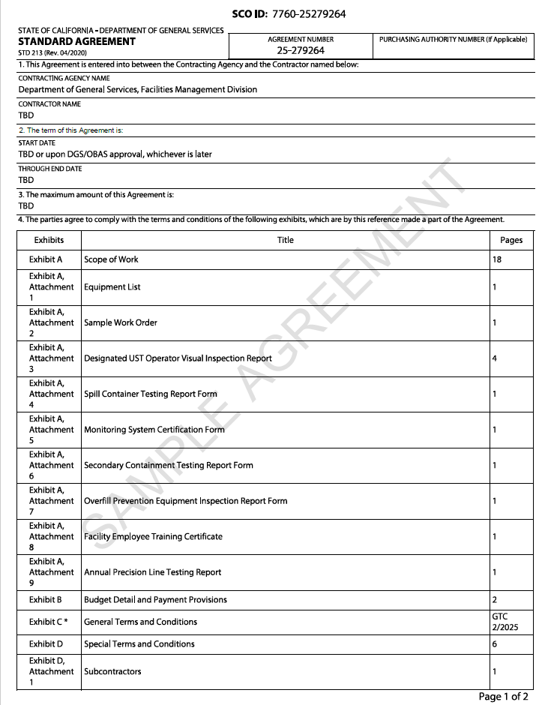

EXHIBIT A
SCOPE OF WORK
The State of California (State), Department of General Services (DGS), Facilities Management Division (FMD) manages, maintains and operates state buildings and grounds statewide, pursuant to Government Code Section 14685 (a), which authorizes DGS to establish rules and regulations for the government and maintenance of state buildings and grounds. FMD is procuring services for aboveground and underground storage tank maintenance and repairs on state property.
  - PROJECT SUMMARY

    - The Contractor shall provide all labor, equipment, and materials required to provide services for underground storage tanks (UST) and aboveground storage tanks (AST) for the equipment identified in Exhibit A, Attachment 1, Equipment List. Services shall include the following:

      - Preventive Maintenance, Testing and Certification
      - Repairs
      - Training
    - The services will be performed at the following locations:
State Building Locations
Energy Commission Building (008) 1516 9th Street  Sacramento, CA 95814 | Twin Towers (039 & 045)  744 P Street  Sacramento, CA 95814
Employment Development Department, Solar Building (013) 722 Capitol Mall  Sacramento, CA 95814 | Department of Justice (075) 4949 Broadway Street  Sacramento, CA 95814
Paul Bonderson Building (016) 901 P Street  Sacramento CA 95814 | CalEPA (Building #024)  1001 I Street  Sacramento, CA 95814
Elihu Harris State Building (602)  1515 Clay Street  Oakland, CA 94612 | Ronald M George SOC  Building (#402)  455 Golden Gate Ave.  San Francisco, CA 94102

    - The rates specified in Exhibit B, Attachment 1, Cost Sheet, shall stay in effect for the entire Agreement term. Contractor was afforded the opportunity at the walk-through to examine work sites and specifications and investigate conditions, character and quality of surface, subsurface materials or obstacles and conditions that might be encountered. No additions or increases to the Agreement amount will be made due to conditions that existed at the walk-through.

  - PROJECT REPRESENTATIVES
    - The Contract Representatives during the term of this Agreement will be:

Representatives | FMD Contract Administrator | Contractor’s Contract Administrator
Name and Title: | TBE | TBD
Address:
City, State, Zip:
Phone Number:
E-mail Address:

    - The State reserves the right to identify an FMD Designated Representative in the absence of the FMD Contract Administrator.

    - Any changes in Contractor’s Contract Administrator must be immediately reported in writing to the FMD Contract Administrator or FMD Designated Representative.
  - QUALIFICATION REQUIREMENTS

    - Contractor must possess and maintain, at all times during the term of this Agreement, a valid Class A-General Engineering Contractors License with a HAZ Certification attached, or a valid classification B-General Building Contractor License and a classification C-61 Limited Specialty with a subcategory D-40 Service Station Equipment and Maintenance License, issued by the California Department of Consumer Affairs, Contractors State License Board.

    - Per California Code of Regulations (CCR), Title 23, Chapter 16, Contractor’s employees providing training and performing monthly visual inspections and inspection report services are required to possess and maintain at all times during the term of this agreement; a valid California UST System Operator Certification issued by the International Code Council (ICC) and shall be continuously present on-site throughout the duration of all work activities. Prior to commencement of work, Contractor shall submit current copies of the ICC certification for each employee who will be performing the required services to the FMD Contract Administrator or FMD Designated Representative.

    - Per CCR, Title 23, Chapter 16, Contractor’s employees providing 36-month (SB 989) Secondary Containment Test services are required to possess and maintain, at all times during the term of this agreement, a valid California UST Service Technician Certification issued by the ICC or a Tank Tester License issued by the State Water Resources Control Board’s (SWRCB) Office of Tank Tester Licensing (OTTL).
    - The Services provided shall be in accordance with the standards and regulations established by Occupational Safety and Health Administration (OSHA), National Fire Protection Association (NFPA), Underwriters Laboratories (UL), American National Standards Institute (ANSI), California

Code of Regulations, SB 989, and all other jurisdictional authorities including local, State, and Federal regulations.

    - All personnel responsible for confined space entry shall be trained in accordance with Cal/OSHA regulations and the State of California’s Confined Space Program. Confined space permits must be issued prior to entry and shall be site-specific, reflecting the unique hazards and requirements of each building. Permits shall be placed outside of the tanks while work is being completed. Contractor is responsible for issuing Confined space permits and determining entry procedures in accordance with Title 8, California Code of Regulations, Section 5157.
    - The Contractor must always possess and maintain during the term of this Agreement a valid Veeder-Root Startup & Service Technician Certification. Certification shall be provided to FMD Contract Administrator upon request.
    - Technicians providing services must be regularly employed by the Contractor.

  - PERFORMANCE DETAILS
    - Contractor shall perform all services in accordance with California Code of Regulations, Title 24, California Building Standards Code.

    - Contractor shall be responsible for supplying miscellaneous materials (i.e., grease, lubrications, gloves, etc.) incidental to service, including safety materials needed or required to perform service, at no additional charge to the State.
    - The State will not pay for fees not listed on Exhibit B, Attachment 1, Cost Sheet (i.e. travel, freight, trip, tax, and/or fuel surcharges, etc.).
    - Contractor shall separately invoice the service and repairs performed at each building, in accordance with Exhibit A, Attachment 1, Equipment List.

    - Any damage to existing facilities or structures resulting from this work shall be reported immediately to the FMD Contract Administrator or FMD Designated Representative and be repaired to the satisfaction of the FMD Contract Administrator or FMD Designated Representative at the contractor’s expense and only with prior approval of the FMD Contract Administrator or FMD Designated Representative.

  - SERVICE DETAILS

    - Work Days, Hours and State Holidays
- The State's normal business hours are: Monday through Friday, 8:00 a.m. to 5:00 p.m. (PT), excluding observed State holidays. All scheduled services under this Agreement shall be completed within normal business hours (unless approved in writing and in advance by the FMD Contract Administrator or FMD Designated Representative). Any unapproved hours of work will be considered performed at Contractor's own expense.
- Contractor shall not be regularly scheduled for services on observed State holidays. Current observed State holidays are New Year’s Day, Martin Luther King, Jr. Day, President’s Day, Farmworkers Day, Memorial Day, Independence Day, Labor Day, Veteran’s Day, Thanksgiving Day, Day after Thanksgiving and Christmas Day.

    - Scheduling of Work
- After the Agreement has been approved, Contractor shall confer with the FMD Contract Administrator or FMD Designated Representative in a start-up meeting.

- 36-Month services shall be coordinated with the FMD Contract Administrator or Designated FMD Representative within the first annual service occurring no later than 365 calendar days from Agreement execution. 36-Month services thereafter shall be provided no more frequently than 35 months from completion of the previous same 36-Month service and as coordinated with the FMD Contract Administrator or FMD Designated Representative.

- Monthly services shall be coordinated with the FMD Contract Administrator or Designated FMD Representative with the first monthly service occurring no later than 30 calendar days from Agreement execution. Monthly services thereafter shall be provided no more frequently than 25 calendar days from completion of the previous same monthly service and as coordinated with the FMD Contract Administrator or FMD Designated Representative.

- Quarterly services (only buildings 402 and 602) shall be coordinated with the FMD Contract Administrator or Designated FMD Representative with the first quarterly service occurring no later than 90 calendar days from Agreement execution. Quarterly services thereafter shall be provided no more frequently than 75 calendar days from completion of the previous same quarterly service and as coordinated with the FMD Contract Administrator or FMD Designated Representative.
- Annual services shall be coordinated with the FMD Contract Administrator or FMD Designated Representative with the first annual service occurring no later than 365 calendar days from Agreement execution. Annual services thereafter shall be provided no more frequently than 300 calendar days from completion of the previous same annual service and as coordinated with the FMD Contract Administrator or FMD Designated Representative.

- During the term of this Agreement, and notwithstanding the described hours and calendar schedule, the FMD Contract Administrator or FMD Designated Representative and Contractor shall mutually agree in writing to modify workdays or hours to reasonably accommodate the completion of work.

    - Building Security

- The State shall perform a background check (LIVE SCAN) on any of the Contractor’s employees that will enter the DOJ building #075 and the Elihu Harris Building #602. The Contractor shall incur all costs associated with obtaining LIVE SCAN clearance. If there is a need for the Contractor’s employee to enter the building(s) in the interim of the LIVE SCAN, they shall be escorted by the FMD Contract Administrator or FMD Designated Representative during that time. Should Contractor’s personnel fail the LIVE SCAN, under no circumstances shall those individuals be granted access to the building(s).

- The State shall have and exercise full and complete control over granting, denying, withholding or terminating building clearances for Contractor’s personnel.

- Contractor’s staff shall check in with building security at building’s main entrance, where they are to provide a valid State of California issued identification and will be issued a temporary pass that will be returned at the end of each day. Temporary pass shall be worn while performing services in the building and on building’s grounds.
- All Contractor’s personnel shall notify the FMD Contract Administrator or FMD Designated Representative upon arrival each day and sign-in and out on the FMD Maintenance Log Book daily.

- Contractor’s staff shall be in a uniform (with a name-tag) that easily identifies them as Contractor’s staff.
- Contractor shall be responsible for all costs incurred as a result of false fire alarms or other system alarms activated by Contractor’s negligence or that of its employees, material suppliers, and/or subcontractors.
    - Parking

The State does not provide parking, however, off-loading of equipment and materials may be performed at the building’s loading dock if permission is obtained in advance from the FMD Contract Administrator or FMD Designated Representative and sufficient space is available.

    - Utilities

Water, electricity, elevator and restroom facilities are available free of charge while performing services associated with this Agreement. However, these facilities shall be kept clean at all times and are not to be used for anything other than their intended purpose.

    - Interference
Contractor shall make provisions to accomplish the work of this Agreement, without undue interference with the operations of the State, its tenants and visitors, or surrounding businesses and buildings.

    - Clean-Up

Contractor shall keep all work areas clean and free of debris. During progress of work and at the end of each workday, Contractor shall clean-up materials, remove from building location and discard appropriately and in accordance with any local or county ordinances. Any cleaning of equipment on State property requires the approval of the FMD Contract Administrator or FMD Designated Representative.
  - WORK DETAILS

The services Contractor shall perform consists of, but is not limited to, the following:

    - Monthly UST Designated Operator Inspection:

Contractor shall perform the following:

- Perform UST Designated Operator Visual Inspections at all locations.
Contractor shall complete all sections of Exhibit A, Attachment 3, and Designated UST Operator Visual Inspection Report to include the following information:

- Facility Information (name and Location)
- Designated UST Operator Information
- Compliance Issues
- Name of Contractor’s Designated UST Operator Conducting
Inspection and Certification.
- Owner and Operator Description of Follow-up Action
- Owner and Operator Acknowledgement of Inspection Results
- Inspection History
- Release Detection Alarm History
- UST System Inspection
- Testing and Maintenance
- Facility Employee Training
- Comments and Observations

- Contractor shall submit two (2) copies of the completed Exhibit A, Attachment 3, Designated UST Operator Visual Inspection Report. The original copy shall be sent to the FMD Contract Administrator or FMD Designated Representative listed in Exhibit A, Section 2 and one (1) copy of the report shall be sent to the Local Regulatory Agency. Contractor shall utilize the latest applicable Underground Storage Tanks forms and documents in accordance with the Sacramento County Environmental Management and Alameda County Environmental Health requirements within thirty (30) calendar days of the inspection.

- Contractor shall be responsible for providing forty-eight (48) hour notice, prior to
the test to the local Regulatory Agency for each Designated UST Operator
Visual Inspection Report.

    - Description and Location of Three (3) Above Ground Storage Day Tanks Located at Elihu Harris (#602)

- One (1) 275-Gallon above ground day tank is located in the Generator Room.
- Two (2) 265-Gallon above ground day tanks are located in the Garage of the Basement Level 1-Fire Pump Room.
- In Pump Room, there are two (2) pumps which will feed the day tanks, the level is 80% of the tank.
- In the Generator Room, there is one (1) pump which will feed the generator day tank.

    - Quarterly – Above Ground Day Tank Preventive Maintenance Located at Elihu Harris (#602)

The services Contractor shall perform consists of, but is not limited to, the following:

- Provide scheduled Preventive Maintenance and Inspection Work shall comply with T23 CCRC 16.
- Monitor tank with Veeder-Root TLS-300C.
- A 910 Series Anti-Siphon Valve is installed. It is equipped with a built-in expansion relief feature that will relieve pressure created by thermal expansion from the downstream side of the valve to the upstream side of the valve.
- Check valve for any damage or defects. If either found, the valve must be replaced. This valve should not be disassembled. Do not attempt to make any repairs or adjustments to the valve.
- Make sure the piping system in which you are installing the valve is not under pressure or filled with product that could be spilled.
- Ensure the valve has the proper size and setting for the specific application.
- This valve must be installed on top of the tank or in the piping system above the top of the tank.
- The valve may be installed in any orientation as long as the valve is aligned with the fluid flow.
- Apply a fuel resistant, non-hardening, anti-seize sealant to the male pipe threads. Teflon tape is not recommended. When tightening the valve onto the associated piping, make certain you use the valve flat that is closest to the pipe. When threading pipe into the other end of the valve make certain that you hold, with the wrench, the valve flats on the end. Do not cross torque the valve.
- Test proper operation.

    - Semi-Annual – 12B Day Tank Pump Set Maintenance at Elihu Harris (#602)

Contractor shall perform the following:

      - Simplex Pump Sets should be visually inspected for maintenance purposes during light duty cycles.
      - Prior to performing the maintenance procedure ensure that the optional Main Disconnect Switch is operating properly, the user supplied circuit breaker is in the Off position, and that all sources of power are isolated from the Pump Set. Proceed only after this is verified.
      - Check Main Disconnect Switch, door, and hinge operation.
      - Check cabinet mounting hardware at feet and wall mounting flange. Tighten as necessary.
      - Test pumps in duplex pump sets. Ensure both pumps are operating normally, test each pump individually, text simultaneous operation, text alternating operation.
      - Check Pump/motor hardware for tightness. Pump/motor hardware will loosen after normal operation due to vibration. This hardware is double nutted, check all bolts for double nuts.
      - Rotate shaft by hand and check for smooth operation. Check pump/motor coupler shown at left for proper alignment and spacing. The Lovejoy coupler should be approximately 1/8” clearance between coupler halves. If this clearance is reduced or the pump and motor are not properly aligned excessive noise and pump/motor wear will occur. Loosen pump motor mounting hardware to realign motor/coupler. Loosen one end of pump coupler to adjust for necessary coupler clearance.
      - Check all electrical terminals and connections for tightness.
      - All motors are permanently lubricated and do not require any lubrication.
      - All pumps are self-lubricating and do not require any maintenance.
      - Check all plumbing joints for leaks.
      - Tighten fitting and joints as necessary.
      - Drain accumulated fuel in catch basin as necessary by removing catch basin plug.
      - Inspect all fuel strainers. Disassemble strainer and clean strainer element, replace as necessary. Reassemble unit and check for leaks.
      - Test hand pump operation, check for fuel leaks, tighten as necessary.

    - Semi-Annual – 12F Day Tank Load Bank Maintenance at Elihu Harris (#602)

Contractor shall perform the following:

- Check fan blades for stress fractures.
- The load branches should be checked for blown fuses or opened load resistors.
- If the current reading is a sizable difference, check the load fuses or load resistors for replacement.
- Check fan, cooling chamber and exhaust opening for obstructions.
    - Annual – 12E 244 Day Tank Emergency Vents Maintenance at Elihu Harris (#602)

Contractor shall perform the following:

- Immediate inspection is needed during freezing conditions.
- Contractor is required to ensure venting devices are functioning properly before filling or unloading a tank.
    - Annual – 12C Day Tank Maintenance at Elihu Harris (#602)

Contractor shall perform the following:

- Remove a sample of the diesel fuel from the day tank and test for algae and flash point.
- Inspect tank for damage, leakage, or rust on both inside and outside the tank.
- Water and sediment should be drained from the tank. If normal engine/generator testing does not consume one full of diesel fuel each year, the tank should be drained and refilled with fresh fuel.
- Remove the inspection port from the Day Tank. Examine the interior of the Day Tank and inspect all the components. With Tank drained test sending unit operation, install a new inspection port gasket and replace the inspection port cover.
- Observe pump and motor performance.
- Inspect pump/motor alignment and wear. Inspect pump for leaks.
- Tighten hose clamps at pump/hose connections.
- Tighten the pump bracket, motor bracket and pump/motor coupler hardware.
- Inspect all plumbing connections for leaks.
- Test all options and fuel levels alarms for proper operation.
- Tighten all electrical connections.
    - Annual – 12D Day Tank Overfill Prevention Valve Maintenance (9095AA EVR 2) at Elihu Harris (#602)
Contractor shall perform the following:

- The valve is installed through a 4” threaded opening and has a built-in bleed hole that allows the fill hose pressure to be relieved after the valve closes.
- Contractor shall provide maintenance according to local codes or to America Petroleum Institute (API) Recommended practice 2350.

    - Tank Testing and Preventive Maintenance shall be paid by the State at the Contractor’s rates specified in Exhibit B, Attachment 1, Cost Sheet, Table 1, Preventive Maintenance.

    - Quarterly Preventive Maintenance - Two (2) Above Ground Storage Tanks (Bldg. #402)

Contractor shall perform the following:
      - Monitor tank with Veeder-Root TLS-300C.
      - Inspect and test valve for any damage or defects. If damaged or defective, the valve must be replaced. This valve should not be disassembled. Do not attempt to make any repairs or adjustments to this valve.
      - Ensure the piping system in which you are installing the valve is not under pressure or filled with product that could be spilled.
      - Ensure the valve has the proper size and setting for the specific application.
      - The valve must be installed on top of the tank or in the piping system above the tank where no section of the piping between the tank and the anti-siphon valve extends below the top of the tank.
      - The valve may be installed in any orientation as long as the valve is aligned with the fluid flow.
      - Apply a fuel resistant, non-hardening, anti-seize sealant to the male pipe threads. Teflon tape is not recommended. When tightening the valve onto the associated piping, make certain you use the valve flat that is closest to the pipe. When threading pipe into the other end of the valve make a certain that you hold, with the wrench, the valve flats on the end. Do NOT cross torque the valve.
      - Test for proper operation.

    - Semi-Annual Maintenance – Pump Set (Bldg. #402)
Contractor shall perform the following:
      - Simplex Pump Sets should be visually inspected for maintenance purposes during light duty cycles.
      - Prior to performing the maintenance procedure ensure that the optional Main Disconnect Switch is operating properly, the use supplied circuit breaker is in off position, and that sources of power are isolated from the Pump Set. Proceed only after this is verified.
      - Inspect and test Main Disconnect switch, door, and hinge operation.
      - Inspect cabinet mounting hardware at feet and wall mounting flange. Tighten as necessary.
      - Test pumps in duplex pump sets. Ensure both pumps are operating normally, test each pump individually, text simultaneous operation, text alternating operation.
      - Inspect pump/motor hardware for tightness. Adjust as necessary.
      - Pump/motor hardware for tightness. Pump/motor hardware will loosen after normal operation due to vibration. This hardware is double nutted, check all bolts for double nuts.
      - Rotate shaft by hand and check for smooth operation. Check pump/motor coupler shown at left for proper alignment and spacing. The Lovejoy coupler should be approximately 1/8” clearance between coupler halves. If this clearance is reduced or the pump and motor are not properly aligned excessive noise and pump/motor wear will occur. Loosen pump motor mounting hardware to realign motor/coupler. Loosen one end of pump coupler to adjust for necessary coupler clearance.
      - Inspect all electrical terminals and connections for tightness.
      - All motors are permanently lubricated and do no require any lubrication.
      - All pumps are self-lubricating and do not require any maintenance.
      - Inspect all plumbing joints for leaks. Repair as needed.
      - Tighten fittings and joints as necessary.
      - Drain accumulated fuel in catch basin as necessary by removing catch basin plug.
      - Contractor shall be responsible for proper disposal of all drainage.
      - Inspect all fuel strainers. Disassemble strainer and clean strainer element, replace as necessary. Reassemble unit and test for leaks.
      - Test hand pump operation, test for fuel leaks, tighten as necessary.

    - Semi-Annual Maintenance – Load Bank (Bldg. #402)
Contractor shall perform the following:
      - Inspect fan blades for stress fractures.
      - The load branches should be checked for blown fuses or open load resistors.
      - Repair or replace as needed.
      - If the current readings are a sizable difference, check the load fuses or load resistors for replacement.
      - Inspect fan, cooling chamber and exhaust opening for obstructions. Clear obstructions as needed.

    - Annual Maintenance – Day Tank (Bldg. #402)
Contractor shall perform the following:
      - Remove a sample of the diesel fuel from day tank and test for algae and flash point.
      - Inspect tank for damage, leakage, or rust on both inside and outside the tank.
      - Repair as needed.
      - Water and sediment should be drained from the tank. If normal engine/generator testing does not consume one tank full of fuel each year, the tank should be drained and refilled with fresh fuel.
      - Contractor shall be responsible for proper disposal of all drainage.
      - Remove the inspection port from the Day Tank. Examine the interior of the Day Tank and inspect all the components. With Tank drained testing sending unit operation, replace the inspection port gasket and replace the inspection port cover.
      - Inspect and test pump and motor performance.
      - Inspect pump/motor alignment and wear. Inspect pump for leaks. Repair as needed.
      - Tighten hose clamps at pump/hose connections.
      - Tighten the pump bracket, motor bracket and pump/motor coupler hardware.
      - Inspect all plumbing connections for leaks.
      - Test all options and fuel levels alarms to ensure proper operation.
      - Tighten all electrical connections.

    - Annual Maintenance – Overfill Prevention Valve – 9095AA EVR (Bldg. #402)
Contractor shall perform the following:
      - The valve is installed through a 4” threaded opening and has a built-in bleed hole that allows the fill hose pressure to be relieved after the valve closes.
      - Contract shall provide maintenance according to local codes or to American Petroleum Institute (API) Recommend practice 2350.

    - Annual Maintenance – 244 Emergency Vents (Bldg. #402)
Contractor shall perform the following:
      - During freezing conditions contractor must respond FMD contract administrator’s or designated representative’s request for service within 24 hours.
      - Contractor is required to ensure venting devices are functioning properly before filling or unloading a tank.

    - Annual – UST and AST Training
Contractor shall perform the following:
- The Contractor shall provide Annual Training for State employees responsible for the daily operation of the UST and AST along with additional training for new hires as needed. The training shall meet all requirements of Title 23 CCR Section 2715€.
- The Contractor shall schedule a formal training session on at least two (2) separate days each year. The Contractor shall have facility employees complete the Facility Employee Training Certificate, Exhibit A, Attachment 8, for this training. The state will provide the classroom for the training.
- The Contractor shall provide two (2) hours of in-service training on operation of the Storage Tanks in accordance with manufacturers recommendations.
- The Contractor shall coordinate with the FMD Contract Administrator to schedule these training sessions. The Contractor must give the State thirty (30) calendar days’ notice prior to scheduling the training.
- The Contractor shall submit two (2) hard copies or email the training outline and the sign in sheets within five (5) calendar days of the completion of the training. The original copy shall be sent to the FMD Contract Administrator.
- One (1) hard copy of the report should be mailed or emailed to the local regulatory agency.
- Provide digital PDF and hard copy of training manual upon request to the FMD Contract Administrator or FMD Designated Representative.
- Class cancellations will not be charged if FMD Contract Administrator or FMD Designated Representative provides cancellation notice to Contractor’s Contract Administrator at least ten (10) business days prior to the start date of the scheduled class.
- Training sessions will take place at the following locations:

Region 1 | Region 2 | Region 1 | Bay Region | Region 3
Employment Development Department  722 Capital Mall Sacramento, CA | Twin Towers  744 P Street  Sacramento, CA 95814 | CalEPA  (Building #024)  1001 I Street  Sacramento, CA 95814 | Elihu Harris State Building (#602)  1515 Clay Street  Oakland, CA 94612  Ronald M George SOC  Building (#402)  455 Golden Gate Ave.  San Francisco, CA 94102 | Department of Justice  4949 Broadway St. Sacramento, CA 95814

    - Annual Spill Bucket Test (add applicable buildings)

- Perform Annual Spill Bucket Test
- Contractor shall submit two (2) copies of the completed Exhibit A, Attachment 4, Spill Container Testing Report Form within five (5) calendar days of the inspection. One (1) original copy for each location shall be sent to the FMD Contract Administrator and one (1) copy of the report shall be sent to the local regulatory agency.
- The Contractor is responsible for providing forty-eight (48) hour notice, prior to the test, to the local regulatory agency for each Annual Spill Bucket Test.

    - Annual UST Monitoring System Certification
- Perform Annual Monitoring System Certification inspection and testing at each listed location.
- Contractor shall submit two (2) copies of completed Exhibit A, Attachment 5, Monitoring System Certification Form, hard copy of the report should be mailed or emailed within five (5) calendar days of the inspection and testing. Original copy for each location shall be sent to the FMD Contract Administrator or FMD Designated Representative and one (1) copy of the report shall be sent to the local regulatory agency.
- The Contractor shall also affix a tag or sticker on each monitoring system component upon certification.
- The tag or sticker shall be in a readily visible location and shall include the date certified and the Contractor’s license number.

- Annual Precision Line Test (Department of Justice Building 075 Only)
- Perform Annual Precision Line Testing at the Department of Justice Building (075).
- Contractor shall submit two (2) copies of Exhibit A, Attachment 9, Annual Precision Line Testing Report, (provided by Contractor), within five (5) calendar days of the inspection and testing.
- Original copy for each location shall be sent to the FMD Contract Administrator or FMD Designated Representative and one (1) copy of the report shall be sent to the local regulatory agency.

- 36-Month Secondary Containment Test

- Perform 36-month Secondary Containment Test at each listed location.
- Contractor shall submit two (2) copies of Exhibit A, Attachment 6, Secondary Containment Testing Report Form , within five (5) calendar days of completing the test. The original is to be sent to the FMD Contract Administrator or FMD Designated Representative and one (1) copy shall be sent to the regulatory agency.

- 36-Month Overfill Prevention Equipment Test

- Perform 36 month Overfill Prevention Equipment Test at each listed location.
- Contractor shall submit two (2) copies of Exhibit A, Attachment 7, Overfill Prevention Equipment Inspection Report Form within five (5) calendar days of completing the test. The original is to be sent to the FMD Contract Administrator or FMD Designated Representative and one (1) copy shall be sent to the regulatory agency.

- Discarding Waste and Equipment

- The Contractor shall provide appropriate Department of Transportation (DOT) approved containers for any waste generated in the performance of the contract. The Contractor shall be responsible for the offsite disposal of all waste generated.
- Removed equipment is the property of the State. The State reserves the right to retrieve all system equipment, and any product contained or previously contained within the UST system(s).
- The FMD Contract Administrator or FMD Designated Representative reserves the right to increase or decrease preventive maintenance services, or to decrease the scheduled number of services, should equipment be added or old equipment become obsolete.

- Preventive Maintenance shall be paid by the State at the Contractor’s rates specified in Exhibit B, Attachment 1, Cost Sheet, Table 1, Preventive Maintenance.

- Contractor shall provide testing and maintenance services for the equipment specified in Exhibit A, Attachment 1, Equipment List.

- This Agreement does not include Public Works services, pursuant to Public Contract Code (PCC) Section 1101, public works contracts involve the erection, construction, alteration, repair or improvement of a public structure, building, road or other improvement. If the Contractor discovers required services of this nature, the Contractor shall verbally notify the FMD Contract Administrator or FMD Designated Representative of these findings immediately and confirm verbal notification in writing within 24 hours.
  - REPAIR SERVICES

    - Contractor shall provide repair services required to keep the equipment fully operational in accordance with manufacturer’s standards.

    - Foreseeable Repairs shall be paid by the State at the Contractor’s Repair Service- Hourly Rates, specified in Exhibit B, Attachment 1, Cost Sheet, Table 2, Foreseeable Repair Services.

    - Unforeseeable Repairs shall be paid by the State at the Contractor’s Repair Service- Hourly Rates, specified in Exhibit B, Attachment 1, Cost Sheet, Table 3, Unforeseeable Repair Services.
    - Contractor shall respond to requests for repair service within one (1) business day of notification by the FMD Contract Administrator or FMD Designated Representative.
    - Contractor shall make every attempt to complete repairs the same business day. When a part(s) must be ordered that will delay completion of repairs the same working day, Contractor shall inform the FMD Contract Administrator or FMD Designated Representative immediately.

  - EMERGENCY REPAIR SERVICES

    - Contractor shall provide any necessary emergency repair services upon request from the FMD Contract Administrator or FMD Designated Representative.

    - Contractor must respond to requests for emergency repair services within two (2) hours of notification by the FMD Contract Administrator or FMD Designated Representative.

    - When possible, emergency repairs shall be performed during normal business hours as specified herein.
    - The FMD Contract Administrator or FMD Designated Representative may, at their discretion, allow access to the equipment outside of normal business hours when necessary.

    - Emergency services provided by the Contractor, shall be charged at the Contractor’s Emergency Repair Service-Hourly Rates, specified in Exhibit B, Attachment 1, Cost Sheet, Table 3, Unforeseeable Repair Services.

    - When calculating Emergency Repair costs relative to Foreseeable Repairs, the hourly rate shall be as identified in Exhibit B, Attachment 1, Table 3, Unforeseeable Repair Services. All other costs shall be billed consistent with Table 2, Foreseeable Repair Services.
    - Any emergency repair services provided shall be completed the same business day. When a part(s) must be ordered that will delay completion of repairs the same business day, Contractor shall inform the FMD Contract Administrator or FMD Designated Representative immediately.
  - PARTS REPLACEMENT

    - This Agreement shall include replacement of any parts found to be worn, inoperable, or that otherwise affects the equipment’s operability in any way.

    - All replacement parts require a receipt when invoicing the State and will be reimbursed as specified in Exhibit B, Attachment 1, Cost Sheet.

    - Parts replaced by the Contractor under this Agreement shall be new, factory manufactured, or equivalent to manufacturer’s standards.
    - Contractor agrees to maintain an adequate supply and/or be able to obtain within 48 hours, or as specified by the FMD Contract Administrator or FMD Designated Representative, any necessary replacement parts in order to perform repairs and maintenance in a timely manner. When replacement parts are not available within 48 hours, Contractor shall inform the FMD Contract Administrator or FMD Designated Representative immediately.

    - Replaced parts become the property of the State.

  - WORK ORDER
    - Contractor shall submit a written itemized estimate for repair and emergency repair services to the FMD Contract Administrator or FMD Designated Representative and receive an approved Work Order, prior to performing repair services. Exhibit A, Attachment 2, Sample Work Order is included for reference.

    - Contractor shall notify and submit a written estimate of required part(s) to the FMD Contract Administrator or FMD Designated Representative and receive an approved work order, prior to ordering or replacement of part(s). Exhibit A, Attachment 2, Sample Work Order is included for reference.

    - In the case of conflict between the rates identified on Exhibit B, Attachment 1, Cost Sheet and the rates identified on the Work Order, the Cost Sheet shall prevail.

  - REPORTS

    - Where reporting is required, the Contractor shall email the written reports to the FMD Contract Administrator or FMD Designated Representative within the timeframe specified above.
    - After each visit, the Contractor shall provide a written report of detailing all needed repairs and any repairs previously authorized that were made. If repairs were made, the report shall include the date, the manufacturer and part number of any replacement parts used, copies of all relevant drawings, copies of the manufacturer’s written performance claims, and any calibration date.
  - TECHNICAL SUPPORT SERVICES
    - Contractor shall provide up to eighty-four (84) hours of technical support services per 12 month period, via telephone to address or troubleshoot equipment problems, as requested by the FMD Contract Administrator or FMD Designated Representative . Technical Support Services shall be paid by the State at the hourly rates specified in Exhibit B, Attachment 1, Cost Sheet, Table 4, Technical Support Services. The State will only pay for the hours actually spent providing technical support services, not to exceed the maximum amount as specified above. The State does not guarantee the actual amount of technical support service hours to be performed.
    - Contractor shall make every attempt to start and complete Technical Support Services the same business day . When a delay in completion of Technical Support Services occurs the same business day, the Contractor shall inform the FMD Contract Administrator or FMD Designated Representative immediately.
    - Contractor shall keep a written record/log of Technical Support Services provided, containing number of hours, assistance provided, outcome and recommendation.
    - Contractor shall email the record/log to the FMD Contract Administrator or FMD Designated Representative monthly for review and approval.
    - Contractor shall attach a copy of the FMD pre-approved record/log to the invoice. Any unapproved technical support service hours will be considered performed at the Contractor’s own expense.
  - INSPECTIONS BY STATE

Any services performed by the Contractor are to be inspected by the FMD Contract Administrator or FMD Designated Representative after completion. The FMD Contract Administrator or FMD Designated Representative is solely responsible for determining acceptability of service performed and the operability of the equipment/system.

  - WARRANTY
    - Contractor unconditionally warrants the work performed under this Agreement conforms to the Agreement requirements and is free of any defect in equipment, material, or design furnished, or workmanship performed by Contractor or any tier.

    - This warranty shall continue for a period of one (1) year from the date of acceptance of the work.
    - Upon written notification, Contractor shall immediately repair or replace, at Contractor’s expense, work that fails to conform to the requirements of the Agreement or any defect in equipment, material, design furnished, or workmanship performed by Contractor or any subcontractor or supplier at any tier. In addition, Contractor shall remedy at Contractor’s expense any damage to State-owned or controlled real or personal property when that damage is the result of Contractor’s failure to conform to Agreement requirements or any defect of equipment, material, workmanship or design furnished.

    - Contractor shall restore any work damaged in fulfilling the terms and conditions of this clause. Contractor’s warranty with respect to work repaired or replaced will run for one (1) year from the date of acceptance of the repair or replacement. As used in this clause, “acceptance” means the act of the State’s representative by which the State assumes for itself, or as agent of another, ownership of equipment, materials and supplies, or approves specific services, as complete performance of the Agreement.
    - The State’s representative shall notify Contractor, in writing, within a reasonable time after the discovery of any failure, defect, or damage.

    - If Contractor fails to immediately remedy any failure, defect or damage after receipt of notice, the State shall have the right to replace, repair, or otherwise remedy the failure, defect or damage at Contractor’s expense.

    - With respect to all warranties from subcontractors, manufacturers, or suppliers for work performed and/or materials furnished under this Agreement, Contractor shall:
- Obtain all warranties that would be given in normal commercial practice.
- Require all warranties be executed, in writing, for the benefit of the State.
- Enforce warranties for the benefit of the State.

EXHIBIT A, ATTACHMENT 1

EQUIPMENT LIST
Service shall be applicable for the following equipment:

QTY | BLDG | EQUIPMENT DESCRIPTION | CAPACITY | MANUFACTURER | TANK ID | FACILITY ID
1 | 008 | Underground  Storage Tank | 500 gal. | Joor | 24757 | FA0008300
1 | 013 | Underground Storage Tank | 500 gal. | Pomeco | 34-000-  009789-002 | FA0009789
1 | 016 | Underground  Storage Tank | 500 gal. | Trusco | 26715 | FA0009900
1 | 039 &  45 | Underground Storage Tank | 2,000 gal. | Joor | 26405 | FA0009899
1 | 075 | Underground  Storage Tank | 10,000 gal. | Trusco | TA0024987 | FA0010584
1 | 024 | Underground Liquid Holding Tank | Not Available | Ronan (X7YS) | Not Available | Not Available
1 | 024 | Leak Detection System | Not Available | Ronan | Not Available | Not Available
1 | 602 | Storage Tank  (Underground) | 2,500 gal. | Not Available | Not Available | Not Available
1 | 602 | Day Tank  (Above  Ground) | 275 Gal. | Simplex (SST275B) | Not Available | Not Available
2 | 602 | Day Tanks  (Above  Ground) | 265 Gal. | Arrow Tank Works (T-97) | Not Available | Not Available
1 | 402 | Aboveground Tank  (In the basement inside the room) | 1,000 Gal | Modern | Not Available | Not Available
1 | 402 | Aboveground Tank  (Under the street level next to RMG building) | 500 Gal | Modern | Not Available | Not Available
1 | 402 | SPS-25 Control Pump  System | Not Available | Simplex | Not Available | Not Available
1 | 402 | SPS-25 Control Pump System | Not Available | Simplex | Not Available | Not Available
1 | 402 | Cabinet | Not Available | Not Available | Not Available | Not Available
1 | 402 | Cabinet | Not Available | Not Available | Not Available | Not Available
1 | 402 | Pump | Not Available | Not Available | Not Available | Not Available
1 | 402 | Pump | Not Available | Not Available | Not Available | Not Available
1 | 402 | Panel | Not Available | Veeder Root | Not Available | Not Available
1 | 402 | Panel | Not Available | Veeder Root | Not Available | Not Available

EXHIBIT A, ATTACHMENT 2
SAMPLE WORK ORDER
Building Name and Number

Between Department of General Services, Facilities Management Division and Contractor Name
Contract #
Work Order #
The parties mutually agree to this Work Order (WO). All terms and conditions of the original Agreement shall remain in full force and effect. The scope of work for this WO is described below.

Building Number: |  | Building Name:
Building Location:
Project Title:
Jobsite Contact: | Email: |  |  |  | Phone:

Start Date:
Work Hours & Days of Week:

Required License(s):
Description of work:
Schedule:

Description of work and validation of cost according to original Agreement.

IN WITNESS WHEREOF, this Work Order has been executed by the parties hereto.
State Agency:  Department of General Services,  Facilities Management Division Project & Construction Management | State Agency:  Department of General Services, Facilities Management Division - Fiscal
By: (Authorized Signature): | By: (Authorized Signature):
Printed Name and Title of Person Signing: | Printed Name and Title of Person Signing:
By (Authorized Signature):
Printed Name and Title of Person Signing:

EXHIBIT A, ATTACHMENT 3

Designated UST Operator Visual Inspection Report

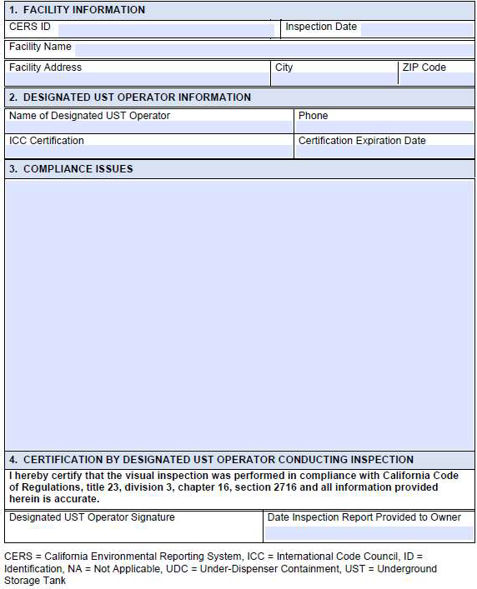

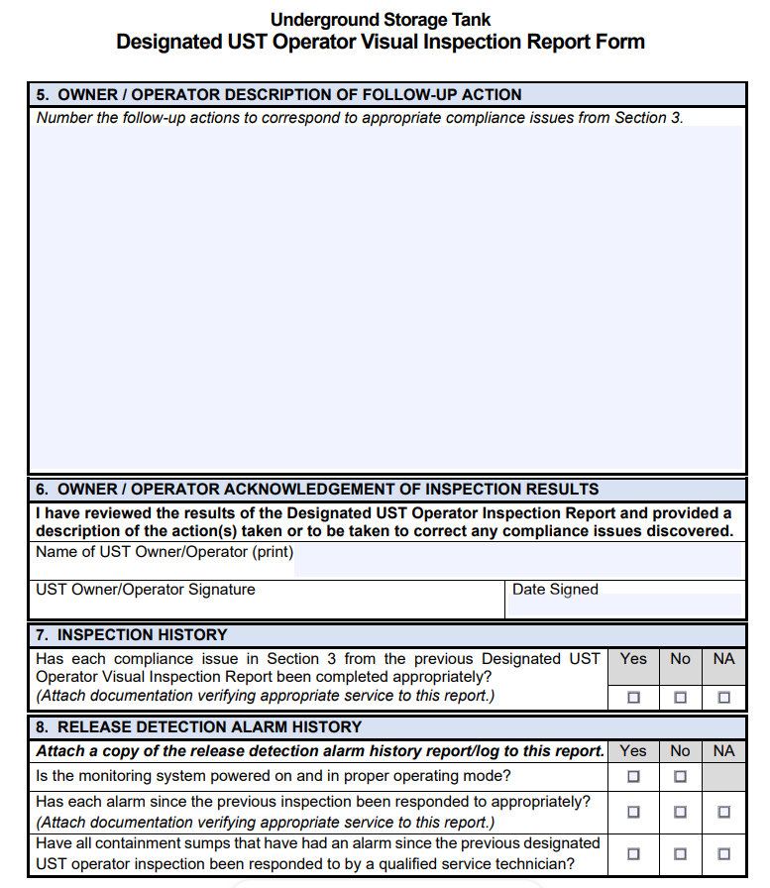

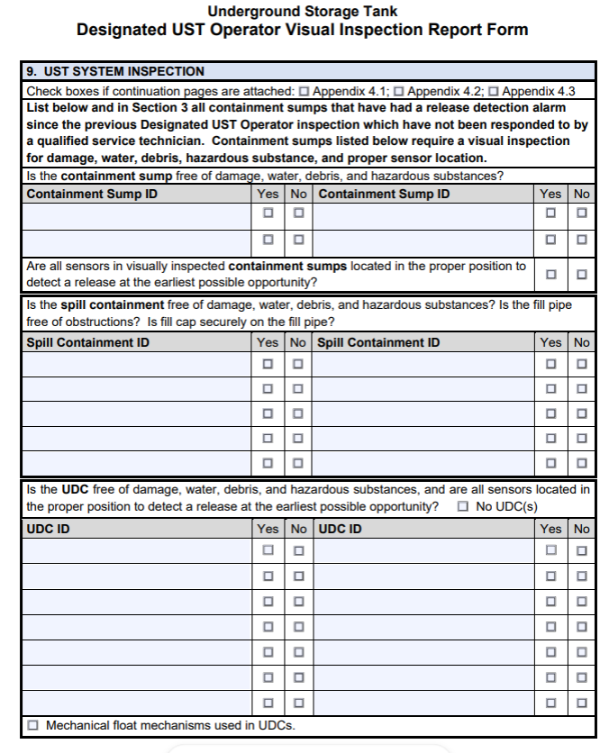

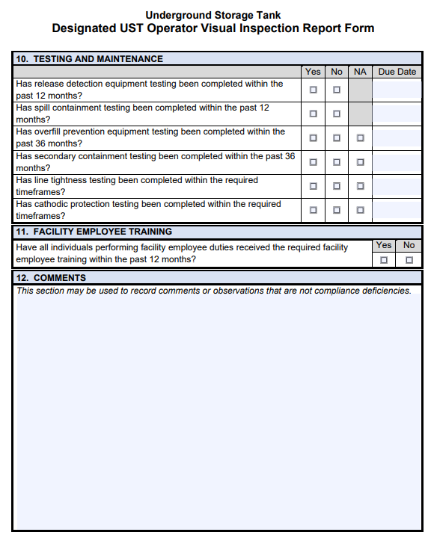

EXHIBIT A, ATTACHMENT 4
Spill Container Testing Report Form
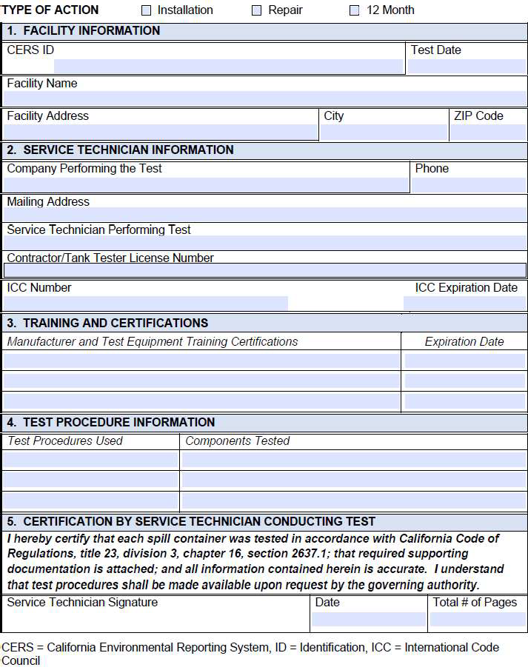

EXHIBIT A, ATTACHMENT 5
Monitoring System Certification Form

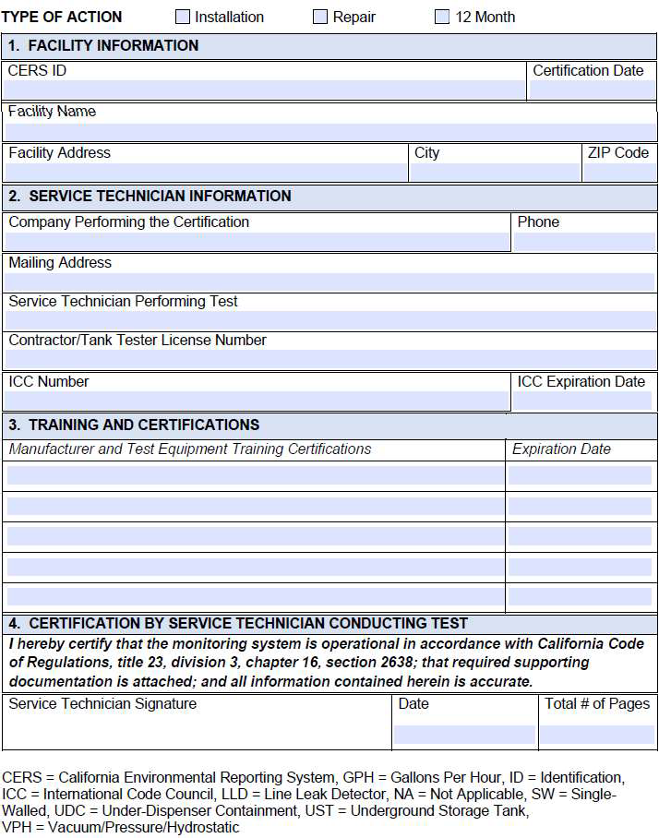

EXHIBIT A, ATTACHMENT 6
Secondary Containment Testing Report Form

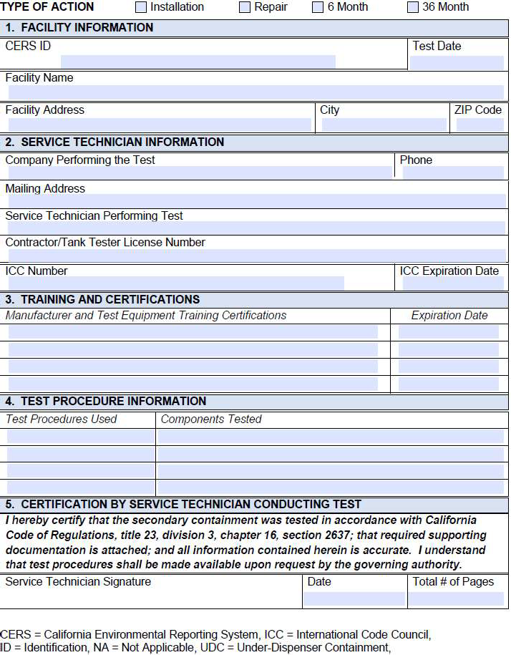

EXHIBIT A, ATTACHMENT 7
Overfill Prevention Equipment Inspection Report Form

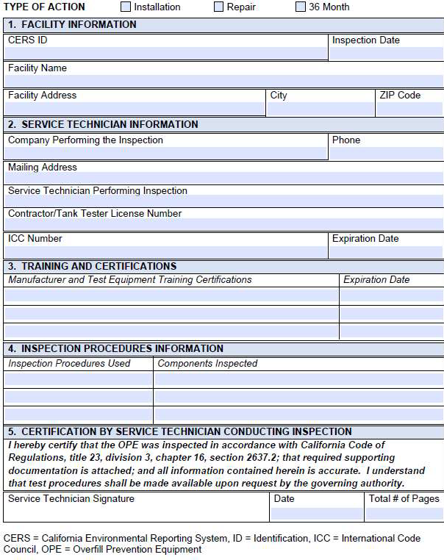

EXHIBIT A, ATTACHMENT 8
Facility Employee Training Certificate

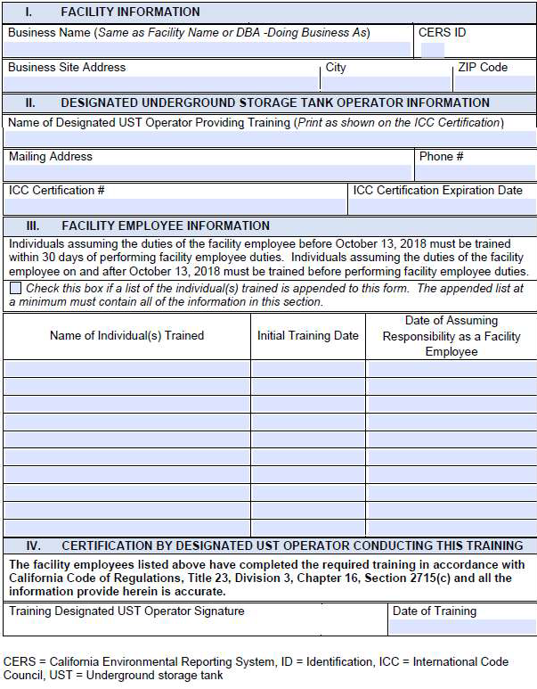

EXHIBIT A, ATTACHMENT 9

Annual Precision Line Testing Report
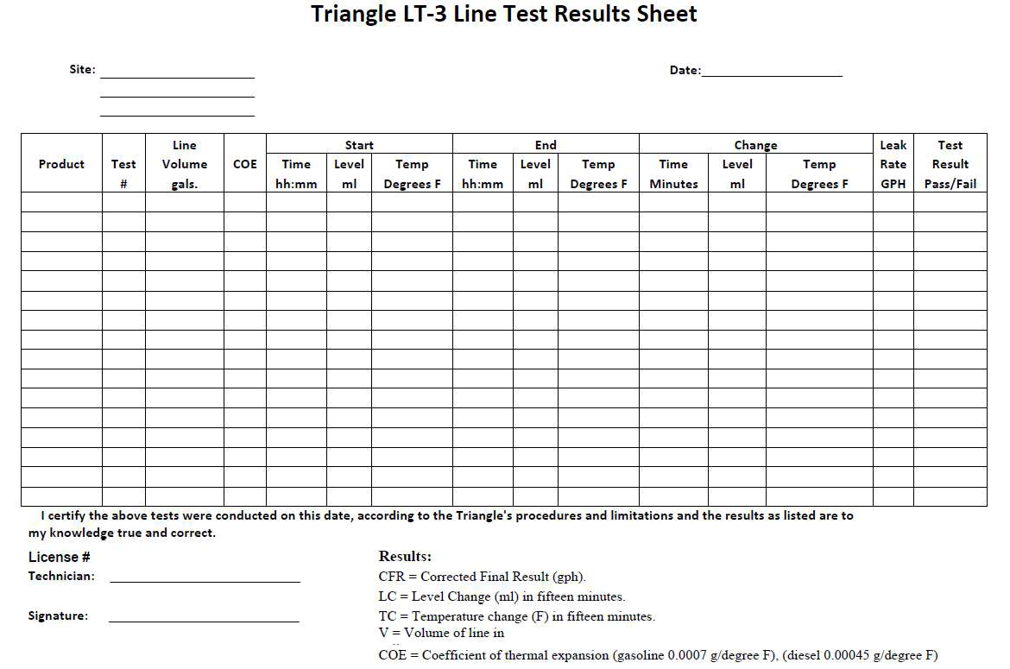

EXHIBIT B

BUDGET DETAIL AND PAYMENT PROVISIONS

- INVOICING AND PAYMENT

- For services satisfactorily rendered, and upon receipt and approval of the invoices, the State agrees to compensate the Contractor in accordance with the rates specified in Exhibit B, Attachment 1, Cost Sheet.

- Itemized invoices shall be submitted monthly in arrears of the service performed. Invoices must be submitted with the Contractor’s letterhead information exactly matching the Contractor name on the Standard Agreement 213 and be signed by an authorized representative.

- Invoices will include:
  - Contract Number
  - Date of Invoice
  - Date of Service
  - Location of Service (each building location shall be invoiced separately)
  - Description of Services, applicable rates and total dollar amount
  - Contractor’s California Certified Small Business Certification Reference Number or Disabled Veteran Business Enterprise Reference
  - Contact phone number for billing questions

- The DGS Supplier Payment Page includes detailed information on how to submit invoices to DGS and how to check the status of payments:
https://www.dgs.ca.gov/OFS/Services/Page-Content/Office-of-Fiscal-Services-Services-List-Folder/DGS-Supplier-Payment

- There are 3 options for submitting invoices to DGS as follows:
  - Through the Invoice Payment Portal (this is the preferred method of delivery)
https://dgs.service-now.com/dgs_ssp
  - By Mail
Department of General Services
Office of Fiscal Services
707 3rd Street, MS 413
West Sacramento, CA 95605
  - By Email
    - For the appropriate email address, please visit the DGS Supplier Payment page above and select “How to Submit Invoices to DGS”

- Should an invoice be disputed, Contractor will correct any/all disputed items on the invoice and resubmit the invoice as indicated above. Failure to provide and resubmit corrected invoice will result in a delay of payment. Under no circumstances will a credit memo be accepted in lieu of a corrected invoice.

- DVBE Withhold: Pursuant to Exhibit D, Section 7. F. this agreement is subject to a ten thousand dollar ($10,000) withhold from the final payment, or the full final payment if less than ten thousand dollars ($10,000), until the Contractor complies with the certification requirements of subdivision (d) of Mil. & Vet. Code Section 999.5. Contractor shall be given 30 days’ notice to cure the defect. If, after 30 calendar days from the date of notice, the prime contractor refuses to comply with the certification requirements, DGS shall permanently deduct ten thousand dollars ($10,000) from the final payment, or the full payment if less than ten thousand dollars ($10,000).

- Each building shall be invoiced separately for services/repairs provided to each building in accordance with the Equipment List, Exhibit A, Attachment 1.

- BUDGET CONTINGENCY CLAUSE

- It is mutually agreed that if the Budget Act of the current year and/or any subsequent years covered under this Agreement does not appropriate sufficient funds for the program, this Agreement shall be of no further force and effect. In this event, the State shall have no liability to pay any funds whatsoever to the Contractor or to furnish any other considerations under this Agreement and the Contractor shall not be obligated to perform any provisions of this Agreement.

- If funding for any fiscal year is reduced or deleted by the Budget Act for purposes of this program, the State shall have the option to either cancel this Agreement with no liability occurring to the State, or offer an Agreement Amendment to the Contractor to reflect the reduced amount.

- This contract is subject to any additional restrictions, limitations or conditions enacted by the Legislature that may affect the provisions, terms or funding of this contract in any manner.

- PROMPT PAYMENT CLAUSE

- Payment will be made in accordance with, and within the time specified in, Government Code Chapter 4.5, commencing with section 927.

- CONTRACTOR OVERPAYMENTS

- If the State determines that an overpayment has been made to the Contractor, the State will seek recovery immediately upon discovery of the overpayment by: (a) calling the Contractor’s accounting office to request a refund of the overpayment amount, or (b) offsetting subsequent Contractor payments by the amount of the overpayment if Contractor repayment or credit is not received within thirty (30) days from the date of notice.

- If Contractor discovers it has received an overpayment, Contractor must notify the State and refund the overpayment immediately.

EXHIBIT C

GENERAL TERMS AND CONDITIONS

PLEASE NOTE: This page will not be included with the final contract. The General Terms and Conditions will be included in the contract by reference to Internet site:

https://www.dgs.ca.gov/OLS/Resources/Page-Content/Office-of-Legal-Services-Resources-List-Folder/Standard-Contract-Language

If Contractor/bidder does not have Internet access, a hard copy will be provided by contacting the Acquisitions Analyst listed on the Notice to Prospective Bidders.

EXHIBIT D

SPECIAL TERMS AND CONDITIONS

- Standard Conditions of Service

  - Contractor will abide by all State and Federal laws in performance of this contract.

  - The Contractor shall maintain all license(s) required by law for accomplishing any work required with this agreement. In the event any license(s) expire at any time during the term of this agreement, Contractor agrees to provide to the State a copy of the renewed license(s) within thirty (30) days following the expiration date. In the event the Contractor fails to keep in effect at all times all required license(s), the State may, in addition to any other remedies it may have, terminate this agreement upon occurrence of such event.

  - The Contractor certifies that it has appropriate systems and controls in place to ensure that State funds will not be used in the performance of this Contract for the acquisition, operation or maintenance of computer software in violation of copyright laws.

  - If signing this contract as a sole proprietor, Contractor certifies that it is not an alien that is ineligible for state and local benefits, as defined in Subtitle B of the Personal Responsibility and Work Opportunity Act (8 U.S.C. § 1601 et seq.).

  - Pursuant to Public Contract Code section 10295.4, persons or companies identified as the largest tax delinquents by the Franchise Tax Board (FTB) or the California Department of Tax and Fee Administration (CDTFA) are ineligible to enter into any contract with the state for non-IT goods or services. Any contract entered into in violation of section 10295.4 is void and unenforceable.

  - If contract activities include collection of organic waste, the Contractor must be aware and adhere to Public Resources Code § 42649.1 et. seq. concerning organic waste recycling requirements. Organic waste includes: food waste, green waste, landscape and pruning waste, nonhazardous wood waste, and food-soiled paper waste that is mixed in with food waste.

  - If applicable, The Contractor's, and any subcontractor's, own data center or cloud computing, where data may be stored, must be physically located in the continental United States or Hawaii. Remote access to data from outside the continental United States or Hawaii is prohibited.

  - If applicable, Pursuant to PCC 10230, this contract included Disabled Veteran Business Enterprise (DVBE) participation in the bid. The Contractor must comply with rules, regulations, ordinances, and statutes that apply to the California DVBE Program, as defined in Section 999 of the Military and Veterans Code, including, but not limited to, the requirements of subdivision (d) of Section 999.5 of the Military and Veterans Code.

  - Pursuant to LC 1060, any Contractor or subcontractor providing janitorial and/or building maintenance services, that is awarded a contract to provide such services at a new site(s) must retain for 60 days, the current employees employed at that site(s) by the previous contractor/sub-contractor. The State shall obtain from the previous contractor employee information and provide the same information to the new contractor so the new contractor can make necessary notifications required by law.

- EXCISE TAX: The State of California is exempt from Federal Excise Taxes, and no payment will be made for any taxes levied on employees' wages. The State will pay for any applicable State of California or local sales or use taxes on the services rendered or equipment or parts supplied pursuant to this agreement. California may pay any applicable sales or use tax imposed by another state.

- RIGHT TO TERMINATE

  - The State reserves the right to cancel all or a portion of the service for any reason, subject to thirty (30) days written notice to the Contractor.

  - This agreement can be immediately terminated for cause. The term “for cause” means that the Contractor fails to meet the terms, conditions, and/or responsibilities of the contract. In this instance, the contract termination shall be effective as of the date indicated on the State’s notification to the Contractor.

- RESOLUTION OF CONTRACT DISPUTES

  - In the event of a dispute, Contractor will attempt resolution with the FMD Contract Administrator with a written explanation of the situation. If no resolution is found, Contractor shall file a “Notice of Dispute” with the Department of General Services within ten (10) days of the failed resolution at the following address:
Attn: FMD Deputy Director
Department of General Services, FMD
707 3rd Street, 3rd Floor
West Sacramento, CA 95605

  - FMD Deputy Director or designee shall meet with the Contractor for purposes of resolving the dispute. The decision of the FMD Deputy Director or the designee shall be final. In the event of a dispute, the language contained within this agreement and its attendant Exhibits shall prevail over any other language.

  - Neither the pendency of a dispute nor its consideration by the FMD Deputy Director will excuse the Contractor from full and timely performance in accordance with the terms of the Agreement.

- HEALTH AND SAFETY PROVISIONS

  - Contractor and all subcontractors shall abide by all health and safety mandates issued by federal, state, and local governments and/or public health officers as well as those issued by DGS, and worksite specific mandates. If multiple mandates exist, the Contractor and subcontractors shall abide by the most restrictive mandate. The term “employee”, “worker”, “state worker” or “state employee” in health and safety mandates includes contractor and subcontractor personnel.

  - Costs associated with adhering to health and safety mandates are the responsibility of the Contractor. Contractor is responsible for the tracking and compliance of health and safety mandates and may be audited upon request.

- SUBCONTRACTORS

- Nothing contained in this Agreement or otherwise, shall create any contractual relationship between FMD and any subcontractors, and no subcontract shall relieve the Contractor of its responsibilities and obligations hereunder. The Contractor agrees to be as fully responsible to FMD for the acts and omissions of its subcontractors and of persons either directly or indirectly employed by the Contractor. The Contractor's obligation to pay its subcontractors is an independent obligation from FMD’s obligation to make payments to the Contractor. As a result, FMD shall have no obligation to pay or to enforce the payment of any monies to any subcontractor.

- Any subcontractors are identified in Exhibit D, Attachment 1.

- PREFERENCE PROGRAM- SB/DVBE

  - Should this contract be awarded based in part on the commitment to use a Disabled Veteran Business Enterprise (DVBE) subcontractor(s) identified in their bid or offer, per Military and Veterans Code section 999.5, subdivision (e), a DVBE subcontractor may only be replaced by another DVBE subcontractor and must be approved in writing by the Department of General Services (DGS) Office of Small Business and DVBE Services (OSDS). Changes to the scope of work that impact the DVBE subcontractor(s) identified in the bid or offer and approved DVBE substitutions will be documented by contract amendment.

  - Failure of Contractor to seek substitution and adhere to the DVBE participation level identified in the bid or offer may be cause for contract termination, recovery of damages under rights and remedies due to the State, and penalties as outlined in Military and Veterans Code section 999.9, or Public Contract Code sections 10115.10 or 4110 (applies to public works only).

  - If for this agreement Contractor made a commitment to achieve DVBE participation, upon completion of the awarded contract, the Contractor must certify to the awarding department all of the following:
    - The total amount the contractor received under the contract.
    - The name and address of the DVBE that participated in the performance of the contract and the contract number
    - The amount and percentage of work the Contractor committed to provide to one or more DVBE under the requirements of the contract and the amount each DVBE received from the Contractor.
    - That all payments under the contract have been made to the DVBE(s). Upon request by the awarding department, the Contractor shall provide proof of payment for the work.

  - STD 817 shall be used for Contractor’s certification and provided to the State’s Contract Administrator. STD 817 is located at the following internet site:
https://www.documents.dgs.ca.gov/dgs/fmc/pdf/std817.pdf

  - A person or entity that knowingly provides false information will be subject to a civil penalty for each violation. (Mil. & Vet. Code, § 999.5, subd. (d).)

  - Withhold: Ten thousand dollars ($10,000) will be withheld from the final payment, or the full final payment if less than ten thousand dollars ($10,000), until the Contractor complies with the certification requirements of subdivision (d) of Mil. & Vet. Code Section 999.5. Contractor shall be given 30 days’ notice to cure the defect. If, after 30 calendar days from the date of notice, the prime contractor refuses to comply with the certification requirements, DGS shall permanently deduct ten thousand dollars ($10,000) from the final payment, or the full payment if less than ten thousand dollars ($10,000).

- INSURANCE REQUIREMENT

  - General Provisions Applying to All Policies
    - Coverage Term – Coverage needs to be in force for the complete term of the contract. If insurance expires during the term of the contract, a new certificate must be received by the State at least thirty (30) days prior to the expiration of this insurance. Any new insurance must still comply to the original terms of the contract.
    - Policy Cancellation or Termination & Notice of Non-Renewal – Contractor is responsible to notify the State within 5 business days of any cancellation, non-renewal or material change that affects required insurance coverage. In the event Contractor fails to keep in effect at all times the specified insurance coverage, the State may, in addition to any other remedies it may have, terminate this Contract upon the occurrence of such event, subject to the provisions of this Contract.
    - Deductible – Contractor is responsible for any deductible or self-insured retention contained within their insurance program.
    - Primary Clause – Any required insurance contained in this contract shall be primary, and not excess or contributory, to any other insurance carried by the State.
    - Insurance Carrier Required Rating – All insurance companies must carry a rating acceptable to the Office of Risk and Insurance Management. If the Contractor is self-insured for a portion or all of its insurance, review of financial information including a letter of credit may be required.
    - Endorsements – Any required endorsements requested by the State must be physically attached to all requested certificates of insurance and not substituted by referring to such coverage on the certificate of insurance.
    - Inadequate Insurance – Inadequate or lack of insurance does not negate the Contractor’s obligations under the contract.
    - Owner Operated Company - If Contractor is an owner operated company, a Workers’ Compensation Statement of Exemption would need to be on file rather than stipulations in Section 9.D.
    - Subcontractors – If Contractor has identified subcontractors for the work/services identified in the scope of work, the Contractor shall include all subcontractors as insureds under Contractor’s insurance or supply evidence of subcontractor’s insurance to the State equal to policies, coverages and limits required of Contractor.

  - Commercial General Liability – Contractor and any subcontractors shall maintain general liability on an occurrence form with limits not less than $1,000,000 per occurrence for bodily injury and property damage liability combined. If Commercial General Liability insurance or other form with a general aggregate limit is used, either the general aggregate limits shall apply separately to this project/location, or the general aggregate limit shall be twice the required occurrence limit. If the aggregate applies “per project/location” it shall so state on the certificate. The policy shall include coverage for liabilities arising out of premises, operations, independent contractors, products, completed operations, personal & advertising injury, and liability assumed under an insured contract. This insurance shall apply separately to each insured against whom claim is made or suit is brought subject to the Contractor’s limit of liability. The policy must be endorsed to include the State of California, its officers, agents and employees as additional insured, but only with respect to work performed under the contract. The additional insured endorsement shall be provided with the certificate of insurance.

  - Automobile Liability – Contractor shall maintain motor vehicle liability with limits not less than $1,000,000 combined single limit per accident. Such insurance shall cover liability arising out of a motor vehicle including owned, hired and non-owned motor vehicles. The policy must be endorsed to include the State of California, its officers, agents and employees as additional insured, but only with respect to work performed under the contract. The additional insured endorsement shall be provided with the certificate of insurance.

  - Workers Compensation and Employers Liability – Contractor shall maintain statutory worker’s compensation and employer’s liability coverage for all its employees who will be engaged in the performance of the Contract. Employer’s liability limits of $1,000,000 are required. The Workers’ Compensation policy shall be endorsed with a waiver of subrogation in favor of the State.

  - Errors and Omissions/Professional Liability- Contractor shall maintain Errors and Omissions/Profession liability with limits of not less than $1,000,000 each incident and $2,000,000 aggregate covering damages caused by negligent, acts or omissions. The policy retro date must be shown on a certificate of insurance and must be before the Contract date, or before the date contract work begins. Insurance must be maintained, and evidence of insurance must be provided for at least five (5) years after completion of the contract of work. If coverage is canceled or non-renewed, and not replaced with another claims-made policy form with a retroactive date prior to the contract effective date, the Contractor must purchase “extended reporting” coverage for a minimum of five (5) years after the completion of work.

  - Certificate of Insurance - The Contractor shall furnish a Certificate of Insurance. The Certificate of Insurance will provide the above listed liability coverages and the Certificate Holder shall read
Department of General Services, The Ziggurat
Attn: FMD Contract Administrator – 25-279264
Mailstop: 700
707 Third Street
West Sacramento, CA 95605

- RUSSIAN SANCTION ORDERS: On March 4, 2022, Governor Gavin Newsom issued Executive Order (EO) N-6-22 regarding Economic Sanctions against Russia and Russian entities and individuals. “Economic Sanctions” refers to sanctions imposed by the U.S. government in response to Russia’s actions in Ukraine, as well as any sanctions imposed under state law. The EO directs state agencies to terminate contracts with, and to refrain from entering any new contracts with, individuals or entities that are determined to be a target of Economic Sanctions. Accordingly, should the State determine Contractor is a target of Economic Sanctions or is conducting prohibited transactions with sanctioned individuals or entities, that shall be grounds for termination of this agreement. The State shall provide Contractor advance written notice of such termination, allowing Contractor at least 30 calendar days to provide a written response. Termination shall be at the sole discretion of the State.

- NEWS RELEASES: News releases pertaining to award of, or work performed as a result of, contract may not be made without prior written approval of:

The Public Information Officer
707 Third Street, MS 101
West Sacramento, CA 95605
Phone: (916) 376-5037
Email: DGSPublicAffairs@dgs.ca.gov

EXHIBIT D, ATTACHMENT 1

SUBCONTRACTORS

Bidder Declaration, Form GSPD-05-105 shall be requested from the apparent winning bidder. A modified version of the form will be entered into the final Agreement.

EXHIBIT E

PREVAILING WAGE

INFORMATION FOR BIDDERS

- Pursuant to Sections 1725.5 and 1771.1 of the Labor Code, all contractors and subcontractors must be currently registered with the Department of Industrial Relations (DIR) in order to qualify to bid on; be listed in a bid proposal, subject to the requirements of Section 4104 of the Public Contract Code; or engage in the performance of any contract for public work.
Note that limited exceptions for Joint Venture Bidders and Projects with Federal Funds may apply pursuant to Section 1771.1 of the Labor Code
For complete information and the online registration, please see internet site:
http://www.dir.ca.gov/Public-Works/PublicWorks.html

- Contractor’s bid and/or quote shall be in accordance with prevailing wage rates ascertained by DIR and set forth on the DIR web site for General Prevailing Wage Rates.

- Pursuant to Labor Code, Section 1770, DIR has ascertained general prevailing rate of per diem wages in the locality in which the work is to be performed. Copies of the prevailing rate of per diem wages are available from:

Department of Industrial Relations, Labor Statistics & Research Division
PO Box 420603
San Francisco, CA 94142
(415) 703-4780

Or wage rates may be accessed on the internet at:
http://www.dir.ca.gov/OPRL/statistics_research.html.

Note: When the wage determination shows an expiration date (noted by a double asterisk**), to expire during the term of the contract, the Contractor must call or write the DIR to obtain the new rates and incorporate them in this contract for submittal of bid/quote.
Note: Contractor is responsible to comply with the Labor Code Sections and prevailing wage determinations, including all the guidelines and the fine print in the prevailing wage determinations.

- Pursuant to Labor Code, Section 1774, the Contractor to whom the contract is awarded, and any subcontractor under him, shall pay not less than the specified prevailing rates of wages to all workers employed in the execution of the contract.

Bidder’s attention is directed to Labor Code Section 1771.1, relating to inadvertent errors in the listing of subcontractors not currently registered with DIR.

(The information above in orange will not be included in the final contract)
  - The Contractor shall comply with Labor Code Sections 1774 and 1775. Pursuant to Section 1774, the Contractor and every subcontractor, regardless of tier, shall pay not less than the specified prevailing wage rates to all workers employed in the execution of the Contract. In accordance with Section 1775, the Contractor shall forfeit to the State up to $200 for each day, or portion thereof, for each worker paid less than the prevailing wage rates for the work or craft in which the worker is employed for any work executed under the Contract by the Contractor or by any subcontractor, regardless of tier, in violation of the provisions of the Labor Code; and, in particular, Labor Code Sections 1770 to 1780, inclusive. In addition to such forfeiture, the difference between such stipulated prevailing wage rates and the amount paid to each worker for each day, or portion thereof, shall be paid to each underpaid worker by the Contractor. This provision shall not apply to properly registered apprentices.

  - Pursuant to Labor Code, Section 1770, the Director of the Department of Industrial Relations (DIR) has ascertained the general prevailing rate of per diem wages and a general prevailing rate for legal holiday and overtime work for each craft required for execution of the Contract. The Contractor shall obtain copies of the prevailing rate of per diem wages from:

Department of Industrial Relations, Division of Labor Statistics & Research
PO Box 420603
San Francisco, CA 94142-0603
(415) 703-4780

Or wage rates may be accessed on the internet at
http://www.dir.ca.gov/OPRL/statistics_research.html.

The Contractor is responsible to read, understand and comply with all the guidelines, including the fine print in the prevailing wage determinations; and shall post a copy of the prevailing wage rates, specific to the Project, at the Project site.

  - Wage rates set forth are the minimum that may be paid by the Contractor. Nothing herein shall be construed as preventing the Contractor from paying more than the minimum rates set. No extra compensation will be allowed by the State due to the inability of the Contractor to hire labor at minimum rates, nor for necessity for payment by the Contractor of subsistence, travel time, overtime, or other added compensations, all of which possibilities are elements to be considered and ascertained to the Contractor's own satisfaction in preparing their Cost Sheet at the time of the bidding opportunity and will be applicable for the term of the contract.

  - If it becomes necessary to employ crafts other than those listed in DIR’s General Prevailing Wage Rate booklet, the Contractor shall contact the Division of Labor Statistics and Research as noted above. The rates thus determined shall be applicable as minimum for the contract and incorporated in the Cost Sheet. When the wage determination shows an expiration date (noted by a double asterisk**), to expire during the term of the contract, the Contractor must call or write the DIR to obtain the new rates and will have incorporated them into their Cost Sheet at the time of the bidding opportunity and will then be applicable for the term of the contract.
  - The Contractor and each subcontractor, regardless of tier, shall keep an accurate payroll record showing the names, addresses, social security numbers, work classifications, straight time and overtime hours worked each day and week, and the actual per diem wages paid to each journeyman, apprentice, worker, or other employee employed by the Contractor and/or subcontractor in connection with the Work. Payroll records shall be certified and shall be on forms provided by the Division of Labor Standards Enforcement, or shall contain the same information as those forms. The Contractor's and subcontractor's certified payroll records for each employee shall be submitted with each payment request, covering the period of the payment request unless requested otherwise by the Labor Commissioner of the Department of Industrial Relations pursuant to Labor Code Section 1771.4(c)(2)(b) If this contract was awarded on or after April 1, 2015, monthly payrolls should be sent directly to the Department of Industrial Relations in the current prescribed electronic format. Refer to http://www.dir.ca.gov/Public-Works/PublicWorks.html for access to the electronic Certified Payroll Application.

  - Labor Compliance Monitoring and Enforcement: This project is subject to monitoring and enforcement by the Department of Industrial Relations (DIR), Compliance Monitoring Unit if awarded after January 1, 2015. All Contractors and subcontractors, regardless of tier, shall be required to comply with the Monitoring and Enforcement Program, including, but not limited to, contractor registration, submittal of electronic certified payroll reports directly to the DIR and cooperation with on-site monitoring by DIR personnel. Refer to Labor Code 1771.4 et seq.

