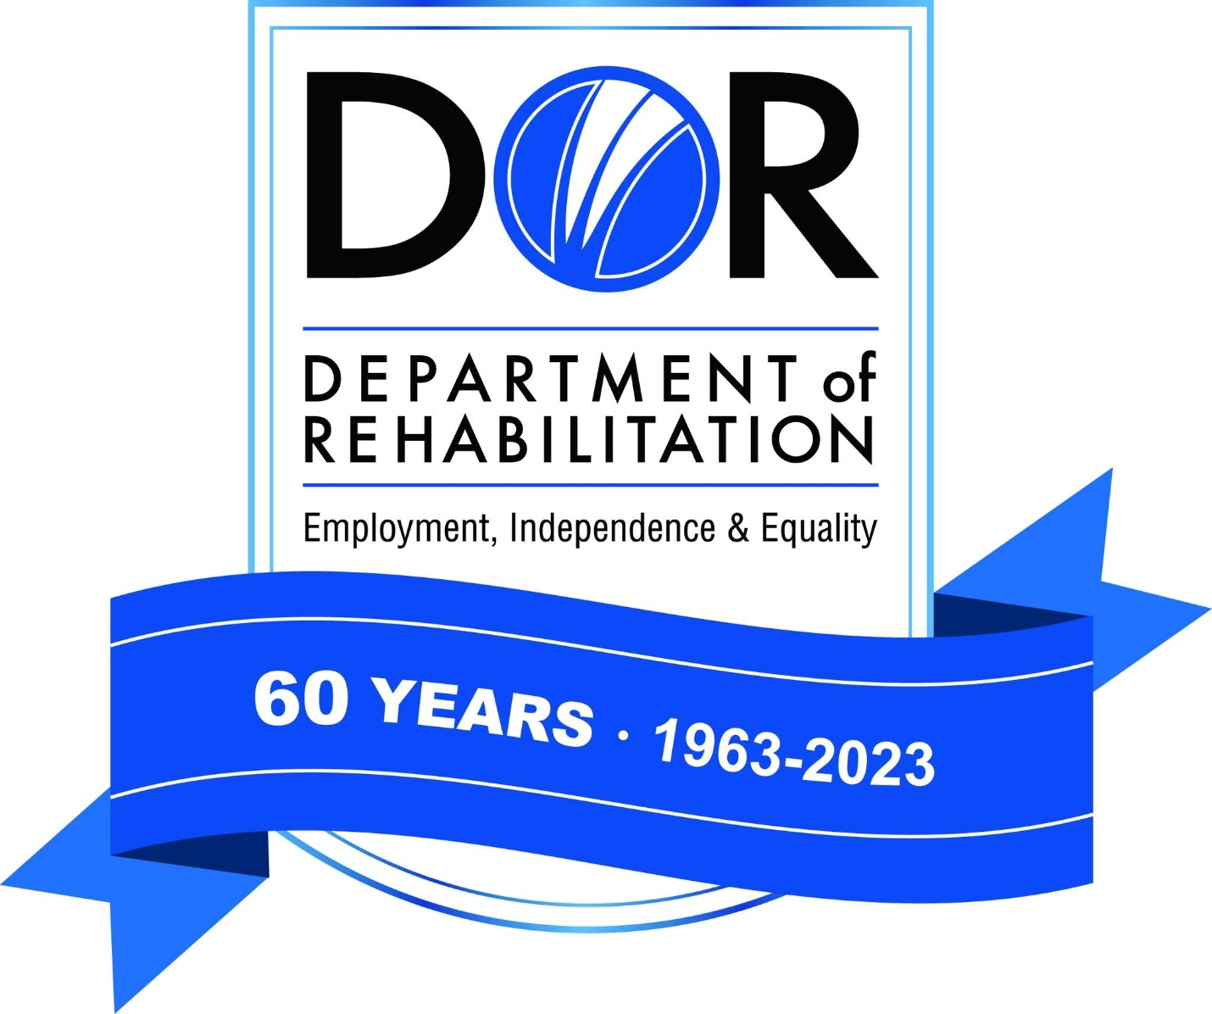 | Gavin Newsom  Governor    State of California  Health and Human Services Agency
Department of Rehabilitation
721 Capitol Mall
Sacramento CA 95814
June 23, 2026

USPO Processing and Distribution Bldg.
RFQ # 03-0812C
Informal Competitive

You are invited to review and respond to the Request for Quote (RFQ) 03-0813C USPO Processing and Distribution Bldg. for drink and snack vending machines. In submitting your quote, you must comply with all the instructions outlined in the RFQ.

Note that all agreements entered with the State of California will include by reference General Terms and Conditions that may be viewed and downloaded at Internet site http://www.dgs.ca.gov/pd. If you do not have Internet access, a hard copy can be provided by contacting the person listed below.

The RFQ Due Date is:

July 7, 2026, by 2:00 p.m.

Questions regarding this RFQ may be submitted by email to the department contact below. Any questions regarding this RFQ must be received NO later than 3 business days prior to the due date at 2:00 pm. Quotes received after the due date and time will not be accepted.

The State assumes no responsibility if a bidder cannot submit their quote via email or if the entire quote is not received prior to the quote due date and time.

ALL BIDS MUST BE SUBMITTED TO:
Department of Rehabilitation
Jim Abad, Procurement Analyst II
Jim.Abad@dor.ca.gov
And
Tiffany Baker, Procurement Analyst II
Tiffany.Baker@dor.ca.gov

