Date: June 26, 2026

To: All Bidders for IFB 25-282057 Boiler Tune-Up and Coen Burners Maintenance

From: Department of General Services
Office of Business and Acquisition Services (OBAS)

Subject: IFB 25-282057 – Questions and Answers

As of June 15, 2026, OBAS received on behalf of Facilities Management Division the following questions (Q) and is providing the following answers (A):

Q1: Is there DVBE requirements for this solicitation.
A1: Yes. Please see IFB Instructions Section D.2 Disabled Veteran Business Enterprise:
“There is a 3% DVBE participation minimum requirement for this contract.”

Q2: I didn't see any drawings of the boilers to work, would you please send me the file?
A2: Due to security concerns, we do not provide drawings. The purpose of the walkthrough allows bidders the opportunity to walk the site, to be familiar with the site and determine conditions that might impact their bids. All the specifications we have available were provided within the Exhibit A, Attachment 1, Equipment List.

Q3: [Our Company] operates with General A license. I just wanted to confirm that this meets the requirements covering the C-4 license mentioned in the minimum requirements.
A3: No. Pursuant to IFB, Section B.1 (b) and IFB Attachment 9, Sample Agreement, Exhibit A, Section 3(A):

Contractor must possess and maintain, at all times during the term of this agreement, a valid Class C-4, Boiler, hot water heating and steam fitting Contractor license issued by the California Department of Consumer Affairs, Contractors State License Board.

Q4: Considering this Bid is subject to prevailing wage, is there a fixed markup to be applied to the rate we present?
A4: There is no fixed markup, however the appropriate prevailing wages should be included in your rate. See Exhibit E- Prevailing Wage. Rates are available for review on the Department of Industrial Relations website at the following link: https://www.dir.ca.gov/Public-Works/Prevailing-Wage.html. It is up to each bidder to ensure that their bid is in compliance with Labor Code pertaining to prevailing wage.

Q5: Is drinking water included in the utilities provided?
A5: Pursuant to IFB Attachment 9, Sample Agreement, Exhibit A, Section 5 (E), Utilities: water, electricity, elevator and restroom facilities are available free of charge while performing services associated with this Agreement.

The facility is equipped with drinking fountains.

Q6: Is this request to remove the entire controller and probes?
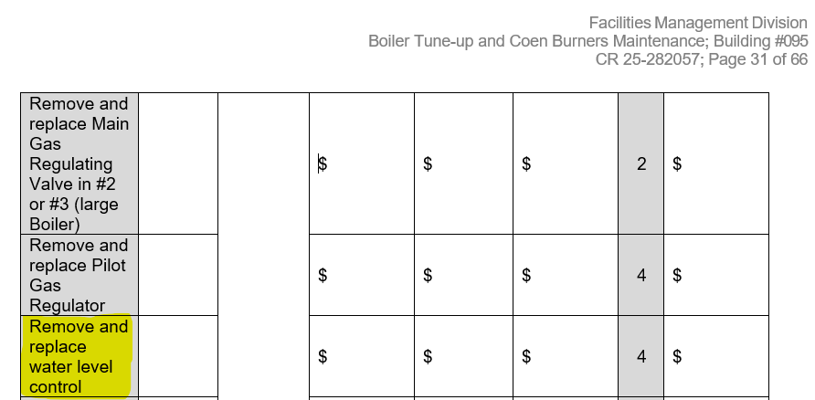
A6: This service item is to replace the probes. Per IFB 25-282057, Addendum 2, IFB Attachment 8, Exhibit B, Attachment 1, Cost Sheet, Table 2, Foreseeable Repair Services was revised to clarify this service item.

Q7: The boilers have different requirement per boiler size. Should there be a separate line item for each boiler size?
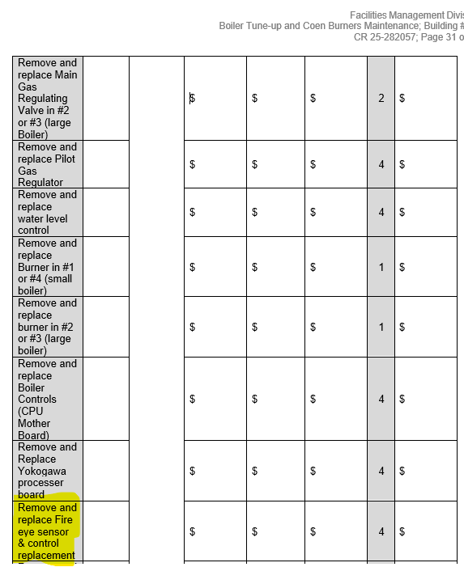
A7: Yes, a separate line item for each boiler is needed and per IFB 25-282057, Addendum 2, IFB Attachment 8, Exhibit B, Attachment 1, Cost Sheet, Table 2, Foreseeable Repair Services was revised to clarify the service item.

.

