INVITATION FOR BID
Notice To Prospective Bidders

Freight Shipping and Delivery Services
IFB FTB-2526-PW-038
ADDENDUM 2

May 21, 2026

You are invited to review and respond to this Invitation for Bid (IFB), entitled “Freight Shipping and Delivery Services,” BID LOG # IFB FTB-2526-PW-038 Addendum 2. The Franchise Tax Board (FTB) is asking that in submission of your bid, you comply with the following instructions:

Note that all Agreements entered into with the State of California will include by reference the State’s General Terms and Conditions (GTC 02/2025) which may be viewed and downloaded at the Internet site https://www.dgs.ca.gov/OLS/Resources/Page-Content/Office-of-Legal-Services-Resources-List-Folder/Standard-Contract-Language. If you do not have Internet access, a hard copy can be provided by contacting the person listed below.
Please note that for purposes of this bid, the Disabled Veteran Business Enterprises (DVBE) Program Requirement has been waived.

In the opinion of the Franchise Tax Board, this IFB is complete and without need of explanation. However, if you have questions, or should you need any clarifying information, the contact person for this IFB is:

Marisa Lai
Procurement Official
Franchise Tax Board
(916) 845-4518
Marisa.Lai@ftb.ca.gov

and Cc

Ranu Bhatt
Procurement Official
Franchise Tax Board
(916) 845-2145
Ranu.Bhatt@ftb.ca.gov

Please note that no verbal information given will be binding upon the Franchise Tax Board unless such information is issued in writing as an official addendum.

TABLE OF CONTENTS

INFORMATION AND BIDDER REQUIREMENTS 3
A. PURPOSE AND DESCRIPTION OF SERVICES 3
B. BIDDER’S MINIMUM QUALIFICATIONS AND REQUIREMENTS 3
C. PREVAILING WAGE 4
D. KEY ACTION DATES 4
E. WRITTEN QUESTIONS 5
F. SUBMISSION OF BID 5
G. PUBLIC BID OPENING 7
H. EVALUATION AND SELECTION 7
I. AWARD AND PROTEST 7
J. DISPOSITION OF BIDS 8
K. AGREEMENT EXECUTION AND PERFORMANCE 8
L. VERIFYING CORPORATE QUALIFICATION TO DO BUSINESS IN CALIFORNIA 8
M. PAYEE DATA RECORD 9
N. PAYEE DATA RECORD SUPPLEMENT 9
O. CONTRACTOR CERTIFICATION CLAUSES 9
P. DARFUR 9
Q. GENERATIVE ARTIFICIAL INTELLIGENCE (GENAI) 10
R. COMMERCIALLY USEFUL FUNCTION 10
S. EXECUTIVE ORDER N-6-22 – RUSSIA SANCTIONS 10
T. INSURANCE REQUIREMENTS 11
U. BIDDER DECLARATION……………………………………………………………………………..11
V. PREFERENCE PROGRAMS 11
W. REQUIRED DOCUMENTS 14
ATTACHMENTS 15
ATTACHMENT 1 – REQUIRED DOCUMENTS CHECKLIST 15
ATTACHMENT 2 – BID/BIDDER CERTIFICATION SHEET 17
ATTACHMENT 3 – BID COST SHEET 18
ATTACHMENT 4 – COMMERCIALLY USEFUL FUNCTION (CUF) CERTIFICATION 25
ATTACHMENT 5 – COMPANY EXPERIENCE……………………………………………………...…26
SAMPLE OF STANDARD AGREEMENT, STD 213 27
EXHIBIT A – SCOPE OF WORK 30
EXHIBIT A-1 – SERVICE REQUEST/WORK ORDER……...………………………………………….52
EXHIBIT A-2 – CERTIFICATE OF INSURANCE & INDEMNITY AGREEMENT…………………….53
EXHIBIT A-3 – CONTRACTORS INSURANCE AND IDEMNITY AGREEMENT…….....................54
EXHIBIT A-4 – CONTRACTOR’S FREIGHT/DOCK DELIVERY REQUEST 56
EXHIBIT A-5 – ADMIT AUTHORIZATION 58
EXHIBIT A-6 – LOADING DOCK/TEMPORARY PARKING REQUEST FORM 59
EXHIBIT B - BUDGET DETAIL AND PAYMENT PROVISIONS……..…….…………………….…...60
EXHIBIT D - NON-IT FTB SPECIAL PROVISIONS 62
EXHIBIT E - ADDITIONAL PROVISIONS 70

INFORMATION AND BIDDER REQUIREMENTS

Purpose and Description of Services
The purpose of this Invitation for Bid (hereinafter called the “IFB”) is to solicit bids from qualified vendors to provide the Franchise Tax Board (FTB) freight shipping and delivery services, on an as-needed basis, for freight cargo weighing at least one-hundred fifty (150) pounds or more. Reference Exhibit A, Scope of Work (SOW), of this IFB for additional detailed information.

The locations for performance of work are:

Franchise Tax Board (Central Campus)  9646 Butterfield Way  Sacramento, CA 95827 | Franchise Tax Board (Sacramento Field Office)  3321 Power Inn Road Suite 250  Sacramento, CA 95826
Franchise Tax Board (Van Nuys Field Office)  15350 Sherman Way, Suite 100  Van Nuys, CA 91406 | Franchise Tax Board (Santa Ana Field Office)  600 West Santa Ana Boulevard, Suite 300 & 400  Santa Ana, CA 92701
Franchise Tax Board (San Diego Field Office)  7575 Metropolitan Drive, Suite 201  San Diego, CA 92108 | Franchise Tax Board (Los Angeles Field Office)  300 South Spring Street, Suite 5704  Los Angeles, CA 90013
Franchise Tax Board (West Covina Field Office)  100 N Barranca Street, Suite 350, 500 & 600  West Covina, CA 91791 | Franchise Tax Board (Oakland Field Office)  1515 Clay Street, Suite 305  Oakland, CA 94612-1445
Franchise Tax Board (San Jose Field Office)  2665 N 1st Street, Suite 210  San Jose, CA 95134-2035 | Franchise Tax Board (San Francisco Field Office)  455 Golden Gate Avenue, Suite 8600, San Francisco CA 94102
Franchise Tax Board (Chicago Field Office)  One North Franklin, Suite 400  Chicago, IL 60606-3448 | Franchise Tax Board (Houston Field Office)  1415 Louisiana Street, Suite 2600  Houston, TX 77002-7392
Franchise Tax Board (New York Field Office # 1)  1212 Avenue of the Americas, Suite 400  New York, NY 10036 | Managed Facility Solutions, LLC  128 Component Drive  San Jose, CA 95131
Franchise Tax Board (New York Field Office # 2)
1180 Avenue of the Americas, Suite 900
New York, NY 10036

Bidder’s Minimum Qualifications and Requirements

- Bidder must have a minimum of one (1) year experience with performing freight shipping and delivery services the same type and scope required for the work outlined in Exhibit A, SOW, in the Sample Standard Agreement section, of this IFB. Reference Attachment 5 – Company Experience to demonstrate compliance with the mandatory, minimum one (1) year experience requirement for freight shipping and delivery services.

- Bidder personnel must possess a valid Motor Carrier permit issued by the California Department of Transportation for office deliveries and pick-ups authorizing transportation of property for hire by motor vehicle and operate within the scope of the permit.

- In response to this IFB, the Bidder shall provide a copy of a valid Commercial (Class A) Driver’s License.

- By submitting their bid and signing Attachment 2, Bid/Bidder Certification Sheet, the Bidder certifies under penalty of perjury that their company and their staff possess the appropriate license and meet the minimum qualifications listed above to perform the work outlined in Exhibit A, SOW, in the Sample Standard Agreement section, of this IFB.

Prevailing Wage

The State General Prevailing Wage Rates will apply for the County in which work is to be performed as described in this Exhibit A, Scope of Work, in the Sample Standard Agreement section, of this IFB. The prevailing wage rate determinations can be downloaded from the Department of Industrial Relations’ (DIR) website at https://www.dir.ca.gov/oprl/DPreWageDetermination.htm or available upon written request by the Procurement Official. Additional questions regarding prevailing wage determinations shall be referred to the DIR’s Labor Research and Statistics Office at Statistics@dir.ca.gov. It is the Bidder’s responsibility to use the correct classification determination published by the Department of Industrial Relations.

The State of Texas prevailing wage rates, if applicable, willy apply in accordance with the requirements defined by the U.S. Department of Labor under the Davis-Bacon Act .

The State of Illinois prevailing wage rates, if applicable, will apply in accordance with the requirements defined by the Illinois Department of Labor current prevailing wage rates.

The State of New York prevailing wage rates, if applicable, will apply in accordance with the provisions of Article 8 defined by New York Department of Labor.

Key Action Dates

Below are the important dates and times by which the actions must be taken or completed. If the State finds it necessary to change any of these dates, it will be accomplished via an addendum to the IFB. All dates after the final date for Bid submission deadline are approximate and may be adjusted as conditions indicate, without addendum to this IFB.

Event | Date | Time
IFB available to prospective bidders | April 29, 2026
Final Date for Written Questions for Clarification of IFB | May 6, 2026 | 12:00 pm PT
IFB Addendum # 1 posted on Cal eProcure | May 19, 2026 | -
IFB Addendum # 2 posted on Cal eProcure | May 21, 2026 | -
Questions and Answer Set posted on Cal eProcure | May 21, 2026* | -
Final Date for Bid Submission | June 1, 2026 | 2:00 pm PT
Public Bid Opening | June 2, 2026* | 11:00 am PT
Evaluation and Selection | June 9, 2026*¹ | -
Notice of Intent to Award | June 9, 2026* | -
Award of Agreement to successful bidder | 5 business days after Intent to Award* | -
Proposed Start Date of Agreement | July 1, 2026, or upon approval, whichever is later | -
Date Term of Agreement Ends | July 31, 2027 | -
* This date is subject to change without notice or addendum to this IFB.

¹If requested, the Notice of Intent to Award shall be published on Cal eProcure in the same location as the solicitation was published: Bid opportunities in the California State Contracts Register (CSCR).

Written Questions

- Every attempt has been made to produce complete specifications for this service. Should the Bidder discover any ambiguity, conflict, omission or other error in the IFB, or have any questions concerning interpretation or clarification, the Bidder shall immediately notify the State of such in writing and request clarification or modification of the document. All questions or concerns regarding this IFB must be sent in writing via email to the contact person listed on page one (1) of this IFB. All questions must be received on or before the date and time indicated in the Key Action Date, and include the Bidder’s name, the business name, phone number, and this IFB name and number. Questions not submitted by the Key Action Date shall be answered at FTB’s option.

- Upon FTB completion of review, all questions will be answered in writing and posted to the original advertisement on the Cal eProcure website by the Key Action Date identified above. The Question and Answer Set will state each question, but not the source of the question, along with the State’s response. If there are any changes to the IFB as a result of any questions, there will be an IFB addendum that will become part of the IFB, and posted to the original IFB advertisement on Cal eProcure. Only written responses shall be considered binding. Bidders should rely on written, rather than verbal, responses from the State. The State reserves the right to cancel or modify this IFB, in whole or in part.

- An error in the Final Bid may cause the rejection of that bid; however, the State may at its sole option retain the bid and make certain immaterial corrections, including obvious clerical errors.

Submission of Bid

Bidders are required to submit an electronic bid response to the following email address: Marisa.Lai@ftb.ca.gov and Cc Ranu.Bhatt@ftb.ca.gov by the due date and time identified in the Information and Bidder Requirements, Section D, Key Action Dates. Bids not received by the due date and time specified, will be rejected. Please maintain a record of your emailed bid response as proof of timely submittal. Emails will be opened during the Public Bid Opening on the date identified in the Information and Bidder Requirements, Section D, Key Action Dates.

The subject line of the bid response email should read: IFB FTB-2526-PW-038 Bid Response - (Your Company’s Name)

Bids are to be sent electronically to the following email address: Marisa.Lai@ftb.ca.gov with a Cc to Ranu.Bhatt@ftb.ca.gov

- The State reserves the right to consider authorized emailed bid responses as properly “sealed” if received prior to the due date and time specified. Authorized emailed bid responses will be considered only if they are sent to the email address listed above. Bid responses sent to any other email address (unless otherwise specified) will not be considered. To be considered, all pages of an emailed bid response must be completely received prior to the bid response due date and time identified in the Information and Bidder Requirements, Section D, Key Action Dates.

- All bids shall include the required documents. Bids not including the “required attachments” may be deemed non-responsive and cause for rejection. A non-responsive bid is one that does not meet the basic bid requirements.

- All documents in the original bid requiring a signature must bear an original signature of a person authorized to bind the bidding firm.

- Bids must be submitted for the performance of all the services described herein. Any deviation from the work specifications will not be considered and may cause a bid to be rejected.

- More than one bid from an individual, a firm or partnership, a corporation, or an association under the same or different names will not be considered. Reasonable grounds for believing that any Bidder is interested in more than one bid for the work contemplated will cause the rejection of all bids in which such Bidder is interested. If there is reason for believing that collusion exists among the vendors, none of the participants in such collusion will be considered in this or future bids.

- A bid may be rejected if it is conditional or incomplete, or if it contains any alterations of form or other irregularities of any kind. The State may reject any or all bids, and may waive an immaterial deviation in a bid. Errors or omissions in the Bidder’s bid, if deemed material, will cause rejection of the bid. The State may at its sole option retain the bid and correct certain immaterial errors, including obvious clerical errors. The State’s waiver of an immaterial deviation shall in no way modify the IFB document or excuse the Bidder from full compliance with all requirements if awarded the Agreement.

- Costs incurred for developing bids and in anticipation of award of the Agreement, are entirely the responsibility of the Bidder, and shall not be charged to the State of California.

- An individual who is authorized to bind the Bidder contractually shall sign Attachment 2, Bid/Bidder Certification Sheet. The signature should indicate the title or position that the individual holds in the firm. An unsigned bid may be rejected.

- A Bidder may modify or withdraw a bid after its submission by withdrawing its original bid and resubmitting a new bid prior to the bid submission deadline. Bidder modifications offered in any other manner, verbal or written, will not be considered.

- The State may modify the IFB prior to the date fixed for submission of bids by the issuance of an addendum posted to the original advertisement on the Cal eProcure website.

- The State is not required to award an Agreement. The State reserves the right to reject all bids.

- Before submitting a response to this solicitation, bidders should review, correct all known errors and confirm compliance with the IFB requirements. Review the Bidders Instructions (GSPD-451) for additional information.

- Where applicable, the Bidder should carefully examine work sites and specifications. The Bidder shall investigate conditions, character, and quality of surface or subsurface materials or obstacles that might be encountered. No additions or increases to the Agreement amount will be made due to inaccurate examination of work sites and specifications.

- The State does not accept alternate Agreement language from a prospective bidder. A bid with such language shall be considered a counter bid and will be rejected. The State’s General Terms and Conditions (GTCs) are not negotiable.

- No verbal understanding or agreement shall be binding on either party.

Public Bid Opening

A virtual public bid opening is scheduled via Microsoft Teams (See Information and Bidder Requirements, Section D. Key Action Dates). The public bid opening is for the purpose of announcing the “Grand Total” from Attachment 3 as submitted on each Bidder’s Bid Cost Sheet. For Bidders that want to attend the Bid Opening, contact the Procurement Official at Marisa.Lai@ftb.ca.gov with a Cc to Ranu.Bhatt@ftb.ca.gov and provide your email address no later than Thursday, May 28, 2026, at 2:00 pm so that an invitation to the Microsoft Teams meeting can be provided.

Evaluation and Selection

- The State will put each bid through a process of evaluation to determine the responsiveness of bidders to the State’s needs. The final selection will be made on the basis of the responsive and responsible bid with the lowest cost to the State. The State is not required to award an Agreement.

- In the event of a precise tie between a certified small business and a certified disabled veteran owned business that is also a small business, the contract shall be awarded to the disabled veteran owned small business, per Government Code 14838 (f); 2 California Code of Regulations 1896.8(f). For all other ties, a witnessed drawing of lots will be conducted by the Procurement Official. If a drawing of lots is needed, the Procurement Official will schedule and arrange for the drawing and non-partisan witnesses.

- During the evaluation of bids, the State may ask the bidder to clarify their submitted information but will not allow the bidder to change their bid.

- Bids which contain false or misleading statements, or which provide references which do not support an attribute or condition claimed by the bidder, may be rejected. If, in the opinion of the State, such information was intended to mislead the State in its evaluation of the bid, and the attribute, condition, or capability is a requirement of this IFB, it will be the basis for rejection of the bid.

- At the time of bid opening, each bid will be checked for the presence or absence of required information in conformance with the submission requirements of this IFB.

Award and Protest

- Whenever an agreement is awarded under a procedure, which provides for competitive bidding, but the agreement is not to be awarded to the low bidder, the low bidder shall be notified by email or electronic facsimile transmission, five (5) working days prior to the award of the agreement.

- Upon written request by any bidder, a notice of intent to award shall be published on Cal eProcure in the same location as the solicitation was published for a period of five (5) working days prior to awarding an Agreement: Bid opportunities in the California State Contracts Register(CSCR).

- If, prior to the award of agreement, any bidder files a protest with FTB and the Department of General Services (DGS) against the awarding of the agreement on the grounds that the (protesting) bidder is the lowest responsive responsible bidder meeting the specifications of the IFB, the agreement shall not be awarded until either the protest has been withdrawn or DGS has decided the matter.

- Within five (5) days after filing the initial protest, the Protestant shall file with DGS and the awarding agency a full and complete written statement specifying the grounds for the protest. The written statement of protest shall include the IFB number, the name of the State agency involved and the agency contact person, and should be submitted to the following: Department of General Services, Office of Legal Services, Attention: Bid Protest Coordinator, 707 Third Street, 7th Floor, Suite 7-330, West Sacramento, California 95605 Email: OLSProtests@dgs.ca.gov and Franchise Tax Board, Procurement Bureau, Attention: Marisa Lai 9646 Butterfield Way, Sacramento, California 95827 Email: Marisa.Lai@ftb.ca.gov with a Cc to Ranu.Bhatt@ftb.ca.gov. It is suggested that you submit any protest by certified or registered mail.

Disposition of Bids

After award of the Agreement or rejection of bids, all responses will be regarded as public records under the California Public Records Act and will be subject to review by the public. Any bid that contains language purporting to render all or portions of the bid confidential may not be accepted. (Government Code §6250 et seq.) However, information pertaining to data security, system design or security controls whose public release could compromise the Bidder’s system security and data integrity should be clearly marked both in the bid and on the bid submittal outline.

Bidders are cautioned not to rely on the State during the evaluation to discover and report to the Bidder’s defects and errors in the submitted documents. Bidders, before submitting their documents, should carefully proof them for errors and adherence to the bid requirements.

Agreement Execution and Performance

Service shall be available no later than five (5) business days after FTB notifies the Contractor that the Agreement has been fully executed and all approvals have been obtained, or on the starting date agreed to by FTB and the Contractor at the time of contract award, whichever is later. Notification shall be written and may be sent by email. Should the Contractor fail to commence work at the required time, FTB will notify the Contractor in writing of the default and specify a date [not sooner than five (5) business days from the date of the notice] by which the Contractor must cure the default by beginning the performance of services. Notification may be sent by email. If the Contractor fails to commence work by the date specified in FTB’s notice of default, FTB may terminate the Agreement. In addition, the Contractor shall be liable to the State for the difference between the Contractor’s bid price and the actual cost for performance of the work by the second lowest bidder or by another Contractor.

Verifying Corporate Qualification to do Business in California

To ensure that all obligations due to the State are fulfilled, when agreements are to be performed in the State by corporations, the contracting agencies are required to obtain verification that the Contractor is currently qualified to do business in the State of California.

"Doing business" is defined in the Revenue and Taxation Code (Section 23101) as actively engaging in any transaction for the purpose of financial or pecuniary gain or profit. While there are some statutory exceptions to taxation, it will be a rare instance when a corporate contractor performing within the State will not be subject to the franchise tax.

Both domestic and foreign corporations (those incorporated outside of California) must be in good standing in order to be qualified to do business in California.

If there is any question by any contractor as to his/her status relating to corporate qualification, we suggest he/she check with the Secretary of State, 1500 11th Street, Sacramento, CA 95814, or call for additional information at (916) 653-6814.

Payee Data Record STD 204

The successful bidder will be required to submit a Payee Data Record, STD. Form 204 listing their Taxpayer Identification Number. Acceptable verification results are required prior to contract award. The Payee Data Record STD 204 will be used to determine if the Contractor is subject to a seven percent (7%) State Income Tax withholding pursuant to California Revenue and Taxation Code Sections 18662, 18805, and 26131.

Payments to nonresidents may be subject to withholding. Please refer to reverse side of Payee Data Record or, for complete details, please reference the applicable forms and instructions found on FTB’s Nonresident Withholding page.

When completing this form, please note legal business name provided must match the business name that will appear on invoice. Additionally, the mailing address provided on this form must match the address that will appear on invoice. No payment shall be made unless this form has been returned completed. Refer to the following link:
http://www.documents.dgs.ca.gov/dgs/fmc/pdf/std204.pdf

Payee Data Record Supplement STD 205

The Payee Data Record Supplement STD 205 is used to provide the bidder’s remittance address information only if different than the mailing address on the STD 204. This form allows bidders to provide up to five (5) additional remittance addresses and identify up to three (3) additional authorized representatives for the payee. The STD 205 must be used if bidder requests to have a remittance address other than what is listed on the STD 204. Refer to the following website link for more details:
https://www.documents.dgs.ca.gov/dgs/fmc/pdf/std205.pdf

Contractor Certification Clauses

All Contractors must complete the Contractor Certification Clauses (CCC) and include it with the response. Refer to the following link: https://www.dgs.ca.gov/OLS/Resources/Page-Content/Office-of-Legal-Services-Resources-List-Folder/Standard-Contract-Language

Darfur Contracting Act Certification

Pursuant to Public Contract Code section 10478, if a bidder or proposer currently or within the previous three years has had business activities or other operations outside of the United States, it must certify that it is not a “scrutinized” company as defined in Public Contract Code section 10476.

If your company has not, within the previous three years, had any business activities or other operations outside of the United States, you do not need to complete this form.
https://www.dgs.ca.gov/-/media/Divisions/PD/Acquisitions/Solicitation-Document-Attachments/Darfur-Contracting-Act.pdf

Generative Artificial Intelligence (GenAI)

The State of California seeks to realize the potential benefits of GenAI, through the development and deployment of GenAI tools, while balancing the risks of these new technologies.

Bidder / Offeror must notify the State in writing if it: (1) intends to provide GenAI as a deliverable to the State; or (2), intends to utilize GenAI, including GenAI from third parties, to complete all or a portion of any deliverable that materially impacts: (i) functionality of a State system, (ii) risk to the State, or (iii) Contract performance. For avoidance of doubt, the term “materially impacts” shall have the meaning set forth in State Administrative Manual (SAM) § 4986.2 Definitions for GenAI.

Failure to report GenAI to the State may result in disqualification. The State reserves the right to seek any and all relief to which it may be entitled to as a result of such nondisclosure.

Upon notification by a Bidder / Offeror of GenAI as required, the State reserves the right to incorporate GenAI Special Provisions into the final contract or reject bids/offers that present an unacceptable level of risk to the State.

Government Code 11549.64 defines “Generative Artificial Intelligence (GenAI)” as an artificial intelligence system that can generate derived synthetic content, including text, images, video, and audio that emulates the structure and characteristics of the system’s training data.

Commercially Useful Function

All certified small business, micro business, and/or DVBE contractors, subcontractors or suppliers must meet the commercially useful function requirements under Government Code Section 14837 (for SB), Military and Veterans Code Section 999 (for DVBE), and Title 2 CCR, Section 1896.4 and 1896.62. A Contractor, subcontractor, or supplier will not be considered to perform a commercially useful function if the Contractor’s, subcontractor(s), or supplier’s role is limited to that of an extra participant in the transaction, the awarded Contract, or project through which funds are passed to obtain the appearance of small business or micro business participation.
The Bidder must complete a Commercially Useful Function (CUF) Certification for each Small Business and/or DVBE (prime and/or subcontractor(s)). All Bidders and subcontractors identified in the bid response to fulfill the requirements for one (1) or more of the socio-economic programs (DVBE and small business) must perform a commercially useful function (CUF) in the resulting Contract. CUF is defined pursuant to Military and Veterans Code §999(b)(5)(B) and Government Code §14837(d)(4)(A) for the DVBE and small business programs, respectively. Reference Attachment 4 to complete form.

Bidders may be required to submit additional written clarifying information regarding CUF. Failure to submit the requested written information as specified may be the basis for rejection of the Bidder’s bid submission.

Executive Order N-6-22 – Russia Sanctions

On March 4, 2022, Governor Gavin Newsom issued Executive Order N-6-22 (the EO) regarding Economic Sanctions against Russia and Russian entities and individuals. “Economic Sanctions” refers to sanctions imposed by the U.S. government in response to Russia’s actions in Ukraine, as well as any sanctions imposed under state law. By submitting a bid or proposal, Contractor represents that it is not a target of Economic Sanctions. Should the State determine Contractor is a target of Economic Sanctions or is conducting prohibited transactions with sanctioned individuals or entities, that shall be grounds for rejection of the Contractor’s bid/proposal any time prior to contract execution, or, if determined after contract execution, shall be grounds for termination by the State.

Insurance Requirements

The Contractor shall, at its own expense, maintain Workers’ Compensation Insurance and General Liability Insurance which must include personal injury coverage for all employees engaged, throughout the term of the Agreement. Contractor will be required to submit the necessary insurance certification within ten (10) business days of Notification of Award or prior to start of service, whichever comes first (reference Exhibit E for additional insurance language).

Bidder Declaration

Bidders must complete the Bidder Declaration (GSPD-05-105) form and include it in their bid submission. Failure to complete or submit the Bidder Declaration form may be cause for rejection of Bidder’s bid submission. Completion and submittal of the Bidder Declaration certifies the Bidder under penalty of perjury.

https://www.documents.dgs.ca.gov/dgs/fmc/gs/pd/gspd05-105.pdf

Preference Programs

- Disabled Veteran Business Enterprise Program (DVBE) Participation Requirement
The State has established goals for DVBE participation in State contracts. For this procurement, the participation goal is waived. For the purpose of this solicitation, the DVBE participation requirement has been waived.

- DVBE Incentive
Important Note: For the purpose of this solicitation, the DVBE participation requirement has been waived, however; the DVBE Incentive for the prime bidder will be applied.

In accordance with Section 999.5(a) of the Military and Veterans Code an incentive will be given to bidders who provide DVBE participation. For evaluation purposes only, the State shall apply an incentive to quotations that propose California certified DVBE participation as identified on the Bidder Declaration GSPD-05-105 and confirmed by the State. The incentive amount for awards based on low price will vary in conjunction with the percentage of DVBE participation. The following percentages will apply for awards based on low price.

Confirmed DVBE Participation of: | DVBE Incentive:
5% or Over | 5%
4% - 4.99% | 4%
3% - 3.99% | 3%

Bidder Declaration Form for listing any subcontracting opportunities. https://www.documents.dgs.ca.gov/dgs/fmc/gs/pd/gspd05-105.pdf

Awards based on low price – the net bid price of responsive bids will be reduced (for evaluation purposes only) by the amount of DVBE incentive as applied to the lowest responsive net bid price. If the #1 ranked responsive, responsible bid is a California certified small business, the only bidders eligible for the incentive will be California certified small businesses. The incentive adjustment for awards based on low price cannot exceed 5% or $100,000.00, whichever is less, of the #1 ranked net bid price. When used in combination with a preference adjustment, the cumulative adjustment amount cannot exceed 15% or $100,000.00, whichever is less.

- DVBE Declarations
Bidders who have been certified by California as a DVBE (or who are bidding rental equipment and have obtained the participation of subcontractors certified by California as a DVBE) must also submit a completed form(s) STD. 843 (Disabled Veteran Business Enterprise Declaration). All disabled veteran owners and disabled veteran managers of the DVBE(s) must sign the form(s). Should the form not be included with the solicitation, contact the State contracting official or obtain a copy online from the Department of General Services Procurement Division, Procurement Division website. The completed form should be included with the quotation/bid response. Please refer to the following URL for more details: https://www.documents.dgs.ca.gov/dgs/fmc/gs/pd/pd_843.pdf

- Small Business Preference
- Section 14835 et seq. of the California Government Code requires that a 5% preference be given to bidders who qualify as a small business or bidders who qualify as a non-small business claiming at least 25% California certified small business subcontractor participation. The rules and regulations of this law, including the definition of a small business, or qualifying non-small business, are contained in Title 2, California Code of Regulations, Section 1896 et seq. The definition of nonprofit veteran service agencies qualifying as a small business is contained in Section 999.50 et seq. of the Military and Veterans Code. Attachment 2, Bid/Bidder Certification, contains appropriate fields for indicating whether a bidder is claiming the Small Business preference.

- The Small Business regulations, located in the California Code of Regulations (Title 2, Division 2, Chapter 3, Subchapter 8, section 1896 et. Seq.), concerning the application and calculation of the small business preference, small business certification, responsibilities of small business, department certification, and appeals are revised, effective 09/09/04. The new regulations can be viewed at SB_DVBE Best Practices for State Departments (ca.gov). For those without Internet access, a copy of the regulations can be obtained by calling the Office of Small Business and DVBE Services at (916) 375-4940.

- Non-Small Business Subcontractor Preference
- A 5% bid preference is now available to a non-small business that commits to subcontracting at least 25% of the net bid price with one or more California certified small business(es). If claiming the non-small business subcontractor preference, the bid response must include a complete list of the certified small business(es) with which you commit to subcontract an amount of at least 25% of the net bid price. Each listed certified small business must perform a “commercially useful function” in the performance of the Agreement as defined in Government Code section 14837(d)(4).

- The required list of California certified small business subcontracts must be attached to the bid response and must include the following: 1) subcontractor name; 2) address; 3) phone number; 4) a description of the work to be performed and/or products supplied; 5) and, the dollar amount or percentage of the net bid price (as specified in the solicitation) per subcontractor. This requirement may be met by completing and submitting the Bidder Declaration Form GSPD 05-105, located at
https://www.documents.dgs.ca.gov/dgs/fmc/gs/pd/gspd05-105.pdf

- Small Business Non-profit Veteran Service Agency (SB/NVSA)
SB/NVSA prime bidders meeting requirements specified in the Military and Veterans Code section 999.50 et seq. and obtaining a California certification as a small business are eligible for the 5% small business preference.

- Small Business Certification
- Bidders claiming the small business preference must be certified by California as a small business or must commit to subcontract at least 25% of the net bid price with one or more California certified small businesses. Completed certification applications and required support documents must be submitted to the Office of Small Business and DVBE Services (OSDS) no later than 5:00 p.m. on the bid due date, and the OSDS must be able to approve the application as submitted.

- Small business nonprofit veteran service agencies (SB/NVSA) claiming the small business preference must possess certification by California prior to the day and time bids are due. Questions regarding certification should be directed to the OSDS at (916) 375-4940.

- Small Business Participation Reporting Requirement
If for the Agreement resulting from this bid, awarded Contractor made a commitment to achieve small business participation, then Contractor must within 60 days of receiving final payment under this Agreement report to the FTB Procurement contact the actual percentage of small business participation that was achieved. (Govt. Code § 14841.). The Prime Contractor's Certification - SB Subcontractor Report shall be sent via hard copy or sent electronically to the procurement contact. It is incumbent on the Contractor to submit the subcontracting form within the specified timeframe.

- DVBE Participation Reporting Requirement
If for the Agreement resulting from this bid, awarded Contractor made a commitment to use a disabled veteran business enterprise (DVBE), then, pursuant to Mil. & Vets. Code §999.5(d), upon completion of this Agreement, and prior to the last payment being made by the awarding Department, the Department requires the Contractor to certify DVBE usage by completing and submitting the Prime Contractor’s Certification – DVBE Subcontracting Report (STD 817) to the awarding Department. Failure to submit the certification will be cause for the awarding Department to withhold ten thousand dollars ($10,000) from the final payment, or the full final payment if less than ten thousand dollars ($10,000). It is incumbent on the Contractor to certify the following:

- The total amount the prime Contractor received under the Agreement;
- The name, address, Contract number and certification ID number of the DVBE(s) that participated in the performance of this Agreement;
- The amount and percentage of work the prime Contractor committed to provide to one or more DVBE(s) under the requirements of the Agreement, and the total amount of payments each DVBE received from the prime Contractor;
- That all payments under the Agreement have been made to the DVBE(s); and
- The actual percentage of DVBE participation that was achieved.

Upon request, the prime Contractor shall provide proof of payment to the DVBE(s) for the work prior to the last contract payment being made to the prime Contractor by the awarding Department.

A prime contractor that fails to comply with the certification requirement shall, after notice, be allowed to cure the defect. Notwithstanding any other law, if, after at least 15 calendar days but not more than 30 calendar days from the date of notice, the prime contractor refuses to comply with the certification requirements, the awarding Department shall permanently deduct ten thousand dollars ($10,000) from the final payment, or the full payment if less than ten thousand dollars.

The Prime Contractor’s Certification – DVBE Subcontracting Report (STD 817) shall be sent via hard copy or sent electronically to the procurement contact stated in the Agreement. It is incumbent on the Contractor to submit the completed subcontracting report form timely at the end of the Agreement.
Link: File DVBE Subcontracting Report (ca.gov)

- Disabled Veteran Business Enterprise (DVBE) Substitution
Awarded Contractor understands and agrees that should award of this contract be based in part on their commitment to use the Disabled Veteran Business Enterprise (DVBE) subcontractor(s) identified in their bid or offer, per Military and Veterans Code 999.5 (e), a DVBE subcontractor may only be replaced by another DVBE subcontractor and must be approved by the Department of General Services (DGS). Changes to the scope of work that impact the DVBE subcontractor(s) identified in the bid or offer and approved DVBE substitutions will be documented by contract amendment.

Failure of Contractor to seek substitution and adhere to the DVBE participation level identified in the bid or offer may be cause for contract termination, recovery of damages under rights and remedies due to the State, and penalties as outlined in M&VC § 999.9; Public Contract Code (PCC) § 10115.10, or PCC § 4110 (applies to public works only).

Required Documents

In order to be considered responsive, the bid must be complete. The Bidder must return all required documents listed on Attachment 1, “Required Documents Checklist,” and any optional attachments for which the Bidder may qualify.

ATTACHMENTS

ATTACHMENT 1 - REQUIRED DOCUMENTS CHECKLIST

A complete bid or bid package will consist of the items identified below. Complete this checklist to confirm the items in your bid. Place a check mark or “X” next to each item that you are submitting to the State. For your bid to be responsive, all required attachments/documents must be returned. This checklist should be returned with your bid package. Failure to return all required forms may cause your bid to be rejected.
Qualification Requirements. I certify that I meet the following qualification requirements: |  |  |  | Confirmed by FTB
Yes | Certify Bidder has met all required tax filings and is in good standing with the FTB or any other agency of the State of California. |  |  | Yes No
Yes | My firm is willing to comply with all terms and conditions addressed in the IFB section entitled, “Scope of Work”, including those terms in the referenced exhibits. |  |  | Yes No
Yes | Certify that Bidder is qualified to do business in the State of California. |  |  | Yes No
Bid Content. I have completed and returned the following REQUIRED MANDATORY Attachments along with my bid. All items listed below must be submitted in order to make a complete bid package. |  |  |  | Confirmed by FTB
Yes | Attachment 1, Required Documents Checklist |  |  | Yes No
Yes | Attachment 2, Bid/Bidder Certification Form |  |  | Yes No
Yes | Attachment 3, Bid Cost Sheet |  |  | Yes No
Yes  N/A | Attachment 4, Commercially Useful Function Certification |  |  | Yes No
Yes | Attachment 5, Company Experience |  |  | Yes No
Yes | Page 3, California Motor Carrier Permit |  |  | Yes No
Yes | Page 4, Commercial (Class A) Driver’s License |  |  | Yes No
Yes | Page 9, Payee Data Record |  |  | Yes No
Yes  N/A | Page 9, Payee Data Record Supplement* |  |  | Yes No
Yes | Page 9, Contractor Certification Clauses |  |  | Yes No
Yes  N/A | Page 9, Darfur Contracting Act Certification* |  |  | Yes No
Yes  N/A | Page 11, DVBE Declaration Form (STD 843)* |  |  | Yes No
Yes | Page 11, Bidder Declaration Form (GSPD 05-105) |  |  | Yes No
*If applicable, this is required to be complete and submitted with your bid.
Name of Firm: |  | Signature
Printed Name & Title: |  |  | Date:

ATTACHMENT 2 – BID/BIDDER CERTIFICATION SHEET

This Bid/Bidder Certification Sheet must be signed and returned along with all the “required attachments” as an entire package. Electronic signatures are acceptable. The bid must be sent electronically in accordance with the IFB instructions.

- Our all-inclusive bid is submitted as detailed in Attachment 3, Bid Cost Sheet.
- All required attachments are included with this certification sheet.
- The signature affixed hereon and dated certifies compliance with all the requirements of this bid document. The signature below authorizes the verification of this certification.
An Unsigned Bid/Bidder Certification Sheet May Be Cause for Rejection.
1. Company Name | 2. Telephone Number  ( ) | 2a. Fax Number  ( )
3. Address
Indicate your organization type:
4. Sole Proprietorship 5. Partnership 6. Corporation
Indicate the applicable employee and/or corporation number:
7. Federal Employee ID No. (FEIN) 8. California Corporation No.
- Indicate applicable license and/or certification information:

10. Bidder’s Name (Print) | 11. Title
12. Signature | 13. Date
14. Are you certified with the Department of General Services, Office of Small Business (SB) and Disabled Veteran Business Enterprise (DVBE) Services (OSDS) as:
- California Small Business  Yes No  If yes, enter certification number: | b. Disabled Veteran Business Enterprise  Yes No  If yes, enter your certification number:
NOTE: A copy of your Certification is required to be included if either of the above items is checked “Yes.”
Date application was submitted to OSDS, if an application is pending:
By checking “Yes” below, the Bidder certifies and claims credit for achieving a 3% - 5% (or more) DVBE incentive.
DVBE INCENTIVE CLAIMED Yes ____% No

By checking “Yes” below, the non-SB Bidder certifies and claims credit for achieving a 25% (or more) SB subcontracting participation.
NON-SB PREFERENCE CLAIMED Yes ____% No

ATTACHMENT 3 – BID COST SHEET

BIDS SUBMITTED WITHOUT THIS BID COST SHEET WILL BE REJECTED. The bid cost data shall be provided based on the information indicated below.
The awarded contractor is to provide, as part of the firm-fixed price of the resulting Agreement, all labor, equipment, tools, materials, parts, supplies, supervision, and any other items and services necessary to accomplish the tasks and services described in Exhibit A, Scope of Work (SOW), in the Sample Standard Agreement section, of this IFB.

Please note: You may include a quote on company letterhead in addition to, but not in lieu of completing the Bid Cost Sheet below.

Our all-inclusive bid cost to the Franchise Tax Board for Bid Log # IFB-FTB-2526-PW-038 is as follows:

BID COST SHEET # 1
SERVICE RATES
Delivery Description | Base Rate (Cost Per Mile)* | Estimated Miles** | Weight | Extended Price (Base Rate x Estimated Miles)
FTB Central Campus  9646 Butterfield Way  Sacramento, CA 95827  to  Sacramento Field Office  3321 Power Inn Road Suite 250  Sacramento, CA 95826 | $ | 4.7 Miles | Various (minimum 150 lbs.) | $
FTB Central Campus  9646 Butterfield Way  Sacramento, CA 95827  to  Van Nuys Field Office  15350 Sherman Way, Suite 100  Van Nuys, CA 91406 | $ | 378 Miles | Various (minimum 150 lbs.) | $
FTB Central Campus  9646 Butterfield Way  Sacramento, CA 95827  to  Van Nuys Field Office  15400 Sherman Way, Suite 450  Van Nuys, CA 91406 | $ | 378 Miles | Various (minimum 150 lbs.) | $
FTB Central Campus  9646 Butterfield Way  Sacramento, CA 95827  to  Santa Ana Field Office  600 West Santa Ana Boulevard, Suite 300 & 400  Santa Ana, CA 92701 | $ | 426 Miles | Various (minimum 150 lbs.) | $
FTB Central Campus  9646 Butterfield Way  Sacramento, CA 95827  to  San Diego Field Office  7575 Metropolitan Drive, Suite 201  San Diego, CA 92108 | $ | 510 Miles | Various (minimum 150 lbs.) | $
FTB Central Campus  9646 Butterfield Way  Sacramento, CA 95827  to  Los Angeles Field Office  300 South Spring Street, Suite 5704  Los Angeles, CA 90013 | $ | 395 Miles | Various (minimum 150 lbs.) | $
FTB Central Campus  9646 Butterfield Way  Sacramento, CA 95827  to  West Covina Field Office  100 N Barranca Street, Suite 350, 500 & 600  West Covina, CA 91791 | $ | 412 Miles | Various (minimum 150 lbs.) | $
FTB Central Campus  9646 Butterfield Way  Sacramento, CA 95827  to  San Jose Field Office  2665 N 1st Street, Suite 210  San Jose, CA 95134-2035 | $ | 123 Miles | Various (minimum 150 lbs.) | $
FTB Central Campus  9646 Butterfield Way  Sacramento, CA 95827  to  San Francisco Field Office  455 Golden Gate Avenue, Suite 8600, San Francisco CA 94102 | $ | 96.5 Miles | Various (minimum 150 lbs.) | $
FTB Central Campus  9646 Butterfield Way  Sacramento, CA 95827  to  Houston Field Office  1415 Louisiana Street, Ste. 1515  Houston, TX 77002-7392 | $ | 1,959 Miles | Various (minimum 150 lbs.) | $
FTB Central Campus  9646 Butterfield Way  Sacramento, CA 95827  to  Chicago Field Office  1 North Franklin, Suite 400  Chicago, IL 60606-3448 | $ | 2,045 Miles | Various (minimum 150 lbs.) | $
FTB Central Campus  9646 Butterfield Way  Sacramento, CA 95827  to  New York Field Office # 1  1212 Avenue of the Americas, Suite 400  New York, NY 10036 | $ | 2,821 Miles | Various (minimum 150 lbs.) | $
FTB Central Campus  9646 Butterfield Way  Sacramento, CA 95827  to  New York Field Office # 2  1180 Avenue of the Americas, Suite 900  New York, NY 10036 | $ | 2,821 Miles | Various (minimum 150 lbs.) | $
FTB Central Campus  9646 Butterfield Way  Sacramento, CA 95827  to  Oakland Field Office  1515 Clay Street, Suite 305  Oakland, CA 94612-1445 | $ | 90.8 Miles | Various (minimum 150 lbs.) | $
FTB Central Campus  9646 Butterfield Way  Sacramento, CA 95827  to  Managed Facility Solutions  128 Component Drive  San Jose, CA 95131 | $ | 123 miles | Various (minimum 150 lbs.) | $
Expedited Delivery:  Delivery to any location within three (3) calendar days of the pickup date | $
TOTAL COST:  (for evaluation purposes only) |  |  |  | $
Note:

*Cost Per Mile is referred to as the Base Rate. The Base Rates quoted above by the Bidder shall be binding for the term of the resulting Agreement. All expenses related to the cost for the delivery of goods shall be included in the Bidder’s proposed Base Rate, and no separate fees shall be incurred by the State. Bidder is required to provide a Base Rate for each Delivery Description item as specified in the Bid Cost, Service Rates table above. Failure to indicate a dollar amount in any Base Rate column may be grounds to reject the entire bid. Failure to indicate a dollar amount in any Base Rate column, and any zero-dollar ($0.00) amount(s) listed in any Base Rate column, will be interpreted and understood by the State to mean that the Bidder shall perform any such services at no cost to the State. The Total Cost indicated above by the Bidder is used for evaluation purposes only and shall not be binding to the State for the term of the resulting Agreement.

**Estimated Miles is the estimated number of miles to be billed for freight delivery from and to each location as specified in the above Service Rates table. The Estimated Miles and Extended Price specified in the table above shall be used for evaluation purposes only and shall not be binding on the State.

BID COST SHEET # 2
FUEL SURCHARGES
Energy Information Administration (EIA) Diesel Price Range | Surcharge Percentage | Estimated base rate of 150 miles for evaluation purposes | Extended Price (Surcharge Percentage x 150)
$3.00 - $3.50 | % | 150
$3.50 – $4.00 | % | 150
$4.50 – $5.00 | % | 150
$5.00 - $5.50 | % | 150
$6.00 - $6.50 | % | 150
$6.50 - $7.00* | % | 150
Total Cost:
(for evaluation purposes only)
*Or the above diesel price ranges.
Note:
The Total Cost indicated above by the Bidder is used for evaluation purposes only and shall not be binding to the State for the term of the resulting Agreement.
The Surcharge Percentages quoted above by the Bidder shall be binding for the term of the resulting Agreement.

ATTACHMENT 4 – COMMERCIALLY USEFUL FUNCTION (CUF) CERTIFICATION

All certified small business (SB), microbusiness (MB), and/or DVBE Contractors, subcontractors or suppliers must meet the commercially useful function requirements under Government Code Section 14837(d)(4) (for SB), and Military and Veterans Code Section 999(b)(5)(b) (for DVBE) and Title 2 CCR, Section 1896.4 and 1896.62. A California certified SB, MB, or DVBE business must be deemed to perform a Commercially Useful Function (CUF) by meeting ALL of the following CUF requirements for Contract award consideration.

Answer questions 1-5 below, as they apply to your company for the goods and/or services being acquired in this solicitation.

COMMERCIALLY USEFUL FUNCTION (CUF) CERTIFICATION
The Bidder must complete this form and include it in their bid package. One (1) certification is to be completed for the Bidder and one (1) certification is to be completed for each subcontractor proposed by the Bidder.
Bidder Name:
Subcontractor Name:
Mark all that apply: | Micro Business:☐ | Small Business:☐ | DVBE:☐ | N/A:☐
A California certified SB, MB, or DVBE business must be deemed to perform a Commercially Useful Function (CUF) by meeting ALL of the following CUF requirements for Contract award consideration.
Answer questions 1-5 below, as they apply to your company for the goods and/or services being acquired in this solicitation.
- Is responsible for the execution of a distinct element of the resulting Contract. |  |  | Yes ☐ | No ☐
- Carries out its obligation by actually performing, managing, or supervising the work involved. |  |  | Yes ☐ | No ☐
- Performs work that is normal for its business services and functions. |  |  | Yes ☐ | No ☐
- Is responsible, with respect to products, inventories, materials, and supplies required for the Contract, for negotiating price, determining quality and quantity, ordering, installing, if applicable, and making payment.  If this is a SERVICE with NO goods involved, check N/A and go to #5. |  |  | Yes ☐ | No ☐  or  N/A ☐
- Is not further subcontracting a portion of the work that is greater than that expected to be subcontracted by normal industry practices. |  |  | Yes ☐ | No ☐

If the answer to any of the five (5) questions is “NO” (except for #4 when marked with “N/A”), may result in your bid being deemed non-responsive. At the State’s option prior to award, Bidders may be required to submit additional written clarifying information.

ATTACHMENT 5 – COMPANY EXPERIENCE

A separate ATTACHMENT 5 – COMPANY EXPERIENCE must be completed and included as part of the IFB as identified in Section B - Bidder’s Minimum Qualifications and Requirements. Key Personnel must demonstrate their ability to perform the services as described in this IFB
Project Manager or Key Personnel’s First and Last Name (Printed):
Company Name:
Role (Project Manager or Key Personnel)
Company Experience
(Company history within the last three (3) years that reflect the minimum of one (1) full year of experience.
May insert additional rows if needed.)
[Job Title 1]
[Client Name] |  |  | [City] |  |  | [State]
[Dates of Employment (Month & Year – Month & Year)]
[Duties/Tasks] Include detailed work experience for Job Title 1 as it relates to the requirements of the IFB.
[Job Title 2]
[Client Name] |  |  | [City] |  |  | [State]
[Dates of Employment (Month & Year – Month & Year)]
[Duties/Tasks] Include detailed work experience for Job Title 2 as it relates to the requirements of the IFB.
[Job Title 3]
[Client Name] |  |  | [City] |  |  | [State]
[Dates of Employment (Month & Year – Month & Year)]
[Duties/Tasks] Include detailed work experience for Job Title 3 as it relates to the requirements of the IFB.
Professional Certifications/Licenses
(Include professional certifications and licenses as it relates to the requirements of the IFB.)
Education
(Include Education information as it relates to the requirements of the IFB.)

SAMPLE OF STANDARD AGREEMENT, STD 213

The attached sample Standard Agreement includes all of the information applicable to this IFB that will be incorporated in the final Agreement:

- STD 213 STANDARD AGREEMENT

- EXHIBIT A – SCOPE OF WORK

- EXHIBIT A-1 – SERVICE REQUEST/WORK ORDER

- EXHIBIT A-2 - CERTIFICATE OF INSURANCE & INDEMNITY AGREEMENT

- EXHIBIT A-3 - CONTRACTORS INSURANCE AND INDEMNITY AGREEMENT

- EXHIBIT A-4 - CONTRACTOR’S FREIGHT/DOCK DELIVERY REQUEST

- EXHIBIT A-5 - ADMIT AUTHORIZATION

- EXHIBIT A-6 - LOADING DOCK/TEMPORARY PARKING REQUEST FORM

- EXHIBIT B – BUDGET DETAIL AND PAYMENT PROVISIONS

- EXHIBIT C – GTC 02/2025, GENERAL TERMS AND CONDITIONS (Incorporated by reference and made part of this agreement per link on first page of STD 213)

- EXHIBIT D – NON-IT FTB SPECIAL PROVISIONS

- EXHIBIT E – ADDITIONAL PROVISIONS

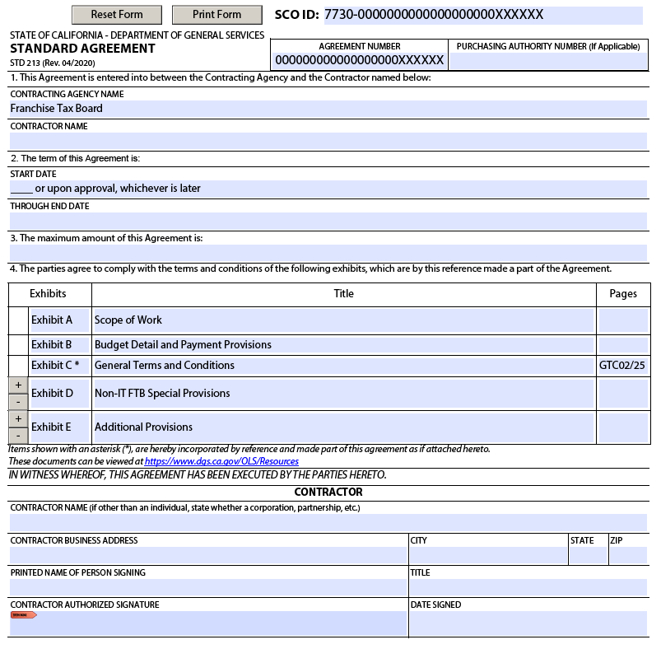

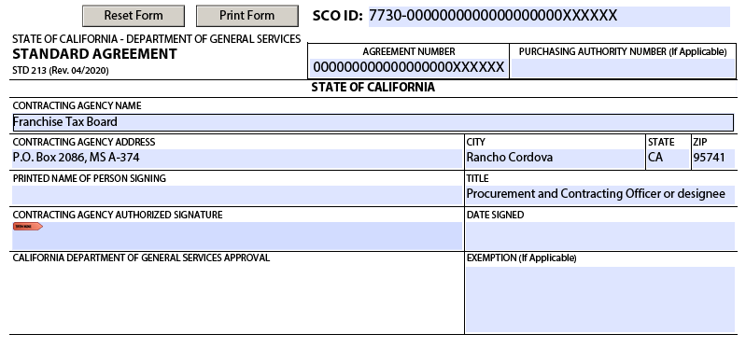

EXHIBIT A – SCOPE OF WORK

- INTRODUCTION

This Agreement is entered into between the California Franchise Tax Board, hereinafter referred to as FTB, and TBD, hereinafter referred to as the Contractor. Contractor agrees to provide FTB with freight shipping and delivery services on an as-needed basis. Freight is identified as any shipment weighing one hundred and fifty (150) pounds or more.

The Contractor must be available to commence the services outlined in this Statement of Work (SOW) during the term specified on the executed Standard Agreement form (STD 213). The anticipated term is thirteen (13) months.

The Contractor shall not be authorized to deliver or commence performance of services as described in the Contract until written approval has been obtained from all entities. Any delivery or performance of service commenced prior to the contractor obtaining all written approvals shall be considered voluntary on the part of the Contractor and non-compensable by the FTB.

Consistent with the terms and conditions of the original solicitation, and upon mutual consent, the State may execute written amendments to this Agreement if needed. At the State’s discretion, this Agreement may be amended for time, money or both based on the rates herein. No verbal understanding or agreement not incorporated into the Agreement is binding on any of the parties.

- LOCATION OF SERVICES

Pickups for freight shipping and delivery services will involve the following locations.

Franchise Tax Board (Central Campus)  9646 Butterfield Way  Sacramento, CA 95827 | Franchise Tax Board (Sacramento Field Office)  3321 Power Inn Road Suite 250  Sacramento, CA 95826
Franchise Tax Board (Van Nuys Field Office)  15350 Sherman Way, Suite 100  Van Nuys, CA 91406 | Franchise Tax Board (Santa Ana Field Office)  600 West Santa Ana Boulevard, Suite 300 & 400  Santa Ana, CA 92701
Franchise Tax Board (San Diego Field Office)  7575 Metropolitan Drive, Suite 201  San Diego, CA 92108 | Franchise Tax Board (Los Angeles Field Office)  300 South Spring Street, Suite 5704  Los Angeles, CA 90013
Franchise Tax Board (West Covina Field Office)  100 N Barranca Street, Suite 350, 500 & 600  West Covina, CA 91791 | Franchise Tax Board (Oakland Field Office)  1515 Clay Street, Suite 305  Oakland, CA 94612-1445
Franchise Tax Board (San Jose Field Office)  2665 N 1st Street, Suite 210  San Jose, CA 95134-2035 | Franchise Tax Board (San Francisco Field Office)  455 Golden Gate Avenue, Suite 8600, San Francisco CA 94102
Franchise Tax Board (Chicago Field Office)  One North Franklin, Suite 400  Chicago, IL 60606-3448 | Franchise Tax Board (Houston Field Office)  1415 Louisiana Street, Suite 2600  Houston, TX 77002-7392
Franchise Tax Board (New York Field Office) # 1  1212 Avenue of the Americas, Suite 400  New York, NY 10036 | Managed Facility Solutions, LLC  128 Component Drive  San Jose, CA 95131
Franchise Tax Board (New York Field Office) # 2
1180 Avenue of the Americas, Suite 900
New York, NY 10036

- SERVICE OVERVIEW

The Contractor shall provide freight shipping and delivery services for the transportation of, including but not limited to, equipment, furniture, or hardware. Services include loading, transportation, unloading and any necessary documentation for the safe and timely delivery of the cargo.

- REQUEST OF SERVICES NEEDED

This Agreement will serve as an as-needed service contract. The FTB Contract Manager will submit a Service Request/Work Order (SR/WO) (reference Exhibit A-1) to the Contractor for each delivery, pickup, and return request. Each SR/WO will include a detailed description of work to be performed.
The Contractor will provide the FTB Contract Manager, within two (2) State business days of receipt of the SR/WO, a good faith estimate of associated time (not to exceed five (5) calendar days, or three (3) calendar days if expedite delivery) and cost required to complete the requested services. Specifically, the Contractor shall provide to the FTB Contract Manager in writing the following details: estimated hours needed to complete the proposed scope described in the SR/WO, the proposed Contractor dates for services to be performed, and the estimated cost for the services to be completed.
Once approved by the FTB Contract Manager, the SR/WO shall be signed by the Contractor and returned to the FTB Contractor Manager. The SR/WO shall be signed by the FTB Contract Manager prior to work being commenced. Once the FTB Contact Manager approves the SR/WO, the Contractor will be notified by the FTB Contract Manager and both parties shall agree to a delivery schedule. Once the delivery schedule is confirmed, the Contractor will have five (5) calendar days from the scheduled pickup date to deliver the goods. If delivery exceeds five (5) calendar days from the scheduled pickup date identified on the SR/WO, it is considered a late delivery. An expedited delivery is considered late if it exceeds three (3) calendar days from the pickup date identified on the SR/WO. Reference Exhibit A – Scope of Work, E. Contractor Responsibilities, 14.
The cost of the requested services shall be invoiced based on Cost Per Mile which is referred to as the Base Rate, after the FTB Contract Manager’s approval, in accordance with the rates specified within the Service Rates table in Exhibit B, Cost Detail and Payment Provisions, and shall not exceed the good-faith cost estimate provided by the Contractor in their response to the corresponding SR/WO.

If there are any changes from the approved SR/WO that would require a revised cost estimate, such changes shall be made in writing and mutually agreed to between FTB and the Contractor.

Electronic mail transmission shall be an acceptable form for SR/WO requests and related correspondence.

- PREVAILING WAGE RATES

No contractor performing services hereunder shall pay any employee actually engaged in the moving and handling of goods being relocated under such contract less than the prevailing wage rate, except in geographical areas where no such employee wage standards and conditions are reasonably available. The term "prevailing wage rate" means the rate paid to a majority of work persons engaged in the particular craft, classification or type of work within the locality if a majority of such work persons are paid at a single rate; if there is no single rate being paid to a majority, then the rate being paid to the greater number of such work persons must be used. Upon written request, wage rates prevailing at the particular point in time will be furnished for information purposes only.

The Contractor shall pay California employees in accordance with the requirements defined by the Department of Industrial Relations under the category of Furniture Mover and Related Classifications, utilizing the ratio of staff as provided on the Prevailing Wage Determinations for the region in which the work is performed.

The Contractor shall pay Texas employees, if applicable, in accordance with the requirements defined by the U.S. Department of Labor under the Davis-Bacon Act.

The Contractor shall pay Illinois employees, if applicable, in accordance with the requirements defined by the Illinois Department of Labor current prevailing wage rates.

The Contractor shall pay New York employees, if applicable, in accordance with the provisions of Article 8 defined by New York Department of Labor.

Invoices shall reflect payment at prevailing wage rates, as specified in Exhibit B - Cost Detail and Payment Provisions.

- CONTRACTOR RESPONSIBILITIES

Under this Agreement, the Contractor agrees to the following:

- Contractor shall provide timely pickup, delivery, and transportation of all freight shipments.

- Contractor shall ensure the safe loading and unloading of the cargo.

- Contractor shall utilize vehicles that are in good working condition and in compliance with all federal, state, and local laws and regulations for operation including requisite insurance. All Contractor vehicles shall be sufficiently equipped with clean protective equipment to ensure safe transit and delivery of State property.

- Contractor shall assume liability for any FTB equipment that is damaged while in their possession.

- Contractor shall be aware of, and be in accordance with, all permit restrictions regarding weight and size of vehicles allowed on the roadways between all locations.

- Contractor shall adhere to all dock and elevator access protocol and security procedures established by the respective building owner(s) and building manager(s) at all FTB office and warehouse locations.

- All Contractor personnel shall be properly licensed, insured, and experienced to perform their tasks. Only Contractor personnel who meet these requirements may perform services under this Agreement.

- The Contractor personnel performing work under this Agreement must possess and maintain the appropriate Commercial Driver’s License for the vehicle(s) being operated: Class A, Class B, or Class C. In addition, Contractor must have personnel and vehicles available for all of these license classes during the term of this Agreement .

- Contractor personnel must possess a valid Motor Carrier permit issued by the California Department of Transportation for office deliveries and pick-ups authorizing transportation of property for hire by motor vehicle and operate within the scope of the permit. Permits must be in good standing prior to the start date of the Agreement and must be kept current and valid throughout the term of the Agreement.

- The Contractor shall provide a moving, fully enclosed van/truck or a vehicle with lift gates that can fit a 48”x48” or 48”x50” wooden pallet, and equally suitable equipment. The Contractor shall assure that State property is always afforded adequate protection. The Contractor shall provide the appropriate type of vehicle applicable to the items requested for delivery or pick up (e.g., van, truck, other). Also, the Contractor shall not provide two smaller vehicles (and charge extra) when one larger vehicle would be more appropriate.

- Contractor shall coordinate with the FTB Contract Manager to schedule pickups between the hours 8:00 a.m. and 4:00 p.m. Pacific Time (PT), Monday through Friday, excluding Saturdays, Sundays, and California (CA) State holidays, unless otherwise specified by the Contract Manager.

Current (CA) State holidays are as follows:
- New Year's Day,
- Martin Luther King, Jr. Day,
- President's Day,
- Farmworkers Day,
- Memorial Day,
- Independence Day,
- Labor Day,
- Veteran's Day,
- Thanksgiving Day,
- Day after Thanksgiving, and
- Christmas Day.

- Contractor personnel providing services to FTB under this Agreement must possess skills, abilities and knowledge identified but not limited to the items below:

- Physical Requirements: Ability to lift heavy items up to one hundred and fifty (150) pounds, and at times heavier, with assistance. The Contractor personnel must not have physical restrictions with regards to bending, prolonged standing, and stooping.

- Communication Requirements: Personnel must have the ability to receive, communicate, and follow instructions effectively in English (orally and in writing).

- Contractor shall provide the FTB Contract Manager with a tracking number via email by close of business for each shipment they are responsible for when the shipment is picked up from the FTB Central campus.

- Contractor shall be responsible for any costs imposed on the State due to the late delivery of any SR/WO requests not caused by the State.

- FIELD OFFICE DOCK PROCEDURES

- New York Field Office # 1

a. Dock Information:

Freight entrance is located on West 48th Street side of the building. Reservations are required (Reference Section H. Points of Contact below) prior to using freight elevator and will incur an additional expense.

b. Freight elevator information:

  - One (1) freight elevator for the entire building - entrance is on West 48th street
  - Dimensions:
  - Height 8’ 4”
  - Width 6’ 3”
  - Depth 4’ 10”

c. Delivery Instructions:

- Certificate of Insurance and Indemnity is required for contractor to enter the building
(Reference Exhibit A-2 – Certificate of Insurance & Indemnity Agreement)

- Operation hours: Monday - Friday, before 8:00 am or after 5:00 pm ET.

- Prior arrangements must be scheduled with the New York Field Office # 1 Manager prior to delivery. FTB’s normal operation hours are Monday through Friday, excluding CA State holidays, 8:00 am – 5:00 pm ET.

- Contractor shall contact the New York Field Office Manager # 1 forty-eight (48) hours prior to delivery to schedule the delivery date and time.

- Contractor shall complete Freight Elevator Requests by calling the building manager (Reference Section H. Points of Contact below) and providing the following:

  - Purpose
  - Day and Time
  - COI and Indemnity
  - Point of Contact (New York Field Office Manager # 1)

- Pallets can be dropped but must be broken down on carts to fit through a standard doorway to freight elevator and inside of our suite. Any dropped pallets will need to be removed by Contractor once the delivery is complete.

- New York Field Office # 2

a. Loading Dock Information:

Entrance is located on Avenue of the Americas at 46th Street.

b. Service Elevator Information:

  - Reservations are required prior to use of the service elevator. Reference Section H. Points of Contact below for scheduling.

  - There is one (1) service elevator for the entire building and its entrance is on 46th street.

  - Service Elevator – A4:

    - Clear door opening: 42”W X 62” H (front & rear)
    - Net inside car: 69”W X 65”D
    - Floor to ceiling: 108”
    - Capacity: 3,000 lbs.
    - Floors served: B, L-12, 14-23
    - Rated Speed: 700 fpm

Note: Contractor shall arrange for adequate protection of all elevator surfaces when in use.

c. Delivery Instructions:

Certificate of Insurance, Indemnity is required for Contractor to enter the building (Reference Exhibit A-3 Contractors Insurance and Indemnity Agreement)

d. Bulk deliveries with loading dock access
- Operation hours: Monday - Friday, before 8:00 am or after 6:00 pm ET, excluding CA State holidays.

- Prior arrangements must be scheduled with the New York Field Office # 2 Manager prior to delivery. FTB’s normal operation hours are Monday through Friday, excluding CA State holidays, 8:00 am – 5:00 pm ET.
- Contractor shall contact the New York Field Office # 2 Manager at least seventy-two (72) hours in advance to schedule the delivery date and time and Contractor shall provide the following information:

  - Detailed work schedule, including day and time
  - List of Contractor staff
  - COI and Indemnity
  - Point of Contact

- At the time of delivery, to gain entry, the Contractor is to ring the buzzer and speak into the intercom. The two-way intercom provides communications from the street side on 46th Street to the service security guard and the concierge.

- Contractor and Contractor’s staff are required to show photo ID to the security guard.

- In the event the service elevator is out of service, a low-rise or high-rise passenger car will be padded for Contractor use.

- All packing crates, pallets, and other delivery-related materials must be promptly removed from the building. No packing materials may be left in common areas, loading zone area, or service corridor.

- Chicago Field Office

  - Loading Dock Information:

  - Loading dock is located on Calhoon St. between Franklin St. and Wells St.

  - Single bay loading area with a maximum clearance height of 14 feet, 31 feet wide and 24 feet deep. Truck must not exceed 24 feet.

  - Certificate of Insurance is required (Reference Exhibit A-4 Contractor’s Freight/Dock Delivery Request)

  - Operation hours: 6:00 am to 6:00 pm CT. During regular hours there is a 30-minute time limit. Any access requiring more time will have to be scheduled for after-hours (Reference Section H. Points of Contact below).

  - Note: FTB’s normal operations hours are Monday through Friday, excluding (CA) State holidays, 8:00 am – 5:00 pm CT.

  - Pallets can be dropped but must be broken down on carts to fit through doorway to freight elevator. Any dropped pallets will need to be removed by Contractor once the delivery is complete.

  - Freight elevator information:

- One (1) freight elevator for the entire building next to the loading dock.

- Dimensions:
- Height 10’
- Width 6’
- Depth 8’
- Door 4’9” W
- Capacity 4,500 lbs.

  - Delivery Instructions:

Small and large deliveries with access to loading dock:

- Call Chicago Field Office Manager and building manager (Reference Section H. Points of Contact below) prior, to schedule a delivery date and time.

- Contractor must provide 48-hour advanced notice for deliveries.

- Complete “Contractor’s Freight/Dock Delivery Request” by calling building manager. (Reference Exhibit A-4) Contractor will provide the following:

- Purpose
- Day/Time
- COI
- Point of Contact (Chicago Field Office Manager)

- Houston Field Office

  - Loading Dock Information:

  - Located on Milam Street.

  - Single bay loading area with a max clearance height of 12 feet.

  - Operation hours: 6:00 am - 6:00 pm CT.

  - Note: FTB’s normal operations hours are Monday through Friday, excluding CA State holidays, 8:00 am – 5:00 pm CT.

  - Freight elevator information:

- One (1) freight elevator for entire building.

- Operation hours: 6:00 am - 6:00 pm CT.

- Available on a first-come, first-serve basis, during normal operation hours.
- Dimensions:

  - Height 12’
  - Width 5’3”
  - Depth 8’ 2.5”
  - Door Width 4’ 2.5” x 7’ 10”

- Pallets can be dropped but must be broken down on carts to fit through doorway to freight elevator. Any dropped pallets will need to be removed by Contractor once the delivery is complete.

  - Delivery Instructions:

Small deliveries with no loading dock access (15 minutes at a time):
- Park in the available contractor parking space.

- Sign in with security before entering the building.

- Use freight elevator.

Small and large deliveries with access to loading dock (up to 30 minutes)

- Sign in with security before entering the building.

- Use freight elevator for deliveries.

Large deliveries with dock access (exceeding 30 minutes):

- Delivery will need to be performed after hours or on a weekend with prior approval from FTB Contract Manager and property manager (Reference Section H. Points of Contact below).

- Submit “Admit Authorization” form and email it to management@wedgeproperties.com to obtain property management approval (Reference Exhibit A-5)

- Vendor must sign in with security before entering the building.

- A $25.00 per hour fee will be charged if a freight elevator operator is requested after hours or on a weekend.

Any issues with dock or freight access please contact the property manager (Reference Section H. Points of Contact below).

- San Diego Field Office

a. Loading Zone Information:

- No loading docks.

- Park at the designated loading area behind the building located at 7575 Metropolitan Dr. Suite 201.

b. Freight elevator information:

  - One (1) freight elevator for the entire building.

  - Operation hours: 6:00 am - 6:00 pm PT.

    - Note: FTB’s normal operations hours are Monday through Friday, excluding CA State holidays, 8:00 am – 5:00 pm PT.

  - Available on a first-come, first-serve basis, during normal operation hours.

  - Dimensions:
        - Height 9’
        - Width 5’7”
        - Depth 8’
        - Door Width 4’ x 8’

c. Delivery Instructions:

All deliveries:
- Access to the FTB suite is on 2nd floor.

- Pallets can be dropped but must be broken down on carts to fit through doorway to freight elevator. Any dropped pallets will need to be removed by Contractor once the delivery is complete.

- Maintain and be prepared to provide proof to property management, upon request, of the following:

- General Liability insurance.
- Automobile insurance.
- Worker’s compensation insurance.

- Large vehicles cannot exit on Mission Valley Road. Large vehicles can exit on Metropolitan or Murray Canyon Rd.

Any issues with loading zone or freight access please contact the property manager (Reference Section H. Points of Contact below).

- Oakland Field Office

a. Loading Dock Information:

- Located on 16th Street.
- Single bay loading area with a maximum clearance height of 14 feet and 72 feet long.
- Operation hours: 7:00 am - 5:00 pm PT.

- Note: FTB’s normal operations hours are Monday through Friday, excluding CA State holidays, 8:00 am – 5:00 pm PT.

- Freight elevator information:

    - One (1) freight elevator for the entire building next to the loading dock.

    - Dimensions:
      - Height 11’10”
      - Width 5’8”
      - Depth 9’4”
      - Door 4’6” W x 9’6” H

- Delivery Instructions:

Small and large deliveries with access to loading dock.

- Call Oakland Field Office Manager before checking in with security (Reference Section H. Points of Contact below).

- Use freight elevator for deliveries.

- Delivery will need prior approval from FTB and Department of General Services using the form below.

- Contractor will complete and submit the “Loading Dock/Temporary Parking Request Form” (Reference Exhibit A-6) to the FTB Contract Manager. The FTB Contract Manager will email the completed form to Elihuharrisrequests@dgs.ca.gov to obtain property management approval.

- Please note: The approval process takes three (3) to five (5) business days, from the date of submission.

- The vendor must sign in with Building security and/or FTB Field Office management before entering the building.

Any issues with dock or freight access please contact the property manager (Reference Section H. Points of Contact table below.

- Sacramento Field Office

- Loading Dock Information:

- Lift gate is located behind the building marked with signage on the asphalt; there is no loading area (dock).

- Operation hours: 8:00 am - 5:00 pm PT.

- Note: FTB’s normal operations hours are Monday through Friday, excluding CA State holidays, 8:00 am – 5:00 pm PT.

- Freight elevator information:

- One (1) freight elevator for the entire building is located in the lobby.

- Dimensions:

  - Height 10’
  - Width 5’
  - Depth 9’6”
  - Door 47.5” W

- Delivery Instructions:

- Upon arrival contractor shall call one of the following onsite staff to gain access to the building (Reference Section H. Points of Contact below).

- Use the rear door which should be unlocked during business hours, follow the hallway to the main lobby.

- Use the freight elevator - The first elevator to the left when looking at the bank of elevators in the lobby.

- Proceed to the 2nd floor.

- Inform public window staff you have a delivery.

- Onsite staff will receive items and sign any paperwork from delivery company.

- Santa Ana Field Office

- Loading Dock Information:

- Entrance on Parton St.

- No Vehicles over 11 feet high.

- Freight Elevator Information:

- One (1) freight elevator for the entire building located in the lobby.

- Dimensions:
  - Height 10’
  - Width 5’
  - Depth 7’10”
  - Door 4’ W
  - Capacity 4,500 lbs.

- Delivery Instructions:

All deliveries:

- Obtain prior approval from the following:

  - Santa Ana Field Office Manager and Contract Manager (Reference Section H. State’s Point of Contact below).
  - Property Management (Reference Section H. Points of Contact below).

- Park in the loading dock.

- Sign in with security.

- Access to the freight elevator is through the first floor.

- Use carts small enough to fit through a standard doorway.

- Maintain and be prepared to provide proof to property management, upon request, of the following:

  - General Liability insurance.
  - Automobile insurance.
  - Worker’s compensation insurance.

- Note: FTB’s normal operations hours are Monday through Friday, excluding CA State holidays, 8:00 am – 5:00 pm PT.

Any issues with dock or freight access please contact the property manager (Reference Section H. Points of Contact below).

- San Francisco Field Office

a. Loading Dock Information:

- Dock Entrance is on Larkin Street on the side of the building.

- Reservations are required prior to using dock if the delivery is longer than 30 minutes (Reference Exhibit A-6 Loading Dock/Temporary Parking Request Form).

- Certificate of Insurance is required (Reference Exhibit A-6 Loading Dock/Temporary Parking Request Form).

- Truck size is limited to under 13 feet tall and less than 30 feet long.

- Operation hours: 7:00 am – 6:00 pm PT.

- Note: FTB’s normal operations hours are Monday through Friday, excluding CA State holidays, 8:00 am – 5:00 pm PT.

  - Freight elevator information:

- One (1) freight elevator for the entire building located in the lobby.

- Dimensions:
  - Height 10’
  - Width 5’
  - Depth 7’10”
  - Door 4’ W
  - Capacity 4,500 lbs.

  - Delivery Instructions:

Small and large deliveries with access to loading dock:

- Call San Francisco Field Office Manager prior to delivery to schedule a delivery date and time (Reference Section H. Points of Contact below).

- The San Francisco Field Office Manager shall complete and submit to Department of General services the “Loading Dock/Temporary Parking Request Form” (Reference Exhibit A-6) if delivery is longer than 30 mins. Contractor will provide the following:

  - Purpose
  - Day/Time
  - COI (DGS will keep on file for future deliveries)
  - Point of Contact (San Francisco Field Office Manager)
  - Vehicle Information
    - DGS will:
      - Respond to request with confirmation of date and time after all requirements have been satisfied

- If the delivery takes less than 30 minutes, these do not require reservation, but COI and advance notice are necessary.

- Pallets can be dropped but must be broken down on carts to fit through doorway to freight elevator. Any dropped pallets will need to be removed by Contractor once the delivery is complete.

- San Jose Field Office

- Loading Zone Information:

    - No Dock. Delivery trucks would need a liftgate to complete deliveries.

    - Trucks can stage behind the building of 2665 N. First St.

    - No reservation process, but please call San Jose Field Office Manager for delivery date and time. (Reference Section H. Points of Contact below).

    - No limits on truck size, plenty of room behind the building.

    - Operation hours: 7:00 am - 5:30 pm PT.

Note: FTB’s normal operations hours are Monday through Friday, excluding CA State holidays, 8:00 am – 5:00 pm PT.

- Freight elevator information:

- One (1) freight elevator for the entire building in the lobby.

- Dimensions:
  - Height 10’
  - Width 6’
  - Depth 8’
  - Door 4’9” W

- Delivery Instructions:

Small and large deliveries with access to loading dock:

- Call San Jose Field Office FTB manager prior to delivery to schedule a delivery date and time.

- Use freight elevator for deliveries.

- Pallets can be dropped but must be broken down on carts to fit through doorway to freight elevator. Any dropped pallets will need to be removed by Contractor once the delivery is complete.

- Van Nuys Field Office

- Loading Zone Information:

- No loading docks.

- No Vehicles over 12,000 lbs.

- Delivery Instructions:

All deliveries:

- Park on the street or enter the parking lot and pay for parking. (Include parking fees on invoice)

- Access to the building is through parking lot behind the building.

- Access to the FTB suite is via the walkway at the backside of the property, off the monthly parking lot behind the building.

- Use carts small enough to fit through a standard doorway.

- Maintain and be prepared to provide proof, to property management upon request, of the following:

- General Liability insurance.
- Automobile insurance.
- Worker’s compensation insurance.

- FTB’s normal operations hours are Monday through Friday, excluding CA State holidays, 8:00 am – 5:00 pm PT.

Large deliveries:

  - Obtain prior approval from the following:
- Van Nuys Field Office Manager (Reference Section H. Points of Contact below).
- Property management (Reference Section H. Points of Contact below).
- Sign in with security before entering the building.

Any issues with dock or freight access please contact the property manager (Reference Section H. Points of Contact below).

- West Covina Field Office

- Loading Zone Information:

- No dock, park in alleyway between Chick-fil-A and Parking Entrance.

- Enter on E. Garvey Ave N.

- Delivery Instructions:

All deliveries:

- Delivery times are within FTB’s normal operations hours are Monday through Friday, 8:00 AM – 5:00 PM PT, excluding CA State holidays.

- One (1) day prior to delivery, Contractor shall obtain approval from the following:
  - West Covina Field Office Manager (Reference Section H. Points of Contact below).

- Property Management (Reference Section H. Points of Contact below).

- On the day of delivery, park in the alley next to Chick-fil-A on the backside of the building.

  - Driveway has a “DO NOT ENTER” sign, but you are permitted to enter for delivery purposes.
  - Do Not enter parking structure. A delivery truck will not fit.

- Sign in with security.

- Use carts small enough to fit through a 4ft doorway.

- Access to the freight elevator is found on P1.

  - It is necessary to contact the FTB Field Office management to place the elevator on independent mode for loading and unloading.

- Dimensions of the freight elevator:

  - Width 6’
  - Depth 6’
  - Height 9’ 6”

- Be prepared to provide proof, to property management upon request, including:

- Automobile insurance
- Certificate of Insurance

- Los Angeles Field Office

- Dock Information:

- No vehicle over 12 feet.

- Enter Loading Dock on Main Street.

- Freight elevator information:

- Operation hours: 8:00 am - 5:00 pm PT.

- Available on a first-come, first-service, basis during normal operation hours.

- Dimensions:
  - Height 10’
  - Width 5’4”
  - Depth 7’ 9”
  - Door Width 4’ 2.5” x 7’ 10”

- Delivery Instructions:

All deliveries:

- Call Los Angeles Field Office Manager prior to scheduling a delivery date and time (Reference Section H. Points of Contact below).

- Email Loading Dock Request to Los Angeles Field Office Manager Contact. Contractor will provide the following:

  - Purpose
  - Day/Time
  - COI (DGS will keep on file for future deliveries)
  - Point of Contact (FTB Rep)
  - Vehicle Information
    - DGS will:
      - Respond to request with confirmation of date and time after all requirements have been satisfied. The approval process typically takes 3-5 business days.

- Pallets can be dropped but must be broken down on carts to fit through doorway to freight elevator. Any dropped pallets will need to be removed by Contractor once the delivery is complete. No pallet jacks are allowed on freight elevators.

- FTB RESPONSIBILITIES

Under this Agreement, FTB agrees to the following:

- FTB shall adequately package, palletize, wrap, and weigh equipment for transport.

- FTB Contract Manager shall provide all necessary shipping and delivery documents.

- FTB shall provide necessary assistance during loading and unloading operations.

- FTB Contract Manager shall notify Contractor when shipment is ready for transport.

- FTB Contract Manager will notify the appropriate FTB Field Office Manager prior to all scheduled deliveries.

- FTB Contract Manager shall provide detailed information on the SR/WO which includes pick-ups or deliveries to or from the FTB’s Central Campus or FTB Field Offices.
- FTB Contract Manager shall communicate regularly with Contractor for each SR/WO.
- FTB Field Office Managers (s) shall provide the Contractor with instructions on dock, loading zone, elevator access protocols and security procedures for delivery and pick-ups at FTB California, Texas, Illinois, and New York offices and warehouses.

- POINTS OF CONTACT

1. FTB’s Contract Manager during the term of this Agreement shall be:
Franchise Tax Board
Name:
Telephone:
Email:

2. Direct all Agreement inquiries to:

Franchise Tax Board
Name: Marisa Lai
Title: Business Acquisitions Analyst
Telephone: (916) 845-1697
Email: Marisa.Lai@ftb.ca.gov

3. Direct all escalations to:

Franchise Tax Board
(Escalation Contact)
Name:
Title:
Telephone:
Email:

Contractor Name [TBD]
(Escalation Contact)
Name: To be completed by Contractor
Title: To be completed by Contractor
Telephone: To be completed by Contractor
Email: To be completed by Contractor

4. Field Office Managers and Building Contacts during the term of this Agreement shall be:

Franchise Tax Board
(New York # 1)
Name:
Telephone:
Email:

Franchise Tax Board
(New York Building # 1 Contact)
Name:
Telephone:
Email:

Franchise Tax Board
(New York # 2)
Name:
Telephone:
Email:

Franchise Tax Board
(New York Building # 2 Contact)
Name:
Telephone:
Email:

Franchise Tax Board
(Chicago)
Name:
Telephone:
Email:

Franchise Tax Board
(Chicago Building Contact)
Name:
Telephone:
Email:

Franchise Tax Board
(Houston)
Name:
Telephone:
Email:

Franchise Tax Board
(Houston Building Contact)
Name:
Telephone:
Email:

Franchise Tax Board
(San Francisco)
Name:
Telephone:
Email:

Franchise Tax Board
(San Francisco Building Contact)
Name:
Telephone:
Email:

Franchise Tax Board
(San Diego)
Name:
Telephone:
Email:

Franchise Tax Board
(San Diego Building Contact)
Name:
Telephone:
Email:

Franchise Tax Board
(Oakland)
Name:
Telephone:
Email:

Franchise Tax Board
(Oakland Building Contact)
Name:
Telephone:
Email:

Franchise Tax Board
(Santa Ana)
Name:
Telephone:
Email:

Franchise Tax Board
(Santa Ana Building Contact)
Name:
Telephone:
Email:

Franchise Tax Board
(San Jose)
Name:
Telephone:
Email:

Franchise Tax Board
(San Jose Building Contact)
Name:
Telephone:
Email:

Franchise Tax Board
(Van Nuys)
Name:
Telephone:
Email:

Franchise Tax Board
(Van Nuys Building Contact)
Name:
Telephone:
Email:

Franchise Tax Board
(West Covina)
Name:
Telephone:
Email:

Franchise Tax Board
(West Covina Building Contact)
Name:
Telephone:
Email:

Franchise Tax Board
(Los Angeles)
Name:
Telephone:
Email:

Franchise Tax Board
(Los Angeles Building Contact)
Name:
Telephone:
Email:

Franchise Tax Board
(Sacramento Field Office)
Name:
Telephone:

Email:

Franchise Tax Board
(Sacramento Field Office Building Contact)
Name:
Telephone:
Email:

Franchise Tax Board
(Sacramento Central Campus)
Name:
Telephone:
Email:

5. Contractor’s Point(s) of Contact during the term of this Agreement shall be:
Contractor Name [TBD]
Name: To be completed by Contractor
Title: To be completed by Contractor
Telephone: To be completed by Contractor
Fax: To be completed by Contractor, if applicable
Email: To be completed by Contractor

Contractor Name [TBD]
Name: To be completed by Contractor
Title: To be completed by Contractor
Telephone: To be completed by Contractor
Fax: To be completed by Contractor, if applicable
Email: To be completed by Contractor

State, Building, or Contractor Points of Contact may be changed without formal amendment to this Agreement. State shall notify Contractor, or Contractor shall notify State at least ten (10) days prior to the change by written notice via fax, mail, or email, which will contain the new Contact’s name, title, telephone number, and email address.

EXHIBIT A-1 – SERVICE REQUEST/WORK ORDER
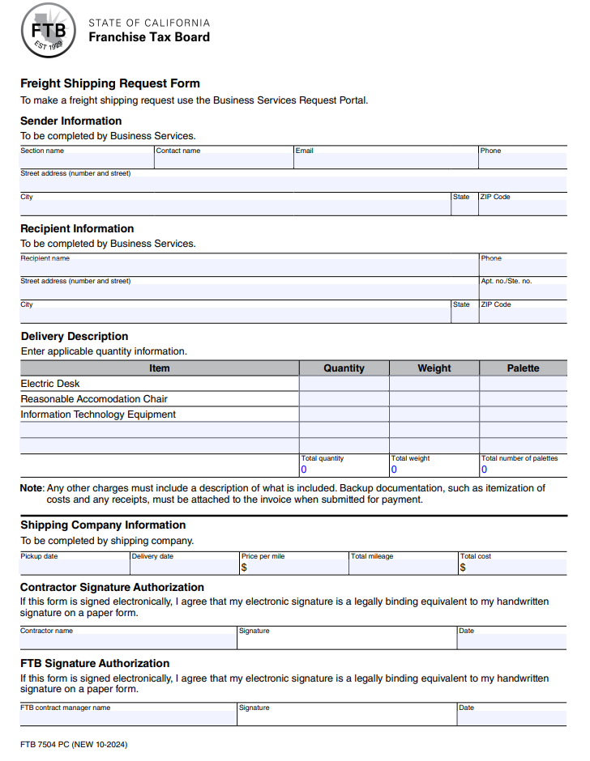

EXHIBIT A-2 - CERTIFICATE OF INSURANCE & INDEMNITY AGREEMENT

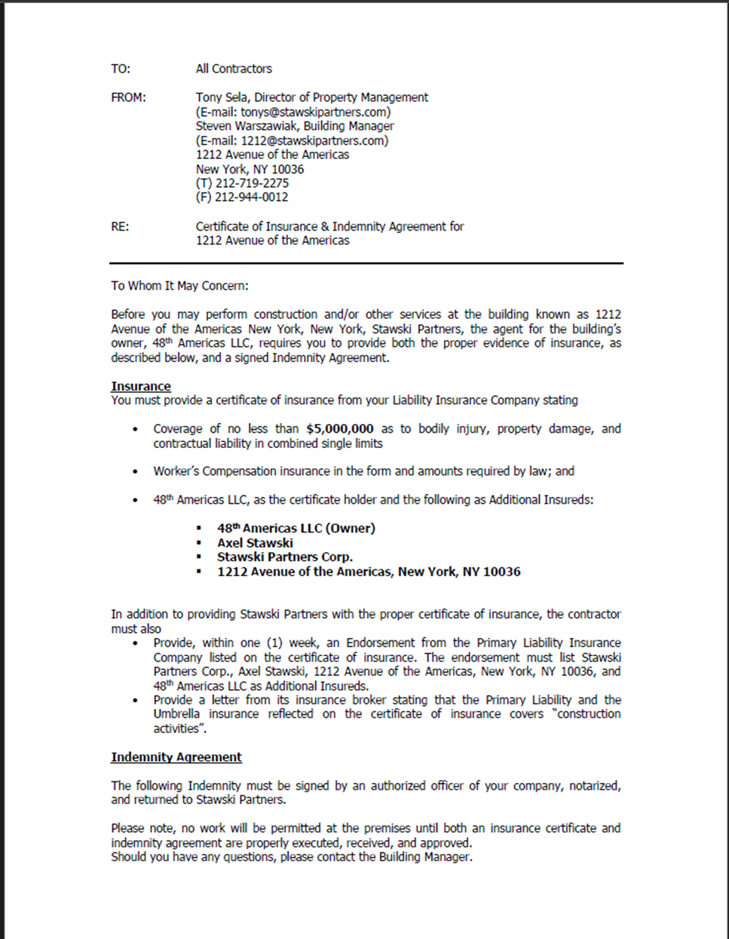

EXHIBIT A-3 – CONTRACTORS INSURANCE AND INDEMNITY AGREEMENT
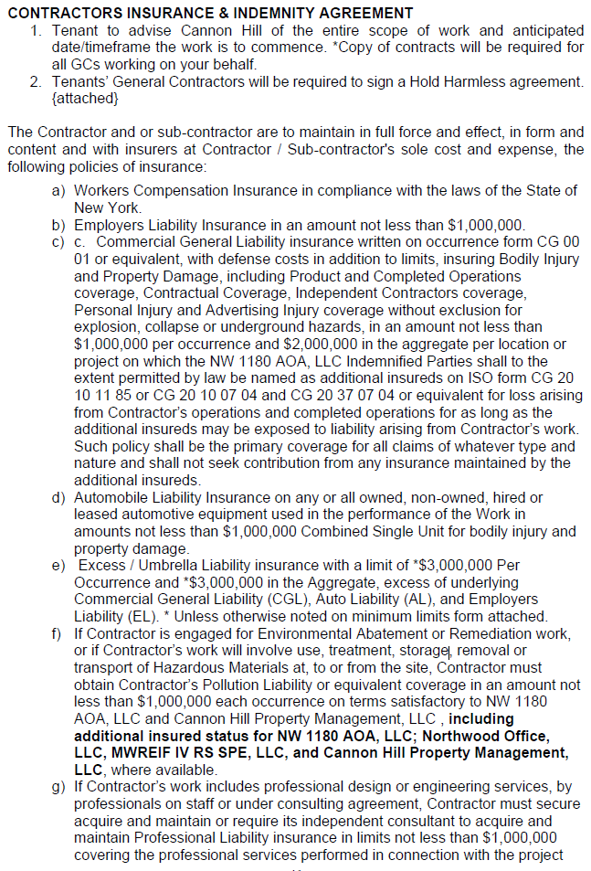
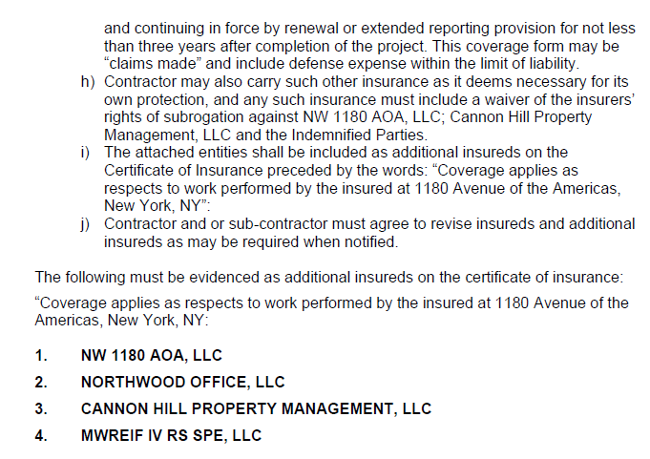

EXHIBIT A-4 – CONTRACTOR’S FREIGHT/DOCK DELIVERY REQUEST

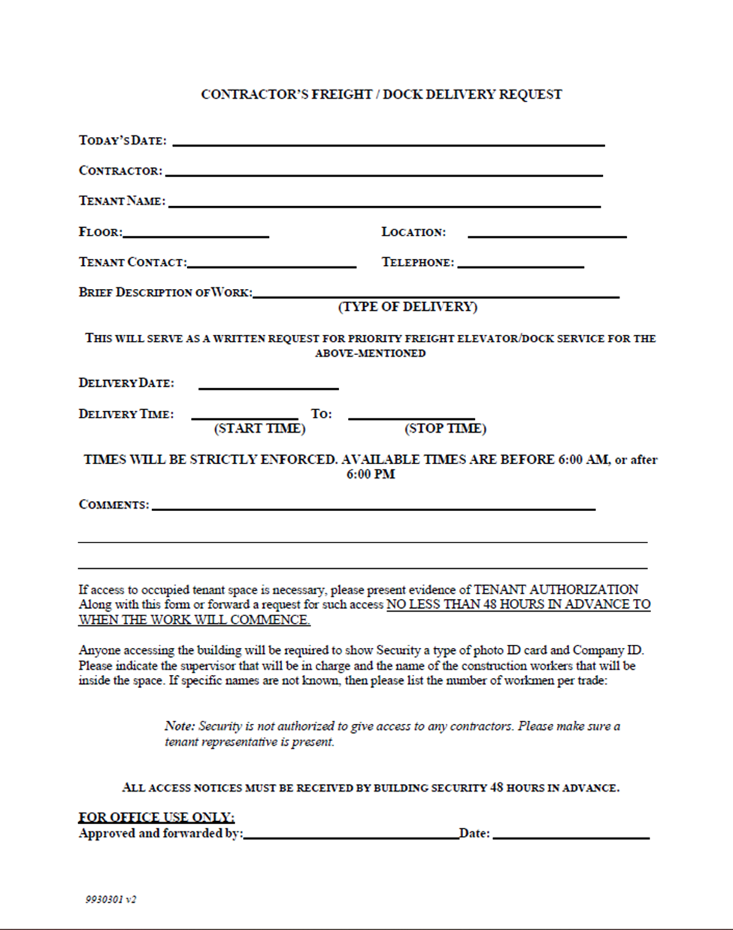

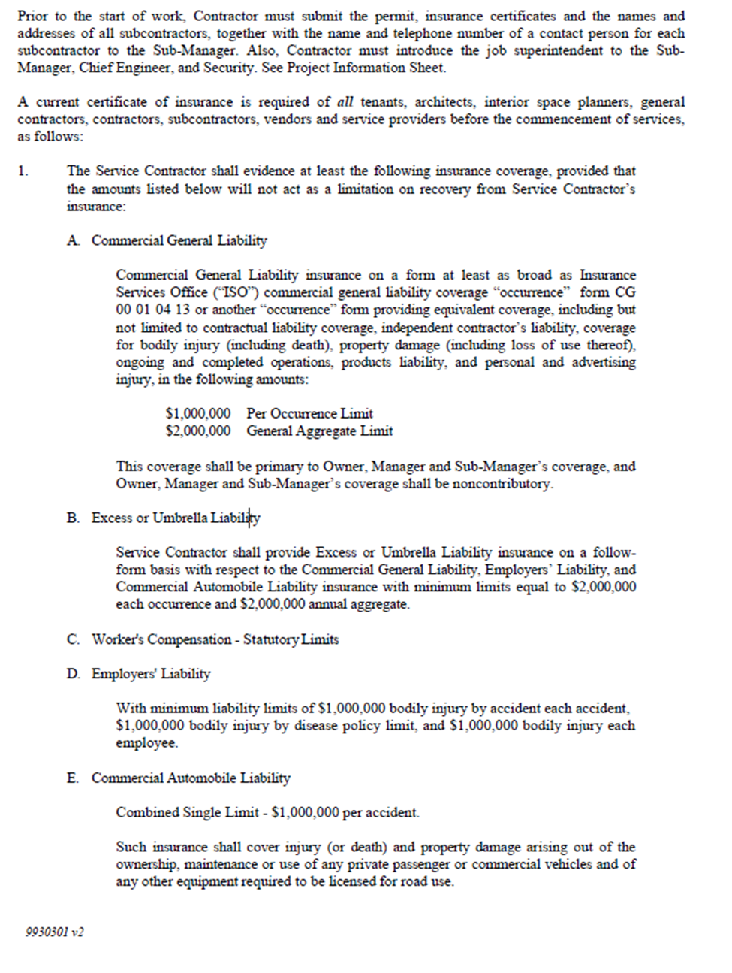

EXHIBIT A-5 – ADMIT AUTHORIZATION
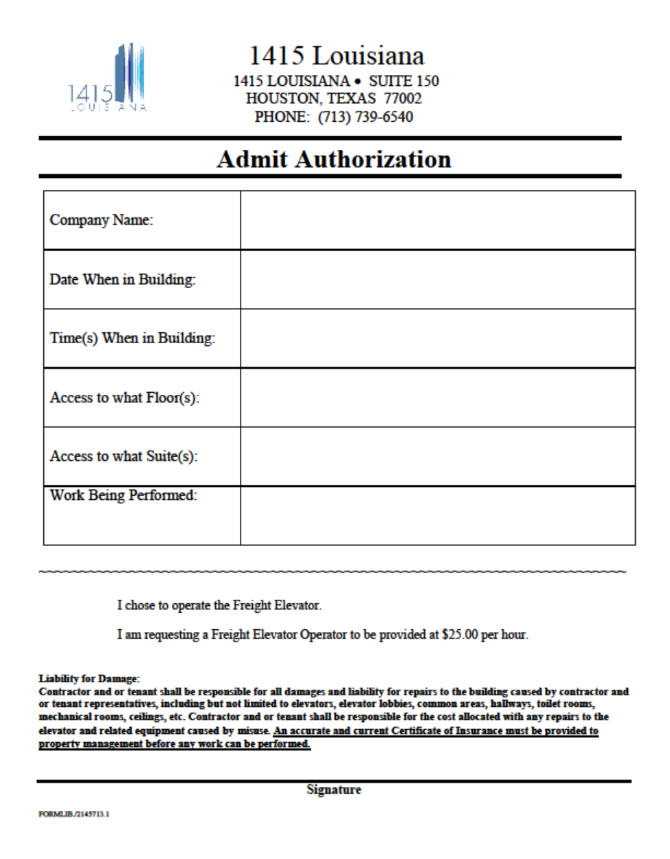

EXHIBIT A-6 – LOADING DOCK/TEMPORARY PARKING REQUEST FORM
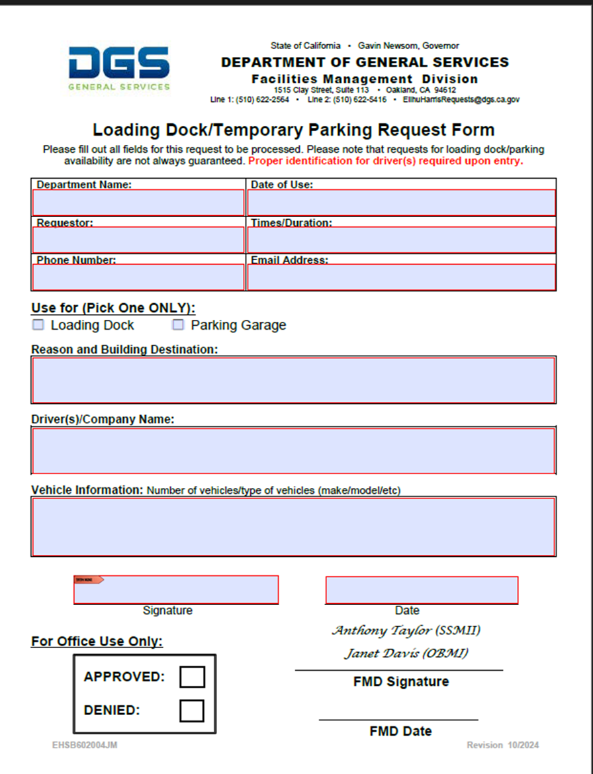

EXHIBIT B - BUDGET DETAIL AND PAYMENT PROVISIONS

1. BUDGET DETAIL
PLACEHOLDER – As part of agreement finalization, the State shall insert in this Exhibit all information contained in Bidder’s completed Attachment 3 – Bid Cost Sheet, Service Rates table submitted by Bidder in response to this solicitation.

2. PAYMENT PROVISIONS

- INVOICING AND PAYMENT: In consideration of the performance of the foregoing services in a satisfactory manner, payment for services performed under this Agreement shall be by deliverables, in arrears. It shall be FTB’s sole determination as to whether deliverables were successfully delivered and are acceptable. Upon successful completion of the deliverables in the table below, the Contractor shall submit an invoice for payment of those deliverables. Payment will be made for the deliverables, subject to acceptance by FTB.

- INVOICE(S) MUST INCLUDE ALL OF THE FOLLOWING:

  - The Agreement number as reflected on the first page of this Agreement.
  - Dates of service for each deliverable.
  - Name of approved tasks/deliverables completed by the Contractor and accepted by the State.
  - Contractor’s name as indicated within this Agreement, address, telephone number, fax number, and email address.
  - Cost associated with the approved deliverable.
  - Total amount invoiced. The total amount invoiced shall be clearly distinguished from other figures or computations appearing on the invoice. The total amount invoiced shall include all costs incurred by the Contractor under the terms of this agreement.
  - Invoice date.

- Invoices shall be submitted in triplicate, by U.S. Mail, clearly referencing the Agreement number identified on the face of the Standard Agreement form, Std. 213 (or face of the Standard Agreement Amendment Std. 213A, if applicable), no more frequently than monthly in arrears, to:

Franchise Tax Board
Attn: Fiscal Accounting
P.O. Box 2800
Sacramento, CA 95812-2800

- The total amount of this Agreement shall not exceed the amount identified on the face of the Standard Agreement form, Std. 213 (or face of the Standard Agreement Amendment Std. 213A, if applicable); including all applicable State tax. There is no obligation on the FTB’s part to utilize the entire amount.

- BUDGET CONTINGENCY CLAUSE: It is mutually agreed that if the Budget Act of the current year and/or any subsequent years covered under this Agreement does not appropriate sufficient funds for the program, this Agreement shall be of no further and effect. In this event, the State shall have no liability to pay any funds whatsoever to Contractor or to furnish any other consideration under this Agreement and Contractor shall not be obligated to perform any provisions of this Agreement.

If funding for any fiscal year is reduced or deleted by the Budget Act for purposes of this program, the State shall have the option to either cancel this Agreement with no liability occurring to the State, or offer an agreement amendment to Contractor to reflect the reduced amount.

- PROMPT PAYMENT CLAUSE: Payment will be made in accordance with, and within the time specified in, Government Code Chapter 4.5, commencing with Section 927.

- TRAVEL AND EXPENSES: There is no travel or expenses associated with this Agreement. Notwithstanding the contract provisions, the State will not be responsible for the cost of travel, travel expense, per diem or travel time to bring Contractor personnel to the agency site to commence work or for any other reason.

EXHIBIT D - NON-IT FTB SPECIAL PROVISIONS
  - STATEMENT OF CONFIDENTIALITY
The Franchise Tax Board has state tax return information and other confidential information and data in its custody. Unauthorized inspection or disclosure of state returns or other confidential information or data is a misdemeanor (Revenue and Taxation Code Sections 19542, 19542.1, 19542.3 and 19552, and Government Code Section 90005).
For purposes of this exhibit, the terms “information” and “data” are used interchangeably and each, when used, encompasses the meanings of both terms. As used in this exhibit, the terms “confidential information” and “confidential data” each include “sensitive information and data”. As used for this exhibit, the term “Party” means FTB, Contractor, or Contracting Agency.
Upon the approval of this Agreement and prior to any access to the confidential data, the Party receiving the information from FTB and each of the Party’s employees, subcontractors, and subcontractors’ employees who may have access to the confidential data of the other Party, will be required to have on file annually a signed Confidentiality Statement (FTB Form 7904 or 7912), attesting to the fact that they are aware of the confidential data and the penalties for unauthorized access, inspection, acquisition, or disclosure thereof under applicable state and federal law.
The Contractor, the Contactor's subcontractors and each of the Contractor's and subcontractors' employees who may have access to the confidential data shall be required to complete Privacy, Security, and Disclosure Training (PSDT) provided by FTB. The training must be completed within two (2) State business days of commencing work with FTB, and annually thereafter. Upon completion of the PSDT, a Privacy, Security and Disclosure Training Certification (FTB Form 7819) will be provided, to be signed confirming that the training was completed, and returned to FTB.
  - USE OF INFORMATION
Each Party receiving FTB’s data agrees that the information furnished or secured pursuant to this Agreement shall be used solely for the purposes described in the Scope of Work of Exhibit A. Each Party receiving FTB’s data further agree(s) that information obtained under this Agreement will not be reproduced, published, sold, or released in original or in any other form for any purpose other than as identified in the Scope of Work of Exhibit A.
  - DATA OWNERSHIP
The confidential tax information or other confidential information provided under this Agreement remains the exclusive property of the providing Party. Confidential tax information and other confidential information are not open to the public and require special precautions to protect from loss and unauthorized access, inspection, acquisition, use, disclosure, modification, or destruction. Each Party shall have the right to use and process the disclosed information for the purposes stated in the Scope of Work of Exhibit A of this Agreement, which right shall be revoked and terminated immediately upon termination of this Agreement.
  - EMPLOYEE ACCESS TO INFORMATION
Each Party receiving data agrees that the information obtained will be kept in the strictest confidence and shall make information available to its own employees only on a “need-to-know” basis. The “need-to-know” standard is met by authorized employees who need information to perform their official duties in connection with the uses of the information authorized by this Agreement. Each Party receiving data recognizes its responsibility to protect the confidentiality of the information in its custody as provided by law and to ensure that such information is disclosed only to those individuals and for such purposes as are authorized by law and this Agreement.
  - PROTECTING CONFIDENTIAL INFORMATION/ INCIDENT REPORTING
Each Party receiving data, in recognizing the confidentiality of the information to be exchanged, agrees to take all appropriate precautions to protect the confidential information obtained pursuant to this Agreement from unauthorized access, use, or disclosure. Each Party receiving data will conduct oversight of its users with access to the confidential information provided under this Agreement, and will immediately notify FTB’s Information Security Audit & Investigations Unit (SecurityAuditMail@ftb.ca.gov) of any unauthorized or suspected unauthorized accesses, uses and/or disclosures (incidents). For purposes of this section, “immediately” is defined as within 24 hours of the discovery of the breach or suspected breach. The notification must describe the incident in detail and identify responsible personnel (name, title and contact information). The Party with an incident will comply with the incident reporting requirements in accordance with Civil Code Section 1798.29, State Administrative Manual (SAM) Chapter 5300 and Section 8643, and Statewide Information Management Manual 5340-A and 5340-C to facilitate the required reporting to the taxpayer(s) or state oversight agencies.
  - INFORMATION SECURITY
Information security is defined as the preservation of the confidentiality, integrity, and availability of information. A secure environment is required to protect the confidential information obtained by each Party or entity pursuant to this Agreement. Each Party or entity receiving data will store information so that it is physically secure from unauthorized access. The records received will be securely maintained and accessible only by employees of the specified program who are committed to protect the data from unauthorized access, use or disclosure. All FTB electronic data must be encrypted when in transit using FIPS 140-3 approved encryption technology, and be password protected and secure at all times when in storage. Confidential information obtained from FTB must be secured in accordance with the SAM, including Chapters 5100 and 5300 (Information Security), and National Institute of Standards and Technology (NIST) Special Publication 800-53 (moderate); and additional security requirements provided by FTB. FTB may require that a Security Questionnaire for the entity receiving confidential data from FTB be completed or be on file with FTB’s Chief Security Officer, or their designee.
  - CLOUD COMPUTING ENVIRONMENT
Each entity receiving FTB’s confidential data must submit a completed FTB Cloud Computing Questionnaire before using a Cloud Computing Environment. The questionnaire will be reviewed for approval by FTB’s Chief Security Officer, or their designee. A Cloud Computing Environment cannot be used to receive, transmit, store or process FTB’s confidential data without prior written approval from FTB’s Chief Security Officer, or their designee.
  - DESTRUCTION OF RECORDS
All records received by each Party under this Agreement, and any database(s) created, copies made, or files attributed to the records received, shall be destroyed when they are no longer needed for the business purpose for which they were obtained. The records shall be destroyed in a manner to be deemed unusable or unreadable, and to the extent that an individual record can no longer be reasonably ascertained.
  - INSPECTION
FTB retains the right to conduct on-site or remote reviews of the other Party’s use of FTB information and the security controls established. The reviews may include, but are not limited to, an examination of the adequacy of information security controls, application of the “need-to-know” standard, and use justifications established by the Party to ensure compliance with the terms and conditions of this Agreement. Unless otherwise agreed by the Parties, FTB will provide a minimum of seven (7) State business days’ notice of a review of the use of FTB information.
  - SURVIVAL OF OBLIGATION TO PROTECT DATA
Each Party’s obligation to protect the data and information received from the other Party shall survive the expiration or termination of this Agreement. In the event a Party continues to provide any data or information to the other Party after the expiration or termination of this Agreement, the receiving Party agrees to continue to protect all such data and information received in accordance with the provisions of this Agreement, including all Attachments and Exhibits incorporated in this Agreement or listed by reference, and all applicable state and federal laws.
  - DISPUTE RESOLUTION
The Parties agree to work cooperatively and in good faith in a timely manner to attempt to resolve any disputes resulting from their conduct under this Agreement. Problems shall be set down in writing by the Party initially identifying the problem and submitted within ten (10) calendar days of discovery of the problem to the other Party for resolution.
If the Parties are unable to resolve an issue within thirty (30) calendar days of the written notice despite their good faith efforts, the Contractor shall file a “Notice of Dispute” with FTB’s Chief Financial Officer within ten (10) calendar days of determination that the Parties are unable to resolve the issue. Within ten (10) calendar days, FTB’s Chief Financial Officer, or their designee, shall meet with the Contractor Designee for purposes of resolving the dispute. The decision of the Chief Financial Officer shall be final.

Upon resolution of a dispute, such resolution shall be set forth in writing and shall be maintained by the Parties.
  - POTENTIAL SUBCONTRACTORS
Prior to the use of any subcontractor to store, use, process, transmit, and/or access FTB data, Contractor must submit written notification to, and seek written approval from FTB at least sixty (60) calendar days in advance. The notification must include complete name and address of the entity, location(s) where the data is or will be stored and/or used, and the name, phone number and email address of the subcontractor’s primary point of contact for this Agreement, and the Agreement number. FTB will require a Security Questionnaire from the subcontractor(s) and perform risk analysis to meet FTB’s security requirements, prior to allowing the subcontractor(s) access to FTB data. FTB approval must be obtained prior to a subcontractor(s)’ access, acquisition, storage, use, processing, and/or transmission of FTB data.

Nothing contained in this Agreement or otherwise shall create any contractual relationship between FTB and any subcontractors, and no subcontract shall relieve Contractor of its responsibilities and obligations hereunder. Contractor agrees to be as fully responsible to FTB for the acts and omissions of its subcontractors and of persons either directly or indirectly employed by any of them, as it is for the acts and omissions of persons directly employed by the Contractor. Contractor agrees to be responsible for ensuring that its subcontractors and persons either directly or indirectly employed by its subcontractors who may have access to FTB’s confidential data are informed of, and comply with, all terms and conditions of this Exhibit D. Contractor’s obligation to pay its subcontractors is an independent obligation from any obligation of FTB to make payments to the Party. As a result, FTB shall have no obligation to pay or to verify the payment of any monies to any subcontractor or agent of the Contractor.
  - DENIAL OF ACCESS TO SUBCONTRACTOR
FTB reserves the right to deny access to the Contractor’s subcontractor immediately in the event FTB determines, in its sole discretion, that the subcontractor is not in compliance with, or at any time in the past has not complied with, any terms or conditions of this Exhibit D, or that the subcontractor’s use of FTB information or security controls, including as identified through an Inspection described under section 10 of this Exhibit, are not satisfactory to FTB. FTB will provide written notice to the Contractor upon termination of the subcontractor’s access. Unless terminated earlier, subcontractor’s access shall be terminated automatically upon termination of this Agreement, without further notice to the subcontractor. The subcontractor’s obligations to protect the confidentiality of FTB’s data and information, including the destruction of records, shall survive the termination of the subcontractor’s access to FTB data and information under this Agreement and the termination of this Agreement.
  - EXECUTIVE ORDER N-6-22 RUSSIA SANCTIONS
On March 4, 2022, Governor Gavin Newsom issued Executive Order N-6-22 (the EO) regarding Economic Sanctions against Russia and Russian entities and individuals. “Economic Sanctions” refers to sanctions imposed by the U.S. government in response to Russia’s actions in Ukraine, as well as any sanctions imposed under state law. The EO directs state agencies to terminate Agreements with, and to refrain from entering any new Agreements with, individuals or entities that are determined to be a target of Economic Sanctions. Accordingly, should the State determine Contractor is a target of Economic Sanctions or is conducting prohibited transactions with sanctioned individuals or entities, that shall be grounds for termination of this agreement. The State shall provide Contractor advance written notice of such termination, allowing Contractor at least thirty (30) calendar days to provide a written response. Termination shall be at the sole discretion of the State.
  - BACKGROUND CHECK AND FINGERPRINTING OF CONTRACTOR PERSONNEL
FTB will investigate the personal history of all Contractor personnel who will have access to FTB’s facilities, data systems or confidential materials during the term of the Agreement. FTB will require all such Contractor personnel, subcontractors, independent contractors, and their employees to complete a Personal History Statement and be fingerprinted. Fingerprints will be sent to the California Department of Justice for information regarding prior criminal history and subsequent arrests while the Agreement is in effect. Based upon the results, FTB reserves the right to prohibit individuals from performing work under this Agreement.
As part of the background check, FTB may require tax identification information to validate compliance with the California Revenue and Taxation Code throughout the term of the Agreement. Compliance with the Revenue and Taxation Code means an individual has filed all required State income tax returns, and all State income taxes are paid, or a current installment payment agreement is in place. Prospective Agreement staff are encouraged to verify their individual filing status by calling 1-800-852-5711 to resolve any potential tax compliance issues.
FTB requires all Contractors, subcontractors, and members of their staff to be residents of and located in the United States. All Contractor personnel, subcontractors, and members of their staff must also be eligible for authorization to work in the US. Individuals must be either: (1) US citizens; (2) lawful permanent residents; or (3)(a) foreign nationals, (b) nonresident aliens, or (c) nonimmigrants, all with the appropriate work visas. Before we grant access to our facilities or data systems, contractors, subcontractors, and members of their staff must meet the citizenship requirement or have the appropriate documentation to work in the US. FTB verifies work eligibility through the E-Verify system.
If the Contractor, subcontractor or a member of the Contractor’s or subcontractor’s staff (including replacements) is ineligible to work for FTB, they will be notified. If the Contractor is unable to provide an eligible replacement per the terms of this Agreement, it may be deemed a breach of this Agreement and may be grounds for termination of this Agreement.
  - EXCISE TAX
The State of California (the State) is exempt from Federal Excise Taxes, and no payment will be made by the State for any taxes levied on employees' wages. The State will pay for any applicable State of California or local sales or use taxes on the services rendered or equipment or parts supplied pursuant to this Agreement. The State may pay any applicable sales or use tax imposed by another state.
The State of California and Contractor will each bear their own respective federal, state and local tax liabilities arising from this Agreement. It is expressly understood that neither the State nor the Contractor will assign, shift, pass on or otherwise assume the tax liabilities of the other Party.
  - FTB LIABILITY
The Contractor warrants, by execution of this Agreement, that no person or selling agency has been employed or retained to solicit or secure this Agreement upon agreement or understanding for a commission, percentage, brokerage, or contingent fee, excepting bona fide employees or bona fide established commercial or selling agencies maintained by the Contractor for the purpose of securing business. For breach or violation of this warranty, FTB will, in addition to other remedies provided by law, have the right to annul this Agreement without liability, paying only for the value of the work actually performed and accepted, or otherwise recover the full amount of such commission, percentage, brokerage, or contingent fee.
  - SOFTWARE
The Contractor certifies that it has appropriate systems and controls in place to ensure that state funds will not be used in the performance of this Agreement for the acquisition, operation, or maintenance of computer software in violation of copyright laws.
  - TAX COMPLIANCE
The Contractor must comply with the Revenue and Taxation Code throughout the term of the Agreement. Failure to comply with this provision shall be deemed to be a breach of this Agreement and shall be grounds for cancellation of this Agreement.
  - ACCOUNTING PRINCIPLES
The Contractor will adhere to generally accepted accounting principles as outlined by the American Institute of Certified Public Accountants. Dual compensation is not allowed; a Contractor cannot receive simultaneous compensation from two or more funding sources for the same services performed even though both funding sources could benefit.
  - CONTRACT VIOLATIONS
The Contractor acknowledges that any violation of Chapter 2 or any other chaptered provision of the Public Contract Code (PCC) is subject to the remedies and penalties contained in PCC Sections 10420 through 10425.
  - EXTENSION OF TERM
If it is determined to be in the best interest of the State, this Agreement may be amended to extend the term. Upon signing the amendment, the Contractor hereby agrees to provide services for the extended period at the rates specified in the original Agreement.
  - CONFLICT OF INTEREST
In recognition of the fact that Contractor personnel providing services under this Agreement may perform similar services from time to time for others, this Agreement shall not prevent Contractor from performing such similar services or restrict from using the personnel provided to the State under this Agreement, providing that such use does not conflict with the performance of services under this Agreement.
During the performance of this Agreement, should the Contractor become aware of a financial conflict of interest that may foreseeably allow an individual or organization involved in this Agreement to materially benefit from the State’s adoption of an action(s) recommended as a result of this Agreement, the Contractor must inform the State in writing within ten (10) State business days. If, in the State’s judgment, the financial interest will jeopardize the objectivity of the recommendation, the State shall have the option of terminating the Agreement.
Failure to disclose a relevant financial interest on the part of the Contractor will be deemed grounds for termination of the Agreement, with all associated costs to be borne by the Contractor.
  - ORDER OF PRECEDENCE
In the event of any inconsistency between the articles, attachments, specifications or provisions which constitute this Agreement, the following order of precedence shall apply:
- State’s General Terms and Conditions (GTC 02/2025), or State’s General Terms and Conditions for Interagency Agreements (GIA – 11/2022), whichever is listed on the face of the Standard Agreement (STD 213) or Purchase Order;
- Standard Agreement (STD 213), Purchase Order, and any amendments thereto;
- Scope of Work, including any specifications incorporated by reference herein;
- these Non-IT FTB Special Provisions; and
- all other attachments or exhibits incorporated in the Agreement or listed by reference.
  - SMALL BUSINESS PARTICIPATION REPORTING REQUIREMENT
If for this Agreement, Contractor made a commitment to achieve small business participation, then Contractor must within sixty (60) calendar days of receiving final payment under this Agreement report to the FTB Procurement contact the actual percentage of small business participation that was achieved. (Gov. Code § 14841.). The Prime Contractor's Certification - SB Subcontractor Report shall be sent via hard copy or sent electronically to the procurement contact. It is incumbent on the Contractor to submit the subcontracting form within the specified timeframe.
  - DVBE PARTICIPATION REPORTING REQUIREMENT
If for this Agreement, the Contractor made a commitment to use a disabled veteran business enterprise (DVBE), then, pursuant to Military and Veterans Code section 999.5, subdivision (d), upon completion of this Agreement, and prior to FTB’s issuance of the last payment under this Agreement, the Contractor must certify DVBE usage by completing and submitting the Prime Contractor’s Certification – DVBE Subcontracting Report (STD 817) to FTB. Failure to submit the certification will be cause for the awarding Department to withhold ten thousand dollars ($10,000) from the final payment, or the full final payment if less than ten thousand dollars ($10,000). It is incumbent on the Contractor to certify the following:
- The total amount the prime contractor received under the Agreement;
- The name, address, and certification ID number (as located on Cal eProcure) of the DVBE(s) that participated in the performance of this Agreement, along with the Agreement number of this Agreement;
- The amount and percentage of work the prime contractor committed to provide to one or more DVBE(s) under the requirements of the Agreement, and the total amount of payments each DVBE received from the prime Contractor;
- That all payments under the Agreement have been made to the DVBE(s); and
- The actual percentage of DVBE participation that was achieved.
Upon request, the prime contractor shall provide proof of payment to the DVBE(s) for the work prior to the last Agreement payment being made to the prime contractor by the awarding Department.
A prime contractor that fails to comply with the certification requirement shall, after notice, be allowed to cure the defect. Notwithstanding any other law, if, after at least fifteen (15) calendar days but not more than thirty (30) calendar days from the date of notice, the prime contractor refuses to comply with the certification requirements, FTB shall permanently deduct ten thousand dollars ($10,000) from the final payment, or the full payment if less than ten thousand dollars.
The Prime Contractor’s Certification – DVBE Subcontracting Report (STD 817) shall be sent via hard copy or sent electronically to the procurement contact stated in the Agreement. It is incumbent on the Contractor to submit the completed subcontracting report form timely at the end of the Agreement.
  - DISABLED VETERAN BUSINESS ENTERPRISE (DVBE) SUBSTITUTION
If the award of this Agreement is based in part on the Contractor’s commitment to use the Disabled Veteran Business Enterprise (DVBE) subcontractor(s) identified in their bid or offer, the Contractor shall use such DVBE subcontractors or suppliers unless a substitution is requested and approved, as required under Military and Veterans Code section 999.5, subdivision (g). A DVBE subcontractor may only be replaced by another DVBE subcontractor and must be approved by the Department of General Services (DGS).The Contractor shall submit the written request for substitution to FTB, and obtain approvals from both FTB and the Department of General Services in writing prior to the commencement of any work by the proposed subcontractor or supplier. Changes to the scope of work that impact the DVBE subcontractor(s) identified in the bid or offer, including approval of substitutions of subcontractor(s) or supplier(s) will be documented by Agreement amendment.
Failure of Contractor to seek substitution and adhere to the DVBE participation level identified in the bid or offer may be cause for Agreement termination, recovery of damages under rights and remedies due to the State, and penalties as outlined in Military and Veterans Code section 999.9; Public Contract Code (PCC) section 10115.10, or (as to contracts for public works) PCC section 4110.
  - TEMPORARY NONPERFORMANCE
If, because of mechanical failure or for any other reason, the Contractor is temporarily unable to perform the work as required under this Agreement, Contractor must notify FTB in writing of the inability to perform within two (2) State business days of Contractor becoming aware of such inability or potential inability to perform. If FTB determines in its sole discretion that Contractor’s temporary inability or potential inability to perform materially impacts the purpose of this Agreement, FTB may accomplish the work during the period of Contractor’s inability to perform by other means and shall be reimbursed by the Contractor for any additional costs above the Agreement price, as outlined in the original Statement of Work incorporated into this Agreement, or as otherwise agreed upon by the Parties in writing.
  - ELECTRONIC WASTE RECYCLING
The Contractor certifies that it complies with the requirements of the Electronic Waste Recycling Act of 2003, Chapter 8.5, Part 3 of Division 30, commencing with Section 42460 of the Public Resources Code, relating to hazardous and solid waste. Contractor shall maintain documentation and provide FTB reasonable access to its records and documents that evidence compliance.
  - LIMITED WARRANTY
Neither party represents or warrants the accuracy or content of the material available through this Agreement, nor each expressly disclaims any express or implied warranty, including any implied warranty of fitness for a specific purpose.
  - CANCELLATION
FTB may terminate this Agreement for any reason upon thirty (30) calendar days’ prior written notice. FTB may terminate this Agreement immediately, to be followed by written notice, upon material breach by Contractor of the terms of this Agreement. In the event of such termination, FTB shall pay all amounts due under this Agreement to the Contractor for services or goods accepted prior to date of termination, or notification of termination.
  - NO THIRD-PARTY LIABILITY
Nothing contained in or related to this Agreement shall create any contractual relationship between either of the Parties and any other party, except between FTB and the Contractor; and no other party shall relieve the Contractor or FTB of its responsibilities and obligations hereunder. Each of the Parties agrees to be fully responsible for the acts and omissions of its third-party contractors and agents, and of persons either directly or indirectly employed by the Party. Neither of the Parties shall have any obligation to pay, or to see to the payment of, any monies to any party or persons either directly or indirectly employed by the other.

EXHIBIT E - ADDITIONAL PROVISIONS

1. General Provisions Applying to All Insurance Policies

- Coverage Term – All required insurance coverage must be in force for the complete term of the contract. The required coverage(s) as set forth in this Exhibit E shall be a condition of FTB’s obligation to pay for services provided under this contract. Evidence of coverage shall be for not less than the remainder of the term of the Agreement or for a period of not less than one year, whichever is shorter. The State reserves the right to verify the Contractor’s evidence of coverage. If any required insurance expires during the term of the contract, Contractor agrees to give FTB at least thirty (30) days’ prior notice of the expiration date. In addition, a new certificate must be received by the State at least ten (10) days prior to the expiration of the insurance. Any new insurance must comply with the terms of this contract.
- Policy Cancellation or Termination & Notice of Non-Renewal – Contractor and/or Permittee shall notify the State within five (5) business days before the effective date of any cancellation, non-renewal, or material change that affects required insurance coverage. In the event Contractor and/or Permittee fails to keep the specified insurance coverage in effect at all times as required, the State may, in addition to any other remedies it may have, terminate this contract upon the occurrence of such event, subject to the provisions of this contract, and pursue any other remedies afforded by law.
- Deductible – Contractor and/or Permittee is responsible for any deductible or self-insured retention contained within their insurance program.
- Primary Clause – Any required insurance contained in this contract shall be primary, and not excess or contributory, to any other insurance carried by the State.
- Insurance Carrier Required Rating – All insurance companies must carry a rating acceptable to the Office of Risk and Insurance Management (A- or better and financial size category of VII or better to the latest edition of the A.M. Best Key Rating Guide). If the Contractor and/or Permittee is self-insured for a portion or all of its insurance, review of financial information, including a letter of credit, may be required.
- Endorsements – Any required endorsements requested by the State must be physically attached to all requested certificates of insurance and not substituted by referring to such coverage on the certificate of insurance.
- Inadequate Insurance – Inadequate or lack of insurance does not negate the Contractor’s and/or Permittee’s obligations under the contract.
- Satisfying SIR - All insurance required by this contract must allow the State to pay and/or act as the Contractor’s agent in satisfying any self-insured retention (SIR). The choice to pay and/or act as the Contractor’s agent in satisfying any SIR is at the State’s discretion.
- Available Coverages/Limits - All coverage and limits available to the Contractor shall also be available and applicable to the State, regardless of the minimum limits required in Section 2. Insurance Requirements below.
- Subcontractors - In the case of Contractor’s and/or Permittee’s utilization of subcontractors to complete the contracted scope of work, Contractor and/or Permittee shall include all subcontractors as insureds under Contractor’s and/or Permittee’s insurance or supply evidence of insurance to the State equal to policies, coverages and limits required of Contractor and/or Permittee.
- Premiums – The Contractor/Permittee shall be responsible for any premium, deductible or self-insured retention in connection with any Required Insurance.
- Required Insurance - By requiring the insurance herein, FTB does not represent that the insurance coverage and limits will necessarily be adequate to protect the Contractor/Permittee, and such coverage and limits shall not be deemed as a limitation on the Contractor’s/Permittee’s liability under the indemnities granted to FTB in this contract.
- Insurance Certificate – Contractor and any subcontractor shall provide to FTB an insurance certificate(s) evidencing the required insurance coverage before work commences under this Agreement. Insurance Binders are not acceptable as evidence of coverage. The certificate of insurance must include the following provisions:

    - The California Franchise Tax Board must be named as the “Certificate Holder” and list the following:

State of California
California Franchise Tax Board
Procurement Bureau
9646 Butterfield Way
Sacramento, CA 95827

2. Insurance Requirements

A. Commercial General Liability

Contractor shall maintain general liability insurance on an occurrence form with limits of not less than $1,000,000 per occurrence and $5,000,000 annual policy aggregate for bodily injury and property damage liability. The policy shall include coverage for liabilities arising out of premises, operations, independent contractors, products, completed operations, personal and advertising injury, and liability assumed under an insured Agreement. This insurance shall apply separately to each insured against which claim is made or suit is brought, subject to the Contractor's limit of liability. The policy must include The State of California, its officers, agents, and employees as additional insureds, but only with respect to work performed under the contract.

    - Automobile Liability

Contractor shall maintain motor vehicle liability insurance with limits of not less than $1,000,000 combined single limit per accident. Such insurance shall cover liability arising out of a motor vehicle, including owned, hired, and non-owned motor vehicles. The policy must name The State of California, its officers, agents, and employees as additional insureds, but only with respect to work performed under the contract. If Contractor will not have any commercially owned vehicles used during the term of this Agreement, by signing this Agreement, the Contractor certifies that the Contractor and any employees, subcontractors, servants and agents possess valid automobile coverage in accordance with California Vehicle Code Sections 16450 to 16457, inclusive. The State reserves the right to request proof of coverage at any time.

    - Workers’ Compensation and Employer’s Liability

Contractor shall maintain statutory worker’s compensation and employer’s liability insurance coverage for all its employees who will be engaged in the performance of the contract. In addition, employer’s liability limits of $1,000,000 are required. By signing this contract, Contractor acknowledges compliance with these requirements. The insurer waives any right of recovery the insurer may have against the State because of payments the insurer makes for injury or damage arising out of the work done under contract/permit with the State. A Waiver of Subrogation or Right to Recover endorsement in favor of the State of California must be attached to the certificate. Contractor hereby represents and warrants that Contractor is currently carrying and shall, for the duration of this Agreement carry, workers’ compensation insurance, at Contractor’s expense, or that it is self-insured through a plan acceptable to the State, for all of its employees who will be engaged in the performance of this Agreement. Contractor also agrees to indemnify, defend and hold the State, its officers, agents and employees harmless from any and all of Contractor’s workers’ compensation claims and losses by Contractor’s officers, agents and employees related to the performance of this Agreement.
3. License and Permits

The Contractor shall be an individual or firm licensed to do business in California and shall obtain at Contractor’s expense all license(s) and permit(s) required by law for accomplishing any work required in connection with this contract. In the event any license(s) and/or permit(s) expire at any time during the term of this contract, Contractor agrees to provide FTB with a copy of the renewed license(s)
and/or permit(s) within thirty (30) days following the expiration date. In the event the Contractor fails to keep in effect at all times all required license(s) and permit(s), the State may, in addition to any other remedies it may have, terminate this contract upon occurrence of such event.

