ATTACHMENT #5 – NJMVC EXHIBITS AND LICENSE PLATE SAMPLES

T2854 Bid Solicitation #25DPP01178 - License Plate Materials, Manufacturing, Printing and Related Services for the New Jersey Motor Vehicle Commission (NJMVC)

Exhibit A

Table A: Digital Plate Types

Standard, Special, Dedicated, Organizational and Sports Plate Types issued by New Jersey:

Agriculture - Commercial- Standard | NFL - NY Jets- Standard
Agriculture - Farm Use- Standard | NFL - Philadelphia Eagles- Standard
Agriculture – Farmer - Standard | NHL - NJ Devils- Standard
Agriculture - Standard | NHL - Philadelphia Flyers- Standard
Agriculture – Tractor - Standard | No Fee - Standard
Air Force Reserve - Standard | Non-Conventional - Standard
Alpha Kappa Alpha - Standard | Olympic Spirit - Standard
Amateur Radio - Standard | Omega Psi Phi - Standard
Animal Friendly - Standard | Omnibus 2 - Ambulance- Standard
Apportioned - Standard | Omnibus 2 - Driving School- Standard
Army Reserve - Standard | Omnibus 2 - Hotel Bus- Standard
Assembly - Standard | Omnibus 2 - Jitney- Standard
Assembly Speaker - Standard | Omnibus 2 - Mobility Assistance Vehicle - Standard
Autocycle - Standard | Omnibus 2 - ParaTransit- Standard
Battleship - Standard | Omnibus 2 - Standard
Baymen's Heritage - Standard | Omnibus 2 – Taxicab - Standard
Cabinet - Standard | Omnibus - Standard
Chiropractor - Standard | Organ Donor - Standard
Coast Guard Reserve- Standard | Organization- Alumni- NJ Institute of Technology - Standard
Combat Infantryman Badge - Standard | Organization - Alumni - Notre Dame - Standard
Commuter Van - Standard | Organization - Alumni - Penn State - Standard
Congressional Medal of Honor - Standard | Organization – Alumni – Rutgers - Standard
Conquer Cancer - Standard | Organization – Alumni - Seton Hall- Standard
Conserve Wildlife - Standard | Organization – Alumni - Stevens Technical Institute - Standard
Contractor Equip In Transit - Standard | Organization – Alumni - Temple University - Standard
County Government - Courtesy | Organization – Alumni - University of Delaware - Standard
County Officer - County Clerk - Standard | Organization – Alumni - University of Michigan - Standard
County Officer - Standard | Organization - Community - Children’s First - Standard
County Officer – Commissioner - Standard | Organization – Community - Fireman's Mutual Ben. Assoc. - Standard
County Officer - Medical Examiner - Standard | Organization – Community - Fraternal Order of Police - Standard
County Officer – Sheriff - Standard | Organization – Community - International Brotherhood of Teamsters - Standard
County Officer – Surrogate - Standard | Organization – Community - International Firefighters - Standard
Courtesy - Standard | Organization – Community - Kiwanis International - Standard
Dentist (DDS) - Standard | Organization – Community - Knights of Columbus - Standard
Dentist (DMD) - Standard | Organization – Community – Masons - Standard
Disabled Veterans - Standard | Organization – Community - National Police Defense Foundation - Standard
Discover NJ History - Standard | Organization – Community - Newark Firefighters - Standard
EMTA - Standard | Organization – Community - Operating Engineers - Standard
Fallen Officer - Standard | Organization – Community - Police Benevolent Association - Standard
Farm Truck (Farmer) - Standard | Organization – Community - Police Department Honor Legion - Standard
Farm Use - Standard | Organization – Community - Professional Engineers - Standard
Firefighter - Standard | Organization – Community - Rotary International - Standard
First Aider - Standard | Organization – Community - Square Dancers - Standard
Former – Assembly - Standard | Organization – Community - Telephone Pioneers - Standard
Former - Mayor (Emeritus) - Standard | Organization – Community - United Bowhunters of NJ - Standard
Former Senator - Standard | Organization – Service - Air Force Retired - Standard
Governor - Standard | Organization – Service – Airborne - Standard
Healing Hearts (Deborah) - Standard | Organization – Service - American Legion - Standard
Highway Authority - Standard | Organization - Service- AMVETS- Standard
Historic – Auto - Standard | Organization – Service - Army Retired - Standard
Historic – Motorcycle - Standard | Organization – Service - Civil Air Patrol - Standard
In-transit Empty - Standard | Organization – Service - Coast Guard Auxiliary - Standard
Liberty State Park - Standard | Organization – Service - Disabled American Veterans - Standard
Limousine - Standard | Organization – Service - Gold Star - Standard
Low Speed - Standard | Organization – Service - Lakehurst Navy - Standard
Manufacture - Standard | Organization – Service - Marine Corps League - Standard
Marine Reserve - Standard | Organization – Service - Merchant Marine - Standard
Mayor - Standard | Organization – Service - Merchant Marines Academy - Standard
Meadowlands - Standard | Organization- Service - Navy League - Standard
Medical Doctor (DO) - Standard | Organization – Service - Pearl Harbor - Standard
Medical Doctor (MD) - Standard | Organization - Service- Purple Hearts - Standard
MLB - NY Mets - Standard | Organization - Service- Submarine Veterans - Standard
MLB - NY Yankees - Standard | Organization – Service - Tin Can Sailors - Standard
MLB - Philadelphia Phillies - Standard | Organization – Service - Veterans of Foreign Wars - Standard
Moped - Standard | Organization – Service - Vietnam Veterans - Standard
Motorcycle - Commercial- Standard | Organization – Service - West Point - Standard
Motorcycle – Dealer - Standard | Pageant (Temporary) - Standard
Motorcycle – Manufacture - Standard | Persons with a Disability – Auto - Standard
Motorcycle- Persons with a Disability- Standard | Pinelands - Standard
Motorcycle - Standard | Podiatrist - Standard
Municipal Government - Standard | Prisoner of War - Standard
Nascar - Dale Earnhardt #3 - Standard | Sample Plate - Standard
Nascar - Dale Earnhardt HOF - Standard | School Vehicle 1 - Standard
Nascar - Dale Earnhardt, Jr. #88 - Standard | School Vehicle 2 - Standard
Nascar - Danica Patrick #10 - Standard | Senate - Deputy Minority Leader - Standard
Nascar – Fan - Standard | Senate - Majority Leader - Standard
Nascar - Ford Racing - Standard | Senate - Standard
Nascar - Jeff Gordon #24 - Standard | Shore to Please - Standard
Nascar - Jimmie Johnson #48 - Standard | Silver Star - Standard
Space Intentionally Left Blank. | State Government - Standard
Nascar - Kevin Harvick #4- Standard | State Police - Standard
Space Intentionally Left Blank. | Street Rod - Standard
Nascar - Martin Truex, Jr. #78 - Standard | Temporary (Financing) - Standard
Space Intentionally Left Blank. | Temporary (Leasing) - Standard
Space Intentionally Left Blank. | Temporary (Non-Licensed Leasing) - Standard
Nascar - Tony Stewart #14 - Standard | Temporary (Transporter) - Standard
National Guard - Air Guard - Standard | Tractor - Standard
National Guard - Army Guard - Standard | Transportation Department - Standard
Navy Cross - Standard | Treasure Our Trees – Commercial - Standard
Navy Reserve - Standard | Treasure Our Trees - Standard
Space Intentionally Left Blank. | Turnpike Authority - Standard
NBA - NY Knicks - Standard | United We Stand - Standard
NBA - Philadelphia 76ers - Standard | US Congress - Standard
New Car Dealer - Standard | US Senate - Standard
New Jersey Press - Standard | Used Car Dealer - Standard
New York Press - Standard | Vehicle Converter - Standard
NFL - NY Giants - Standard | Veterans of Foreign Wars - Standard

NOTE: Additional organizations may enter into an agreement with the NJMVC for new license plates. For purposes of this Bid Solicitation, any new license plate will be considered a Specialty Plate and will be included into Table A as required.

Exhibit B

Standard License Plate types issued by New Jersey.

Table B: Standard Plates
Standard – Commercial
Standard – Passenger
Standard – Trailer

License Plate Samples
Bar Code Sample:

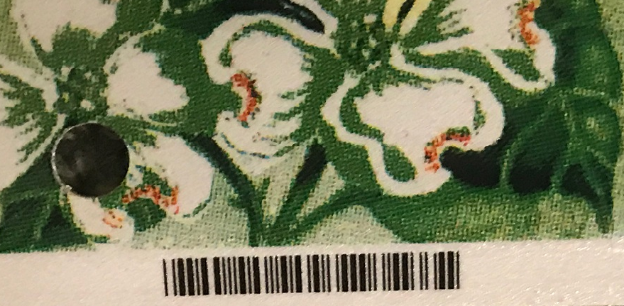

Dedicated Plate Sample – Baymen’s Heritage:

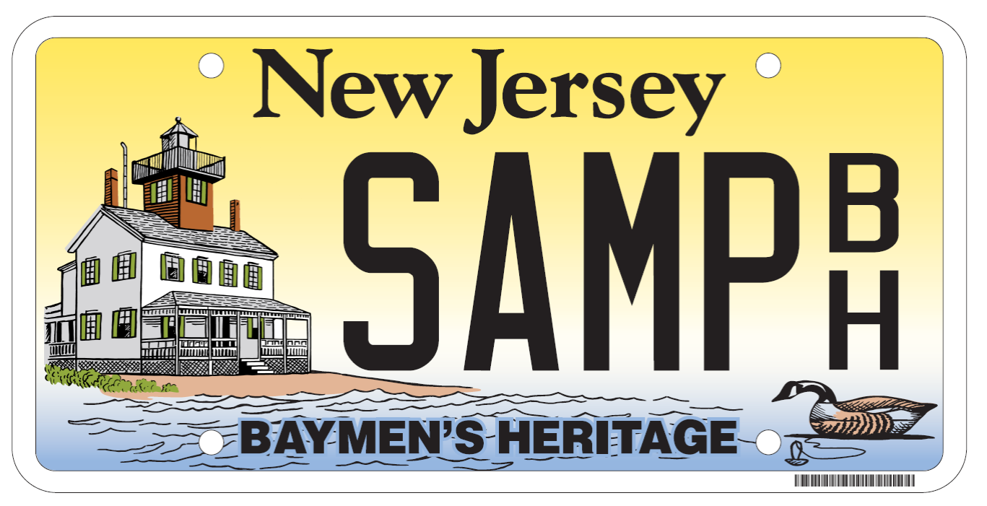
Standard Motorcycle Plate Sample:

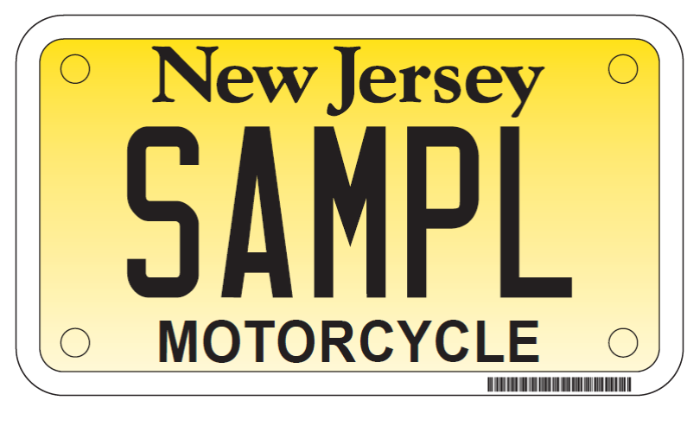
Standard License Plate Sample:

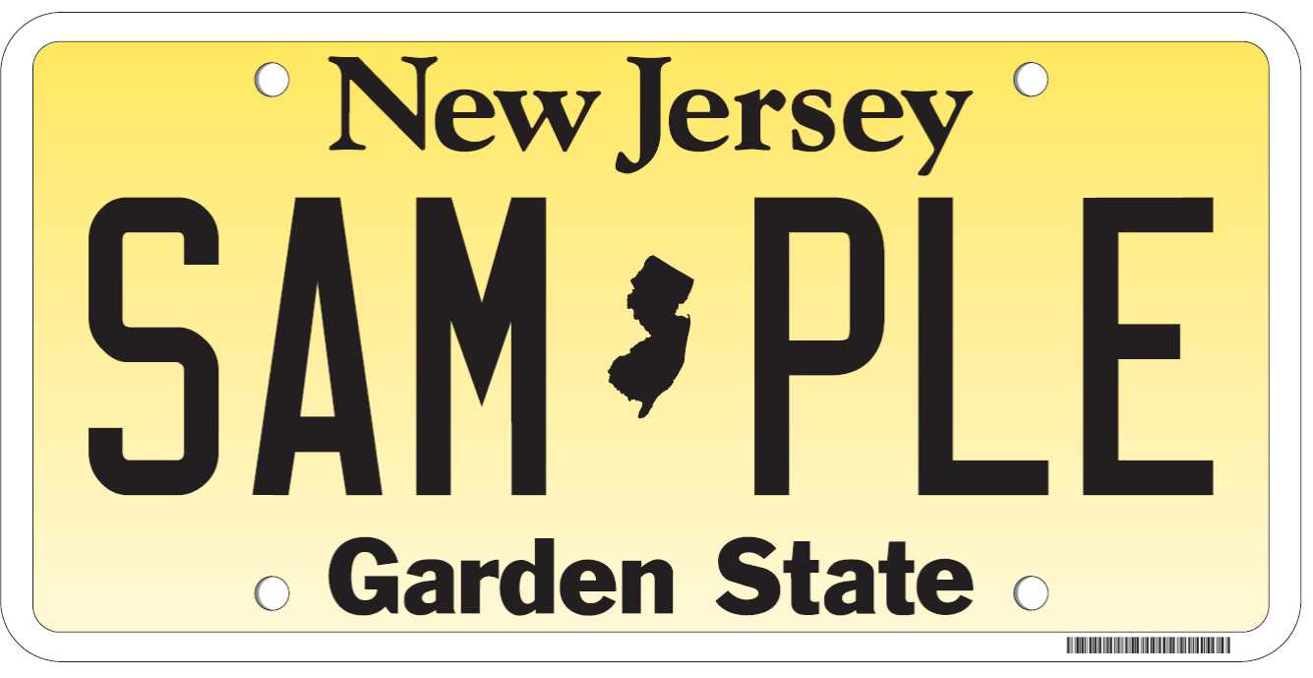

Organization License Plate Sample:

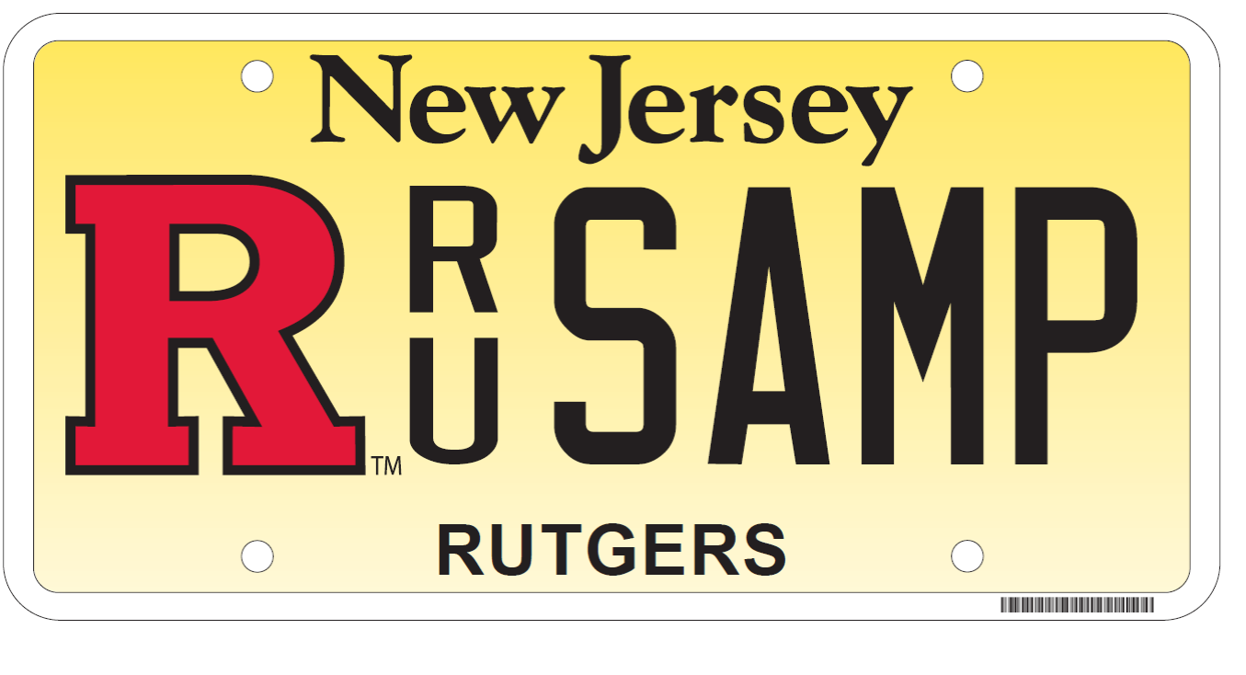
Sports License Plate Samples:

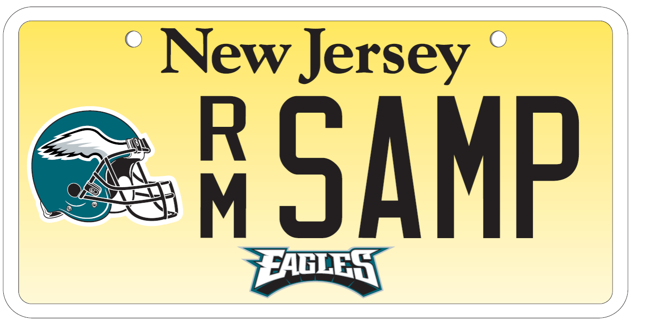

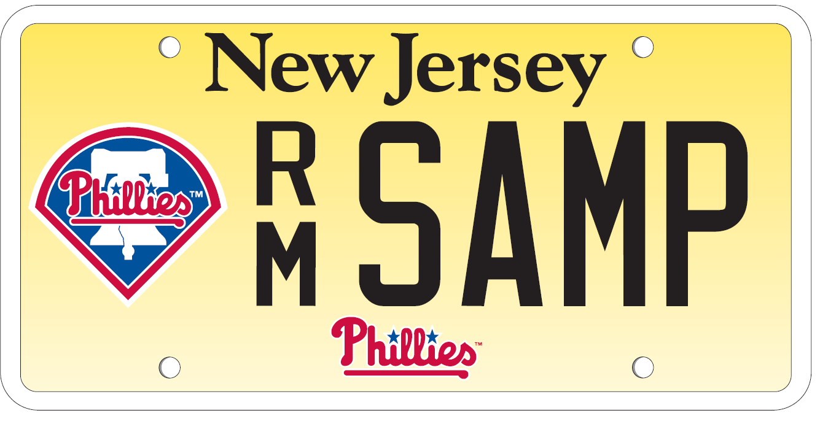

Vanity License Plate Sample:

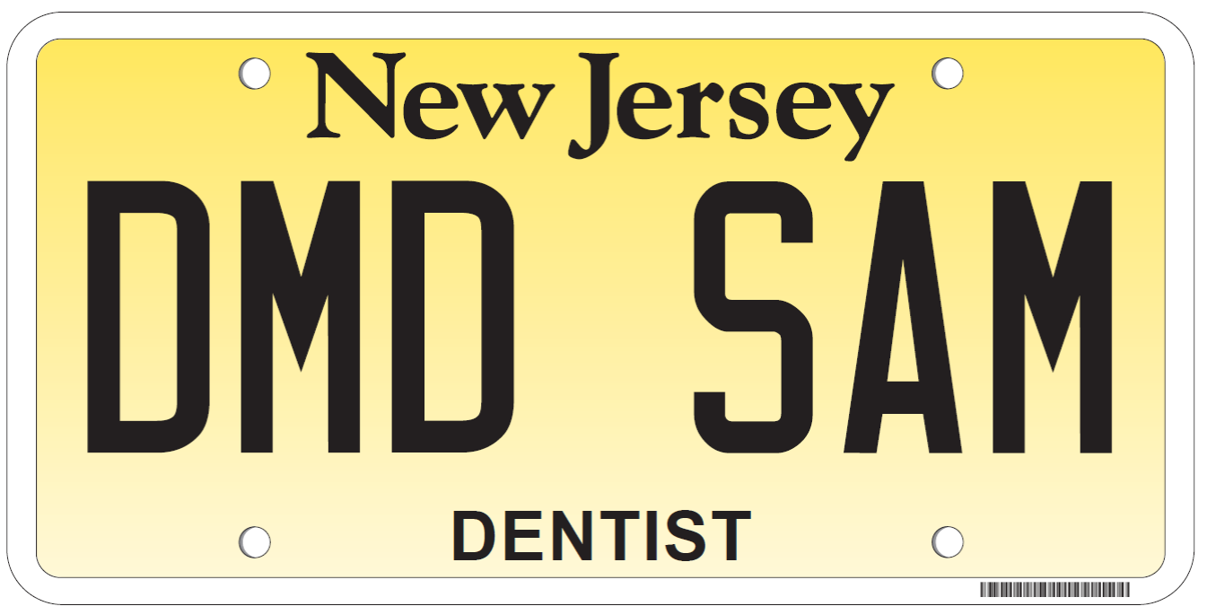

Autocycle License Plate Sample:



