June 25, 2025

To: All Interested Bidders

Re: Bid Solicitation # 25DPP01157
T0121 Breakaway U-Post Sign Supports - Statewide

Quote Submission Due Date: June 10, 2025 (2:00 p.m. Eastern Time)

Quote Submission Due Date: June 27, 2025 (2:00 p.m. Eastern Time)

REVISED Quote Submission Due Date: July 11, 2025 (2:00 p.m. Eastern Time)

Bid Amendment #2

The following constitutes Bid Amendment #2 to the above referenced Bid Solicitation:

- Answers to questions from the Electronic Question and Answer Period that concluded on May 15, 2025;
- Revised Attachment 5 NJDOT Sketches titled “Attachment 5 - NJDOT Sketches Revised 6.19.2025”;
- Revised State-Supplied Price Sheet titled “T0121 25DPP01157 Revised State-Supplied Price Sheet 6.19.2025”
- Revisions to the Bid Solicitation (from Part 2 of the Bid Amendment);

Please note that for all additions, deletions, clarifications and modifications to the Bid Solicitation, please refer to the Revised Bid Solicitation titled, “T0121 25DPP01157 Revised Bid Solicitation 6.19.2025”

It is the sole responsibility of the Bidder to be knowledgeable of all of the additions, deletions, clarifications, and modifications to the Bid Solicitation and/or the New Jersey Standard Terms and Conditions relative to this Bid Solicitation as set forth in all Bid Amendments.

All other instructions, terms, and conditions of the Bid Solicitation shall remain the same.

Bid Solicitation #25DPP01157
T0121 Breakaway U-Post Sign Supports - Statewide

Part 1 - Answers to Questions

Where applicable, each question references the appropriate Bid Solicitation section.

# | Bid Solicitation  Section Reference | Question (Bolded) and Answer
1 | Quote Submission | Please confirm a Bidder may deliver a hardcopy quote instead of submitting a response electronically.  Please be advised that all Quotes shall be submitted electronically through NJSTART.
2 | Quote Submission | Should I check that I have properly completed and attached all of the required documents with my submitted Quote?  Yes. Prior to the Quote Opening Deadline, a Bidder should review the documents comprising the submitted Quote to ensure that all of the required documents have been completed and attached. Oftentimes a Quote is deemed non-responsive because a Bidder fails to attach a required form or attaches a blank form. To review a submitted a Quote, a Bidder should log into NJSTART and review each document attached to the Quote submission. Instructions on how to review a submitted Quote can be found in the Quick Reference Guide entitled ‘How to Review a Submitted Quote’, which is available on the NJSTART Vendor Support Page under Vendor Reference Guides.
3 | PDF Documents | When trying to open a Portable Document Format (PDF), I am receiving an error message and am unable to access the PDF. How should I proceed?  It is recommended that users utilize Microsoft Edge to view PDFs. Certain PDF forms cannot be opened in the Chrome or Firefox built in PDF viewers that are enabled by default. If using Chrome or Firefox it is recommended that the file is downloaded instead by clicking the download button in the upper right-hand corner of the browser after an error message is received. An alternative option is to disable the built in PDF viewers in Chrome or Firefox.
4 | Exceptions | Will the State allow Bidders to take exception to any of the Standard Terms and Conditions?  As stated in Bid Solicitation Section 2.2, Exceptions to the State of NJ Standard Terms and Conditions (SSTC): “Questions regarding the State of New Jersey Standard Terms and Conditions and exceptions to mandatory requirements MUST be posed during the Electronic Question and Answer period and shall contain the Bidder’s suggested changes and the reason(s) for the suggested change(s).” Moreover, as stated in Bid Solicitation Section 3.11, Bidder proposed terms or conditions that conflict with those contained in the State of New Jersey Standard Terms and Conditions may render a Quote non-responsive.
5 | Specification Conformance Certification | Is a Bidder required to provide the signed Specification Conformance Certification with the Quote?  Yes; Bidders are required to provide, with its Quote, the signed Specification Conformance Certification as indicated in Bid Solicitation Section 3.21. Bid Solicitation Section 3.21 states: “The Bidder shall submit with its Quote the Specification Conformance Form. By submitting this form, the Bidders certifies that all items offered in response to this Bid Solicitation conform to the requirements set forth in the Bid Solicitation.”
6 | Price Lines 30 and 31 of the State-Supplied Price Sheet and Attachment 5 – NJDOT Sketches Revised 6.19.2025 | Question: What is the length of the Corner Bolts?  Answer: The length of the bolts from Price Lines 30 and 31 of the State-Supplied Price Sheet are included on page 9 of Attachment 5 – NJDOT Sketches Revised 6.19.2025. Page 9 is titled “Steel Square Post Sign Supports”.  Below is a close-up of the dimensions from page 9.  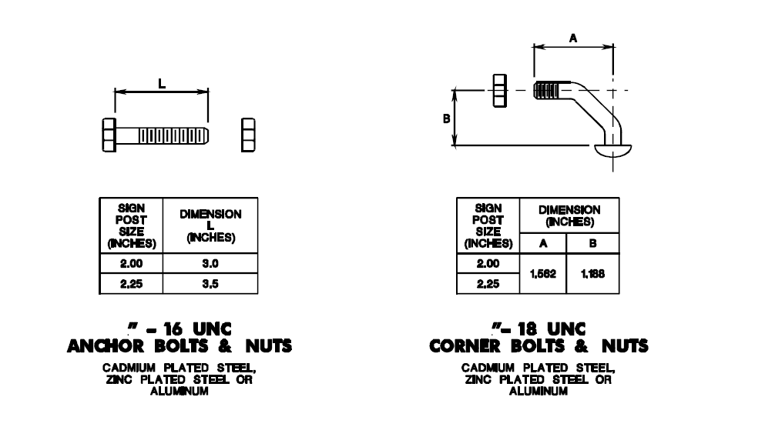  Please refer to Page 9 of the revised Attachment 5 titled “Attachment 5 - NJDOT Sketches Revised 6.19.2025”.  Please note the description for Price Line 31 has been revised. Please refer to Item Number 3 under Part 2 of this Bid Amendment below.
7 | Bid Solicitation Section 4.8 | Question: Can we require purchasing entities to buy full bundles? For example, 25 each for the square posts or 50 each of the u-channel posts.  Answer: No.  Please refer to Item Number 4 under Part 2 of this Bid Amendment below.  Bid Solicitation Section 4.8 has been revised to include the following paragraph:  “The State will order any quantity necessary to meet its requirements. No guarantee is made by the State to purchase any amount of product from any Contractor. The State guarantees neither minimum, nor average, nor maximum quantities per order, nor total quantity during the Contract term, including any extension(s) thereof.”  Please see the revised Bid Solicitation titled “T0121 25DPP01157 Revised Bid Solicitation 6.19.2025”.
8 | Bid Solicitation Section 5.1 and New Jersey Standard Terms and Conditions Section 6.1 | Question: The terms state that the contract may be extended for up to 3 years with each extension being 1 year, and also states terms, conditions, and pricing at the rate in effect in the last year of contract. What does this mean exactly?  Note: This question has been paraphrased in the interest of readability and clarity.  Answer: At the time of extension, the Contractor is encouraged to honor its current contract pricing. However, if the Contractor requires an increase to the contracted price(s), a price increase may be requested, in accordance with New Jersey State Standard Terms & Conditions Section 6.1.  Question: There is a clause for a decrease in price but I don't see and escalation clause, after the initial contract term. Can we increase the price each year based off the current market?  Answer: Yes, price adjustments will be considered following Contract award. Price increases may be requested pursuant to New Jersey State Standard Terms and Conditions Section 6.1, which states, "In an exceptional situation the State may consider a price adjustment. Requests for price adjustments must include justification and documentation."
9 | Bid Solicitation Section 4.2, 4.3, 4.4, and 4.5 | Question: The bid included an attachment of the omni breaks. There was no attachment for the u-channel, soil anchor plates, hardware, or square posts. It referenced an area to find it. Can the specifications be e-mailed or attached to the bid the same way as the Omni breaks?  Note: This question has been paraphrased in the interest of readability and clarity.  Answer: Attachment 5 has been revised to include additional sketches. The additional sketches have been published under the subject Bid Solicitation’s Attachments tab in NJSTART.  Please refer to the revised Attachment 5 titled “Attachment 5 - NJDOT Sketches Revised 6.19.2025.
10 | New Jersey State Standard Terms and Conditions  Section 6.4 | Question: It looks as if we have the option to deny the use of a purchasing card. Is this correct?  Answer: Yes, Contractors have the option to deny the use of a purchasing card. Section 6.4 of the New Jersey State Standard Terms and Conditions, states, in part, “A contractor’s acceptance and a State agency’s use of the p-card are optional.”
11 | Bid Solicitation Section 1.5 & Section 9.2 | Question: Can we opt out of the Cooperative Purchase Participants and only offer to the State of New Jersey?  Answer: No. This Bid Solicitation and any subsequent contract awards will be made available for use by Statewide Using Agencies and the Cooperative Purchasing Participants.  Bid Solicitation Section 1.5 states: “The State intends to extend the Contracts awarded to the State's Intrastate Cooperative Purchasing Participants. Although the State is making the use of any Contract resulting from this Bid Solicitation available to Intrastate Cooperative Purchasing Participants, the State makes no representation as to the acceptability of the Bid Solicitation’s terms and conditions to any Intrastate Cooperative Purchasing Participants.”  Bid Solicitation Section 9.2 defines the Cooperative Purchasing Program and the State's Intrastate Cooperative Purchasing Participants as follows:  “Cooperative Purchasing Program – The Division’s intrastate program that provides procurement-related assistance to New Jersey local governmental entities and boards of education, State and county colleges and other public entities having statutory authority to utilize select State Contract s issued by the Division, pursuant to the provisions of N.J.S.A. 52:25-16.1 et seq.”  “Intrastate cooperative purchasing participants – refers to political subdivisions, volunteer fire departments and first aid squads, and independent institutions of higher education and school districts pursuant to N.J.S.A. 52:25-16.1 et seq., State and county colleges pursuant to N.J.S.A. 18A:64-60 and 18A:64A-25.9, quasi-State agencies and independent authorities pursuant to N.J.S.A. 52:27B-56.1, and other New Jersey public entities having statutory authority to utilize select State contracts issued by the Division.”

Bid Solicitation #25DPP01157
T0121 Breakaway U-Post Sign Supports - Statewide

Part 2 - Revisions to the Bid Solicitation and State-Supplied Price Sheet

# | Bid Solicitation  Section Reference | Revision
1 | Bid Solicitation Cover Page | Please be advised that the Quote opening date has been changed from Friday, June 27, 2025 to Wednesday, July 11, 2025 at 2:00 PM (Eastern Standard Time).  In the Set-Asides area of the Bid Solicitation Cover Page, the ‘Not Applicable’ box has been checked for the ‘Disabled Veteran-Owned Business Set-Aside’.
2 | Bid Solicitation Table of Contents, Date for Attachment 1 - State of New Jersey Standard Terms and Conditions | A revised version of the State of New Jersey Standard Terms and Conditions has been published in NJSTART. As such, the version date for Attachment 1 - State of New Jersey Standard Terms and Conditions has been changed from 2/8/2024 to 6/3/2025.
3 | Bid Solicitation Sections 1.1 and 3.36 (Table Description for Price Line 31) and Price Line 31 on the State-Supplied Price Sheet | The tables in Bid Solicitation Sections 1.1 and 3.36 for Price Line 31 and the description for Price Line 31 on the State-Supplied Price Sheet have been revised as follows:
  31 | 3/8 INCH CORNER ANCHOR BOLT AND NUT – 16 UNC, AS PER BID SOLICITATION SECTION 4.2.3. | Each
4 | Bid Solicitation Section 4.8 | The following paragraph has been added to Bid Solicitation Section 4.8:  “The State will order any quantity necessary to meet its requirements. No guarantee is made by the State to purchase any amount of product from any Contractor. The State guarantees neither minimum, nor average, nor maximum quantities per order, nor total quantity during the Contract term, including any extension(s) thereof.”
5 | Attachment 1 - State of New Jersey Standard Terms and Conditions, Page 4 of the Bid Solicitation (Table of Contents) and Attachment 1 in NJSTART under the Attachments Tab | A revised version of the State of New Jersey Standard Terms and Conditions, dated 6/3/2025, has been published under the Attachments tab of the Bid Solicitation in NJSTART. This replaces the previous version of the State of New Jersey Standard Terms and Conditions dated 2/8/2024.

