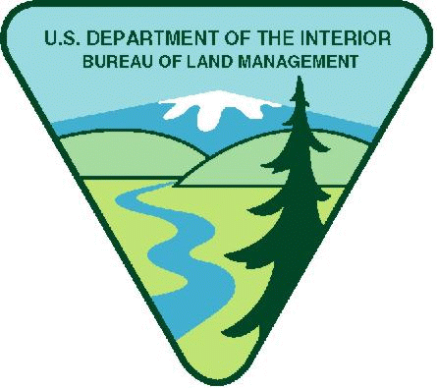
Project Title: California-King Range NCA Youth Crew Opportunity
Available Funding in FY26: $35,000
Maximum Funding (if multi-year): $105,000
Note: BLM has determined $800 weekly stipend equal to $20.00 per hour is reasonable. Stipends above this amount must justify in budget narrative increase needed.
Period of Performance: December 31, 2026- December 30, 2030
Project Background Information: The King Range (KRNCA) encompasses more than 68,000 acres of rugged mountains, wild coastline, rivers, forests, and wilderness area along California’s remote North Coast. The Bureau of Land Management (BLM) protects outstanding natural, cultural, and recreational resources, including the renowned Lost Coast Trail, one of the few places in California where the mountains rise directly from the Pacific Ocean. The KRNCA provides habitat for diverse wildlife, supports watershed and coastal ecosystem land management, and offers opportunities for hiking, camping, backpacking, wildlife viewing, and environmental education in one of the state's most undeveloped and scenic landscapes.
Project Objectives: The BLM will introduce youth to natural resource careers along with recreation and wilderness management through projects focused on trail maintenance and resource protection. BLM resource staff and other collaborating resource agencies will provide mentorship and work experience to youth for career development and educational benefit. This will be accomplished by providing opportunities to gain experience, learn about public lands, further their understanding and appreciation of recreation and wilderness resources, and pique youth’s interest in the natural resource sector. The program will aim to increase appreciation and understanding of our public lands and become life-long stewards.
The King Range (KRNCA) Youth Corps Opportunity will provide a vital investment in both the stewardship of public lands and the development of the next generation of land management leaders. Serving a rural and economically challenged region of California's North Coast, the program will provide local youth with paid, hands-on work experiences that build job skills, leadership capacity, environmental literacy, and career awareness. Participants will engage in meaningful land management projects while developing teamwork, communication, problem-solving, and workplace skills that prepare them for future education and employment opportunities. For many participants, the program will represent a rare opportunity to gain professional experience, connect with mentors, and develop a lasting relationship with the public lands in their own communities.
A strong partnership with a local nonprofit organization is essential to the success of the program. The nonprofit partner will serve as a co-leader of the youth crew, helping to recruit and support participants, coordinate program activities, and provide mentorship and community connections that enhance the youth experience. As the program's fiscal agent, the nonprofit will be responsible for managing grant funds, administering payroll and participant support, and ensuring efficient program operations. This collaborative model allows the Bureau of Land Management to leverage local expertise and community relationships while focusing on land management outcomes. Together, the partners will provide a comprehensive program that benefits both youth and the King Range NCA. Youth crews will complete priority projects that enhance visitor experiences, improve public access, restore habitat, maintain trails and facilities, and support resource land management across this nationally significant landscape. By combining stewardship with youth workforce development, the program will create lasting benefits for the land, the community, and the future of public land management.
Qualification Requirements: This project would not require a college degree, rather, this opportunity would allow for youth to gain an interest and understanding of land management while they develop hands-on skills that would help them become job ready for many career fields. Applicants must be able to pass a DOI security background check.

Housing: Including either housing or a housing allowance would ensure interns’ needs are met. The King Range is extremely remote and would like to invest in the local gateway communities so this could be a commuter crew, although should an intern need housing KRNCA has a bunk house.

Vehicle Needs: Interns will be able to ride in government vehicles and after meeting all the requirements they may be able to drive government vehicles.

Other Project Considerations: Local organizations and youth might be better suited to handling the challenges posed by such a remote location.

Duties: Youth crews will support the BLM Arcata Field Office (ARFO) and the King Range (KRNCA) which has the world-renowned Lost Coast Trail and famed Paradise Royale mountain biking loop. Members would engage in a variety of hands-on projects that align with the agency’s Recreation, Travel Management, and Interpretation programs. Their work would include trail restoration and erosion mitigation to improve public access, protecting natural resources, as well as habitat restoration to enhance ecosystem health. The youth may assist in monitoring and maintaining recreation areas, perform inventory and assessments along trail corridors, and contribute to the development of interpretive materials that educate the public on geology, ecology, and cultural history. In addition, youth crews may support travel management plans through signage and outreach efforts promoting Leave No Trace and Tread Lightly principles. These tasks will provide valuable mentorship and skill-building opportunities in land stewardship, environmental science, and public engagement, while directly contributing to the long-term sustainability and accessibility of America’s public lands for current and future generations. Youth crews will work on and maintain sections of the 24.6-mile Lost Coast Trail and the 25-miles of mountain bike trails including the 13-mile Paradise Royale Loop, and other local BLM trails. These efforts will contribute directly to BLM’s goals for recreation, travel management, and landscape restoration.

BLM’s Substantial Involvement: There will be substantive BLM programmatic involvement by BLM professionals to include mentoring, oversight, and engagement with youth participants. BLM will have the right to intervene by modifying the project management plan, if project is not staying on schedule, technical issues arise, etc. In addition, BLM and recipient will meet weekly to discuss progress and track project outcomes; review any training needs; and then determine what direction to take in finalizing project or move to the next phase.

BLM Program Contact:
Field PO Name: Sandra Miles
Field PO Phone Number: 707-986-5415
Field PO Email: smiles@blm.gov

Applicants are encouraged to refer to the full program announcement number L26AS00064 posted on Grants.gov for all program requirements and applicable terms and conditions. Recipients selected for awards will be required to adhere to those requirements should an award be made.

