Attachment 6, Network Access Instructions

Network Access Instructions

Introduction

One of the State’s key objectives is to determine if your organization can provide accessible health care services to its employees. In order to assess your network’s ability to meet our client’s needs, the State requires that you prepare a network match (Quest Analytics Suite™ Access Analysis) using residential ZIP Codes and your network of providers. Instructions for using both software applications are included in this document.
We ask that you prepare your results in the following formats:
1. Quest Analytics Report (Adobe Acrobat .pdf file)
2. Microsoft Access Database (Access 2010)

VERY IMPORTANT: some of the illustrations in this document indicate access naming conventions of .mdb (Access 2002 – 2003). We ask however that you remit using .accdb type (Access 2010) Otherwise we have experienced issues of not receiving the database at all via email.
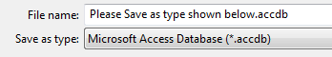

In order for your organization’s response to be evaluated, it is critical that you comply with all instructions and include the required network match analysis as part of your firm’s Quote.

File Attachments

Summary of Census Information
Included with this request is a summary database in Microsoft Access format. The database summarizes unique ZIP Codes and total employees.
The following fields are included in the table named “Census for Analysis” and defined as:
1. Zip—Employee’s residential ZIP Codes
2. STD_Class—R=Rural, S=Suburban, U=Urban
3. Total Employees—Total number of employees residing in that ZIP Code and class
Note: ZIP Codes for employees in the Northeast may not have a leading zero.

Creating Quest Analytics Reports
Please follow the four-step process to complete the Dental request.
- Log into the Quest Enterprise Services through the Quest Analytics Suite™, as seen in the picture below. If you are a current QES user, please enter your login information. If you are not a QES user, please enter your company’s serial number and password.

Call Quest Analytics Support at 920-739-4577 if you need help logging in or updating to the most current version of the Quest Analytics Suite™.

- Navigate to File > New and click the “From Quest Enterprise Services Template” radio button and select “Aon Dental” from the drop-down menu.
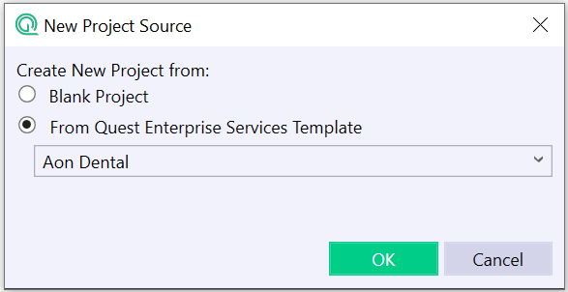 (Once this is complete, the Quest Analytics Suite will open an Aon Dental Project shell)
- The Quest Analytics Suite™ will already have your groups set up as outlined on the Accessibility Detail Page (Page 3). Link Provider Groups that have been created to Data and create appropriate filters. Link the Employee Groups to the Member Data provided and create filters on the Urban, Suburban and Rural as indicated in the Data. Make sure in each Employee Group that you select the “Zip Code Census”.
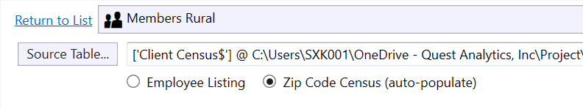
VERY IMPORTANT: In order to avoid rework.
- if Zip Code Census (auto-populate) is not selected, your output will be errant and rejected, the comments back may say something like, you only provided one member in each zip code, please start over using the Zip Code Census (auto-populate) selection.
- if Zip Code Census (auto-populate) is not selected, your output will be errant and rejected, the comments back may say something like, you omitted certain zips codes and or people in them, please start over using the Zip Code Census (auto-populate) selection. We are unable to accept files with missing zip codes or people in them.

- Run and Export the report. (The table names and column headings will be in the expected format.)
Setting up the Report Page Options
VERY IMPORTANT: Your reports should include every ZIP Code that is in Quest’s census summary, even ZIP Codes with no access should be included.
By default, the Quest Access Analysis software includes all employees.

Saving the Page Results to a Data File
Simply navigate to File>Export and export to Microsoft Access 2007-2013. Each report page will be a separate table in your Access database and be formatted with the expected column headings as outlined on page 8.

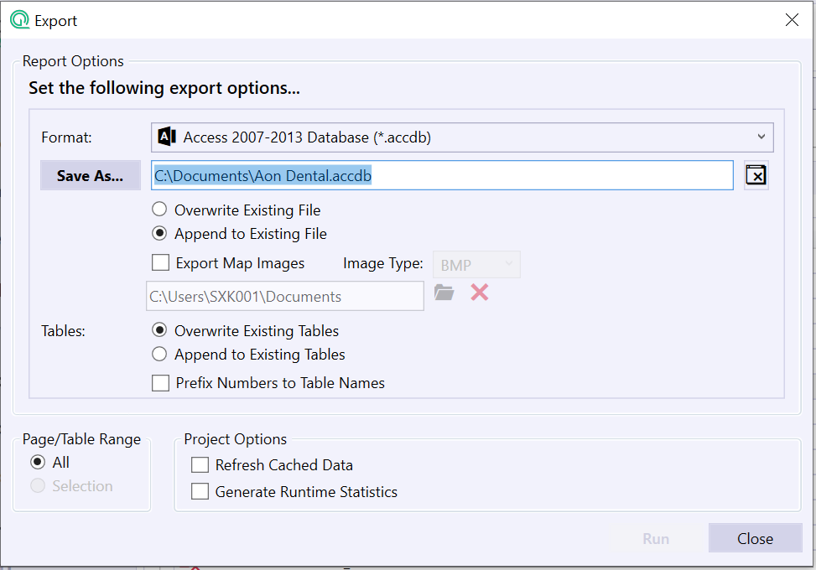

VERY IMPORTANT: Please name the tables according to what is outlined below.
(Quest Analytics Suite™ does this for you) Please also include the number and colon.

Dental:

2: Endo_U
2: Endo_S
2: Endo_R
3: GenDent_U
3: GenDent_S
3: GenDent_R
4: Oral_U
4: Oral_S
4: Oral_R
5: Ortho_U
5: Ortho_S
5: Ortho_R
6: Pedo_U
6: Pedo_S
6: Pedo_R
7: Perio_U
7: Perio_S
7: Perio_R

Accessibility Detail Pages

The access report will be created with three Employee Groups – Urban, Suburban and Rural employees. The report should also include a Provider Group for each provider type that is to be analyzed. Table 1.3 details the access standards that should be used to analyze each employee and provider group.
Table 1.3—Dental
Employee Group | Provider Group | Access Standard
Urban | General Dentists | 2 providers within 5 miles
Suburban | General Dentists | 2 providers within 10 miles
Rural | General Dentists | 2 providers within 20 miles
Urban | Pedodontists | 1 provider within 5 miles
Suburban | Pedodontists | 1 provider within 15 miles
Rural | Pedodontists | 1 provider within 25 miles
Urban | Orthodontists | 1 provider within 5 miles
Suburban | Orthodontists | 1 provider within 15 miles
Rural | Orthodontists | 1 provider within 25 miles
Urban | Periodontists | 1 provider within 5 miles
Suburban | Periodontists | 1 provider within 15 miles
Rural | Periodontists | 1 provider within 25 miles
Urban | Oral Surgeons | 1 provider within 5 miles
Suburban | Oral Surgeons | 1 provider within 15 miles
Rural | Oral Surgeons | 1 provider within 25 miles
Urban | Endodontists | 1 provider within 5 miles
Suburban | Endodontists | 1 provider within 15 miles
Rural | Endodontists | 1 provider within 25 miles

Please Note: Only show access to providers that are currently practicing. Use Estimated Driving Distance for calculating distance.
After each access standard has been defined using the Table above, an Accessibility Detail Page for each combination of Employee Group, Provider Group, and Access Standard should be created. Using Table 1.3, the report should contain 18 Accessibility Detail pages (18 tables in Microsoft Access).

VERY IMPORTANT: Please name the tables according to what is shown below including the number and colon.
Dental:

2: Endo_U
2: Endo_S
2: Endo_R
3: GenDent_U
3: GenDent_S
3: GenDent_R
4: Oral_U
4: Oral_S
4: Oral_R
5: Ortho_U
5: Ortho_S
5: Ortho_R
6: Pedo_U
6: Pedo_S
6: Pedo_R
7: Perio_U
7: Perio_S
7: Perio_R

Microsoft Access Report Format—All Software Applications
The Quest Analytics report data has now been saved to a Microsoft Access database. Open the newly saved database and open the tables to ensure that the data was extracted correctly.
VERY IMPORTANT: All tables created in Microsoft Access must be identical to the column headings as in Table 1.9. If your tables do not show the column headings identical to Table 1.9, call Quest Analytics Support at 920-739-4577 to discuss.
Table 1.9
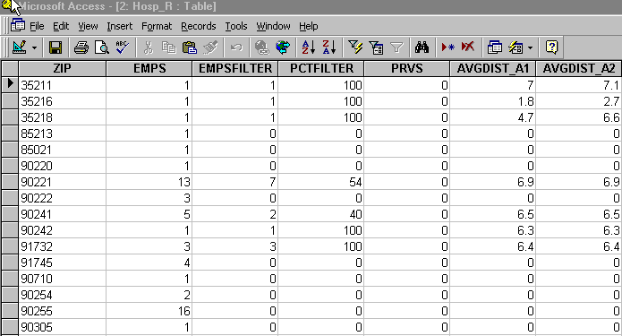
Quest Analytics—The columns should appear as in Table 1.9 by default.
Each column heading corresponds to the Report (Adobe Acrobat file) as follows:
ZIP—ZIP Code
EMPS—Total Employees in ZIP Code
EMPSFILTER—Employees in ZIP Code with Desired Access
PCTFILTER—Percent of Employees in ZIP Code with Desired Access
PRVS—Number of Providers in ZIP Code
AVGDIST_A1—Average Distance to One Provider
AVGDIST_A2—Average Distance to Two Providers

Sending Files to the State of New Jersey
Double-check that the Quest Analytics Report (Adobe Acrobat file) and Microsoft Access Database (18 tables) are complete and accurate. When finished, use a compressing software program (such as SecureZIP or WinZip) to compress the two files. It is imperative that you ZIP the MS Access database or the State will not accept the file attachment.
All information must be submitted to the State’s procurement portal (NJSTART) as part of the Quote submission.

Questions?
Please direct all technical or software related questions to:

Quest Analytics Support
920-739-4577
support@questanalytics.com

Timing
In order for your organization’s response to be accepted evaluated, it is critical that you comply with all instructions and respond to this Bid Solicitation by the specified due date. Refer to the Bid Solicitation for additional information.

