May 28, 2024

To: All Interested Bidders

Re: Bid Solicitation # 23DPP00860
Bid Solicitation TITLE: T2924- Snow Plowing Services by Area- NJDOT
Revised Quote Submission Due Date: Wednesday, June 12, 2024 (2:00 p.m. Eastern Time)
Quote Submission Due Date: Tuesday, May 28, 2024 (2:00 p.m. Eastern Time)

Bid Amendment #2

The following constitutes Bid Amendment #2 to the above referenced Bid Solicitation:

- This Bid Amendment includes answers to questions;
- Revision to the Bid Solicitation Document; and
- Revision to the State Supplied Price Sheet;
- Please note that for all additions, deletions, clarifications and modifications to the Bid Solicitation, please refer to the Revised Bid Solicitation entitled “T2924 Revised Bid Solicitation 5.28.2024.”

It is the sole responsibility of the Bidder to be knowledgeable of all of the additions, deletions, clarifications, and modifications to the Bid Solicitation and/or the New Jersey Standard Terms and Conditions relative to this Bid Solicitation as set forth in all Bid Amendments.

All other instructions, terms, and conditions of the Bid Solicitation shall remain the same.

Bid Solicitation #23DPP00860

T2924- Snow Plowing Services by Area - NJDOT

# | Bid Solicitation  Section Reference | Revision
1 | Bid Solicitation Cover Page | Please be advised that the Quote Submission Date has been changed from Tuesday, May 28, 2024 (2:00 p.m. Eastern Time) to Wednesday, June 12, 2024 (2:00 p.m. Eastern Time).  Please refer to the Bid Solicitation titled “T2924 Revised Bid Solicitation 5.28.2024”

Note: Some of the questions have been paraphrased in the interest of readability and clarity. Each question references the appropriate Bid Solicitation section.
# | Bid Solicitation  Section Reference | Question (Bolded) and Answer
1 | Quote Submission | Please confirm a Bidder may deliver a hardcopy quote instead of submitting a response electronically.  Please be advised that all Quotes shall be submitted electronically through NJSTART.
2 | Quote Submission | Should I check that I have properly completed and attached all of the required documents with my submitted Quote?  Yes. Prior to the Quote Opening Deadline, a Bidder should review the documents comprising the submitted Quote to ensure that all of the required documents have been completed and attached. Oftentimes a Quote is deemed non-responsive because a Bidder fails to attach a required form or attaches a blank form. To review a submitted a Quote, a Bidder should log into NJSTART and review each document attached to the Quote submission. Instructions on how to review a submitted Quote can be found in the Quick Reference Guide entitled How to Review a Submitted Quote, which is available on the NJSTART Vendor Support Page under Vendor Reference Guides.
3 | PDF Documents | When trying to open a Portable Document Format (PDF), I am receiving an error message and am unable to access the PDF. How should I proceed?  It is recommended that users utilize Microsoft Edge to view PDFs. Certain PDF forms cannot be opened in the Chrome or Firefox built in PDF viewers that are enabled by default. If using Chrome or Firefox it is recommended that the file is downloaded instead by clicking the download button in the upper right-hand corner of the browser after an error message is received. An alternative option is to disable the built in PDF viewers in Chrome or Firefox.
4 | Exceptions | Will the State allow Bidders to take exception to any of the Standard Terms and Conditions?  As stated in Bid Solicitation Section 2.2, Exceptions to the State of NJ Standard Terms and Conditions (SSTC): “Questions regarding the State of New Jersey Standard Terms and Conditions and exceptions to mandatory requirements MUST be posed during the Electronic Question and Answer period and shall contain the Bidder’s suggested changes and the reason(s) for the suggested change(s).” Moreover, as stated in Bid Solicitation Section 3.11, Bidder proposed terms or conditions that conflict with those contained in the State of New Jersey Standard Terms and Conditions may render a Quote non-responsive.
 | Section 1.1  Intent  &  Section 8.16  0Contract Award | Please be advised Section 1.1 and Section 8.16 have been revised as follows:  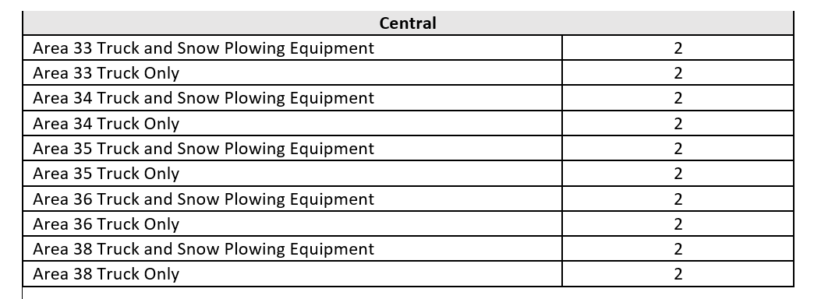  Please refer to the Bid Solicitation titled “T2924 Revised Bid Solicitation 5.28.2024”
 | Section 1.1  Intent  &  Section 3.21  State Supplied Price Sheet Instructions | Please be advised Section 1.1 and Section 3.21 have been revised as follows:  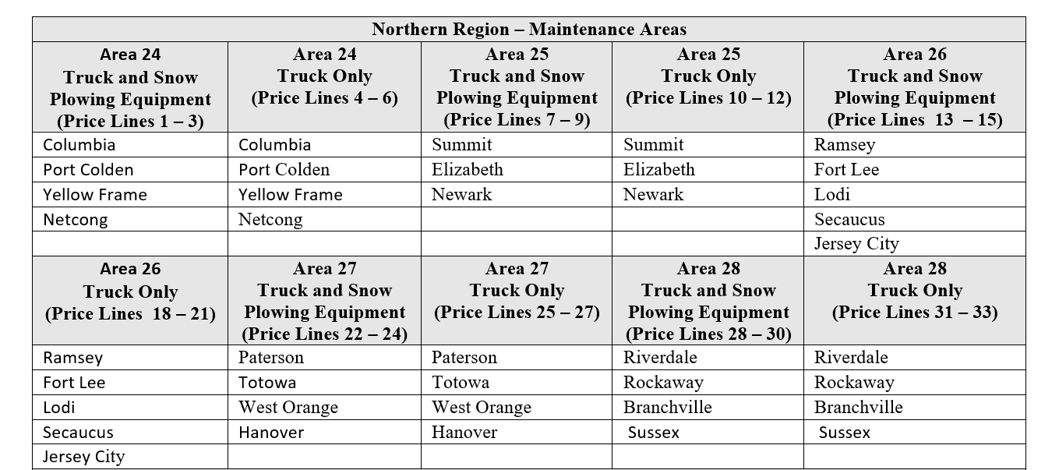  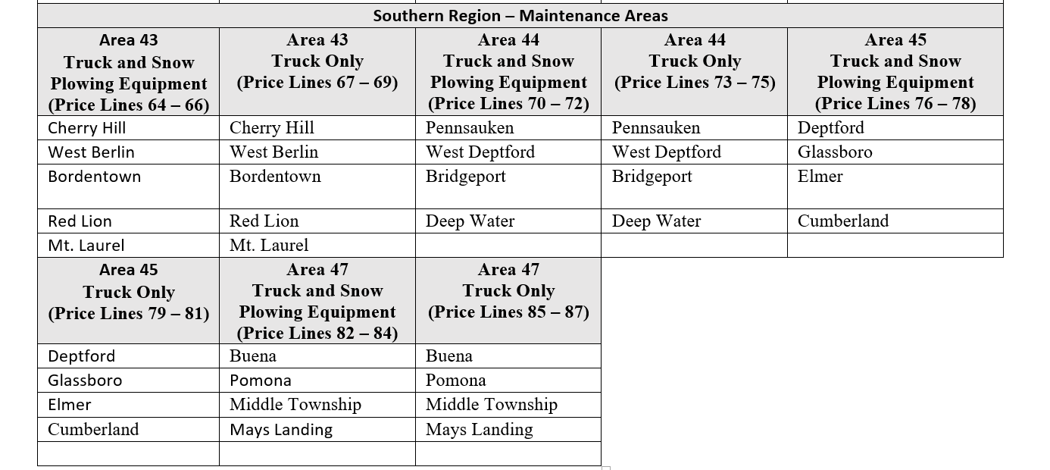  Please refer to the Bid Solicitation titled “T2924 Revised Bid Solicitation 5.28.2024”
5 | Section 4.1  Regional Maintenance Areas | Q - Reviewing the list of maintenance areas, it's unclear which sites, roads, or lots require plowing. Could you supply a site map indicating the service areas along with their approximate square footage or mileage?  A – Yes, the State has added the following attachments to the “Attachment Tab” inn NJSTART:  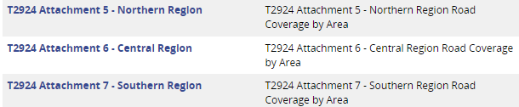  Additionally, Bid Solicitation Section 4.1 has been revised as follows:  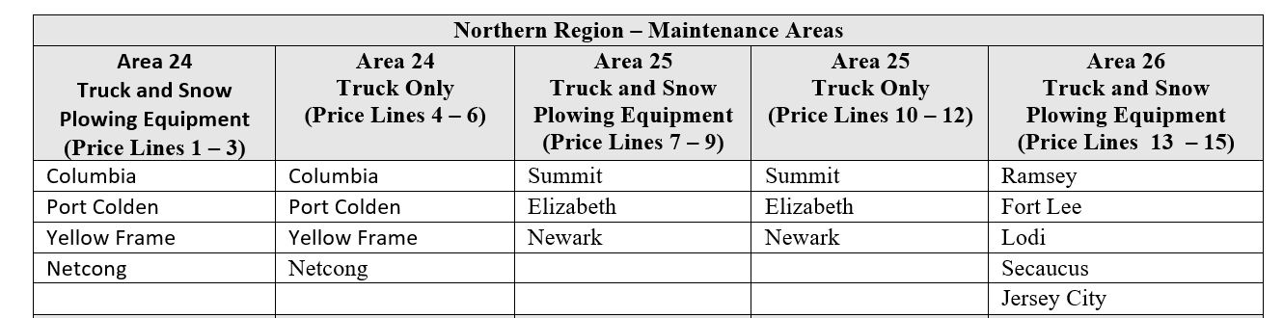  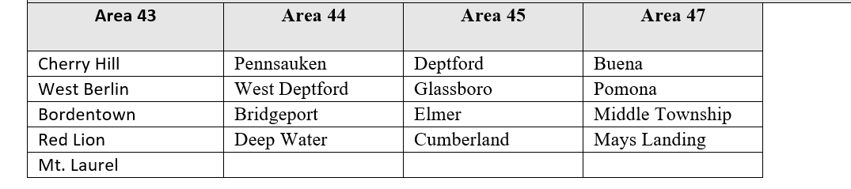  “Note: For information regarding the breakdown of Road Coverage by Region please refer to Attachment 5 - Northern Region, Attachment 6 - Central Region and Attachment 7 - Southern Region.”  Please refer to the Bid Solicitation titled “T2924 Revised Bid Solicitation 5.28.2024”
6 | Section 4.7  Contractor Readiness and Call-Out | Q - Will there be any coordination or overlap between this contract and T0777 - Snow Plowing and Spreading Services?  A - Please be advised, while there are times of overlap, the strike teams are strategically placed to supplement shortages or provide extra help in conjunction with Contract T0777.  Please refer to the Bid Solicitation titled “T2924 Revised Bid Solicitation 5.28.2024”
7 | 4.7  Contractor Readiness and Call-Out | Q - When you award contracts for area's that require 2 strike force crews for both contractors with and without their own equipment (4 total per area), then will all of the strike force teams be call out for any given event or will the State only call out some of the strike force crews if they feel that they don't need an extra 28 (4X7=28) plows for a particular event?  Q - If so what (which) crew would receive precedence for being called out first?  A - There is no preference as to which strike force is called out. The decision for call-out would be based on the need for a particular storm to ensure the safety of the motoring public, and is at the discretion of State Contract Manager.  Additionally, Section 4.7 has been revised as follows:  “There is no preference as to which strike force is called out (Truck and Snow Plowing Equipment or Truck Only). The decision for a call-out would be based on the need in response to a snow event/storm. The strike force will be called out at the discretion of the SCM, and will be assigned strategically by the SCM to ensure safety on State roads.”  Please refer to the Bid Solicitation titled “T2924 Revised Bid Solicitation 5.28.2024”
8 | 4.7  Contractor Readiness and Call-Out | Q - With the current Strike Force contract, I believe that each area only has 1 strike force crew of 7 trucks for the most part at present? With this new contract you may get a possible 4 to 6 crews (28 to 42 trucks) in any given area. That is a lot of excessive trucks. With that being said, Is this going to interfere with the present & future contractors that have or will have established route(s) snow sections through the established 20DPP00525 contract or will have any through any proceeding (upcoming rebid) contract, as far as callout preference?  Q - Can you please clarify this, as to who gets called first the Strike Force or the established crews committed to any given snow section(s)?  For example, if I'm correct, at present Area 24 has 48 contractor trucks assigned to the 11 committed snow sections within its Area. Furthermore I believe there is 1 Strike Force crew with 7 trucks committed to this area at present. In trying to understand this RFP, you would be looking to add up to 6 Strike Force crews (3 with State equipment & 3 with contractor supplied equipment), which would total up to possible additional 42 trucks to back up the 48 contractor trucks already committed to the existing snow sections within this area? If I'm correct, this seems very excessive in its context. More importantly, who will be primary coverage if the State feels the need to call out any plow trucks for this or any other area during any snow event?  The reason I ask this is because in the past on some storms we were not called out on sections that we were the committed contractor for, rather the State called out the Strike Force crew to cover our area. Now going forward, if you have all of these excessive Strike Force crews along with the committed section crews, I feel it is going to cause a turmoil amongst all of the contractors as to who takes precedent as far as being called out first during any given snow event. This is something that I strongly feel needs to be clarified because you have the primary committed contractors who are assigned to their awarded sections and should be kept as primary coverage at all times before deploying any Strike Force crews.  Q - Can you please clarify this situation so everyone understands the order of preference as far as callout are conducted? Thank you  A - The current Contract has 3 strike force teams for Area 24 equaling 28 trucks, the rest of the Areas have 2 strike force teams totally 14 extra trucks per Area. This contract has run in conjunction with T0777 for many years and there is always a need to strategically place extra plow trucks in certain areas to help with shortages statewide. Callouts are based on the need(s) for that particular winter event.  Additionally, Section 4.7 has been revised as follows:  “There is no preference as to which strike force is called out (Truck and Snow Plowing Equipment or Truck Only). The decision for a call-out would be based on the need in response to a snow event/storm. The strike force will be called out at the discretion of the SCM, and will be assigned strategically by the SCM to ensure safety on State roads.”  Please refer to the Bid Solicitation titled “T2924 Revised Bid Solicitation 5.28.2024”
`

