Exhibit 2
Supporting Documents

Table of Contents
Document | RFP Reference | Page
Consumer Registration Form | Intake | 3
Screen for Community Services | Assessments | 6
Screen for Community Services Algorithm | Assessments | 11
Nutritional Survey | Assessments | 16
Plan of Care | Care Management | 19
JACC Co-Pay Worksheet | Care Management | 21
HCBS Authorization Data | Interfaces & Service Delivery | 22
Integrated Program Summary Sample from SAGE | Interfaces | 24
APC Service Taxonomy Reporting Crosswalk | Interfaces & Service Delivery | 27
APC Fund Identifiers | Interfaces & Service Delivery | 31
Beneficiary Contact Form | Interfaces & Intake | 33
Assistive Technology List | General | 35

Consumer Intake
Consumer Intake
A. Consumer Profile
1.a.First Name (request full legal name)
1.b.Middle Initial
1.c.Last Name
2.Notes on this Consumer
3.a.Care Manager Assigned?
No
Yes
Don't Know
3.b.If yes, Care Manager
4.a.Home Phone
4.b.Is this an unlisted number?
No
Yes
Don't Know
4.c.Authorized to share phone number with other service agencies?
No
Yes
Don't Know
5.Cell Phone
6.Email for Consumer ‑ use the format: name@email.server
7.a.Address 1
Consumer Intake
S:\Omnia\Assessment Forms\NJ Consumer Intake.afm
Page 1 of 5
3/31/2022

7.b.Address 2
7.c.City
7.d.State
7.e.Zip Code
7.f.County
7.g.Municipality
7.h.Directions to Home
8.Do you live alone?
No
Yes
9.Gender
Male
Female
10.Date of Birth
______/______/____________
11.a.Ethnic Race (choose as many as apply)
White
Black/African American
Asian
Pacific Islander
American Indian
White‑Hispanic
Other
11.b.Ethnicity
Hispanic or Latino
Not Hispanic or Latino
Unknown
Consumer Intake
S:\Omnia\Assessment Forms\NJ Consumer Intake.afm
Page 2 of 5
3/31/2022

12.Primary Language
English
Spanish
French
Other
13.a.Have you gained or lost 10 pounds in the past six months without wanting to?
No
Yes
Don't know
13.b.Do you eat less than 2 meals per day?
No
Yes
Don't Know
13.c.Do you sometimes not have enough money to buy the food you need?
No
Yes
Don't know
14.a.Physical disability
No
Yes
14.b.Developmental Disability
No
Yes
14.c.Serious mental illness
No
Yes
14.d.Dementia‑related impairment
No
Yes
14.e.Other disability
No
Yes
14.f.If other disability, please describe:
Consumer Intake
S:\Omnia\Assessment Forms\NJ Consumer Intake.afm
Page 3 of 5
3/31/2022

15.a.Marital status
Single / Not Married
Married
Widowed
Separated
Divorced
Civil union
Other
15.b.Spouse or Significant Other
15.c.Spouse or Significant Other Date of Birth
______/______/____________
16.a.Primary contact person (if not spouse)
16.b.Work phone
16.c.Home phone
16.d.Cellular phone
16.e.Fax Number
16.f.Best way to reach primary contact
Home Phone
Work Phone
Cell Phone
16.g.Best time to reach primary contact
16.h.Email for primary contact ‑ use the format: name@email.server
Consumer Intake
S:\Omnia\Assessment Forms\NJ Consumer Intake.afm
Page 4 of 5
3/31/2022

17.State / Federal / Private Insurance
Pharmaceutical Assistance to the Aged and Disabled Program (PAAD)
Senior Gold
Medicare ‑ Part D
Medicare
Medicaid
Private Insurance
18.Are you a U.S. citizen?
No
Yes
19.Are you currently receiving or have applied for any of the following:
Social Security Disability (SSD)
Supplemental Security Income (SSI)
Medicaid
None of the Above
20.a.Are you currently receiving any home or community‑based services (i.e. Home Delivered Meals, Home Health Aide, Home Care, etc)?
No
Yes
Don't Know
20.b.If yes, specify the services received
Date
Title :
Date
Title :
Consumer Intake
S:\Omnia\Assessment Forms\NJ Consumer Intake.afm
Page 5 of 5
3/31/2022

Screen for Community Services
2022 SCS
2022 Screen for Community Services
2022 Screen for Community Services
Is the person currently receiving or have applied for any of the following?
Social Security Disability (SSD)
Supplemental Security Income (SSI)
New Jersey FamilyCare (Medicaid)
None of the Above/Unknown
INSTRUMENTAL ACTIVITIES OF DAILY LIVING
1.a. In the last seven days, how difficult is it (or would it be) for the person to do the following activities on his/her own: SHOPPING
NO DIFFICULTY
SOME DIFFICULTY ‑ e.g., needs some help, is very slow, or fatigues
GREAT DIFFICULTY ‑ e.g., little or no involvement in the activity possible
1.b. In the last seven days, how difficult is it (or would it be) for the person to do the following activities on his/her own: TRANSPORTATION
NO DIFFICULTY
SOME DIFFICULTY ‑ e.g., needs some help, is very slow, or fatigues
GREAT DIFFICULTY ‑ e.g., little or no involvement in the activity possible
1.c. In the last seven days, how difficult is it (or would it be) for the person to do the following activities on his/her own: ORDINARY HOUSEWORK
NO DIFFICULTY
SOME DIFFICULTY ‑ e.g., needs some help, is very slow, or fatigues
GREAT DIFFICULTY ‑ e.g., little or no involvement in the activity possible
1.d. In the last seven days, how difficult is it (or would it be) for the person to do the following activities on his/her own: USING THE PHONE
NO DIFFICULTY
SOME DIFFICULTY ‑ e.g., needs some help, is very slow, or fatigues
GREAT DIFFICULTY ‑ e.g., little or no involvement in the activity possible
1.e. In the last seven days, how difficult is it (or would it be) for the person to do the following activities on his/her own: MANAGING MEDICATIONS
NO DIFFICULTY
SOME DIFFICULTY ‑ e.g., needs some help, is very slow, or fatigues
GREAT DIFFICULTY ‑ e.g., little or no involvement in the activity possible
1.f. In the last seven days, how difficult is it (or would it be) for the person to do the following activities on his/her own: MANAGING MONEY
NO DIFFICULTY
SOME DIFFICULTY ‑ e.g., needs some help, is very slow, or fatigues
GREAT DIFFICULTY ‑ e.g., little or no involvement in the activity possible
1.g. In the last seven days, how difficult is it (or would it be) for the person to do the following activities on his/her own: PREPARING MEALS
NO DIFFICULTY
SOME DIFFICULTY ‑ e.g., needs some help, is very slow, or fatigues
GREAT DIFFICULTY ‑ e.g., little or no involvement in the activity possible
2022 SCS
S:\Omnia\Assessment Forms\2022 NJ Screen for Community Services.afm
Page 1 of 6
3/30/2022

2.In the last three days, has the person's condition required meals be prepared FULLY by others?
No
Yes
Activity Did Not Occur
ACTIVITIES OF DAILY LIVING
3.In the last three days, has the person engaged in ANY physical activity, such as walking, cleaning house, or exercising?
2 or more hours
Not performed or performed less than 2 hours
4.In the last three days, what assistive devices has the person used to move around indoors?
No Assistive Device
Cane, Walker, Scooter
Wheelchair
Activity Did Not Occur
5.In the last three days, has the person required ANY help (including set‑up or supervision more than two times in that period) to move around indoors?
No
Yes
Activity Did Not Occur
6.a. In the last three days, has the person required ANY help (including set‑up or supervision more than two times in that period) to do: DRESSING
No
Yes
Activity Did Not Occur
6.b. In the last three days, has the person required ANY help (including set‑up or supervision more than two times in that period) to do: EATING
No
Yes
Activity Did Not Occur
6.c. In the last three days, has the person required ANY help (including accessing toilet room, transfer on/off commode, using commode or urinal, cleaning after, adjust clothing, set‑up or supervision more than two times in that period) to do: TOILETING
No
Yes
Activity Did Not Occur
6.d. In the last three days, has the person required ANY help (including set‑up or supervision more than two times in that period) to do: MOVING IN BED
No
Yes
Activity Did Not Occur
7.In the last three days, has the person required ANY help (including set‑up or supervision more than two times in that period) to bathe, shower, or take a sponge bath?
No
Yes
Activity Did Not Occur
2022 SCS
S:\Omnia\Assessment Forms\2022 NJ Screen for Community Services.afm
Page 2 of 6
3/30/2022

8.What kind of bathing help was provided?
No help
Set‑up help: e.g., placing bathing articles at tubside
Supervision: e.g., oversight or encouragement more than three times
Physical assistance more than three times
Bathing did not occur
LIVING ARRANGEMENT
9.In the last 90 days, has the person moved in with others, or have others moved in with the person?
No
Yes
10.In the last three days, has the person been left alone in the mornings or afternoons?
No ‑ Person is never or hardly ever left alone
Yes ‑ Person is left alone, even if only for about an hour
11.Does either the person or primary caregiver believe that the person would be better off in another living environment?
No
Yes
12.Are there any hazards that make it difficult for the person to enter or leave the home?
No
Yes
HEALTH STATUS
13.In the last three days, has the person experienced a flare up of a recurrent or chronic health problem?
No
Yes
14.In the last three days, has the person experienced any troubling skin conditions, such as burns, bruises, rashes or itching?
No
Yes
15.a. In the last seven days, has the person received care for: Prevention/care of a wound or skin ulcer, such as dietary treatments, or use of pressure‑relieving devices?
No
Yes
15.b. In the last seven days, has the person received a visit from: Home care aide
No
Yes
15.c. In the last seven days, has the person received any care from: Physical Therapist
No
Yes
15.d. In the last seven days, has the person received any care from: Social worker in the home
No
Yes
16.a. In the last seven days, has the person received or been scheduled for: Treatment with peripheral intravenous medication?
No
Yes
2022 SCS
S:\Omnia\Assessment Forms\2022 NJ Screen for Community Services.afm
Page 3 of 6
3/30/2022

16.b. In the last seven days, has the person received or been scheduled for: Monitoring from a registered nurse?
No
Yes
COMMUNICATION, COGNITION and BEHAVIOR
17.In the last three days, how well has the person been able to make him/herself understood?
Person is understood even if difficulty finding words or finishing thoughts
Person is limited to making concrete requests or is rarely or never understood
18.In the last three days, how well did the person make decisions about organizing their day (e.g., when to get up or have meals, what clothes to wear, what to do)?
Person made decisions that were consistently reliable without difficulty
Person made decisions, even if difficult, or were poor and required supervision
Person rarely or never made decisions
19.In the past 90 days, has the person become agitated or disoriented such that the person's safety was endangered?
No
Yes
20.In the last three days, has the person threatened, cursed at, or screamed at others?
No
Yes
21.Does the person have any history or diagnosis of chronic/serious intellectual disability? (If YES, please complete Screen and make referral to OCCO for Assessment and final disposition).
No
Yes
22.Does the person have any history or diagnosis of Mental Illness? (If YES, please complete Screen and make referral to OCCO for Assessment and final disposition).
No
Yes
23.Does the person have any history or diagnosis of developmental disability? (If YES, please complete Screen and make referral to OCCO for Assessment and final disposition).
No
Yes
FINANCIAL
24.Select the client's current marital status.
Single
Married
Widowed
Divorced
Legally Separated
Significant Other
25.Individual Applicant Gross Monthly Income (If married do not combine)
Up to $872.25
$872.26 ‑ $1133
$1134 ‑ $2,523
$2,524 ‑ $4,134
$4,135 or higher
2022 SCS
S:\Omnia\Assessment Forms\2022 NJ Screen for Community Services.afm
Page 4 of 6
3/30/2022

26.Gross Monthly Income of Married Couple
Up to $1,286.35
$1,286.36 ‑ $1,526
$1,527 ‑ $5,569
$5,570 or higher
27.Liquid Assets (Single or Combined Assets if Married)
Up to $2,000
$2,001 ‑ $3,000
$3,001 ‑ $4,000
$4,001 ‑ $6,000
$6,001 ‑ $10,000
$10,001 ‑ $40,000
$40,001 ‑ $60,000
$60,001 or higher
28.Does the person/spouse have a life insurance (whole life only) policy where a CASH SURRENDER VALUE is over $1,500?
No
Yes
RESULTS FROM SCREEN
Results from Screen
Level of Service Need Score
1 ‑ I & R
2 = Homemaker
3 = Intermittent Personal Care
4 = Home Care
5 = Nursing Home
Financial Screen Score
If Score is '1', '2', '3', '4', '5', or '6' ‑ Possible Medicaid. Send to CWA.
If Score is '0' ‑ Closer Review for possible QIT, Medicaid Spend down, State funded Programs, APC Programs, Private Pay
Would the person like a home visit?
No
Yes
Assessor Assigned
QUALITY ASSESSMENT QUESTIONS
How many minutes did it take to complete the Community Screen?
Indicate any issues/concerns you have regarding specific screening questions, by number
2022 SCS
S:\Omnia\Assessment Forms\2022 NJ Screen for Community Services.afm
Page 5 of 6
3/30/2022

Date
Title:
Date
Title:
2022 SCS
S:\Omnia\Assessment Forms\2022 NJ Screen for Community Services.afm
Page 6 of 6
3/30/2022

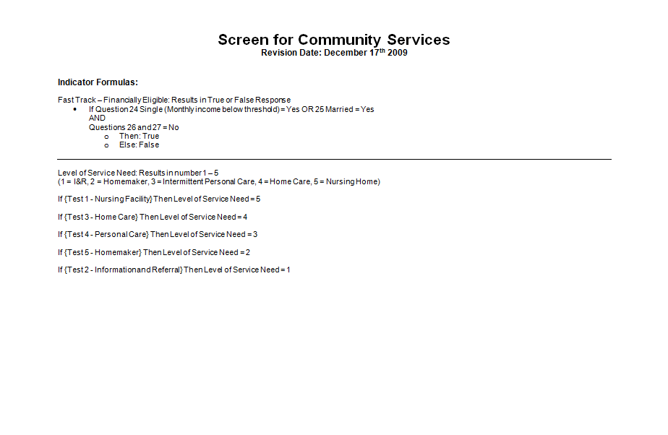
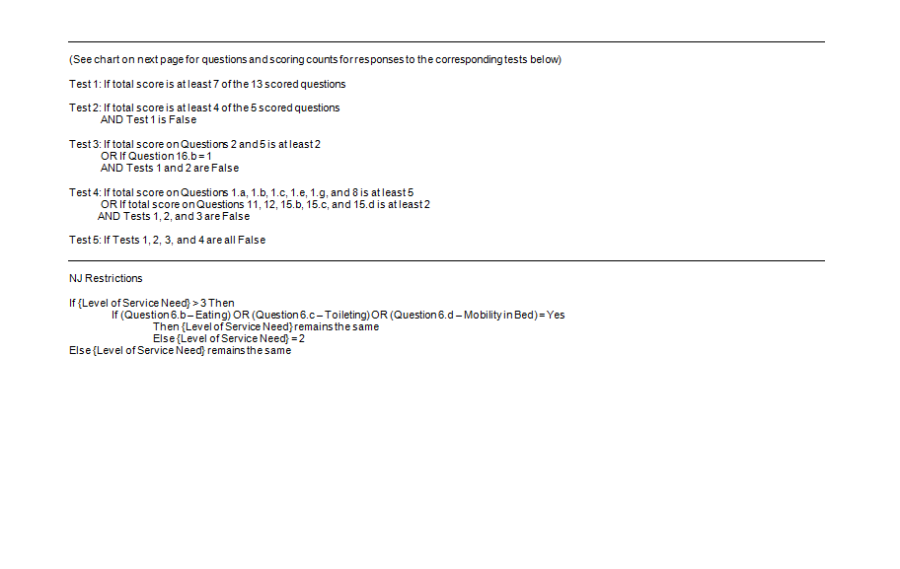
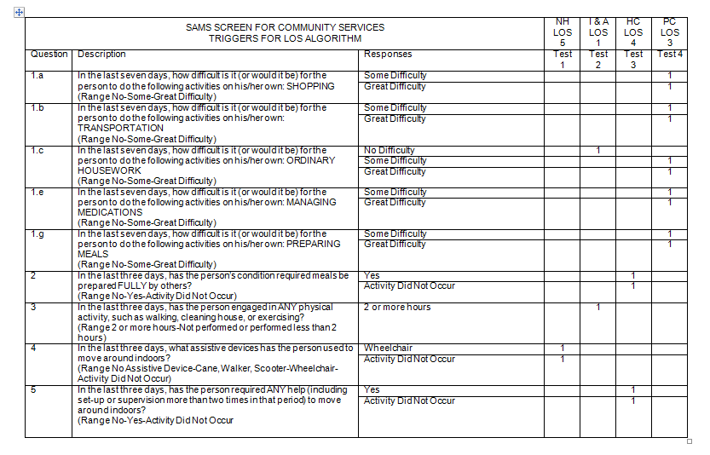
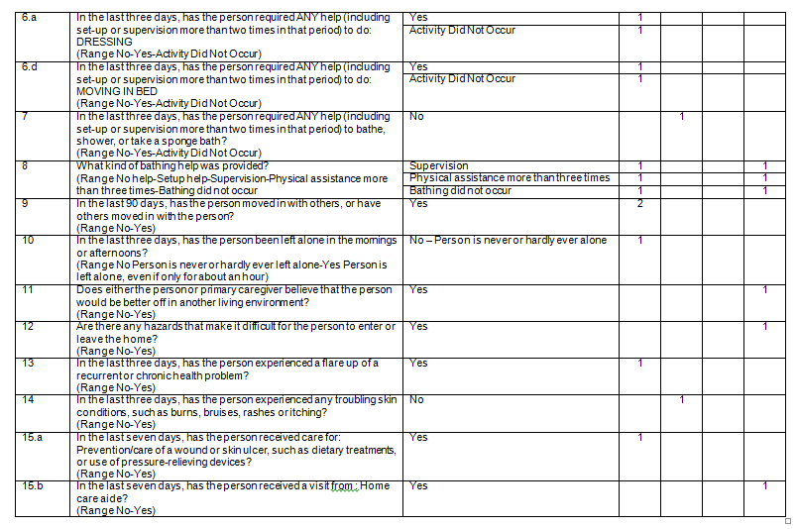

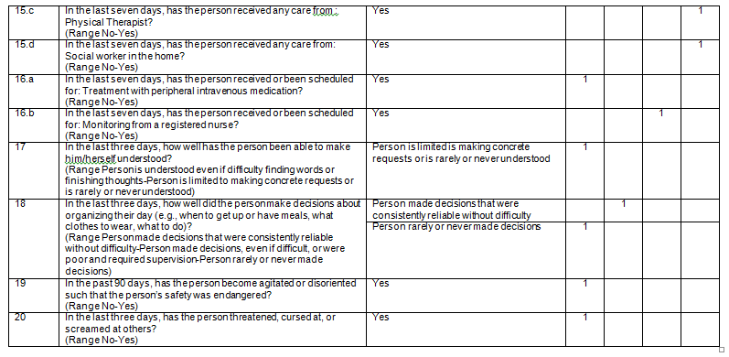

Nutrition Intake/Screen

Nutrition Intake
NUTRITION SCREEN
A. INTAKE
1.Last Name
2.First Name
3.DOB
______/______/____________
What is the client's height in Inches?
What is the client's weight?
4.Referral Source
Self
Family
Friend
Hospital
Caregiver
Agency
Other
5.Are you able to leave your home without assistance?
No
Yes
6.Kind of Diet?
Regular
Special
B. NUTRITION SCREENING INITIATIVE
1.Do you eat fewer than 2 meals per day?
No
Yes
2.Do you eat alone most of the time?
No
Yes
3.Do you eat fewer than two servings of milk or milk products every day?
No
Yes
4.Do you eat fewer than five servings of fruits and/or vegetables every day?
No
Yes
Nutrition Intake
S:\Omnia\Assessment Forms\NJ Nutrition Intake.afm
Page 1 of 3
3/29/2022

5.Do you have 3 or more drinks of beer, liquor or wine most days?
No
Yes
6.Without wanting to, have you lost or gained 10 pounds in the last 6 months?
No
Yes, Gained
Yes, Lost
7.Do you have an illness or health condition that made you change the kind or amount of food that you eat?
No
Yes
8.Do you take 3 or more different prescribed or over‑the‑counter drugs a day?
No
Yes
9.Are you not always physically able to shop, cook and/or feed yourself (or get someone to do it for you)?
No
Yes
10.Do you have problems with your teeth or mouth that makes it hard to eat?
No
Yes
11.Do you sometimes run out of money to buy the food that you need?
No
Yes
What is the client's nutritional risk score?
C. ACTIVITIES OF DAILY LIVING
1.Bathing
No Impairment
Impairment
2.Dressing
No Impairment
Impairment
3.Eating
No Impairment
Impairment
4.Walking/Transferring
No Impairment
Impairment
5.Continence
No Impairment
Impairment
6.Toileting
No Impairment
Impairment
D. INSTRUMENTAL ACTIVITIES of DAILY LIVING
Nutrition Intake
S:\Omnia\Assessment Forms\NJ Nutrition Intake.afm
Page 2 of 3
3/29/2022

1.Preparing Meals
No Impairment
Impairment
2.Ordinary Housework
No Impairment
Impairment
3.Laundry
No Impairment
Impairment
4.Shopping
No Impairment
Impairment
5.Managing Medications
No Impairment
Impairment
6.Using Transportation
No Impairment
Impairment
7.Paying Bills/Managing Money
No Impairment
Impairment
8.Using Telephone
No Impairment
Impairment
Would you like to speak with a nutritionist?
No
Yes
Date
Title:
Date
Title:
Nutrition Intake
S:\Omnia\Assessment Forms\NJ Nutrition Intake.afm
Page 3 of 3
3/29/2022

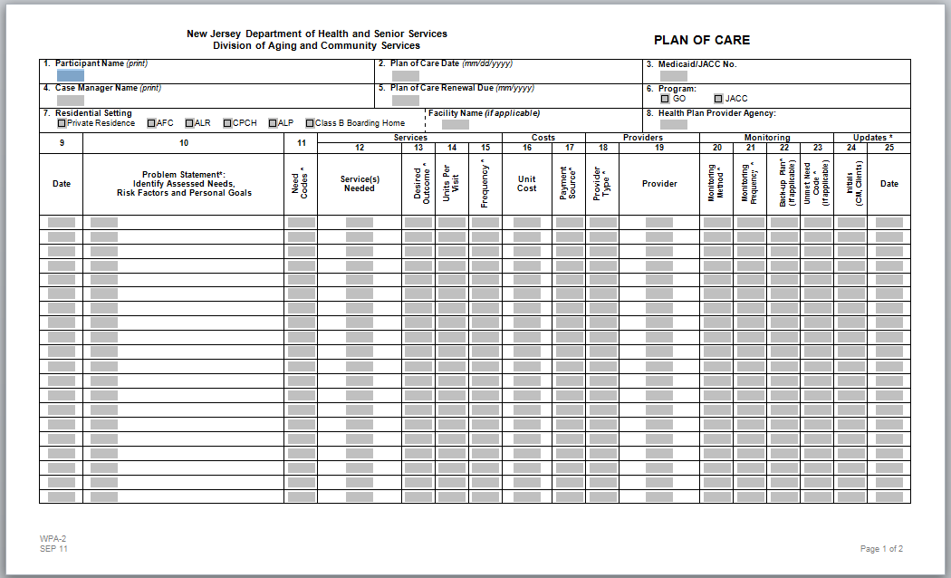
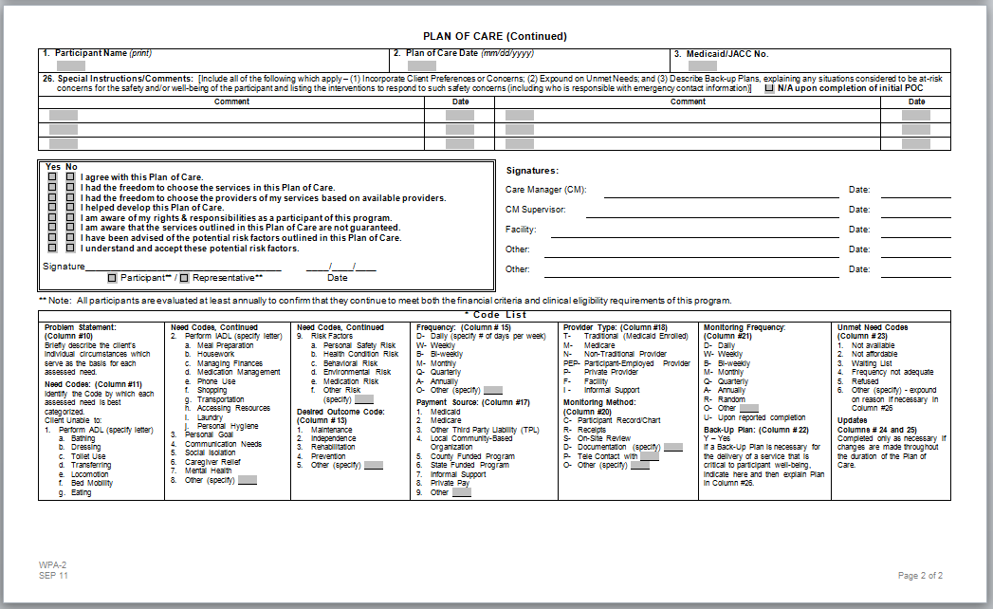

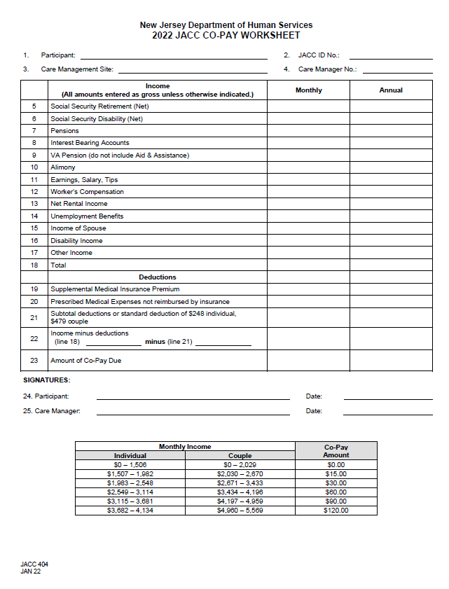
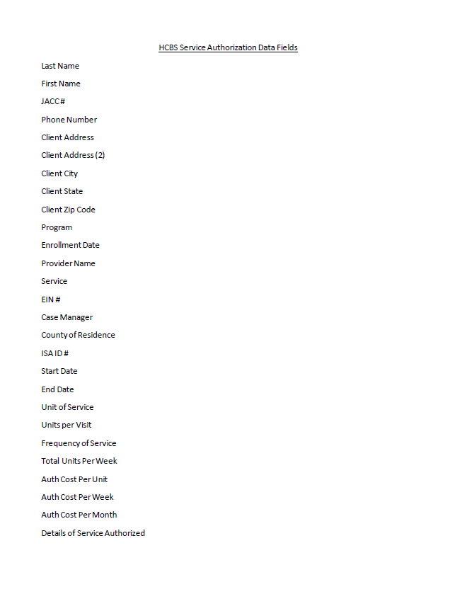
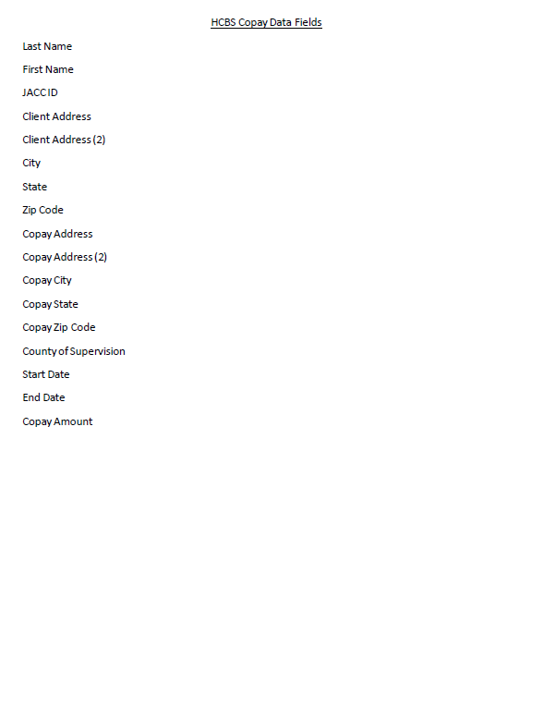

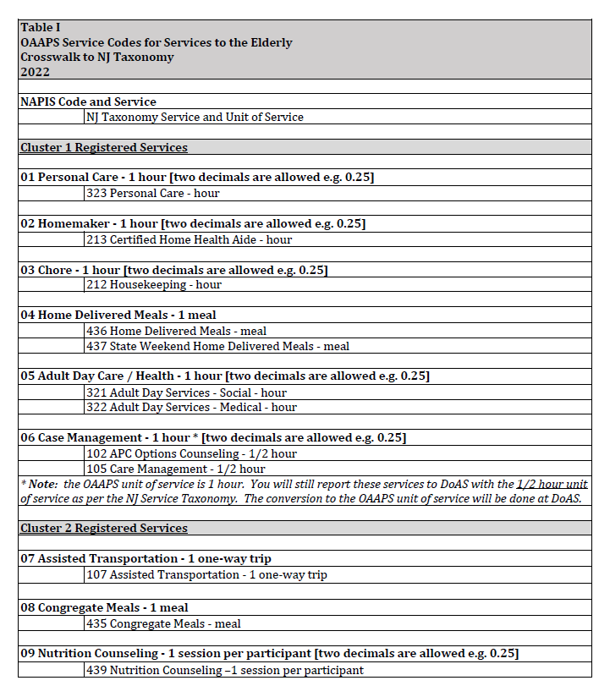
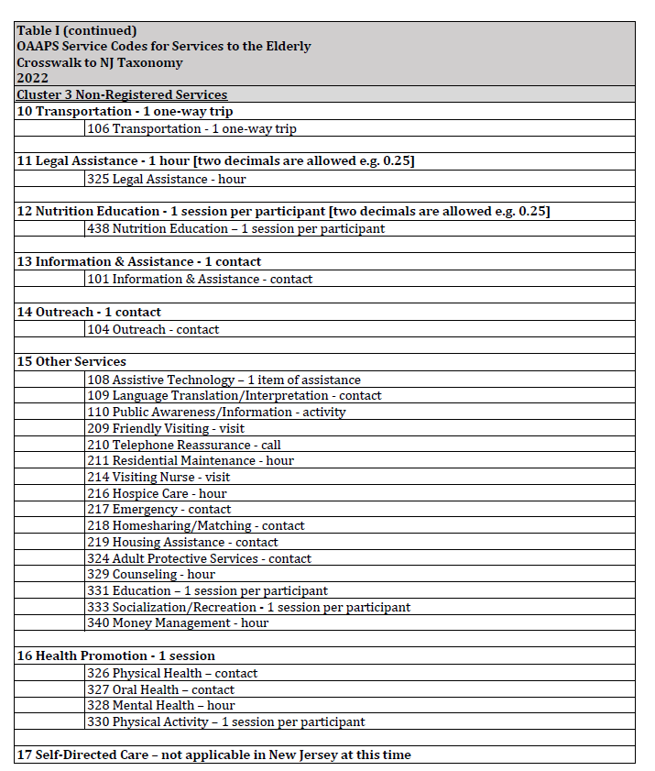
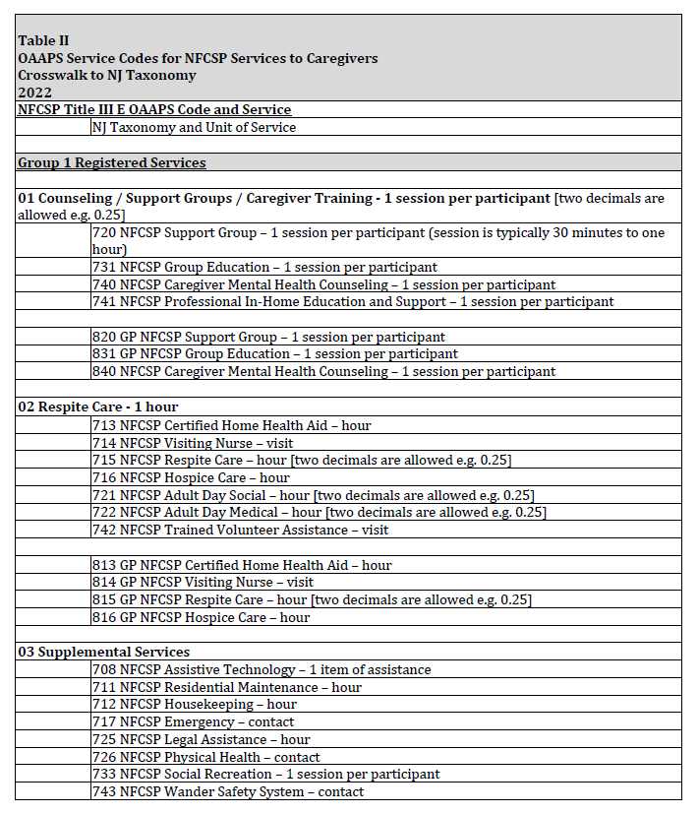
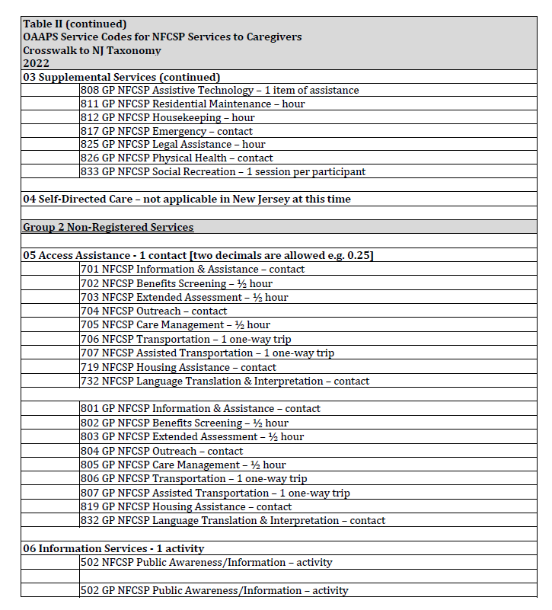

Area Plan Contract Fund Identifier List
March 2022
Title III - Administration - 01
Title III B - Supportive Services – 02
Title III C 1 - Congregate Nutrition - 03
Title III C 2 - Home Delivered Meals – 04
State Weekend Home Delivered Meals (SWHDM) - 06
Title III E - National Family Caregiver Support Program (NFCSP) – 08
Title III D - Health Promotion – 10
Safe Housing and Transportation Program (SHTP) - 11
Safe Housing and Transportation Program Admin - 12
Adult Protective Services (APS) – 14
Care Management/Quality Assurance (CMQA) - 17
Supplemental Home Delivered Meals (SHDM) - 19
Supplemental Aging Supportive Services (SASS) - 20
Supplemental Aging Supportive Services Admin - 21
Non-APC Funds - 25
FFP Federal Financial Participation - Services - 30
FFP Federal Financial Participation - Administration - 31
Medicaid Match - 35
Disaster Relief Funding - 45
Care Transitions - 46
Community Based Senior Program - 48
FFCRA C1 Congregate meals – 49
FFCRA C2 Home Delivered Meals - 50
CARES - T III B Supportive Services - 51
CARES - T III C2 Home Delivered Meals - 52
CARES - T III E Family Caregiver Support Program - 53
CARES - Administration – 54
ADRC - COVID-19 – 55
ADRC - COVID-19 Administration - 56
CAA - T III C2 Home Delivered Meals - 57
CRRSA - Adult Protective Services – 58
VAC5 Covid-19 Vaccine – 59
Vaccine ADRC Covid-19 Supplement - 60
ARP - Title III B - 61
ARP - Title III C1 - 62
ARP - Title III C2 - 63
ARP - Title III D - 64
ARP - Title III E - 65
ARP - Administration - 66

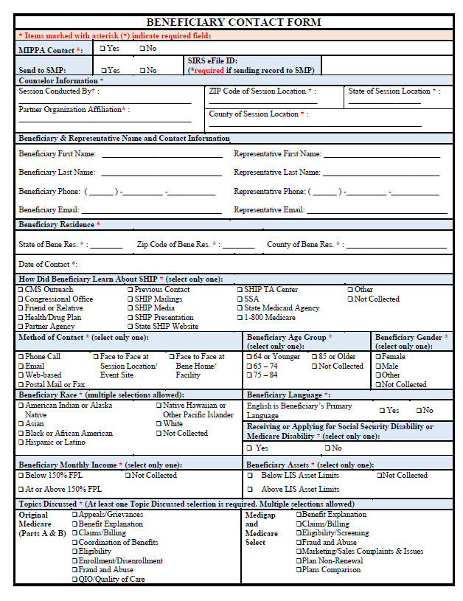

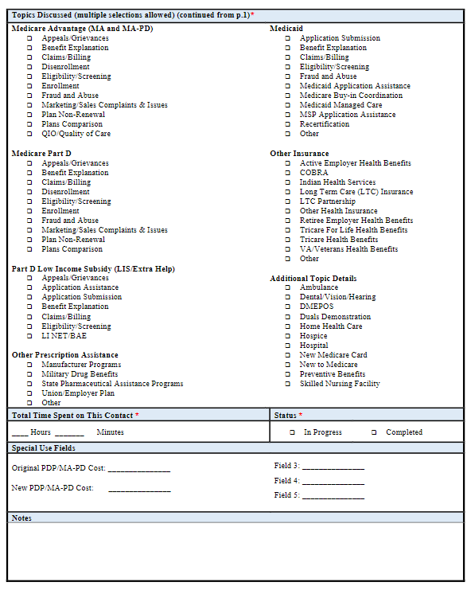

Assistive Technology List examples
iPad Apps:
• Highest version of Note Sharing (like PaperDesk, Notability, Evernote, Flashcards, Chalkboard)
• Highest version Speech to Text (like Dragon Dictation, Speak it!, AudioMemos)
Hard ware:
• Mini keyboard
• Echo Pen (Highest Version)
• Printed text reader
• Low vision magnifiers (like Magni Sight Explorer)
• High quality phone headsets (like Sennheiser)
• High quality microphone (like Xtag)

Computer programs:
• Text to Speech (Highest version)
• Natural Reader (Highest version)
• Type it Read it (Highest version)
• Read Please (Highest version)
• Kurzweil (Highest version)
• FS Reader (Highest version)
• Zoom Text (Highest version)
• Jaws (Highest version)
• Dragon naturally Speaking (Highest version)

