Appendix A

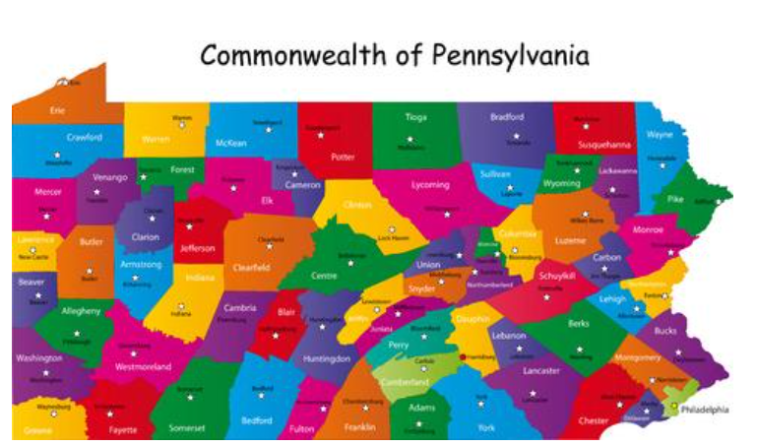

County | Cost | County | Cost | County | Cost | County | Cost
Adams |  | Dauphin |  | Mercer |  | Wayne
Alleghany |  | Delaware |  | Mifflin |  | Westmorland
Armstrong |  | Elk |  | Monroe |  | Wyoming
Beaver |  | Erie |  | Montgomery |  | York
Bedford |  | Fayette |  | Montour
Berks |  | Forest |  | Northampton
Blair |  | Franklin |  | Northumberland
Bradford |  | Fulton |  | Perry
Bucks |  | Greene |  | Philadelphia
Butler |  | Huntingdon |  | Pike
Cambria |  | Indiana |  | Potter
Cameron |  | Jefferson |  | Schuylkill
Carbon |  | Juniata |  | Snyder
Centre |  | Lackawanna |  | Somerset
Chester |  | Lancaster |  | Sullivan
Clarion |  | Lawrence |  | Susquehanna
Clearfield |  | Lebanon |  | Tioga
Clinton |  | Lehigh |  | Union
Columbia |  | Luzerne |  | Venango
Crawford |  | Lycoming |  | Warren
Cumberland |  | McKean |  | Washington
Elk |  | McKean |  | Union

