December 1, 2020

To: All Interested Vendors {Bidders}

Re: Bid Solicitation # 21DPP00594
Bid Solicitation: T2432 Recycled Paper: Toilet Tissue for Distribution and Support
Services- REBID

Quote Submission Due Date: December 22, 2020 (2:00 p.m. Eastern Time)

Bid Amendment #1

The following constitutes Bid Amendment #1 to the above referenced Bid Solicitation:

- This Bid Amendment includes answers to questions.

It is the sole responsibility of the Vendor {Bidder} to be knowledgeable of all of the additions, deletions, clarifications, and modifications to the Bid Solicitation and/or the New Jersey Standard Terms and Conditions relative to this Bid Solicitation as set forth in all Bid Amendments.

All other instructions, terms, and conditions of the Bid Solicitation shall remain the same.

Bid Solicitation #21DPP00594
T2432 Recycled Paper: Toilet Tissue for Distribution and Support Services- REBID

Answers to Questions

Where applicable, each question references the appropriate Bid Solicitation section.

# | Bid Solicitation  Section Reference | Question (Bolded) and Answer
1 | PDF Documents | When trying to open a Portable Document Format (PDF) I am receiving an error message and am unable to access the PDF. How should I proceed?  Answer: It is recommended that users utilize Internet Explorer to view PDFs. Certain PDF forms cannot be opened in the Chrome or Firefox built in PDF viewers that are enabled by default. If using Chrome or Firefox it is recommended that the file is downloaded instead by clicking the download button in the upper right-hand corner of the browser after an error message is received. An alternative option is to disable the built in PDF viewers in Chrome or Firefox.
2 | Quote Submission | Should I check that I have properly completed and attached all the required documents with my submitted Quote?  Answer: Yes. Prior to the Quote Opening Deadline, a Vendor {Bidder} should review the documents comprising the submitted Quote to ensure that all of the required documents have been completed and attached. Oftentimes a Quote is deemed non-responsive because a Vendor {Bidder} fails to attach a required form or attaches a blank form. To review a submitted a Quote a Vendor {Bidder} should log into NJSTART and review each document attached to the Quote submission. Instructions on how to review a submitted Quote can be found in the Quick Reference Guide entitled How to Review a Submitted Quote which is available on the NJSTART Vendor Support Page under Vendor Reference Guides.
3 | Exceptions | Will the State allow Vendors to take exception to any of the Standard Terms and Conditions?  Answer: As stated in Bid Solicitation Section 1.3.1.1, Exceptions to the NJ Standard Terms and Conditions (SSTC): "Questions regarding the SSTC proposed exceptions to mandatory requirements, including the Special and Standard Terms and Conditions in Sections 5 and 9 of this Bid Solicitation must be posed during this Electronic Question and Answer period and shall contain the Vendor's {Bidder's} suggested changes and the reason(s) for the suggested changes." Additionally, as stated in Section 4.1, General: "Quotes including Vendor {Bidder} proposed terms and conditions may be accepted, but Vendor {Bidder} proposed terms or conditions that conflict with those contained in the Bid Solicitation, as defined in Section 2.0 of this Bid Solicitation, or that diminish the State's rights under any Blanket P.O. resulting from the Bid Solicitation, may render a Quote non-responsive."
4 | Specification Data Sheets | What will happen if a Bidder does not provide specification data sheets for all equivalent brands bid that are not listed as an approved brand?  Answer: If a Vendor {Bidder} fails to provide, with its Quote, specification data sheets for an equivalent brand bid on a given price line, its Quote for that equivalent brand and given price line will be deemed non-responsive.  Bid Solicitation Section 4.4.3.3 states:  “Vendors {Bidders} shall submit with its Quote specification data sheets for all equivalent brands bid. The specification data sheets must document that its product bid meets or exceeds the requirements of the Bid Solicitation specifications.  Vendors {Bidders} offering approved products identified in this Bid Solicitation are not required to submit specification data sheets for those approved products only. However, all required information identified on the State-Supplied Price Sheet is necessary to confirm specification conformance and must be provided.  FAILURE TO PROVIDE THIS INFORMATION WILL RENDER A VENDOR’S {BIDDER’S} QUOTE NON-RESPONSIVE.”
5 | Section 1.2 | Can you please provide previous award information and tabulations?  Answer: To view the current Blanket P.O. specifications and pricing information, please follow the instructions in Bid Solicitation Section 1.2 (Background), also listed below:  Go to: www.njstart.gov  Select “Contract & Bid Search”  Select “Contracts/Blankets”  Under “Contract/Blanket Description” type in T2432 Click “Find It”  The current Blanket P.O.s will appear under “Results.”  Please note that the price line item specified in this Bid Solicitation (Bid Solicitation #21DPP00594) is a new product. As such, no current Blanket P.O. pricing is available for reference.  Blanket P.O. awards have been made for Price Lines 1, 3, 4 and 5 from Bid Solicitation 19DPP00408. Information pertaining to the T2432 Blanket P.O. awards in NJSTART can found by following the instructions above.  Please submit an OPRA request to obtain the bid tabulation from the previous bidding cycle (Bid Solicitation #14-X-23075) by clicking on the following link: https://www.state.nj.us/opra/
6 | Section 1.2  Section 5.2 | If an additional P.O. is awarded, does the end date remain May 14, 2021 or will that be extended and for how long?  Note: This question has been paraphrased in the interest of readability and clarity.  Answer: If a Blanket P.O. is awarded as a result of this Bid Solicitation (Bid Solicitation #21DPP00594), the end date will not remain May 14, 2021.  Bid Solicitation Section 5.2 (Blanket P.O. Term and Extension Option) states, in pertinent part: “The base term of this Blanket P.O. shall be for a period of three (3) years. The anticipated "Blanket P.O. Effective Date" is provided on the “Summary” page of the Bid Solicitation in NJSTART. If delays in the procurement process result in a change to the anticipated Blanket P.O. Effective Date, the Vendor {Bidder} agrees to accept a Blanket P.O. for the full term of this Blanket P.O. This Blanket P.O. may be extended up to three (3) years with no single extension exceeding one (1) year, by the mutual written consent of the Vendor {Contractor} and the Director at the same terms, conditions, and pricing at the rates in effect in the last year of this Blanket P.O. or rates more favorable to the State or as per SSTC Section 6.1.”  Please give end date for this bid contract. Is it May 14, 2021 or will it be extended and for how long?  The current T2432 Blanket P.O. has been extended until May 14, 2021 or until a new Blanket P.O. award is made, whichever occurs first. Please refer to Bid Solicitation Section 1.2. The State does not anticipate that an extension beyond May 14, 2021 will be pursued.
7 | Section 3.2 and  Section 3.8 | Will all orders be truckload, single destination?  Answer: Yes, all orders will be delivered to a single destination, as follows:  Department of the Treasury  Distribution & Support Services (DSS)  1620 Stuyvesant Avenue  West Trenton, New Jersey 08625-0234  Please refer to Bid Solicitation Section 3.2 (Delivery Requirements).  As stated in Bid Solicitation Section 3.8 (Estimated Order Quantities):  DSS’ Estimated Minimum Order Quantity Per Delivery is 650 cases or full truckload.  Bid Solicitation Section 3.8 further states: “The State makes no guarantees of Blanket P.O. usage or total quantities ordered during the Blanket P.O. term, including any extension(s) thereof. The State reserves the right to increase, decrease or eliminate quantities in their entirety. Product ordering is on an as-needed basis, normally weekly, and may vary.”
8 | Section 4.3 | It appears that electronic submission is the only acceptable form, is this correct?  Answer: As stated in Bid Solicitation Section 1.3.2, “Vendors {Bidders} shall submit a Quote electronically through NJSTART.”  Please review Bid Solicitation Section 4.3.1 (NJSTART Submission of Quote) for information on how to electronically submit a Quote through NJSTART.
9 | Section 4.4.5.2 | Our price sheet has no information on the sheet. Do we just fill it in?  Answer: If the State-Supplied Price Sheet appears blank, as shown below, please click on the ‘Enable Editing’ button at the top of the page. Please refer to the arrow below for the exact location.  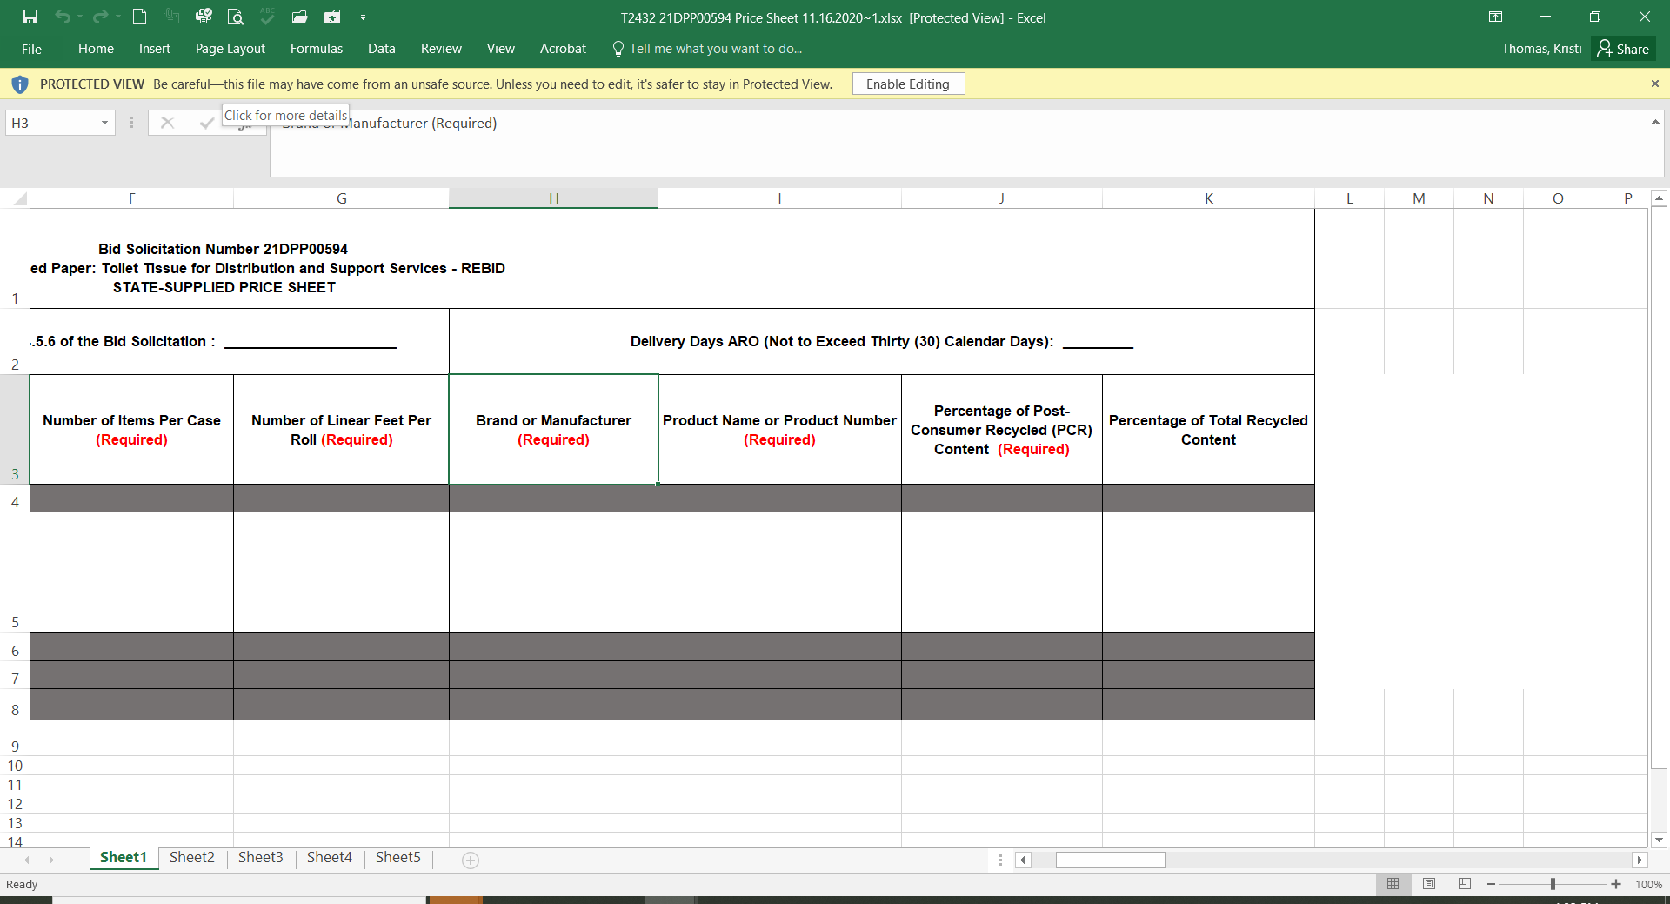  Once the ‘Enable Editing’ button has been selected, the information in the State-Supplied Price Sheet will appear, as follows:  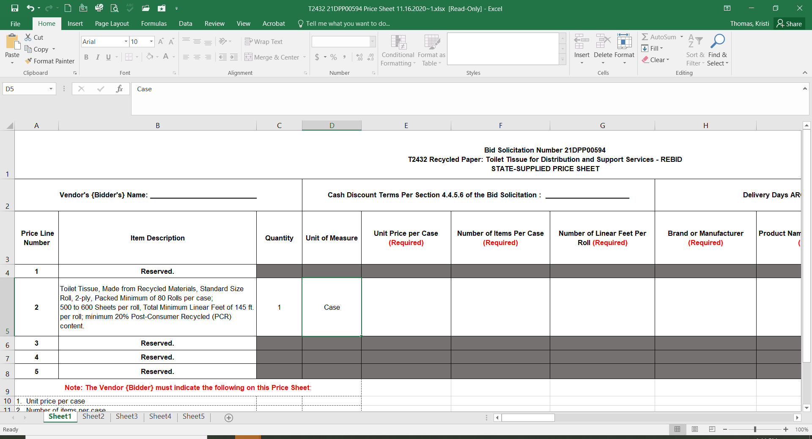  Vendors {Bidders} are required to bid on Price Line 2 only.  Please see Bid Solicitation Section 4.4.5.2 for State-Supplied Price Sheet instructions.  Bid Solicitation Section 4.4.5.2 states, in part, “Please be advised that the fields listed in Steps 4 through 9 are required fields that must be completed on the State-Supplied Price Sheet. A Vendors {Bidders} failure to complete any of these fields on the State-Supplied Price Sheet may render its Quote non-responsive.”
10 | Section 1.1, 3.1 | How many items are on this bid?  Answer: As stated in Bid Solicitation Sections 1.1 and 3.1, the Bid Solicitation and State-Supplied Price Sheet contain one (1) price line item. Please refer to Section 3.1, Product Specifications, for current specifications for this item.
11 | Section 3.1 | Since the bid asks for recycled with 20% post-consumer content and it is an old specification I was wondering if you will overlook that part of the bid specification due to the Covid-19 pandemic. Most suppliers are not using recycled content or very little due to the shortage of raw material. Green Seal has even allowed suppliers to use whatever they need to make product.  Answer: The specifications illustrated in Section 3.1 of the Bid Solicitation are current specifications, which were developed by the Using Agency, Distribution and Support Services, utilizing current product information. The products offered must meet all of the specifications illustrated in Section 3.1.
12 | Section 4.4.1.4 Small Business Set-Aside Blanket P.O. | How can I check if my business is registered and approved as a small business with the Division of Revenue and Enterprise Services?  By clicking on the below link, you will be directed to the New Jersey Department of the Treasury, Division of Revenue and Enterprise Services, Small Business Registration and M/WBE Certification Services Unit. Here you can login to your account or apply for certification:  https://www.nj.gov/njbusiness/contracting/sbsa/  Can I apply online?  Yes, here is the link to the online application:  https://www.njportal.com/DOR/SBERegistry/
13 | Section 1.1 Purpose and Intent  Section 4.4.1.4 Small Business Set-Aside Blanket P.O. | What if I submit a Quote but my firm’s small business status is listed as ‘Expired’ or ‘Revoked’ with the Division of Revenue and Enterprise Services (DORES), Small Business Registration and M/WBE Certification Services Unit by the date the Quote is received and opened? Does this mean that my Quote will not be considered responsive?  If your firm’s small business status is listed as ‘Expired’ or ‘Revoked’ by the DORES Small Business Registration and M/WBE Certification Services Unit at the date the Quote is received and opened, the Quote submitted by your firm will be considered non-responsive and will not be evaluated and considered for a Blanket P.O. award.

