March 4, 2020

To: All Interested Vendors {Bidders}

Re: Bid Solicitation #20DPP00498
T2637 Insurance and Real Estate License Examinations and Selected Services

Quote Submission Due Date: May 1, 2020 (2:00 p.m. Eastern Time)

Bid Amendment #1

The following constitutes Bid Amendment #1 to the above referenced Bid Solicitation:

- PowerPoint slides presented during the Optional Pre-Quote Conference held on March 3, 2020 at 10 am; and

- Optional Pre-Quote Conference Sign-In Sheet.

It is the sole responsibility of the Vendor {Bidder} to be knowledgeable of all of the additions, deletions, clarifications, and modifications to the Bid Solicitation and/or the New Jersey Standard Terms and Conditions relative to this Bid Solicitation as set forth in all Bid Amendments.

All other instructions, terms, and conditions of the Bid Solicitation shall remain the same.

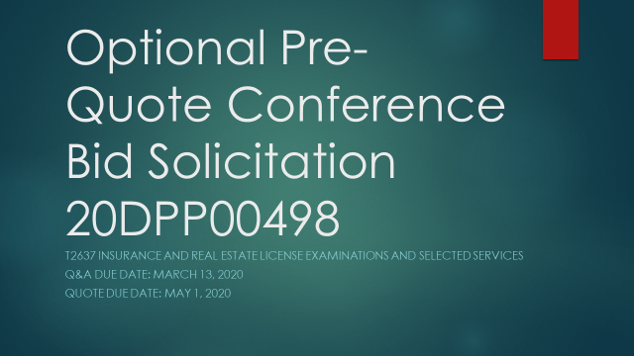

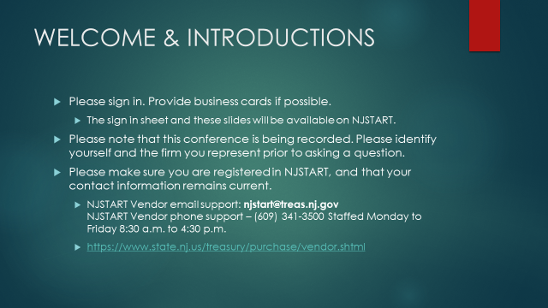

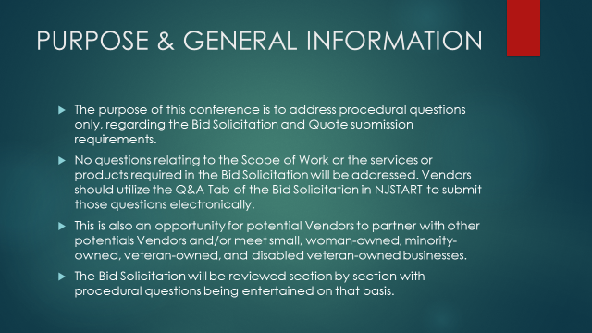

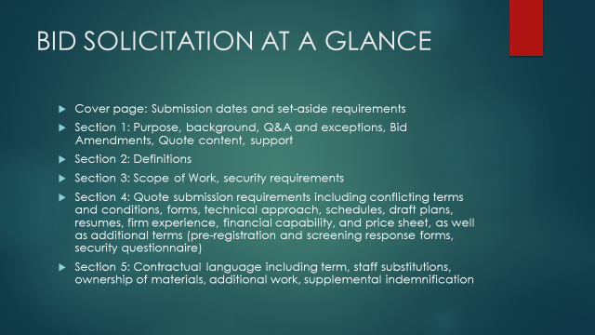

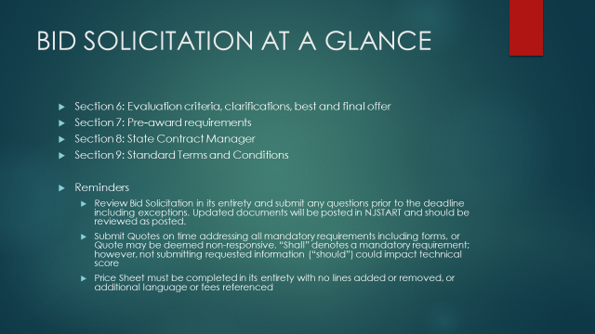

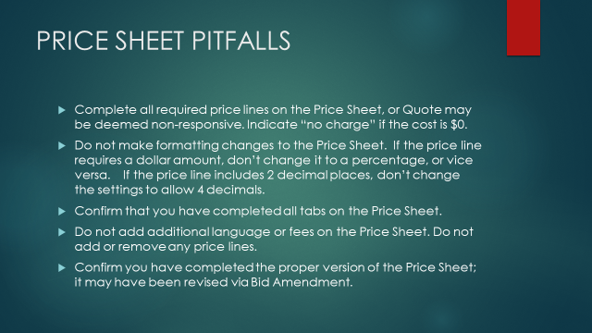

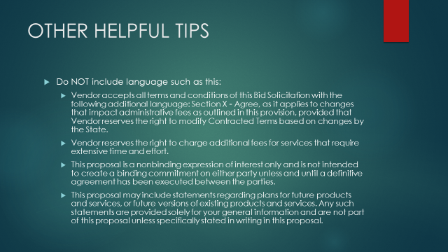

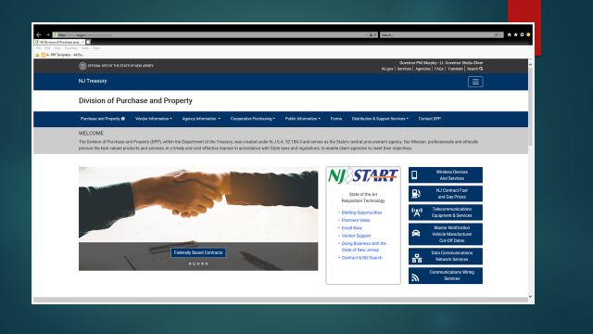

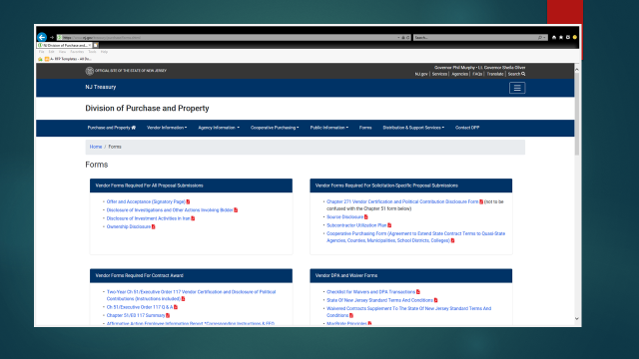

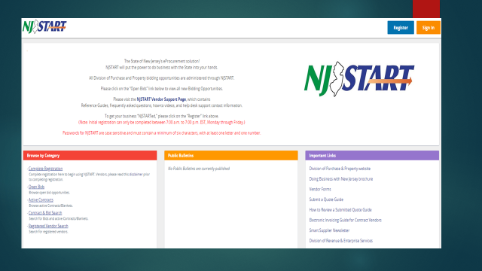

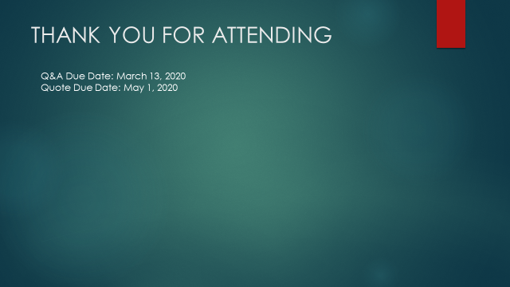

Optional Pre-Quote Conference Attendees
20DPP00498, T2637 Insurance and Real Estate License
Examinations and Selected Services
Company Name | City & State | Contact Person | Phone Number | E-Mail Address | SBE Designation
Pearson | Bala Cynwyd, PA | Christopher Herbst | (610)-617- 5198 | christopher.herbst@pearson.com | N/A
Pearson | Bala Cynwyd, PA | Tom Magallanes | (610) 617-5198 | tom.magallanes@pearson.com | N/A
PSI | Landover, MD | Ho. J. Mun | (818)-847-6180 x7269 | hmun@psionline.com | N/A

