ATTACHMENT 1
Screenshots of NJFC Admin Tool and MAGI Calculator

- Admin Tool which has the provision to update cases status:
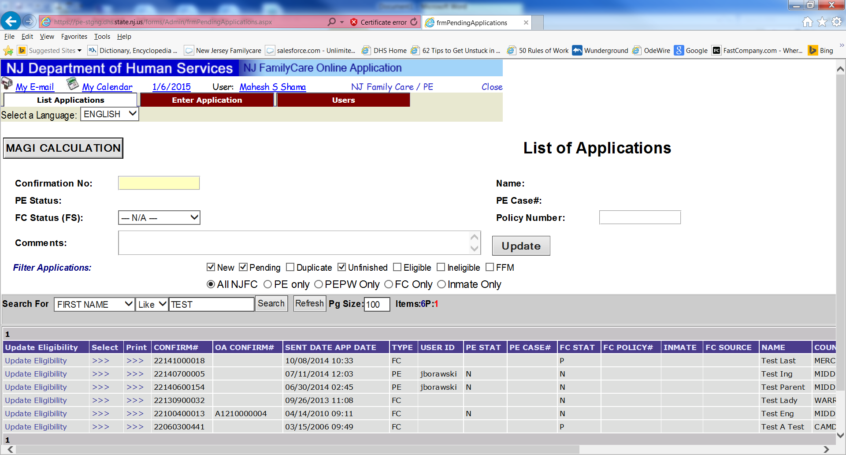

- Screen on the Admin tool to update individual (households) level eligibility, denial or pending status:
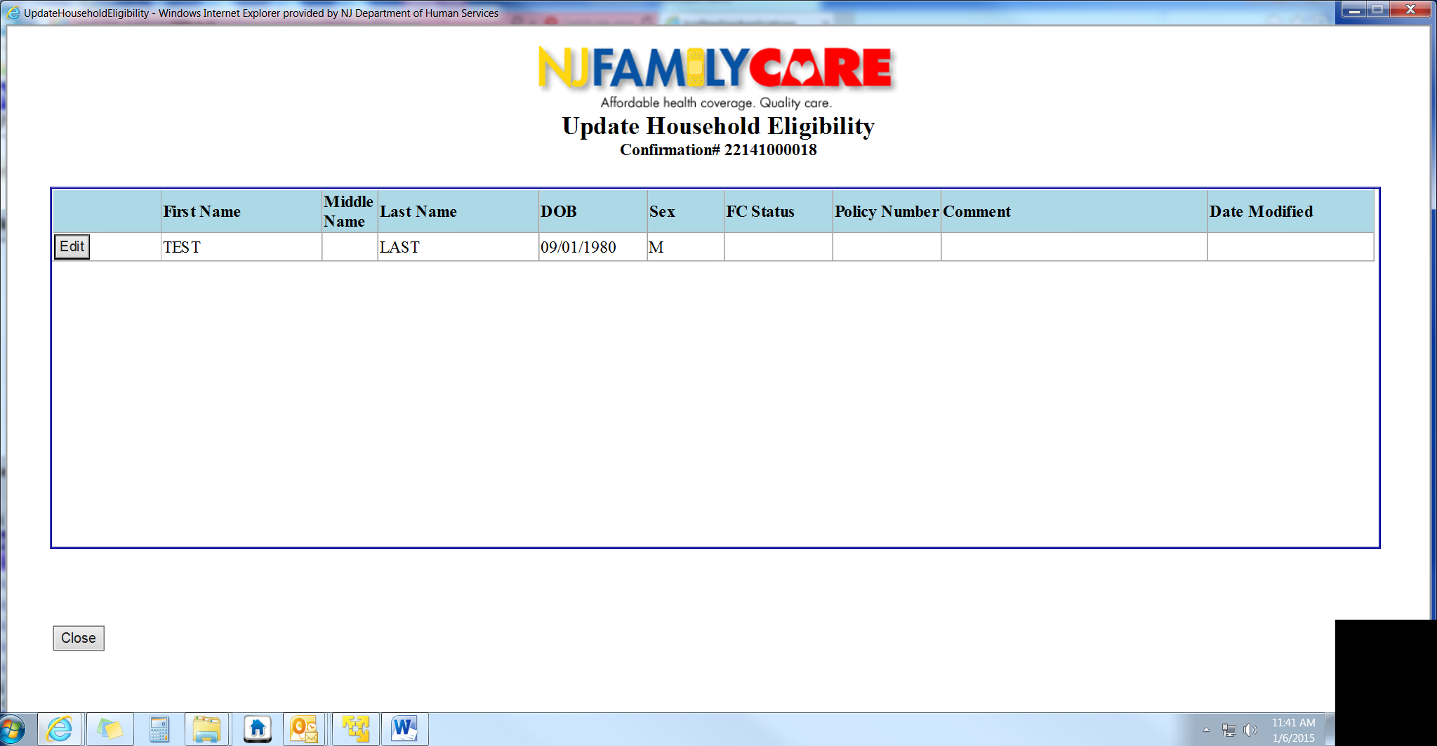
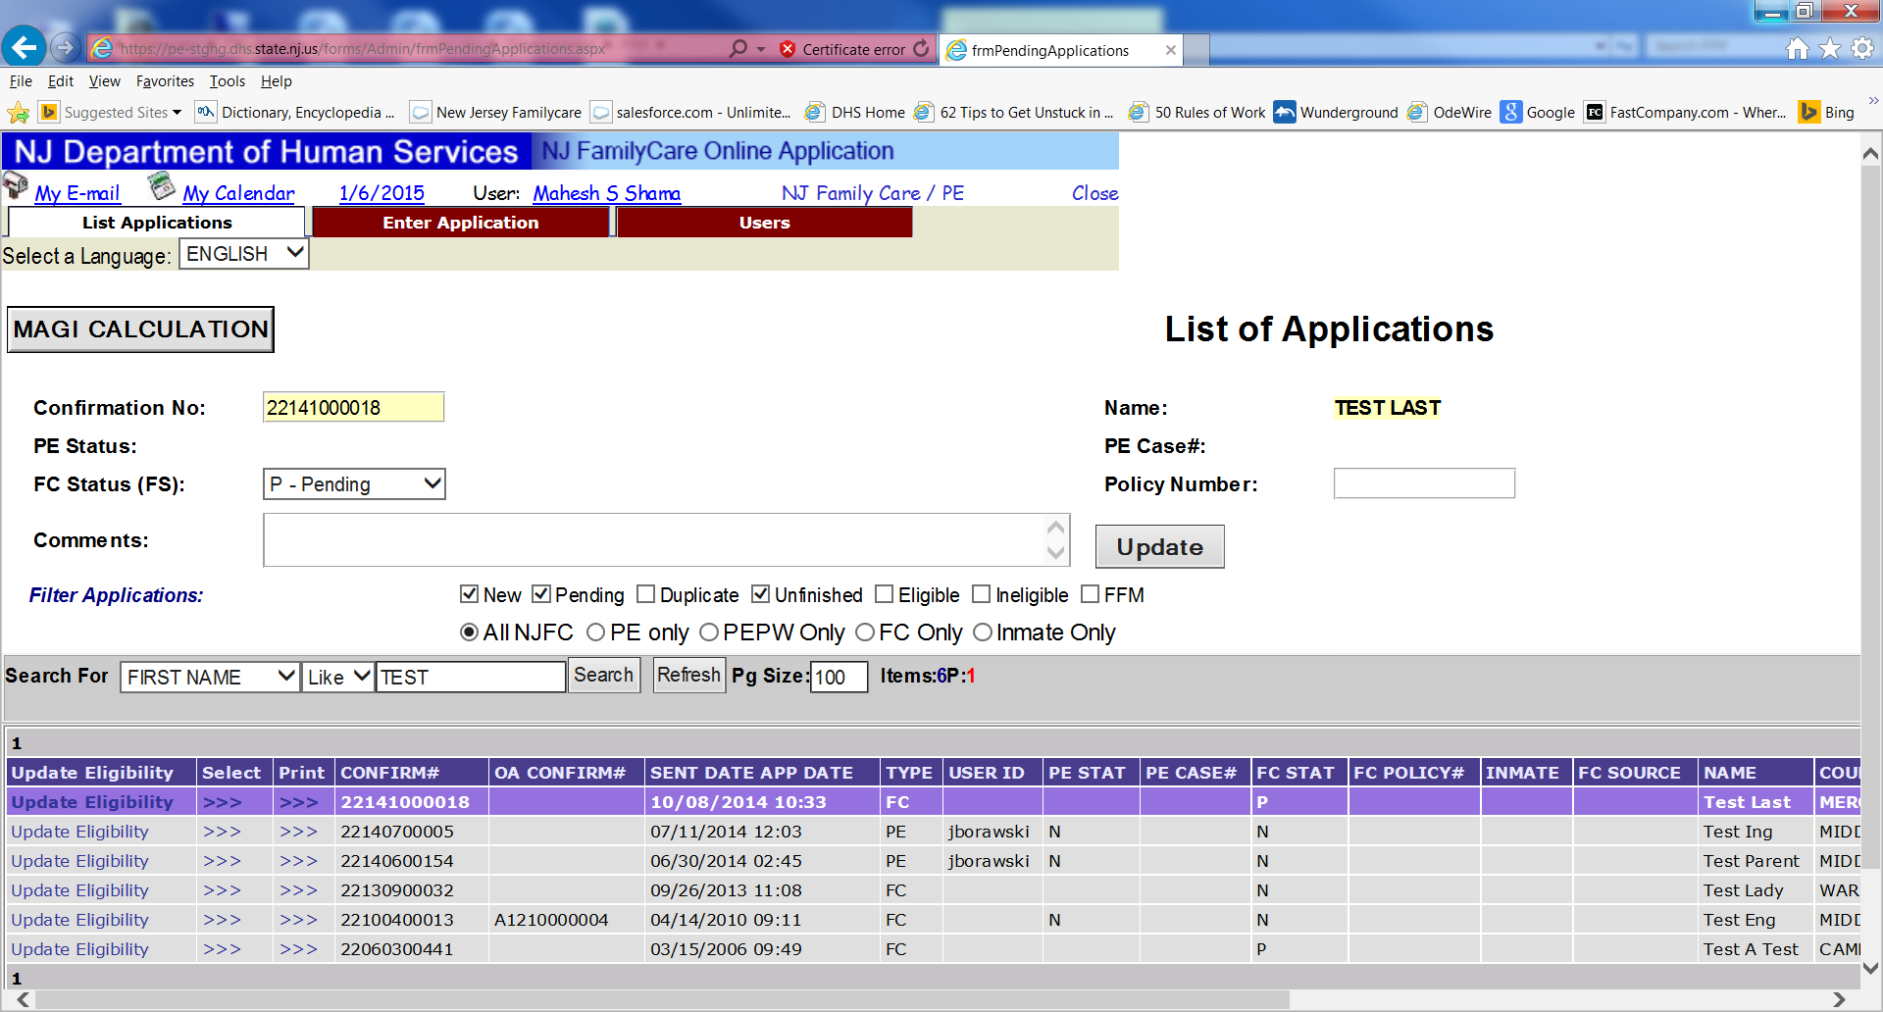

- MAGI & PSC Calculater (Auto populated from Online FamilyCare application):
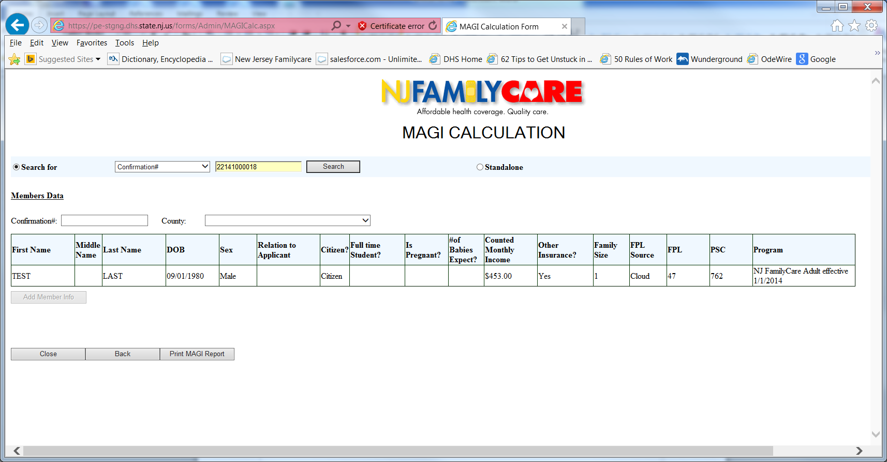

MAGI Output with FPL and PSC determination (PDF Report):
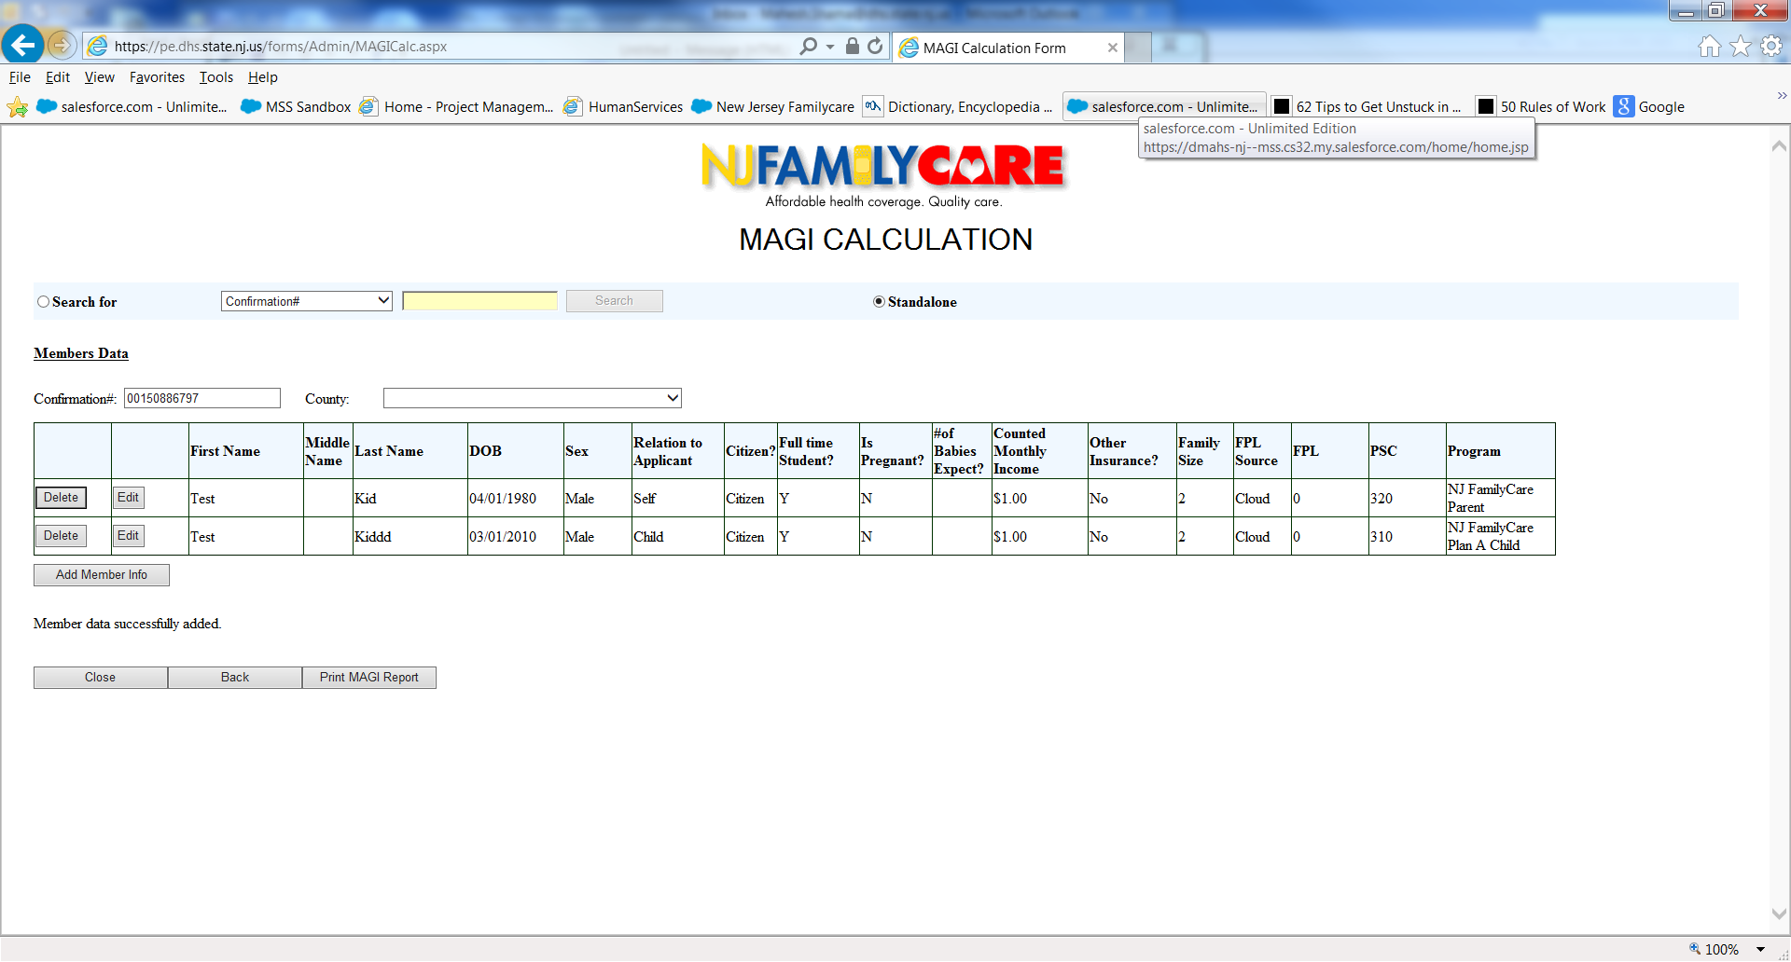
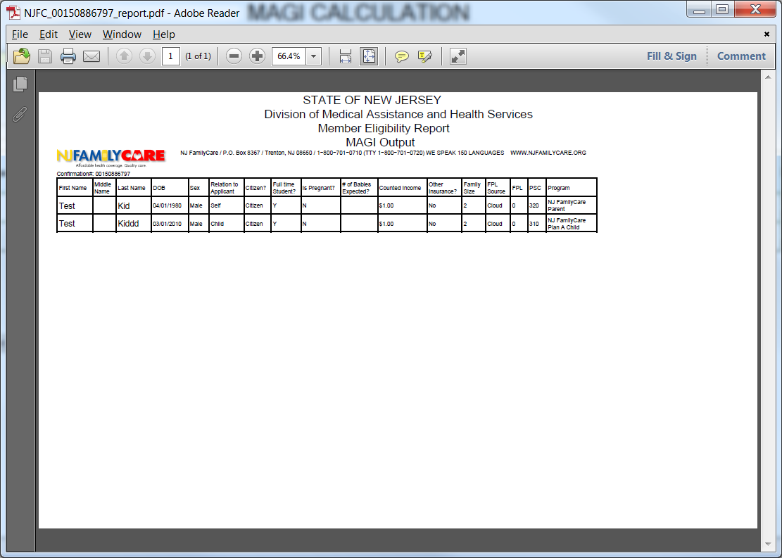

- MAGI Calculater with standalone option, this option is used to calculate MAGI for cases which did not come via FamilyCare.org site.

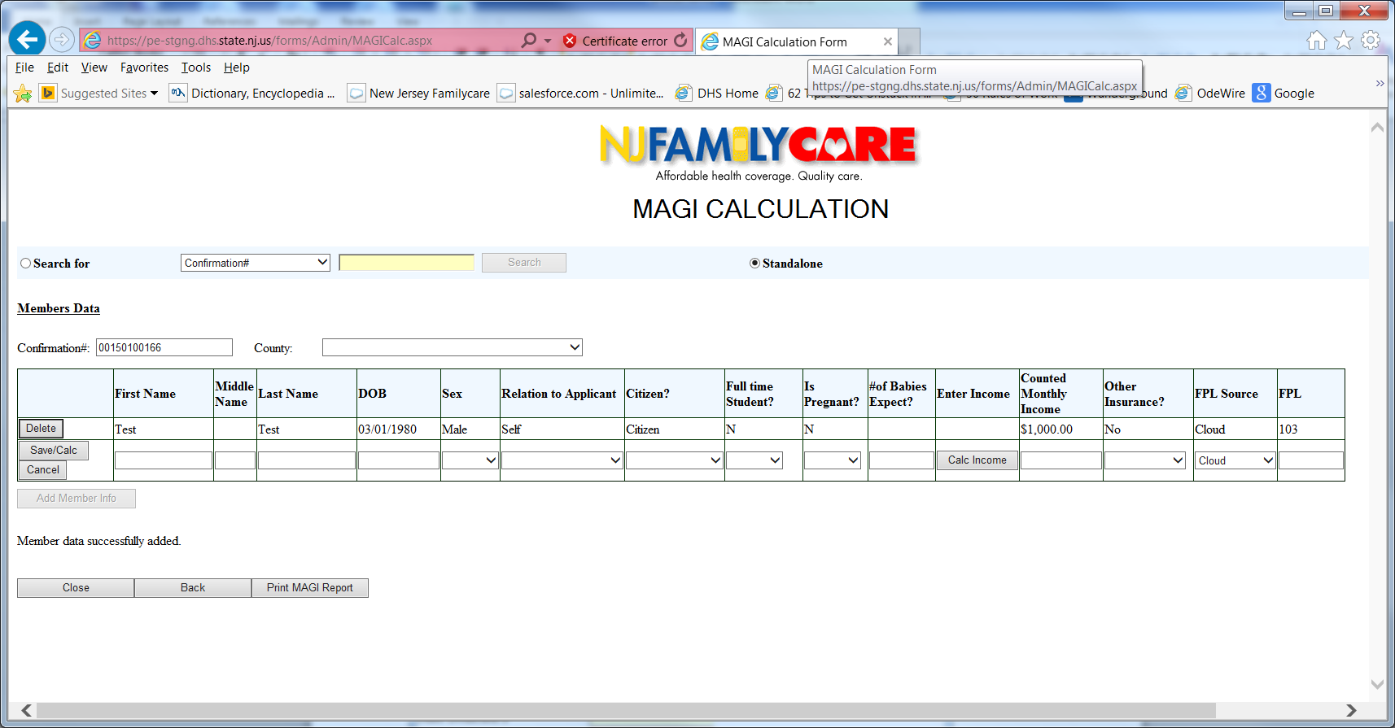

- Income Calculator inside MAGI tool.


