August 6, 2021

To: All Interested Vendors {Bidders}

Re: Bid Solicitation #20DPP00439
T3075 Next Generation 9-1-1 Services

Current Quote Submission Due Date: August 20, 2021 (2:00 p.m. Eastern Time)

Bid Amendment #11

The following constitutes Bid Amendment #11 to the above referenced Bid Solicitation:

- Answer to electronic inquiry submitted to NJSTART regarding formula errors and clarification on the State Supplied Price Sheet;

- For all additions, deletions, clarifications and modifications to the Price Sheet, please refer to the Revised Price Sheet entitled “T1628 Revised Price Sheet 08/06/2021;” and
- Due to concerns with COVID-19, hard copies of Quotes will NOT be accepted. All Quote documents and samples must be submitted through the NJSTART eProcurement site. For more information, see the Special Notice released by the State on March 16, 2020: https://www.state.nj.us/treasury/purchase/specialnotices/03162020a.shtml.

It is the sole responsibility of the Vendor {Bidder} to be knowledgeable of all of the additions, deletions, clarifications, and modifications to the Bid Solicitation and/or the New Jersey Standard Terms and Conditions relative to this Bid Solicitation as set forth in all Bid Amendments.

All other instructions, terms, and conditions of the Bid Solicitation shall remain the same.

Bid Solicitation #20DPP0439
T3075 Next Generation 9-1-1 Services

Answers to Questions

Where applicable, each question references the appropriate Bid Solicitation section.

Note: This question has been paraphrased in the interest of readability and clarity.

# | Bid Solicitation  Section Reference | Question (Bolded) and Answer
1 | State-Supplied Price Sheet Instructions, Section 4.4.5.2 | Please provide an updated and corrected worksheet for Re: Bid Solicitation # 20DPP00439T3075 –Next Generation 9-1-1 Services.  Vendor {Bidder} is preparing the secured Revised T3075 - State Supplied Price Sheet 7-6-21 PM.xlsx file and have determined that some inadvertent errors have been built into the file that we cannot correct. First, by locking the cells under 2.5 All-Inclusive CPE/LPG and Monthly Maintenance that are related to KML, Smart DMS, we are prevented from including the amortization of non-recurring and maintenance related to providing i3 Compliant ESInet services to the PSAP. Furthermore, on some other sites, the total under 2.7 Total PSAP Monthly Recurring Cost is not including the values entered under 2.5 All-Inclusive CPE/LPG and Monthly Maintenance due to an apparent formula error. (Reference cell K5 of sheet PSAP Price Sheet.) We respectfully request that the State re-release the T3075 – State Supplied Price Sheet after correcting the formulas under 2.7 Total PSAP Monthly Recurring Cost and allowing entry of a value under 2.5 All-Inclusive CPE/LPG and Monthly Maintenance for the sites currently using KML, Smart DMS CPE equipment.  As a reference, we’re highlighting the sections in the RFP that instruct us to include only the recurring cost of two circuits under 2.6.2 and to include all non-recurring costs of PSAP implementation to be amortized under 2.5.  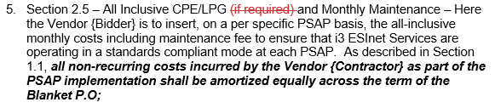  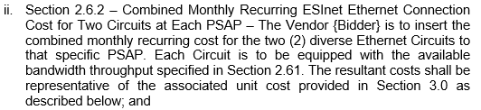  The State has fixed the formula errors for the total under 2.7 Total PSAP Monthly Recurring Cost for the cells under Atlantic County. Please see the Revised Price Sheet, dated 08/06/2021.  The Vendor {Bidder} does not need to provide an All-Inclusive CPE/LPG and Monthly Maintenance price for KML, Smart DMS in Section 2.5 All Inclusive CPE/LPG of the State Supplied Price Sheet. However, the Vendor {Bidder} will need to provide Ethernet services to PSAPs with KML, Smart DMS after they have been replaced with NG enabled systems. Please see Question #10 of Bid Amendment #9, dated 07/06/2021. Additionally, please see the Revised Bid Solicitation Section 1.2.1, dated 07/06/2021.

