Bid Solicitation #19DPP00332
T1714 Shoe Components, Including Upper Leather – DEPTCOR/State Use Industries

ATTACHMENT A

Images of the Split Leather purchased under the current Blanket P.O.:
Brand: LMI Split Leather

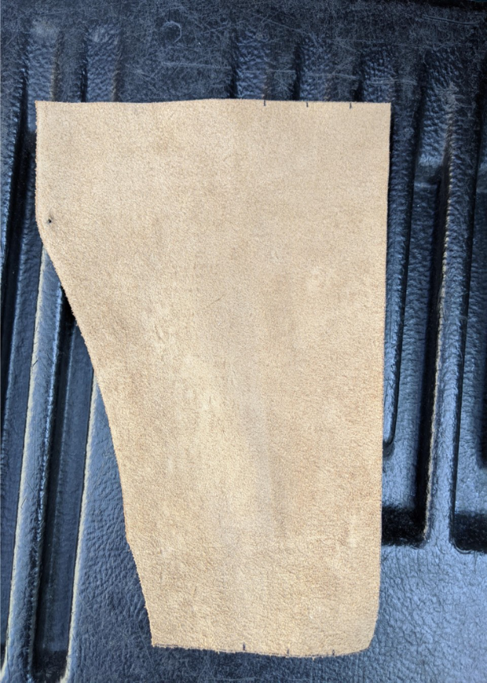
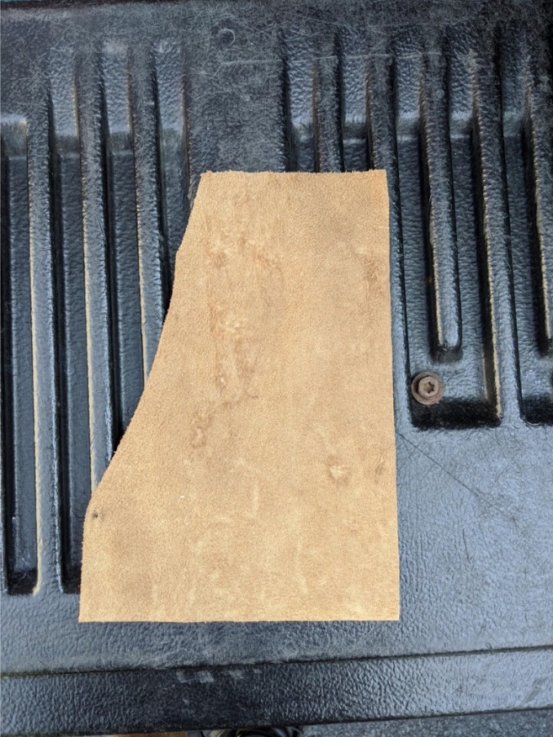

Images of the Upper Leather purchased under the current Blanket P.O.:
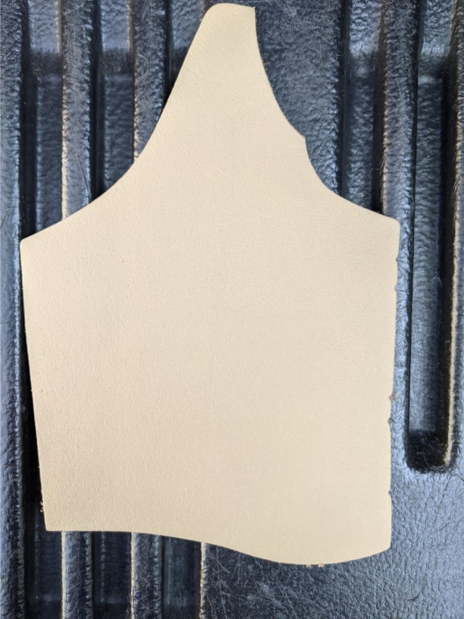
Brand: LMI B-NUT



