Attachment E – CURRENT LICENSE SAMPLES
Turkey, Bear, and Deer Season Permits
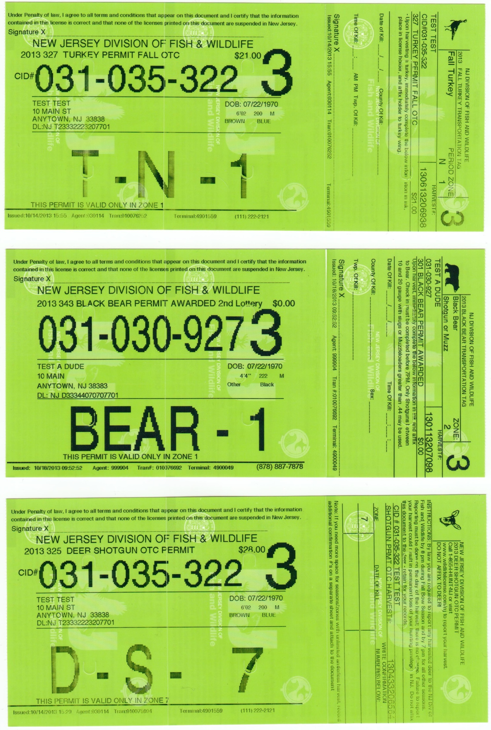
Attachment E – CURRENT LICENSE SAMPLES
Turkey, Bear, and Deer Season Permits

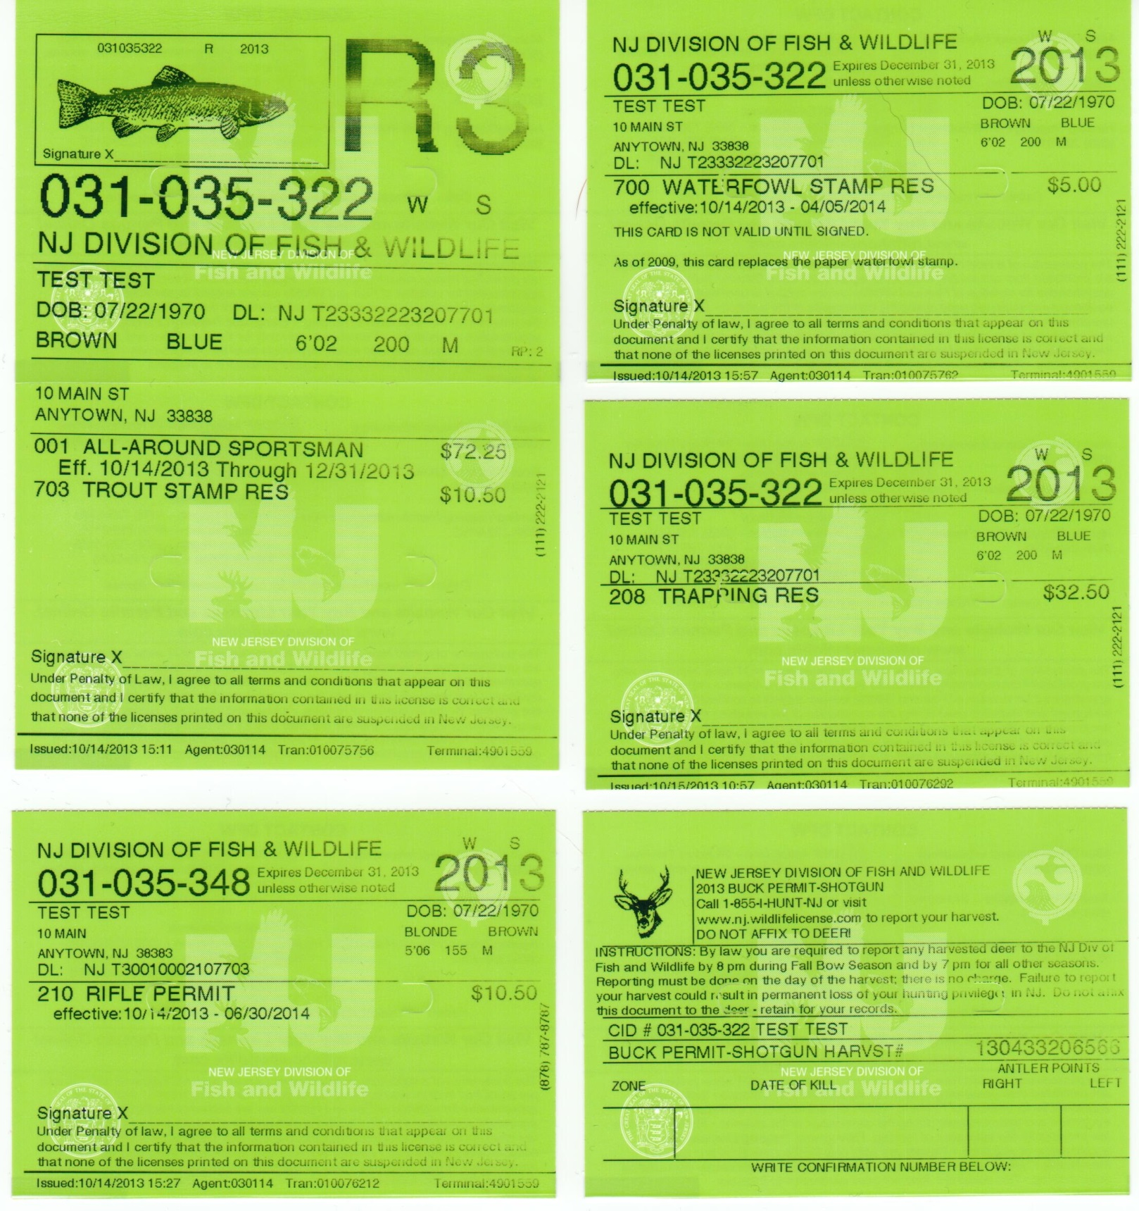

Attachment E – CURRENT LICENSE SAMPLES
Hunting License and Associated Tags

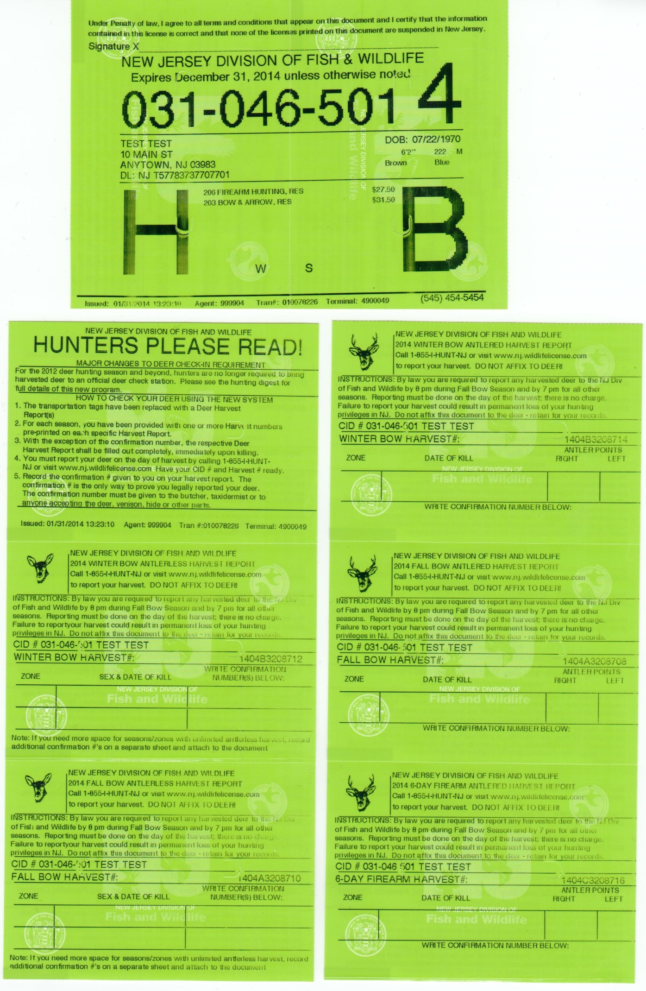

Attachment E – CURRENT LICENSE SAMPLES
Child Support Certification

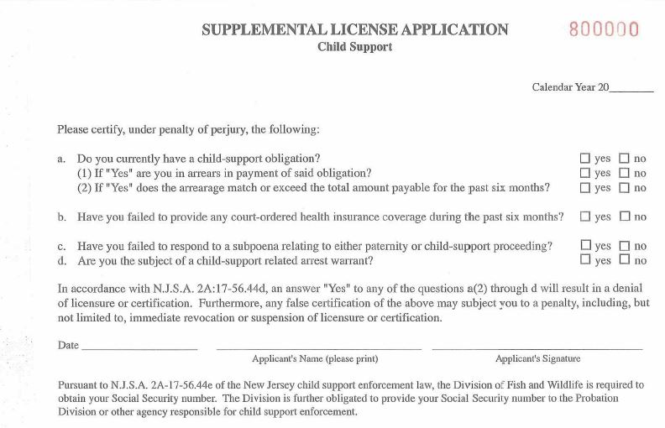

Attachment E – CURRENT LICENSE SAMPLES
Sample Commercial Marine License


