Distributed Information Technology Architecture

PROJECT: IT Architecture

VERSION: 11.0

PREPARED FOR: 2015-2016

Contents
1 VERSION HISTORY 4
2 AUTHORS 6
3 INTRODUCTION 7
3.1 General Overview 7
3.2 Objective 7
4 FACILITIES AND ENVIRONMENT 7
4.1 Security and Monitoring 9
4.2 Power Distribution 9
4.3 Environmental Climate Control 10
4.4 Fire Detection and Suppression Systems 10
5 DHS NETWORK 10
5.1 Distributed N-Tier Architecture 10
5.2 DHS Network Architecture 11
5.3 DHS Security Framework 11
5.4 DHS Secure Remote Access Architecture 12
6 ENTERPRISE SERVER AND OPERATING SYSTEMS 12
6.1 Shared Server Infrastructure 12
6.2 Hardware and Software 12
6.3 Storage Area Network 13
6.4 Backup and Recovery 14
7 DATA MANAGEMENT 15
7.1 Database Management Systems (DBMS) 15
7.2 Data Transfers 15
8 APPLICATION DEVELOPMENT AND INFRASTRUCTURE 16
8.1 Application Development Environment and Programming Languages 16
8.2 Service Oriented Architecture and Enterprise Framework 16
9 Integration and Messaging 16
9.1 Message Oriented Middleware 16
9.2 Enterprise Application Integration (EAI) 17
9.3 Web to Host 17
10 GEOGRAPHIC INFORMATION SYSTEM (GIS) SERVICES 17
11 IDENTITY MANAGEMENT 17
11.1 Enterprise Directory Services 17
12 PRESENTATION AND PORTAL SERVICES 18
13 DESKTOP, E-MAIL AND DIRECTORY SERVICES 18
14 Network Monitoring and Performance Assessment 19
15 Enterprise Systems Management (ESM) Architecture 19
15.1 IBM / AIX 20
15.2 Intel / Microsoft Windows 20
16 Enterprise Service and Asset Management 20
17 Appendix 1: Logical Network Diagram 21
18 Appendix 2: Physical Network (Summary) Diagram 22
19 Appendix 3: Physical Network (Summary) Diagram 23
20 Appendix 4: Storage Area Network Diagram 24
21 Appendix 4: Storage Area Network Diagram 25
22 Appendix 5: Product and Technologies 26
23 Appendix 6: Standard Desktop Image 30
24 Appendix 7: Federal and State Regulations 31

VERSION HISTORY

Date | Version # | Author | Description of Changes
6/25/04 | 1.0 |  | Distributed IT Architecture Document created
10/12/04 | 2.0 |  | Added Hubs/Switches/Routers, Firewalls, Specialized Appliances to Appendix 4
2/18/05 | 3.0 |  | - Added this version control sheet.  - Added Single-Sign On description in Application Development and Infrastructure.  - Added Development Environment and Storage Area Network diagrams as Appendices and updated Logical and Physical Network diagrams
12/15/05 | 4.0 |  | - Removed ‘2005’ from title page and page headers.  - Incorporated changes from DHS OIS groups and divisional IT organization input.
2/28/06 | 5.0 |  | - Changed Commissioner and Chief of Staff names on cover page.  - Minor updates to diagrams and wording.
11/28/06 | 6.0 |  | - Updates to diagrams and wording  - Changed Commissioner and Chief of Staff names on cover page
1/17/07 | 7.0 |  | - Added DHS Secure Remote Access Architecture, Desktop, E-Mail and Directory Services and Dell / Windows SAN.  - Reorganized content
7/30/07 | 8.0 |  | - Changed Commissioner and Chief of Staff names on cover page.  - Revised network diagrams
3/26/09 | 9.0 |  | - Added IT Director name on cover page.  - Added Security Framework section.  - Modified content for Enterprise Directory Services.  - Updated diagrams.  - Updated Products and Technologies
2/17/2010 | 10.0 |  | - Changed AD and ADAM authorization model.  - Removed Public Key Infrastructure  - Changed windows reference
10/14/2015 | 11.0 |  | - Updated entire document (overseen by Ed Michalak)  - Added Appendix 7.

AUTHORS

KEY AUTHORS
Name: | John Horoski | Name: | Edward Michalak
Title: | CIO | Title: | Assistant Division Director
Dep/Div: | DHS-CO | Dep/Div: | DHS-CO
Date: | 10/14/2015 | Date: | 10/14/2015

INTRODUCTION

General Overview

The New Jersey Department of Human Services (DHS) Office of Information Systems (OIS) is responsible for the development, maintenance and hosting of many applications serving the agency, its employees, business partners, and clients throughout the State.

The current DHS OIS computing and data communications environment is a combination of centrally managed enterprise servers; division and departmental application, database, and file servers; county-administered applications; and desktop clients. Network interconnectivity is provided via Local Area Networks (LANs), and Wide Area Networks (WANs) linking DHS facilities to the State HUB Data Center, State HAM Data Center, Capital Place One, the Garden State Network (GSN), and the Internet. This environment supports hundreds of various sized applications and services across all DHS. The computing environment includes security and disaster recovery resources.

DHS has implemented and continues to expand the delivery of distributed services through the Internet and intranets. DHS continues to enhance its large network and continues to initiate application modernizations in an effort to enhance client access to DHS services, while empowering employees with expanded client and program information and analysis.

Objective

Building Technology Solutions that Support the Care, Protection and Empowerment of our Clients Scope

FACILITIES AND ENVIRONMENT

The DHS computing facilities and network are distributed across the State. There are six computer centers:

- Capital Place One (CP1)
- Quakerbridge Center (QBC)
- Luczak Data Center (LDC)
- Capital Center (CC)
- Office of Information Technology (HUB)
- Office of Information Technology (HAM)

There are seven communication hub sites:

- Joseph Kohn Rehabilitation Center (JKRC)
- Capital Place One (CP1)
- Quakerbridge Center (QBC)
- Capital Center (CC)
- Office of Information Technology (HUB)
- Woodbine Developmental Center (Woodbine)
- Ancora Psychiatric Hospital (Ancora)

Security and Monitoring

DHS employs physical security to ensure that client assets are safe, secure, and protected against outside intrusion and unauthorized access. Uniformed and civilian personnel control the movement of all persons within the center facilities. Security measures include registration of all visitors, viewable credentials worn by employees and visitors, access key controlled door locks, camera surveillance systems and random patrolling of facilities by security personnel.

Access to secured areas is permitted via an authorized badge access system that is maintained by the State and DHS Facility Management Groups. The access badge system database is audited to ensure that only authorized personnel are permitted access to secure areas within the data center facilities. All previously authorized personnel that are no longer working with DHS or for the State of New Jersey are purged from the access badge system database.

The majority of the servers are housed within standard unlocked cabinet systems that are open and available to authorized system administrators (and vendors under system administrator supervision) to perform standard software, hardware, and diagnostic services. Locked smart cabinet systems are utilized to secure access to sensitive servers and the information they contain.

The responsibility of the Computer Center personnel is to ensure the availability, reliability and operational status of all production servers, the network, the environmental systems, and security systems within the facility. Facility Management, Capacity/Performance and Network Management systems and software are utilized by the Computer Center personnel to proactively monitor and display the status of these systems within the facility.

Alarms are strategically placed throughout each computer center facility and within the server rooms to alert personnel in the event of an unauthorized intrusion, environmental system failure, or fire. All support systems within these facilities are tested on a regularly scheduled basis to ensure that the alarm systems properly operate.

Power Distribution

Each computer center is fed commercial power to multiple onsite transformers. Each data center contains redundant power systems to achieve maximum availability and reliability of all systems. Computer Center personnel closely monitor external and internal power distribution systems to maximize system uptime.

Each computer center maintains multiple Uninterruptible Power Supplies (UPS) that allow all critical systems and associated equipment to remain powered up and operational in the event of a power failure.

Environmental Climate Control

Each computer center is equipped with a complete environmental system to guarantee optimal heating, cooling, and humidity levels in order to facilitate the availability, reliability, and continued operation of all systems.

Fire Detection and Suppression Systems

Each computer center has a complete fire detection and suppression system equipped with an annunciator panel that shows the current status of the fire detection and suppression system.

DHS NETWORK

Distributed N-Tier Architecture

DHS has implemented distributed n-tier network architecture to provide state-of-the-art security design to DHS’ network resources. This architecture consists of multiple firewalls with strict firewall rules protecting the network resources from the Internet and Internal networks. The firewall rules control access to each tier, requiring source, destination and TCP and/or UDP ports. A server or workstation can communicate with any device on a higher layer, and the response can come back to only that originating device. Therefore, in communicating downward in the model, at each tier there must be a process, which takes a request and hands it down to the next layer. Typically, this model fits well with distributed application design, where tier 1 handles presentation (Web or Public tier servers), tier 2 handles business logic (Application servers), and tier 3 houses the data (Data servers). Refer to Appendix 1 – Logical Network Diagram.

N-Tier (Internet)

An Internet user can only communicate with the public tier load balance network hardware. The load balance network hardware will communicate with a public tier server. The public tier server will communicate with the tier 2 enterprise business load balance network hardware or application server. A tier 2 application server can only communicate with tier 3 enterprise business database servers.

N-Tier (Enterprise Business)

Internal and Extranet users can only communicate with the tier 1 enterprise business load balance network hardware. The load balance network hardware will communicate with a tier 1 presentation web server. A tier 1 presentation web server can only communicate with tier 2 enterprise business load balance network hardware or application server. A tier 2 application server can only communicate with tier 3 enterprise business database servers.

DHS Network Architecture

DHS builds and manages a multi-agency, TCP/IP network across New Jersey. This network supports agencies through dedicated and switched services in support of centralized and distributed data processing applications resident in mainframe, server, local area network (LAN), and personal computer environments. The DHS network also provides network services such as DNS (domain name system), DHCP (Dynamic Host Configuration Protocol), Active Directory, Email, Calendar, Collaboration Services, file and print shares.

The DHS network is comprised of seven communication hub sites. These sites are interconnected to form a statewide backbone network. The backbone is designed with multiple paths to increase service reliability and availability in the event of a failure. The major contracted carrier service providers at this time are AT&T and Verizon for the Garden State Network (GSN), the State’s network maintained by the Office of Information Technology.

Internet access to DHS public information is provided through the State’s public access Web server (www.state.nj.us).The DHS network firewall infrastructure provides a physical n-tier architecture designed for internal, external and extranet networks. The External firewall infrastructure has a tier 1 for web serving, tier 2 for application serving (business logic) and tier 3 for database serving. The Internal firewall infrastructure has a tier 1 for web serving, tier 2 for application serving (business logic) and tier 3 for database serving. The Extranet firewall infrastructure has a perimeter defense to restrict Extranet Partners to access only State mandated systems and network services by way of TCP/IP protocol and ports. Refer to Appendix 1 – Logical Network Diagram.

The policy prohibits advancing inbound more than one tier at a time without a process to supervise communications with the next tier. Firewall rules are created to allow specific connection defined by specific ports. The typical public access is by port 80 (http) and 443 (https). Extranet connections require point-to-point connections from the vendor to the secure layer of the firewall infrastructure. The cost of these connections varies based on the circuit ordered.

DHS Security Framework

DHS continues to work on a security framework to address information technology security requirements based on Federal and State laws. The framework uses HIPAA Security (Health Insurance Portability and Accountability Act of 1996, 42 USC 1301 et seq., and the associated regulations at 45 CFR Parts 160 and 164), IRS Publication 1075 Security Guidelines, ISO-17799 (International Standards Organization) Information Security Management System and Information Technology Standards, the Health Information Technology for Economic and Clinical Health (HITECH) Act, and the Federal Information Security Management Act (FISMA) of 2002, among others. See Appendix 7 for a list of Federal and State Regulations.

The framework establishes a best practice, safeguards and a dynamic security plan for information technology.

The Security Framework has policies, procedures and standards but it also leverages hardware and software solutions to protect and minimize potential security risks and threats. The Distributed IT Architecture fits within the security framework and adheres to the policies and standards.

DHS Secure Remote Access Architecture

DHS has implemented a secure remote access architecture utilizing Citrix. Access is achieved through one or more firewalls and is restricted by firewall rules, protecting the internal network resources. The access method uses directory services to verify the user’s credentials and remote access privileges. Access to the internal network and its resources are limited and must receive approval from an authorized IT administrator or management.

ENTERPRISE SERVER AND OPERATING SYSTEMS

Shared Server Infrastructure

The Shared Server Infrastructure (SSI) is located at the HUB, Capital Place One and HAM data centers. It is an area in each computer room where servers are centralized to offer a common location to manage the distributed environment. Optimizing key server resources through common logical and physical environments positions DHS to properly plan, manage and control a growing server infrastructure. The SSI supports the following operating system platforms:

    - IBM AIX
    - Microsoft Windows

Hardware and Software

The hardware is the IBM Power Systems platform running AIX UNIX, WebSphere and Oracle software for the J2EE model, and Dell hardware and Microsoft TMG, IIS.NET and SQL Server for the Microsoft model.

Web Serving:
      - IBM Power Systems (AIX UNIX) running IBM HTTP Server
      - Dell PowerEdge Servers (Windows Server OS) running Microsoft Internet Information Services (IIS) and Microsoft Internet Security and Acceleration (ISA)

Application Serving:

      - IBM Power Systems running both Oracle Internet Application Server (iAS) and IBM WebSphere Application Server software
      - Dell PowerEdge Servers (Windows Server OS) running Microsoft .NET

Data Serving:
      - IBM Power Systems (AIX UNIX) running Oracle
      - Dell PowerEdge Servers (Windows Server OS) running Microsoft SQL
      - IBM WebSphere MQ (formerly MQ Series)

Directory Serving:
      - Lightweight Directory Access Protocol (LDAP)
      - Microsoft Active Directory

DHS has a development, staging, user acceptance and production infrastructures. A number of applications have a disaster recovery (DR) infrastructure and DHS continues to implement a DR infrastructure for its mission critical applications and services.

Storage Area Network

DHS manages Storage Area Networks (SANs) at Capital Place One, State HUB and State HAM. The SANs consists of a communication infrastructure that provides physical connections, and a management layer, which organizes the connections, storage elements and computer systems so that data transfer is secure and robust. The DHS SANs attaches storage devices to servers in a networked fashion, using hubs, switches, bridges, and directors to build the topology.

Backup and Recovery

Database

For daily database backup, Oracle’s Recovery Manager (RMAN) utility and Tivoli’s Data Protection for Oracle (TDPO) product are utilized to perform “hot” physical backups to tape. A hot backup means that the databases being backed up actually remain open and available to end-users.
“Cold” physical backups are also performed in development environments only. In this case, the database is shut down and the key Oracle database components (control, database and redo log files) are backed up at the file system level via Tivoli Storage Manager (TSM).
Logical backups are performed where data (tables, stored procedures, etc.) is extracted with the Oracle Data Pump Utility and stored in a binary file. Logical backups are used to supplement Physical backups.
For remote backup, Oracle’s Data Guard product provides complete protection against corruptions and data loss. Redo data is synchronously transmitted from the primary production database to a remote, standby database. Data Guard automates the manual process of maintaining this standby copy of the production database. The standby database can be used if the production database is taken offline for routine maintenance or becomes unexpectedly damaged or unavailable. Data Guard can also be configured in such a way to also provide off-line reporting capabilities.
Finally, copies of backup tape sets created by Tivoli Storage Manager (see above) are stored at a remote location for disaster recovery purposes.

IBM/AIX

For IBM Power Systems servers, DHS uses a combination of AIX Operating System (OS) tools and third party products to permit a complete data solution for enterprise level storage management, backup and recovery across heterogeneous IT environments comprised of hardware devices, applications, databases, and operating systems.
At the Operating System level, Tivoli Storage Manager (TSM) provides policy-based back up and restoration functionality across the entire network so that a copy of business critical data can be kept secure at all times from both natural and unnatural disasters. TSM optimizes storage utilization, minimizes downtime and streamlines storage management. AIX operating system backup images are created using the AIX TSM Sys Back command.

Intel/Microsoft Windows

The Intel platform running all Microsoft Windows servers are backed up using Veritas BackupExec, Symantec LiveState Recovery, Veritas NetBackup or Microsoft DPM. Backups occur nightly, with full backups occurring daily or weekly with daily incremental. The servers are imaged using the Symantec LiveState Recovery software. A server image can be restored and data restored using these products.

DATA MANAGEMENT

DHS has built a logical data model and data management framework to manage a core of common data at the enterprise level. This strategy has enabled DHS to use relational technologies to collect disseminate and maintain the integrity of critical data elements across multiple DHS programs. By adhering to common data standards, DHS will be able to:
      - Collect data once and use it often, improving data accuracy
      - Warehouse data more effectively for various needs
      - Store data more effectively for a timelier and more complete information picture
      - Better protect the privacy of individuals while improving access to non-restricted information

The intent is to manage the overall data assets to achieve optimal integration, sharing, access, and utilization of technology resources and infrastructure. DHS utilizes various concepts and tools to accomplish these goals. These include:

      - Shared Data Warehouse and Data Mart
      - Business Intelligence Tools
      - Extract, Transform and Load (ETL) Tools
      - Metadata Management
      - Data Modeling
      - Data Quality Tools
      - Data Cleansing
      - Data Integration
      - Data Mining

Database Management Systems (DBMS)

The strategic relational database for DHS is Oracle. DHS also maintains some SQL Server Relational DBMS databases.

Data Transfers

DHS has multiple ways of sending and receiving files for host to host transfer. One method is via secure file transfer (SFT) utilizing advanced data encryption technologies. Connectivity is through the use of SFTP and authenticating to the destination host. Another method is a secure file transfer (SFT) utilizing advanced data encryption technologies. This is a manual interface through the DHS Citrix server environment. Connectivity is through the use of the Citrix client and authenticating to the Citrix server environment. The user selects the file needed to send, receive or browse and selects the source or destination of that file. Another method is through the DHS firewall infrastructure using the private network and communicating directly to the destination host. This can be accomplished via FTPS. No transfers occur over the Internet or the public network. In all methods, the transfer uses 128-bit encryption and the user or host is advised of the success of that transfer.

An additional data transfer protocol currently in use for the legacy MLTSS system is FTP.

APPLICATION DEVELOPMENT AND INFRASTRUCTURE

Application Development Environment and Programming Languages

The application environment for new web browser based applications is object-oriented design using Java or .Net components running on WebSphere or MS IIS application servers. Programs are developed utilizing HTML, Java Server Pages, Java Script, Microsoft .Net components, Servlets, Java Beans and Enterprise Java Beans. The goal of the enterprise is to develop reusable components and make use of DHS standard shared architectural components.

Service Oriented Architecture and Enterprise Framework

The DHS strategic direction is the placement of existing and future services into an enterprise design consistent with service oriented architectures. An enterprise design moves otherwise wholly unique and separate designs into an architecture that supports sharing of business processes, technical services, and common data. Each program manages its own unique business rules and information but builds from a common data model. Enterprise frameworks provide the ‘glue’ that simplifies the required integration among the programs. Benefits include:

      - Providing common technical services such as security, scheduling, and auditing,
      - Utilizing shared human services functions such as case management,
      - Presenting a common interface for users and clients, and
      - Reduced development and maintenance costs.

Integration and Messaging

Message Oriented Middleware

DHS has implemented IBM WebSphere MQ (formerly MQ Series) in many critical application environments for enterprise messaging between systems. WebSphere MQ is currently in production on the IBM Power Systems platforms for connectivity to the J2EE application environment and IIS applications.

Enterprise Application Integration (EAI)

An EAI solution enables real-time data and workflow integration from one system to another. DHS uses IBM WebSphere MQ as its EAI product.

Web to Host

The State supports two Web to Host products; GWEB for access to the Bull environment and IBM Host Integrator for access to the IBM environment.

GEOGRAPHIC INFORMATION SYSTEM (GIS) SERVICES

DHS currently has access to the State GIS services. The State’s management and access of spatial data is facilitated through a gateway, which utilizes a combination of technologies including Oracle Spatial and Environmental Research Institute (ESRI) Arc Spatial Data Engine (ArcSDE). Spatial data is provided in a format that can be accessed by a variety of desktop GIS clients or by other applications using standard SQL queries. Any proposed solution that includes a GIS component and/or incorporates spatial data is evaluated, planned, designed, and implemented in concert with the OIT Office of GIS.

IDENTITY MANAGEMENT

Enterprise Directory Services

DHS continues to leverage its existing Microsoft Active Directory (AD) environment to support its enterprise identity management needs. Active Directory’s services provide the means to manage the identities and relationships that make up the enterprise environment.

AD integrated and .NET applications will use the Active Directory environment for authentication. The servers running the applications are or will become member servers to the DHS existing Active Directory environment.

Applications will use third party or custom authorization security modules to identify user roles and permissions.

DHS maintains personnel names, locations, telephone information, business related information and e-mail addresses in its directory. Over 20,000 entries, one for each DHS employee, extranet business partner and community service provider organizations now reside in the directory.

PRESENTATION AND PORTAL SERVICES

DHS has implemented a distributed n-tiered technical architecture and production environment to facilitate the delivery of web based services to clients, business partners and employees of the State of New Jersey. The distributed architecture facilitates true portal functionality through the registration and management of intranet, extranet and Internet based members into appropriate portal venues. Management of portal members is role based; i.e., users are assigned one or more roles (e.g., DHS Client, DHS Employee, Provider, etc.), which govern their access to informational and transactional services.

The Distributed architecture provides the following functional services:

      - User registration, authentication & security services
      - Policy Management
      - Directory Services
      - Data, application and web serving platforms Portal Management
The DHS portal environment is provided via a combination of:

      - Microsoft Content Management Server software
      - Microsoft SharePoint
      - Microsoft Active Directory
      - Microsoft SQL database services
      - A custom administration tool, with an HTML user interface, written in .Net and served from the distributed application server platform

Access to the directory and SQL database services is managed by COTS products and custom .Net framework served from the distributed application server platform.

DESKTOP, E-MAIL AND DIRECTORY SERVICES
DHS has implemented a new Standard Desktop Management framework and an Active Directory and Exchange Architecture framework.

The Standard Desktop Management framework establishes standards for building, securing, delivering and managing the desktop computer for employees within the DHS.

The Department desktop computer use Windows operating systems with 100% of present deployments in Windows 7 Enterprise 64-bit. See Appendix 6 for the standard configuration of desktop software.

The Active Directory and Exchange Architecture framework provides a directory, email and calendar environment. The framework is part of the Distributed N-Tier Architecture, and includes security and disaster recovery resources. The framework’s protocol or interface is RPC over https (SSL) and is accessible using the email software Microsoft Outlook or a web browser. The interface allows mobile devices to access the same services as the other software. The framework is accessible on the DHS internal network and the Internet. The framework allow employees within the DHS to communicate with other state departments, federal government, county, business partners, providers and the public through a secure network environment.

Components of the Standard Desktop Management and Active Directory and Exchange Architecture frameworks are:

      - Multi-layer network environment
      - Central Desktop Management
      - Directory Services
      - Email and Calendar Services
      - Security Control Services
      - Application Deployment Management
      - External Interface Management
      - Redundancy and Disaster Recovery Services

Network Monitoring and Performance Assessment

IPSwitch Whatsup Gold is used to perform baseline analysis of the existing network environment prior to deploying new and existing applications, and connectivity to Human Service network facilities. The existing application protocols and their respective volumes traversing the local (LAN) and wide area network (WAN) are identified and their bandwidth consumption, average response times and traffic volumes measured. This analysis can be used as a benchmark comparison against future performance. In instances where a wide area network connection employs Frame Relay technologies, the circuit utilization can be obtained.

Etherpeek, Ethereal and TCPDump are used to collect local area network traffic packets. The packet analysis provides data for tracking host to host connectivity and type of data being sent and received over TCP/IP, IP addresses, protocols and port numbers.

Enterprise Systems Management (ESM) Architecture

Enterprise Systems Management (ESM) can be concisely defined as the end-to-end management of the evolving, heterogeneous, multi-platform, distributed computing environment. ESM tools are used to detect, correlate, escalate and prioritize events; manage responses to those events; and report on those incidents in a pro-active, real-time event management environment in order to provide a secure, highly available, robust, multi-platform enterprise infrastructure that meets or exceeds system requirements.

DHS has implemented various monitors, distributed storage management, and event management components that are integrated with problem management for the automatic generation of trouble tickets for critical events.

IBM / AIX
Ganglia is a scalable distributed monitoring system for high-performance computing systems such as clusters and Grids. It is based on a hierarchical design targeted at federations of clusters. It leverages widely used technologies such as XML for data representation, XDR for compact, portable data transport, and RRDtool for data storage and visualization.

NMon tool is used to monitor and analyze performance data including CPU, Memory, Disk, Network and hardware components.

OEM is a separate Oracle product that combines a graphical console, agents, common services, and tools to provide an integrated and comprehensive systems management platform for managing Oracle products.

Intel / Microsoft Windows

DHS uses Microsoft System Center Operations Manager (SCOM) to monitor and manage its Intel platforms. The Intel / Microsoft Windows platform, software products and event management report to the central SCOM system.

SCOM detects, records, and correlates all enterprise significant events; and provides notification through the system, as well as e-mail and pagers.

Enterprise Service and Asset Management

DHS uses Alloy Navigator for Incident and Problem Management, Change Management, Asset Management, Knowledge Management and Software Licensing Compliance. This product improves client application availability through the automatic notification and escalation of problems via e-mail and pagers, and integration into the DHS Active Directory environment.

Appendix 1: Logical Network Diagram
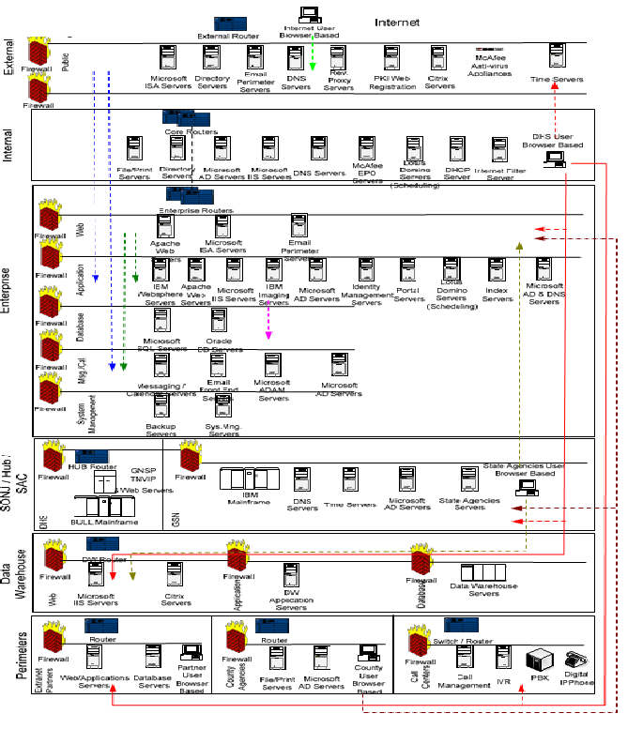

Appendix 2: Physical Network (Summary) Diagram
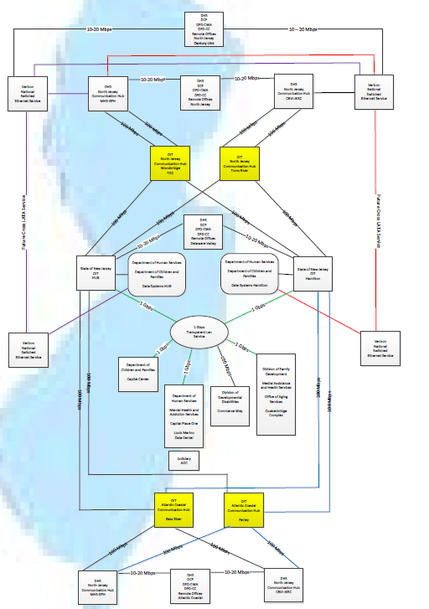

Appendix 3: Physical Network (Summary) Diagram
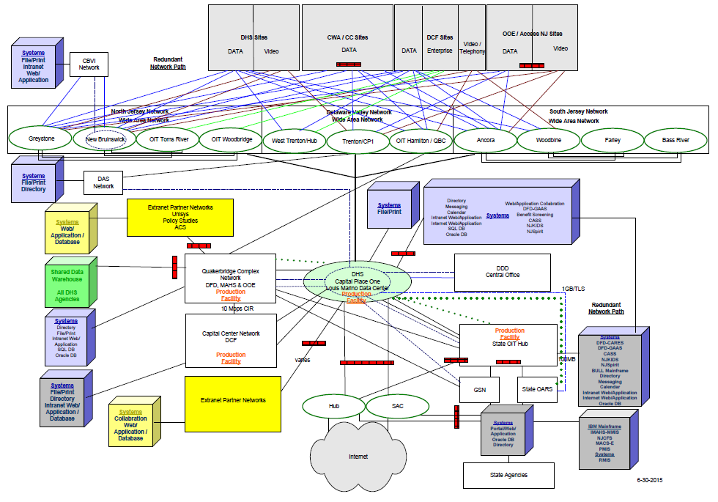

Appendix 4: Storage Area Network Diagram

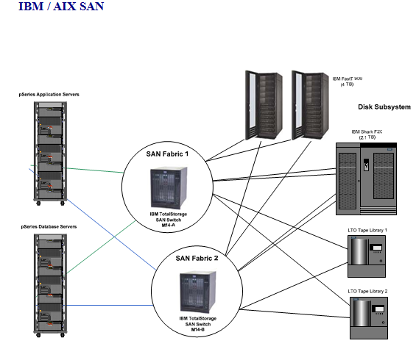

Appendix 4: Storage Area Network Diagram
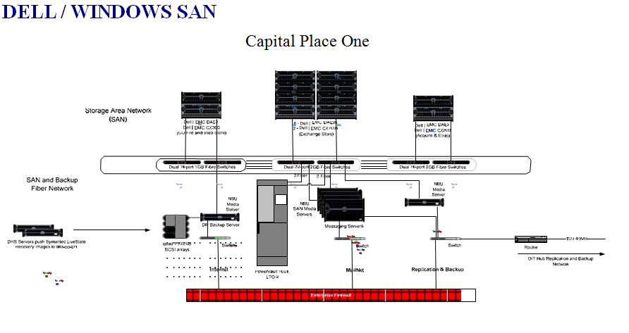
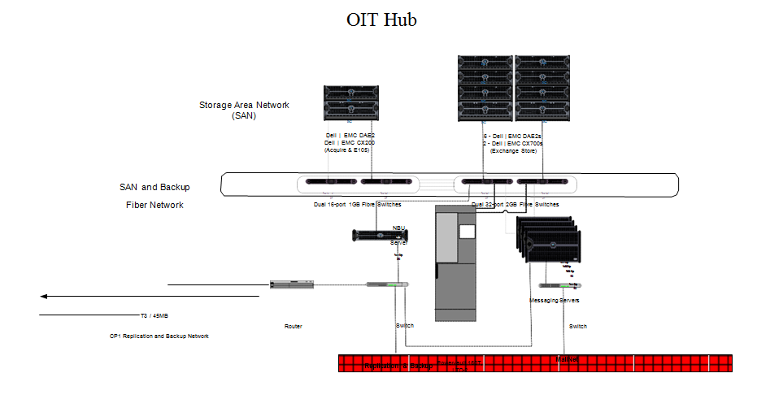

Appendix 5: Product and Technologies
* Direction Key:
P = Preferred | This technology represents our strategic direction. DHS will give priority to this technology.
A = Acceptable | This technology represents our minimum requirements. DHS considers this technology adequate/satisfactory.
S = Sunset | This technology is in use, but DHS deems this technology undesirable/unacceptable.

Note: While release versions are not listed for products below, DHS expects to use the most current or next current released production version at the time of implementation.

Category | Product | Direction*
Operating Systems - Servers | AIX UNIX  LINUX  Windows 2003 Server  Windows 2008 Server  Windows 2012 Server | P  P  S  P  P
Operating Systems – PCs | Windows 7 | P
Database Platforms | Oracle  Microsoft SQL Server | P  P
Languages | COBOL  Java  HTML  JavaScript  SQL  XML  .NET | A  P  P  P  A  P  P
Portal Services | Microsoft SharePoint | P
Directory Services | Microsoft Active Directory | P
Identity Management / Policy Services | Authentication and application controls through Active Directory | P
Data Transfer | Secure File Transfer  Direct Private Connection | P  A
EAI (Enterprise Application Integration) | IBM WebSphere MQ Series | P
GIS Technology | ESRI: ArcSDE – Spatial Data Hosting via State services | P
Application Servers | Oracle Internet Application Server (iAS)  IBM WebSphere Application Server  Microsoft Internet Security and Acceleration (ISA) | A  P  P
Web Servers | IBM HTTP Server  Microsoft IIS  Apache | P  P  P
Messaging Technology | IBM WebSphere MQ Series P | P
Security | ACF2  SSL  McAfee Vulnerability Manager  McAfee Intrusion Prevention System  McAfee Security Suite  Microsoft Baseline Analyzer  DOTNET FXCOP  IBM Rational AppScan  Internet Filter: Websense | A  P  P  P  P  P  P  P  P
Document Imaging | IBM Content Manager  Kodak Scanners and Kofax Software | P  S
Network / System Management | IPSwitch Whatsup  Ganglia  NMON  IBM Tivoli Storage Productivity Center  OEM  Microsoft System Center Operations Manager | P  A  P  S  P  P
Mail | Microsoft Outlook | P
Calendar | Microsoft Outlook | P
Audio / Video | Real Media  Microsoft  Avid Xpress | A  A  A
OLAP (Online Analytical Processing) | Business Objects  WebFOCUS | A  P
Software Administration | TFS | P  P
Data Warehouse Products | Informatica (ETL Platform) P  Trillium (Data Integration - UCI) P  MetaCenter (Meta Data Repository) A  Teleran i-Sight (Performance Tool) P  ArcView (Geographic Analysis) P  Citrix Metaframe (Network Tool) P | P  P  A  P  P  P
Data Mining & Statistical Analysis | BusinessObjects (Data Retrieval, Reporting & Analysis)  SPSS (Statistical Analysis) A  SPSS Clementine (Data Miner) A  QueryPath (Data Retrieval and Reporting) A  SAS | P  A  A  A  A
Reporting Tools | Oracle Reports  Crystal Reports  Web Focus  Magna8 | A  A  P  S
Development Tools | Macromedia DreamWeaver (HTML)  Forte  Adobe  Quark  Macromedia Flash  Macromedia Fireworks  Pagemaker  Microsoft FrontPage  Microsoft Developer Studio  Microsoft Source Safe  Rationale Rapid Application Development | A  P  A  A  A  A  A  P  P  P
Performance Assessment Tools | IPSwitch Whatsup Gold  Multi-protocol Routing Traffic Grapher (MRTG) P  WildPackets Etherpeek  Ethereal  TCPDump  Mercury Load Runner  CA Interscope  CA Wily  Watchfire WebXM | P  P  P  P  P  A  S  S  A
Desktop Software | Internet Explorer  Office 2010  McAfee VirusScan  McAfee ePolicy Orchestrator (ePO) P  Tivoli TME  Microsoft System Center Operations Manager (SCOM)  Symantec Livestate Delivery P  Glink  Oracle Client  Adobe Acrobat  Sun JAVA Runtime  Macromedia Flash Player P  Microsoft Media Player  Microsoft Visio Viewer  ExtendNet Connect for TCP/IP P  HP JetDirect Printing System P | P  P  P  P  A  P  P  P  P  P  P  P  P  P  P  P
Hubs/Switches/Router | Data: Cisco  Data: HP / ProCurve  VOIP: Avaya | P  A  P
Firewalls | Cisco – Pix  Nokia – Check Point FW1 | A  P
Specialized Appliances | Cache Engine: Cisco  Load Balancing: Array Networks | P  P

Appendix 6: Standard Desktop Image

Adobe Flash Player 10 Active X
Adobe Reader X (10.0.1)
Adobe Shockwave Player 11.5
Glink Professional Edition 8.l2.3 (C:\glpro)
Internet Explorer 8
Java ™ 6 Update 25 (64 bit)
McAfee Agent
McAfee VirusScan Enterprise
Microsoft .NET Framework 4 Client Profile
Microsoft .Net Framework 4Extended
Microsoft Office Professional Plus 2010
Microsoft Silverlight
Microsoft Visual C++2005 Redistributable (x64)
Microsoft Visual C++ 2008 Redistributable – x64 9.0.30729.4148
Microsoft Visual C++ 2008 Redistributable – x86 9.0.30729.4148
Quest Secure Password Extension x64
Windows 7 Enterprise

Appendix 7: Federal and State Regulations



