SNAPTrac Technical Environment

The SNAPTrac application is a web enabled n-tier architecture system built using Microsoft .Net technologies runs on Microsoft Windows platform. The SNAPTrac architecture is built in accordance with the state’s DHS Distributed Information Technology Architecture specifications and standards.
This document provides a comprehensive overview of the SNAPTrac infrastructure, environment and architecture.

1.1 Network Infrastructure
The SNAPTrac application is accessed by DFD CWA users across the state in multiple counties. The system is operated and maintained on the state’s network infrastructure framework that comprises of four major components: Enterprise Core, Enterprise Network, Wide Area Network (WAN) and Local Area Network (LAN).
Zones | Network Components | Description
1 | Enterprise Core | The Enterprise Core consists of network connectivity between various tiers and systems. Through the use of firewall access control, network traffic is restricted to only allow access from network to server and server to server.
2 | Enterprise Network | The Enterprise Network provides the network communications path to the Enterprise Core and the SNAPTrac application and network services. The network spans the State of New Jersey and interconnects through eight network communication hub facilities. Site locations use the site’s central switch to access the Enterprise Network and Core.
3 | Wide Area Network (WAN) | THE WAN provides each site location with redundant paths to the DHS Enterprise network that can access the Enterprise Core applications and State legacy application and network services. Firewalls and router access control lists restrict network traffic to allow access to authorized applications and network services.
4 | Local Area Network (LAN) | Site location specific at each office and county. The LAN traffic is routed out of a site location through the DHS Enterprise Network or Wide Area Network.

1.2 SNAPTrac Environments
The SNAPTrac Enterprise Core comprises of the following two (2) physical server environments.
- Production
- Non-Production

The Production environment is the primary site that hosts the production system accessed by the CWA county users to perform case functions.

The Non-Production environment hosts multiple regions (logical environments) to cater system development and testing activities.

- Development – The development team uses this environment for development, and for issue fixes activities including both unit and integration testing.
- System Test – The development team uses this environment to perform system test activities.
- UAT (User Acceptance Testing) – This environment is used by the UAT team to perform testing activities to approve system build releases.
- Staging – This environment is used by the Configuration Management team to test the build and deployment of the software before releasing into production.

A separate Disaster Recovery environment is not yet in place. However, a temporary plan is in place to host the system in the non-production environment in the event the primary site is unavailable for an extended duration.

1.3 System Architecture
The SNAPTrac is an n-tier architecture system built on Microsoft .Net technologies runs on Microsoft Windows platform with multiple physical tiers: load balancer, web, application, database and storage tiers.
Each physical tier in the SNAPTrac environment uses a clustered server topology implementation to eliminate single point failure thereby providing a design for high availability assurance, reliability, and scalability.
The graph below provides a comprehensive overview the SNAPTrac system.
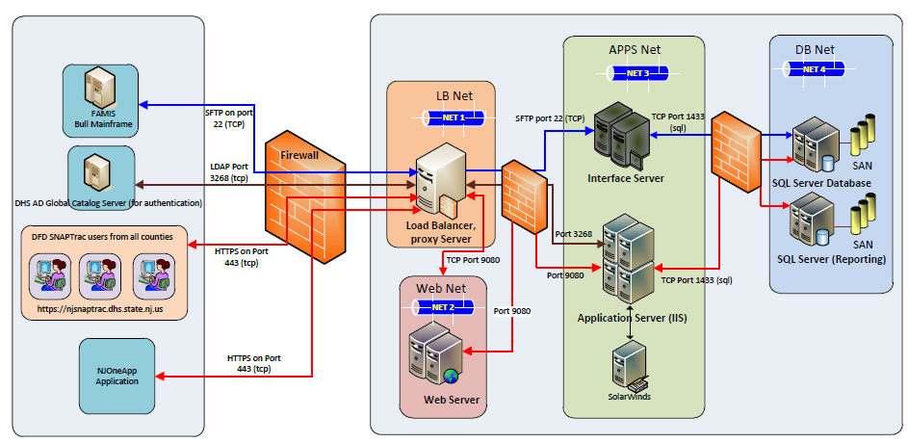

The SNAPTrac core enterprise comprises the following server components in each of the tiers.
Tier | Server Component | Description
Load Balancer Tier | Array APV3650 | This server is used for load balancing, gateway to access the application and as an SSL accelerator for SNAPTrac application infrastructure.
Web Tier | Microsoft IIS Web Server 8.5 | Web server software is responsible for serving the user request with static contents and interacting with the applications servers for relevant dynamic business contents. It runs on two (2) virtual hosts.
Application Tier | Microsoft IIS Application Server 8.5 | Application server software is responsible handling requests from the web servers to the database for relevant dynamic business contents as well as execute batch processes. It runs on two (2) virtual hosts.
Application Tier | Interface Server | This server is used by the SNAPTRAC application to interface with multiple external systems (FAMIS Bull Mainframe, OIT Mainframe) to exchange data files over SFTP protocol and manage the data exchange capabilities.
Database Tier | Microsoft SQL Server 2013 enterprise edition | Microsoft SQL Server 2013 database software is deployed in a clustered configuration to ensure high performance, scalability, and failover capabilities at the database tier. It runs on two (2) virtual hosts to perform the database functions.
Storage Tier | Dell Compellent SC8000 | The SAN consists of two Dell Compellent SC8000 controllers connected to the Dell Compellent storage enclosure with two 10GB fiber channel ports as well as two 10GB fiber channel ports to each of the Brocade 5300 fiber switches.

The SNAPTrac enterprise server infrastructure uses multiple DELL PowerEdge R720 server hardware configured in a VMWare ESXi cluster. Each physical server hardware encompasses multiple virtual server(s) and each virtual server runs on Windows Server 2012 Release 2 operating system. This design provides a clustered virtual environment to handle failover and optimal usage of server resources.
Microsoft Team Foundation Server (TFS) software is the Application Lifecycle Management (ALM) tool used by the SNAPTrac project team to manage Source Code Control, Automated Builds, Issue and Defect Tracking functions. Microsoft Visual Team Studio is the integrated development environment (IDE) tool used by the SNAPTrac development team for system development activities.

1.4 Application Architecture
The SNAPTrac web application framework is implemented on .Net platform using the Model View Controller (MVC Model 2) pattern with multiple logical layers: the client-side presentation, server-side presentation, controller, business, integration, data access and data storage layers.
The MVC pattern features the use of a controller between the browser and the delivery of content to the browser through ASPX pages or AJAX retrievals. The application’s client side presentation layer comprises of JavaScript, HTML, images, and AJAX based requests and responses. The client-side JavaScript mainly performs XML/JSON (JavaScript Object Notation) asynchronous (AJAX) calls between the browser and web server farm over HTTPS protocol.
The business layer provides implementation classes and entity classes using business rules and persistence data to display and update information on the view. The Integration layer comprises a Data Access Object (DAO) component built on the Data Access Object design pattern encapsulating the ADO.NET data access calls to the database and provides a mechanism for fetching and updating data in SQL Server database.
The application stored procedure layer composes the resource tier that services requests based on user actions from the presentation layer. A stored procedure, a named group of SQL statements, creates, compiles, and stores the statements in the SQL Server database. SNAPTrac data is stored in the SQL Server database implemented using a clustered topology for high availability, scalability and performance.
Document Generation Architecture: The SNAPTrac Application architecture includes a notice generation framework to generate and print documents online and batch for central print processing.
Reporting Architecture: The reporting architecture primarily uses the application architecture framework to perform operational reporting and analytical reporting. It also includes a process to extract, transform and load data from OLTP data store to reporting data store.
Batch Architecture: The SNAPTrac application batch job execution is automated using Microsoft’s SQL Server Scheduler. The Scheduler is used for scheduling and executing the batch programs based on the specified job definitions, dependencies, and starting conditions. The scheduler is loaded with the complete inventory of application job definitions. The job definitions include the batch program to execute, dependencies, and system specific information required for execution on a daily, weekly and monthly basis including on-demand requests.

1.5 Client User Workstation Environment
Client user workstation runs on MS Windows 7 operating system with Microsoft Internet Explorer 11.0 and above.
The SNAPTrac application design supports a resolution of 1024 x 768 or greater. The browser in the workstation is enabled to run JavaScript and cookies to support the application.

