Attachments for T2880
Vibracore Sampling, Process, & Grain Size Analysis
of Offshore Sediment Samples

NJGWS Penetration Graph Attachment 1
(example for Core No. 999, Run 1)

NJGWS UXO Detection Method Attachment 2

Geophysical Prove-out and Protocol for UXO Detection in Marine Vibracore
NJGWS Geophysical Technical Memorandum

Introduction

The New Jersey Geological Survey (NJGS) collects marine vibracores as a part of its geological mapping project for beach nourishment sand resources. Recent offshore dredging has encountered unexploded ordinance (UXO) from areas not previously identified as an area of munitions and explosives of concern (MEC) or munitions and explosives of concern/munitions constituents (MEC/MC). This occurrence raises the possibility that UXO may unintentionally be collected in a marine vibracore.

To address UXO in marine vibracore, the NJGS uses a protocol that is based on the results of an NJGS/New Jersey State Police (NJSP) Arson/ Bomb Unit, simulation test called a geophysical prove-out (GPO). The geophysical prove-out follows the guidelines in USACE Engineer Pamphlet EP-75-1-2 [Munitions and Explosives of Concern (MEC) Support during Hazardous, Toxic, and Radioactive Waste (HRTW) and Construction Activities] and Geophysical Prove-Outs for Munitions Response Projects prepared by the Interstate Technology & Regulatory Council, Unexploded Ordnance Team. Of particular note was that the NJGS/NJSP prove-out addresses the detection of both ferrous and non-ferrous ordinance.

Methods

The NJGS and NJSP tested several simulations using types of ordinance that may be found in NJ's offshore areas.

Representatives from the NJSP Arson/ Bomb Unit and the NJGS conducted a geophysical prove-out using simulated vibracores on 12/12/2007 and 1/8/08. The NJSP
provided several examples of the type of ordinance that may be found in NJ's offshore
areas (Figures 1, 2, and 3).

Tests were conducted using simulated cores that mimic actual cores commonly collected in the offshore New Jersey marine environment. A 1 to 2 ft long clear PVC core sleeve was filled with sediment. The core plastic sleeve is 0.15 inches thick with in internal diameter of 3.5 inches. The test cores were filled with medium-grained quartz sand derived from previously sampled offshore vibracores.

Different ordinance types, both ferrous and non-ferrous (fuse type) supplied by the NJSP (Figs 1-3) were buried within the sediment-filled core tubes and the tubes were capped. Cores were tested first with dry sand and then flooded with salt water to saturation (figures 4, 5, and 6). The saturated cores would indicate if the electrically conductive salt water would prevent ordinance detection. Core tubes were placed on a wooden platform supported by steel sawhorses. The steel sawhorses simulate typical background metallic material found aboard a marine vessel which may interfere with detection.

Three detection units were tested. A Torfino Enterprises Inc, Metal-TEC™, a hand-held (electromagnetic) metal detector (figure 4) and a Schonstedt GA 52CX™ magnetic locator (figure 5) were evaluated on 12/12/07 and a Garrett SuperScanner™ (electromagnetic) (figure 6) was tested on cores on 1/08/08. The Metal-TEC™ and SuperScanner™ are law enforcement equipment. The Schonstedt GA 52CX™ is primarily used as an underground metal locator.

Results

It is important that non-ferrous UXO fuses can be detected in a screening process since they may pose an equal or greater danger than ferrous ordinance. The results of the test are summarized in table 1.

 | Ferrous  (dry core) | Ferrous  (flooded) | Non-ferrous  (dry) | Non-Ferrous  (flooded)
Schonstedt GA  52CX™ | Detected | Detected | Not detected | Not detected
Metal-TEC™ | Detected  (multiple scans) | Detected  (multiple scans) | Detected  (multiple scans) | Detected  (multiple scans)
SuperScanner™ | Detected | Detected | Detected | Detected
Table 2.1. Summary of geophysical prove-out for UXO in vibracore

The Schonstedt GA 52CX™, by its design and in practice was not able to detect the non-ferrous ordinance. All units are able to detect the ferrous ordinance; however the Schonstedt GA 52CX™ was also adversely affected by the metal sawhorses that simulated conditions on the boat.

The Metal-TEC™ was able to detect the fuse and ferrous ordinance with multiple passes at different orientations to effectively screen the core volume. The SuperScanner™ was able to detect ferrous and non-ferrous UXO without difficulty in
one pass penetrating the entire core thickness. The SuperScanner™ has a larger coil and a lower electromagnetic operating frequency than the Metal-TEC™. The SuperScanner's interference elimination feature was able to further delineate the UXO and minimize cultural noise effects. The SuperScanner™ was the best of all three at resolving the target size of both ferrous and non-ferrous UXO in the vibracore.

Disscussion/Conclusions

The likelihood of UXO recovery as a part of the vibracore acquisition process is low, yet it is possible. The use of an electromagnetic instrument for detection was found to be most effective to identify both ferrous and non-ferrous material. Of the three units tested the Garrett SuperScanner™ was best able to detect and resolve sampled UXO in vibracore. The NJGS and NJSP developed a mutually acceptable protocol using this device for both onboard and dockside screening of UXO. The geophysical prove-out demonstrated that an effective screening procedure could be low-cost and take only a few minutes per core.

Protocol
Section 1: UXO screening aboard vibracore acquisition vessel. This is an addendum to step 6 in Protocol for Vibracore Acquisition (personal communication, Jane Uptegrove, NJGS, October 2007).

1) The protocol is to be reviewed and accepted by the vibracore contractors, vessel operators and crew prior to coring operations. At the start of the acquisition day,
at least two operating Garrett SuperScanners™ (one for scanning and one for backup) must be present on board.
2) Upon removal of the vibracore sleeve from the core barrel, the entire length of core should be placed on a nonmetal stand or support for cutting into lengths (usually 5 ft intervals). The stand must be at least 1 foot away from any metal bulkhead in order to reduce cultural interference effects on the UXO detection unit. The core will be marked and measured.
3) Prior to cutting the core, the vibracore crew will allow the geophysical technician
to scan the length of the core with the Garrett SuperScanner™ using the following procedure:
a. The SuperScanner™ will be tested prior to core scanning using a metal object such as a metal ring or watch for control.
b. The technician will pass the SuperScanner™ over the core in several passes using a range of orientations of sensor to core. Typically scanning a 20 foot core will take 1-2 minutes.
c. Any positive detection will be confirmed by multiple passes and use the interference elimination feature of the SuperScanner™.
d. The length of positive detection limits will be marked.
4) If a positive detection zone is located, the vibracore crew will first excise the core
1 foot on either side of the positive detection zone and dispose of the section overboard. The vibracore technician and NJGS staff will make note of the detection and record the location of the disposal.
5) The vibracore crew will proceed using the NJGS vibracore acquisition protocol.

Section 2: UXO screening upon receipt of cut-to-length vibracores. To be used when the NJGS receives cut-to-length vibrocores that have either not been screened or have been screened using a method that has not been demonstrated (by geophysical prove-out) to detect both ferrous and non-ferrous UXO. This protocol can be used dockside, at a contractor facility, or the NJGS shop.

1) As soon as possible, the NJGS should set up a UXO screening station where core can be processed prior to loading on vehicles or placed in storage. The stand must be at least 1 foot away from any metal bulkhead or object in order to reduce cultural interference effects on the UXO detection unit.
2) The geophysical technician will scan the length of the core with the Garrett
SuperScanner™ using the following procedure:
a. The SuperScanner™ will be tested prior to core scanning using a metal object such as a metal ring or watch for control.
b. The technician will pass the SuperScanner™ over the core in several passes using a range of orientations of sensor to core. Typically scanning a cut 20 foot core will take 1-2 minutes.
c. Any positive detection will be confirmed by multiple passes and use the interference elimination feature of the SuperScanner™.
d. The length of positive detection limits will be marked.

3) If a positive detection zone is located, the vibracore crew will mark the location of the positive detection zone, and set the core aside. Promptly contact the New Jersey State Police (NJSP) Bomb Squad Unit for handling and disposal.

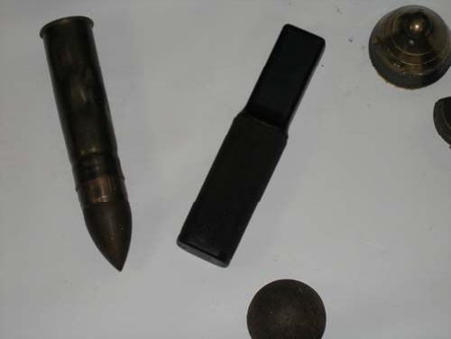

Figure 2.1. Ferrous projectile with non-ferrous brass casing (left) and Metal-TEC detectorTM (right).

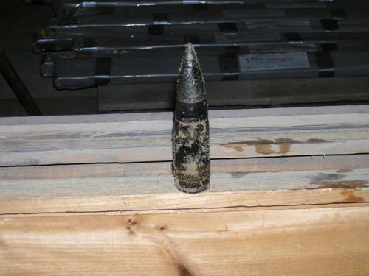

Figure 2.2. Ferrous projectile with non-ferrous brass casing.

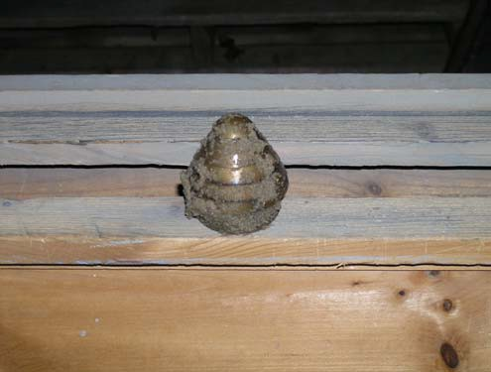
Figure 2.3. Non-ferrous (brass) fuse.

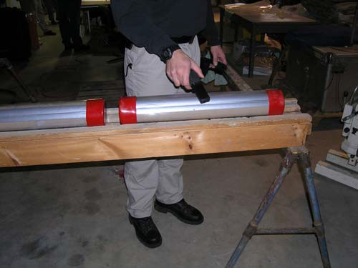

Figure 2.4. Geophysical prove out using Metal-TECTM detector.

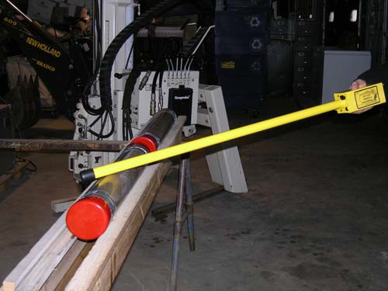

Figure 2.5. Geophysical prove-out using Schondtedt GA 52CXTM detector.

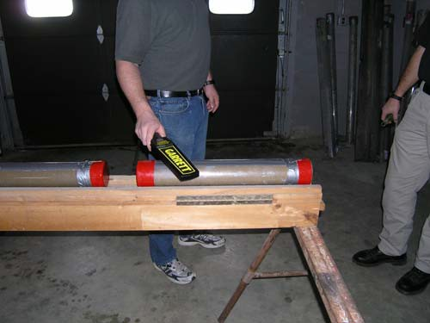
Figure 2.6. Geophysical prove-out using Garrett SuperScannerTMdetector.

References

The Interstate Technology & Regulatory Council Unexploded Ordnance Team, 2004, Geophysical Prove-Outs for Munitions Response Projects, Interstate Technology
& Regulatory Council, 444 North Capitol Street, NW, Suite 445, Washington, DC
20001 2 pages.

U.S. Army Corps of Engineers (USACE), 1999, Engineer Pamphlet EP-75-1-2, Munitions and Explosives of Concern (MEC) Support during Hazardous, Toxic, and Radioactive Waste (HRTW) and Construction Activities, Washington D.C.,
80 pages.

Vibracore Processing Attachment 3

Protocol #1: Core section opening and positioning on processing rack

Opening the core sections on the long dimension

- The vibracores are transferred to the Contractor in five (5) foot, full-round sections, with rubber “shoes” on each end. Typically they are labeled “Core xxx”, with core depth marked on each end to show top and bottom ends of the core sections (for example, “0’TOP………. CORE xxx………..5’ BOT”. (See Figure 2.1). The core sections are stored vertically, top end up, to limit deformation of core contents. The rubber shoes are perforated immediately after drilling to allow water to drain from the core sections. Core sections are labeled by core number and drilled depth in feet.

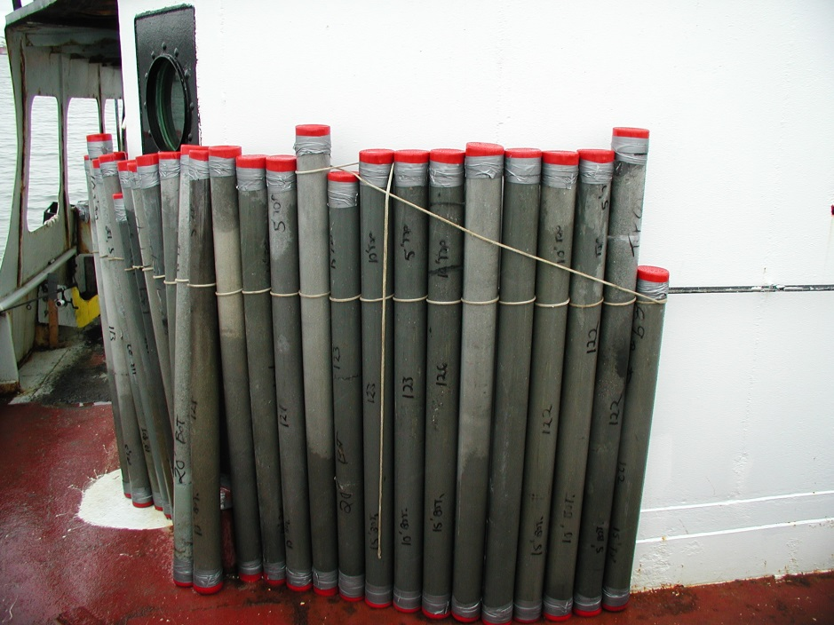
Figure 3.1. Photo shows cores labeled and stored vertically on board the vibracore drilling vessel.

Typically the fourth of the four (4) core sections (which is the deepest-drilled section of the vibracore) will be marked indicating the total depth of the core. Typically it is not a full five (5) foot length, so the total depth is less than 20 feet (e.g.15’ – 17.8’). Alternatively, this last section may exceed five (5) feet if the total depth was just over 20 feet. Use the same protocol described herein to prepare “short” and/or “long” core sections. Note that the sawing jig must be able to hold a core section as long as six (6) feet.

- As mentioned above, core sections are marked for core ID and section ID (depth in feet). Before cutting on the long dimension, wipe dirt and salt off the PVC tube and copy the core markings onto the core directly opposite the original markings, so that each long half has a core ID and section ID.

- The Contractor shall place the core section in the jig, positioned such that the long cut will not cut the core ID information. Using a circular saw with a high quality seven-and-a-quarter (7 ¼)” 40 tooth carbide-tip blade (National American or equivalent), the Contractor shall make a cut along the length of the core, with the blade cutting mainly the PVC tubing, with as little disruption to the core contents as possible. Operators and assistants must wear protection for eyes, ears, and lungs and follow all OSHA rules and regulations.

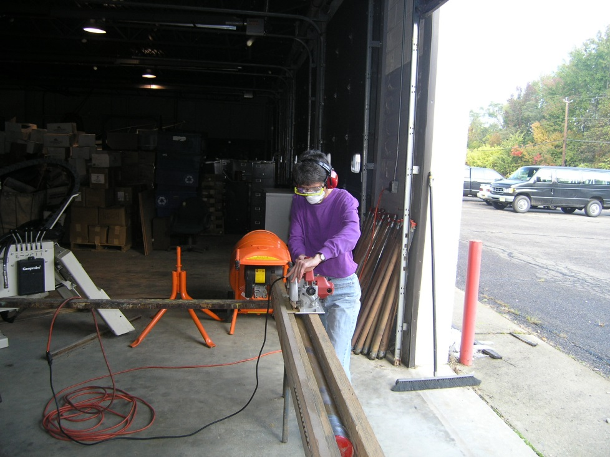
Figure 3.2. Photo shows proper placement of saw on jig and operator with required protective gear.

- The Contractor shall make sure that the long cut completely cuts through the PVC tube along the entire length of the core section. If not, it shall be re-done, usually by lowering the blade slightly. Check each cut before you re-position the core. Carefully lift the core out of the rack and turn a half round one hundred eighty (180º) to prepare for the second long cut. Be careful not to twist one end of the core. The core at both ends should have the first cut now at the center point of the jig, underneath (i.e., at the six (6) o’clock position). Both ends shall be at the center bottom. If one or both ends are not in position, lift the core section and place it in again. If there is a twist in the core when it is cut, it is hard to move it to the processing table without losing sediment.

- The two cuts shall include cutting through the red rubber shoe. Please note that, particularly on the second long cut, the PVC tube is apt to sag in the rack. This often requires re-setting the saw blade to cut about two (2) – three (3) mm deeper in order to cut through the PVC in the middle “sagging” section.

- To minimize contamination of the core by the PVC tubing sawdust, the Contractor shall wipe away the sawdust from the cut core in the rack.

- With extreme care, lift one end of the now-cut core section in a steady smooth movement, high enough so that the other worker at the opposite end of the section can reach into the rack to get a good hold on the core. In the second half of this movement, when both workers have a good grip on the core section, turn it a quarter round (ninety (90)º) such that the two cuts are on the side (i.e., at the three (3) o’clock and nine (9) o’clock positions) so that the contents do not spill out. Once you have the cuts on the side, transfer the core section to a clean five (5) or six (6)foot table.

- At the table, clean the core section again with a rag. Have a utility knife with a sharp blade and a wire (cable) saw ready. Using personal safety awareness (your stabilizing grip on the core section should be at least six (6) inches away from the rubber shoe), use the utility blade to finish the cut on the rubber shoe between the two saw blade cuts. Do this on both ends.

- While one person holds the core steady with the long cuts on the sides, the other person carefully draws the plastic pipe cable saw down the length of the core, starting by feeding the cable saw through the cut made with the utility knife.

Caution:

- If you hit resistance, do not strain. It will disrupt the core contents. Take a second wire saw; lead it in from the opposite end, and where they meet, leave them there in the core before you open it. It could be lodged on a large cobble, or a shell, and they are best preserved and the core less disturbed by this accommodation.

- When drawing the cable saw through the core, ease up on the force as you get to the end of the core, in order to avoid spraying yourself and the work table with sediment and lose material from the core.

- Once the cable saw has been drawn through the entire length of the core section, the core section is effectively split. With both workers holding the ends of the core section (including the rubber shoes, now also split), steadily turn the core section a quarter round (ninety (90)º) so that the long cut is now vertical. With a quick and steady motion, let the two halves fall open alongside each other. A quick steady motion will help limit the amount of sediment that falls out of the core section halves during this opening.

- Examine the core halves for general contents. Evaluate which half has the better intact sediments. If there is a whole section that has fallen out of a core half, please replace that sediment as close as reasonably possible to its correct depth position in the core section. Due to the “fall-out”, the disrupted section should be designated as the “archive” section.

- After choosing the better half to be processed, set aside the archive half and use the proper ID and depth label for the archive section. NJGWS will provide a standard label form. You will be wrapping both the sampled and archive sections for storage when the processing is completed.

- Using a small and thin metal (ceramics or laboratory) spatula, remove excess sediment from the “better half”. The aim is to gently remove sediment off to the sides of the core, not smeared down the core length, such that the sediment and lithologies down-core are revealed and not mixed with each other. Work around large shells and cobbles. Take care not to “pluck” out the contents by smoothing too forcefully. Take care not to burnish clay layers (they become shiny). With clay layers, it is best to leave them mostly “as is”. Try to remove traces of the wire saw cut if possible, but don’t if the sediment becomes rough or shiny.

- The processing rack must be at least twelve (12) feet in length. Using a dust broom and pan and/or a sponge, clean the processing rack of any dust or sediment. With much care, transfer the “better half” to the clean processing rack. Do not push the core into the head of the rack with force, which will create impact marks in the sediment. Facing the processing rack, the top of the core will be to the left.

- With the first core half in position, locate the next core section down-core, and repeat the steps above to this point. The result will be two core section halves positioned in the processing rack.

- Proceed to Protocol #2: Core section labeling for photos, lithologic description, and sampling
Vibracore Processing Attachment 4

Protocol #2: Core section labeling for photos, lithologic description, and sampling

General Concept - This protocol starts from the point at which the first two core sections have been opened with the circular saw, transferred to the table, fully cut with the wire saw, fully opened, with sample and archive halves selected, and the sample halves positioned in the processing rack. Note: the sampled half is the one in better condition, showing better contacts between units, etc.

The labeling pattern is designed to accomplish two (2) things: 1) it provides a “down-core” labeling pattern with enough frequency for at-a-glance lithologic review; 2) it uses the “R” in the word “CORE” as a centering tool for stitching photos that uniformly capture thirty-five (35) cm of core length and are advanced twenty-five (25) cm down-core for each photo. The panorama tool in photo editing software joins the sequence of images from one core section into one (1) long panoramic image (approximately seven (7) – ten (10) images per core section). The Contractor will re-create a panoramic image of the core section in its entirety. (For reference, see Figure 3.1, panorama shot of an NJGWS core section.)

- Placing the tape measures. Position two tape measures on the “shelf edge” of the rack, one scaled in feet (tenths), the other metric, such that core ID and core depth labels can be positioned between them. The flat surface of the core half should be flush with the “shelf edge” of the rack. (See Figure 3.1).

- When positioning the top two core sections, align the 0.0 meters and 0.0 feet measures with the beginning of the core (the outside or top of the red rubber shoe). Use thumbtacks to secure the tapes, so that they do not detract from the image. Copies of composite photos (four (4) sections) of an NJGWS core have been included to show tape measure placement (See Figure 3.1).

When positioning the lower two (2) core sections (the last two (2) of four (4) total core sections, including the bottom of the core), check the lithologic log you are preparing for the exact depth of the end of the previous section. Typically, this is ~3.1 m depth. Please note the depth, and start your tape measures at that depth at the top end of the rack for the second set of core sections.

Secure the tape measures with duct tape approximately one (1) foot beyond the end of the lower core section (beyond the view range of the last digital image).

- Depth labels. Place these labels every 0.2 meters (twenty (20) cm) perpendicular to the tape measures, centered between them, skipping a label at each full-meter depth. Place the labels at 0.0, 0.2, 0.4, 0.6, 0.8, 1.2, 1.4, 1.6, 1.8, 2.2, 2.4 m, etc. Do not place a depth label at the 1.0, 2.0, 3.0 m (etc.) depth. There will be a core ID label placed at all the full meter depths.

- Core ID Labels. Place these labels at 0.25-m (25-cm) intervals, starting at 0.25 m. The sequence is 0.25, 0.5, 0.75, 1.0, 1.25, 1.5, 1.75, 2.0 m, etc. The label will read, “CORE XXX”. Align the “R” in the word “CORE” with the tick mark on the meter tape that corresponds to the 0.25-m interval. This 0.25-m interval is based on the focal length that works the best for taking a sequence of seven (7) – eight (8) individual shots. This number of shots will “capture” the entire five (5) foot (1.5-m) core section. Shooting at wider intervals creates non-uniform photo sizes which in turn degrades the panorama function for the entire core section. Refer to Figure 3.1 regarding the placement of the depth labels and the core labels. This step is key to creating quality panoramic images and a useful archive of individual shots. Any questions about this step should be directed to NJGWS.

- Align the labels on the rack. This step is KEY to having high-quality photographs of the core. The entire section will be labeled as follows (depth labels interspersed with Core ID labels):

0.0 m
0.2 m
0.25 core ID label with the “R” of “CORE” centered at 0.25 m, parallel to core section
0.4 m
0.5 core ID label with the “R” of “CORE” centered at 0.5 m, parallel to core section
0.6 m
0.75 core ID label with the “R” of “CORE” centered at 0.75 m, parallel to core section
0.8 m
1.0 core ID label with the “R” of “CORE” centered at 1.0 m, parallel to core section
1.2 m
1.25 core ID label with the “R” of “CORE” centered at 1.25 m, parallel to core section
1.4 m
1.5 core ID label with the “R” of “CORE” centered at 1.5 m, parallel to core section
1.6 m
1.75 core ID label with the “R” of “CORE” centered at 1.75 m, parallel to core section
1.8 m
2.0 core ID label with the “R” of “CORE” centered at 2.0 m, parallel to core section
2.2 m
2.25 core ID label with the “R” of “CORE” centered at 2.25 m, parallel to core section
2.4 m
2.5 core ID label with the “R” of “CORE” centered at 2.5 m, parallel to core section
2.6 m
2.75 core ID label with the “R” of “CORE” centered at 2.75 m, parallel to core section
2.8 m
3.0 core ID label with the “R” of “CORE” centered at 3.0 m, parallel to core section, etc.

Follow this same pattern up to about 6.2 m, depending on the total depth of the core. The total depth of the core can be determined from looking at the last two (2) core sections, or looking on the drilling record for the total recovery of the core.

NOTE: As stated above, when working with the upper two (2) core sections, it is important to note the end depth of the second core section in the rack. Typically it is over three (3) meters (e.g. 3.15 m). When positioning the labels for the lower set of core sections (processing the lower half of the vibracore), align the tape measures at the left hand end of the rack to run from the end depth of the second core section (e.g. 3.15 m). This is very important for accurate measurement to ensure that the panoramic core photos make sense.

- Copies of Core ID labels and core depth labels are included Attachments 4a and 4b.

- Proceed to Protocol #3: Photographing core sections

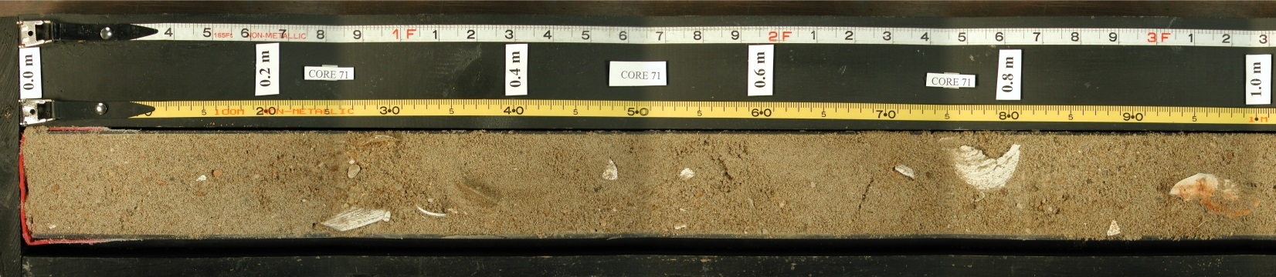
Figure 4.1. Panorama shot of an NJGWS core section.

Sample Core ID Labels Attachment 4a
(Using NJGWS Core XXX as an example)

CORE XXX  CORE XXX  CORE XXX  CORE XXX  CORE XXX  CORE XXX  CORE XXX | CORE XXX  CORE XXX  CORE XXX  CORE XXX  CORE XXX  CORE XXX  CORE XXX

NJGWS Sample Core Depth Labels Attachment 4b

0.0 m | 2.0 m | 4.0 m | 6.0 m
0.2 m | 2.2 m | 4.2 m | 6.2 m
0.4 m | 2.4 m | 4.4 m | 6.4 m
0.6 m | 2.6 m | 4.6 m | 6.6 m
0.8 m | 2.8 m | 4.8 m | 6.8 m
1.0 m | 3.0 m | 5.0 m | 7.0 m
1.2 m | 3.2 m | 5.2 m | 7.2 m
1.4 m | 3.4 m | 5.4 m | 7.4 m
1.6 m | 3.6 m | 5.6 m | 7.6 m
1.8 m | 3.8 m | 5.8 m | 7.8 m

Vibracore Processing Attachment 5

Protocol #3: Photographing core sections

Main Concept - Digital panoramic images of each five (5) foot core section and the component individual photos are one of the four (4) deliverables in the vibracore processing section of the contract. Photograph each five (5) foot core section in a series of images, with a field of view in each image of thirty-five (35) cm of core section along the meter measuring tape. Each thirty-five (35) cm digital image of core section must be of sufficiently high resolution that it is at least twelve (12) megapixels. To provide sufficient “stitching” area for merging photos, move the core twenty-five (25) cm for each successive image. We recommend moving the core, not the camera, so that the camera does not need to be re-leveled after each shot. If not re-leveled, the stitching will fail. We strongly recommend using a tripod over the core rack with an arm or seating that holds the camera with the lens facing down. You will need to be able to adjust the level of the camera in two directions where it attaches to the tripod. It is not necessary to use studio lamps with digital cameras. Light quality and quantity must be constant across all the images. Do not use flash, due to the reflective nature of the sediment. Use ambient light, not studio lights (ignore studio light set-up shown in Figure 5.1). It is imperative to use a remote tool to take the shot. Pushing the “shutter release” button on the camera creates camera movement and loss of level positioning. (See Figure 5.1 for example of NJGWS setup and equipment for core section photography.)

The “R” in CORE on the horizontal core ID labels is positioned at twenty-five (25) cm increments as a guide. One core section typically includes six (6) – eight (8) individual shots. With photo merging software, create a panoramic image which seamlessly captures the entire core section.

Required Equipment

- Digital SLR camera, minimum of twelve (12) megapixels, with an eighteen (18) – fifty (50) mm lens and a panorama shooting function;
- Camera tripod with capability to mount the camera with lens level and facing straight down to the core rack, with enough focal distance so that the image size is thirty-five (35) cm along the length of the core, and such that both tape measures and both the core-ID and core-depth labels are visible in the frame;
- Remote control shooting tool or cable for remote shooting; and
- Room with constant/controllable light source to establish uniform light quality and quantity in core photos.
Photographing Protocol

- Check that the core is level in the core rack; that is, that the flat surface you have cut and cleaned is level with the core rack and the table.
- Check that the camera is positioned such that the image size is thirty-five (35) cm, and so that the letter “R” in consecutive CORE XXX labels fits in the image stitching box on each end of the image. The distance between the “R”s is twenty-five (25) cm, and the total dimension of the image with the stitching boxes is about thirty-five (35) cm.

- After sizing the image correctly, check that the camera is level using a level in both directions of the image. This will properly align the images for stitching. If the camera is not level, and if the camera is not orthogonal (squared) with the core in the rack, the images will not stitch properly, and they will have to be photographed again.
- Take the series of photos for each core section in the rack, shooting down-core. For each consecutive photo, the “R” that was in the right hand stitching box is moved to the left hand stitching box. When you are shooting the end of the core section, include the red “shoe” in the image to show the end of the core section. Finish the first panorama group by starting the second panorama group when you shoot the second core section in the rack. Continue to “stitch” on the “R”s. That will take you across the red shoe boundary without having to shoot an interval of core twice. There will be a total of thirteen (13) to sixteen (16) images. When finished photographing the two (2) core sections, transfer the images to the computer and open the photo merging software.
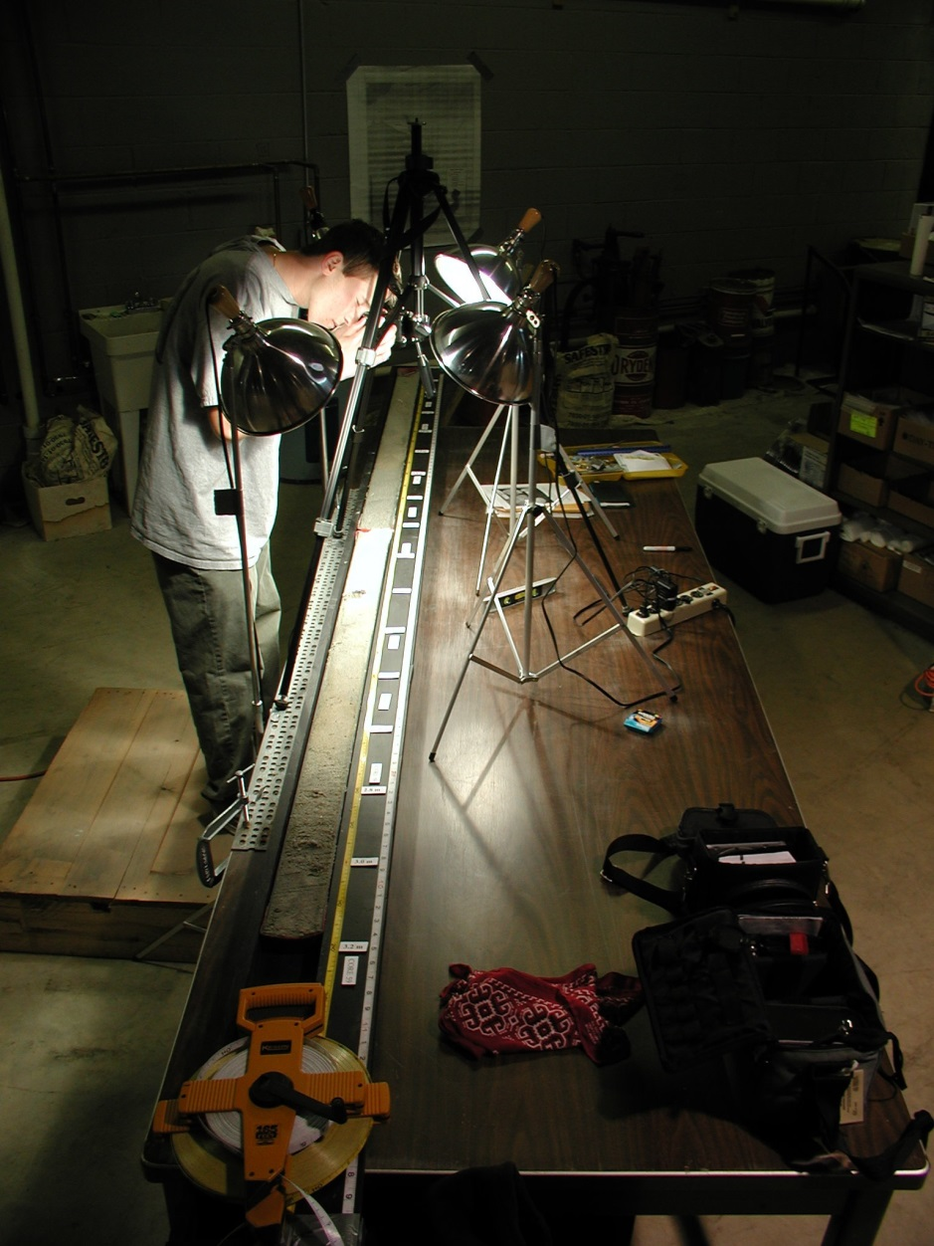
Figure 5.1. Example of NJGWS setup and equipment for core section photography.

- When working in the photo merging software, stitch together all the photos for the first core section, including the image that has the red “shoe”, and save the panoramic image with the following naming convention:

The first core section pan photo would be saved with the file names:
XXX0005.jpg
XXX0005.tiff
representing a .jpg and .tiff file for the core section from zero (0) – five (5) feet.

The second core section pan photo would be saved with the file names:
XXX0510.jpg
XXX0510.tiff
representing a .jpg and .tiff file for the core section from five (5) – ten (10) feet.

Proceed with the same naming convention to the end of the core:
XXX1015.jpg
XXX1015.tiff
and
XXX1520.jpg
XXX1520.tiff

It is not uncommon for the total length of the vibracore to be less than twenty (20) feet, and the actual depth will be marked on the deepest core section, as described in Protocol #1. Still use the XXX1520 name for the deepest core section pan photos.

For each core section, you may need to use the last image from the first pan for the first image in the second pan, etc. if the last image in a pan group shows more core beyond the “shoe” junction. You will need to check the overlap in consecutive images to make this determination.

Save all the merged image files in a folder named for the core, e.g. Core XXX

Create a sub-folder entitled “Individual Shots” in each core photo folder. Save .jpg and uncompressed .tiff files of all the individual shots and place them in that sub-folder. Information regarding the camera make and exposure data should be recorded and accessible at the properties information tab for each photo .jpg and photo .tiff file. (See Figure 5.2 for an example of panoramic photos of NJGWS Core 179.)

- QAQC – Upon completing the photographing of the first two (2) core sections (first half of first entire vibracore), submit the first group of photos, both merged and individual shots, to NJGWS personnel for a quality assurance review. If these images are approved by NJGWS personnel and represent accurately the quality of the work that will be done subsequently, the Contractor may proceed with the photographing. NJGWS reserves the right to conduct spot checks of photo quality for the duration of the contract. Poor quality photos will be returned for re-shooting.

- To prevent disruption, desiccation, and other damage that would negatively impact photo quality, core sections must be photographed within seventy-two (72) hours of being opened. If the cleaned surface has become dry, spray lightly with water before photographing. Avoid moistening the paper labels on the core rack.

- Build the digital panoramic shot for each core section while the core section is still open and unsampled, in case there are problems with the individual images or the pan shot. The image sequence may need to be re-photographed. Once there are satisfactory panoramic shots of the two (2) core sections, the core ID and core depth labels can be removed. Core depth labels should be saved for the next vibracore. Core ID labels will not be needed again, once the entire vibracore has been photographed to satisfaction.

- Keep the two (2) measuring tapes in place for accurate depth and thickness measurements during the lithologic description.

- Proceed to Protocol #4: Lithologic description of the core

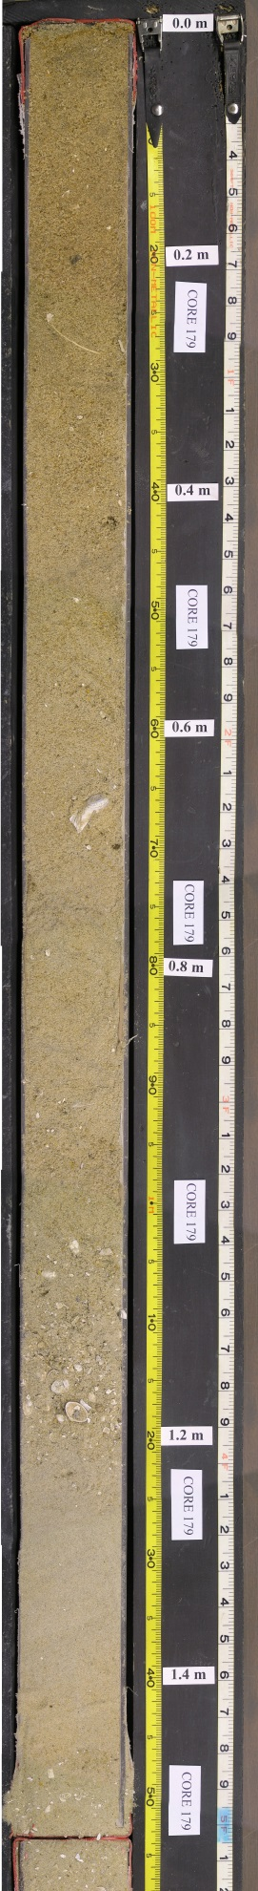 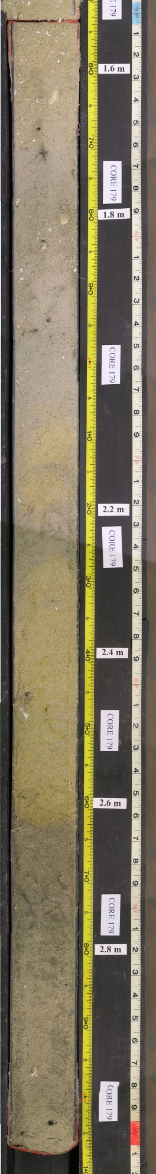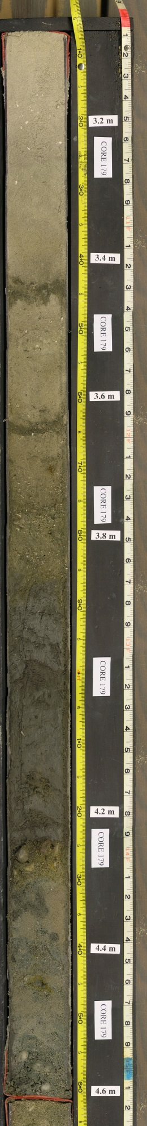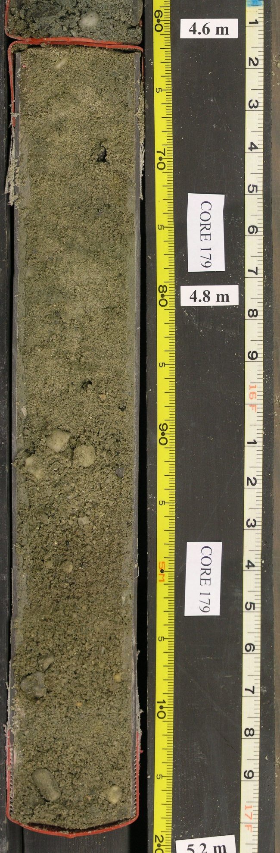
Vibracore Processing Attachment 6
Figure 5.2. Example of panoramic photographs of completed cores for NJGWS Core 179, with approved overlap. Photo on right is an enlarged image of the last section of Core 179.

Protocol #4: Lithologic description of the core

Main Concept – Completed lithological logs of all the vibracores, prepared on NJGWS lithologic log sheets, with proper sediment and feature symbols, is one of the four (4) deliverables of the vibracore processing segment of this contract. After opening two (2) core sections, cleaning the top surface, placing in the rack, and taking the photographs:

- There will be two (2) sections of core (typically). Look first at the entire length of core in the rack to get a sense of the lithologies and lithologic changes down-core.

- On a general scale, note the breaks in lithologies, or where you would distinguish different describable units. You may later change these calls based on closer examination; this is intended as a guide for your description.

- For the unit starting at the top of the uppermost core section, take a small sample with a laboratory spatula and look at it with the grain size chart and a hand lens. Look at the following features in this hand sample:

a. grain size (use the hand chart and train your eye to the relative sizes)
b. mineral content –
mostly quartz?
% other minerals? (or rock fragments)
% opaque minerals? (% glauconite, a major opaque in our samples)
any other mineral features that you notice
c. roundness of grains (angular – rounded)
d. color – match to a color in the Munsell Soil Color Chart
e. gravel content (and whether the gravel is dispersed or concentrated)
f. if silt/clay, determine which:
1. clay will ball or ribbon between your fingers, silt will not
2. taste test: a gritty texture indicates some silt content
g. if clay, look for mica, organics

Before recording this information on the lithologic log sheets, take several other hand samples from the unit and compare to what you noted in the first hand sample. If features a, b, c, and d are similar in your other hand samples, then you can record that data. On the other hand, if they are slightly different, incorporate their qualities into your description. If they are very different, designate a separate unit. NJGWS will provide paper log sheets for recording lithology. Indicate the total thickness of the unit by counting the proper depth on the log sheet and drawing a line with a ruler across the sheet at that depth to indicate the lithologic boundary. Also record the depth of the contact on the lithology log, near the scale margin. A lithologic symbol legend is included as Attachment 6a.

- When recording the color using the Munsell Soil Color Chart, note that color is not diagnostic, because it can be affected by secondary oxidation or moisture content. However, it can be helpful in understanding the history of the sediments. Also, over many cores, color characteristics of certain age sediments are significant.

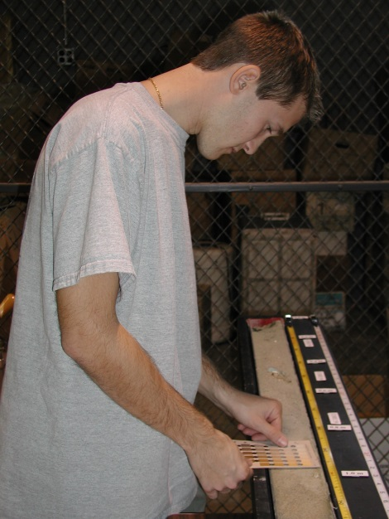
Figure 6.1. Matching the core sediment color with a soil color panel from the Munsell Soil Color Chart.

- Evaluate shell material, specifically their size, concentration, and condition. List by genera; include species if they are numerous and common. Identify shells by general occurrence in the sediment, not individually, unless the shell is large (> 2 inches diameter), unusual, or a very good specimen.

  - How big are they?
  - Are the shells whole or broken?
  - Are they articulated? (e.g. bivalves still together = died in situ).
  - Are they dispersed throughout a sand unit?
  - Are they clustered as a shell hash at the base or in a layer within a sand unit? (possible evidence of a storm event or sequence boundary.)
  - Do they look fresh or oxidized? (The oxidized shells (brown stain) indicate a sub-aerial setting.)

- Identify or note other organic material:

  - wood or peat fragments – record depth in core (in hundredths of meters, e.g. x.xx m; extract for age date if possible)
  - root structures – typically vertical in the core, very small, only found in inter-bedded silts, sands, and clays (back bay/lagoon environment)
  - the very rare bone fragment, or shark’s tooth
  - or any extracted organic material. Please wrap gently in foil and place in a zip-closing plastic sample bag, listing core number, depth of sample, date of sampling, and possible identification of organic material.

- Sedimentary structures: Though our cores are small in diameter, one can identify some structures including:

  - thin layers or laminae – if these repeat, they may indicate rhythmic bedding, cyclicity. These can appear arched up-core from distortion during coring.
  - mix of gravel and clay
  - thin layers or “streaks” of heavy-mineral concentrations
  - burrows, often evident between units where material from the upper unit infills the burrow into the lower unit. Note whether horizontal or vertical and depth and extent of prominent burrows.
  - coarsening upward or fining upward within a unit (does the sand size change within the unit?)
  - iron-staining on the sands or clays (reddish brown to yellow)
  - clasts of clay in sand (probably ripped up from underlying unit)
  - sand laminae (hard to see in our cores, but can indicate cross bedding; sometimes the heavy-mineral layers can show this too)
  - nature of the contacts between units – gradual or sharp, clay on sand, sand on sand, gravel on clay, etc.

- Note the depth of the bottom of the first two (2) sections. You will need to use this depth as your starting depth for the tape measures and core depth labels when you load the last two (2) core sections into the rack. Mark the depth of the end of the first two sections as EOS = X.XX. Refer to that for calibrating the depth of the next two (2) sections.

- Note the depth of the end of the core by writing “EOC = X.XX m” at the end of the lithologic record.

- Each lithologic description page should be initialed and dated by the qualified, experienced geologist described in the Scope of Work, Section 3.2. The initials indicate that person’s approval of, and responsibility for, the completed lithologic log.

- See Attachment 6a for listing of lithologic symbols and Attachment 6b for lithologic log sheets.

- Keep the two (2) measuring tapes in place for accurate measurement during the sampling for grain size analysis.

- QAQC – Upon completing the lithologic logging of the first two (2) core sections (first half of first entire vibracore), submit the log sheets for those core sections to NJGWS personnel for a quality assurance review. If these lithologic log sheets are approved by NJGWS personnel, and if they represent accurately the quality of the work that will be done subsequently, the Contractor may proceed with the lithologic logging of the remainder of the cores. NJGWS reserves the right to conduct periodic checks of lithologic log quality for the duration of the contract. Unsatisfactory log sheets will be returned and the Contractor will have to re-log the core sections and produce a satisfactory log sheet.

- Proceed to Protocol #5: Sampling core sections for grain size analysis

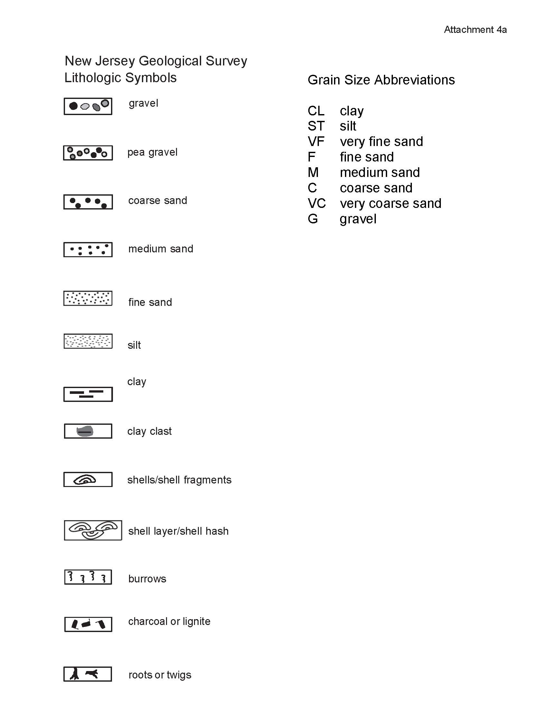
New Jersey Geological Survey
Lithological Symbols

Attachment 6a
Attachment 5a

Vibracore Processing Attachment 6b
NJGWS Core Logsheet

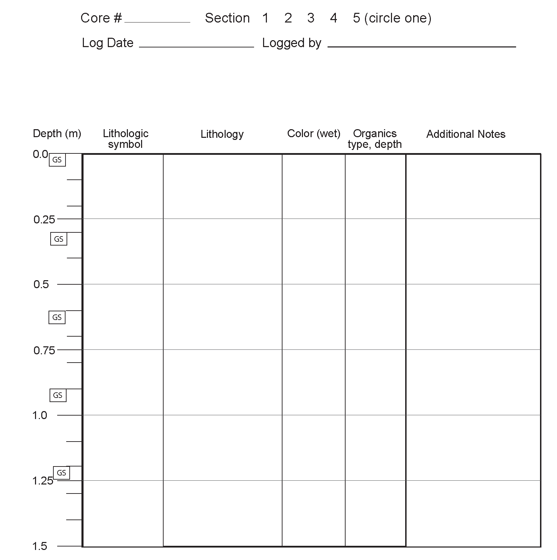

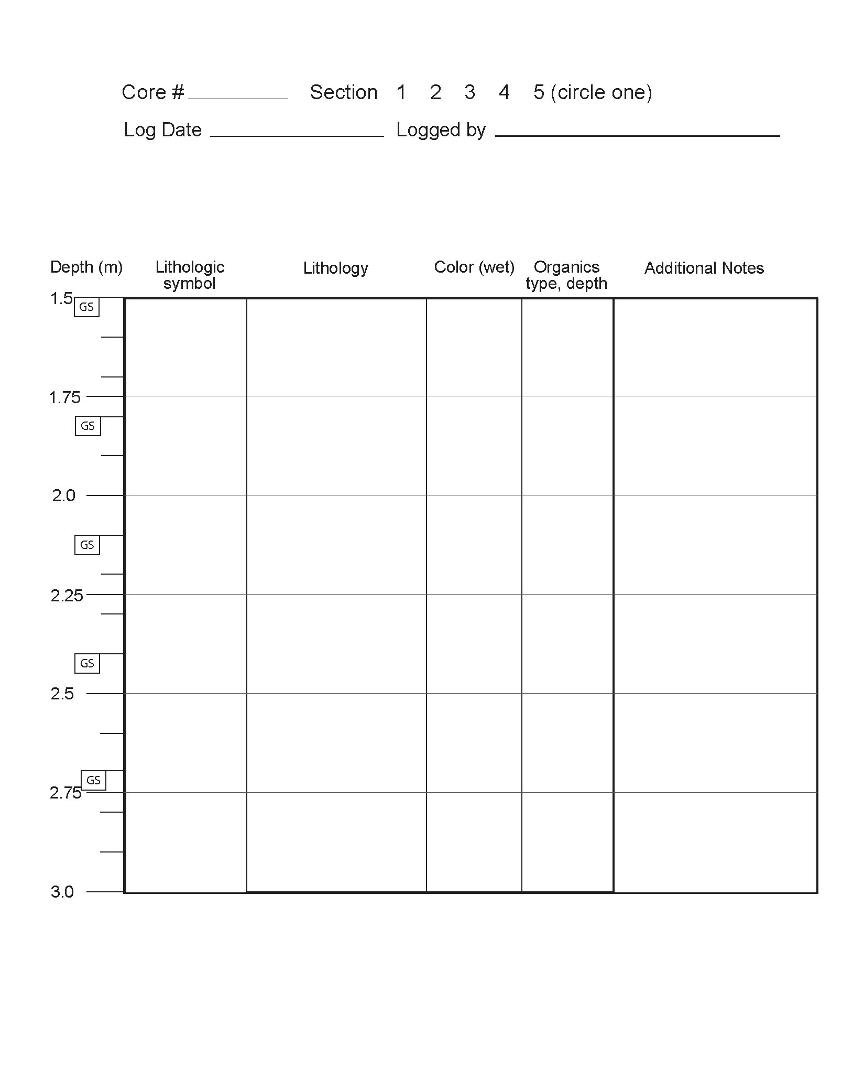

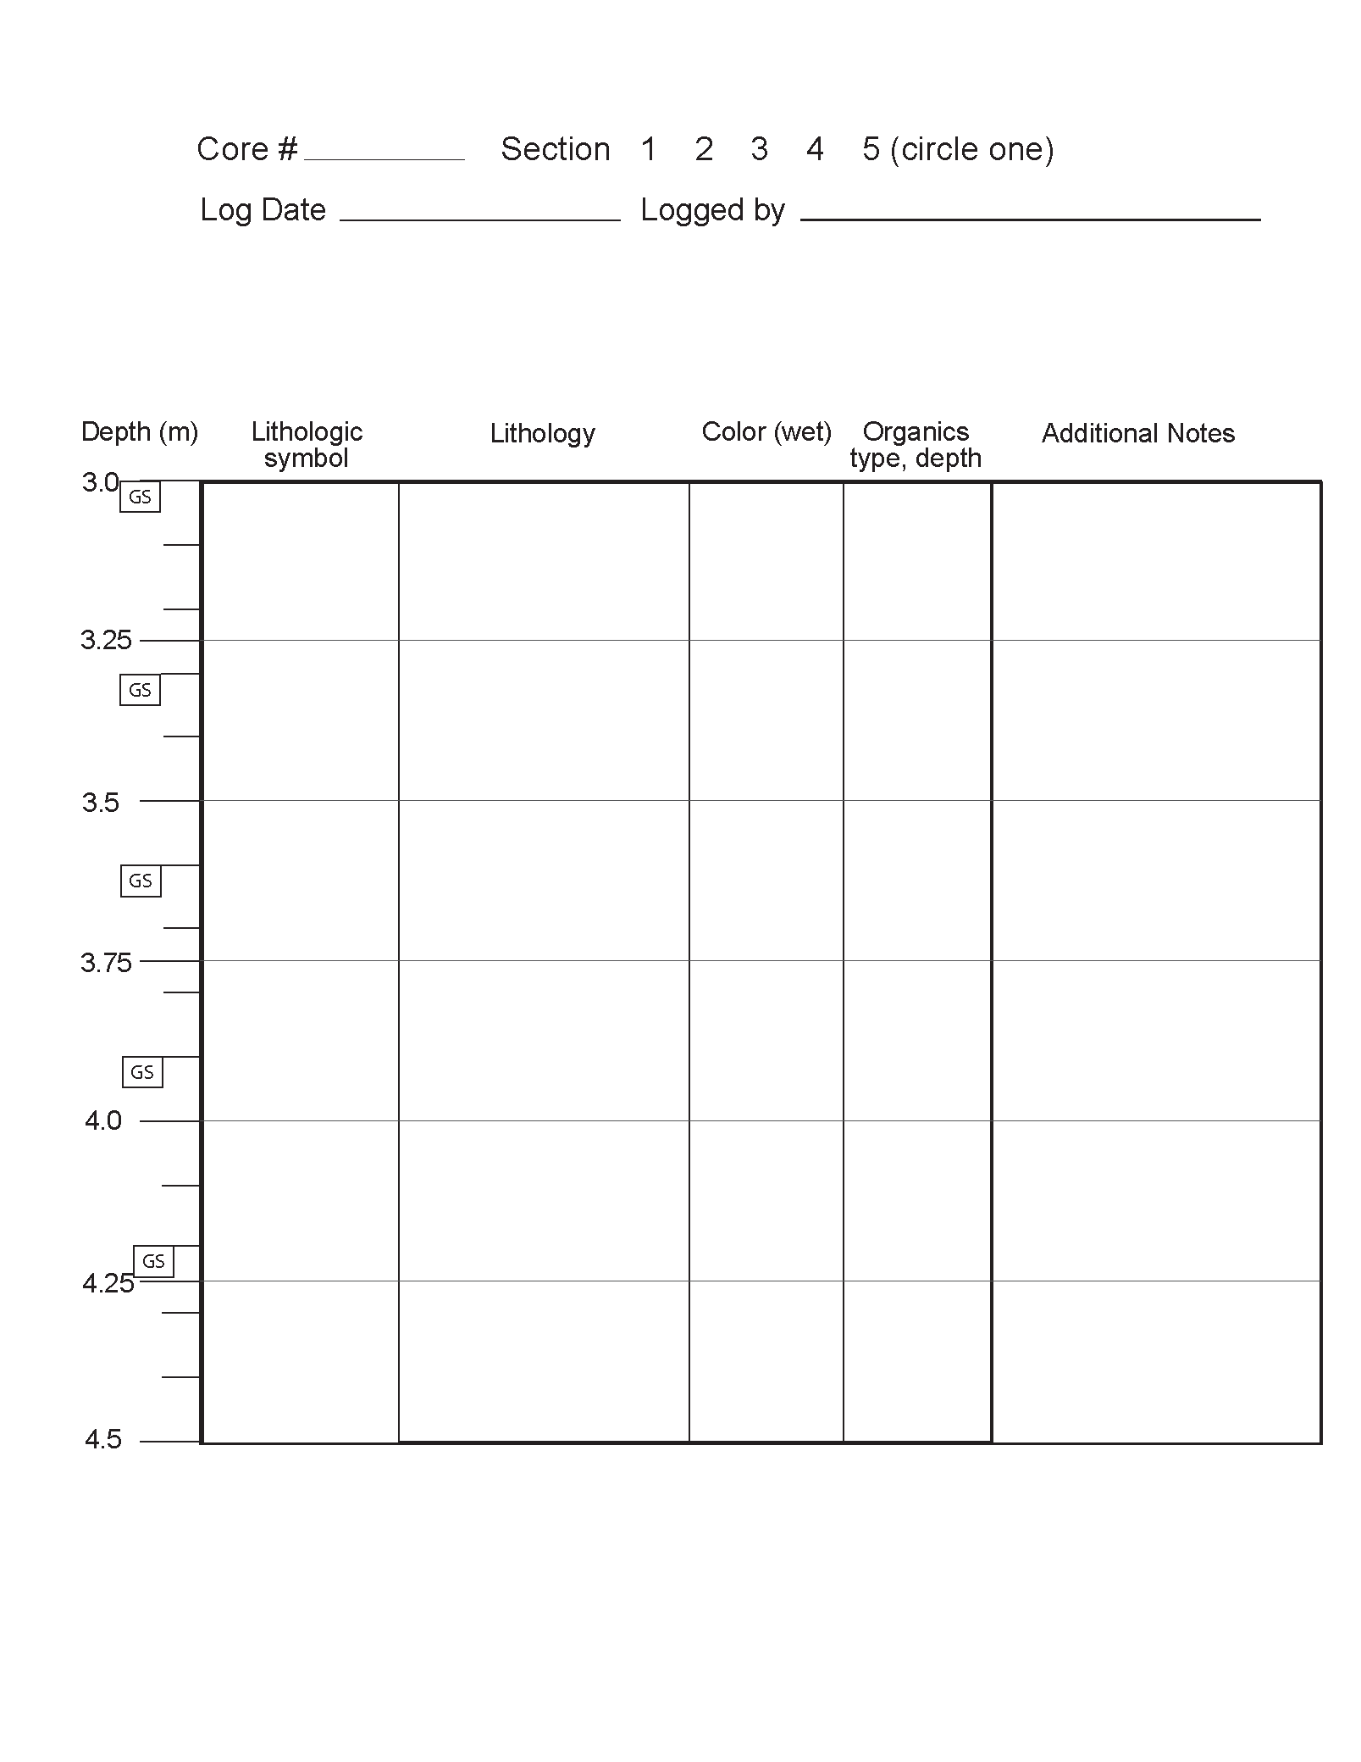

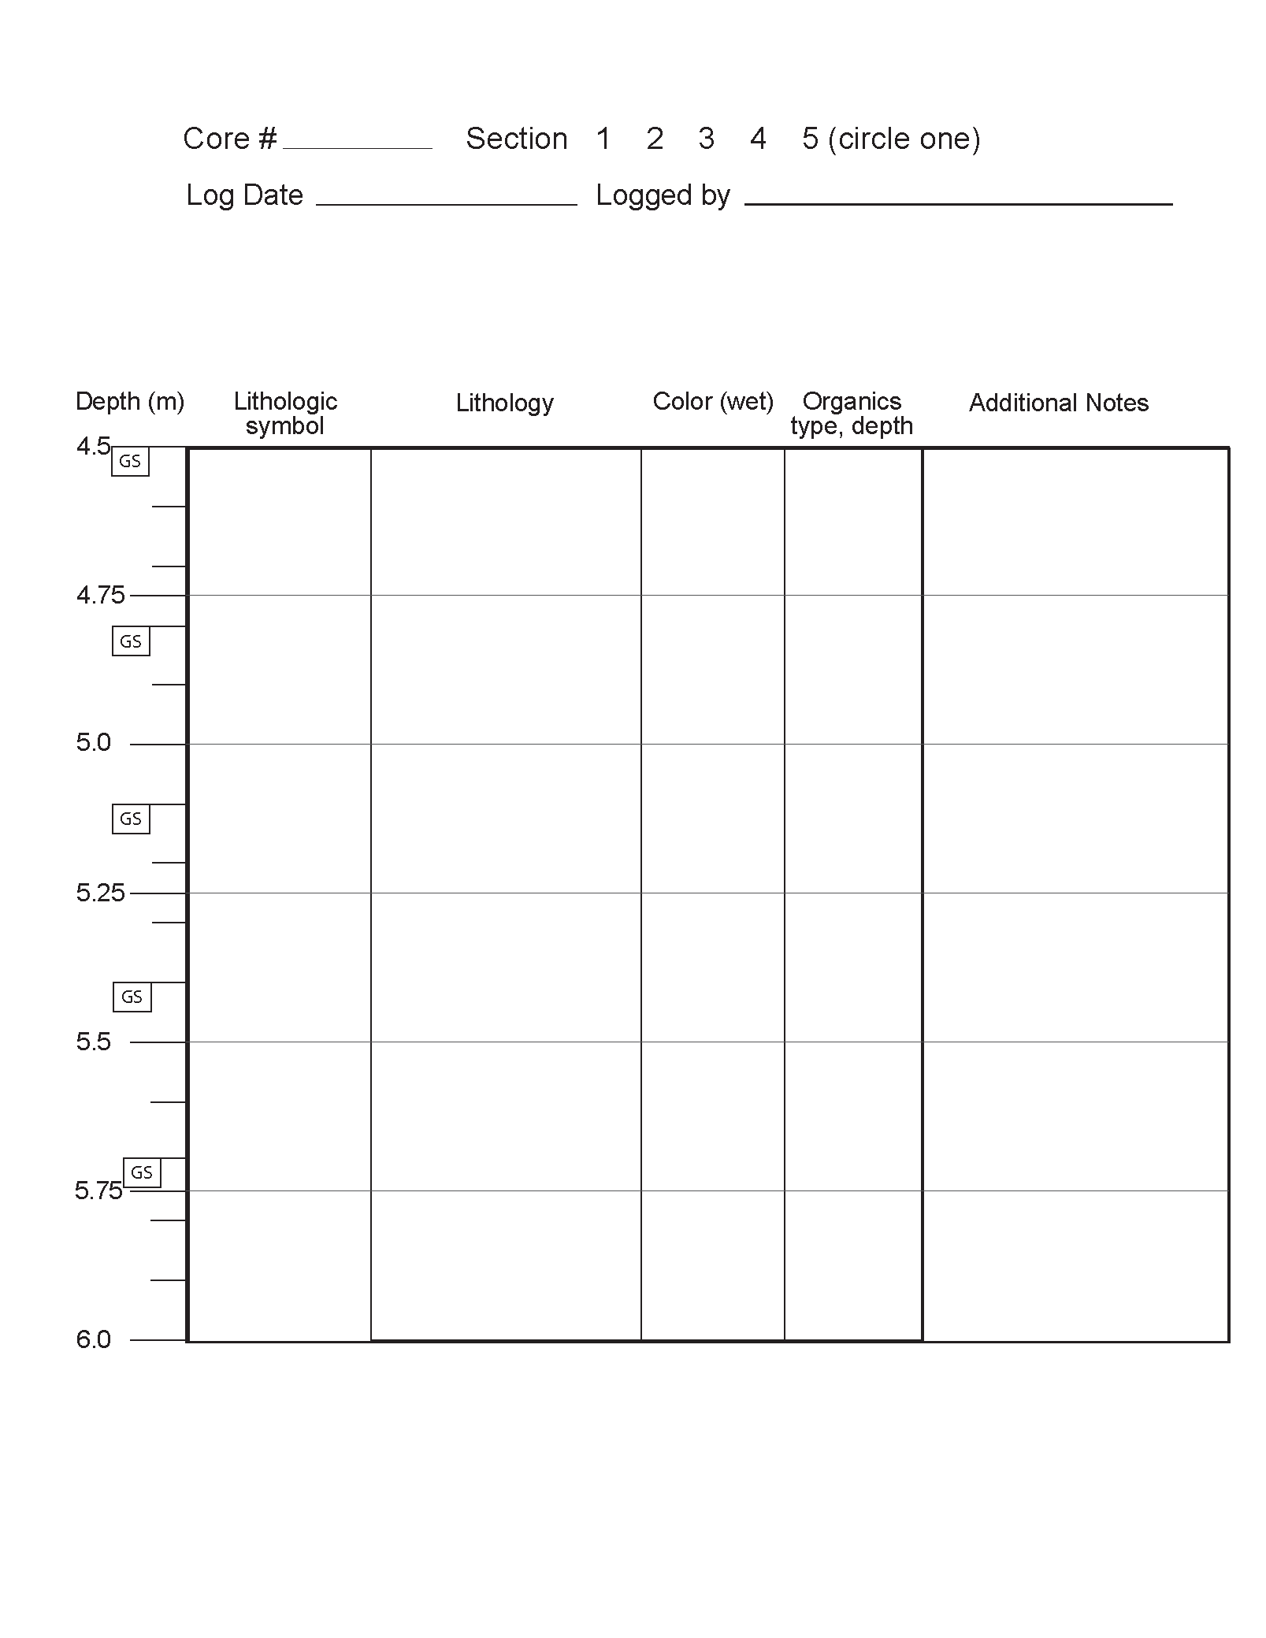

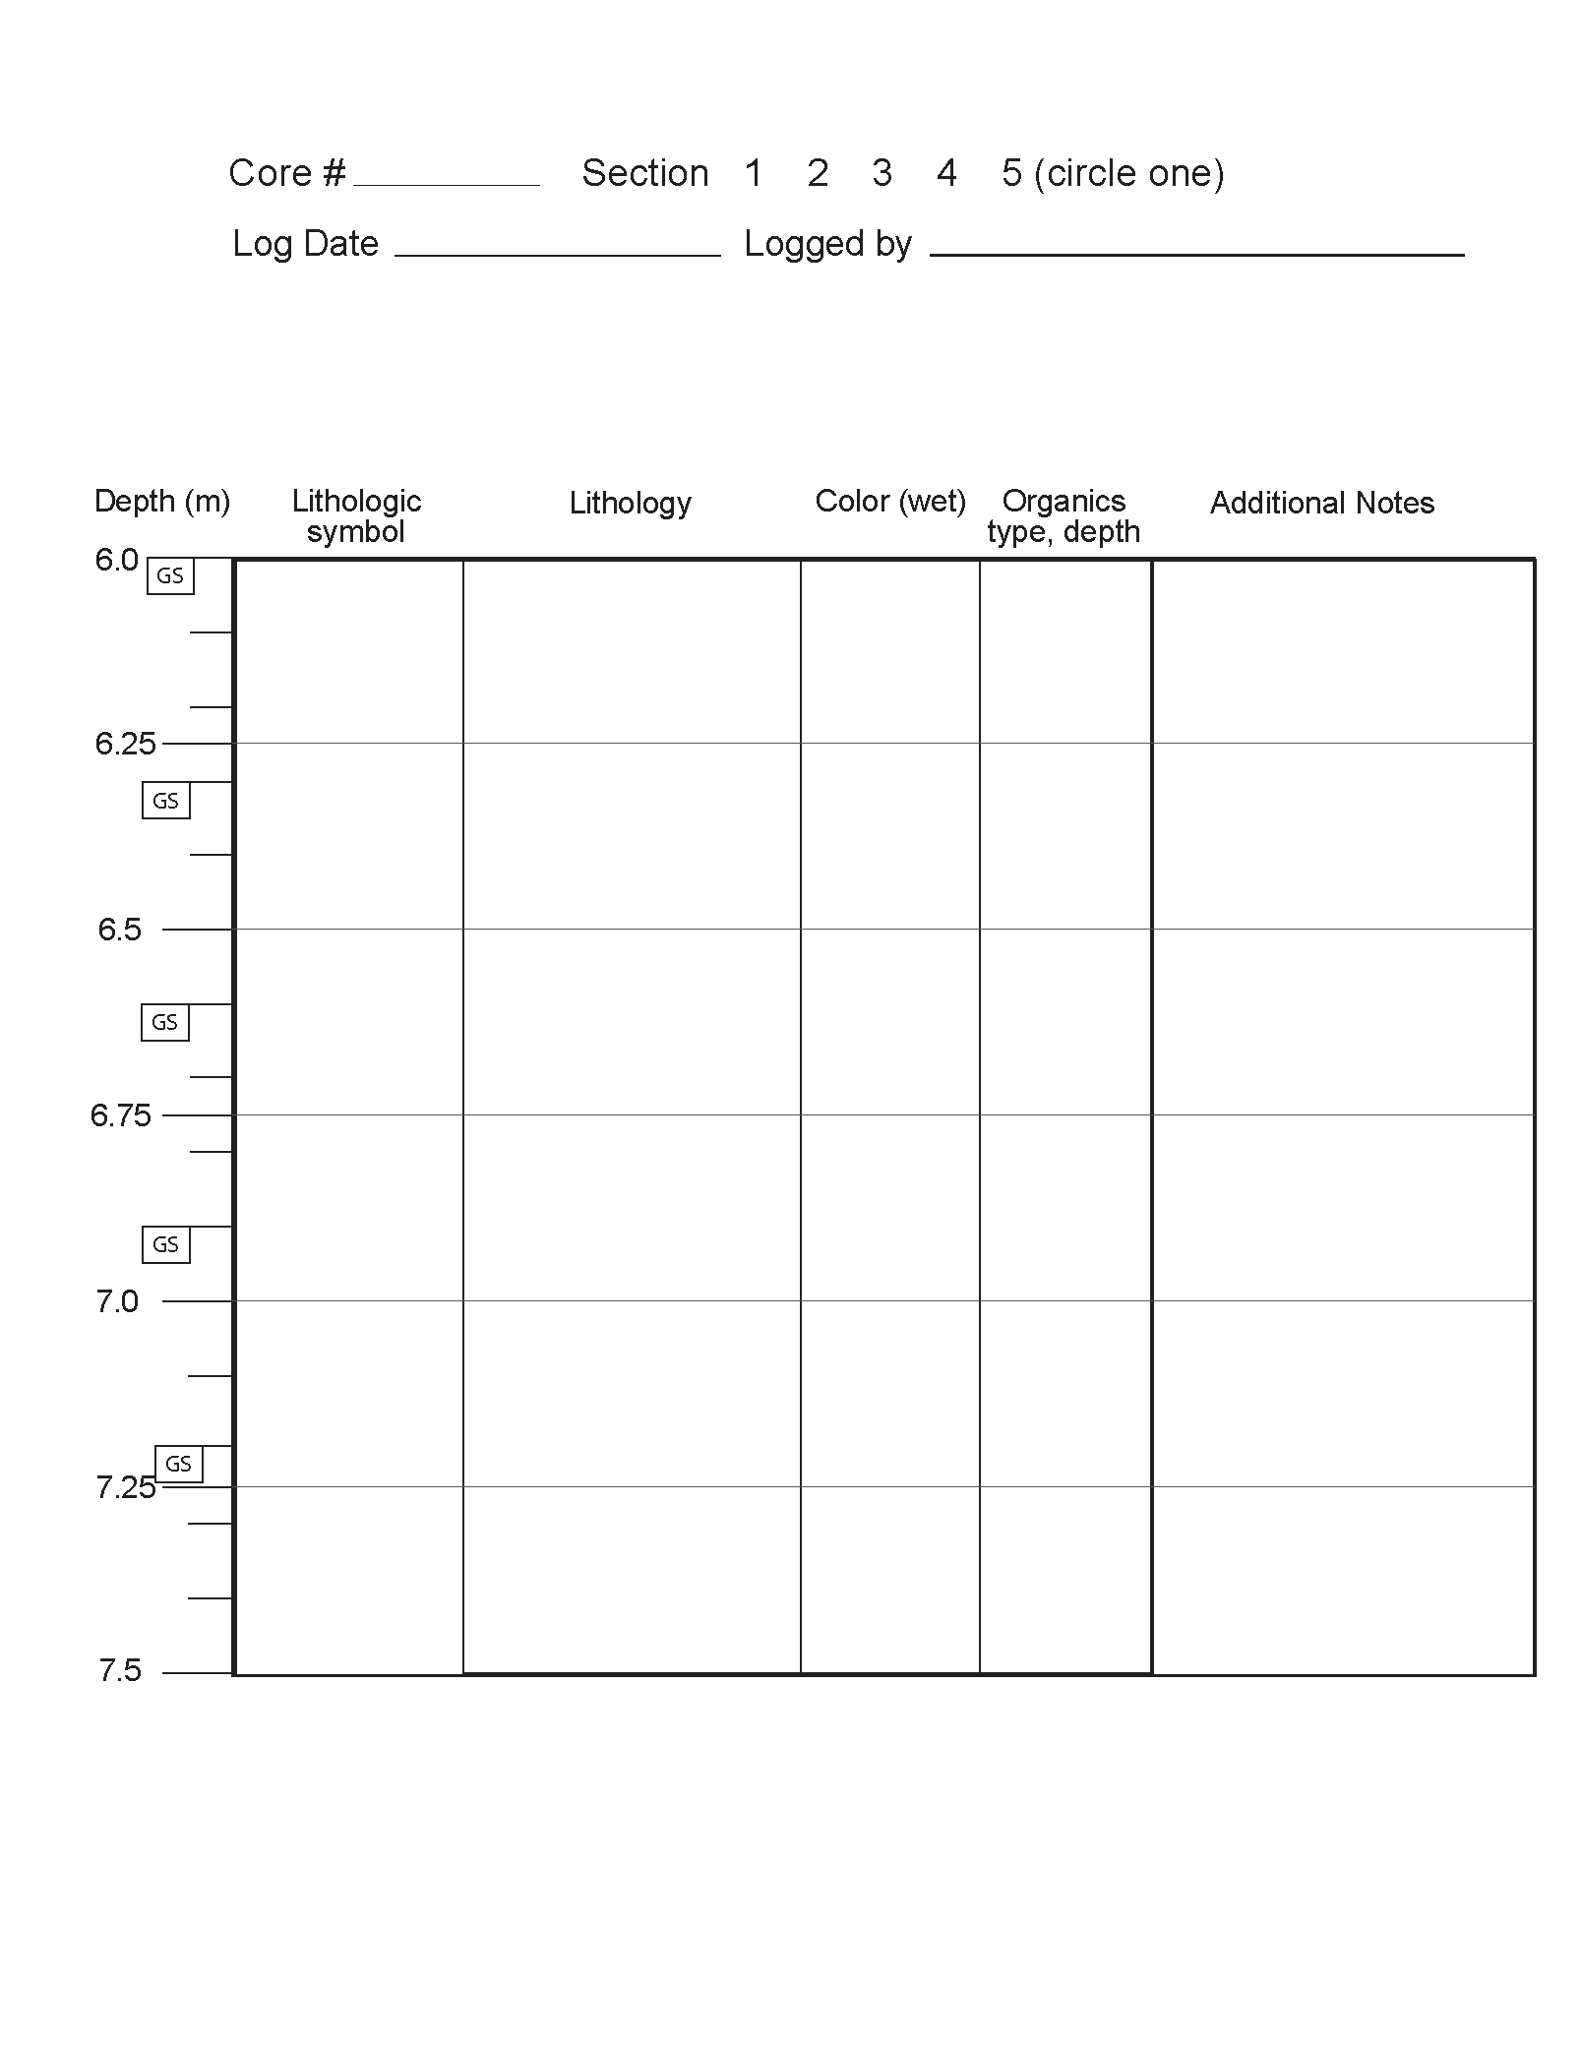

Vibracore Processing Attachment 7

Protocol #5: Sampling core sections for grain size analysis

Main Concept – Grain size samples (one hundred (100) – one hundred twenty (120) gm per sample) collected at thirty (30) cm intervals for all the vibracores is one of the required deliverables of this segment of this contract. Grain size samples will be collected every thirty (30) cm. At each 0.3 m increment, starting at 0.0 meters, make a mark and make another mark five (5) cm farther down. Using the center of the core as the inner boundary, sample a quarter-round of core or “quarter-core” between 0.0 and 0.05 m, 0.3 and 0.35 m, 0.6 and 0.65 m, etc. (See Figure 6.1 for example of sampling intervals from core section.)

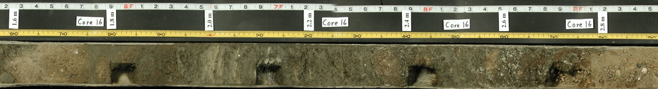
Figure 7.1. Example of sampling intervals from core section.

Accordingly, the sample is collected from 0.0 – 0.05 m, then from 0.3 - 0.35 m, from 0.6 - 0.65 m, etc. If the sample is located between core sections, collect from both sections over the five (5) cm interval. If the deepest sample (end of the core) is within five (5) cms of the next thirty (30) cm interval, sample the five (5) cm interval at the end of the core, indicating that the exact depth is different from the usual thirty (30) cm interval and that it was the end of the core.

- Preparation - Label bags with “NJGWS” followed by the four-digit year (YYYY), the core number, sample ID number based on depth in the core (e.g. XXX030 = core XXX sampled at the 0.30 - 0.35 interval), depth in the core, and date on which you are collecting the sample. Be sure that the label records a depth range of 0.05 m, not 0.5 m. (See Figure 7.2 for example of label.)

Example Bag Label

Project NJGWS YYYY
Core XXX
Sample # XXX000
Depth 0.00 – 0.05 m
Process date month/day/year
Figure 7.2. Example of NJGWS sample bag labels.

Samples must be taken after photos and lithologic descriptions have been recorded, with measuring tapes still in place.

- Collection

- Starting with the interval 0.00 - 0.05 m, remove half of the cut core (one quarter of the original cylindrical core). The sample should weigh between one hundred (100) and one hundred twenty (120) grams.

- Place the sediment in a six (6) x nine (9) inch, two (2) mil zip closing sample bag with a white label panel. Before sealing, remove as much air as possible from the bag.

- Sample five (5) cm sections every thirty (30) cm to the end of the core (0.00 – 0.05 m, 0.30 - 0.35 m, 0.60 - 0.65 m, etc.). Reading down the columns, core sample numbers will be in this sequence, based on the depth of the sample in cms:

Start
XXX000
XXX030
XXX060
XXX090
XXX120
XXX150
XXX180
XXX210
XXX240
XXX270
XXX300
XXX330
XXX360
XXX390
XXX420
XXX450
XXX480
XXX510
XXX540
XXX570
XXX600
XXX630
End

- For reference, the depth at which the grain size samples are collected is marked on the NJGWS lithologic log sheets.

- Unconsolidated sandy material will slump in the core when sampled. Please extract the required amount by weight, staying within the five (5) cm interval as much as possible.

- Sample inventory and custody - Place grain size samples in a storage box, in depth order. As each full vibracore is completed, inventory the number of grain size samples collected from the vibracore on the NJGWS digital spreadsheet, indicating the total depth of the core and the number of samples collected. Typically, a twenty (20) foot-deep core will have twenty (20) grain-size samples. As noted above, these samples are one of the required deliverables for this segment of this contract.

- QAQC – After collecting grain size samples from the first two core sections (first half of first entire core), submit the samples and the spreadsheet to NJGWS personnel for a quality assurance review. If these are approved by NJGWS personnel, and if they represent accurately the quality of the work that will be done subsequently, the Contractor may proceed with the sampling of the remainder of the cores. NJGWS reserves the right to conduct periodic checks of the sampling for the duration of the contract. If any subsequent sampling and sample inventory are not up to the standards outlined in the protocol, the Contractor will have to re-sample those core sections according to the protocol.

- Remove meter and feet tape measures after sampling for the two (2) core sections is completed.

- Proceed to Protocol #6: Wrapping core sections and returning to NJGWS

Vibracore Processing Attachment 8

Protocol #6: Wrapping core sections and returning to NJGWS

General Concept – The processed, wrapped and labeled core sections of all the vibracores, plus an inventory of all the sections, both sampled and archived, is one of the required deliverables of this segment of the contract. Core sections will be wrapped for storage in sturdy, two (2) mil plastic sheeting. Each core section requires a sheet that measures the length of the core section plus about twelve (12) inches (for a six (6) inch margin for secure closure at both ends), and the width of about one-and-a –half (1 ½) wraps around the half-cylinder, typically about eighteen (18) inches.

- Position the core section in the top half (in the width dimension) of the plastic sheet.
- Take the lower half (of the width dimension) and wrap it over the flat side of the half cylinder and tuck under the curve of the half-cylinder, all the way along the section.
- Pull the top half over the lower half all along the core section. Tuck the CORE XXX section ID label under the top flap of the plastic sheeting, such that it can be read easily on the flat surface through the plastic sheeting. Standard section ID labels are included in Attachment 7a.
- Secure the label by wrapping duct tape around the half-cylinder on both sides of the label.
- Secure the plastic sheeting at the ends of the core section by tucking the excess sheeting under the half-cylinder and wrapping tightly with duct tape at each end. (See Figure 7.1).
Figure 8.1. Wrapping and labelling core sections. Note core ID label placed under plastic edge at center of core section, plastic secured with duct tape in four places, ends of plastic secured with the duct tape several inches from the end of the core. The plastic sheeting is labeled with the core number at both ends of the core section.
- Store core sections horizontally on a pallet to prevent disruption of core contents. Core halves must be stacked cut side up, grouped by two (2) for each section. Do not stack core sections halves more than eight (8) high on the pallet. Group together all the core sections for each vibracore, both sampled and archived halves, for ease of inventory at the end of the work.
- QAQC – After completion of wrapping and labeling the first two (2) core sections (first half of first entire core), NJGWS personnel will evaluate the wrapping method as part of the initial quality assurance review. If approved, and if the core wrapping and labeling accurately represent the quality of the work that will be done subsequently, the Contractor may proceed with wrapping and labeling the remainder of the cores. NJGWS reserves the right to conduct spot checks of the wrapping for the duration of the contract. If any subsequent core wrapping is not up to the standards outlined in the protocol, the Contractor will re-wrap and label those core sections halves according to the protocol.

- The Contractor will transport the core section halves to the NJGWS facility located at 29 Arctic Parkway, Trenton, NJ, grouped by vibracore and arranged horizontally on palettes. The Contractor will stack no more than 6 section halves on top of each other to avoid slippage and damage to core halves in transit.

The Contractor will return the core sections from the twenty (20) to thirty (30) Vibracores. At the time of transfer of custody of the core sections, the Contractor and NJGWS will check the delivery against the original core section inventory to verify that all the listed core sections in the group of twenty (20) to thirty (30) vibracores have been returned in good order.
Vibracore Processing Attachment 8b
NJGWS Core Labels

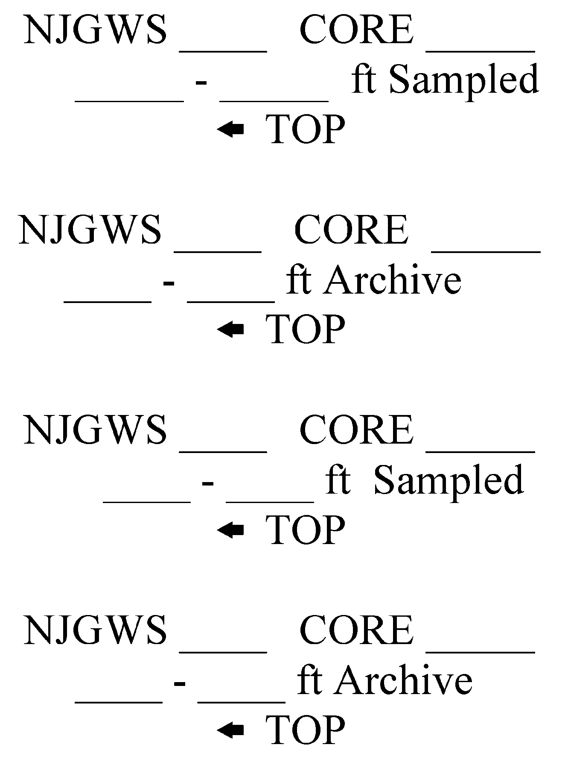
Grain Size Analysis Attachment 9

Protocol #1: Laboratory prep and sieve analysis of coarse-grained sediment samples

I. Preparing the Spreadsheet
Microsoft Excel® spreadsheets, one spreadsheet per core, will be provided ahead of time with the samples. Enter data into each spreadsheet in the course of performing the analysis, as indicated below. Upon completion of the analysis, save each spreadsheet and copy to a CD. Samples are labeled by core number (first three digits) and core depth (in centimeters, last three digits). For example, the Sample ID# from a depth of 3.6 meters in Core 146 would be 146360. All instructions related to inputting data to the spreadsheet are listed in purple.

See Attachment 12 for a blank sample of the spreadsheet, Core 999.xls.

II. Sizing into Coarse and Fine Fractions

A. Dispersion, a.k.a. Shaking (to disperse the aggregates of particles so that they will be sized as individual grains, as much as possible)

1. Tare the balance (accurate to four (4) decimals in grams) with a catch pan. Place a sub-sample of approximately one hundred (100) g of sediment in the catch pan. Record weight to four (4) decimal places as the “wet weight” in column F.

2. Remove any shell material that is > one (1) cm diameter, either by hand or by passing the sample through the top sieve in the stack (ASTM E11). Record approximate percentage by weight of the shell material in the Comments column (column DA). Set shell material aside for use in step B4.

3. Label a five hundred (500) ml Erlenmeyer flask with sample ID number. Transfer
sample into flask using funnel and brush or double distilled (d.d.) water squeeze bottle. Cover sample with d.d. water up to three hundred (300) ml line.

4. Add the deflocculant (sodium hexametaphosphate, in a concentration of fifty (50)
g/liter.) If the sample is coarse grained, add ten (10) ml of deflocculant. If the
sample is moderately clayey, add forty (40) ml of deflocculant. Generally, our
samples only require ten (10) ml of deflocculant. Record volume of deflocculant
added in column G. On clayey samples, the higher volume of deflocculant must
be recorded accurately in column G. Stopper the flask. Allow to soak for at least
sixteen (16) hours.

5. Repeat steps A1 through A4 to yield as many samples as you will be processing at a time.

6. Dispersion of coarse-grained sediment using a wrist-action shaker. Place the set of samples on the wrist action shaker for at least twenty (20) minutes. Because wet sieving must follow immediately after shaking, set shaker to shake continuously after the twenty (20) minute mark is reached, and remove one (1) flask at a time for wet sieving. Additional shaking will not damage samples.

7. Reset the balance to zero (0). For each sample, label a one hundred fifty (150) ml beaker and a sample pan. Weigh each beaker and each pan. Record empty beaker weights in column H. Record empty pan weights in column AU. Set beakers and pans aside for use in steps B4, B5.

B. Wet sieving (to separate the coarse from the fine fraction and recover a sample of the fine fraction)

Equipment and set-up:

a) sixty-three (63) micron (No. 230) sieve (reinforced if available), set in
b) a funnel large enough to be wider in diameter than the sieve, nestled in a
c) one thousand (1000) ml graduated cylinder (see Attachment 10, Figure 10.3)

1. Immediately after dispersion by shaking, remove flask from shaker. Remove stopper; rinse with d.d. water squeeze bottle over the sieve. Empty sample from flask onto sieve, using d.d. water squeeze bottle. Empty flask completely.

2. Wash sample on the sieve with additional d.d. water to remove any clay particles. All wash water and clay is to be captured in the one thousand (1000) ml cylinder below. Add water to bring water level in cylinder to one thousand (1000) ml mark. Do not exceed the one thousand (1000) ml mark. The material remaining on the sieve is the coarse fraction. The material passing into the cylinder is the fine fraction.

- Transfer coarse fraction. Place pre-weighed, pre-labeled one hundred fifty (150) ml beaker (from Step A6) on a catch tray. Using a d.d. water squeeze bottle, transfer sample from sieve into beaker. (Use minimum amount of water to avoid over-filling the beaker.) Wash contents of catch tray into beaker when finished. Let beaker stand for twenty (20) minutes. Decant the water to a level of approximately one (1) cm above the sample surface. Be careful not to lose sediment. If shell material was removed from the sample in step A2, add the shell material to beaker.

4. Transfer fine fraction. Plunge sixteen (16) strokes with plunger to mix the contents of the one thousand (1000) ml cylinder. Immediately insert pipette, extract twenty (20) ml of fluid from about the seven hundred (700) ml line on the cylinder. Release the fluid into a twenty-five (25) ml graduated cylinder to check for accurate amount of sample.

Transfer with d.d. water squeeze bottle to pre-weighed, pre-labeled sample pan (from Step A5). This extracted fluid represents 2% of the total fines that passed the No. 230 sieve.

5. Dry the samples. Place sample pan (containing fine fraction) and one hundred
fifty (150) ml beaker (containing coarse fraction) in oven at one hundred (100) degrees C. Allow to dry overnight. (See Attachment 11, Figure 11.4).

III. Dry-Sieving the Coarse Fraction

A. Weighing the fine fraction and the pre-sieving coarse fraction.
Remove beakers and sample pans from oven; allow to cool to handling temperature. Weigh with the balance. Enter coarse fraction weight in column I. Enter fine fraction weight in column AV. Dispose of fine fraction. It does not need to be returned to the NJGWS.

B. Dry Sieving.
1. With brush, transfer coarse fraction from beaker into top of a stack of eight (8)”
diameter sieves. The sieves are stacked fining down in 0.5-phi increments,
with a catch pan at the bottom, ranging from –3 phi to 4 phi. Half-height sieves
work well with this size of stack. (See Attachment 11, Figure 11. 5).

2. Set the stack of sieves carefully in the Ro-Tap mechanical shaker. Set timer
and run for ten (10) minutes. (See Attachment 11, Figure 11.6).

3. Label and weigh one sample pan per sieve. Label and weigh a sample pan for
the catch pan. Enter sample pan weights into the spreadsheet. See Section IV
for instructions regarding the way to enter these weights.

Transfer contents of each sieve and the catch pan into the appropriate sample
pan. To transfer sediment, invert sieve on glossy paper, banging firmly to
loosen trapped grains. Carefully pour and brush sediment into the appropriate
pan.

4. Weigh the sample pans with sediment for each phi fraction. Record weights in
appropriate columns (L, N, P, etc.) If there is no sediment in a phi fraction pan,
enter the pan weight for that specific pan, as determined in step B3.

5. Label a sample bag as follows:

sample number grain size
date

example:

158330 coarse
5/24/06

Pour the contents of each pan into the labeled sample bag for return to the NJGWS. (See Attachment 11, Figure 11.1).

6. Check that all data has been entered on the spreadsheet.
Copy spreadsheet to a CD for backup.

IV. Data Entry Guidelines/Warnings

Enter data in columns with blue titles.

In addition, for this contract, enter the weight of the sample pan for each coarse fraction sieve (by mesh size) in row 3 of the appropriate column. For instance, the weight of the sample pan for the –3 phi sieve fraction is entered in Cell L3, the –2.5 phi pan weight is entered in Cell O3, etc. Once weighed and recorded (and if not replaced with different collection pans) these pan weights will be constant for the duration of the testing contract. If collection pans are replaced during the analysis, new pans must be weighed and their weights recorded as described above.

Columns with red shaded titles are columns to monitor during sample analysis.
• Total Weight % (Column BT) and Mud Pan cum % (Column CK) should each always equal 100%
• If a sample contains shell material, note approximate percentage by volume in the Comments column (Column DA).

• Problems or notes regarding individual samples can be added in the
Comments column (Column DA).

V. Reporting Data

Grain size analysis results will be recorded and reported in the following two formats:

1. The completed NJGWS spreadsheets for each core shall be compiled on a CD.
Also, the spreadsheets will be sent to the NJGWS by email in sub-groups of samples
from two (2) cores at a time as they are completed.

2. A cumulative particle size plot for each sample, in digital format, shall be
prepared according to ASTM standard D2487 and generated from the cumulative
weight percent data on the completed NJGWS spreadsheet.

If problems or questions arise, please contact the New Jersey Geological and Water Survey immediately.

Grain Size Analysis Attachment 10

Protocol #2: Laboratory prep and sieve analysis of fine-grained sediment samples

I. Preparing the Spreadsheet
Microsoft Excel® spreadsheets, one (1) spreadsheet per core, will be provided ahead of time with the samples. Enter data into each spreadsheet in the course of performing the analysis, as indicated below. Upon completion of the analysis, save each spreadsheet and copy to a CD. Samples are labeled by core number (first three (3) digits) and core depth (in centimeters, last three (3) digits). For example, the Sample ID# from a depth of 3.6 meters in Core 146 would be 146360. All instructions related to inputting data to the spreadsheet are listed in purple.

See Attachment 12 for a blank sample of the spreadsheet, Core 999.xls.

II. Sizing into Coarse and Fine Fractions

A. Dispersion, a.k.a. Shaking (to disperse the aggregates of clay-size particles so that they will be sized as individual grains, as much as possible)

  - Tare the balance (accurate to four (4) decimals in grams) with a catch pan.
Place a sub-sample of approximately one hundred (100) g of sediment in the catch pan. Record weight to four (4) decimal places as the “wet weight” in column F.

  - Remove any shell material that is > one (1) cm in diameter, either by hand or by passing the sample through the top sieve in the stack (ASTM E11). Record approximate percentage by weight of the shell material in the Comments column (column DA). Set shell material aside for use in step B4.

  - Label a five hundred (500) ml Erlenmeyer flask or a five hundred (500) ml beaker with Sample ID number. Transfer sample into flask or beaker using a funnel and brush or double distilled (d.d.) water squeeze bottle. Cover sample with d.d. water up to three hundred (300) ml line.

4. Add the deflocculant (sodium hexametaphosphate, in a concentration of fifty
(50) g/liter). For clayey samples, add forty (40) ml of deflocculant. If sample is
extremely clayey, add eighty (80) ml of deflocculant. Record volume of
deflocculant added in column G. On clayey samples, the higher volume of
deflocculant must be recorded accurately in column G. Stopper the flask or
cover the beaker. Allow to soak for at least sixteen (16) hours.

5. Repeat steps A1 through A4 to yield as many samples as you will be
processing at a time.

6. Reset the balance to zero (0). For each sample, label a one hundred fifty
(150) ml beaker and a sample pan. Weigh each beaker and each pan. Record
empty beaker weights in column H. Record empty pan weights in column AU.
Set beakers and pans aside for use in step B4, B5.

7. Dispersion of fine-grained sediment using a high-speed mechanical stirrer. At the end of the soaking period, disperse the sample further, using a mechanical stirring apparatus (a.k.a. Apparatus A in ASTM Standard D-422). Transfer the sediment-water slurry from the flask (or beaker) into the special dispersion cup, washing any residue from the flask into the cup with double distilled water. A wash-water bottle works well for rinsing the residue from the flask (or beaker) to the cup. Add double distilled water if necessary until the cup is more than half full. Stir for a period of one (1) minute. The sediment must be sufficiently dispersed so that the sample can be completely wet-sieved. Wet sieving must follow immediately after stirring.

B. Wet sieving (to separate the coarse from the fine fraction and recover a sample of the fine fraction)

Equipment and set-up:

a) sixty-three (63) micron (No. 230) sieve (reinforced if available), set in
b) a funnel large enough to be wider in diameter than the sieve, nestled in a
c) one thousand (1000) ml graduated cylinder (see Attachment 10, Figure 10.3).

1. Immediately after dispersion of the sample, transfer the suspension to the sixty-
three (63) micron (No. 230) sieve (reinforced, if available) set in the large funnel and
rinse with a d.d. water squeeze bottle over the sieve. Empty cup completely.

2. Wash sample on the sieve with additional d.d. water to remove any clay particles.
All wash water and clay is to be captured in the one thousand (1000) ml cylinder
below. Add water to bring water level in cylinder to one thousand (1000) ml mark.
Do not exceed the one thousand (1000) ml mark. The material remaining on the
sieve is the coarse fraction. That passing into the cylinder is the fine fraction.

- Transfer coarse fraction. Place pre-weighed, pre-labeled one hundred fifty (150) ml beaker (from Step A6) on a catch tray. Using a d.d. water squeeze bottle, transfer sample from sieve into beaker. (Use minimum amount of water to avoid over-filling the beaker.) Wash contents of catch tray into beaker when finished. Let beaker stand for twenty (20) minutes. Decant the water to a level of approximately one (1) cm above the sample surface. Be careful not to lose sediment. If shell material was removed from the sample in Step A2, add the shell material to beaker.

4. Transfer fine fraction. Plunge sixteen (16) strokes with plunger to mix the contents
of the one thousand (1000) ml cylinder. Immediately insert pipette, extract twenty
(20) ml of fluid from about the seven hundred (700) ml line on the cylinder. Release
the fluid into a twenty-five (25) ml graduated cylinder to check for accurate amount of
sample.

Transfer with d.d. water squeeze bottle to pre-weighed, pre-labeled sample pan (from Step A5). This extracted fluid represents two (2)% of the total fines that passed the No. 230 sieve.

5. Dry the samples. Place sample pan (containing fine fraction) and one
hundred fifty (150) ml beaker (containing coarse fraction) in oven at one hundred (100) degrees C. Allow to dry overnight. (See Attachment 11, Figure 11.4).

III. Dry-Sieving the Coarse Fraction

Weighing the fine fraction and the pre-sieving coarse fraction.
Remove beakers and sample pans from oven; allow to cool to handling temperature.
Weigh with the balance. Enter coarse fraction weight in column I. Enter fine fraction
weight in column AV. Dispose of fine fraction. It does not need to be returned to
NJGWS.

Dry Sieving

1. With brush, transfer coarse fraction from beaker into top of a stack of 8”
diameter sieves. The sieves are stacked fining down in 0.5-phi increments, with a
catch pan at the bottom, ranging from –3 phi to 4 phi. Half-height sieves work well with
this size of stack. (See Attachment 11, Figure 11.5).

2. Set the stack of sieves carefully in the Ro-Tap mechanical shaker. Set timer
and run for ten (10) minutes.

3. Label and weigh one (1) sample pan per sieve. Label and weigh a sample pan for
the catch pan. Enter sample pan weights into the spreadsheet. See Section IV for
instructions regarding the way to enter these weights.

Transfer contents of each sieve and the catch pan into the appropriate sample pan.
To transfer sediment, invert sieve on glossy paper, banging firmly to loosen
trapped grains. Carefully pour and brush sediment into the appropriate pan.

4. Weigh the sample pans with sediment for each phi fraction. Record weights in
appropriate columns (L, N, P, etc.) If there is no sediment in a phi fraction pan, enter
the pan weight for that specific pan, as determined in step B3.

5. Label a sample bag as follows:

sample number grain size
date

example:

158330 fine 5/24/06

Pour the contents of each pan into the labeled sample bag for return to the
NJGWS. (See Attachment 11, Figure 11.1).

6. Check that all data has been entered on the spreadsheet. Copy spreadsheet to a
CD for backup.

IV. Data Entry Guidelines/Warnings

Enter data in columns with blue titles.

In addition, for this segment of this contract, enter the weight of the sample pan for each coarse fraction sieve (by mesh size) in row three (3) of the appropriate column. For instance, the weight of the sample pan for the –3 phi sieve fraction is entered in Cell L3, the –2.5 phi pan weight is entered in Cell O3, etc. Once weighed and recorded (and if not replaced with different collection pans) these pan weights will be constant for the duration of the testing contract (eighty (80)+ samples). If collection pans are replaced during the analysis, new pans must be weighed and their weights recorded as described above.

Columns with red shaded titles are columns to monitor during sample analysis.
- Total Weight % (Column BT) and Mud Pan cum % (Column CK) should each always equal one hundred (100)%.
- If a sample contains shell material, note approximate percentage by volume in the Comments column (Column DA).
- Problems or notes regarding individual samples can be added in the Comments column (Column DA).
V. Reporting Data

Grain size analysis results will be recorded and reported in the following two formats:

1. The completed NJGWS spreadsheet for each core compiled on a CD. Also, the
spreadsheets will be sent to NJGWS by email in sub-groups of samples from two (2)
cores at a time as they are completed.

2. A cumulative particle size plot for each sample, in digital format, prepared according
to ASTM standard D2487, and generated from the cumulative weight percent data on the
completed NJGWS spreadsheet.

If problems or questions arise, please contact the New Jersey Geological and Water Survey immediately.

Grain Size Analysis Attachment 11

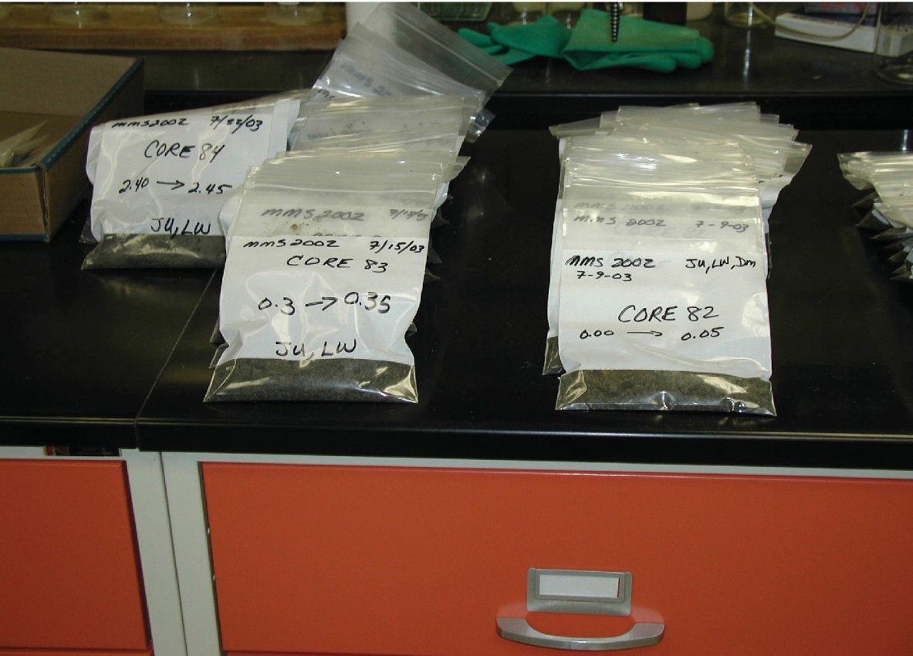
Figure 11.1. Sediment samples, approximately one hundred (100)+ grams
of sand, gravel, silt, and/or clay.

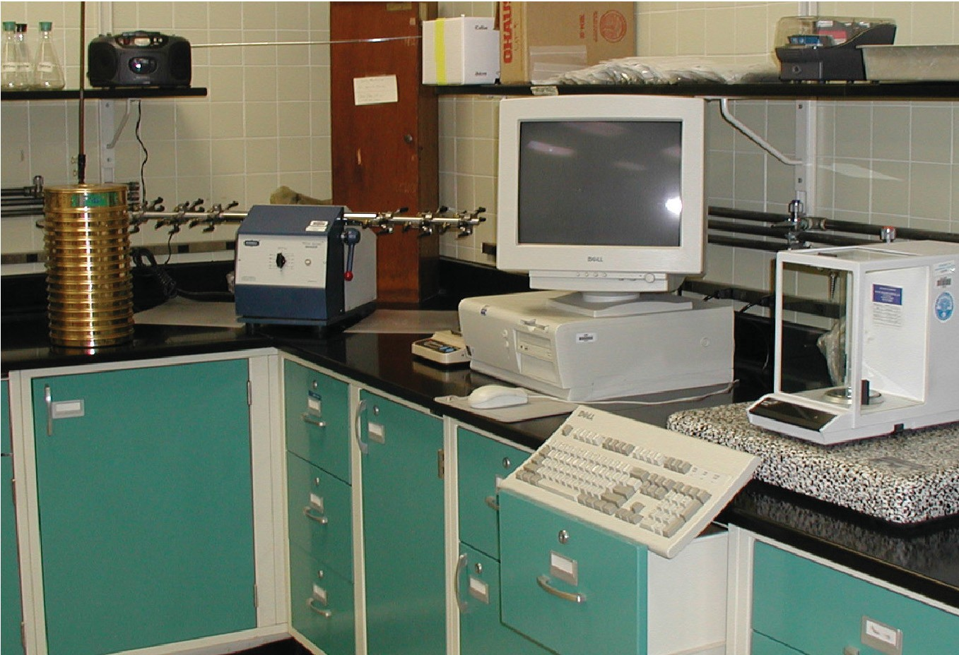
Figure 11.2. Equipment used in the grain size analysis, including the sieve stack, wrist-action shaker, balance, and computer.

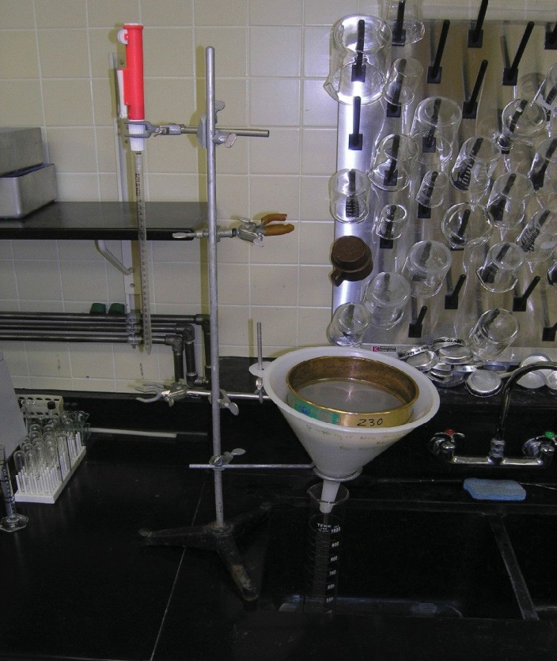
Figure 11.3. Wet-sieving apparatus, including reinforced
No 230 sieve set in funnel in 1000 ml graduated cylinder.
Pipette at left used for extracting the 20 ml water sample
containing suspended fines from the water.

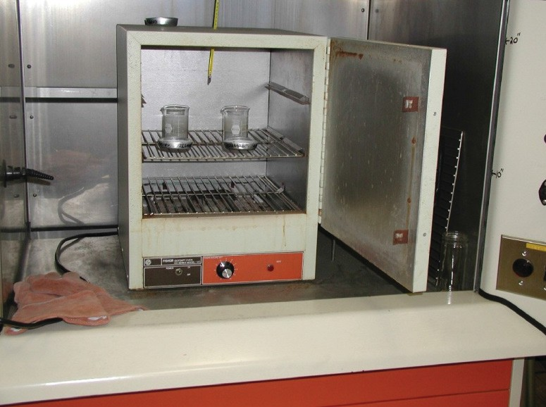
Figure 11.4. Drying the samples: sample pan (containing fine fraction) and 150 ml beaker (containing coarse fraction) in oven at 100 degrees C.

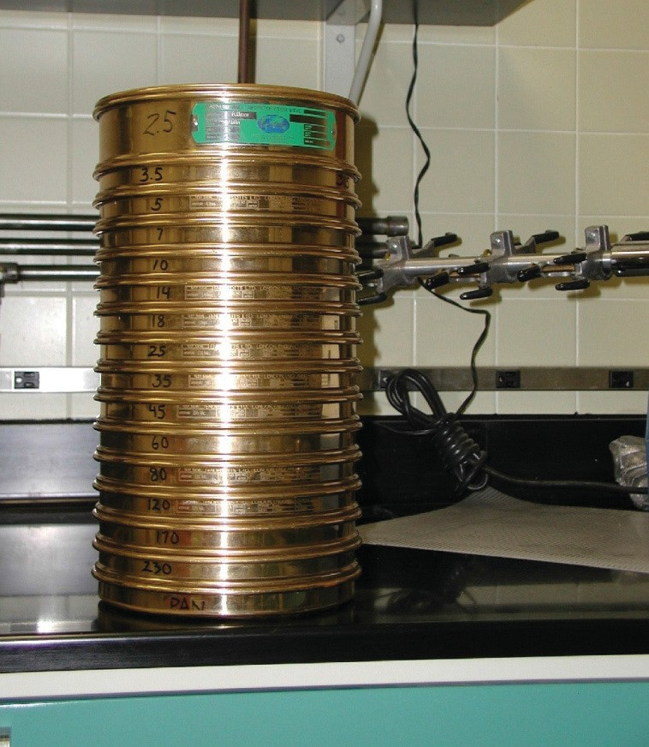
Figure 11.5. Sieve stack: 15 sieves, 0.5-phi increments,
From -3 phi to +4 phi, with catch pan at the base.

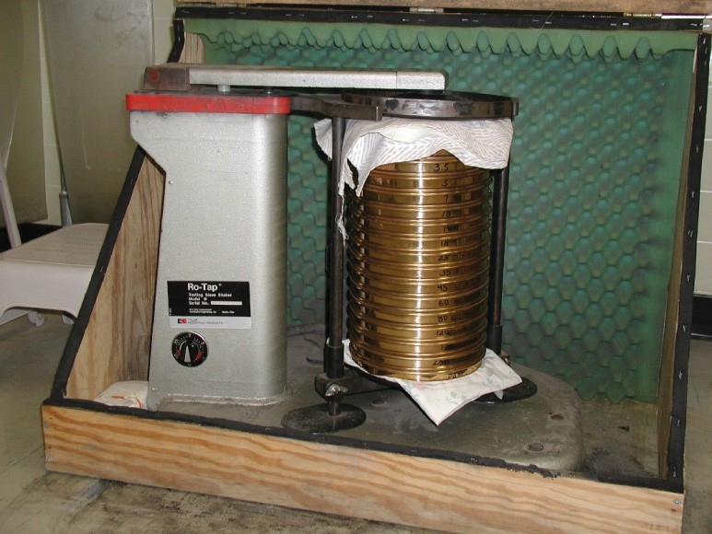
Figure 11.6. Sieves loaded in mechanical shaker.
Grain Size Analysis Attachment 12

NJGS Core Grain Size Analysis Core 999.xls
Core Number: 999
Analysis Date: 9/9/2009

Created by: Michael Schumacher
Sample Prep Sample Prep
Analysis Date | Core # | Sample Interval (m) | Sample # | Wet Weight | Deflocculant (mL) | Empty beaker weight | Beaker and Sample weight
9/9/2009 999 0 -0.05 999000
9/9/2009 999 0.3 -0.35 999030

9/9/2009 | 999 | 0.6 -0.65 | 999060
9/9/2009 | 999 | 0.9 -0.95 | 999090
9/9/2009 | 999 | 1.2 -1.25 | 999120
9/9/2009 | 999 | 1.5 -1.55 | 999150
9/9/2009 | 999 | 1.8 -1.85 | 999180
9/9/2009 | 999 | 2.1 -2.15 | 999210
9/9/2009 | 999 | 2.4 -2.45 | 999240
9/9/2009 | 999 | 2.7 -2.75 | 999270
9/9/2009 | 999 | 3 -3.05 | 999300
9/9/2009 | 999 | 3.3 -3.35 | 999330
9/9/2009 | 999 | 3.6 -3.65 | 999360
9/9/2009 | 999 | 3.9 -3.95 | 999390
9/9/2009 | 999 | 4.2 -4.25 | 999420
9/9/2009 | 999 | 4.5 -4.55 | 999450
9/9/2009 | 999 | 4.8 -4.85 | 999480
9/9/2009 | 999 | 5.1 -5.15 | 999510
9/9/2009 | 999 | 5.4 -5.45 | 999540
9/9/2009 | 999 | 5.7 -5.75 | 999570
9/9/2009 | 999 | 6 -6.05 | 999600

49

Coarse Fraction
 | #2.5 pan weight (g) |  | #3.5 pan weight (g) |  | #5 pan weight (g) |  | #7 pan weight (g) |  | #10 pan weight (g) |  | #14 pan weight (g)
 | 0.0000 |  | 0.0000 |  | 0.0000 |  | 0.0000 |  | 0.0000 |  | 0.0000
Pre-sieve total | Gravel Gravel  #2.5 mesh #2.5 mesh phi -3.0 phi -3.0  Weight Fraction |  | Gravel Gravel  #3.5 mesh #3.5 mesh phi -2.5 phi -2.5  Weight Fraction |  | Gravel Gravel  #5 mesh #5 mesh phi -2.0 phi -2.0  Weight Fraction |  | Gravel Gravel  #7 mesh #7 mesh phi -1.5 phi -1.5  Weight Fraction |  | Gravel Gravel  #10 mesh #10 mesh phi -1.0 phi -1.0  Weight Fraction |  | V. Coarse V. Coarse  #14 mesh #14 mesh phi -0.5 phi -0.5  Weight Fraction
0.0000 0.0000 0.0000 0.0000 0.0000 0.0000 0.0000
0.0000 0.0000 0.0000 0.0000 0.0000 0.0000 0.0000
0.0000 0.0000 0.0000 0.0000 0.0000 0.0000 0.0000
0.0000 0.0000 0.0000 0.0000 0.0000 0.0000 0.0000
0.0000 0.0000 0.0000 0.0000 0.0000 0.0000 0.0000
0.0000 0.0000 0.0000 0.0000 0.0000 0.0000 0.0000
0.0000 0.0000 0.0000 0.0000 0.0000 0.0000 0.0000
0.0000 0.0000 0.0000 0.0000 0.0000 0.0000 0.0000
0.0000 0.0000 0.0000 0.0000 0.0000 0.0000 0.0000
0.0000 0.0000 0.0000 0.0000 0.0000 0.0000 0.0000
0.0000 0.0000 0.0000 0.0000 0.0000 0.0000 0.0000
0.0000 0.0000 0.0000 0.0000 0.0000 0.0000 0.0000
0.0000 0.0000 0.0000 0.0000 0.0000 0.0000 0.0000
0.0000 0.0000 0.0000 0.0000 0.0000 0.0000 0.0000
0.0000 0.0000 0.0000 0.0000 0.0000 0.0000 0.0000
0.0000 0.0000 0.0000 0.0000 0.0000 0.0000 0.0000
0.0000 0.0000 0.0000 0.0000 0.0000 0.0000 0.0000
0.0000 0.0000 0.0000 0.0000 0.0000 0.0000 0.0000
0.0000 0.0000 0.0000 0.0000 0.0000 0.0000 0.0000
0.0000 0.0000 0.0000 0.0000 0.0000 0.0000 0.0000
0.0000 0.0000 0.0000 0.0000 0.0000 0.0000 0.0000

50

#18 pan weight (g) | #25 pan weight (g) | #35 pan weight (g) | #45 pan weight (g) | #60 pan weight (g) | #80 pan weight (g) | #120 pan
0.0000 | 0.0000 | 0.0000 | 0.0000 | 0.0000 | 0.0000 | 0.0000

V. Coarse V. Coarse
#18 mesh #18 mesh phi 0 phi 0
Weight Fraction
Coarse Coarse
#25 mesh #25 mesh phi 0.5 phi 0.5
Weight Fraction
Coarse Coarse
#35 mesh #35 mesh phi 1.0 phi 1.0
Weight Fraction
Medium Medium
#45 mesh #45 mesh phi 1.5 phi 1.5
Weight Fraction
Medium Medium
#60 mesh #60 mesh phi 2.0 phi 2.0
Weight Fraction
Fine Fine
#80 mesh #80 mesh phi 2.5 phi 2.5
Weight Fraction
Fine
#120 mesh phi 3.0
Weight

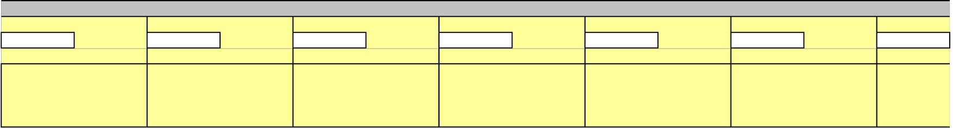
0.0000 0.0000 0.0000 0.0000 0.0000 0.0000

0.0000 | 0.0000 | 0.0000 | 0.0000 | 0.0000 | 0.0000
0.0000 | 0.0000 | 0.0000 | 0.0000 | 0.0000 | 0.0000
0.0000 | 0.0000 | 0.0000 | 0.0000 | 0.0000 | 0.0000
0.0000 | 0.0000 | 0.0000 | 0.0000 | 0.0000 | 0.0000
0.0000 | 0.0000 | 0.0000 | 0.0000 | 0.0000 | 0.0000
0.0000 | 0.0000 | 0.0000 | 0.0000 | 0.0000 | 0.0000
0.0000 | 0.0000 | 0.0000 | 0.0000 | 0.0000 | 0.0000
0.0000 | 0.0000 | 0.0000 | 0.0000 | 0.0000 | 0.0000
0.0000 | 0.0000 | 0.0000 | 0.0000 | 0.0000 | 0.0000
0.0000 | 0.0000 | 0.0000 | 0.0000 | 0.0000 | 0.0000
0.0000 | 0.0000 | 0.0000 | 0.0000 | 0.0000 | 0.0000
0.0000 | 0.0000 | 0.0000 | 0.0000 | 0.0000 | 0.0000
0.0000 | 0.0000 | 0.0000 | 0.0000 | 0.0000 | 0.0000
0.0000 | 0.0000 | 0.0000 | 0.0000 | 0.0000 | 0.0000
0.0000 | 0.0000 | 0.0000 | 0.0000 | 0.0000 | 0.0000
0.0000 | 0.0000 | 0.0000 | 0.0000 | 0.0000 | 0.0000
0.0000 | 0.0000 | 0.0000 | 0.0000 | 0.0000 | 0.0000
0.0000 | 0.0000 | 0.0000 | 0.0000 | 0.0000 | 0.0000
0.0000 | 0.0000 | 0.0000 | 0.0000 | 0.0000 | 0.0000
0.0000 | 0.0000 | 0.0000 | 0.0000 | 0.0000 | 0.0000

51


Fine Fraction
Coarse Fraction
weight (g) | #170 pan weight (g) |  | #230 sieve weight (g) |  | silt/clay pan weight (g)
 | 0.0000 |  | 0.0000 |  | 0.0000
Fine  #120 mesh phi 3.0  Fraction | V. Fine V. Fine  #170 mesh #170 mesh phi 3.5 phi 3.5  Weight Fraction |  | V. Fine V. Fine  #230 mesh #230 mesh phi 4.0 phi 4.0  Weight Fraction |  | Silt/Clay Silt/Clay  Pan Pan phi 4.5 phi 4.5  Weight Fraction |  | Sieve Total | Percent  Sieve Loss
0.0000 0.0000 0.0000 0.0000 0.0000 #DIV/0!
0.0000 0.0000 0.0000 0.0000 0.0000 #DIV/0!
0.0000 0.0000 0.0000 0.0000 0.0000 #DIV/0!
0.0000 0.0000 0.0000 0.0000 0.0000 #DIV/0!
0.0000 0.0000 0.0000 0.0000 0.0000 #DIV/0!
0.0000 0.0000 0.0000 0.0000 0.0000 #DIV/0!
0.0000 0.0000 0.0000 0.0000 0.0000 #DIV/0!
0.0000 0.0000 0.0000 0.0000 0.0000 #DIV/0!
0.0000 0.0000 0.0000 0.0000 0.0000 #DIV/0!
0.0000 0.0000 0.0000 0.0000 0.0000 #DIV/0!
0.0000 0.0000 0.0000 0.0000 0.0000 #DIV/0!
0.0000 0.0000 0.0000 0.0000 0.0000 #DIV/0!
0.0000 0.0000 0.0000 0.0000 0.0000 #DIV/0!
0.0000 0.0000 0.0000 0.0000 0.0000 #DIV/0!
0.0000 0.0000 0.0000 0.0000 0.0000 #DIV/0!
0.0000 0.0000 0.0000 0.0000 0.0000 #DIV/0!
0.0000 0.0000 0.0000 0.0000 0.0000 #DIV/0!
0.0000 0.0000 0.0000 0.0000 0.0000 #DIV/0!
0.0000 0.0000 0.0000 0.0000 0.0000 #DIV/0!
0.0000 0.0000 0.0000 0.0000 0.0000 #DIV/0!
0.0000 0.0000 0.0000 0.0000 0.0000 #DIV/0!

Empty Pan  Weight | Pan & Sample  Total | Sample  Weight
 |  | 0
 |  | 0
 |  | 0
 |  | 0
 |  | 0
 |  | 0
 |  | 0
 |  | 0
 |  | 0
 |  | 0
 |  | 0
 |  | 0
 |  | 0
 |  | 0
 |  | 0
 |  | 0
 |  | 0
 |  | 0
 |  | 0
 |  | 0
 |  | 0

52

Weight Percents
Fine Fraction
Dispersing Agent  Mass in 20 mL sample | Sample Weight minus agent | wetsieve mud weight | wetsieve +  drysieve mud | dry sieve mass +  fine fraction
0 0 0 0 0.0000
0 0 0 0 0.0000
0 0 0 0 0.0000
0 0 0 0 0.0000
0 0 0 0 0.0000
0 0 0 0 0.0000
0 0 0 0 0.0000
0 0 0 0 0.0000
0 0 0 0 0.0000
0 0 0 0 0.0000
0 0 0 0 0.0000
0 0 0 0 0.0000
0 0 0 0 0.0000
0 0 0 0 0.0000
0 0 0 0 0.0000
0 0 0 0 0.0000
0 0 0 0 0.0000
0 0 0 0 0.0000
0 0 0 0 0.0000
0 0 0 0 0.0000
0 0 0 0 0.0000

Gravel
#2.5 mesh phi -3.0 weight %
Gravel
#3.5 mesh phi -2.5 weight %
Gravel
#5 mesh phi -2.0 weight %
Gravel
#7 mesh phi -1.5 weight %
Gravel
#10 mesh phi -1.0 weight %
V. Coarse
#14 mesh phi -0.5 weight %

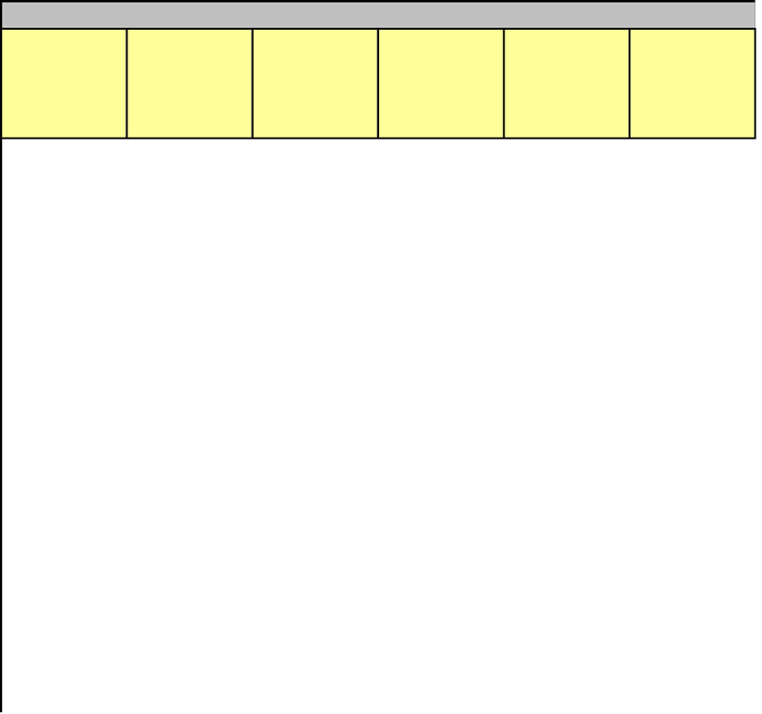
#DIV/0! #DIV/0! #DIV/0! #DIV/0! #DIV/0! #DIV/0!
#DIV/0! #DIV/0! #DIV/0! #DIV/0! #DIV/0! #DIV/0!
#DIV/0! #DIV/0! #DIV/0! #DIV/0! #DIV/0! #DIV/0!
#DIV/0! #DIV/0! #DIV/0! #DIV/0! #DIV/0! #DIV/0!
#DIV/0! #DIV/0! #DIV/0! #DIV/0! #DIV/0! #DIV/0!
#DIV/0! #DIV/0! #DIV/0! #DIV/0! #DIV/0! #DIV/0!
#DIV/0! #DIV/0! #DIV/0! #DIV/0! #DIV/0! #DIV/0!
#DIV/0! #DIV/0! #DIV/0! #DIV/0! #DIV/0! #DIV/0!
#DIV/0! #DIV/0! #DIV/0! #DIV/0! #DIV/0! #DIV/0!
#DIV/0! #DIV/0! #DIV/0! #DIV/0! #DIV/0! #DIV/0!
#DIV/0! #DIV/0! #DIV/0! #DIV/0! #DIV/0! #DIV/0!
#DIV/0! #DIV/0! #DIV/0! #DIV/0! #DIV/0! #DIV/0!
#DIV/0! #DIV/0! #DIV/0! #DIV/0! #DIV/0! #DIV/0!
#DIV/0! #DIV/0! #DIV/0! #DIV/0! #DIV/0! #DIV/0!
#DIV/0! #DIV/0! #DIV/0! #DIV/0! #DIV/0! #DIV/0!
#DIV/0! #DIV/0! #DIV/0! #DIV/0! #DIV/0! #DIV/0!
#DIV/0! #DIV/0! #DIV/0! #DIV/0! #DIV/0! #DIV/0!
#DIV/0! #DIV/0! #DIV/0! #DIV/0! #DIV/0! #DIV/0!
#DIV/0! #DIV/0! #DIV/0! #DIV/0! #DIV/0! #DIV/0!
#DIV/0! #DIV/0! #DIV/0! #DIV/0! #DIV/0! #DIV/0!
#DIV/0! #DIV/0! #DIV/0! #DIV/0! #DIV/0! #DIV/0!

53

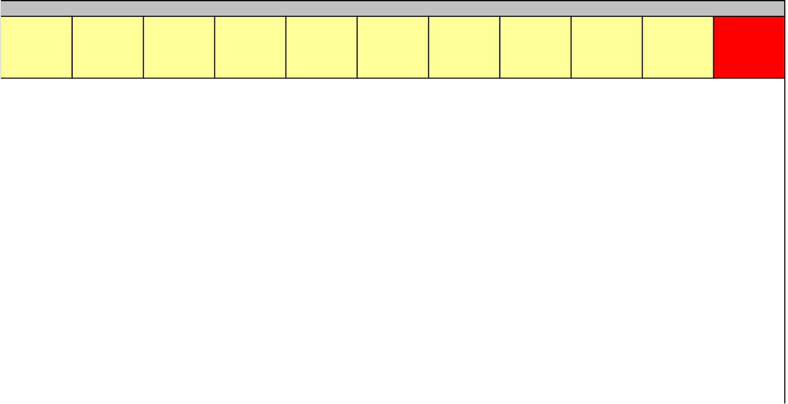
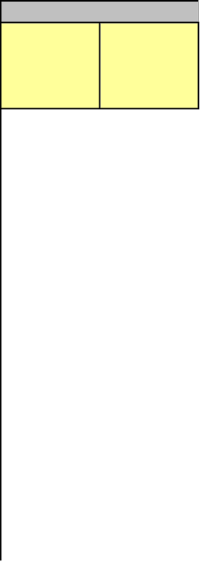
Cumulative Weight Per c
V. Coarse  #18 mesh phi 0 weight % | Coarse  #25 mesh phi 0.5 weight % | Coarse  #35 mesh phi 1.0 weight % | Medium  #45 mesh phi 1.5 weight % | Medium  #60 mesh phi 2.0 weight % | Fine  #80 mesh phi 2.5 weight % | Fine  #120 mesh phi 3.0 weight % | V. Fine  #170 mesh phi 3.5 weight % | V. Fine  #230 mesh phi 4.0 weight % | Mud  wet & dry phi 4.5 weight %

Total weight %
Gravel
#2.5 mesh
-3.0 cum. %
Gravel
#3.5 mesh
-2.5 cum. %

#DIV/0! #DIV/0!
#DIV/0! #DIV/0!
#DIV/0! #DIV/0!
#DIV/0! #DIV/0!
#DIV/0! #DIV/0!
#DIV/0! #DIV/0!
#DIV/0! #DIV/0!
#DIV/0! #DIV/0!
#DIV/0! #DIV/0!
#DIV/0! #DIV/0!
#DIV/0! #DIV/0!
#DIV/0! #DIV/0!
#DIV/0! #DIV/0!
#DIV/0! #DIV/0!
#DIV/0! #DIV/0!
#DIV/0! #DIV/0!
#DIV/0! #DIV/0!
#DIV/0! #DIV/0!
#DIV/0! #DIV/0!
#DIV/0! #DIV/0!
#DIV/0! #DIV/0!

54
Cumulative Weig
Gravel  #5 mesh  -2.0 cum. % | Gravel  #7 mesh  -1.5 cum. % | Gravel  #10 mesh  -1.0 cum. % | V. Coarse  #14 mesh  -0.5 cum. % | V. Coarse  #18 mesh  0.0 cum. % | Coarse  #25 mesh  0.5 cum. % | Coarse  #35 mesh  1.0 cum. % | Medium  #45 mesh  1.5 cum. % | Medium  #60 mesh  2.0 cum. % | Fine  #80 mesh  2.5 cum. % | Fine  #120 mesh  3.0 cum. % | V. Fine  #170 mesh  3.5 cum. % | V. Fine  #230 mesh  4.0 cum. %

#DIV/0! | #DIV/0! | #DIV/0! | #DIV/0! | #DIV/0! | #DIV/0! | #DIV/0! | #DIV/0! | #DIV/0! | #DIV/0! | #DIV/0! | #DIV/0! | #DIV/0!
#DIV/0! | #DIV/0! | #DIV/0! | #DIV/0! | #DIV/0! | #DIV/0! | #DIV/0! | #DIV/0! | #DIV/0! | #DIV/0! | #DIV/0! | #DIV/0! | #DIV/0!
#DIV/0! | #DIV/0! | #DIV/0! | #DIV/0! | #DIV/0! | #DIV/0! | #DIV/0! | #DIV/0! | #DIV/0! | #DIV/0! | #DIV/0! | #DIV/0! | #DIV/0!
#DIV/0! | #DIV/0! | #DIV/0! | #DIV/0! | #DIV/0! | #DIV/0! | #DIV/0! | #DIV/0! | #DIV/0! | #DIV/0! | #DIV/0! | #DIV/0! | #DIV/0!
#DIV/0! | #DIV/0! | #DIV/0! | #DIV/0! | #DIV/0! | #DIV/0! | #DIV/0! | #DIV/0! | #DIV/0! | #DIV/0! | #DIV/0! | #DIV/0! | #DIV/0!
#DIV/0! | #DIV/0! | #DIV/0! | #DIV/0! | #DIV/0! | #DIV/0! | #DIV/0! | #DIV/0! | #DIV/0! | #DIV/0! | #DIV/0! | #DIV/0! | #DIV/0!
#DIV/0! | #DIV/0! | #DIV/0! | #DIV/0! | #DIV/0! | #DIV/0! | #DIV/0! | #DIV/0! | #DIV/0! | #DIV/0! | #DIV/0! | #DIV/0! | #DIV/0!
#DIV/0! | #DIV/0! | #DIV/0! | #DIV/0! | #DIV/0! | #DIV/0! | #DIV/0! | #DIV/0! | #DIV/0! | #DIV/0! | #DIV/0! | #DIV/0! | #DIV/0!
#DIV/0! | #DIV/0! | #DIV/0! | #DIV/0! | #DIV/0! | #DIV/0! | #DIV/0! | #DIV/0! | #DIV/0! | #DIV/0! | #DIV/0! | #DIV/0! | #DIV/0!
#DIV/0! | #DIV/0! | #DIV/0! | #DIV/0! | #DIV/0! | #DIV/0! | #DIV/0! | #DIV/0! | #DIV/0! | #DIV/0! | #DIV/0! | #DIV/0! | #DIV/0!
#DIV/0! | #DIV/0! | #DIV/0! | #DIV/0! | #DIV/0! | #DIV/0! | #DIV/0! | #DIV/0! | #DIV/0! | #DIV/0! | #DIV/0! | #DIV/0! | #DIV/0!
#DIV/0! | #DIV/0! | #DIV/0! | #DIV/0! | #DIV/0! | #DIV/0! | #DIV/0! | #DIV/0! | #DIV/0! | #DIV/0! | #DIV/0! | #DIV/0! | #DIV/0!
#DIV/0! | #DIV/0! | #DIV/0! | #DIV/0! | #DIV/0! | #DIV/0! | #DIV/0! | #DIV/0! | #DIV/0! | #DIV/0! | #DIV/0! | #DIV/0! | #DIV/0!
#DIV/0! | #DIV/0! | #DIV/0! | #DIV/0! | #DIV/0! | #DIV/0! | #DIV/0! | #DIV/0! | #DIV/0! | #DIV/0! | #DIV/0! | #DIV/0! | #DIV/0!
#DIV/0! | #DIV/0! | #DIV/0! | #DIV/0! | #DIV/0! | #DIV/0! | #DIV/0! | #DIV/0! | #DIV/0! | #DIV/0! | #DIV/0! | #DIV/0! | #DIV/0!
#DIV/0! | #DIV/0! | #DIV/0! | #DIV/0! | #DIV/0! | #DIV/0! | #DIV/0! | #DIV/0! | #DIV/0! | #DIV/0! | #DIV/0! | #DIV/0! | #DIV/0!
#DIV/0! | #DIV/0! | #DIV/0! | #DIV/0! | #DIV/0! | #DIV/0! | #DIV/0! | #DIV/0! | #DIV/0! | #DIV/0! | #DIV/0! | #DIV/0! | #DIV/0!
#DIV/0! | #DIV/0! | #DIV/0! | #DIV/0! | #DIV/0! | #DIV/0! | #DIV/0! | #DIV/0! | #DIV/0! | #DIV/0! | #DIV/0! | #DIV/0! | #DIV/0!
#DIV/0! | #DIV/0! | #DIV/0! | #DIV/0! | #DIV/0! | #DIV/0! | #DIV/0! | #DIV/0! | #DIV/0! | #DIV/0! | #DIV/0! | #DIV/0! | #DIV/0!
#DIV/0! | #DIV/0! | #DIV/0! | #DIV/0! | #DIV/0! | #DIV/0! | #DIV/0! | #DIV/0! | #DIV/0! | #DIV/0! | #DIV/0! | #DIV/0! | #DIV/0!
#DIV/0! | #DIV/0! | #DIV/0! | #DIV/0! | #DIV/0! | #DIV/0! | #DIV/0! | #DIV/0! | #DIV/0! | #DIV/0! | #DIV/0! | #DIV/0!  55 | #DIV/0!

55

ht Percents
Mud
Statistical Analysis
Median | Mean | Sorting | Skewness | Kurtosis
#DIV/0! #DIV/0! #DIV/0! #DIV/0! #DIV/0!
#DIV/0! #DIV/0! #DIV/0! #DIV/0! #DIV/0!
#DIV/0! #DIV/0! #DIV/0! #DIV/0! #DIV/0!
#DIV/0! #DIV/0! #DIV/0! #DIV/0! #DIV/0!
#DIV/0! #DIV/0! #DIV/0! #DIV/0! #DIV/0!
#DIV/0! #DIV/0! #DIV/0! #DIV/0! #DIV/0!
#DIV/0! #DIV/0! #DIV/0! #DIV/0! #DIV/0!
#DIV/0! #DIV/0! #DIV/0! #DIV/0! #DIV/0!
#DIV/0! #DIV/0! #DIV/0! #DIV/0! #DIV/0!
#DIV/0! #DIV/0! #DIV/0! #DIV/0! #DIV/0!
#DIV/0! #DIV/0! #DIV/0! #DIV/0! #DIV/0!
#DIV/0! #DIV/0! #DIV/0! #DIV/0! #DIV/0!
#DIV/0! #DIV/0! #DIV/0! #DIV/0! #DIV/0!
#DIV/0! #DIV/0! #DIV/0! #DIV/0! #DIV/0!
#DIV/0! #DIV/0! #DIV/0! #DIV/0! #DIV/0!
#DIV/0! #DIV/0! #DIV/0! #DIV/0! #DIV/0!
#DIV/0! #DIV/0! #DIV/0! #DIV/0! #DIV/0!
#DIV/0! #DIV/0! #DIV/0! #DIV/0! #DIV/0!
#DIV/0! #DIV/0! #DIV/0! #DIV/0! #DIV/0!
#DIV/0! #DIV/0! #DIV/0! #DIV/0! #DIV/0!
#DIV/0! #DIV/0! #DIV/0! #DIV/0! #DIV/0!

Phi Size at Given Cumulative Weight Percents

Pan
4.5 cum. %
Phi at 5 cumulative weight %
Phi at 16 cumulative weight %
Phi at 25 cumulative weight %
Phi at 50 cumulative weight %
Phi at 75 cumulative weight %
Phi at 84 cumulative weight %
Phi at 95 cumulative weight %

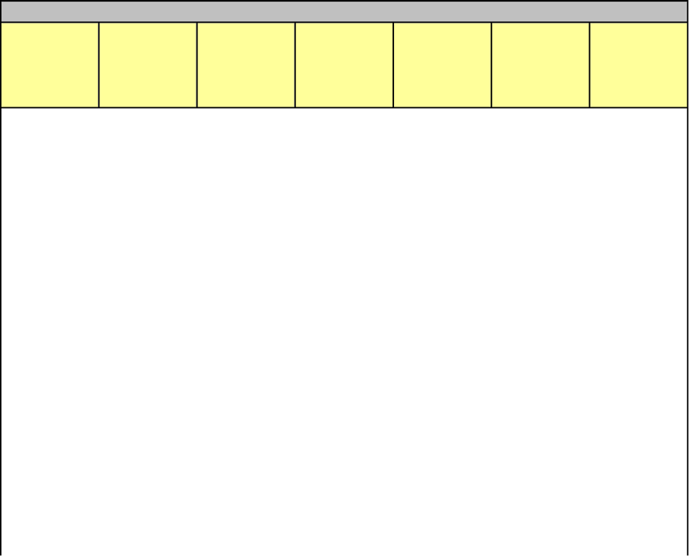
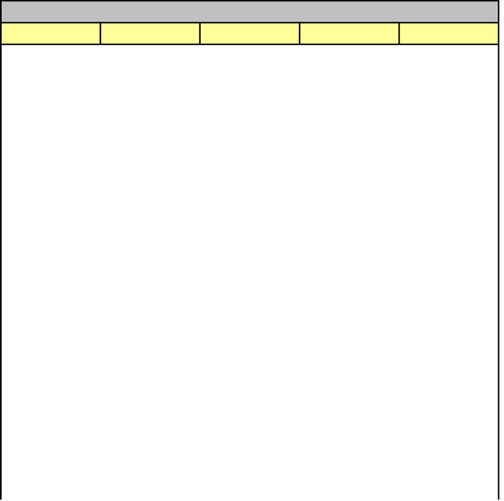
#DIV/0!
#DIV/0!
#DIV/0!
#DIV/0!
#DIV/0!
#DIV/0!
#DIV/0!
#DIV/0!
#DIV/0!
#DIV/0!
#DIV/0!
#DIV/0!
#DIV/0!
#DIV/0!
#DIV/0!
#DIV/0!
#DIV/0!
#DIV/0!
#DIV/0!
#DIV/0!
#DIV/0!
Comments:

#DIV/0! #DIV/0! #DIV/0! #DIV/0! #DIV/0! #DIV/0! #DIV/0!
#DIV/0! #DIV/0! #DIV/0! #DIV/0! #DIV/0! #DIV/0! #DIV/0!
#DIV/0! #DIV/0! #DIV/0! #DIV/0! #DIV/0! #DIV/0! #DIV/0!
#DIV/0! #DIV/0! #DIV/0! #DIV/0! #DIV/0! #DIV/0! #DIV/0!
#DIV/0! #DIV/0! #DIV/0! #DIV/0! #DIV/0! #DIV/0! #DIV/0!
#DIV/0! #DIV/0! #DIV/0! #DIV/0! #DIV/0! #DIV/0! #DIV/0!
#DIV/0! #DIV/0! #DIV/0! #DIV/0! #DIV/0! #DIV/0! #DIV/0!
#DIV/0! #DIV/0! #DIV/0! #DIV/0! #DIV/0! #DIV/0! #DIV/0!
#DIV/0! #DIV/0! #DIV/0! #DIV/0! #DIV/0! #DIV/0! #DIV/0!
#DIV/0! #DIV/0! #DIV/0! #DIV/0! #DIV/0! #DIV/0! #DIV/0!
#DIV/0! #DIV/0! #DIV/0! #DIV/0! #DIV/0! #DIV/0! #DIV/0!
#DIV/0! #DIV/0! #DIV/0! #DIV/0! #DIV/0! #DIV/0! #DIV/0!
#DIV/0! #DIV/0! #DIV/0! #DIV/0! #DIV/0! #DIV/0! #DIV/0!
#DIV/0! #DIV/0! #DIV/0! #DIV/0! #DIV/0! #DIV/0! #DIV/0!
#DIV/0! #DIV/0! #DIV/0! #DIV/0! #DIV/0! #DIV/0! #DIV/0!
#DIV/0! #DIV/0! #DIV/0! #DIV/0! #DIV/0! #DIV/0! #DIV/0!
#DIV/0! #DIV/0! #DIV/0! #DIV/0! #DIV/0! #DIV/0! #DIV/0!
#DIV/0! #DIV/0! #DIV/0! #DIV/0! #DIV/0! #DIV/0! #DIV/0!
#DIV/0! #DIV/0! #DIV/0! #DIV/0! #DIV/0! #DIV/0! #DIV/0!
#DIV/0! #DIV/0! #DIV/0! #DIV/0! #DIV/0! #DIV/0! #DIV/0!
#DIV/0! #DIV/0! #DIV/0! #DIV/0! #DIV/0! #DIV/0! #DIV/0!

56

Particle Size Chart Attachment 13

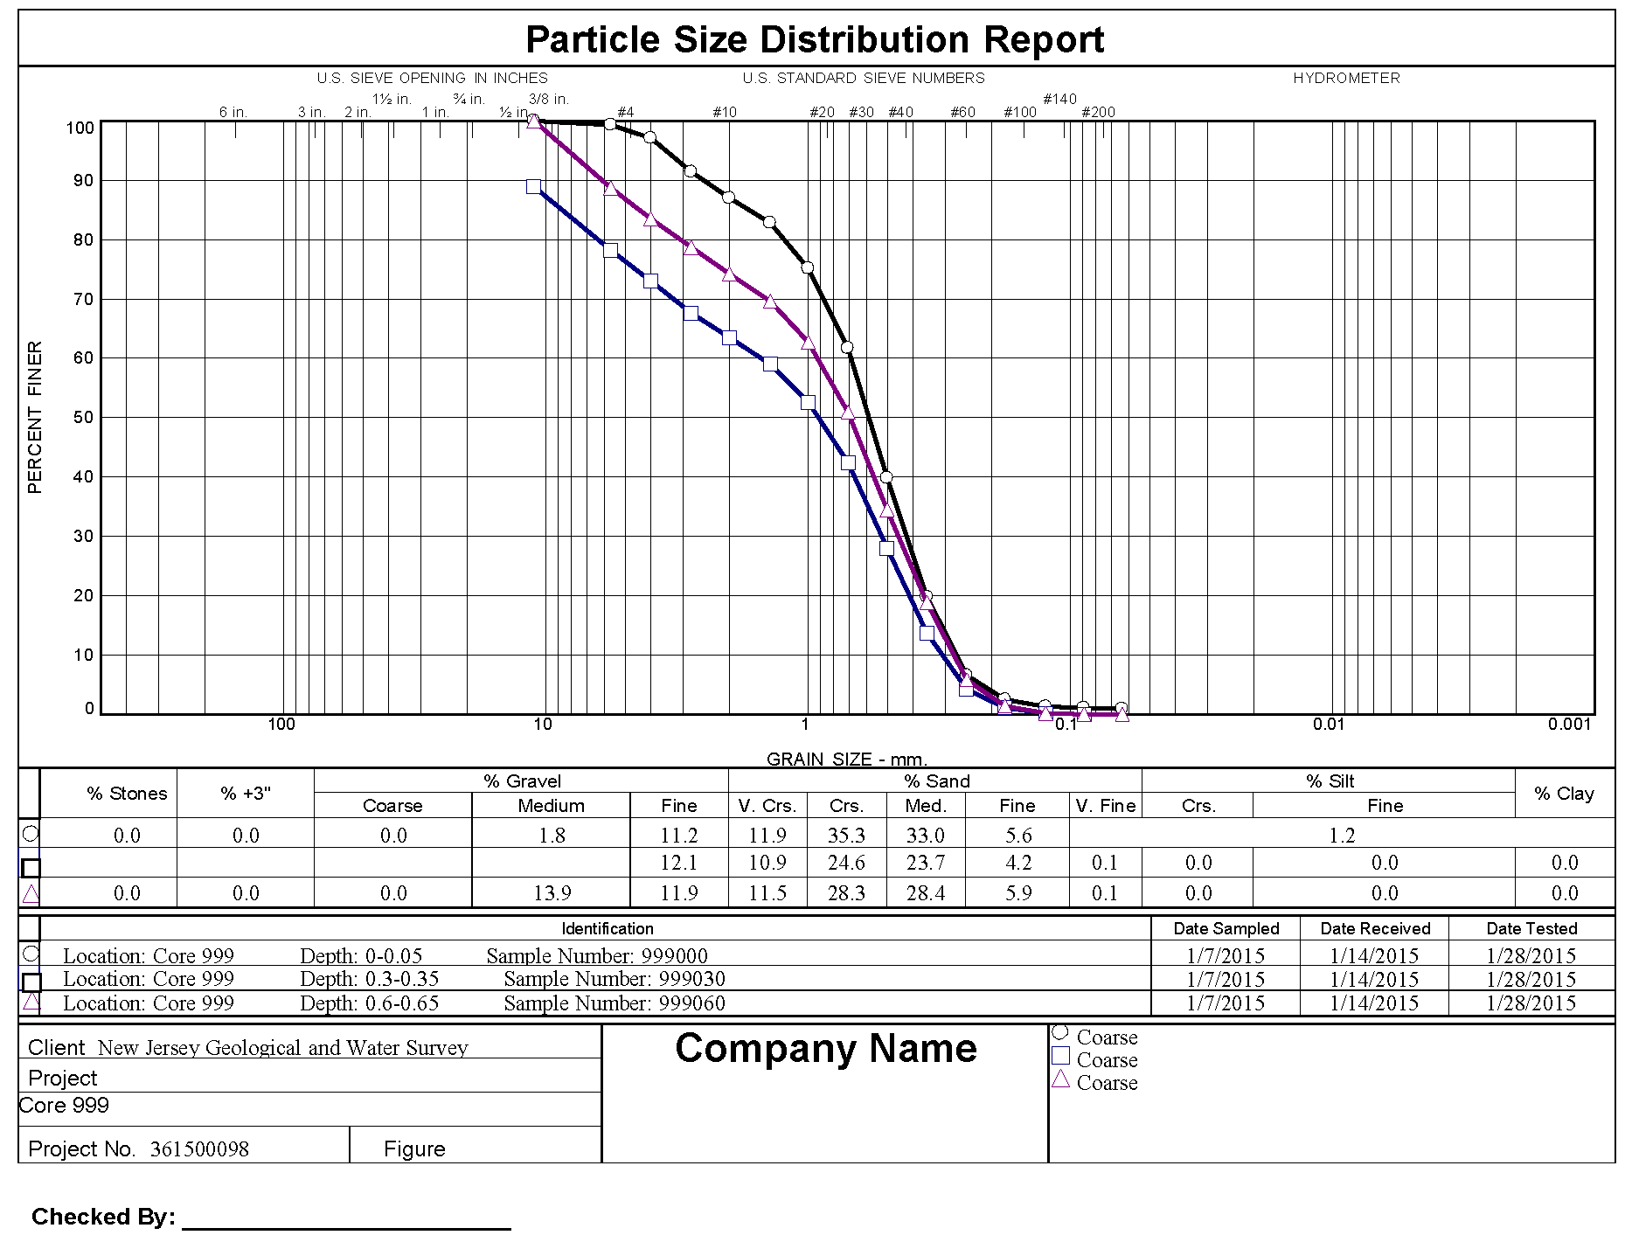

57

