IPM WORK LOCATIONS

CORE ZONE

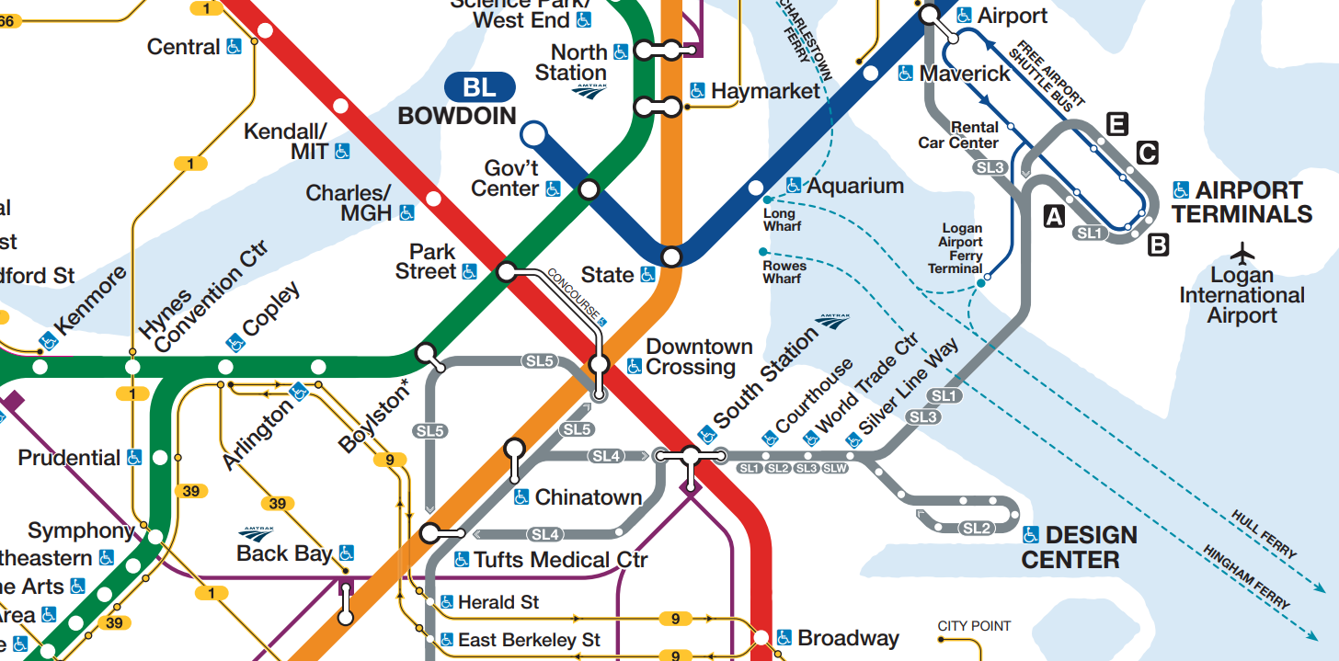

Core Zone Stations

Haymarket
North Station
State
Downtown Crossing
Chinatown
Tufts Medical
Aquarium
Bowdoin
South Station
Charles/MGH
Government Center
Park Street
Boylston
Arlington
Copley
Hynes
Prudential
Symphony
Courthouse
World Trade Center
Silver line Way
Northern Ave @ Harbor St
Northern Ave opp Harbor St
Northern Ave @ Tide St.
23 Dry Dock Ave
27 Dry Dock Ave
88 Black Falcon Ave
Dry Dock Ave @ Design Center Place
Temple Pl @ Washington

Core Zone Facilities

45 High Street
City Point Operator’s Lobby
North Station Operator’s Lobby

*Planned station/facility

