IPM WORK LOCATIONS

NON-CORE NORTH ZONE

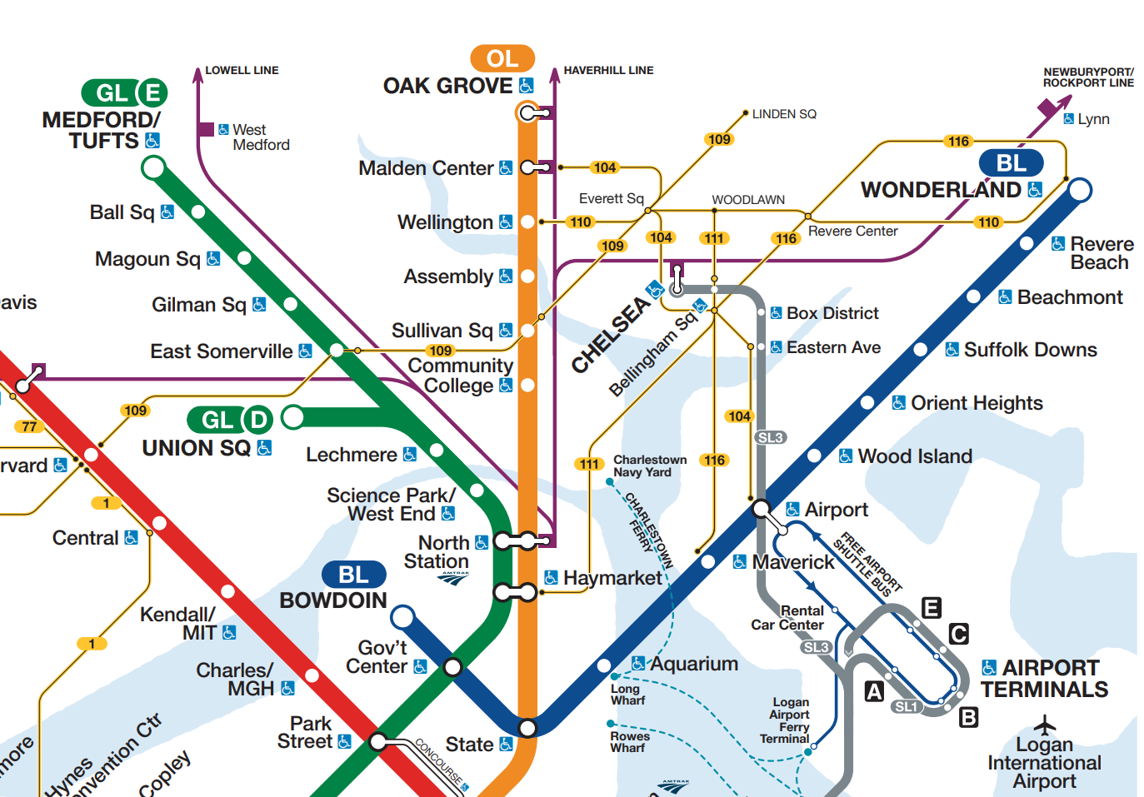

Non-Core North Zone Stations

Oak Grove (Orange Line)
Malden Center (Orange Line)
Wellington (Orange Line)
Assembly (Orange Line)
Sullivan Sq. (Orange Line)
Community College (Orange Line)
Wonderland (Blue Line)
Revere Beach (Blue Line)
Beachmont (Blue Line)
Suffolk Downs (Blue Line)
Orient Heights (Blue Line)
Wood Island (Blue Line)
Airport (Blue Line)
Maverick (Blue Line)
Science Park (Green Line)
Lechmere (Green Line)
East Somerville Station (Green Line)
Gilman Square Station (Green Line)
Magoun Square Station (Green Line)
Ball Square Station (Green Line)
Medford/Tufts Station (Green Line)
Union Square Station (Green Line)
Meridian St. @ White St.(Silver Line)
Eastern Ave (Silver Line)
Box District (Silver Line)
Bellingham Sq. (Silver Line)
Chelsea BRT Station (Silver Line)

Non-Core North Zone Facilities

Charlestown Yard
Charlestown Bus Simulation
90 Inner Belt Rd.
440 Riverside Ave.
Everett Yard
Fellsway Carhouse
Fellsway Lobby
Wellington Yard
Lynn Bus Garage
Lynn Station Walkway
Orient Heights Yard
Lechmere Operators Trailer
GLX Warehouse and Operations Office

*Planned station/facility

