IPM WORK LOCATIONS

NON-CORE SOUTH ZONE

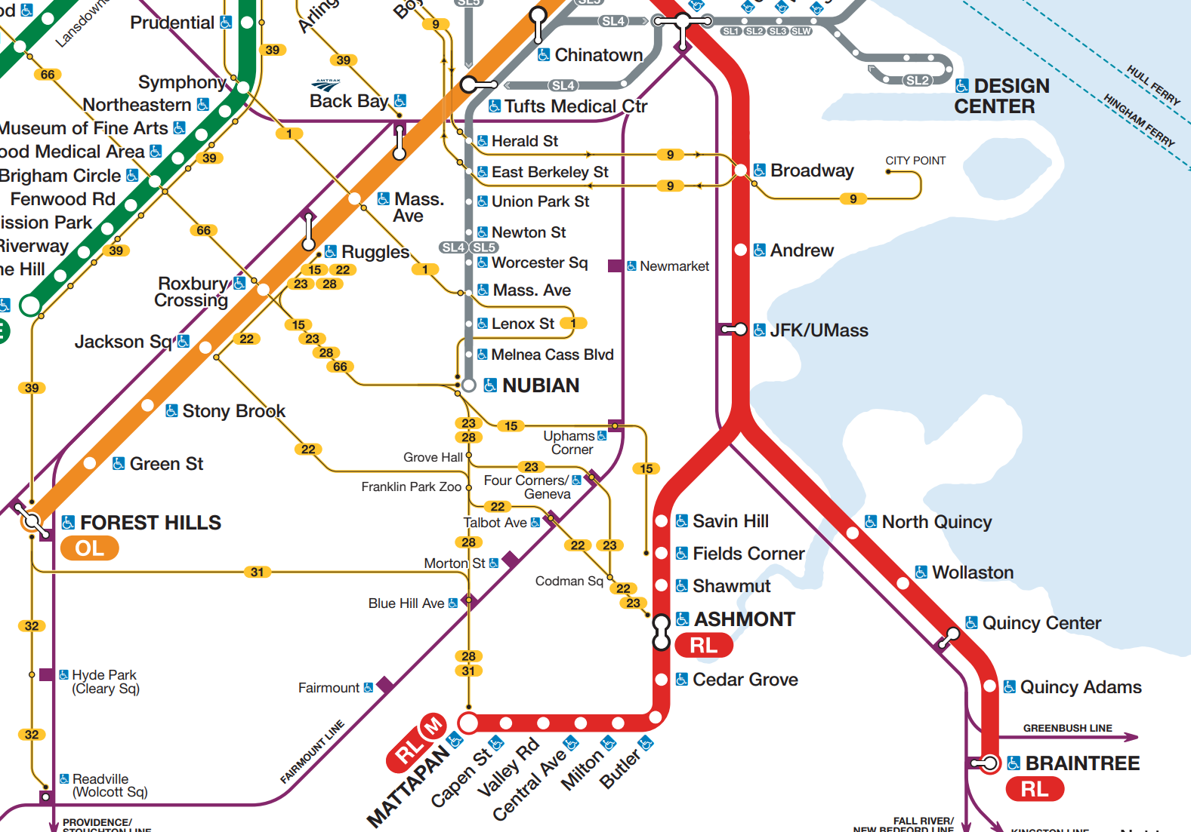

Non-Core South Zone Stations

Back Bay (Orange Line)
Mass. Ave (Orange Line)
Ruggles (Orange Line)
Roxbury Crossing (Orange Line)
Jackson Sq (Orange Line)
Stony Brook (Orange Line)
Green St (Orange Line)
Forest Hills (Orange Line)
Broadway (Red Line)
Andrew (Red Line)
JFK/UMass (Red Line)
North Quincy (Red Line)
Wollaston (Red Line)
Quincy Center (Red Line)
Quincy Adams (Red Line)
Braintree (Red Line)
Savin Hill (Red Line)
Fields Corner (Red Line)
Shawmut (Red Line)
Ashmont (Red Line)
Cedar Grove (Red Line)
Butler (Red Line)
Milton (Red Line)
Central Ave (Red Line)
Valley Rd (Red Line)
Capen St (Red Line)
Mattapan (Red Line)
Nubian (Silver Line/Bus)
Washington St @ Melnea Cass Blvd (Silver Line)
Washington St @ Lenox St. (Silver Line)
Washington St @ Massachusetts Ave. (Silver Line)
Washington St @ Worcester St. (Silver Line)
Washington St @ Newton St. (Silver Line)
Washington St @ Union Pk. (Silver Line)
Washington St @ E Berkeley St. (Silver Line)
Washington St @ Tufts Med Ctr (Silver Line)
Washington St @ Essex St. (Silver Line)
Essex St. @ Atlantic Ave. (Silver Line)

Non-Core South Zone Facilities
Cabot Yard
Southampton Garage
Emergency Training Center
Albany St Garage
JFK/UMass Operations Building
Codman Yard
Tenean Yard
Caddigan Yard
Forest Hills Head House
Quincy Yard
71 Von Hillern*
Quincy Bus Maintenance Facility*

*Planned station/facility

