IPM WORK LOCATIONS

NON-CORE WEST ZONE

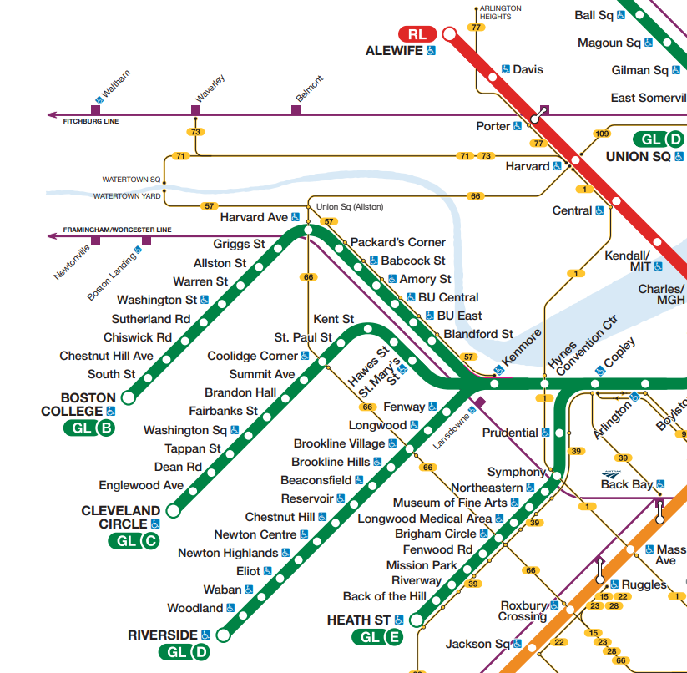

Non-Core West Zone Stations

Alewife (Red Line)
Davis (Red Line)
Porter (Red Line)
Harvard (Red Line)
Central (Red Line)
Kendall/MIT (Red Line)
Kenmore (Green Line)
Fenway (Green Line D)
Longwood (Green Line D)
Brookline Village (Green Line D)
Brookline Hills (Green Line D)
Beaconsfield (Green Line D)
Chestnut Hill (Green Line D)
Newton Centre (Green Line D)
Newton Highlands (Green Line D)
Eliot (Green Line D)
Waban (Green Line D)
Woodland (Green Line D)
Riverside (Green Line D)
Blandford (Green Line B)
BU East (Green Line B)
BU Central (Green Line B)
Amory St. (Green Line B)
Babcock St. (Green Line B)
Packard’s Corner (Green Line B)
Harvard Ave. (Green Line B)
Griggs St. (Green Line B)
Allston St. (Green Line B)
Warren St. (Green Line B)
Washington St. (Green Line B)
Sutherland Rd. (Green Line B)
Chiswick Rd (Green Line B)
Chestnut Hill Ave (Green Line B)
South St. (Green Line B)
Boston College (Green Line B)
St. Mary’s St. (Green Line C)
Hawes Ave. (Green Line C)
Kent St. (Green Line C)
St. Paul St. (Green Line C)
Coolidge Corner (Green Line C)
Summit Ave (Green Line C)
Brandon Hall (Green Line C)
Fairbanks St. (Green Line C)
Washington Sq. (Green Line C)
Tappan St. (Green Line C)
Dean Rd (Green Line C)
Engelwood (Green Line C)
Cleveland Circle (Green Line C)
Northeastern (Green Line E)
Museum of Fine Arts (Green Line E)
Longwood Medical Area (Green Line E)
Brigham Circle (Green Line E)
Fenwood Rd. (Green Line E)
Mission Park (Green Line E)
Riverway (Green Line E)
Back of the Hill (Green Line E)
Heath St. (Green Line E)

Non-Core West Zone Facilities
North Cambridge Carhouse
North Cambridge Operator’s Lobby
Arlington Heights Operator’s Lobby
Bennet St. Operator’s Lobby
Watertown Operator’s Lobby
Reservoir
Riverside
Lake St. Carhouse
Lake St. Operator’s Lobby
Clarendon Hill Operator’s Lobby
Central Sq. Starters Booth
Health St. Operator’s Lobby
Water St. Yard Trailer

*Planned station/facility

