REQUEST FOR PROPOSAL (RFP)
Artificial Turf Installation Project
Medical Center Campus

Medical Center: _Chickasaw Nation Medical Center_
Project Location: 1921 Stonecipher Blvd. Ada, OK 74820
RFP Issue Date: _______3/12/2026_____________
Proposal Due Date: ______7/31/2026 _________
Procurement Contact: Shannon Sanders______
Procurement: 1009 N. Country Club Rd. Ada, OK 74820
Email: shannon.sanders@chickasaw.net______
Phone: ___(580)272-1330______________________

1. Introduction
The Medical Center is requesting proposals from qualified contractors for the removal of existing natural turf/sod and installation of commercial-grade artificial turf at a designated location (pictured below) on the medical center campus.
The objective of this project is to improve durability, reduce maintenance costs, conserve water usage, and maintain an attractive healthcare environment.
Total project area: approximately 5,700 square feet (84' x 66').

2. Project Overview
The selected contractor shall provide all labor, materials, equipment, and supervision required to complete the project.
- Removal and disposal of existing sod
- Site preparation and grading
- Installation of base materials
- Installation of commercial-grade artificial turf
- Final grooming and site cleanup

3. Scope of Work

3.1 Sod Removal
Remove and properly dispose of all existing sod, organic materials, and debris from the project area.

3.2 Site Preparation
Excavate and grade the site to ensure a stable base and proper drainage conditions.

3.3 Base Installation
Install and compact an aggregate base suitable for artificial turf systems to ensure long-term durability and drainage.

3.4 Artificial Turf Installation
- Provide and install commercial-grade artificial turf
- Install seaming and anchoring systems
- Install appropriate infill material
- Provide proper edging and transitions
- Perform final brushing and grooming

3.5 Site Restoration
Clean the project site and restore surrounding areas impacted during construction.

4. Material Requirements
Artificial turf must meet the following minimum standards:
- Commercial landscape-grade turf
- UV-resistant fibers
- Permeable backing for drainage
- Minimum 8–10 year manufacturer warranty
- Designed for high durability and low maintenance
- Safe for pedestrian areas

5. Project Area
Total Project Size: 5,700 square feet
Approximate Dimensions: 84 feet x 66 feet
Contractors should verify measurements during site visit.

6. Contractor Qualifications
- Experience installing commercial artificial turf systems
- Provide at least three similar project references
- Maintain appropriate licensing and insurance
- Compliance with OSHA safety standards

7. Proposal Requirements
- Company background and contact information
- Detailed project approach
- Product specifications
- Project timeline
- Detailed cost proposal
- References

8. Project Timeline
RFP Issued: __3/12/2026_______________
Questions Due: __6/30/2026___________
Proposal Deadline: __7/31/2026_______
Contract Award: ___ TBD _____________
Project Start: __________TBD _____________
Project Completion: ___TBD_____________

9. Evaluation Criteria
- Contractor experience
- Quality of materials proposed
- Project timeline
- References
- Total project cost

10. Submission Instructions
Submit proposals electronically or in sealed envelope to the procurement contact listed on the cover page.
Late submissions may not be accepted.

11. Terms and Conditions
- The Medical Center reserves the right to reject any or all proposals.
- Contractors must verify site conditions.
- All work must comply with applicable local regulations.
- Contractor responsible for required permits unless otherwise stated.

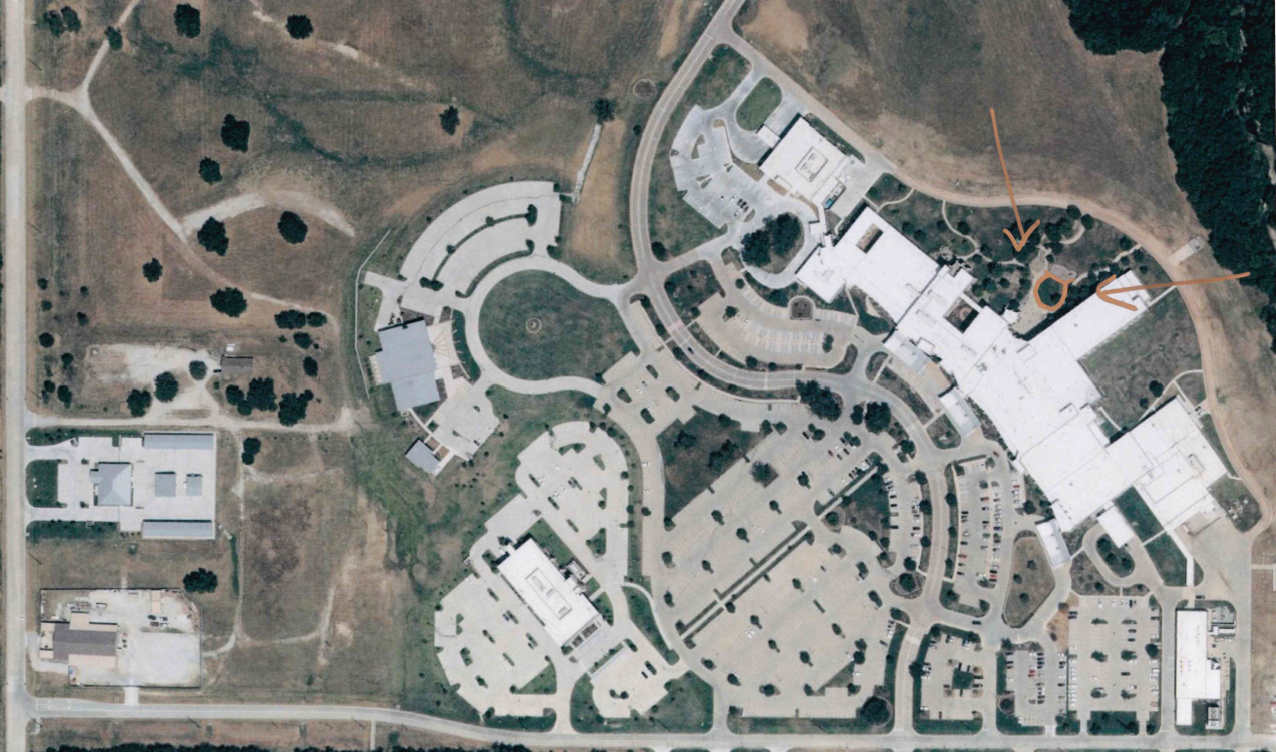
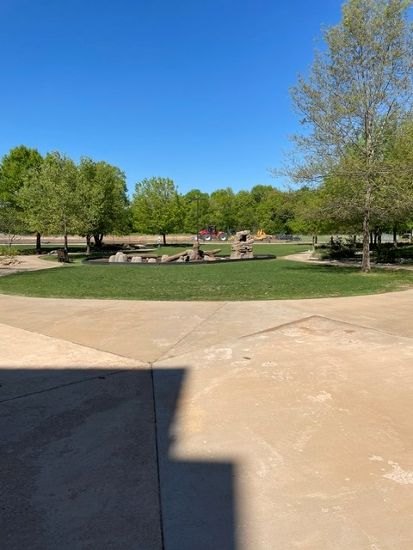
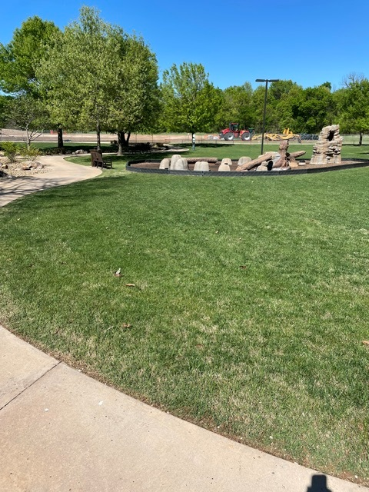
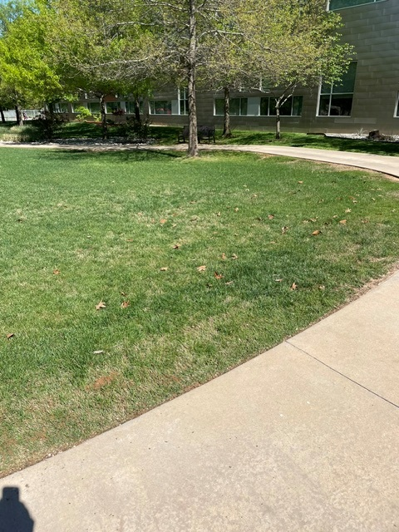
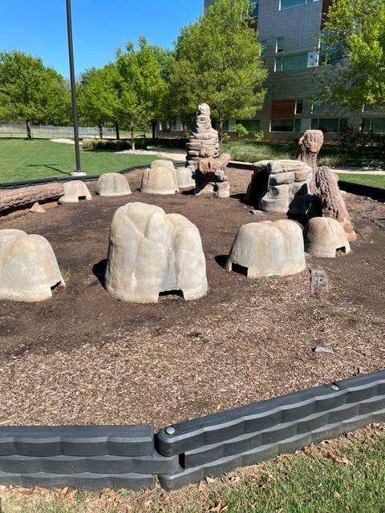
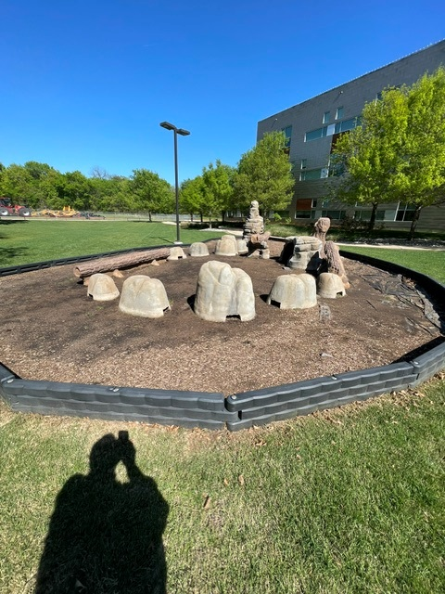
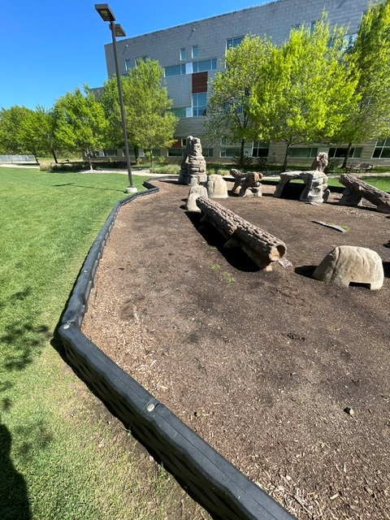
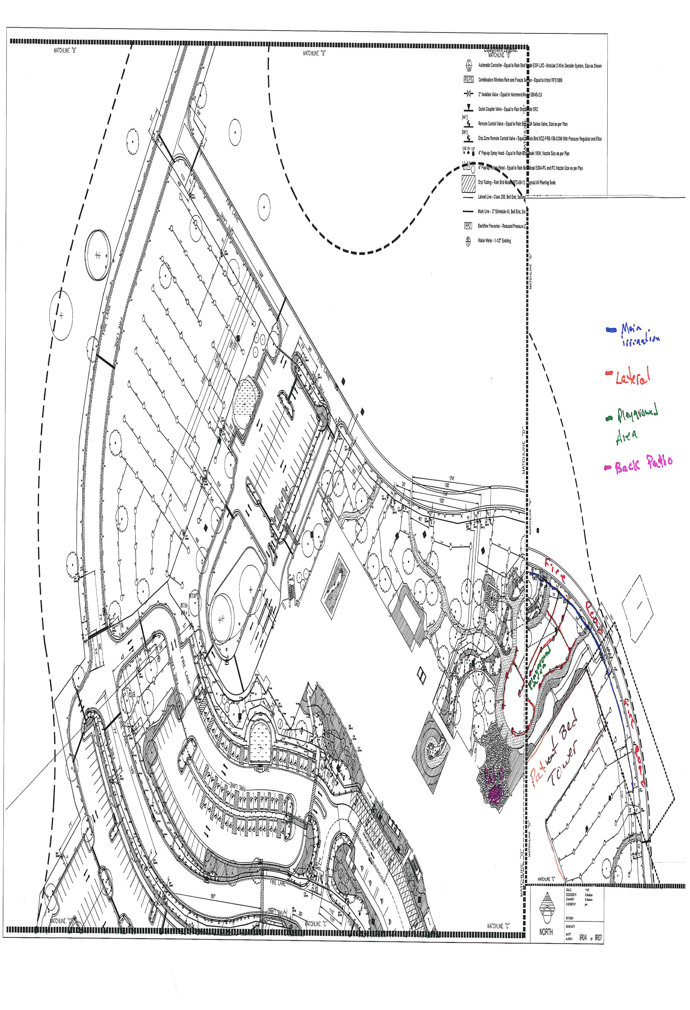

Per our initial site visit meeting held on March 24th, 2026, the following notes have been added to the proposal:

1. PROJECT OVERVIEW
This project includes the installation of both standard artificial turf and a designated playground turf system, along with associated site preparation, drainage improvements, and potential playground enhancements.
- Total project area: 5,700 sq. ft.
  - Playground area: 1,495 sq. ft.
  - Standard turf area: 4,205 sq. ft.
- Estimated material required: 6,500 sq. ft. (includes waste for trimming and fitting)
- Installation target: October / November
Vendors are requested to provide separate quotes for:
- Standard turf areas
- Playground turf areas

2. TURF SYSTEM REQUIREMENTS
Subgrade & Base
- Substrate depth: up to 4 inches for drainage
- Proper grading required to ensure water runoff
Infill
- Preferred: Coarse silica sand
- Not recommended: Rubber infill (due to displacement during heavy rain)
Turf Specifications
- Standard turf: Thicker, blade height (longer than playground turf)
- Playground turf blade height: approximately ½ inch height
- Turfing must support vehicle loads (car traffic) without damage
- Warranty: Up to 15 years
Backing
- Preferred: W-style backing (enhanced sun protection for blades)
- C-style backing may be considered
Cooling Options (Alternate Pricing Requested)
- Eco-cooling turf systems
- Water-activated cooling turf systems

3. PLAYGROUND AREA REQUIREMENTS
System Build-Up
- 4-inch gravel base + safety pad + playground turf
Safety Compliance
- Equipment 18 inches or higher must include 6-foot fall protection zone
Design Considerations
- Playground turf must be impact-rated for safety
- Turf color options should be provided
- Playground turf can be visually distinct from standard turf
Additional Scope
- Vendor to include:
  - Grass repair for construction access paths
  - Coordination for potential equipment relocation (pending design review)

4. BORDERS & EDGING
Preferred Option
- 6-inch concrete curb around turf behind playground area
Alternate Option
- Turf pinned flush with adjacent hardscape (no border)
Notes
- Border must secure turf edges and integrate with drainage design
- Turf will sit approximately 1–2 inches above adjacent grass areas

5. DRAINAGE REQUIREMENTS
- Include minimum of 2 catch basins tied into existing drainage system
- Ensure proper grading to direct water toward drainage points
- Tie-in recommended near existing concrete (light post area behind playground)

6. SITE & DESIGN CONSIDERATIONS
- Front area to remain natural grade and maintain a grass-like appearance
- Playground area may be elevated to meet safety requirements
Shade Structures (Future Consideration)
- Preferred: Cantilever shade structures
- Not preferred: Shade sails (due to long-term maintenance)
- Install footers during construction for future shade installation

7. ACCESS & CONSTRUCTION LOGISTICS
Site Access
- Access via grass across fire road near pediatrics building site
- Vendors must use plywood protection to prevent turf damage during construction
Staging Requirements
- Staging area must be left:
  - Flat
  - Free of ruts
  - Free of debris and rocks
General Requirements
- Vendors must remove all spoils and debris off-site
- Provide and maintain temporary fencing during construction to restrict pedestrian access

8. UTILITIES & INFRASTRUCTURE
- Existing water line under turf area should be capped if not in use
- Coordinate with project team for any required adjustments

9. COORDINATION
The following will be coordinated by the project team:
- Final layout and line placement
- Equipment access coordination
- Existing turf/grass protection

10. DELIVERABLES REQUIRED FROM VENDORS
Vendors shall provide:
- Detailed cost proposal (separate for standard and playground turf)
- Product specifications and cut sheets/brochures
- Drainage plan and integration details
- Installation timeline
- Warranty documentation
- Maintenance recommendations

11. MAINTENANCE REQUIREMENTS
- Annual maintenance required for infill leveling
- Periodic cleaning via power washing (max 1800 PSI)
- Vendor to provide any extra labeled materials for future repairs

Please direct any questions or requests for site visit to Shannon Sanders via shannon.sanders@chickasaw.net

