Kitchen Cheat Sheet Magnet - 20 mil, QTY 2500
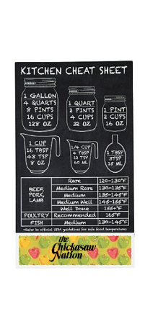
2 Cup Measuring Cup, QTY 2295
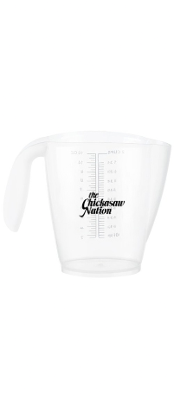

Colorful Whisk, QTY 2400, half blue, half green

Sandwich Spreader, QTY 2500, various colors


Dishcloth, QTY 2500, half blue, half yellow

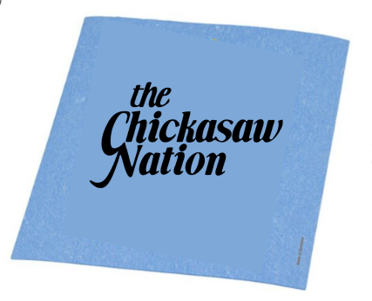
Jar Opener – Pumpkin, QTY 4000
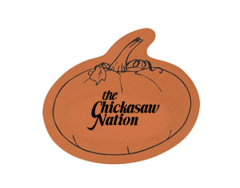

Reusable Sandwich & Food Bag, QTY 4000
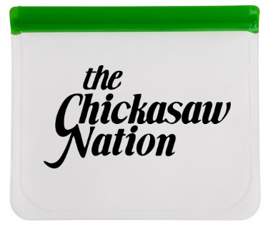

Growable Planter, QTY 4000
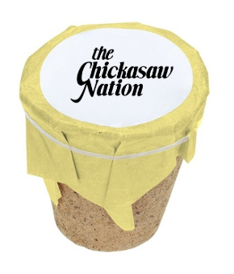

Terra Cotta Planter Kit – Small, QTY 4000
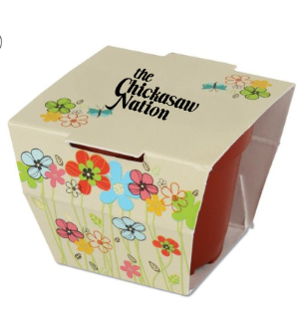
Flat Top Bottle Opener Keychain, QTY 4000, half blue and half red
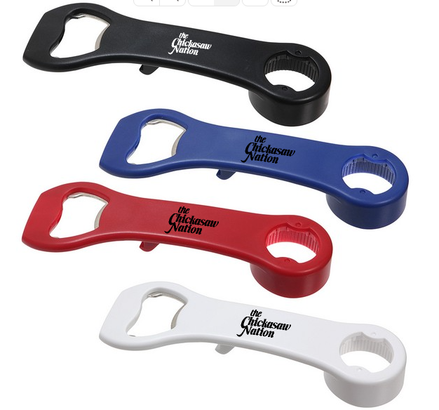

Growable Planter Gift Kit – Pumpkin, 2850


