DEPARTMENT OF CALIFORNIA HIGHWAY PATROL

July 2, 2026 Page 1 of 1

ADDENDUM NUMBER 2

TO

IFB - NUMBER 26C650001
CALIFORNIA HIGHWAY PATROL
Addendum #2 revises the IFB, Time Schedule, Item B, Page 1 as follows:

- IFB, Time Schedule, Item B, Page 1:

From:

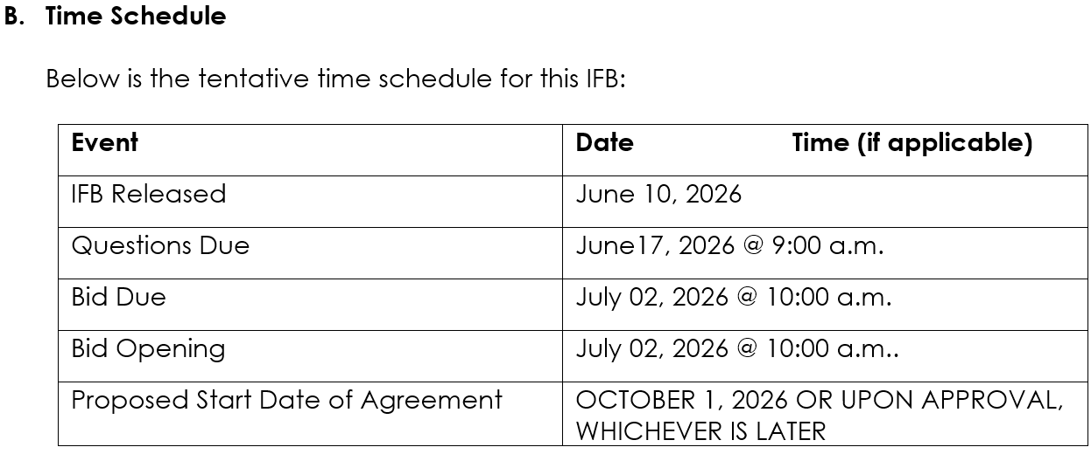
To: 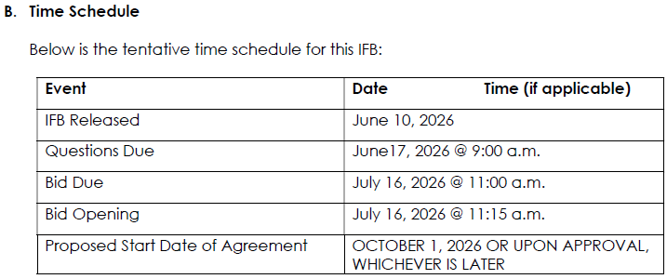

A COPY OF THIS ADDENDUM IS NOT REQUIRED TO BE SUBMITTED WITH YOUR SUBMISSION. If you have any questions, contact Zeanna Merilice, Contract Services Unit, at (916) 843-3610.

