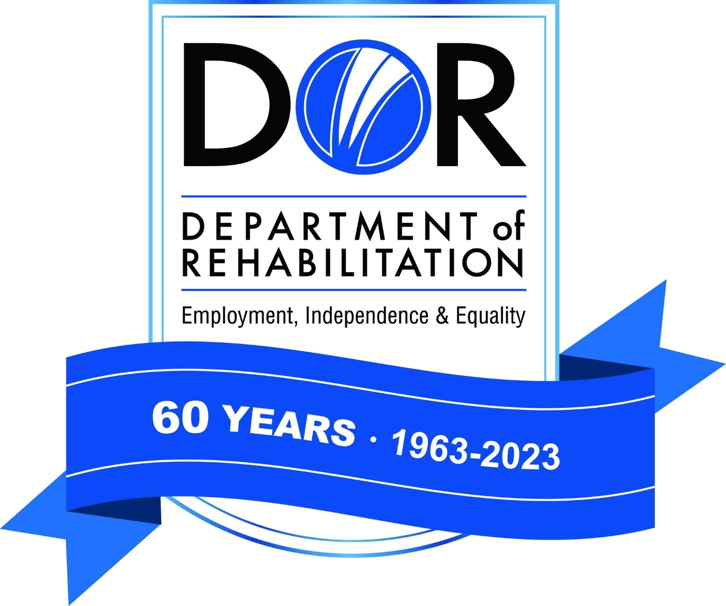 | Gavin Newsom  Governor    State of California  Health and Human Services Agency
Department of Rehabilitation
721 Capitol Mall
Sacramento CA 95814
July 16, 2026

Calipatria State Prison
RFQ # 07-0784A
Informal - Competitive Solicitation

You are invited to review and respond to the Request for Quote (RFQ) for various vending machines titled RFQ 07-0784A Calipatria State Prison. In submitting your quote, you must comply with all the instructions outlined in the RFQ.

Note that all agreements entered with the State of California will include by reference General Terms and Conditions that may be viewed and downloaded at Internet site http://www.dgs.ca.gov/pd. If you do not have Internet access, a hard copy can be provided by contacting the person listed below.

The RFQ Due Date is:

July 30, 2026 by 2:00 p.m.

Questions regarding this RFQ may be submitted by email to the department contact below. Any questions regarding this RFQ must be received NO later than 3 business days prior to the RFQ DUE DATE at 2:00 pm. Quotes received after the due date and time will not be accepted.

The State assumes no responsibility if a bidder cannot submit their quote via email or if the entire quote is not received prior to the quote due date and time.

ALL BIDS MUST BE SUBMITTED TO:
Department of Rehabilitation
Andrew Amicangelo, Procurement Analyst
Andrew.Amicangelo@dor.ca.gov
And
Roxette Yabes, Procurement Analyst
Roxette.Yabes@dor.ca.gov

