Date: July 24, 2026

To: All Bidders for Informal Competitive CR25-288946 – BAS Maintenance

From: Department of General Services
Office of Business and Acquisition Services (OBAS)

Subject: Informal Competitive CR25-288946 – Questions and Answers

As of 7/21/2026, OBAS received on behalf of FMD the following questions (Q) and is providing the following answers (A):

Q1: Are bidders required to subcontract a portion of the work to a DVBE?
A1: The State has established a 3% goal for Disabled Veteran Business Enterprises (DVBE) participating in State contracts. To be considered responsive, bidders must complete and return the Bidder Declaration GSPD-05-105 (03/15), the DVBE Declarations, STD. 843 (5/2006), and signed, written confirmation (described below). Failure to complete and submit all required forms with the bid, that fully document and meet the DVBE Program Requirement, may cause the bid to be rejected. This solicitation provides an incentive for DVBE participation, and the “California DVBE Program Requirements” packet includes information about the DVBE incentive.

Q2: Could you please clarify the existing BAS installed at the building?
A2: Siemens Titan JACE-8000 as identified in the parameters section of the BAS.

Q3: Please clarify the type of BAS system in place at this site, Tridium Niagara by Siemens is mentioned on SOW, Quarterly-Preventive Maintenance; Metasys is mentioned on SOW, BAS Software Support Services. Does the site have Tridium Niagara or Metasys or both?
A3: Siemens Titan JACE-8000 running the Tridium Niagara framework. METASYS in Section 3-1 (BAS Software Support Services) should be removed and replaced with NIAGARA.

Remove METASYS replace with NIAGARA in the SOW in 6. WORK DETAILS 3, 1, BAS Software Support Services - "The Contractor shall provide software patches, revisions, and/or bug fixes to standard METASYS NIAGARA Software in order to maintain system operations. The Maintenance costs of software services are included as part of the services identified in Exhibit B, Attachment 1, Cost Sheet. ". - See Addendum# 1.
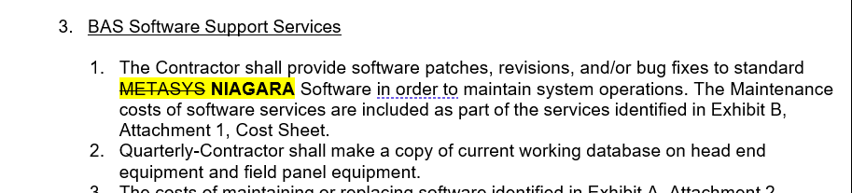

Q4: Please provide a model number and/or the manufacturer of the VAV Controller SM2-VAV86 in Equipment List, Exhibit A, Attachment 1.
A4: Staefa Smart 2 Controller 090-60230-03 V4.6 (Will need Smart 2 Hand Programming tool or PC Tool through DOSBOX to communicate / program)

Q5: Could you please provide the as-built controls drawings and BMS system architecture? Is a bill of materials (BOM) available?
A5: Please diagram below.



