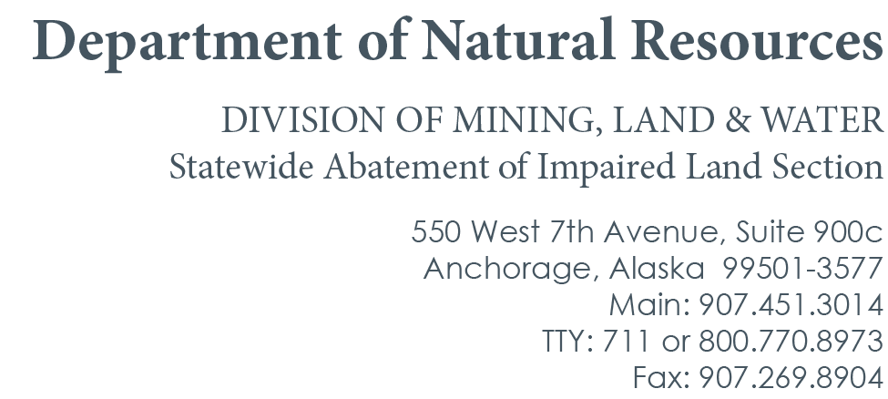
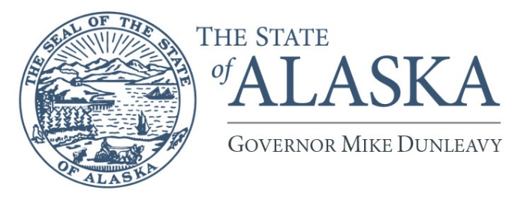

August 17, 2026
Notice of Intended Impoundment of a Derelict Vessel – ADL 234927
(AS 30.30.040)

Vessel Name: Unknown

Vessel Number(s): Unknown

Vessel Description: A 18-20 ft white cabin cruiser with blue upper cabin striping.
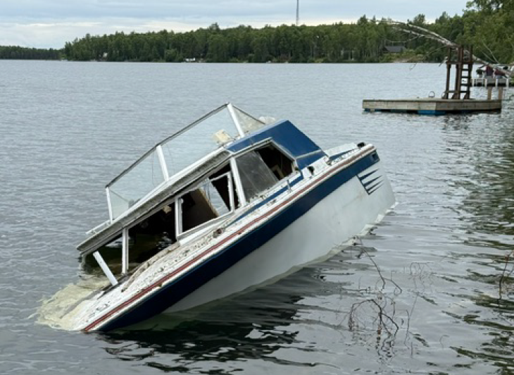

Vessel Location: Seymour Lake – Wasilla, AK, near the Mat-Su Borough public access ramp

Known Ownership Information: No known information. Vessel reported abandoned to the Department of Natural Resources on July 10, 2026.

The state intends to impound and dispose of the vessel if the vessel is not repossessed by the owner or a person with a financial or security interest in the vessel.

The owner of the vessel may file a written demand for a pre-impoundment hearing with the Department of Natural Resources within 15 days after the postmark date of this notice. If the written demand is made by a person who is not the owner of the vessel, the written demand must establish that the person requesting the hearing has an interest in the vessel. An owner or a person with a financial or security interest in the vessel who fails to request or attend a scheduled hearing waives the right to a hearing.

If requested, a pre-impoundment hearing must be conducted within 10 business days after the receipt of a written demand for a pre-impoundment hearing unless the person requesting the hearing consents to a later date.

If a hearing is requested, the Department of Natural Resources has the burden of showing substantial evidence that the vessel is derelict. After the hearing, the hearing officer shall issue a written decision of whether there is substantial evidence that the vessel is derelict. A copy of the decision shall be provided to the vessel owner and the person requesting the hearing, if other than the vessel owner.

If the hearing officer determines that there is substantial evidence establishing that the vessel is derelict, then the Department of Natural Resources may impound the vessel and proceed with disposition of the vessel as provided under AS 30.30.055.

If you have any questions or wish to request a hearing, please contact Kyrstyn Kelly (907-269-8528) or Kyrstyn.kelly@alaska.gov.

Hearing requests can also be sent to the address below:

Kyrstyn Kelly
550 W 7th Avenue, STE 900C
Anchorage, AK 99501

