STATE OF CALIFORNIA
California Science Center

Request for Quotation
DMP Security System Installation Services

Solicitation Release Date: 08/25/26  Mandatory Pre-bid Conference/ Walkthrough: 09/09/26 at 10:00 AM  Written Questions Due Date: 09/10/26 by 2PM  Written Response Release Date: 09/14/26 by 5PM  Quote Due Date: 09/16/26  Responses must be emailed or delivered to the California Science Center by 2PM on the quote due date.  Proposed Notice of Intent to Award: 09/18/26 by 5PM  Estimated Proposed Award: 09/28/26 |  |  |  |  |  |  | Return quote to:  California Science Center  700 Exposition Park Drive  Los Angeles, CA 90037  Or  EGuzman@californiasciencecenter.ca.gov |  |  |  |  |  |  |  |  | SOLICITATION NO. RFQ CSC 26-217  REVISION NO.
For further information contact:  Erica Guzman  213-744-2261  EGuzman@californiasciencecenter.ca.gov |  |  |  |  |  |  | Delivery Location:  California Science Center  Attn: Erica Guzman  700 Exposition Park Drive Los Angeles, CA 90037 |  |  |  |  |  |  |  |  | Delivery:  Final Delivery, inspection and acceptance shall be at the location described herein.
SUPPLIER INFORMATION
Supplier Name: |  |  |  |  |  |  | Address: |  |  |  |  |  |  |  |  | Contact Name:
 |  |  |  |  |  |  |  |  |  |  |  |  |  |  |  | Phone:
 |  |  |  |  |  |  |  |  |  |  |  |  |  |  |  | Fax:
Federal Employer Identification Number:
 |  |  |  |  |  |  |  |  |  |  |  |  |  |  |  | Email:
ARE YOU CLAIMING TO BE A CALIFORNIA CERTIFIED SMALL BUSINESS? |  |  |  |  |  |  | ARE YOU CLAIMING TO BE A CALIFORNIA CERTIFIED DISABLED VETERAN BUSINESS ENTERPRISE? |  |  |  |  |  |  |  |  | Name (Print):   
 |  |  |  |  |  |  |  |  |  |  |  |  |  |  |  | 
YES, No. |  |  |  |  |  | NO | YES, No. |  |  |  |  |  | NO
IF YES, MANUFACTURER? |  |  |  |  |  |  | IF YES, BROKER? |  |  |  |  |  |  |  |  | Title: 
YES NO N/A |  |  |  |  |  |  | YES NO N/A |  |  |  |  |  |  |  |  |     
ARE YOU A NON-SMALL BUSINESS CLAIMING AT LEAST 25% SMALL BUSINESS SUBCONTRACTOR PREFENCE? |  |  |  |  |  |  | ARE YOU A NON-DVBE CLAIMING DVBE SUBCONTRACTOR INCENTIVE? |  |  |  |  |  |  |  |  | Signature:
 |  |  |  |  |  |  |  |  |  |  |  |  |  |  |  | 
YES, No. |  |  |  |  |  |  NO | YES, No. |  |  |  |  |  | NO
 |  |  |  |  |  |  |  |  |  |  |  |  |  |  |  | Date:
$ |  |  |  |  |  |  |  |  |  |  | % $ |  |  |  |  | 
Bidder offers and agrees if this response is accepted within 45 calendar days following the date the response is due to furnish all the items upon which prices are quoted, at the prices set opposite each item, delivered at the designated point(s) by the method of delivery and within the times specified and subject to the attached General Provisions. DELCARATIONS UNDER PENALTY OF PERJURY; By signing above, with inclusion of the date of signature, the above signed bidder DECLARES UNDER PENALTY OF PERJURY under the laws of the State of California as follows: (1) (STATEMENT OF COMPLIANCE). The above signed as complied with the non-discrimination program requirements of Government Code 12990 and Title 2, California Administrative Code Section 8103, and such declaration is true and correct. (2) The National Labor Relations Board declaration set forth in Paragraph 48 of the General Provisions is true and correct. (3) If a claim is made for the Small Business or Disabled Veterans Business preference, the information set forth within is true and correct.

ITEM NO. |  |  | DESCRIPTION |  |  |  |  | QTY |  | UNIT |  | COMMODITY/ PRODUCT CODE |  |  |  |  |  | UNIT PRICE | EXTENSION
1. |  |  | Labor for installation service of Digital Monitoring Product (DMP) Security System |  |  |  |  | 1 |  | FIXEDRATE |  |  |  |  |  |  |  | $ | $
2. |  |  | Materials for installation |  |  |  |  | 1 |  | FIXED RATE |  |  |  |  |  |  |  | $ | $
SHIPPING/FREIGHT: |  |  |  |  |  |  |  |  |  |  |  |  |  |  |  |  |  |  | $
TAXABLE SUBTOTAL: |  |  |  |  |  |  |  |  |  |  |  |  |  |  |  |  |  |  | $
TAX: |  |  |  |  |  |  |  |  |  |  |  |  |  |  |  |  |  |  | $
NON-TAXABLE SUBTOTAL: |  |  |  |  |  |  |  |  |  |  |  |  |  |  |  |  |  |  | $
GRAND TOTAL: |  |  |  |  |  |  |  |  |  |  |  |  |  |  |  |  |  |  | $
Notes:
    - All services performed are paid in arrears according to billing cycle indicated above.
    - Shipping/Freight - Carrier freight bill will be required for freight costs over $50.00 prior to payment. Freight over 100 lbs. and/or over will be subject to freight rate analysis to determine best rates.
    - Taxes are assessed based upon where the products are physically received.
    - If sales tax is separately charged, Contractor shall provide a valid California Seller’s Permit number. If Contractor is the consumer of materials furnished and installed and sales tax is not separately charged, enter “$0.00” (Seller’s Permit not required for purposes of this bid).

REQUEST FOR QUOTATION CONTINUATION | Supplier Name: | Solicitation No.  RFQ CSC 26-217 | Rev.
Bid Requirements:
- Specifications: Vendor is required to meet all specifications as outlined in Specifications, Attachment 8.

- Bidder’s Instructions and General Provisions: Vendor is required to read the following carefully:
☒ Bidders Instructions (DGS PD 451) - Revised 11/09/11
☐ General Terms and Conditions for Non-IT Services contracts except for Interagency Agreements (GTC) – Revised 02/21/2025
☐ General Terms and Conditions for Non-IT Goods (DGS PD 401-NITGP Goods) – Revised 02/20/2025
☐ General Provisions Information Technology Cloud Computing Services (DGS PD 402-ITGP Cloud) – Revised 02/20/2025
☒ General Provisions Information Technology Non-Cloud Goods & Services (DGS PD 403-ITGP Non-Cloud) - Revised 02/20/2025

- Delivery: Delivery shall take place during regular working hours, 7:30 am to 4:00 pm., Monday through Friday, except State observed holidays. Final delivery, inspection and acceptance shall be at the location described herein.

- Tie Bids: In the event of a precise tie between vendors, a coin toss will determine the vendor to receive the award. Such event will be observed by witnesses and documented within the procurement file.

- Quotation Award: For the purposes of this solicitation, contract award will be made based on “All or None”.

- Cash Discounts: Cash discounts will not be considered when evaluating bid responses for award purposes. However, cash discounts may be offered and taken by departments processing invoices within the timeframe specified.

- Shipment: For the purposes of this solicitation, only responses quoting F.O.B Destination will be accepted.

- Inquiries/Questions: Written questions must be submitted to EGuzman@californiasciencecenter.ca.gov and received by 2:00 PM on 09/10/2026.
Science Center response to written questions will be provided by 5:00 PM on 09/14/2026.

- Quotation Attachments: Responses that reference a supplier’s own terms and conditions or provisions will be considered non- responsive and will be rejected.

- Important Note: Only offers quoted on the State’s own quotation forms will be considered. BID SHEET CANNONT BE ALTERED.
All fees must be included in the goods price.
Seller’s Permit: Science Center must be provided your company’s California Retailer’s Seller’s Permit or Certification of Registration and, if applicable, the permit or certification of all participating affiliates, issued by California’s State Board of Equalization (BOE), pursuant to all requirements as set form in Sections 6487, 7101 and sections 6452.1, 6487.3, 18510 of the Revenue and Taxation Code, and Section 10295.1 of the Public Contract code. See Seller’s Permit, Attachment 1. An award will be conditional until Science Center receives the required document.
Declaration Forms: All bidders must complete the Bidder Declaration (GSPD-05-105), Attachment 2 and include it with the response. When completing the declaration, bidders must identify all subcontractors proposed for participation in the contract. Bidders awarded a contract are contractually obligated to use the subcontractors for the corresponding work identified unless a written request for substitution is submitted and State agrees to it.

Per Military Veteran Code (MVC) 999.5, a prime contractor who commits to subcontracting to a Disabled Veteran Business Enterprise (DVBE) must complete the Prime Contractor Certification (Std. 817) upon completion of work to certify the following: The total amount the prime contractor received under the contract.

- The name and address of the disabled veteran business enterprise that participated in the performance of the contract and the contract number.
- The amount and percentage of work the prime contractor committed to provide to one or more disabled veteran business enterprises under the requirements of the contract and the amount each disabled veteran business enterprise received from the prime contractor.
- That all payments under the contract have been made to the disabled veteran business enterprise.

Contractor also agrees to certify on Prime Contractor’s Certification DVBE Subcontractor Report (Form STD 817) that DVBE subcontractor participation under this agreement is in compliance with the goals specified at the time of award of contract or with any subsequent amendment.

Upon request by the awarding department, the prime contractor shall provide proof of payment for the work. Per Military Veteran Code (MVC) 999.7, if a prime contractor who commits to subcontracting to a Disabled Veteran Business Enterprise (DVBE) fails to return a completed Std. 817 to the awarding department, then the awarding department shall withhold, on contracts entered into on or after January 1, 2021, ten thousand dollars ($10,000), until the prime contractor who committed to subcontracting to a Disabled Veteran Business Enterprise (DVBE) complies with the certification requirements of subdivision (d) of Section 999.5.

A prime contractor that fails to comply with the certification requirement shall, after notice, be allowed to cure the defect. Notwithstanding any other law, if, after at least 15 calendar days but not more than 30 calendar days from the date of notice, the prime contractor refuses to comply with the certification requirements, the awarding department shall permanently deduct ten thousand dollars ($10,000) from the final payment, or the full payment if less than ten thousand ($10,000).

At the State’s option prior to award, bidders may be required to submit additional written clarifying information. Failure to submit the required written information as specified will be grounds for rejection.
Recycled Content Products: State agencies are required to report purchases in many product categories. In order to comply with those requirements, contractors are required to complete and return the Recycled Content Certification Form, Attachment 4 with your bid response. Failure to complete and return the form will disqualify your bid from consideration.
Payee Data Record: The successful bidder is required to submit a Payee Data Record (Std. 204), Attachment 5 listing their Taxpayer Identification Number. Payee Data Record Supplement (Std. 205), Attachment 6 is optional. Form is used to provide remittance address information if different than the mailing address on the Std. 204 – Payee Data Record.
Proposers must follow State’s Bidder Instructions GSPD-451 and General Provisions Information Technology Non-Cloud Goods & Services (DGS PD 403-ITGP Non-Cloud)
GenAI Disclosure Notification: The State of California seeks to realize the potential benefits of GenAI, through the development and deployment of GenAI, while balancing the risks of these technologies.

Bidder/Offeror must notify the State in writing if it: (1) intends to provide GenAI as a deliverable to the State; or (2), intends to utilize GenAI, including GenAI from third parties, to complete all or a portion of any deliverable that materially impacts: (i) functionality of a State system, (ii) risk to the State, or (iii) Contract performance. For avoidance of doubt, the term "materially impacts" shall have the meaning set forth in State Administrative Manual (SAM) 4986.2.

Failure to report GenAI to the State may result in disqualification. The State reserves its right to seek any and all relief it may be entitled to as a result of such non-disclosure.

Upon notification by a Bidder/Offeror of GenAI as required, the state reserves the right to incorporate GenAI Special Provisions into the final contract or reject bids/offers that present an unacceptable level of risk to the state.

Government Code 11549.64 defines “Generative Artificial Intelligence (GenAI)” as an artificial intelligence system that can generate derived synthetic content, including text, images, video, and audio that emulates the structure and characteristics of the system’s training data.
Secretary of State: The Contractor shall be an individual or firm licensed to do business in California and shall obtain, at his/her expense, all licenses and permits required by law for accomplishing any work required in connection with a Purchase Order.

If a Contractor is located within the State of California, a business license from the City/County in which they are headquartered is necessary; however, if they are a corporation, a copy of their incorporation documents/letters from the Secretary of State’s Office can be submitted. If a Contractor is outside the State of California, they will need to submit to Science Center, a copy of their business license or incorporation papers for their respective State showing that their company is in good standing in that State.

In the event any licenses and/or permits expire at any time during the term of the Purchase Order, Contractor agrees to provide the Science Center, a copy of the renewed licenses and/or permits within thirty (30) days following the expiration date. In the event the Contractor fails to keep in effect, at all times, all required licenses and permits, the State may, in addition to any other remedies it may have, terminate the Purchase Order upon occurrence of such event.
Responsible Bidder: The California Science Center may require bidder(s) to submit evidence of their qualifications at such times and under conditions, as it may deem necessary. The question of whether a particular bidder is a responsible bidder may involve an evaluation of the bidder’s experience, type of facility, expertise or financial resources regarding the particular items requested by the pertinent solicitation. If a bidder has been determined to be non-responsible, the bid shall be rejected.
New Equipment: All equipment to be provided in response to a State of California solicitation shall be new and latest model in current production. USED, SHOPWORN, DEMONSTRATOR, PROTOTYPE OR DISCONTINUED MODELS ARE NOT ACCEPTABLE.
Emailed Quotes: If bids are submitted via email, the subject line must clearly identify the solicitation number and the offer due date.
Quotes submitted via email must be submitted to EGuzman@californiasciencecenter.ca.gov by the date and time specified on page one (1) of this RFQ.
Small Business Certification: Any bidder claiming to be a small business must possess certification by California prior to the day and time bids are due.

Small business nonprofit veteran service agencies (SB/NVSA) claiming to be a small business must possess certification by California prior to the day and time bids are due.

Procurement staff will complete the Commercially Useful Function (CUF) Evaluation Worksheet to determine if small business is CUF compliant at time of bid submission.

Questions regarding certification should be directed to the OSDS at (916) 375-4940.
Small Business Regulations: The Small Business regulations, located in the California Code of Regulations (Title 2, Division 2, Chapter 3, Subchapter 8, Section 1896 et. seq.), concerning the application and calculation of the small business preference, small business certification, responsibilities of small business, department certification, and appeals are revised, effective 09/09/04. The new regulations can be viewed at (www.pd.dgs.ca.gov/smbus). Access the regulations by Clicking on “Small Business Regulations” in the right sidebar. For those without Internet access, a copy of the regulations can be obtained by calling the Office of Small Business and DVBE Services at (916) 375-4940.
Non-Small Business Subcontractor Preference: A 5% bid preference is now available to a non-small business claiming 25% California certified small business subcontractor participation. If applicable, claim the preference in the box on the right-hand side of the first page of this solicitation.
Small Business Nonprofit Veteran Service Agencies (SB/NVSA): SB/NVSA prime bidders meeting requirements specified in the Military and Veterans Code Section 999.50 et seq. and obtaining a California certification as a small business are eligible for the 5% small business preference. If applicable, claim the preference in the box on the right-hand side of the first page of this solicitation.
Attachment with bid required if claiming the Small Business Preference: All bidders must complete and include the Bidder Declaration form GSPD-05-105. If claiming the non-small business subcontractor preference, the form must list all of the California certified small businesses with which you commit to subcontract in an amount of at least twenty-give percent (25%) of the net bid price. (GC 14838 et seq.)

All certified small businesses must perform a “commercially useful function” in the performance of the contract as defined in Government Code Section 14837(d)(4).
Disabled Veteran Business Enterprise Certification: Any bidder claiming to be a disabled veteran business enterprise must possess certification by California prior to the day and time bids are due. Procurement staff will complete the Commercially Useful Function (CUF) Evaluation Worksheet to determine if disabled veteran business enterprise is CUF compliant at time of bid submission. Questions regarding certification should be directed to the OSDS at (916) 375-4940.
California Disabled Veteran Business Enterprise (DVBE) Program Requirements:
“For the purposes of this solicitation, the DVBE program requirements have been exempted, but the DVBE incentive still applies.”

DVBE Bid Incentive: In accordance with Section 999.5(a) of the Military and Veterans Code an incentive will be given to bidders who provide DVBE participation. For evaluation purposes only, the State shall apply an incentive to bids that propose California certified DVBE participation as identified on the Bidder Declaration GSPD-05-105 and confirmed by the State. The incentive amount for awards based on low price will vary in conjunction with the percentage of DVBE participation. Unless a table that replaces the one below has been expressly established elsewhere within the solicitation, the following percentages will apply for awards based on low price.

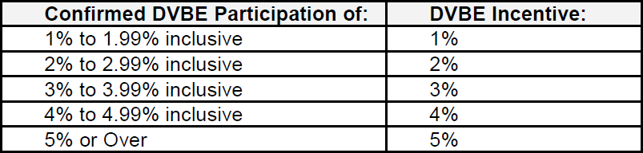

Awards based on low price - the net bid price of responsive bids will be reduced (for evaluation purposes only) by the amount of DVBE incentive as applied to the lowest responsive net bid price. If the #1 ranked responsive, responsible bid is a California certified small business, the only bidders eligible for the incentive will be California certified small businesses. The incentive adjustment for awards based on low price cannot exceed 5% or $100,000, whichever is less, of the #1 ranked net bid price. When used in combination with a preference adjustment, the cumulative adjustment amount cannot exceed $100,000.

Procurement staff will complete the Commercially Useful Function (CUF) Evaluation Worksheet to determine if DVBE is CUF compliant at time of bid submission.
Attachments: The following documents are considered part of this solicitation and those asterisked (*) must be returned with the quote response or the quote may be considered invalid and be rejected.

- Seller’s Permit, Attachment 1 (1 page) *
- Bidder Declaration Written (GSPD-05-105), Attachment 2 (2 pages) *
- C-10 Electrical contractor License, Attachment 3 (1 page)
- Recycled Content Certification (CalRecycle 74), Attachment 4 (2 pages) *
- Payee Data Record (STD 204), Attachment 5 (2 pages) *
- Payee Data Record (STD 205), Attachment 6 (2 pages) **
- Disabled Veteran Business Enterprise Declarations, Attachment 7 (1 page)**
- Exhibit A, Scope of Work (11 pages)

*Please note that Attachment #1, #2, #3, #4, #5, and Page 1 of the RFQ MUST be returned with the quotation or the quotation may be rejected. Page 1 and 2 MUST be completed in its entirety (e.g., amount of each item needs to include a dollar amount. Please refrain from stating see quote, see totals, see subtotals, bulk price, etc., or leaving blank.).
**Bidder must return Attachment #6 and #7 if applicable.
Page 1 and 2 MUST be completed in its entirety (e.g., amount of each item needs to include a dollar amount. Please refrain from stating see quote, see totals, see subtotals, bulk price, etc., or leaving blank.).

Attachment 1 – California Retailer’s Seller’s Permit
- Does your company have a presence in California? |  |  |  |  | ☐ Yes ☐ No
- If yes, proceed to Question 2.
- If no, initial each statement below that is applicable to your company:
 |  | Company is located outside of California.
 |  | Company does not have any office, sales room, warehouse, or place of business in California.
 |  | Company does not have any sales representative(s), agent(s), or canvasser(s) located in California.
 |  | Company does not receive any rental payments from the lease of tangible personal property in California.
Note: A California Retailer’s Seller’s Permit or Certification of Registration is required for this award unless all the exemptions listed above are applicable. As a company, you are responsible for self-certifying that each item supporting a Seller’s Permit exemption is or not applicable.
- Do you intend to sell or lease good or services that would ordinarily be subject to sales tax if sold at retail? |  |  |  |  | ☐ Yes ☐ No
- If no, action is not required.
- If yes,

- Provide CA Retailer’s Seller’s Permit Number: |  |  |  |  |  |  | AND
- Attach a copy of your company’s California Retailer’s Seller’s Permit or Certification of Registration, and if applicable, the permit or certification of all participating affiliates, issued by the California State Board of Equalization (BOE), which is pursuant to all requirements set forth in Sections 6487, 7101 and sections 6452.1, 6487.3, 18510 of the Revenue and Taxation Code, and Section 10295.1 of the Public Contract Code.

Note: This Attachment, and if applicable, a copy of your company’s California Retailer’s Seller’s Permit or Certification of Registration must be returned with your RFQ response or be considered non-responsive, and the bid rejected.

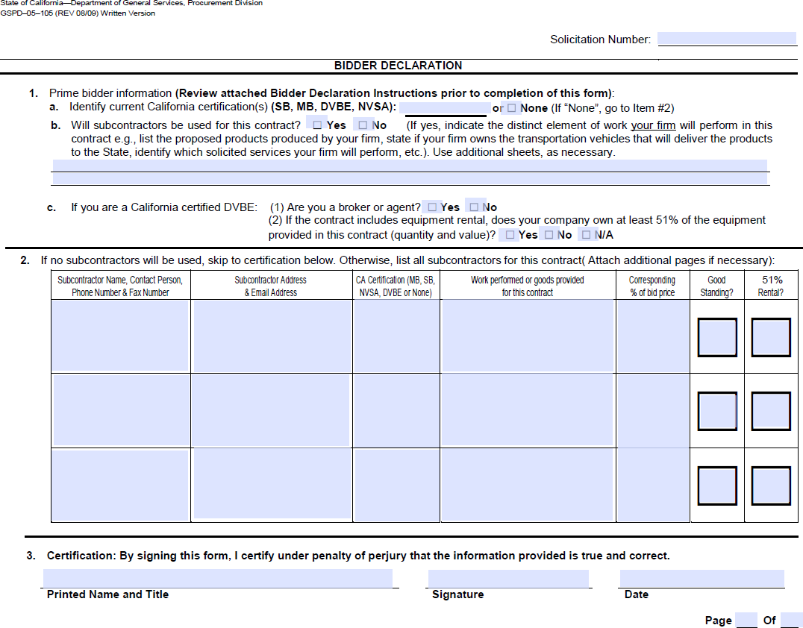
Attachment 2 – Bidder Declaration

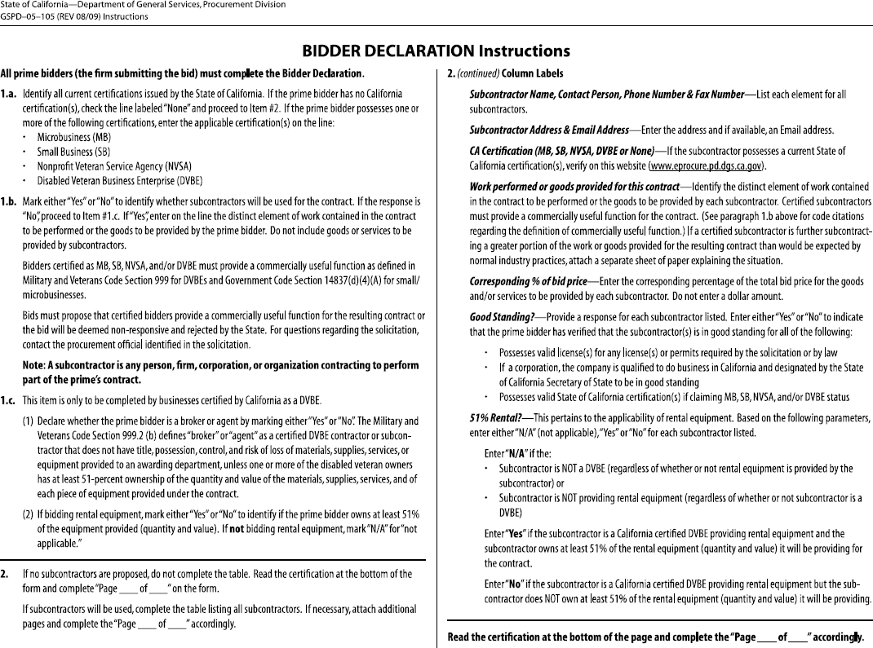

Attachment 3 – C-10 Electrical Contractor License

Copies of the bidder’s C-10 Electrical Contractor License issued by the State of California’s Contractors State Licensing Board issued are required for bid to be considered responsive. Below are samples of Contractor Licenses.


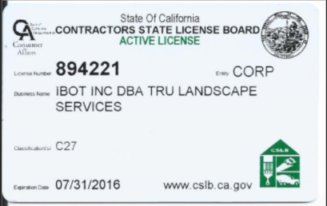

SAMPLE

Attachment 4 – Postconsumer Recycled-Content Certification

STATE OF CALIFORNIA  Department of Resources Recycling and Recovery (CalRecycle)  CalRecycle 74 (Revised 01/23) | To be completed by the State agency
 | State Agency:
Postconsumer Recycled-Content Certification | Purchasing Agent: | PO #:
Postconsumer Recycled-Content Certification | Phone: | E-mail:

The State Agency Buy Recycled Campaign (SABRC) is a state mandated program that requires the reporting of all purchases made within 16 specified product categories. All state agencies are required to verify the recycled-content of all products purchased within each of these categories.
All businesses shall certify the minimum percentage in writing to the contracting officer or his or her representative, if not the exact percentage, of postconsumer recycled-content (PCRC) material in the products, materials, goods, or supplies offered or sold to the State regardless of whether the product meets the minimum content requirements specified in law (see reverse side). The certification shall be furnished under penalty of perjury. The certification shall be provided regardless of content, even if the product contains no recycled material. A State agency may waive the certification requirement if the percentage of postconsumer material in the products, materials, goods, or supplies can be verified in a written advertisement, including, but not limited to, a product label, a catalog, or a manufacturer or vendor Internet website.
Public Contract Code sections 12205(a)(1), (2), (3) and (b)(1), (2), and (3)
Contractor/Company Name_________________________________________________________________________________
Address_____________________________________________________________________Phone___________________

Purchase Order #  RFQ #  RFP #  IFB #  Cal Card Order # | Item # | Product or Services Description | ¹Percent Postconsumer Recycled-Content Material | ²SABRC Product Category Code | Meets SABRC

Pursuant to Public Contract Code 12205(b)(1), I certify under penalty of perjury under the laws of the State of California that the above information is true and correct.
___________________________________________________________________________________________________
Print Name Signature Title Date
FOOTNOTES:
- “Postconsumer recycled-content material” is defined as products that were bought, used, and recycled by consumers. For example, a newspaper that has been purchased, recycled, and used to make another product would be considered postconsumer material.
- “Product category” refers to one of the categories listed below, into which the reportable purchase is best placed.
- If the product does not belong in any of the product categories, enter “N/A.” Common “N/A” products include wood products, aggregate, concrete, and electronics such as computers, TV, software on a disk or CD, and telephones.
- For reused or refurbished products, there is no minimum content requirement. (PCC 12209(l))

California Department of Resources Recycling and Recovery (CalRecycle)
State Agency Buy Recycled Campaign (SABRC) - SABRC@CalRecycle.ca.gov
Code* | Product Categories | Product Subcategories | Product Examples in each SABRC Category (PCC 12207 )  Examples include, but are not limited to, these individual products/materials. | Minimum Post-Consumer Content Requirement per Statute (PCC 12209 )
1A | Paper Products | Toilet Paper | Toilet paper. | 45 percent by fiber weight post-consumer fiber.
1B | Paper Products | Paper Towels | Paper towels. | 40 percent by fiber weight post-consumer fiber.
1C | Paper Products | Facial Tissues | Facial tissue. | 10 percent by fiber weight post-consumer fiber.
1D | Paper Products | Toilet Seat Covers | Toilet seat covers. | 20 percent by fiber weight post-consumer fiber.
1E | Paper Products | General Purpose Paper Wipes | General purpose paper wipes. | 40 percent by fiber weight post-consumer fiber.
1F | Paper Products | Food Serviceware | Napkins, plates, bowls, food trays, takeout boxes, and placemats. | 40 percent by fiber weight post-consumer fiber.
1G | Paper Products | Miscellaneous Paper Products | Cartons, wrapping, packaging, file folders, hanging folders, building insulation and panels, corrugated boxes. | 30 percent by fiber weight post-consumer fiber.
2 | Printing and  Writing Papers | Printing and Writing Papers | Copy, xerographic, watermark, cotton fiber, offset, forms, computer printout paper, white wove envelopes, manila envelopes, book paper, note pads, writing tablets, newsprint, and other uncoated writing papers, posters, index cards, calendars, brochures, reports, magazines, and publications. | 30 percent by fiber weight post-consumer fiber.
3A | Soil Amendments and Toppings | Compost | Soil amendments, soil conditioner for potting or plant mix, organic materials used for water conservation; organic materials such as biosolids or other comparable substitutes such as livestock, horse, or other animal manure, food residues or fish processing byproducts; mechanical breakdown of materials. | 80 percent recovered material that would otherwise be normally disposed of in a landfill.
3B | Soil Amendments and Toppings | Mulch | Ground covers, weed suppressants. | 80 percent recovered material that would otherwise be normally disposed of in a landfill.
4A | Glass Products | Glass Products | Windows, test tubes, beakers, laboratory or hospital supplies, reflective beads, tiles, construction blocks, desktop accessories, flat glass sheets, loose- grain abrasives, deburring media, liquid filter media, and containers. | 25 percent post-consumer, by weight.
4B | Glass Products | Fiberglass | Fiberglass (insulation), | 30 percent post-consumer, by weight.
5 | Lubricating Oils |  | Intended for use in a crankcase, transmission, engine, power steering, gearbox, differential chainsaw, transformer dielectric, fluid, cutting, hydraulic, industrial, or automobile, bus, truck, vessel, plane, train, heavy equipment, or machinery powered by an internal combustion engine. | 70 percent re-refined base oil.
6 | Plastic Products |  | Printer or duplication cartridges, diskette, carpet, office products, plastic lumber, buckets, wastebaskets, containers, benches, tables, fencing, clothing, mats, packaging, signs, posts, binders, sheet, buckets, building products, garden hose, and trays. | 20 percent postconsumer, by weight; is remanufactured or has a take back program.
7A | Paint: | Low-VOC: < 50 grams/liter | Water-based paint, graffiti abatement, interior and exterior, and maintenance. | 50 percent post-consumer paint.
7B | Paint: | Other VOC: > 50 grams/liter | Water-based paint, graffiti abatement, interior and exterior, and maintenance. | 50 percent post-consumer paint.
8 | Antifreeze |  | Recycled antifreeze, and antifreeze containing a bittering agent or made from  polypropylene or other similar non-toxic substance. | 70 percent post-consumer material.
9 | Tires (Retreaded tires) |  | Truck and bus tires, and those used on fleet vehicles (and passenger cars where available). | Retreaded: Must use an existing casing that has undergone retreading or recapping process in accordance with Public Resource Code (commencing with section 42400).
10 | Tire- Derived Products |  | Flooring, mats, wheelchair ramps, playground surfacing, sports surfacing, parking bumpers, bullet traps, hoses, bumpers, truck bedliners, pads, walkways, tree ties, wheel chocks, rollers, traffic-related products, mudflaps, accessibility ramps, paths and sidewalks, animal care products, including, but not limited to, horse arena surfacing, stall mats, cow mats, and equestrian barn and breezeway flooring, artificial turf, landscaping and rubber mulch, outdoor surfacing, pavers and tiles, and posts. | 50 percent recycled used tires.
11A | Metal Products | Metal Products | Staplers, paper clips, steel furniture, desks, pedestals, scissors, jacks, rebar, pipe, plumbing fixtures, chairs, ladders, file cabinets, shelving, containers, lockers, sheet metal, girders, building and construction products, bridges, braces, nails, and screws. | 10 percent post-consumer material, by weight.
11B | Metal Products | Vehicles | Vehicles. | 10 percent post-consumer material, by weight.
12 | Building Finishes | Open Office Panel Systems | Open office panel systems. | Middle range of state contracts.
13 | Carpet |  | Carpet | Determined by DGS and Posted in SCM.
14A | Erosion Control Products | Compost Filter Socks | Compost filter sock. | 100 percent post-consumer material.
14B | Erosion Control Products | Compost Blanket | Compost blanket, layer of compost protecting bare soil surfaces. | 100 percent post-consumer material.
14C | Erosion Control Products | Hydraulic Mulch | Hydraulic mulch or erosion control process that uses fiber slurry and tackifier. | 100 percent post-consumer material.
15A | Textiles | Textiles |  | 0 percent post-consumer material.
15B | Textiles | General Textile Wipes | General purpose wipes. | 100 percent post-consumer material.
16A | Pavement Surfacing | Rubberized Pavement Surfaces | Rubberized asphalt concrete and chip seal. | 15 percent post-consumer material.
16B | Pavement Surfacing | Recycled Asphalt Pavement | Recycled Asphalt Pavement | 25 percent post-consumer material.
*It is each agency’s prerogative to assign internal codes/object codes for post-consumer recycled content products based on their internal paper or computer tracking systems.
For additional information, please visit www.CalRecycle.ca.gov/BuyRecycled/StateAgency/

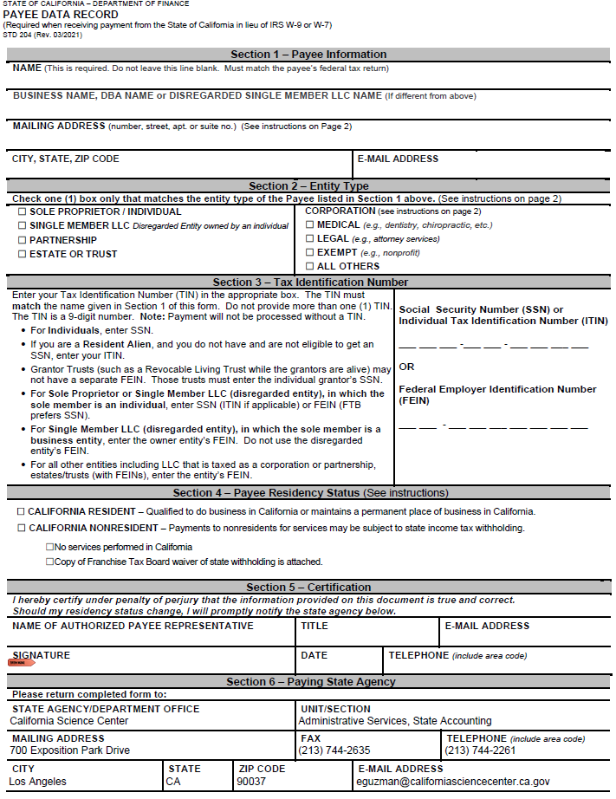
Attachment 5 – Payee Data Record (Std. 204)
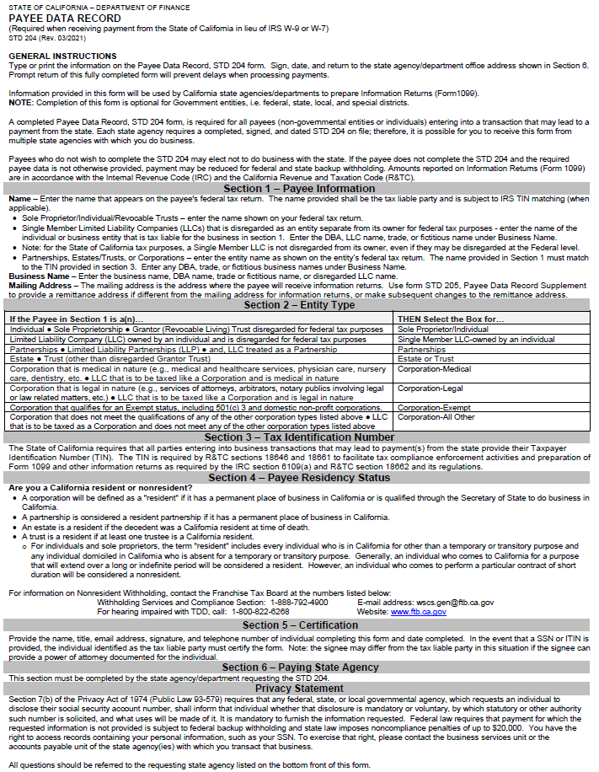

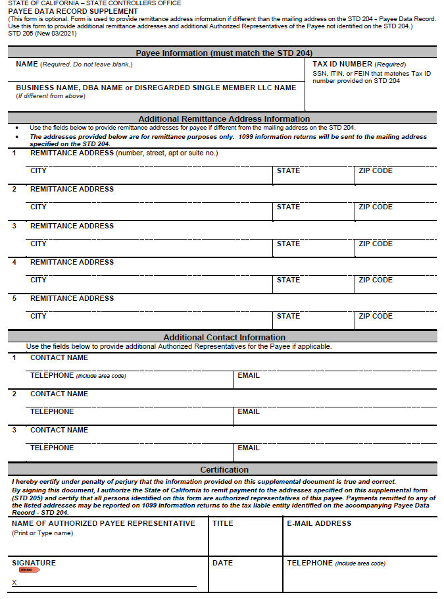
Attachment 6 – Payee Data Record Supplement (Std. 205)
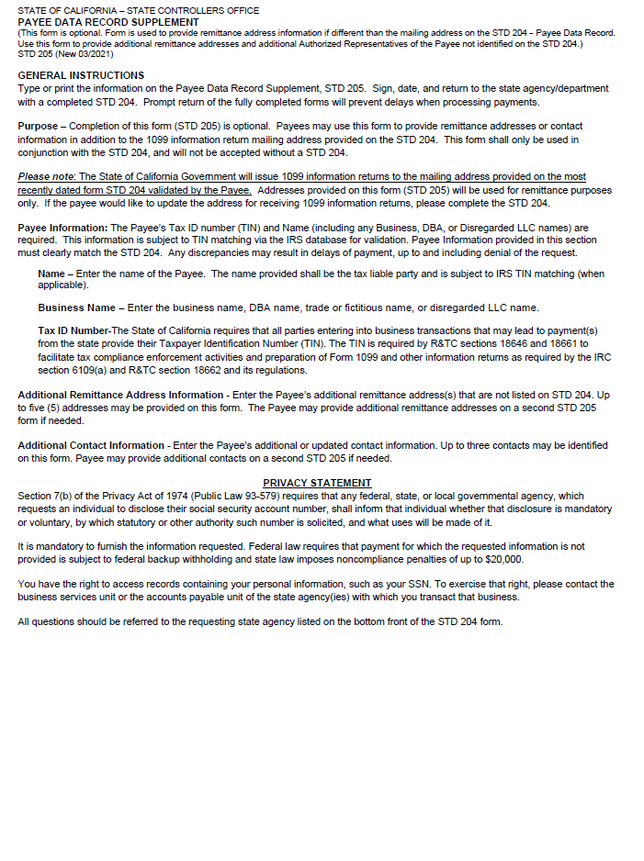

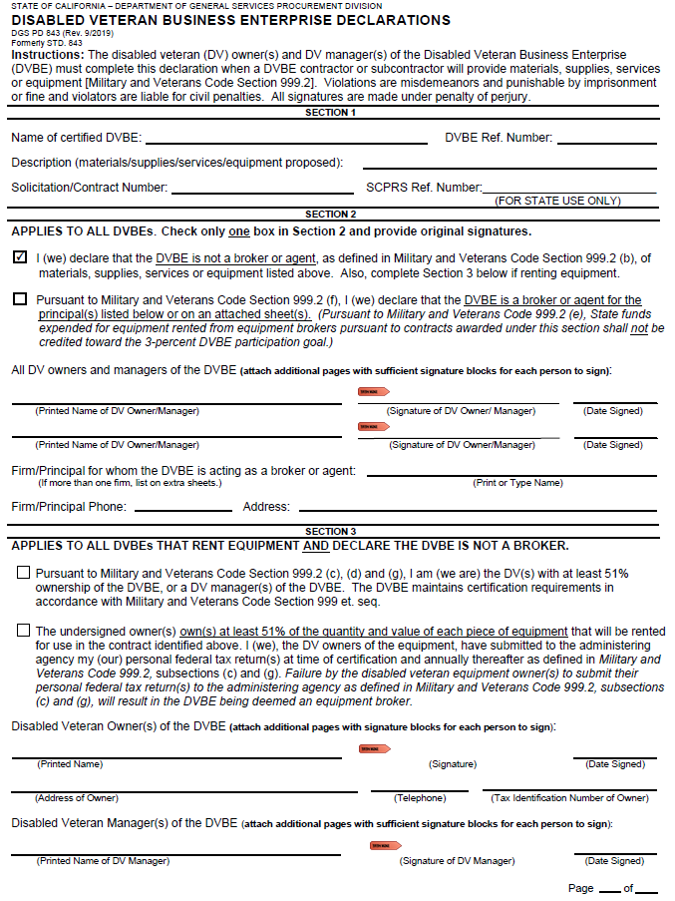
Attachment 7 – DVBE Declarations

Exhibit A – Scope of Work

- Service and Work: Contractor agrees to provide to California Science Center (“Science Center”) all materials, supplies, equipment and labor necessary to install door contact alarms, motion detectors, keypads, glass break contacts, panic buttons and to integrate all with the existing Digital Monitoring Product (DMP) Security System. This service includes configuration and programming of the System Link (LT-0569) software to ensure all new hardware is fully functional within the existing local monitoring database.

- Background Information: The DMP Security System will provide security solutions for intrusion detection and access control in the new temporary exhibit gallery Phase 1 2nd Floor, the new crate room Phase 3, and the new moon rock display cases Phase 3, safeguarding assets and artifacts on display at the Science Center. Core components of the system include control panel, keypads for arming/disarming and system control, sensors/detection devices, and communication module.

- Hours of Service: Work shall take place between 6:00 AM and 3:00 PM, Monday through Friday, excluding State holidays, unless otherwise approved by Science Center Contract Manager or designee. Contractor must notify Science Center Contract Manager of any delays in schedule as soon as possible.

- Service Locations and Schedule: Services will take place on the 2nd Floor Gallery of Ahmanson building (Phase 1) and on the 2nd Floor and Ground Level areas in Samuel Oschin Air and Space Center (Phase 3) at the California Science Center, located at 700 Exposition Park Drive, Los Angeles, California 90037.

- Licenses and Permits: C10 – ELECTRICAL from the California State License Board is required for this project. Licenses and permits required must be provided by Contractor and he/she shall abide by all Federal, State, and city laws or rules affecting the work and shall maintain all required protection for property, employees, and the public and insurance in connection with same, for all of which he/she shall bear the necessary expense.

- Contractor Responsibilities:
- Contractor shall schedule service dates and times with Science Center Contract Manager prior to arrival to the California Science Center.
- Contractor shall provide any equipment, including lifts, if necessary to complete services.
- Contractor shall inspect 2nd Floor Gallery space in Phase I to verify field measurements and determine all materials needed to complete service.
- Contractor shall inspect Crate Room in Phase 3 to verify field measurements and determine all materials needed to complete service.
- Contractor shall inspect Moon Rock displays in Phase 3 to verify measurements and determine all materials needed to complete service.
- Contractor shall complete installation according to manufacturer's specifications.
- Contractor shall provide all labor and materials needed to complete service, including but not limited to the following:
  - (6) roll up door heavy duty door/WAN contacts,
  - (11) double door contacts,
  - (3) single door contacts,
  - (6) motion detectors
  - (2) keypad for arming & disarming,
  - (2) DMP 16 zone expanders or equivalent,
  - (4) Glass Break/Contacts
  - (4) Panic Buttons
  - Any cat6 cable, 22/4 standard wire, and any other materials needed.
- Contractor shall install door/WAN contacts as directed.
- Contractor shall install motion detectors as directed.
- Contractor shall install DMP 16 zone expanders as directed.
- Contractor shall install the keypads where directed.
- Contractor shall install Glass Break/Contact alarms for Moon Rock display located on Ground Level, Shuttle Gallery in Phase 3 as directed.
- Contractor shall install (4) Panic Buttons in Phase 3 as directed:
  - (3) in Phase 3 Retail Store
  - (1) in Phase 3 Box Office
- Contractor shall connect power.
- Contractor shall wire devices.
- Contractor shall install communication modules.
- Contractor shall utilize the existing System Link (LT-0569) software to program the DMP system including, but not limited to:
  - Defining zones new zones and updating the database of panel programming files and event buffers.
  - Setting user codes, authority levels, and arming/disarming schedules for the new hardware.
  - Configuring communication settings for internet access while ensuring no unauthorized cloud-based or GenAI features are enabled.
- Contractor shall perform the installation according to manufacturer specifications.
- Contractor shall perform testing of the Digital Monitoring Product (DMP) Security System and confirm successful integration with the currently operating security system, including power sources.
- Contractor shall troubleshoot any issues that arise as a result of the installation and deliver timely, effective solutions.
- Contractor shall provide training to Science Center Contract Manager including how to arm & disarm the system and how to check the system status.
- Contractor shall provide the Science Center Contract Manager with relevant documentation, user knowledge required for continued operation, and final service report upon completion.
- Contractor shall limit work in public areas of the museum, to minimize any disruptions to museum visitors. Work in these areas shall take place before 10 AM.
- Contractor shall return all parking passes and contractor badges to Science Center Contract manager upon completion of work. Contractor shall take care not to damage the parking passes and contractor badges and ensure that they are reusable. The replacement cost will be determined based on the current fee schedule. This cost may be deducted from final payment or invoiced separately.

- California Science Center Responsibilities:
- Science Center will provide Contractor access to job site with a contractor badge upon request from Science Center Contract Manager. Upon completion of work, Science Center Contract Manager or designee shall collect the badge from the Contractor.
- Science Center shall provide a parking pass to the Contractor for each month the Contractor requires a vehicle in order to perform the work or commute to the work site. Upon completion of work, Science Center Contract Manager or designee shall collect the parking pass from the Contractor.
- The Science Center Contract Manager will provide the Contractor with the necessary credentials and permissions to perform the services listed. These credentials and permissions shall be strictly minimal, temporary, and limited only to the purpose of the System Link (LT-0569) installation/configuration, which shall not exceed Custodian-level privilege. If a higher privilege is required to complete an authorized task, it shall be granted only under the following safeguard conditions:
  - The task requiring elevated access must be performed by Science Center personnel while the Contractor provides expert guidance and direction; or
  - Higher-level credentials will be issued to the Contractor for a limited time duration, with the elevated privilege automatically revoked immediately upon completion of the authorized task or at the end of the predefined window, whichever comes first.

- Warranty: Contractor shall warranty for a period of 90 days from the date of completion against defect of workmanship.

- Acceptance Criteria: Work must be completed to the satisfaction of the Science Center Contract Manager. If services have been satisfactorily completed, Science Center Contract Manager shall approve and accept that the services have been completed. Science Center is solely responsible for determining acceptability of the work performed in order for the work specified in this Contract to be considered complete. If the Science Center Contract Manager has any concerns, they must be addressed with the Contractor immediately and may require correction of work before acceptance.

- Housekeeping: Contractor is responsible for leaving the work site clean and free from debris at the end of each working day.

- Amendments: No charge for any extra work or material will be allowed unless the same has been ordered in writing by the Science Center Contract Manager or designee and with the approval of Science Center for prices stated in such order at which point an approved amendment to this contract would be needed before work is performed or the material is purchased.

Additional amendments required to extend the life of the Contract due to unforeseen circumstances must be approved by both parties and signed as a formal amendment.

- Acceptable Use:
  - Support Services - The Contractor is permitted to access the California Science Center's DMP Security System and associated System Link (LT-0569) software solely for the purpose of providing technical support services, including but not limited to system troubleshooting, maintenance, configuration adjustments, and routine system checks. The Contractor shall provide these services in accordance with industry best practices.

- Technology Recovery Plan and Business Continuity Plan: Contractor shall fully cooperate with the Science Center to ensure the continuity of services and assist in the recovery of State data in the event of an outage or disaster. The Contractor must maintain and provide to the Science Center, upon request, a documented technology recovery plan and business continuity plan for the contracted services. This plan must explicitly define how the Contractor will support the Science Center’s established Recovery Time Objectives (RTOs) and Recovery Point Objectives (RPOs) for the system. The Contractor must also participate in and provide supporting documentation for any disaster recovery tests conducted by the Science Center at least annually. The Contractors’ failure to maintain a tested and documented plan that meets the Science Center’s RTO and RPO requirements may be considered a material breach of this Agreement.

- Project Representatives:
  - Contract Managers during the term of this agreement will be responsible for all contract-related communications, including Security Incident and Breach Notifications pursuant to DGS PD 402 section 21.11 and SIMM 5340-A:
State  Agency: | California Science Center | Contractor: TBD
Name: | Hilda Gallarza | Name:
Title: | Staff Services Manager I | Title:
Phone: | (213) 744-2135 | Phone:
Email: | hgallarza@californiasciencecenter.ca.gov | Email:

  - Direct invoicing inquiries to:
State  Agency: | California Science Center | Contractor: TBD
Name: | Joanne Chen | Name:
Title: | Contracts Analyst | Title:
Address: | 700 Exposition Park Dr., Los  Angeles, CA 90037 | Address:
Phone: | (213) 744-2695 | Phone:
Email: | jchen@californiasciencecente  r.ca.gov | Email:

  - The parties may change their Contract Representative(s) upon providing ten (10) days written notice to the other party’s Contract Representative(s). The notifying party shall provide complete contact information for the replacement Contract Representative(s) to include the information provided above.

Exhibit B – Budget Detail and Payment Provisions

  - Invoicing and Payment
- For services satisfactorily rendered in accordance with Exhibit A, Scope of Work, and upon receipt and approval of invoices, the State agrees to compensate the Contractor at the rates specified in the Cost Sheet below.

- Invoices shall include the Agreement Number, and shall be submitted in arrears (upon completion of each scheduled service) to:

California Science Center
Attn: Accounts Payable - State
700 Exposition Park Drive
Los Angeles, CA 90037

  - Budget Contingency Clause

- It is mutually agreed that if the Budget Act of the current year and/or any subsequent years covered under this Agreement does not appropriate sufficient funds for the program; this Agreement shall be of no further force and effect. In this event, the State shall have no liability to pay any funds whatsoever to Contractor or to furnish any other considerations under this Agreement and Contractor shall not be obligated to perform any provisions of this Agreement.

- If funding for any fiscal year is reduced or deleted by the Budget Act for purposes of this program, the State shall have the option to either cancel this Agreement with no liability occurring to the State or offer an agreement amendment to Contractor to reflect the reduced amount.

  - Prompt Payment Clause: Payment will be made in accordance with, and within the time specified in, Government Code Chapter 4.5, commencing with Section 927.

  - Cost Sheet: The Contractor agrees to be paid at the rates specified below. Such rates shall remain fixed and binding for the term of the Agreement. Services shall be invoiced and paid in arrears in accordance with the billing cycle indicated below. Upon contract award, this section will be updated with the awarded bidder’s cost from the RFQ.

Exhibit C – General Terms and Conditions

General Provisions Information Technology Non-Cloud Goods & Services (DGS PD 403-ITGP Non-Cloud) – Revised 02/20/2025 can be viewed on:
https://www.dgs.ca.gov/-/media/Divisions/PD/Acquisitions/Solicitation-Document-Attachments/IT-General-Provisions-NonCloud-DGS-PD-403ITGP-Revised-02202025.pdf

They are incorporated by reference and made part of this agreement as if attached hereto.

Exhibit D – Special Terms and Conditions

- The Contractor shall provide a written notice to the California Science Center at least thirty (30) calendar days prior to any changes in the Contractor’s current legal name. Upon receipt of required documentation, an amendment will be processed in accordance with the terms of this Agreement.

The California Science Center reserves the right to bar any Contractor’s employee from the work site.

- Certificate of Insurance: Contractor shall maintain a Certificate of Insurance in compliance with the Insurance Requirements detailed in Exhibit E, Additional Provisions section of this package.

- System Access and IT Security Training: Contractor shall provide a list of personnel requiring access to state systems or data, including names and email addresses, for the purposes of account setup, access control, and mandatory IT security training. The Science Center will provide mandatory IT security training to applicable personnel, which must be successfully completed prior to gaining system access.

- Letter of Compliance: Contractor must provide the California Science Center with a Letter of Compliance stating staff assigned to this job will maintain compliance with the items below, including Criminal Background Clearance and Personnel Vetting, Tuberculosis (TB) Testing Verification, and Privacy and Notice on Collection. The Contractor shall maintain supporting documentation demonstrating compliance with these requirements and provide such documentation to the Science Center upon request. The Contractor’s failure to comply with any requirement set forth in this section shall be considered a material breach of the Agreement.

  - Criminal Background Clearance and Personnel Vetting: All Contractor staff working at the California Science Center facilities or requiring access to state systems and data must successfully pass a criminal history clearance from the California Department of Justice prior to performing services or receiving access. The Contractor shall ensure personnel are properly vetted and free of any fraudulent history.

  - Tuberculosis (TB) Testing Verification: Contractor shall ensure all staff assigned to this project have completed and satisfied TB testing requirements prior to commencement of services. Education Code Section 49406 and Board Rule 1950 of the Los Angeles Unified School District require employees to prove freedom from active TB every four years. A TB skin test (Mantoux) is mandatory unless Contractor staff previously tested positive, in which case a chest x-ray is required. Any costs associated with TB testing shall be the responsibility of the Contractor.

  - Privacy and Notice on Collection: Contractor shall be responsible for providing a Notice on Collection, in compliance with the California Information Practices Act of 1977 and the CCPA, to all personnel whose Personally Identifiable Information (PII) will be shared with the Science Center for training and vetting purposes.

- Accident Prevention: Contractor shall exercise precaution at all times for the protection of persons (including employees) and property. These shall include, but not be limited to, the installation of adequate safety guards and protective devices for all equipment and machinery, whether used in the performance of work or permanently installed as part of the work. Contractor shall comply with all applicable laws relating to safety precautions, including the safety regulations of the Division of Industrial Safety, Department of Industrial Relations, of the State.

- Emergency Evacuation Plan and Protocols: Contractor shall follow the California Science Center’s emergency evacuation plan and protocols, and participate in emergency drills.

- DVBE Subcontracting Commitment:

  - Per Military Veteran Code (MVC) 999.5, a prime contractor who commits to subcontracting to a Disabled Veteran Business Enterprise (DVBE) must complete the Prime Contractor Certification (STD 817) upon completion of work to certify the following:

    - The total amount the prime contractor received under the contract.

    - The name and address of the disabled veteran business enterprise that participated in the performance of the contract and the contract number.

    - The amount and percentage of work the prime contractor committed to provide to one or more disabled veteran business enterprises under the requirements of the contract and the amount each disabled veteran business enterprise received from the prime contractor.

    - That all payments under the contract have been made to the disabled veteran business enterprise.

  - Contractor also agrees to certify on Prime Contractor’s Certification DVBE Subcontractor Report (Form STD 817) that DVBE subcontractor participation under this agreement is in compliance with the goals specified at the time of award of contract or with any subsequent amendment.

  - Upon request by the awarding department, the prime contractor shall provide proof of payment for the work.

  - Per Military Veteran Code (MVC) 999.7, if a prime contractor who commits to subcontracting to a Disabled Veteran Business Enterprise (DVBE) fails to return a completed STD 817 to the awarding department, then the awarding department shall withhold, on a contracts entered into on or after January 1, 2021, ten thousand dollars ($10,000) from the final payment, or the full final payment if less than ten thousand dollars ($10,000), until the prime contractor who committed to subcontracting to a Disabled Veteran Business Enterprise (DVBE) complies with the certification requirements of subdivision (d) of section 999.5. A prime contractor that fails to comply with the certification requirement shall, after notice, be allowed to cure the defect. Notwithstanding any other law, if, after at least 15 calendar days but not more than 30 calendar days from the date of notice, the prime contractor refuses to comply with the certification requirements, the awarding department shall permanently deduct ten thousand dollars ($10,000) from the final payment, or the full payment if less than ten thousand dollars ($10,000).

Exhibit E – Additional Provisions

- General Provisions Applying to All Policies:

  - Coverage Term: Coverage needs to be in force for the complete term of the contract. If insurance expires during the term of the contract, a new certificate must be received by the State at least thirty (30) days prior to the expiration of this insurance. Any new insurance must still comply with the original terms of the contract. New certificates of insurance are subject to the approval of DGS/ORIM, and the contractor agrees that no work or services shall be performed prior to such approval.

  - Policy Cancellation or Termination & Notice of Non-Renewal: Insurance policies shall contain a provision stating coverage will not be cancelled without 30 days prior written notice to the State. Contractor is responsible to notify the State within five (5) business days of any cancellation, non-renewal or material change that affects required insurance coverage. In the event Contractor fails to keep in effect at all times the specified insurance coverage, the State may, in addition to any other remedies it may have, terminate this Contract upon the occurrence of such event, subject to the provisions of this Contract.

  - Deductible: Contractor is responsible for any deductible or self-insured retention contained within their insurance program.

  - Primary Clause: Any required insurance contained in this contract shall be primary, and not excess or contributory, to any other insurance carried by the State.

  - Insurance Carrier Required Rating: All insurance companies must carry a rating acceptable to the Office of Risk and Insurance Management. If the Contractor is self-insured for a portion or all of its insurance, review of financial information including a letter of credit may be required.

  - Endorsements: Any required endorsements requested by the State must be physically attached to all requested certificates of insurance and not substituted by referring to such coverage on the certificate of insurance.

  - Inadequate Insurance: Inadequate or lack of insurance does not negate the contractor’s obligations under the contract.

  - Use of Subcontractors: In the case of Contractor’s utilization of subcontractors to complete the contracted scope of work, contractor shall include all subcontractors as insureds under Contractor’s insurance or supply evidence of subcontractor’s insurance to The State equal to policies, coverages, and limits required of Contractor.

  - Satisfying an SIR: All insurance required by this contract must allow the State to pay and/or act as the contractor’s agent in satisfying any self-insured retention (SIR). The choice to pay and/or act as the contractor’s agent in satisfying any SIR is at the State’s discretion.

  - Available Coverages/Limits: All coverage and limits available to the contractor shall also be available and applicable to the State.

- Insurance Requirements:

  - Commercial General Liability: Contractor shall maintain general liability on an occurrence form with limits not less than $1,000,000 per occurrence for bodily injury and property damage liability combined with a $2,000,000 annual policy aggregate. The policy shall include coverage for liabilities arising out of premises, operations, independent contractors, products, completed operations, personal & advertising injury, and liability assumed under an insured contract. This insurance shall apply separately to each insured against whom claim is made or suit is brought subject to the Contractor’s limit of liability.

The policy must include: The State of California, its officers, agents, and employees as additional insured, but only with respect to work performed under the contract. This additional insured endorsement must accompany the certificate of insurance in form acceptable to the Office of Risk Management (ORIM). The certificate of insurance shall meet such additional standards as may be determined by the contracting State agency, either independently or in consultation with ORIM, as necessary for protection of the State.

In the case of Contractor’s utilization of subcontractors to complete the contracted scope of work, contractor shall include all subcontractors as insured under Contractor’s insurance or supply evidence of insurance to The State equal to policies, coverages and limits required of Contractor.

  - Automobile Liability: Contractor shall maintain motor vehicle liability with limits not less than $1,000,000 combined single limit per accident. Such insurance shall cover liability arising out of a motor vehicle including owned, hired and non-owned motor vehicles. The State of California, its officers, agents, and employees are included as additional insured, but only with respect to work performed for the State of California under the contract. The additional insured endorsement must accompany the certificate of insurance in form acceptable to the Office of Risk Management (ORIM). The certificate of insurance shall meet such additional standards as may be determined by the contracting State agency, either independently or in consultation with ORIM, as necessary for protection of the State. If contractor will not have any commercially owned vehicles used during the life of this Agreement, by signing this Agreement, the Contractor certifies that the Contractor and any employees, subcontractors or servants possess valid automobile coverage in accordance with California Vehicle Code Sections 16450 to 16457, inclusive. The State reserves the right to request proof at any time.

  - Workers Compensation and Employers Liability: Contractor shall maintain statutory worker’s compensation and employer’s liability coverage for all its employees who will be engaged in the performance of the Contract. Employer’s liability limits of $1,000,000 are required. A Waiver of Subrogation or Right to Recover endorsement in favor of the State of California must be attached to certificate. The certificate of insurance shall meet such additional standards as may be determined by the contracting State agency, either independently or in consultation with ORIM, as necessary for protection of the State.

