Date: August 25, 2026

To: All Bidders for IFB 25-299352 Water Based Fire Protection System; Building #024

From: Department of General Services
Office of Business and Acquisition Services (OBAS)

Subject: IFB 25-299352 Water Based Fire Protection System; Building #024 – Questions and Answers

As of 8/14/2026, OBAS received on behalf of Facilities Management Division the following questions (Q) and is providing the following answers (A):

Q1: Sprinkler systems only Annual and Quarterly inspections are required by the NFPA. The bid package has Semi-Annual Inspections listed which only apply to Fire Alarm Systems.

Is there something specific that you are requiring as a Semi-Annual or can this field be listed as 0.00 on the Cost Sheet and performed as one of the NFPA required Quarterly Inspections?
A1: Table 1: Preventative Maintenance – Fire Sprinkler System has been revised to remove the Semi-Annual inspection requirement. Scope of Work Section 6. Work Details, has also been revised to remove Semi-Annual Fire Sprinkler System inspections. An addendum is forthcoming.

Q2: Pre-Action systems only Annual and Quarterly inspections are required by the NFPA. The bid package has Semi-Annual Inspections listed which only apply to Fire Alarm Systems.
A2: The minimum NFPA inspection frequency for the pre-action system is annual. However, Facilities Management Division is requiring the pre-action system to be inspected twice annually.

Q3: Are you requiring Diesel Pump maintenance to be included with the Annual Pump inspection? Diesel Pump maintenance would be changing of oil, coolant, and filters, etc.
A3: Yes. Pursuant to Scope of Work Section 6. Work Details, Annual Diesel pump maintenance will include changing of oil, coolant, and filters, etc.

Q4: Can you please provide the make, model, type, size & manufacturer information for the Diesel pump?
A4: Diesel Pump specifications pursuant to Exhibit A, Attachment 1, Equipment List. include: Simplex model 5AEF14, diesel.

Q5: Does the Fire Pump have a test loop?
A5: Yes, the fire pump has a test loop.

Q6: What is a Mule Pump?
- Are you referring to a Wildfire Fire Skid system? (NOTE: Fire Skids are not UL listed and do not require NFPA Testing)
- Can you please provide photos, make, model, type, size & manufacturer information?
A6: A Mule Pump is the Eton horizontal Electrical driven pump. The type of Mule Pump is Allias Chamlers 8200.
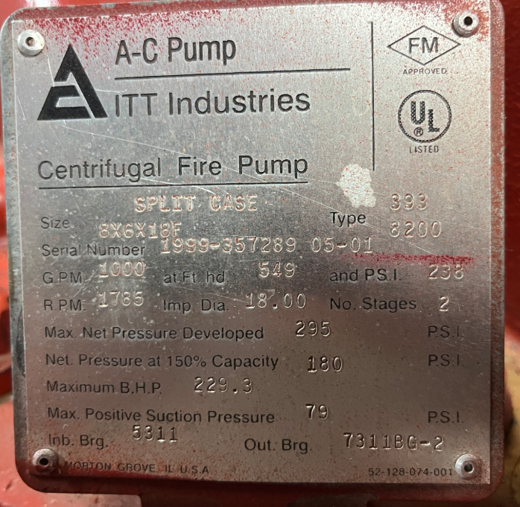

Q7: The bid package calls out for fire hose cap removal and replacement. Are you referring to a standpipe cap?
A7: Yes. Fire Hose Cap pursuant to Exhibit B, Attachment 1, Cost Sheet is referring to a standpipe cap.

Q8: Do you have fire sprinkler system as-builts or previous inspection reports?
A8: We have as-built and inspection reports for fire sprinkler system that will be given to the awarded bidder.

Q9: Do you have pre-action system as-builts or previous inspection reports?
A9: Yes, we have as-built for the pre-action system that will be available to the awarded bidder.

Q10: Do you have electric mule pump as-builts or previous inspection reports?
A10: Yes, we have as-built for the pre-action electric mule pump that will be available to the awarded bidder.

Q11: Do you have diesel pump as-builts or previous inspection reports?
A11: Yes, we have as-built for the diesel pump that will be available to the awarded bidder.

Q12: For the diesel fire pump, do you have an engineer on site that performs weekly inspections or should that pricing be included in this IFB?
A12: Yes. We have two available engineers who perform the weekly diesel fire pump inspections and testing. Weekly inspections performed by FMD engineers are not included in the Contractor’s responsibilities or pricing.

Q13: For the maintenance portion of Section 6: Work Details, E. Annual – Diesel Engine Fire Pump – Inspection, Testing & Maintenance…will the “maintenance portion” also include oil, coolant, and filters, etc. being replaced?
A13: Yes, Annual - Diesel Engine Fire Pump – Inspection, Testing & Maintenance pursuant to Scope of Work Section 6: Work Details, will include, oil, coolant, batteries, filters to be replaced.

Q14: Is the dry pipe inspection requested a standpipe and if so, do you have as-builts or previous reports?
A14: The 3-year dry pipe inspection was completed in February 2026 by JCI. An additional inspection may be required prior to contract renewal. As-built documentation for the dry pipe system will be available to the awarded bidder.

