Date: August 27, 2026

To: All Bidders for IFB – Emergency Generator; Building #063, CR-25-294216

From: Department of General Services
Office of Business and Acquisition Services (OBAS)

Subject: IFB – Emergency Generator; Building #63, CR-25-294216 – Questions and Answers

As of August 19, 2026, OBAS received on behalf of Facilities Management Division the following questions (Q) and is providing the following answers (A):

Q1: What is the proposed location for parking the rental generator?

A1: Per Addendum 4, IFB Instructions, Attachment 9, Sample Agreement, Exhibit A, Scope of Work, 5. Service Details, D. Parking, was revised to clarify as follows:

“The State does not provide parking, however, off-loading of equipment and materials may be performed at the building’s loading dock if permission is obtained in advance from the FMD Contract Administrator or FMD Designated Representative and sufficient space is available. Contractor will park on city streets along P street, between 7th Street and 8th Street, utilizing any of the six (6) spaces on the western side of the block (7th Street side).”

Please see the site map which is included at the end of this document.

Q2: What is the proposed location for parking the load bank during testing?

A2: Per Addendum 4, IFB Instructions, Attachment 9, Sample Agreement, Exhibit A, Scope of Work, 5. Service Details, D. Parking, was revised to clarify as follows:

“The State does not provide parking, however, off-loading of equipment and materials may be performed at the building’s loading dock if permission is obtained in advance from the FMD Contract Administrator or FMD Designated Representative and sufficient space is available. Contractor will park on city streets along P street, between 7th Street and 8th Street, utilizing any of the six (6) spaces on the western side of the block (7th Street side).”

Please see the site map which is included at the end of this document.

Q3: What is the proposed connection location for the rental generator tie-in while the on-site generator is offline for maintenance and repair?

A3: Per Addendum 4, IFB Instructions, Attachment 9, Sample Agreement, Exhibit A, Scope of Work, 6. Work Details, A. Semi-Annual – Preventive Maintenance, Item 17. was revised to clarify as follows:

“Connection Requirements - Temporary generator shall be connected to the existing building Automatic Transfer Switch (ATS) and emergency power system, at the main switching board in SWBD-MSBG. Connection shall comply with NFPA 20 Sections 9.2, 9.3, 9.6, NFPA 110 for emergency power system performance and testing, and local electrical codes and safety standards. There is no existing docking or tap provision.”

Please see the site map which is included at the end of this document.

Q4: What is the proposed tie-in location for the load bank during testing?
A4: Per Addendum 4, IFB Instructions, Attachment 9, Sample Agreement, Exhibit A, Scope of Work, 6. Work Details, C. Two-Hour Load Bank Testing, Item 4. has been added to clarify as follows:

4. The tie-in location for the Two-Hour Load Bank Testing is at the Generator Control Panel located on P street, between 7th Street and 8th Street, utilizing any of the six (6) spaces on the western side of the block (7th Street side).”

Please see the site map which is included at the end of this document.

Q5: Will the load bank testing take place during normal business hours, or is it scheduled for after hours/weekends when the building is unoccupied?

A5: Per IFB Instructions, Attachment 9, Sample Agreement, Exhibit A, Scope of Work, 5. Service Details, A. Work Days, Hours and State Holidays, Item 1. states:

- The State's normal business hours are: Monday through Friday, 8:00 a.m. to
5:00 p.m. (PT), excluding observed State holidays. All scheduled services under this Agreement shall be completed within normal business hours with the exception of the Two (2) Hour Annual Load Bank Testing, which shall be performed after normal business hours (unless approved in writing and in advance by the FMD Contract Administrator or FMD Designated Representative).”

Q6: What is the earliest and latest technicians can be on site during normal working hours?

A6: Per IFB Instructions, Attachment 9, Sample Agreement, Exhibit A, Scope of Work, 5. Service Details, A. Work Days, Hours and State Holidays, Item 1. states:

- The State's normal business hours are: Monday through Friday, 8:00 a.m. to 5:00 p.m. (PT), excluding observed State holidays. All scheduled services under this Agreement shall be completed within normal business hours with the exception of the Two (2) Hour Annual Load Bank Testing, which shall be performed after normal business hours (unless approved in writing and in advance by the FMD Contract Administrator or FMD Designated Representative). Any unapproved hours of work will be considered performed at Contractor's own expense.”

Q7: How many transfer switches are in the preventive maintenance scope?

Exhibit A, Section 6, item A states that ATS inspections include “all ATS.” The Equipment List at Exhibit A, Attachment 1 names three: ATS-R1, ATS-E1 and ATS-S1.

At the walk-through we found that switchboard SWBD-MSBG carries feeders for five: those three, plus ATS-FP1 and ATS-FP2, 600 A each, Pump Room 1-109.

A7: Per Addendum 4, IFB Instructions, Attachment 9, Sample Agreement, Exhibit A, Attachment 1, Equipment List, was revised to clarify there are five (5) transfer switches as follows:

QTY | EQUIPMENT DESCRIPTION | MANUFACTURER | MODEL # | SERIAL #
1 | ENG. Family HCPXL78.INZS | Caterpillar | 3512C | N/A
1 | BATTERY Charger | Sens | NRG24-  20HCLS | 487117-47-19
2 | Battery | CAT | 153-5720 | 210 ah CAP @ 20  HRS, 465 RC 12 v
1 | Generator | Caterpillar | LYH00422 | S/N GAF00506
1 | Power Transfer Switch ATS-R1 | ASCO 7000 Series Power Transfer Switch ATS-R1 | G7ADTBB 32000N5X C | S/N # 1981832 WE
1 | ATS Automatic Transfer switch | ASCO 7000 Series Power Transfer Switch ATS-E1 | J07ATBB3 0400N5XC | S/N 1981833 RE
1 | ATS Automatic Transfer switch | ASCO 7000 Series Power Transfer Switch ATS-S1 | G7ADTBB 31200N5X C | S/N 1811794 WE
1 | Electrical Fire Pump Controller with Automatic Transfer Switch ATS-FP1 | Hubbell Metron | MPT700-200-480C  MTS-400Z | S/N 24360967
1 | Electrical Fire Pump Controller with Automatic Transfer Switch ATS-FP2 | Hubbell Metron | MPT700-200-480C  MTS-400Z | S/N 24373436

Q8.A: Exhibit A, Section 6, item A requires a temporary standby generator “whenever the facility’s permanent standby generator is out of service for scheduled maintenance or repairs.”

Which services does FMD consider to place the generator out of service — the semi-annual service, the annual service, the Two-Hour Load Testing, or some combination — and for how long in each case?

A8.A: Per Addendum 4, IFB Instructions, Attachment 9, Sample Agreement, Exhibit A, Scope of Work, 6. Work Details, C. “Two-Hour Load Bank Testing”

Per Addendum 4, IFB Instructions, Attachment 9, Sample Agreement, Exhibit A, Scope of Work, 6. Work Details, A, Semi-Annual -Preventive Maintenance, Item 15. was revised to clarify as follows:

15. The Contractor shall provide a temporary standby generator whenever the facility’s permanent standby generator is out of service for scheduled maintenance or repairs. The temporary generator shall be sized to support all critical loads, including fire pumps, as required by NFPA 20 (2019 Edition), Sections 9.2, 9.3, and 9.6.u. Annual Preventive Maintenance and Two – Hour Load Bank Testing can be done at the same time and will require the generator to be out of service. Semi-annual Preventive Maintenance must be done by itself and may not take the generator out of service unless repairs are necessary.

Q8.B: Where the outage is for a repair rather than scheduled maintenance, which Cost Sheet table pays for the temporary unit?

A8.B: Per IFB Instructions, Attachment 8, Cost Sheet, Table 4. Unforeseeable Repair Services.

Q8.C: Section 6 refers to “the existing building Automatic Transfer Switch (ATS)” in the singular, but the emergency system has several. Where is the temporary unit to connect — at SWBD-MSBG, or at an individual switch — and is there an existing docking or tap provision?

A8.C: Per Addendum, 4. IFB Instructions, Attachment 9, Sample Agreement, Exhibit A, Scope of Work, Section 6, Work Details, Item A.17. was revised for clarification as follows:

17. Connection Requirements - Temporary generator shall be connected to the existing building Automatic Transfer Switch (ATS) and emergency power system, at the main switching board in SWBD-MSBG. Connection shall comply with NFPA 20 Sections 9.2, 9.3, 9.6, NFPA 110 for emergency power system performance and testing, and local electrical codes and safety standards. There is no existing docking or tap provision.

Q9: Which table pays for the replacements the PM sections already require?

Section 6, item B requires replacing all cooling system hoses, fan belts, thermostats and seals, and the engine oil and filter at each annual service. Section 6, item A requires fuel filters at each semi-annual service.

Cost Sheet Table 3 separately prices Oil Filters, Fan Belts and Air Filters at an Estimated Quantity of 3 each, while every other Table 3 item carries a quantity of 1.

Are these replacements included in the Table 1 Preventive Maintenance rates, with Table 3 reserved for replacements FMD directs outside a scheduled visit? Or are they paid through Table 3, with Table 1 covering inspection and service labor only?

A9: Per IFB Instructions, Attachment 9, Sample Agreement, Exhibit A, Scope of Work, 6. Work Details, Item F. “Preventive Maintenance shall be paid by the State at the Contractor’s rates specified in Exhibit B, Attachment 1, Cost Sheet, Table 1, Preventive Maintenance.”.

Per IFB Instructions, IFB Instructions, Attachment 9 Sample Agreement, Exhibit A Scope of Work, 7. Repair Services, Item B. “Foreseeable Repairs shall be paid by the State at the Contractor’s Repair Service-Hourly Rates, specified in Exhibit B, Attachment 1, Cost Sheet, Table 3, Foreseeable Repair Services.”

Q10: References. The Bidder Minimum Requirements ask for references “similar to parking lot management services,” while Attachment 5 asks for work “similar in scope and type of work required in this solicitation.” Please confirm that generator maintenance references are what is required.

A10: Per Addendum 4, IFB Instructions, B. Bidder Minimum Requirements, Item 3. has been revised to clarify “References: Bidders must provide three (3) or more references. Required Attachment 5, Bidder References, must be completed and submitted with the bid submission. NOTE: References to include satisfactory job performance on operations within the last five (5) years that are similar to parking lot management services Emergency Generator Maintenance Services as required in this solicitation.”

Q11: Insurance attachment number. The Minimum Requirements state the certificate of insurance “will be named Attachment 8” and cite an “Attachment 10, Sample Agreement.” The Attachment 7 section states both “as Attachment 8” and “will be named Attachment 7.” The Attachment 1 checklist lists Attachment 7 as Proof of Insurance, 8 as the Cost Sheet and 9 as the Sample Agreement, and there is no Attachment 10. Please confirm that the checklist numbering controls.

A11: Per Addendum 4, IFB Instructions, B. Bidder Minimum Requirements, Item 2. Insurance, was revised to clarify as follows:

- Insurance:

A Bidder must submit current proof of insurance for the following:
  - General Liability
  - Commercial Automobile Insurance
  - Worker’s Compensation

A certificate of insurance (COI) may be provided as proof of insurance. The COI or proof of insurance documents will be named Attachment 7 8, Proof of Insurance, and be submitted with the bid. Endorsements to insurance policies are not required for bid submission. Endorsements to insurance policies are only required by the winning Bidder as indicated in Attachment 9 10, Sample Agreement.

Per Addendum 4, IFB Instructions, Attachment 7, Proof of Insurance, was revised to clarify as follows:

“A Bidder must submit current proof of insurance as Attachment 7 8 for the following:

- General Liability
- Commercial Automobile Insurance
- Worker’s Compensation

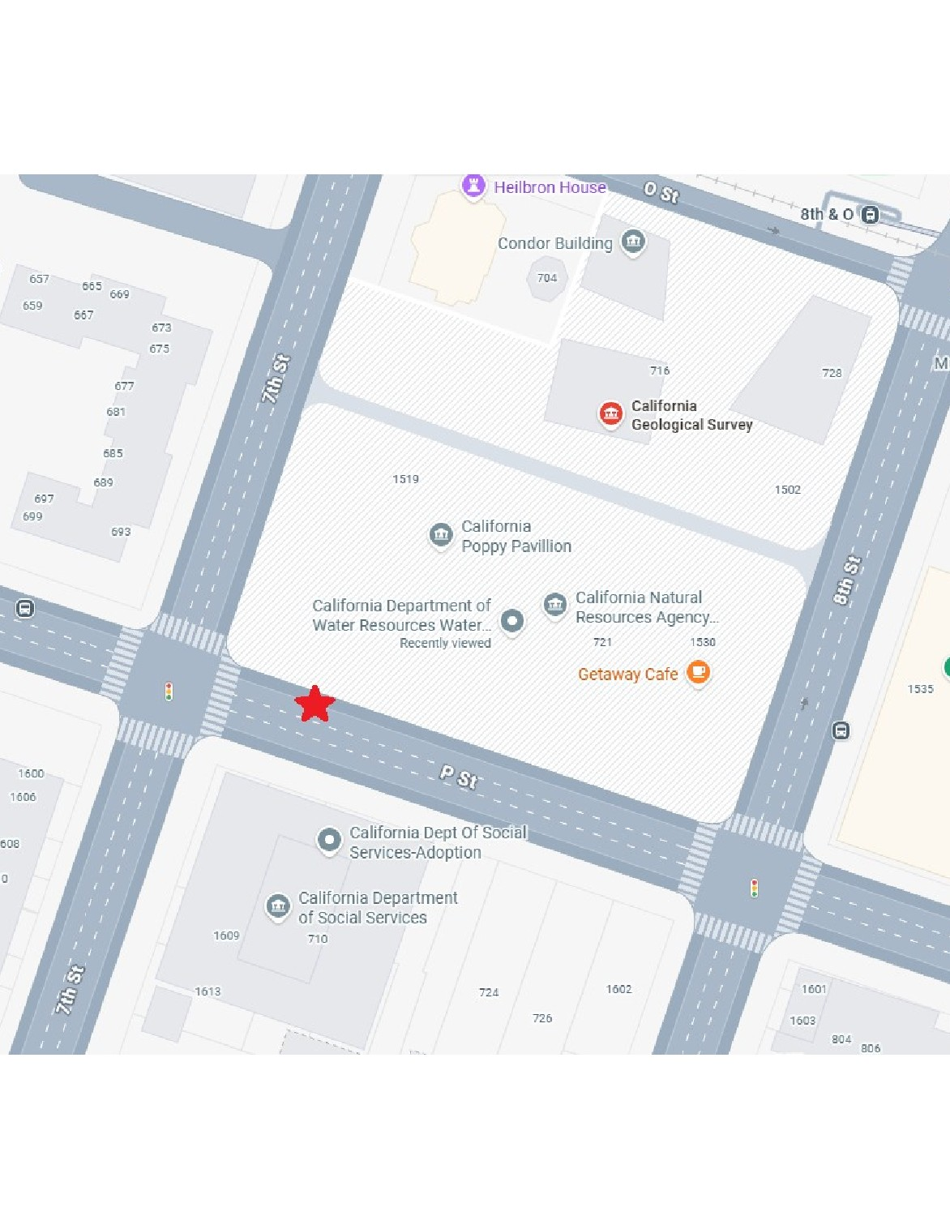
Site Map

