BID FORM A:
Metrogro Nurse Tank Purchases
Return To:  Madison Metropolitan Sewerage District  1610 Moorland Rd.  Madison WI, 53713  Attn: Erik Rehr | Title: Metrogro Nurse Tank Purchases  Date Issued: Monday, August 24, 2026  Project manager Erik Rehr  Telephone: 608-709-1833  Email: rfp@madsewer.org
BIDDER: | Submit Bid by 11:00 a.m. on Tuesday, Sept. 22, 2026 Todays Date: August 18, 2026

1.0 SPECIFICATIONS:
Nurse Tanks
  - General Specifications
    - Tank description: Non-Code Transport
      - Quantity: 2
      - Capacity: Based off dimensions (See Figure 1 Below)
      - Compartments: One
      - Profile: straight Oval
      - Length: 40 feet
      - Width: ~10 feet
      - Product: sludge
      - Product wt./US gal: 13-lb max
    - Vessel
      - Shell material: 1/4-in thick 304 stainless steel plate
      - Floor material: 3/8-in thick 304 stainless steel plate
      - Baffles: none
      - Top Unload Pipe Outlet: Salvage and reuse existing 10-in SS floating assembly from old tank. Top straw cone must protrude above tank rise lip. Straw inlet hole to be 60-in to 72-in from the front bulkhead of tank. Straw is to float in 20-in to 21-in tank opening raised above top of tank Minimum lip rise of 3-in. Bottom of straw to floor distance to be 3.5-in to 4.5-in.
      - Access Manhole with Vent: 20-in to 22-in manhole with a 3-in min. lip rise located 32-in to 60-in from rear bulkhead of tank. Stainless steel lockable cover to be hinged to front. A 6-in vent cover to be installed in the center of the access manhole hinged to front.

      - Exterior Manhole Access: Provide stainless steel ladder and catwalk leading to the access manhole on the top of the tank.
      - Interior Tank Access: Provide stainless steel ladder from access manhole into the tank.
      - Tank Fill Tube: 6-in SCH40 stainless steel pipe fill tube at rear of tank similar to existing tank fill tube (See Figure 3 Below). Fill tube to continue as an internal pipe to push material ahead of rear manhole. Lower hose connection to be 6-in male pipe thread. Flow internally shall not interfere with float ball for level gauge.
      - Tank Drain Line: 6-in SCH40 stainless steel pipe drain line at rear of tank, located not more than 48-in from rear bulkhead. Drain to have 6-in male pipe thread. Drain line to be Installed so it clears frame rail and cross members.
      - Tank Level Gauge: Provide stainless steel tank level gauge at the rear of the tank
    - Chassis
      - Tanks to be installed on existing MMSD nurse tank chassis.
  - Additional Specification:
    - Drawings: send customer drawings for approval before manufacturing
    - Warranty period: 3-year for materials and workmanship.
  - Installation Notes
    - In addition to fabrication of the new nurse tanks, manufacturer to provide the following services:
      - Removal and disposal of existing nurse tanks.
      - Preparation of tank frame for mounting.
      - Mounting of new nurse tanks to existing frames.
    - Existing nurse tanks can be viewed at 1610 Moorland Rd, Madison WI by appointment prior to the bid deadline.
    - Drawings and photos of existing tank for reference are below.

Figure 1: Desired tank dimensions (not for manufacture, bidder must provide own drawings)

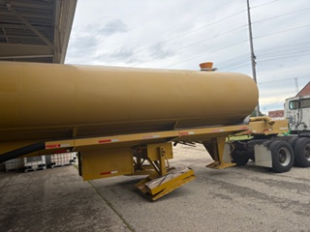
Figure 2: Existing Nurse Tank Photo 1

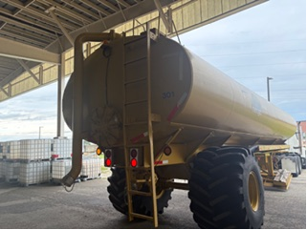
Figure 3: Existing Nurse Tank Photo 2

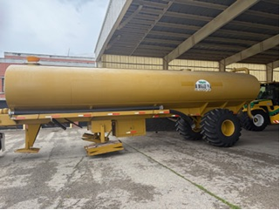
Figure 4: Existing Nurse Tank Photo 3

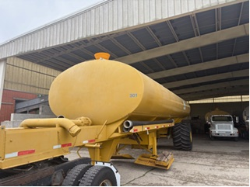
Figure 5: Existing Nurse Tank Photo 4

2.0 Bid:
- To fabricate and provide two (2) new nurse and all other appurtenances for:
2 nurse tanks at $________/unit Extended amount $_____________

- To remove and dispose of two (2) existing nurse tanks for:
2 nurse tanks at $________/unit Extended amount $_____________

- To prepare two (2) existing nurse tank frames and install two (2) new nurse tanks for:
2 nurse tanks at $________/unit Extended amount $_____________

Total Bid Amount: ________________________________________

Company name:________________________________________
Company address:________________________________________
Company phone:________________________________________
Authorization signature:________________________________________
Printed name:________________________________________
Addendum #______________
Estimated delivery date: ________________
Bids will be received until 11:00 a.m. on Tuesday, Sept. 22, 2026.
Date and time received: _________________________

- PURPOSE AND SCOPE
The Madison Metropolitan Sewerage District invites and will accept bids for the purchase and installation of 2 nurse tanks as specified above. MMSD intends to use the results of this process to award and issue a purchase order for the winning bid as a lump sum.
- CORRESPONDENCE, CLARIFICATIONS AND QUESTIONS
Bidders are expected to raise any questions, exceptions or additions they have concerning the bid document by September 10, 2026. If a bidder discovers any significant ambiguity, error, conflict, discrepancy, omission, or other deficiency in this request for bid, the bidder must immediately notify the Project Manager named on the cover page of the issue in writing and request modification or clarification of the bid document. All inquiries must be directed to the person indicated on the cover page. E-mail is the preferred method of contact.

- ADDENDUMS
In the event it becomes necessary to clarify any part of this request for bid, or to revise any part of this RFB, the Project manager will send out an official addendum/amendment to all potential bidders. Bidders must acknowledge the receipt/review of any addendum(s) on the Bidder Response Sheet.

The Project manager has the sole authority for modifications of this specifications and or bid.
- BIDDER QUALIFICATIONS & REQUIREMENTS
All Bidder qualifications in this section are mandatory. Failure to meet a qualification may disqualify your Bid. However, the Procurement Agent reserves the right to waive any qualification if no Bidder is able to satisfy that qualification.
  - Bidder must be in the business of fabricating stainless steel tanks for at least the past three (3) years. (See Bidder Response Sheet Attachment C)
  - Bidder must provide a written warranty providing assurance that manufactured parts are in brand new condition and free of defects in quality or workmanship.
  - Bidder must be able to deliver the nurse tanks within 52 weeks of award.

- METHOD OF BID
Bidder must use the Bidder Response Sheet (Attachment C) and must submit a Net Purchase Price. All prices must be bid in U.S. Dollars. Bidder’s own quotation sheet will not be accepted.
8.0 INVOICING REQUIREMENTS
Contractor shall invoice after materials are shipped. MMSD will pay or reject invoices within 30 days of receipt by MMSD. Only properly submitted invoices shall be officially received for payment. Thus, your prompt payment requires that your invoices be clear and complete in conformity with the instructions below.

All invoices must be itemized showing
a. Purchase Order number
b. Contractor name
c. Remit to address and telephone number
d. Contract price(s) and detail of what is being billed

9.0 METHOD OF AWARD
Award(s) shall be made on the basis of the lowest Net Purchase Price bid from a responsive, responsible bidder who meets all specifications. MMSD will award to one (1) Bidder whichever is judged to be in the best interest of the MMSD. MMSD is the sole determinant of its best interests.
10.0 REQUIRED FORMS
In order for your bid to be considered, the following completed documents must be provided. An “X” preceding the form indicates that it must be completed and returned with the Bid response by the due date and time listed on the bid cover page, in order for your bid to be considered. Include:
X | Bidder Response Sheet | Attachment C

Failure to provide the required documents/information within your bid submittal may disqualify your bid.

BIDDER RESPONSE SHEET. RFB Metrogro Nurse Tank Purchases
ATTACHMENT C

Bidders must submit the following table with a response in the form of a check in one box for each criterion indicating “Yes” or “No”. A check indicating “Yes” certifies that the Bidder is fully capable of providing the service or qualification described. Bids without a response for each requirement or “No” will be rejected. Awarded vendor must be able to answer “Yes” to all requirements.
QUALIFICATIONS AND REQUIREMENTS
Section | Requirement Description | YES, I can meet this requirement | NO, I cannot meet this requirement
1.0, b, i | Send customer drawings for approval before manufacturing
1.0, b, II | Provide a 3-year warranty period for materials and workmanship.
6.1 | Bidder must be in the business of fabricating stainless steel tanks for at least the past three (3) years.
6.2 | Bidder must provide a written warranty providing assurance that manufactured parts are in brand new condition and free of defects in quality or workmanship.
6.3 | Bidder must be able to deliver the nurse tanks within 52 weeks of award.

I certify that the information I have provided in this bid is true, and I understand that any false, misleading, or missing information will disqualify the bid.
Company Name: __________________________________________________________
Bidder’s Name and Title: ____________________________________________________
Bidder Signature: __________________________________________________________
Date: ____________________________________________________________________
Signature of authorized MMSD Employee: ______________________________________
Printed Name: ____________________________________________________________
Date: ___________________________________________________________________

